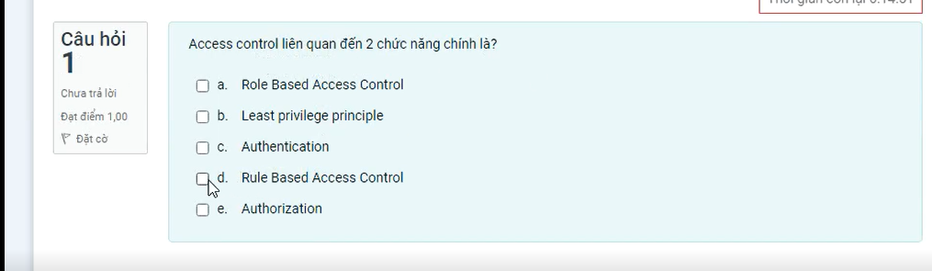

Authentication

Authorization

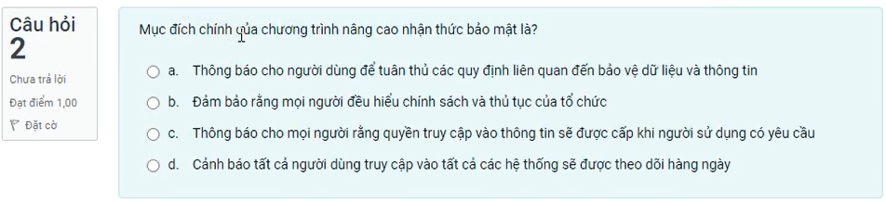

**2A**

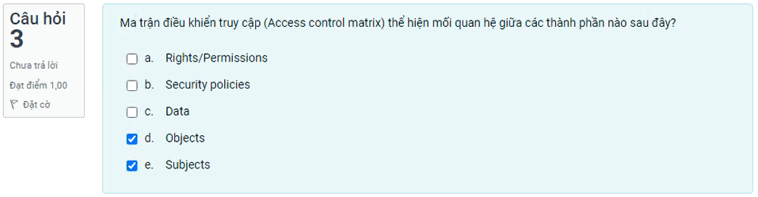

Object Subject right/permission

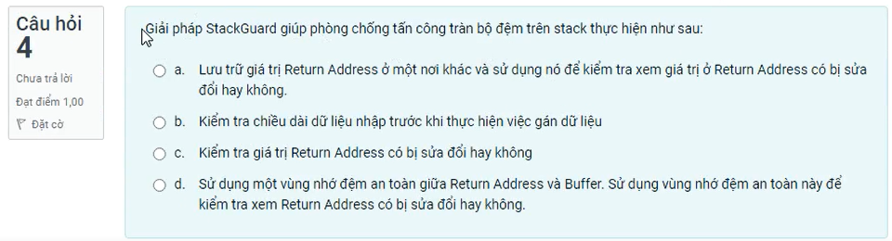

4D

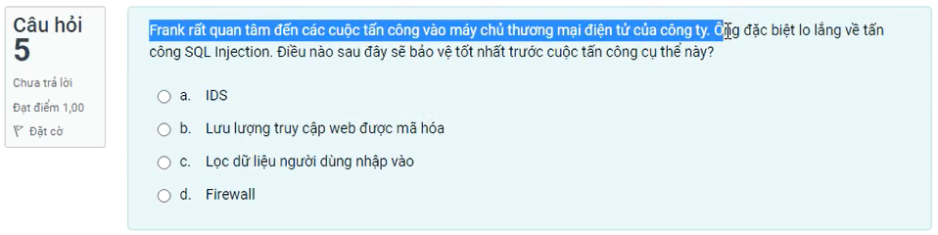

5C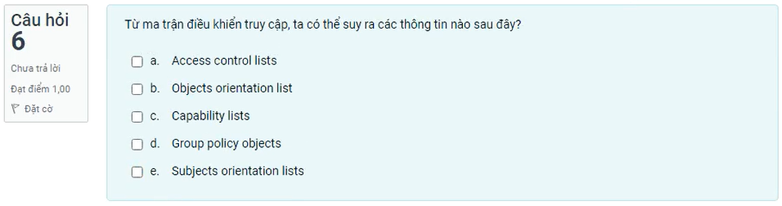

Access control list

Capability list

Objects orientation list

Subjects orientation list

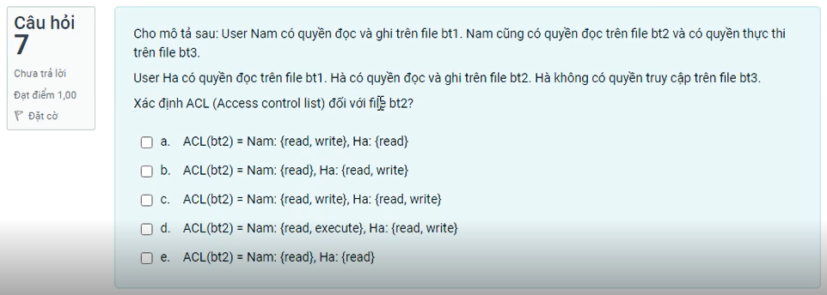

|  |  |  |  |
| --- | --- | --- | --- |
|  | Bt1 | Bt2 | Bt3 |
| Nam | Read, write | Read | Execute |
| Ha | Read | Read, write | - |

ACL(bt2) = Nam: {Read}, Ha: {Read, write}

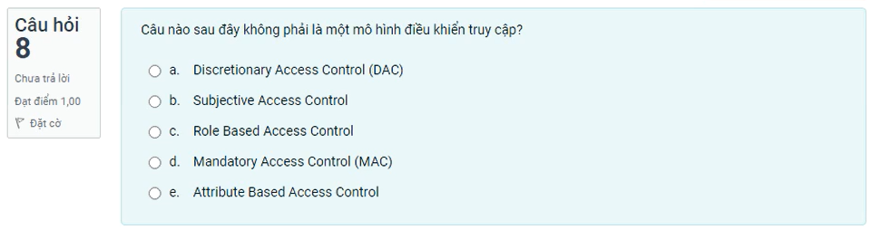

8B

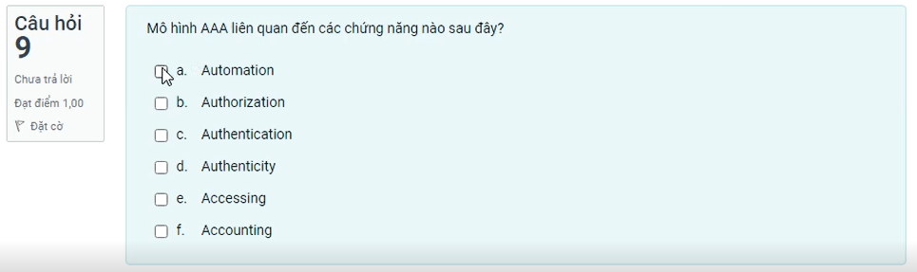

Authentication

Authorization

Accounting

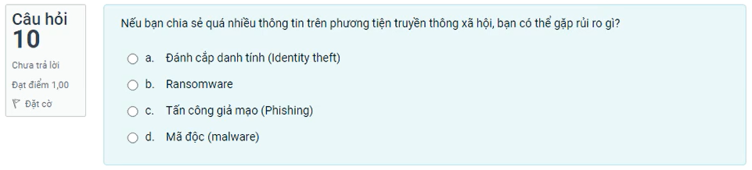

10A

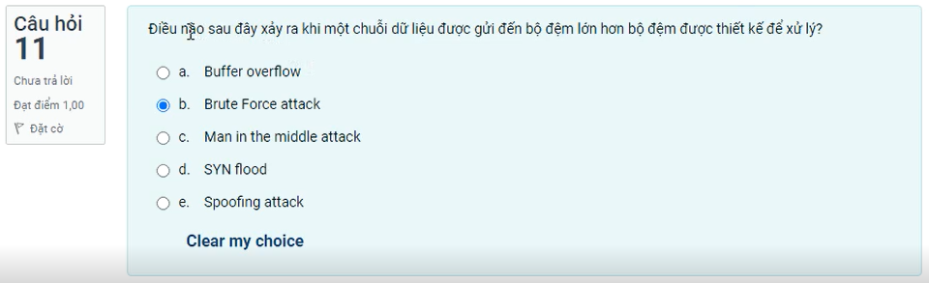

11A

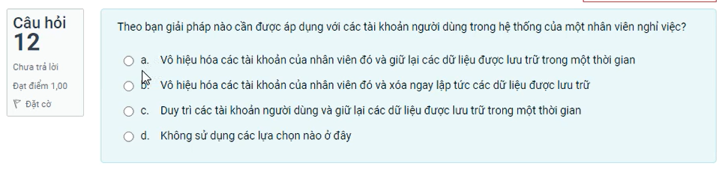

12A

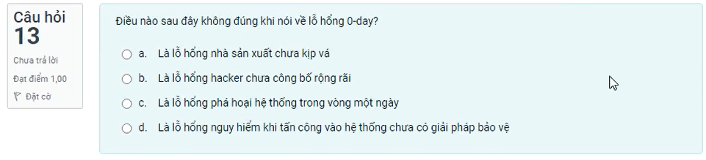

13C

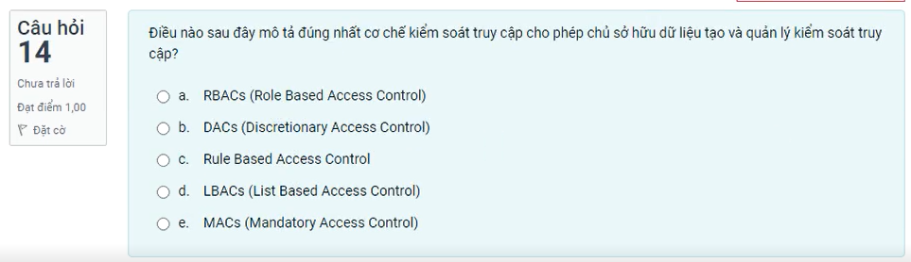

DACS

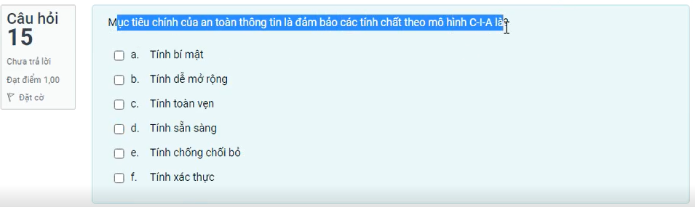

Confidentiality: bí mật

Integrity: toàn vẹn

Availability: sẵn sàn

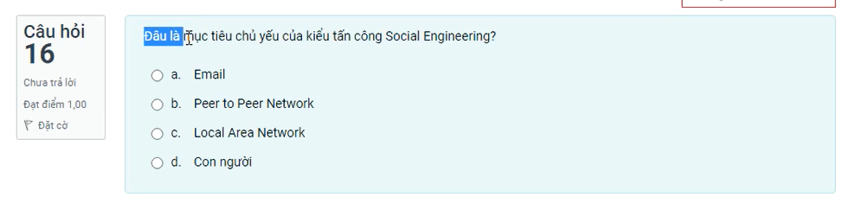

Con người

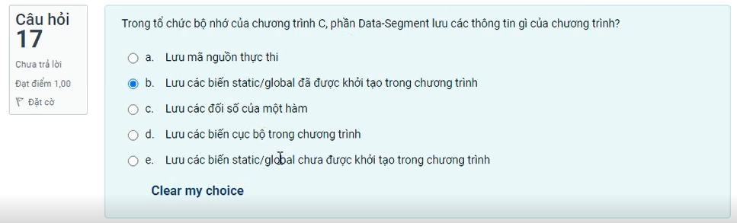  
17B

BSS: Chưa khởi tạo

Data-segment: Đã khởi tạo

Text/code : chứa code

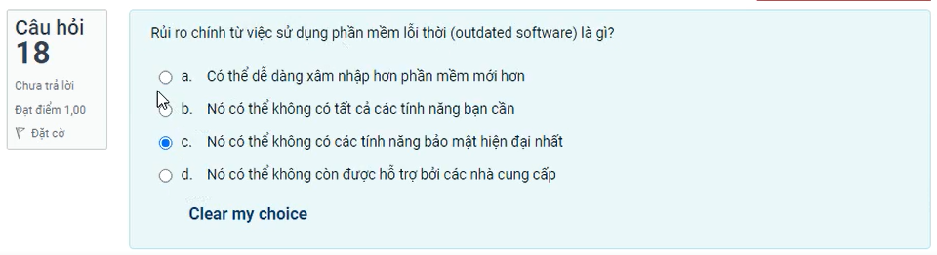

18C

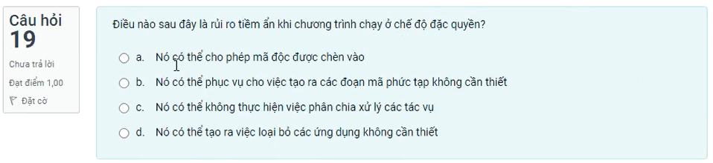

19a

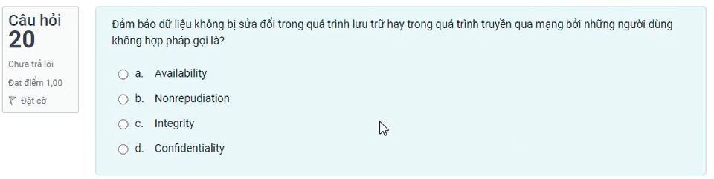

20C