Looking into the expansion (cartridge) port on the back of the C64:

* Pin 1: upper right
* Pin 22: upper left
* Pin 23 (A): lower right
* Pin 44 (Z): lower left

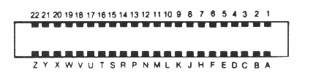

Screen memory at startup is 0x400 (1024).

Characters set: 0x00=’@’ 0x01=’A’... 48=’0’

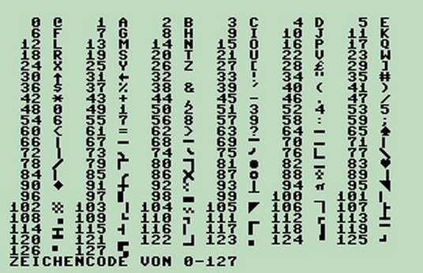

/IO1 is asserted with writes from DE00-DEFF

/IO2 is asserted with writes from DF00-DFFF

Print peed 56832 and 56833

Poke 56832,255

Poke 56833,4

Poke 56832, N

170 = 10101010

85 = 01010101

240 = 11110000

EXROM set low … ROM appears at 8000 – 9FFF

32768

8000 – 9FFF is RAM with no cartridge.

With no jumper RAM is at 8000

With jumper JP4 (EXROM) the memory at 8000 is ROM

PortA – Inputs to cartridge

* 0 Data0-in
* 1 Data1-in
* 2 Data2-in
* 3 Data3-in
* 4 size
* 5
* 6
* 7 clock

PortB – Outputs from cartridge

* 0 Data0-out
* 1 Data1-out
* 2 Data2-out
* 3 Data3-out
* 4
* 5
* 6
* 7 ack

The “clock” transitions to move data into cartridge. Data moves on 0-to-1 and then 1-to-0.

The “ack” transitions to acknowledge data.

If “size” is grounded then all 4 data bits are used. If “size” is floating or 1 then only one data bit is used.

The simplest transfer is made with just two wires (plus ground). Use “clock” to toggle bits in with “data0-in”. Be sure not to overrun the speed of the C64.

Add a connection to “ack” to avoid the waiting guess.

Ground the “size” pin and use all 4 data bits for maximum throughput.

Monitor Program

* Init directions
* Write “M” to upper left
* Read command and branch to routine
  + L DD SS ... Download to cartridge dest=DD, size=SS
  + E DD Execute (call) address=DD
  + R DD SS Upload from cartridge source=DD, size=SS

ReadWord

* Read LSB then MSB

DE00 56832

DE01 56833

DE02 56834

DE03 56835

8000 32768