ITEC624: Network Security and Applications
Week 4 Lab — Assessment 1 — DRAFT ANSWERS
[Your Name] — [Your Student ID]
This is a draft to review, edit into your own words, and check against the lecture notes before submitting. Part E still needs you to run the OpenSSL commands yourself and add screenshots — see the note at the end.

Part A: Review Questions
A1. Define a Security Association (SA). State the three parameters that uniquely identify an SA, and explain the roles of the SPD and SAD.
A Security Association is a one-way (simplex) logical relationship between two IPsec peers that defines the security services applied to traffic carried on it. It is uniquely identified by three parameters: the Security Parameter Index (SPI), the destination IP address, and the security protocol identifier (AH or ESP). When an outbound packet arrives, the Security Policy Database (SPD) is consulted first — it matches the packet against a set of selectors (addresses, ports, protocol) to decide whether the packet should be discarded, allowed to bypass IPsec, or protected, and if protected, which SA or SA bundle to use. The Security Association Database (SAD) then supplies the actual operational parameters for that SA — keys, sequence number counters, lifetimes and mode — so the packet can actually be authenticated and/or encrypted.
A2. Compare IPSec transport mode and tunnel mode: what part of the packet is protected, and give a deployment for each.
Transport mode protects only the payload of the original IP packet (e.g. the TCP/UDP segment), leaving the original IP header largely intact and visible; it is the right choice for end-to-end protection directly between two hosts, such as a workstation securing its traffic straight to a specific server. Tunnel mode protects the entire original IP packet, header included, by encapsulating it inside a new outer IP packet with a new header; it is the right choice whenever at least one endpoint is a security gateway rather than the actual communicating host, such as a site-to-site VPN linking two branch office routers that protect traffic on behalf of all the internal hosts behind them.
A3. Compare AH and ESP: what each protects, why ESP+auth has displaced AH, and AH's problem with NAT.
AH (Authentication Header) provides connectionless integrity, data origin authentication and anti-replay protection, but no confidentiality, and it authenticates most of the outer IP header as well as the payload. ESP (Encapsulating Security Payload) provides confidentiality through encryption and, optionally, the same authentication service AH provides, applied to the payload. ESP with authentication has largely displaced AH in practice because it delivers everything AH offers plus encryption in a single protocol, which simplifies deployment, policy management and hardware support — there is little reason to run AH separately when ESP-with-auth covers the same ground and more. AH's specific problem with NAT is that it authenticates fields in the outer IP header, including the source and/or destination address; when a NAT device rewrites that address in transit, the integrity check value no longer matches, and the packet is rejected — AH is fundamentally incompatible with NAT traversal.
A4. List the ways a secret key can be distributed to two communicating parties, and the main limitation of each.
A can physically deliver the key to B, or a courier/trusted third party can carry it to both — this does not scale and is impractical for frequent rekeying across many parties. If A and B already share an older key, that key can be used to encrypt and send a new one — the limitation is that this offers no protection if the old key is ever compromised, since every key derived from it inherits the compromise, and it only works if the parties already share a secret in the first place. Finally, a trusted third party such as a Key Distribution Centre (KDC) can deliver keys to A and B over links already secured with keys each shares with the KDC — the limitation is that both parties must trust and be able to reach the KDC, which becomes a single point of failure and a high-value target.
A5. Explain session key vs master key, and why the hierarchy improves security.
A session key is a temporary key used to protect data for one particular communication session or transaction between two parties, and it is discarded once that session ends. A master key is a long-term key shared between an end system and a Key Distribution Centre, and it is used only to encrypt the occasional exchange of session keys, never to encrypt bulk traffic directly. This hierarchy improves security, rather than just adding complexity, because it sharply limits how much ciphertext is ever produced under the master key, which reduces its exposure to cryptanalysis and key-compromise; and because exposure is compartmentalised, if a single session key is ever broken, only that one session's traffic is affected, while the rarely-used master key stays protected.
A6. State the requirements a public-key certificate scheme must satisfy.
Any participant must be able to read a certificate to obtain the subject's name and public key. Any participant must be able to verify that the certificate originated from the certificate authority and was not forged. Only the certificate authority may create and update certificates. Any participant must be able to verify the currency of the certificate, i.e. that it falls within its stated validity period.
A7. Explain the purpose of X.509, and name three fields carried in an X.509 certificate with the security function of each.
X.509 defines a standard format for public-key certificates and a framework for certificate-based authentication, and it underpins the public-key infrastructure used across TLS, S/MIME, IPsec and most other PKI-based systems. Three of its fields: the Serial Number uniquely identifies the certificate within its issuing CA's namespace, which is the identifier used when checking a CRL or querying OCSP for revocation status. The Validity Period (Not Before / Not After dates) bounds the lifetime of the certificate, limiting the window in which a compromised key remains trusted. The Subject Public Key Info field carries the subject's actual public key and its algorithm, which is the cryptographic material relying parties use to verify signatures or establish an encrypted session with the subject.

Part B: Discussion Questions
B1. Key and Certificate Revocation
Revocation is hard to enforce in a distributed environment because a CA has no direct channel to every relying party — certificates are cached, used offline, and checked (or not checked) independently by millions of clients, so there is no single point where "withdrawal" can be made to take effect instantly everywhere. CRLs are periodically published signed lists of revoked serial numbers: they are available offline and leak nothing about which sites a client visits, but freshness is poor between publication intervals. OCSP lets a client query a responder in real time for one certificate's status, which improves freshness, but it leaks the client's browsing pattern to the responder and depends on that responder being reachable, and many clients "soft-fail" open if it is not, undermining the guarantee. OCSP stapling has the server itself periodically fetch a signed OCSP response and attach it to the TLS handshake, which keeps freshness reasonable, removes the privacy leak since the client never contacts the CA directly, and removes the client's dependency on responder availability. Shortening certificate lifetimes changes the nature of the problem by shrinking the exposure window itself, so that expiry increasingly does the work revocation used to do. The Heartbleed vulnerability in 2014 forced a mass revocation event that exposed how inconsistently CRLs and OCSP were actually deployed and honoured across browsers.
B2. Timestamps and Nonces in Key Distribution
Timestamps are used in key distribution protocols to reject any message that falls outside an acceptable window around the current time, which is intended to defeat replay attacks where an old, previously valid message is resent later. Nonces achieve the same goal differently: a nonce is a value generated fresh for one exchange and echoed back (often transformed) inside an encrypted reply, so freshness is proven by demonstrating possession of the current key rather than by trusting a clock. The problem with timestamps is that if clocks across a distributed system drift out of synchronisation, legitimate messages start being rejected as too old or arriving "from the future", which forces administrators to widen the acceptance window, and a wider window reopens exactly the replay attack the timestamp was meant to close. Kerberos is a protocol whose security explicitly depends on clock synchronisation across the realm, typically requiring clocks to be within a few minutes of each other or ticket validation fails.
B3. Key Escrow and Forward Secrecy
A key escrow system has a trusted third party — a government agency, regulator, or the organisation's own security team — hold a copy of users' private or session keys, so that under defined conditions such as a warrant or an employee's departure, protected communications can still be decrypted. The advantage for an organisation is that it enables lawful access and regulatory compliance, and it protects the business from losing access to data if a key holder is unavailable. The disadvantage is that the escrowed key store becomes an extremely high-value target and a structural weakening of confidentiality that can be abused if the escrow agent is compromised or coerced. Ephemeral Diffie–Hellman with forward secrecy is fundamentally in tension with escrow: because a fresh DH key pair is generated for each session and the private ephemeral values are discarded immediately afterwards, there is no long-lived private key left for an escrow agent to hold or later use to recover past session traffic. An Australian organisation has to balance its lawful access obligations under legislation such as the Telecommunications (Assistance and Access) Act with the ASD Information Security Manual's guidance favouring forward secrecy; in practice this means not escrowing session keys wholesale, and instead providing access only at specific, legally mandated points such as account or device access rather than defeating forward secrecy across all traffic.

Part C: Challenge Exercise — Key Distribution Architecture
Figure 1 — Key Distribution Scenario 1
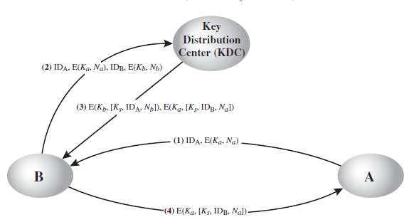
Figure 2 — Key Distribution Scenario 2
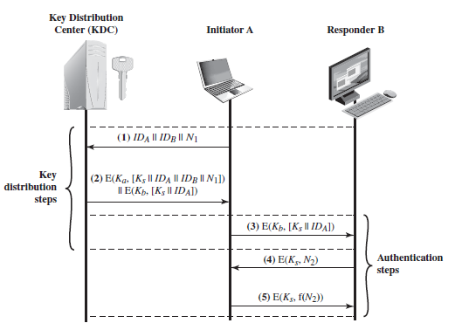
C1. Describe the scheme in Figure 1. Identify every entity, every key, and the purpose of each message.
The entities are the initiator A, the responder B, and the Key Distribution Centre (KDC). A and the KDC share a long-term master key Ka; B and the KDC share a long-term master key Kb; the KDC generates a fresh session key Ks for this exchange; and Na and Nb are nonces chosen by A and B respectively to prove freshness. In message (1), A sends B its identity together with a nonce Na encrypted under Ka, which B cannot read but simply carries forward. In message (2), B forwards that item on to the KDC and adds its own identity and its own nonce Nb encrypted under Kb, effectively asking the KDC to establish a session key for A and B. In message (3), the KDC generates Ks and returns two encrypted blocks to B: one B can decrypt with Kb, containing Ks, A's identity and B's own nonce Nb (which proves to B that this response is fresh and genuinely from the KDC); and one sealed under Ka that B cannot read, containing Ks, B's identity and A's nonce Na, intended for A. In message (4), B forwards that second, still-sealed block on to A, who decrypts it with Ka, recovers Ks, and checks that its own nonce Na and B's identity are present to confirm the exchange is fresh and genuine. At the end, A and B share Ks without either master key ever leaving its owner and the KDC.
C2. Compare Figures 1 and 2 on: trust in the KDC, keys stored, replay resistance, and what an attacker gains by compromising the centre.
Both schemes place essentially total trust in the KDC — it alone generates the session key and both master keys must stay confidential for the whole scheme to hold, so neither design reduces reliance on a central authority. Key storage is also identical in principle: each end system stores only the single long-term master key it shares with the KDC, while the KDC itself must store one master key per registered system, so storage scales linearly with the number of parties either way. The two schemes differ mainly in replay resistance. Figure 1's four-message exchange relies entirely on the nonces Na and Nb being correctly echoed back inside the encrypted blocks; once A and B hold Ks, there is no further step that proves either party is actually online and using it right now. Figure 2's five-message exchange adds an explicit authentication handshake after the key is delivered — B challenges A with a fresh nonce N2 under Ks, and A must return a known transformation of it — which actively proves both parties currently possess the same working session key, closing a gap that nonce-only freshness checks can leave open. On what an attacker gains by compromising the KDC, there is no meaningful difference between the two schemes: in both cases, a compromised KDC exposes every registered master key, letting the attacker mint arbitrary session keys, impersonate any party to any other, and potentially decrypt future exchanges — both designs are equally centralised single points of failure.
C3. Recommend one of the two schemes for a hospital network of 500 workstations, and justify it against the C2 criteria.
Figure 2's five-message protocol is the better fit for a 500-workstation hospital network. Trust in the KDC and key storage burden are identical between the two schemes, so those criteria do not distinguish them, but replay resistance does: a network of that size carrying patient health information is both a high-value target and large enough that an attacker has many opportunities to capture and later replay old key-distribution messages. The extra authentication round trip in Figure 2 directly confirms that both endpoints are actively holding the fresh session key before real communication begins, which meaningfully reduces the risk of a successful replay or impersonation compared with Figure 1's nonce-only freshness check — at the modest cost of one additional message exchange. Given the sensitivity of health data and the corresponding confidentiality obligations a hospital operates under, that small extra cost is well justified by the stronger assurance.

Part D: Diffie–Hellman Calculation (q = 11, α = 2, xₐ = 9, x_b = 4)
D1. Compute Alice's public value yₐ = α^xₐ mod q.
Computing powers of 2 mod 11 step by step: 2¹=2, 2²=4, 2³=8, 2⁴=16 mod 11=5, 2⁵=10, 2⁶=20 mod 11=9, 2⁷=18 mod 11=7, 2⁸=14 mod 11=3, 2⁹=6 mod 11=6. So yₐ = 2⁹ mod 11 = 6.
D2. Compute Bob's public value y_b = α^x_b mod q.
y_b = 2⁴ mod 11 = 16 mod 11 = 5.
D3. Compute the shared secret from both sides and confirm they agree.
From Alice's side: K = (y_b)^xₐ mod q = 5⁹ mod 11. Step by step: 5¹=5, 5²=25 mod 11=3, 5³=15 mod 11=4, 5⁴=20 mod 11=9, 5⁵=45 mod 11=1, 5⁶=5, 5⁷=3, 5⁸=4, 5⁹=9. So K=9. From Bob's side: K = (yₐ)^x_b mod q = 6⁴ mod 11. Step by step: 6¹=6, 6²=36 mod 11=3, 6³=18 mod 11=7, 6⁴=42 mod 11=9. So K=9. Both sides agree on K=9. They must agree because both computations reduce to the same underlying value α^(xₐ·x_b) mod q — Alice computes (α^x_b)^xₐ and Bob computes (α^xₐ)^x_b, and since multiplication in the exponent is commutative, xₐ·x_b = x_b·xₐ, the two routes always land on the same result regardless of which private exponent is applied first.
D4. Describe Darth's man-in-the-middle attack step by step. State the property DH lacks and the TLS 1.3 mechanism that closes the gap.
Darth sits on the line between Alice and Bob and intercepts both public values before they arrive: he stops Alice's yₐ from reaching Bob, and stops Bob's y_b from reaching Alice. Darth chooses his own private value x_d and computes his own public value y_d = α^x_d mod q, then sends y_d to Alice claiming to be Bob, and separately sends y_d (or a second value from a different private exponent) to Bob claiming to be Alice. Darth then computes a shared secret K1 with Alice using her real yₐ and his own private x_d, and a separate shared secret K2 with Bob using his real y_b and his own private x_d. Neither Alice nor Bob notices anything wrong, because each of them completes what looks like a normal Diffie–Hellman exchange and ends up with a working shared key — Alice believes K1 is shared with Bob, and Bob believes K2 is shared with Alice. From then on, whenever Alice sends a message encrypted under K1, Darth decrypts it, reads or modifies it, re-encrypts it under K2, and forwards it to Bob, and does the same in reverse — a fully transparent relay. This works because Diffie–Hellman on its own provides no authentication of the other party; it only guarantees secrecy of the resulting key against a passive eavesdropper, with nothing to stop an active attacker substituting their own public value. TLS 1.3 closes this gap by binding the ephemeral DH exchange to a digital signature over the exchanged values, tied to a certificate verified through the PKI/CA chain, so an attacker without the private key matching a trusted certificate cannot produce a valid signature over a substituted public value without detection.
D5. Explain why q = 11 would be catastrophic in practice, state current minimum parameter sizes, and relate this to Logjam (2015).
A modulus as small as q = 11 leaves only ten possible nonzero residues, so the discrete logarithm problem underlying Diffie–Hellman's security becomes trivial — an attacker can simply enumerate every possible private exponent and match it against the public value almost instantly, with essentially no computational effort required. Current guidance treats finite-field Diffie–Hellman as acceptable only with a modulus of at least 2048 bits, with 3072 bits recommended for longer-term protection, while elliptic-curve Diffie–Hellman achieves equivalent strength with a much smaller key, around 224–256 bits (e.g. curve P-256). The Logjam attack of 2015 demonstrated exactly this class of weakness at real-world scale: many servers still supported, or could be downgraded to, export-grade 512-bit finite-field DH groups, and because a small number of these primes were reused across huge numbers of servers, attackers could precompute enough of the discrete-log structure for those specific primes to break the key exchange for any connection using them in near real time. The q = 11 example in this question is simply a miniature version of the same underlying flaw Logjam exploited: a modulus far too small for the discrete logarithm problem to offer any real protection.

Part E: Practical Tasks

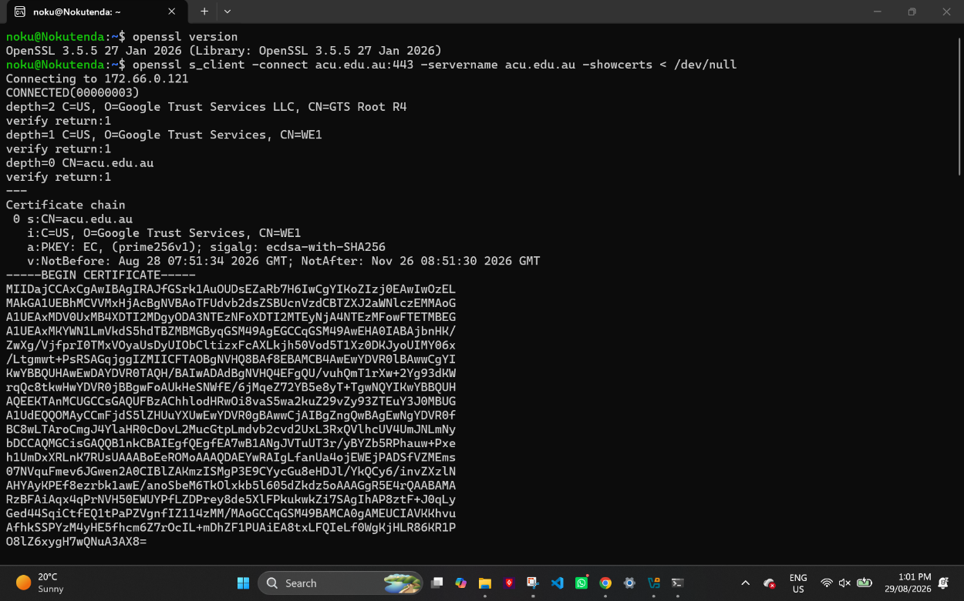

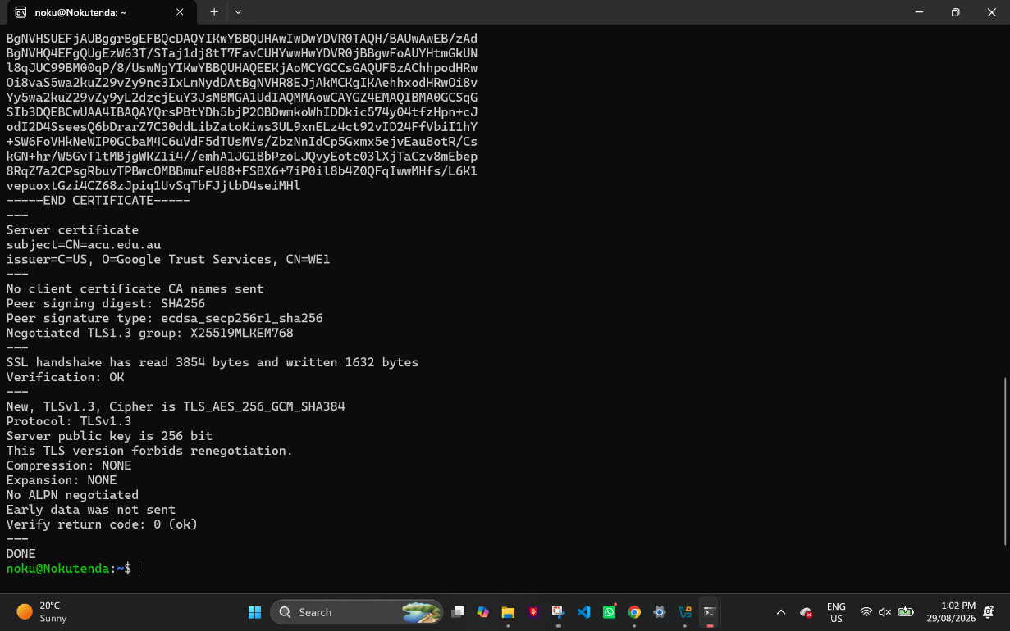

E1 – Certificate Chain Analysis
I ran the command openssl s_client -connect acu.edu.au:443 -servername acu.edu.au -showcerts < /dev/null to grab the actual certificate chain from ACU's website. The output gave back three certificates, which together make up the chain of trust.
The first one (entry 0) is the leaf certificate — this is the actual certificate for the website, with subject CN=acu.edu.au. It was signed by WE1.
The second one (entry 1) is the intermediate CA, WE1 (from Google Trust Services). This is the certificate that actually signed the leaf certificate. The server sends this along with its own certificate so that a client (like my browser or OpenSSL) can trace the chain back to something it already trusts, rather than having to trust ACU's certificate directly.
The third one (entry 2) is the root CA, GTS Root R4. This is where the chain stops, because my machine already has this root certificate stored locally as trusted — it doesn't need to be verified by anything else.
So the way the chain actually links up is that each certificate's issuer field matches the subject of the one below it: leaf ← intermediate ← root. Basically, my computer can trust acu.edu.au's certificate because it can trace a path all the way from that certificate up to a root it already trusts. This is confirmed right at the bottom of the output, where it says Verification: OK and Verify return code: 0 (ok), meaning the whole chain checked out fine.

