專題文件第三章

3-1系統架構

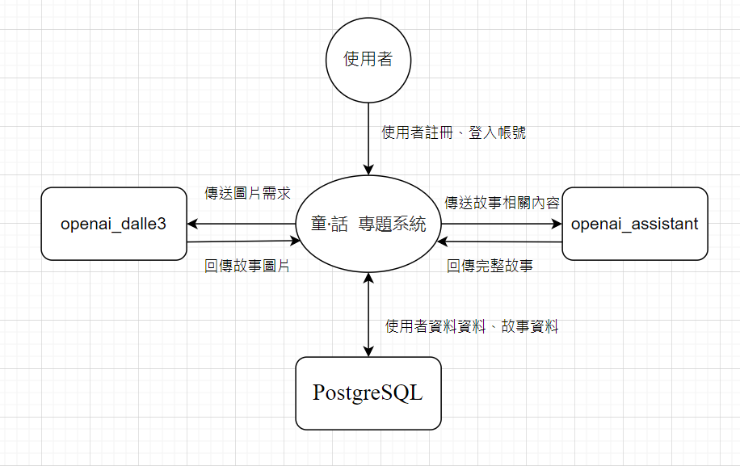

3-2系統軟、硬體需求及技術平台

|  |  |  |
| --- | --- | --- |
| 手機硬體需求 | | |
| 作業系統 | https://lh3.googleusercontent.com/LRO6Sdzt7hZ5KA_50y2mWl_iDruuEu-fyMoUZWwK33muX9V-sOY0NLNIfdxfLTEgfeHeF37MxwMIXGulX4f21ZBNPOx8Hnh4ctzn6_CVYMldM0296vTFzHVa8N6NzjANTzox6r2-kKKDChwO_A https://lh6.googleusercontent.com/DiqTxFDQ4DICh1npxrOsCc1d-nWpF0PtFvl3wqPckhfEh6Oh0TNiA-XdKQRljF0wwaaRth62sGdAO9drW-MuWYgF4kQ9Ao1J17ut46paP6Z074GrPjaGVpOCZjdD9pOlberUp6_QLypLooS1vw | Android/iOS |
| 電腦硬體需求 | | |
| 作業系統 |  | Windows 10(含)以上版本之電腦 |
| 手機軟體需求 | | |
| 系統需求 | https://lh6.googleusercontent.com/EnI1PRQxGXZ--KWbyytYfVoo56r4VPse3LVMCpNW10zwZCXIeAhzcZNFPC4SKD6siZT3j4jxMzMh0WnRZRW5_Kx169UurDzVLRG34E6ToSanDEoXZi-XEizo525rHXnm62Fs_PQ5pPWZpDUP1w | 瀏覽器 |
| 網路需求 | | |
| 網路 | https://lh4.googleusercontent.com/n6uAxRbR5YQQqzu2r6S2KdvEVDEtdBTkKVMTahobjAePsb8K-vCFvXUVQf-OCd47fHspNwgQyz3vx7r_mhiY1ODzHSYKwU0F57NVNjJSpa1-Ka2OwQfBzvjYzXBeVbPfoiJj5LJc3wiCBNmPGA https://lh4.googleusercontent.com/0DRlSbDXYTfEQ8u20vQAqY8mHuF0NE8n1IEjzq-mKWl93dihN9C4xinprv6Tqd0KNgTBZf9Gn5n5zelOMQwCBfqUQG8IEw_LWQb-V35rPXaxepnyo_yG_-qSYHykWOIt31vVT2-f62QZ7u9hKw https://lh6.googleusercontent.com/-1GmrjIFgwIkagVpvkv5PYm4QopjAPS8yr2Eb3YeXGzpT6Ym8z5Gdp-8SCY7V_TvmUYUmUzPPQtVZo6tujbUjeQMCANJXexP3zwl_uMdqN0rHBkXaeEuu8SPtwh0HdDLItf7DNP_NXOOJ_N6wQ https://lh3.googleusercontent.com/PErd9-kDQoVCinmzjNdfSjmo-IVehmintiYJjYKs-HOpI_cJNMrJ2vup68SuxTbOT9SeEa5XFBqnvK9CjYObFL1P21wFIoWChY_uspwtWDLpSyxalAYbL033Chwd8V4M0JblbwVOKF9BN5cOGw | Wifi/乙太網路/4G/5G |

3-3開發標準與使用工具

|  |  |  |
| --- | --- | --- |
| 系統開發環境 | | |
| 作業系統 | https://lh5.googleusercontent.com/fO35PI2iDtHZ-BKydeuW64C_gOD3ilAqFDfYR85T7OKeWYcDRt94T5GzuLCTiNYXXOw33ibDKpdoCkv-u8i40n7vaqJY1wG4SDi7u_7eS2M-bmHei7PjoDe6GPj5Zl_bwuU5nbCSVQ_osk41Nw https://lh5.googleusercontent.com/Io5R6mXFSoO0F3bA1BkFxJkygZyp92pslaqRjxFTBkpEZI1ij3-HVnmnOycUek-B_Y6Ar3CAHDpnV7g94toZsywW84tAshHB_I287-8oFjfG7rAuBrZp2Pajj_ufSdufHAwqSeREitsrnbvimw | Windows/MacOS |
| 撰寫工具 |  | Visual Studio Code |
| 程式語言 | https://lh6.googleusercontent.com/sSSGrprxAFQFDkAIJjNid-21jaROCId7AOYLmK5F4kjp4LfIcC5rlmvuKGxngigXkCXqj6ogCAvK7R2Ykq4y07wJNbet6I2-sro6RJSplFGUSTmKyc5TVt8OMiiLuL5vdFa9zAQFJKW1sDn-1w | Python |
| 程式開發工具 | | |
| 前端 | https://lh5.googleusercontent.com/xSPtF7BK7slK8lk8jY17zvvbXqmYfjt9cDZADzU4nGRR6A0jIq43zTIH6uQ41yaHzlttzfjMRRR73nN6IArkckodIumuBHIPVaBWRou4CPQxyXO1b9xf12zAiGYK6_uxXch_ZxSzBUKwURVSDg https://lh5.googleusercontent.com/uDslkAwoxYJgU1Rl1G1NBBt4Sw4HmzXVxEfFnh8arWW-JtS6-K9S3iu1x-1Ue4yPlxqDt71gbKkatyYlIPGyyibOnwOd-4ZEvLrWlef5kRt6ePSuo3gggPd690Hj98BhWEJNOFxj8J8XYiB_NQ https://lh5.googleusercontent.com/zCGOw9F7w8rhIBcKx1Q1i7Py1MBE7X2CS9K4WD2-SMPA1GWaTJT3fMaCalwwUOBp7d7RkwEuPove2CAk21oS9l94qkO_zy6srnoc9x2WfqT349GdkqSjRA6TBw4WAseO1qZqEXCzqFg9sGq8ww | Html / css / javascript |
| 後端 |  | Flask(Python) |
| 資料庫管理 |  | DBeaver |
| 資料庫 | https://lh6.googleusercontent.com/bMTJvVGGfcX_xSRKi8uODactXXi3MsbzNdwvNLPee8nuHxx-kETE5ryR11c9mEVdGX4zeAjCEp8o2w29uoxDfQ7qNCf7Q5SKtT_ouqRpENAWkuP-i8Z2YGW4PelEJZ9ffnQ0hGmiDOuD9MykqA | PostgreSQL |
| 介面及插圖繪製工具 | | |
| 插圖與logo | https://lh5.googleusercontent.com/_-Wo0GI_3kNwC9YUY1zQkFraooBZuyJ2VfypPvOo3aXwi0C9JD5tpbJ8MKjRXG9A9jdeCE5EaqNQtnGMWb43o5GnCB1o7W2PD_49ZSstWqXgTBf7oZacyU6po-i3vbKcF_OkBk7c3VUIVhVqag https://lh3.googleusercontent.com/Rn551RZXQbPTr4x7UcCtda8EOgoGj2xnAZSJIZO03bipqyoS8rQpCAiOPtB_VdimFP7skWNP4OZVcnzbZ-lk2uP81FwL_GpOIMJrEfLQeWm9L2QXrBUwFByhLEvNbHiNtwhd-b-lwag4XLPTRA | Adobe Illustrator / Photoshop |
| 文件及美化工具 | | |
| 文件 | https://lh3.googleusercontent.com/shvOof2jIp6XQY9tKzg-KPQREnc4GKrPlj_T78V4RgBOYEqQssFx40JJffhh3OxMukx7z4CiJrd9GZEYsn2jpPBcMYdo7-9rRNkOGWv86YAmY6ygWj-9XZdgq1hcNmqi3o3dTkMlHfmFCshMRw | Microsoft Word |
| 圖表 | https://lh3.googleusercontent.com/td-PGR-E_Sue47ez0uT6L0uL9JpLoc-7jVp0r4-q7BBxVsHa4UFW9YEIuQPvAy3L7Q8_kF3QooZXGJ3oFhQsfLFHX_5XOpWLM7oLNrixrnQrDr2nIbzbnki-2PgdXHbxiarh16upQZk_n57acg | Draw.io |
| 簡報 | https://lh3.googleusercontent.com/Wy_cg0w4ZX9g0lRKTT19hSeonSdpRuo8ZPswHzriIAeNZMa71F32nzfBCbiEtFeq9ifh6-WdwoV62gX4pxrl7gao5Wjdgdy-QOw5c3rWr4KH5EYVTKLqINMZ9TIUwerTVFFZaRDVEiu7moX-1Q | PowerPoint、canva |
| 專案管理及版本控制工具 | | |
| 應用程式 |  | fork |
| 版本控制 |  | git |