DBMS Project – Hotel Management System

Produced by The Grand Hotel

Samuel Evans-Adeluka, Mitchell Rudenya and Daniel Akanezi

User Requirements

Leader of section: Samuel E A
Application Background and Purpose
Hotels are increasingly using tech to improve customer service. Imagine a big hotel where everything is connected via a fast, reliable network. Staff can use their phones, tablets, or even smart glasses to instantly access guest info and offer personalized service. The core of this e-hotel is a smooth database system that keeps everyone up to date on guest details and needs.
This project aims to replace old-fashioned, separate processes with a single database to streamline day-to-day tasks, keep data accurate, and boost guest happiness. We'll be using Microsoft Access to build it.

Main User Groups
- Front Desk / Reception
  - What they do: Check-ins/check-outs, reservations, billing, and printing invoices.
  - What they need:
    - Record new reservations with customers and payment info.
    - Check guests in/out and update which rooms are occupied.
    - Print bills and invoices showing all used services.
    - Handle cancellations.
    - See and change the customer instantly.
    - Update guest preferences during their stay.

- Catering
  - What they do: Provide food and drinks, update customer bills, and manage menu items.
  - What they need:
    - Record food and drink orders.
    - Keep a menu with categories.
    - Track orders and tell kitchen/service staff what's up.
    - Add catering costs to the customer's bill automatically for checkout.
- Housekeeping
  - What they do: Keep rooms clean, manage cleaning schedules, and handle requests like laundry.
  - What they need:
    - Track if rooms are clean, dirty, ready, or out of service.
    - Know when rooms are cleaned and ready for the next guest.
    - Record and manage service requests
- Sales
  - What they do: Handle bookings, fill rooms, and keep an eye on customer experience.
  - What they need:
    - Manage group and corporate bookings.
    - Provide discounts and promotions.
Data to be Stored
- Customer – Personal info, loyalty status, preferences, payment type, spending.
- Room – Number, type, price, who's staying there, if it's available, last cleaned date.
- Reservation – Customer, room, check-in/out dates, status, who's taking care of them.
- Payment – How they paid, status, amount, date.
- Service Records – Catering orders, room service, laundry, housekeeping updates.
- Sales Data – Bookings by sales staff, occupancy, discounts.

Operations
- Front Desk: Make/change/cancel reservations, check-in/out, print bills.
- Catering: Add orders to bills, create catering invoices, update menu.
- Housekeeping: Update room status, log laundry, assign cleaning.
- Sales: Manage bookings, check occupancy, create sales/feedback reports.

Business Rules
- A room can only be booked once at a time.
- Check-out must be after check-in.
- All extra charges go on a customer's bill.
- Transaction details get deleted after check-out, but we keep customer info
- Certain staff are assigned to guests to handle any needs or issues.

Non-Functional Requirements
- Data Integrity: Reservations, rooms, and customer data all match up.
- Security: Different departments have different access levels.
- Performance: Things should load fast.
- Usability: Easy to use for everyone, even if they're not tech-savvy.
- Audit: Keep track of when customer records and payments are created or changed.

Database Design

Conceptual Design
Leader of section: Samuel E A

The conceptual design was developed using an ERD through the tool provided in the slides (ERDPlus). It captures entities and relationships within the hotel management system, such as the following:
- Customer, Reservation, Room, ReservationRoom, Payment, Employee, CateringBooking, MenuItem, MenuSelection, HouseKeeping, Sales.
Each entity includes relevant attributes, primary keys, and foreign keys that would be shown in the logical design section of the project. Relationships are defined with appropriate cardinalities. The ERD supports departmental integration across reception, catering, housekeeping, and sales.

Sam’s Draft ERD:
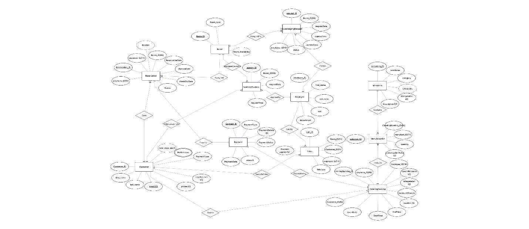
Daniel’s ERD:
Mary’s ERD:
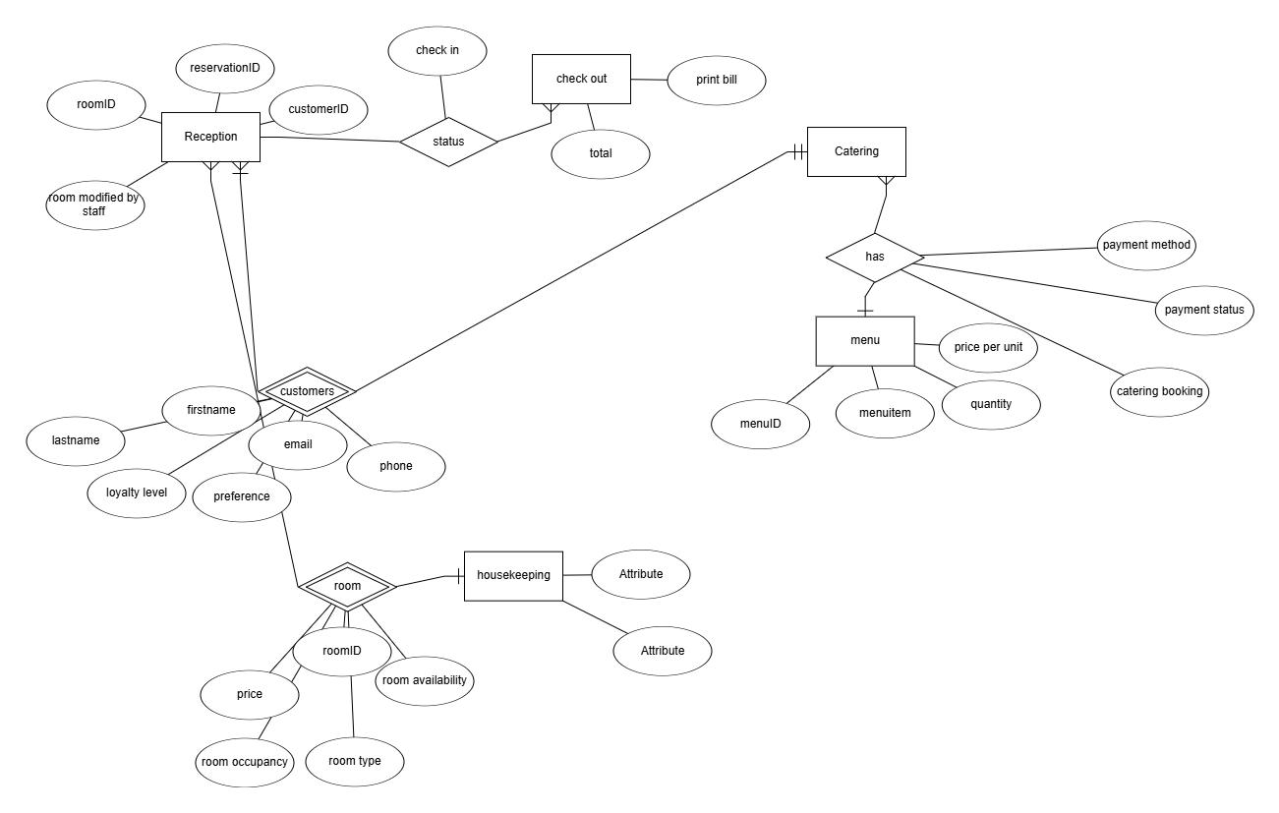

Mitchell’s ERD:
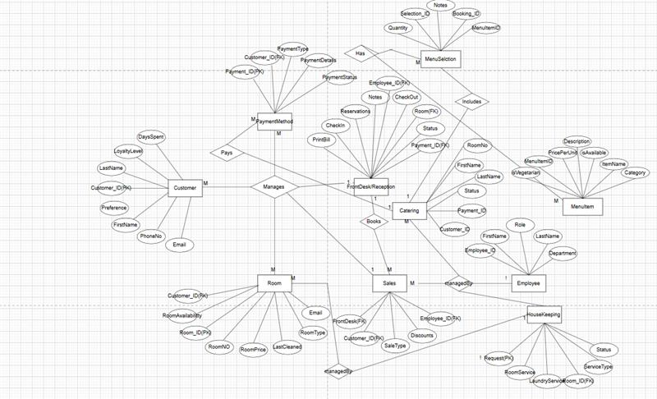

Finalized Sam’s (Group) ERD:
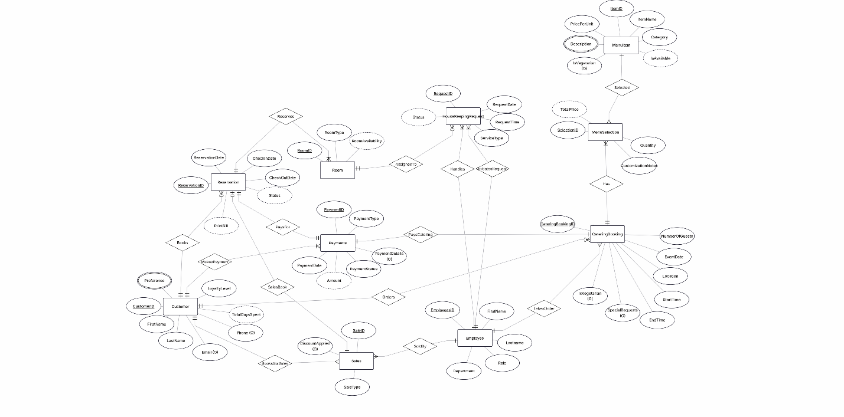

- Relationship Model
Entity Set | Attributes | Key
Customer | CustomerID  FirstName  LastName  Email  Phone  TotalDaySpent  LoyaltyLevel  Preference | CustomerID
Reservation | ReservationID  ReservationDate  CheckInDate  CheckOutDate  Status  PrintBill | ReservationID
Payment | PaymentID  PaymentType  PaymentDetails  PaymentDate  PaymentStatus  Amount | PaymentID
Room | RoomID  RoomType  RoomAvailability  RoomPrice | RoomID
HouseKeepingRequest | RequestID  RequestDate  RequestTime  ServiceType  Status | RequestID
Sales | SaleID  SaleType  DiscountApplied | SaleID
Employee | EmployeeID  FirstName  LastName  Role  Department | EmployeeID
CateringBooking | CateringBookingID  EventDate  StartTime  EndTime  Location  NumberOfGuests  IsVegetarian  SpecialRequests | CateringBookingID
MenuItem | ItemID  ItemName  Category  PricePerUnit  IsAvailable  IsVegetarian  description | ItemID
MenuSelection | SelectionID  Quantity  TotalPrice  customizationNotes | SelectionID

Relationship Set | From Entity | To Entity | Cardinality | Reason
Books | Customer | Reservation | 1:N | A customer can come back to the hotel multiple times
MakePayment | Customer | Payment | 1:N | A single customer might pay multiple times, for catering, reservations, etc.
Orders | Customer | CateringBooking | 1:N | A customer may order catering for different events
BooksViaSales | Customer | Sales | 1:N | A single customer might make multiple bookings via sales over time.
SalesBook | Reservation | Sales | 1:1 | A sale is basically a channel for creating a reservation.
PaysFor | Payment | Reservation | 1:1 | Every reservation requires exactly one payment record
PayCatering | Payment | CateringBooking | 1:1 | A catering booking is paid for in a single transaction.
Reserves | Reservation | Room | 1:N | When a customer makes a reservation, they might book multiple rooms under that single reservation
AssignedTo | Room | HouseKeepingRequest | 1:N | A single Room can have many Requests
InitiatesRequest | Employee | HouseKeepingRequest | 1:N | One employee can initiate multiple requests, but each request has only one creator.
Handles | Employee | HouseKeepingRequest | 1:N | One employee can handle multiple requests, while each request is assigned to exactly one employee.
SoldBy | Employee | Sales | 1:N | Sales need to be made by an employee
TakesOrder | Employee | CateringBooking | 1:N | One employee can take multiple bookings, while each booking is associated with exactly one employee
Has | CateringBooking | MenuSelection | 1:N | One booking can have multiple menu selections, while each menu selection is linked to exactly one booking.
Selected | MenuItem | MenuSelection | 1:N | An item can appear in multiple selections

Leader of section: Mitchell Rudenya

Logical Design
- Relational Schema
  - Customer(CustomerID(PK), FirstName, LastName, Email, Phone, TotalDaySpent, LoyaltyLevel, Preference)
  - Reservation(ReservationID(PK), ReservationDate, CheckInDate, CheckOutDate, , CustomerID(FK), PaymentID(FK), Status)
  - Room(RoomID(PK), RoomType, RoomAvailabilty,ReservationID(FK),RoomPrice)
  - Payments(PaymentID(PK), PaymentDate, Amount, PaymentType, PaymentStatus, PaymentDetails, CustomerID(FK))
  - Employee(EmployeeID(PK), FirstName, LastName, Department, Role)
  - Sales(SaleID(PK), ReservationID(FK), CustomerID(FK), EmployeeID(FK), DiscountApplied, SaleType)
  - HousekeepingRequest(RequestID(PK), RoomID(FK), RequestedByEmployeeID(FK), RequestDate, RequestTime, ServiceType, Status, HandledByEmployee(FK))
  - CateringBooking(CateringBookingID(PK), CustomerID(FK), EmployeeID (FK), PaymentID(FK), NumberOfGuests, EventDate, Location, StartTime, EndTime, IsVegetarian, SpecialRequests)
  - MenuItem(ItemID(PK), ItemName, Category, PricePerUnit, Description, IsAvailable, IsVegetarian)
  - MenuSelection(SelectionID(PK), CateringBookingID(FK), ItemID(FK), Quantity, CustomizationNotes,TotalPrice)
- Normalization
  - 1NF – All table cells must contain atomic values. And each record must be unique
    - Customer(CustomerID(PK), FirstName, LastName, Email, Phone, TotalDaySpent, LoyaltyLevel, Preference)
      - Since Preference would be multivalued as shown in the ERD, it doesn’t meet the rule on 1NF, so we move it to another table and connect it to CustomerID, making them both PK of the new table
      - After 1NF
        - Customer(CustomerID(PK), FirstName, LastName, Email, Phone, TotalDaySpent, LoyaltyLevel)
        - CustomerPreference(CustomerID(PK,FK),Preference(PK))

    - MenuItem(ItemID(PK), ItemName, Category, PricePerUnit, Description, IsAvailable, IsVegetarian)
      - Same as the other
      - After 1NF
        - MenuItem(ItemID(PK), ItemName, Category, PricePerUnit, IsAvailable, IsVegetarian)
        - MenuItemDescription(ItemID(PK,FK), Description(PK))
    - Room and reservation
      - to make things simpler, we create a new table and remove ReservationID from Room
      - After
        - Room(RoomID(PK), RoomType, RoomAvailabilty, RoomPrice)
        - ReservationRoom(ReservationID(PK,FK),RoomID(PK,FK))
        - The relationship then becomes 1:N(Reservation and RoomReservation), Then N:1(ReservationRoom and Room)
    - To achieve 1NF, we remove the derived attributes,
      - Remove the amount from the payment
      - Remove Print bill from Reservation
      - Remove TotalPrice from Menuselection
      - Remove Totaldayspent from Customer
      - Remove PaymentDetails

    - All other tables already had atomic attributes.
  - 2NF
    - Table must already be in 1NF.
    - No partial dependency: All non-key attributes must depend on the whole primary key, not just part of it.
      - The two new tables do not have any non-key attributes, so no partial dependencies, and the rest of the tables had single attribute PKs
  - 3NF
    - Tables are already in 2NF.
    - No transitive dependency: Non-key attributes do not depend on other non-key attributes.
  - BCNF
    - Every Table is in BCNF

Leader of section: Daniel A
Physical Design
Data Dictionary

Table name | Attribute | Data type | P Key | F Key | Nullify | Default | Description | Integrity
Customer | CustomerID | AutoNumber | Yes | No | No | Auto | Unique customer identifier | Enforce PK uniqueness
Customer | FirstName | Short Text (50) | No | No | No | Null | Customer first name | Not Null
Customer | LastName | Short Text (50) | No | No | No | Null | Customer last name | Not Null
Customer | Email | Short Text (50) | No | No | No | Null | Customer email, unique | Unique constraint
Customer | Phone | Short Text (20) | No | No | Yes | Null | Customer phone number | Optional
Customer | TotalDaySpent | Number (Long) | No | No | No | 0 | Total days spent at hotel | Must be ≥0
CustomerPreference | CustomerID | Number (Long) | Yes | Yes | No | Null | Refers to Customer | Referential integrity
CustomerPreference | Preference | Short Text (100) | Yes | No | No | Null | Customer preference | Composite PK
LoyaltyTier | TierID | AutoNumber | Yes | No | No | Auto | Loyalty tier identifier | Enforce PK uniqueness
LoyaltyTier | TierName | Short Text (50) | No | No | No | Null | Tier name (Silver, Gold, Platinum) | Unique
LoyaltyTier | MinSpent | Number (Long) | No | No | No | 0 | Minimum spend for tier | Must be ≥0
LoyaltyTier | MaxSpent | Number (Long) | No | No | No | Null | Maximum spend for tier | Must be ≥ MinSpent
Reservation | ReservationID | AutoNumber | Yes | No | No | Auto | Reservation identifier | Enforce PK uniqueness
Reservation | ReservationDate | Date/Time | No | No | No | Now() | Date reservation made | Not Null
Reservation | CheckInDate | Date/Time | No | No | No | Null | Check-in date | Not Null
Reservation | CheckOutDate | Date/Time | No | No | No | Null | Check-out date | ≥ CheckInDate
Reservation | CustomerID | Number (Long) | No | Yes | No | Null | Refers to Customer | Referential integrity
Reservation | PaymentID | Number (Long) | No | Yes | Yes | Null | Refers to Payments | Optional
Reservation | Status | Short Text (50) | No | No | No | “Pending” | Reservation status | From list
Room | RoomID | AutoNumber | Yes | No | No | Auto | Unique room identifier | Enforce PK uniqueness
Room | RoomType | Short Text (50) | No | No | No | Null | Room type (Single, Double, Suite) | Not Null
Room | RoomPrice | Number | No | No | No | Null | £150, £240, £300 | Not Null
RoomReservation | RoomID | Number (Long) | No | Yes | No | Null | Refers to Room | Referential integrity
RoomReservation | ReservationID | Number (Long) | No | Yes | No | Null | Refers to Reservation | Referential integrity
Payments | PaymentID | AutoNumber | Yes | No | No | Auto | Payment identifier | Enforce PK uniqueness
Payments | PaymentDate | Date/Time | No | No | No | Now() | Date of payment | Not Null
Payments | Amount | Currency | No | No | No | 0.00 | Payment amount | Must be ≥0
Payments | PaymentType | Short Text (50) | No | No | No | “Cash” | Payment method | From list
Payments | PaymentStatus | Short Text (50) | No | No | No | “Pending” | Payment status | From list
Payments | CustomerID | Number (Long) | No | Yes | No | Null | Refers to Customer | Referential integrity
Employee | EmployeeID | AutoNumber | Yes | No | No | Auto | Employee identifier | Enforce PK uniqueness
Employee | FirstName | Short Text (100) | No | No | No | Null | Employee first name | Not Null
Employee | LastName | Short Text (100) | No | No | No | Null | Employee last name | Not Null
Employee | Department | Short Text (50) | No | No | No | Null | Employee department | From list
Employee | Role | Short Text (50) | No | No | No | Null | Employee role (Manager, Staff, Cleaner) | From list
Sales | SaleID | AutoNumber | Yes | No | No | Auto | Sale identifier | Enforce PK uniqueness
Sales | ReservationID | Number (Long) | No | Yes | No | Null | Refers to Reservation | Referential integrity
Sales | CustomerID | Number (Long) | No | Yes | No | Null | Refers to Customer | Referential integrity
Sales | EmployeeID | Number (Long) | No | Yes | No | Null | Refers to Employee | Referential integrity
Sales | DiscountApplied | Number (Double) | No | No | Yes | 0.0 | Discount applied to sale | Must be ≥0
Sales | SaleType | Short Text (50) | No | No | No | Null | Type of sale (Room, Catering, Extra) | From list
HousekeepingRequest | RequestID | AutoNumber | Yes | No | No | Auto | Request identifier | Enforce PK uniqueness
HousekeepingRequest | RoomID | Number (Long) | No | Yes | No | Null | Refers to Room | Referential integrity
HousekeepingRequest | RequestedByEmployeeID | Number (Long) | No | Yes | No | Null | Refers to Employee (who requested) | Referential integrity
HousekeepingRequest | RequestDate | Date/Time | No | No | No | Now() | Date of request | Not Null
HousekeepingRequest | RequestTime | Date/Time | No | No | No | Null | Time of request | Not Null
HousekeepingRequest | ServiceType | Short Text (100) | No | No | No | Null | Type of housekeeping service | From list
HousekeepingRequest | Status | Short Text (50) | No | No | No | “Pending” | Status of request | From list
HousekeepingRequest | HandledByEmployee | Number (Long) | No | Yes | Yes | Null | Employee handling request | Optional
CateringBooking | CateringBookingID | AutoNumber | Yes | No | No | Auto | Catering booking identifier | Enforce PK uniqueness
CateringBooking | CustomerID | Number (Long) | No | Yes | No | Null | Refers to Customer | Referential integrity
CateringBooking | EmployeeID | Number (Long) | No | Yes | No | Null | Refers to Employee | Referential integrity
CateringBooking | PaymentID | Number (Long) | No | Yes | Yes | Null | Refers to Payment | Optional
CateringBooking | NumberOfGuests | Number (Long) | No | No | No | 1 | Number of guests attending | Must be ≥1
CateringBooking | EventDate | Date/Time | No | No | No | Null | Date of event | Not Null
CateringBooking | Location | Short Text (255) | No | No | No | Null | Location of event | Not Null
CateringBooking | StartTime | Date/Time | No | No | No | Null | Event start time | Not Null
CateringBooking | EndTime | Date/Time | No | No | No | Null | Event end time | Must be > StartTime
CateringBooking | IsVegetarian | Yes/No | No | No | No | No | Whether catering is vegetarian | Boolean integrity
CateringBooking | SpecialRequests | Long Text | No | No | Yes | Null | Special requests for catering | Optional
MenuItem | ItemID | AutoNumber | Yes | No | No | Auto | Menu item identifier | Enforce PK uniqueness
MenuItem | ItemName | Short Text (100) | No | No | No | Null | Menu item name | Not Null
MenuItem | Category | Short Text (50) | No | No | No | Null | Menu category (Starter, Main, Dessert) | From list
MenuItem | PricePerUnit | Currency | No | No | No | 0.00 | Price per unit | Must be ≥0
MenuItem | Description | Long Text | No | No | Yes | Null | Description of menu item | Optional
MenuItem | IsAvailable | Yes/No | No | No | No | Yes | Item availability | Boolean integrity
MenuItem | IsVegetarian | Yes/No | No | No | No | No | Whether item is vegetarian | Boolean integrity
MenuSelection | SelectionID | AutoNumber | Yes | No | No | Auto | Selection identifier | Enforce PK uniqueness
MenuSelection | CateringBookingID | Number (Long) | No | Yes | No | Null | Refers to CateringBooking | Referential integrity
MenuSelection | ItemID | Number (Long) | No | Yes | No | Null | Refers to MenuItem | Referential integrity
MenuSelection | Quantity | Number (Long) | No | No | No | 1 | Quantity ordered | Must be ≥1
MenuSelection | CustomizationNotes | Long Text | No | No | Yes | Null | Notes on customization | Optional
MenuItemDescription | ItemID | Number | Yes | yes | no | Null | Foreign key from menu item
MenuItemDescription | Description | Short text | yes | No | no | null | description

Database Implementation
Leader of section: Samuel E A
Table Layer
13 tables inclusive of all user groups and full of sufficient test data for the upcoming query layer. We as a group decided not to deviate from the data dictionary and largely kept to the previous work we established.

Query Layer
As a group we attempted to devise the queries for all relevant user groups and entities such that the relational database operational requirements were met; and a certain level of complexity to demonstrate the knowledge that we have developed throughout the term’s practicals’.

Form layer – Daniel A
Using the form design as well as the switchboard, we created a user interface that added to the functionality of the database. The forms we created allowed specific user groups to display relevant table data enabling data entry, modifying, querying without directly accessing the table. Switchboard manager was utilised to further improve the UI and was demarcated by departments to give access to all forms that were generated from our tables.

Report layer
For the report layer of our database implementation, we went along similar to our form layer by including reports for all departments, user groups and table data so any and all information may be expressed with the forms and other object dependencies (i.e. queries) in mind.

Testing
Test | Expected | Actual | Pass
Check customer catering booking | To check the what the customer booked from catering | Shows the customers booking from catering | YES
Checked in customers | To check all the checked in customers | Shows all the checked in customers | YES
Employee by department | To show where all the employees work | Shows all employees and what department | YES
Most sold item | Shows the most sold item | Shows the most sold item from the menu | YES
Reservations by sales | Shows the reservations made by the sales | Shows all the reservations | YES
Room price for customers | Shows how much a room costs | Shows the price for all the available rooms | YES
Total price of menu selection | How much of what has been selected on the menu | Shows everything that has been ordered from the menu | YES
Unoccupied rooms | Shows all the room without people | Shows all rooms without anybody inside | YES
 |  |  | YES

Database Evaluation
Within the query layer, we created queries permitting all user groups to search for any specific table data they would need (operational requirements). Furthermore, the queries allowed for the hotel database to stratify all departmental information i.e. sales/revenue, booked rooms etc.
Limitations:
Due to time constraints and lack of involvement by some team members we were unable to create or formulate a total bills query, which is highly important for the user group reception.

Conclusion
As a group we believe that the relational database meets the data requirements, operational requirements and specifications within the project scenario and think the Hotel Database demonstrates all key concepts within database design and performance.

