How do I start recycling?

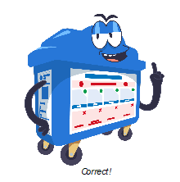

Recycling is easy…

Firstly, set up a recycling corner in your home. Start by placing a recycling receptacle (bin, any container or bag) next to your trash bin so that you can start separating recyclables from general waste.

**See how easy it is to set up a recycling corner!**

[Picture of recycling bin next to trash bin]

Embed video: [How to Set Up a Recycling Corner_V3 (mse.gov.sg)](https://intranet.mse.gov.sg/AboutUs/OurCulture/GR/PublishingImages/Forms/Video/videoplayerpage.aspx?ID=6&FolderCTID=0x0120D520A80800A7E2EF1095A06948A9CC34352622AC4C&List=9eb67d5a-86c1-4ac4-8ffd-68f906068e66&RootFolder=%2FAboutUs%2FOurCulture%2FGR%2FPublishingImages%2FHow%20to%20Set%20Up%20a%20Recycling%20Corner%5FV3%2FAdditional%20Content&RecSrc=%2FAboutUs%2FOurCulture%2FGR%2FPublishingImages%2FHow%20to%20Set%20Up%20a%20Recycling%20Corner%5FV3)

Follow this flowchart to check if your items can or cannot be recycled!

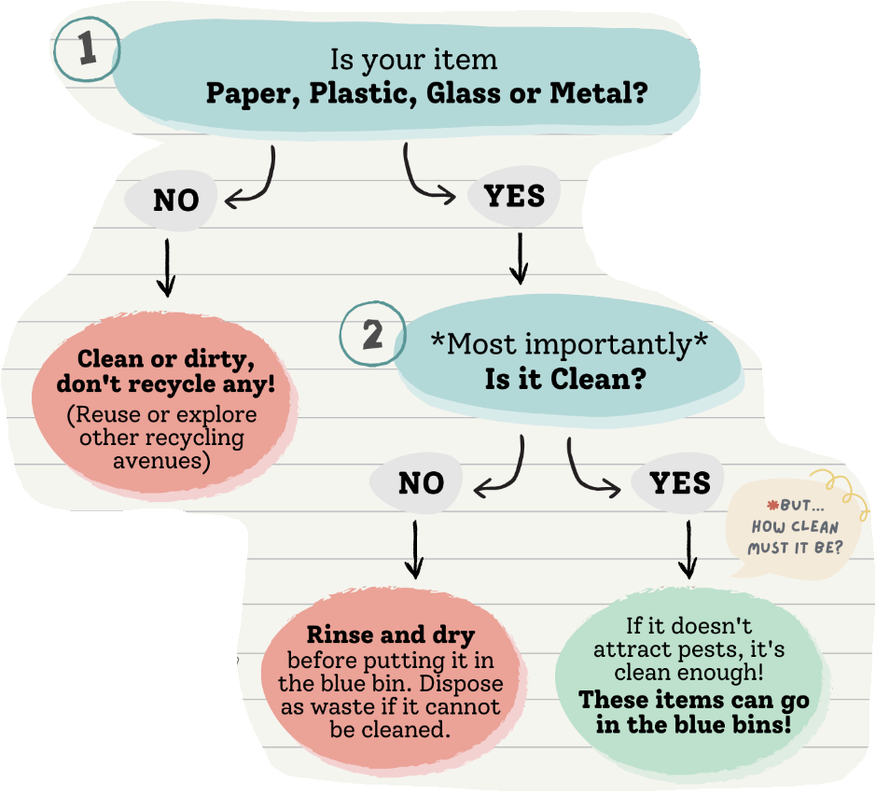

Check out the materials below to learn more about recycling them in details:

* Paper
* Plastic
* Glass
* Metal
* E-waste
* Old Sports Shoes
* Clothes
* Summary list

Paper

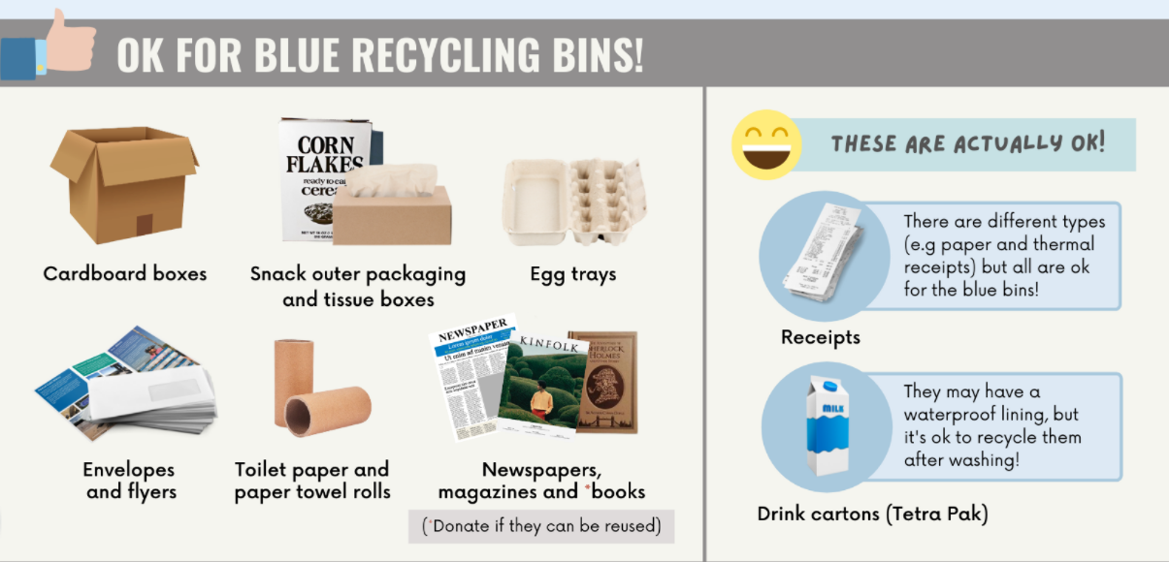

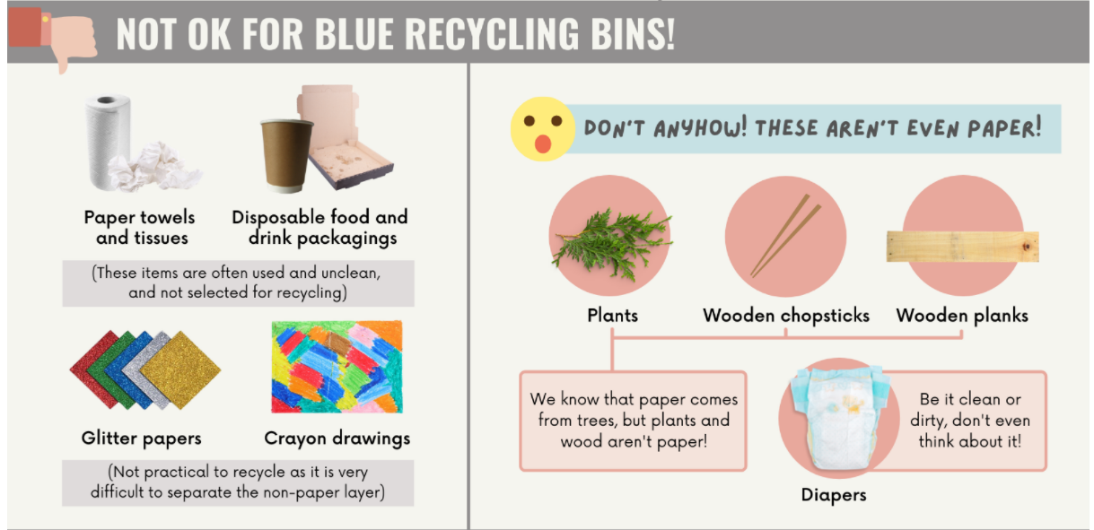

**Plastics**

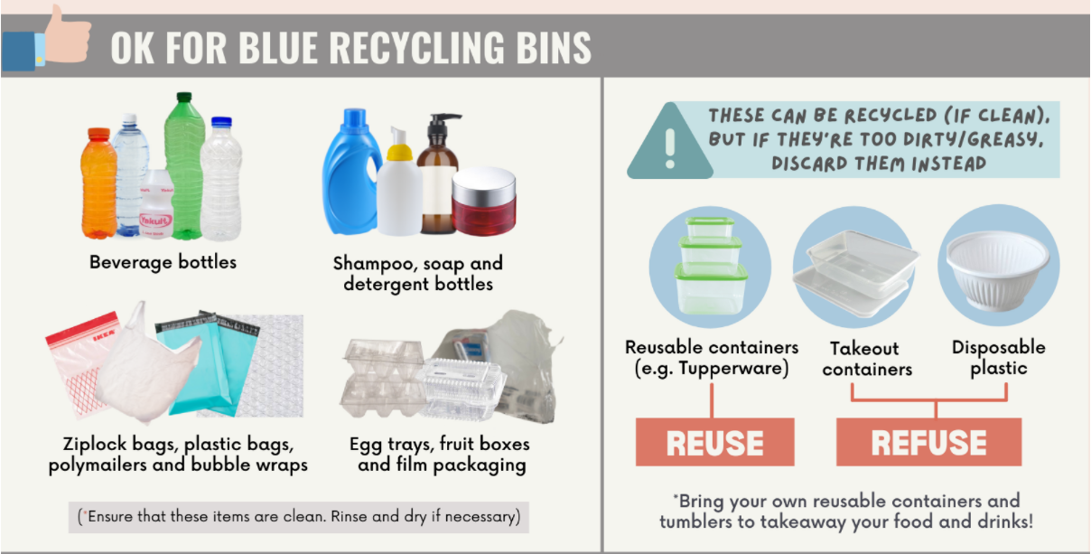

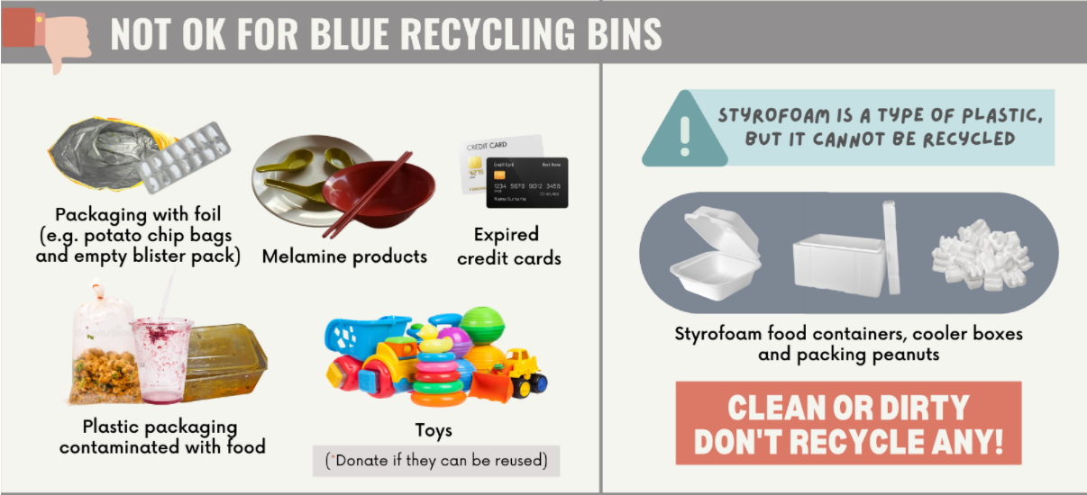

**Glass**

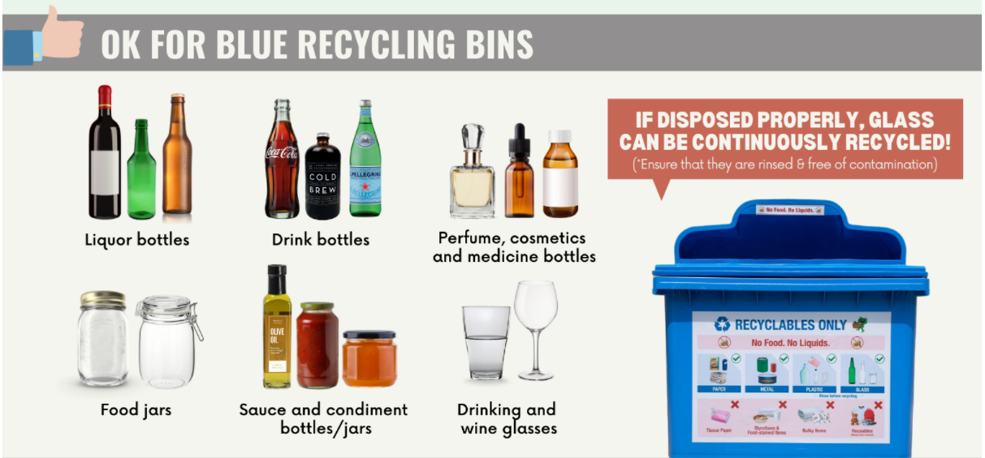

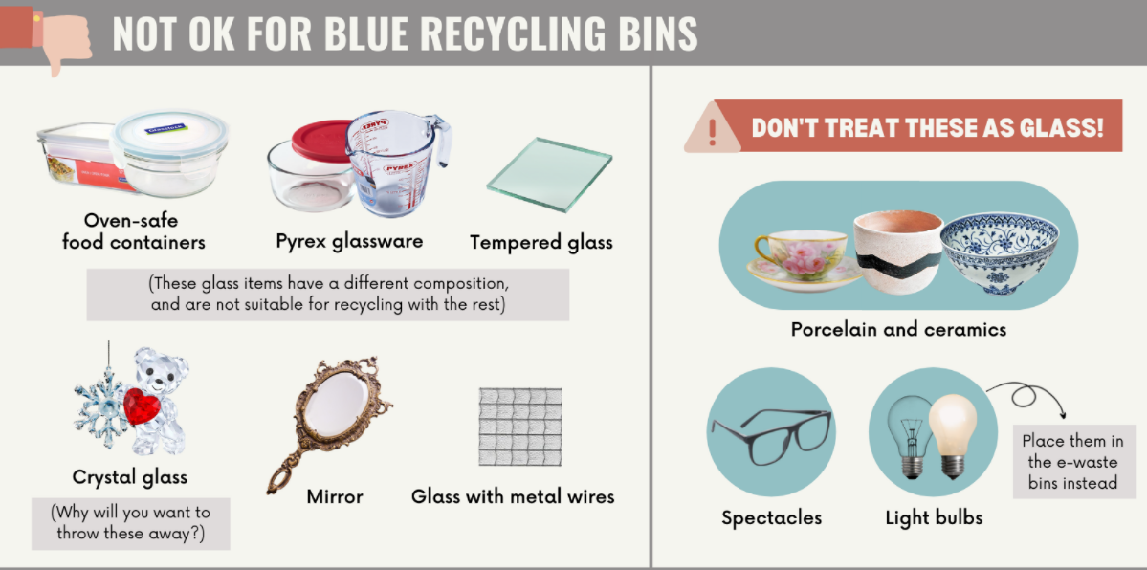

**Metal**

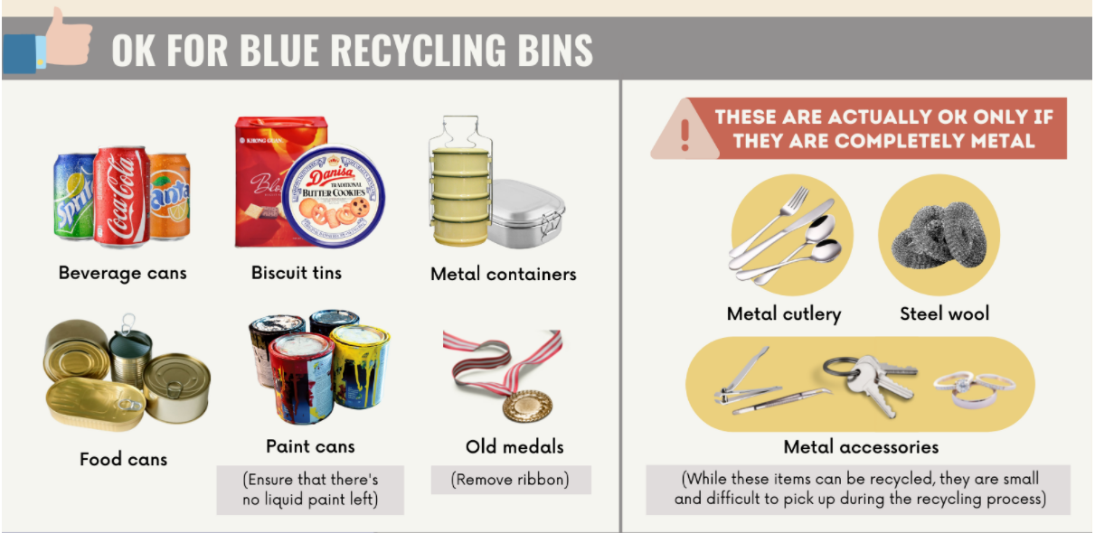

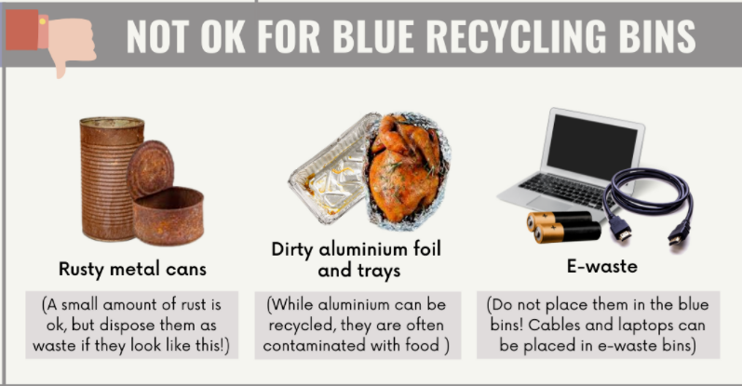

**E-waste**

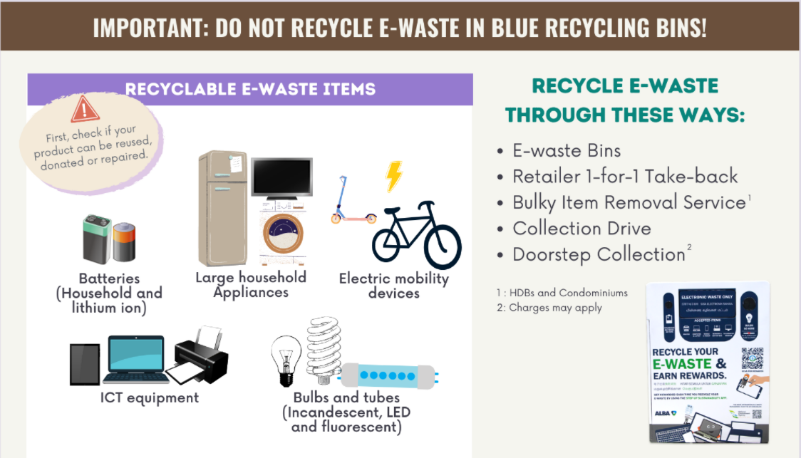

To find out where to recycle E-waste, click [here](https://www.nea.gov.sg/our-services/waste-management/3r-programmes-and-resources/e-waste-management/where-to-recycle-e-waste).

**Old sports shoes**

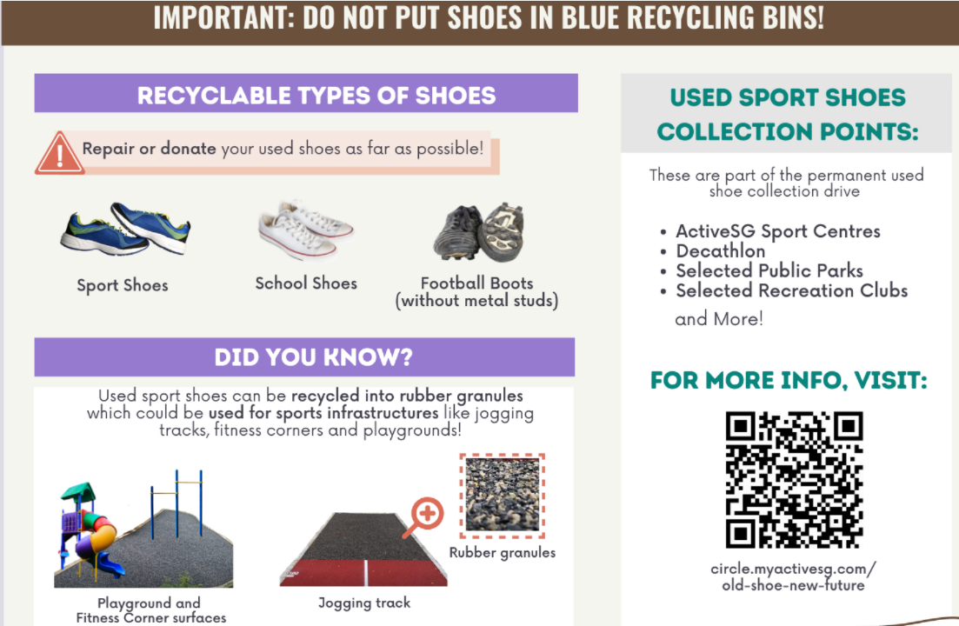

**Clothes**

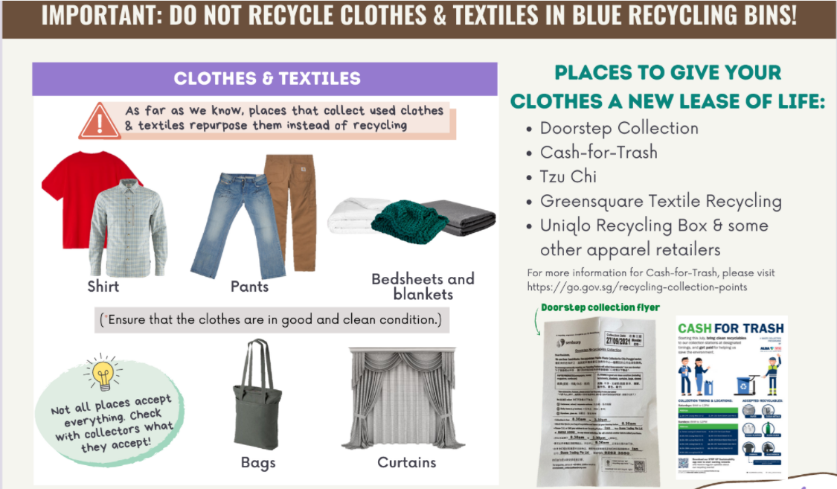

**For the list of common items that can and cannot be placed in the recycling bins, please refer to the table below:**

|  |  |  |  |  |
| --- | --- | --- | --- | --- |
| **S/N** | **Material Type** | **Item** | **Items that can be placed in the blue commingled recycling bins** | **Items that cannot be placed in the blue commingled recycling bins** |
|  |
| 1 | Paper | Printed paper (Glossy and non-glossy) | ü |  |  |
| 2 | Paper | Writing paper | ü |  |  |
| 3 | Paper | Newspaper | ü |  |  |
| 4 | Paper | Flyer (Glossy and non-glossy) | ü |  |  |
| 5 | Paper | Brochure (Glossy and non-glossy) | ü |  |  |
| 6 | Paper | Magazine (Glossy and non-glossy) | ü |  |  |
| 7 | Paper | Book | ü Donate if it can be reused |  |  |
| 8 | Paper | Telephone directory | ü |  |  |
| 9 | Paper | Envelope (With and without plastic window) | ü |  |  |
| 10 | Paper | Red packet | ü |  |  |
| 11 | Paper | Namecard | ü |  |  |
| 12 | Paper | Calendar | ü |  |  |
| 13 | Paper | Greeting card | ü |  |  |
| 14 | Paper | Gift wrapping paper | ü |  |  |
| 15 | Paper | Shredded paper | ü |  |  |
| 16 | Paper | Paper receipt | ü |  |  |
| 17 | Paper | Carton box | ü Please flatten |  |  |
| 18 | Paper | Paper packaging (e.g. printed paper box etc) | ü Please flatten |  |  |
| 19 | Paper | Egg tray | ü |  |  |
| 20 | Paper | Beverage carton (e.g. milk, juice and drink packet) | ü - Please empty and rinse when necessary - Please flatten |  |  |
| 21 | Paper | Paper towel and toilet roll tube | ü |  |  |
| 22 | Paper | Tissue box | ü Please flatten |  |  |
| 23 | Paper | Paper bag | ü |  |  |
| 24 | Paper | Used paper disposables (e.g. paper cup, plate etc) |  | Dispose as general waste |  |
| 25 | Paper | Tissue paper |  | Dispose as general waste |  |
| 26 | Paper | Paper towel |  | Dispose as general waste |  |
| 27 | Paper | Toilet paper |  | Dispose as general waste |  |
| 28 | Paper | Disposable wooden chopstick |  | Dispose as general waste |  |
| 29 | Paper | Wax paper |  | Dispose as general waste |  |
| 30 | Paper | Paper packaging that are contaminated with food |  | Dispose as general waste |  |
| 31 | Plastic | Plastic bottle/Container - Food or Beverage (e.g. PET, PP or PS bottles/container, carbonated and non-carbonated drinks etc) | ü Please empty and rinse when necessary |  |  |
| **S/N** | **Material Type** | **Item** | **Items that can be placed in the blue commingled recycling bins** | **Items that cannot be placed in the blue commingled recycling bins** |
| 32 | Plastic | Plastic bottle/container - Non-food (e.g. shampoo, bodywash, facial cleanser, detergent etc) | ü Please empty and rinse when necessary |  |  |
| 33 | Plastic | CD and CD casing | ü |  |  |
| 34 | Plastic | Plastic bag (except for oxo- and bio-degradable bags, see no.42) | ü |  |  |
| 35 | Plastic | Plastic film/flexible packaging (e.g. magazine wrapper, film packaging for packet drinks, bubble wrap etc.) | ü |  |  |
| 36 | Plastic | Plastic packaging (e.g. sliced bread bag and egg trays) | ü Please empty contents |  |  |
| 37 | Plastic | Plastic clothes hanger | ü |  |  |
| 38 | Plastic | Non-polystyrene foam takeaway food container | üPlease empty and rinse when necessary |  |  |
| 39 | Plastic | Polystyrene foam product (e.g. Styrofoam cup, clam shell-container) |  | Dispose as general waste |  |
| 40 | Plastic | Plastic disposables - cutlery and crockery |  | Dispose as general waste |  |
| 41 | Plastic | Plastic packaging with foil (e.g. potato chip bags, empty blister pack etc) |  | Dispose as general waste |  |
| 42 | Plastic | Oxo- and bio-degradable bags |  | Dispose as general waste |  |
| 43 | Plastic | Drinking straw |  | Dispose as general waste |  |
| 44 | Plastic | Cassette and video tape |  | Dispose as general waste |  |
| 45 | Plastic | Plastic packaging contaminated with food |  | Dispose as general waste |  |
| 46 | Plastic | Melamine products (e.g. Melamine cups, melamine plates etc) |  | Dispose as general waste |  |
| 47 | Glass | Glass bottle - Beverage (e.g. carbonated drink, beer and wine) | ü Please empty and rinse when necessary |  |  |
| 48 | Glass | Glass bottle - Food (e.g. sauce and condiment bottle, jam spread etc) | ü Please empty and rinse when necessary |  |  |
| 49 | Glass | Glass bottle - Cosmetic | ü Please empty and rinse when necessary |  |  |
| 50 | Glass | Glass bottle - Medicine and supplement | ü Please empty and rinse when necessary |  |  |
| 51 | Glass | Glassware - Cup, plate | ü |  |  |
| 52 | Glass | Borosilicate or Pyrex glassware (e.g. bakeware) |  | Dispose as general waste |  |
| 53 | Glass | Windows |  | Dispose as general waste |  |
| 54 | Glass | Mirror |  | Donate if it can be reused |  |
| 55 | Glass | Ceramic product (e.g. ceramic plate, tea pot etc) |  | Donate if it can be reused |  |
| **S/N** | **Material Type** | **Item** | **Items that can be placed in the blue commingled recycling bins** | **Items that cannot be placed in the blue commingled recycling bins** |
| 56 | Glass | Light bulb |  | Could be recycled at specific e-waste collection points which can be found on [here](https://www.nea.gov.sg/our-services/waste-management/3r-programmes-and-resources/e-waste-management/where-to-recycle-e-waste). |  |
| 57 | Metal | Metal can - Beverage (e.g. carbonated drink, beer etc) | ü Please empty and rinse when necessary |  |  |
| 58 | Metal | Metal can - Food (e.g. biscuit and food tin, canned food) | ü Please empty and rinse when necessary |  |  |
| 59 | Metal | Metal bottle cap | ü |  |  |
| 60 | Metal | Aerosol can | ü Please empty contents |  |  |
| 61 | Metal | Clean aluminium tray and foil | ü Please rinse when necessary |  |  |
| 62 | Metal | Metal container - Non-food (e.g. paint container) | ü Please empty contents |  |  |
| 63 | Others | IT accessories (e.g. cable, mouse, keyboard etc) |  | Could be recycled at specific e-waste collection points which can be found on [here](https://www.nea.gov.sg/our-services/waste-management/3r-programmes-and-resources/e-waste-management/where-to-recycle-e-waste) |  |
| 64 | Others | Electronic waste (e.g. Used mobile phone, tablet, laptop) |  | Could be recycled at specific e-waste collection points which can be found on [here](https://www.nea.gov.sg/our-services/waste-management/3r-programmes-and-resources/e-waste-management/where-to-recycle-e-waste) |  |
| 65 | Others | Rechargable battery |  | Could be recycled at specific e-waste collection points which can be found on [here](https://www.nea.gov.sg/our-services/waste-management/3r-programmes-and-resources/e-waste-management/where-to-recycle-e-waste) |  |
| 66 | Others | Household battery |  | Dispose as general waste |  |
| 67 | Others | Old items which cannot be reused (e.g. clothes, shoes, bag, soft toy, umbrella etc) |  | Dispose as general waste |  |
| 68 | Others | Old items which can be reused (e.g. clothes, shoes, bag, soft toy, umbrella, spectacle etc) |  | Donate if it can be reused (Note: old clothes can also be repurposed into cleaning cloths, or damping and insulating materials) |  |
| 69 | Others | Food waste |  | Dispose as general waste |  |
| 70 | Others | Leftover medicine |  | Dispose as general waste |  |
| 71 | Others | Diaper and sanitary pad |  | Dispose as general waste |  |
| 72 | Others | Stationery - Pen and pencil |  | Donate if it can be reused |  |
| 73 | Others | Plant and horticultural waste |  | Only for landed estates: bag and place  outside your unit on collection days |  |
| 74 | Others | Luggage bag |  | Donate if it can be reused |  |
| 75 | Others | Bulky waste (e.g. Furniture, standing fan etc) |  | - Donate if it can be reused - Contact Town council to remove from your residential premises |  |