Summary Report: IAEA Pre-Course Survey (RAS5101)
Report Updated: 6 May 2026
Course: Regional Training Course on Development of New Mutant Germplasm and Populations of Target Food Crops with High Nutrient Content (RAS5101)
Event Code: EVT2505345 | 11–15 May 2026 | Bangkok, Thailand
Survey responses: 15
Halal diet required: 5
(See details in the Excel data file.)

I. Participant Profile & Logistics

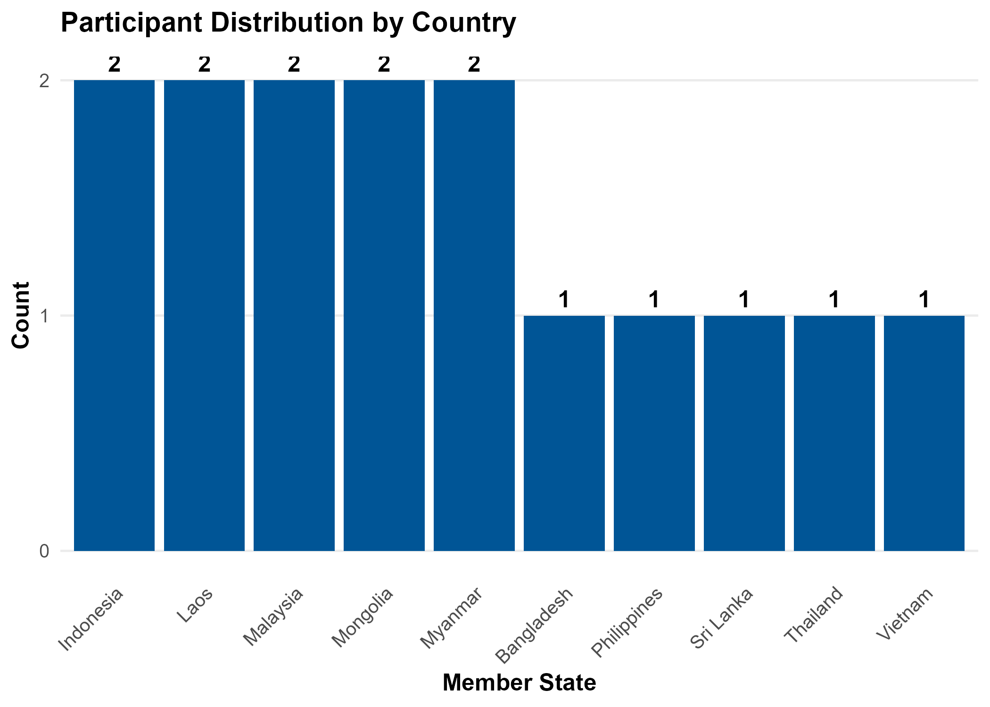
Figure 1. Distribution of Member States.

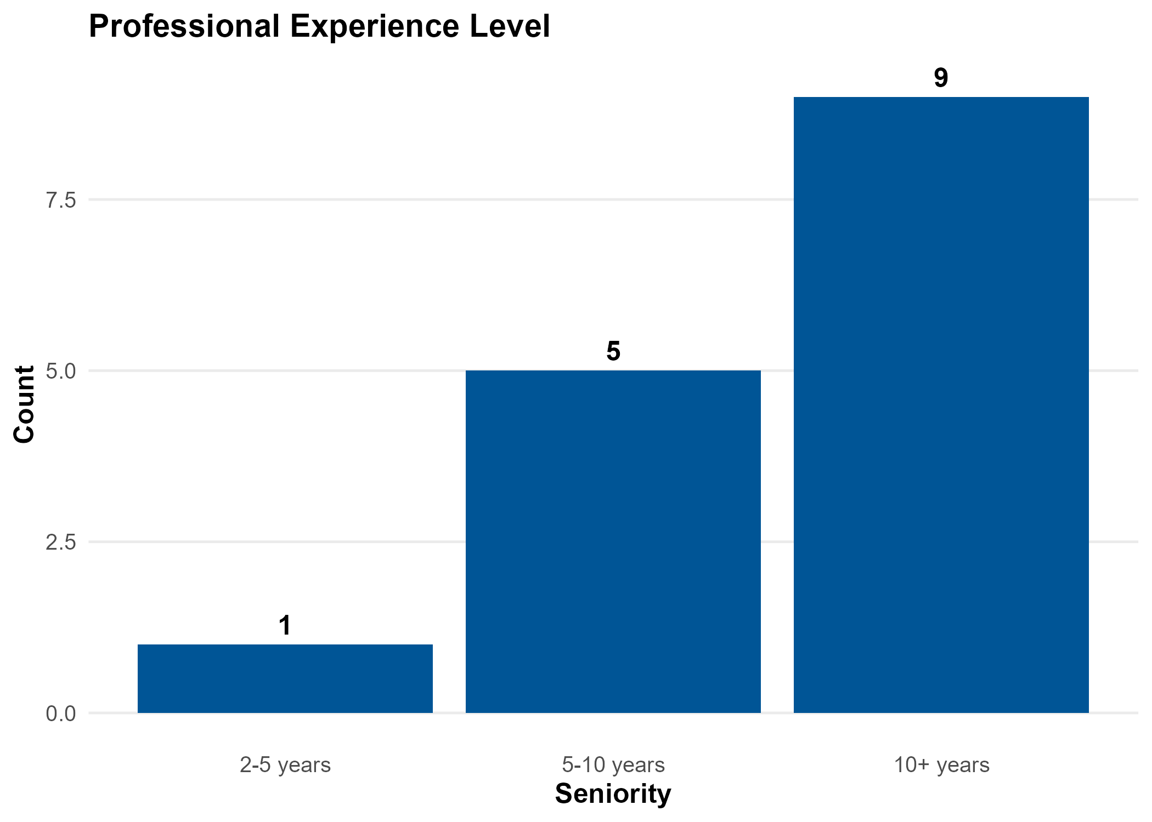
Figure 2. Professional experience levels.

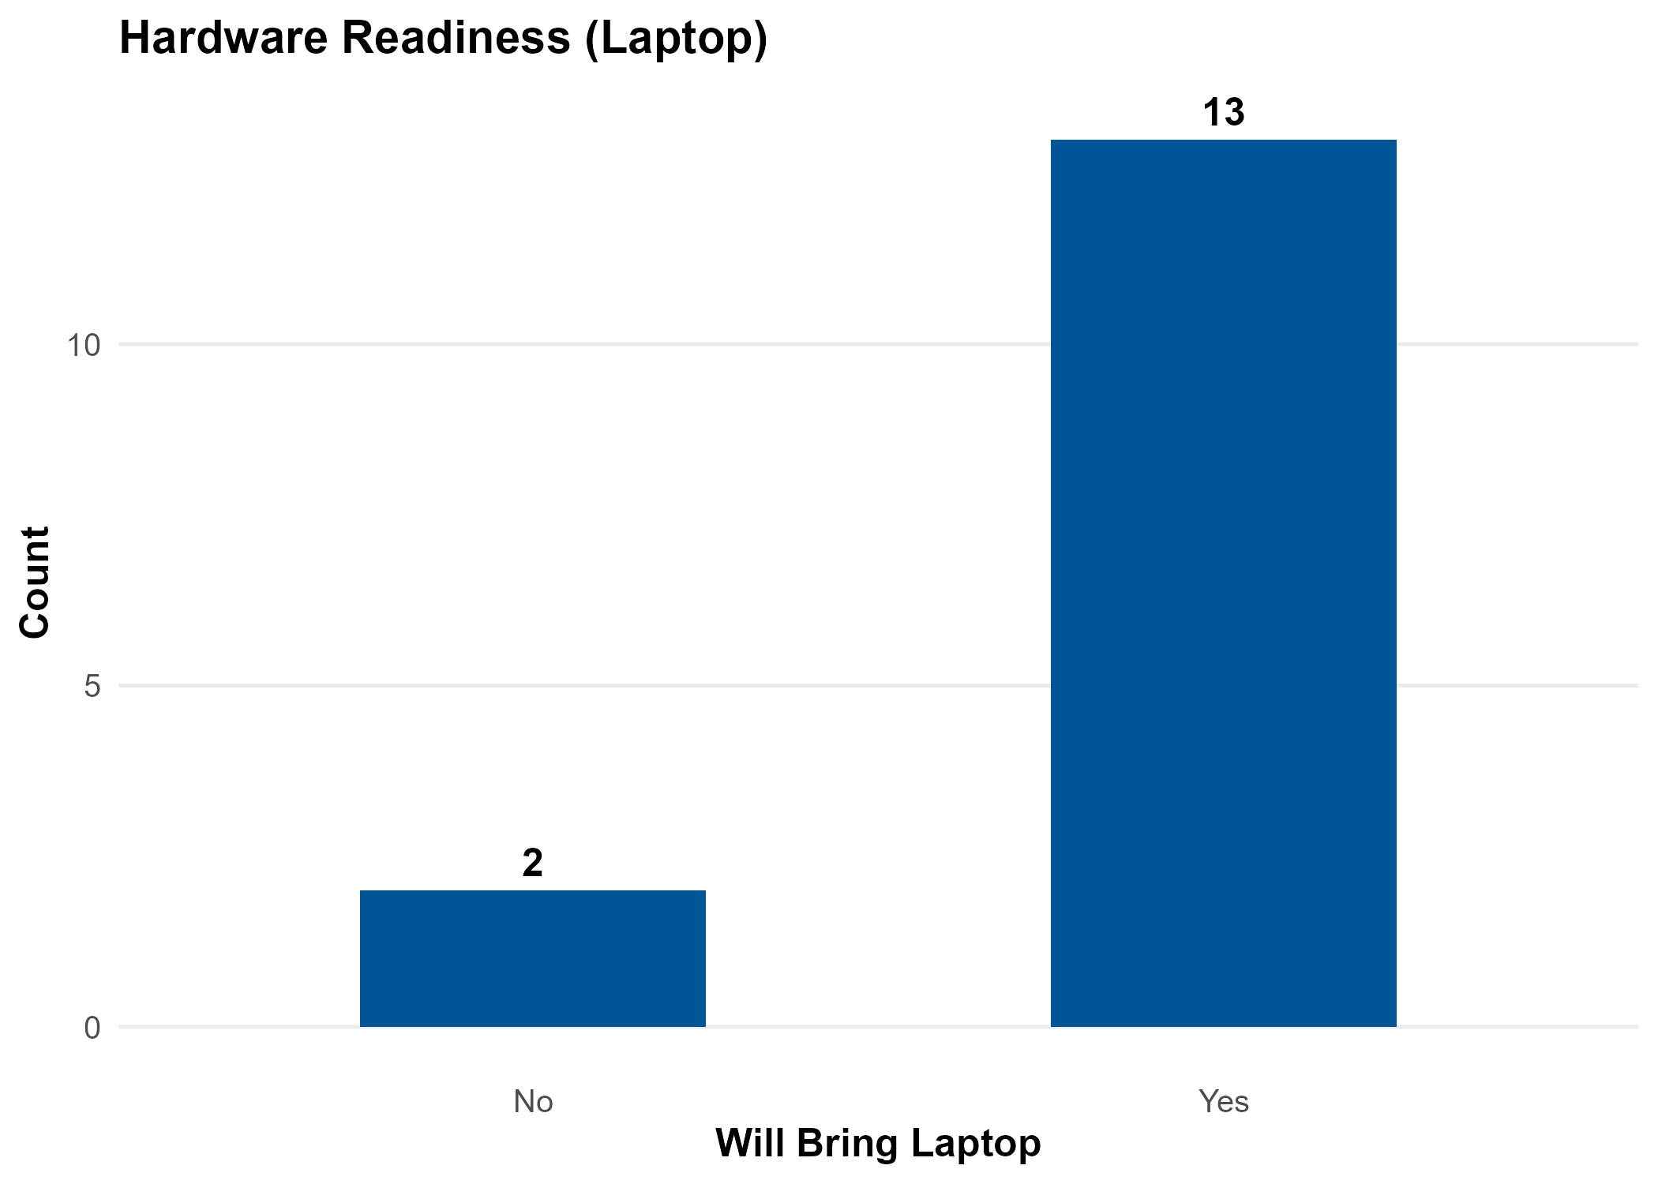
Figure 3. Hardware readiness.

II. Technical Landscape

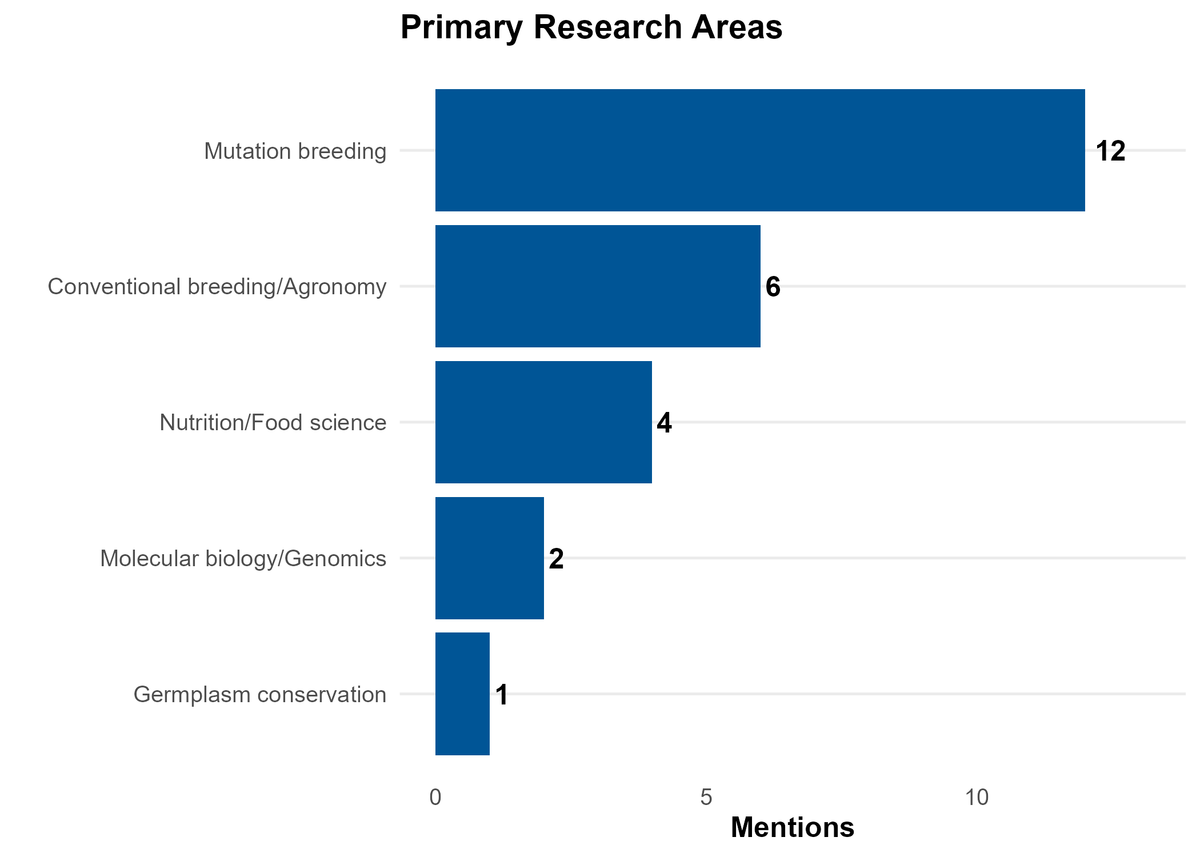
Figure 4. Primary areas of professional focus.

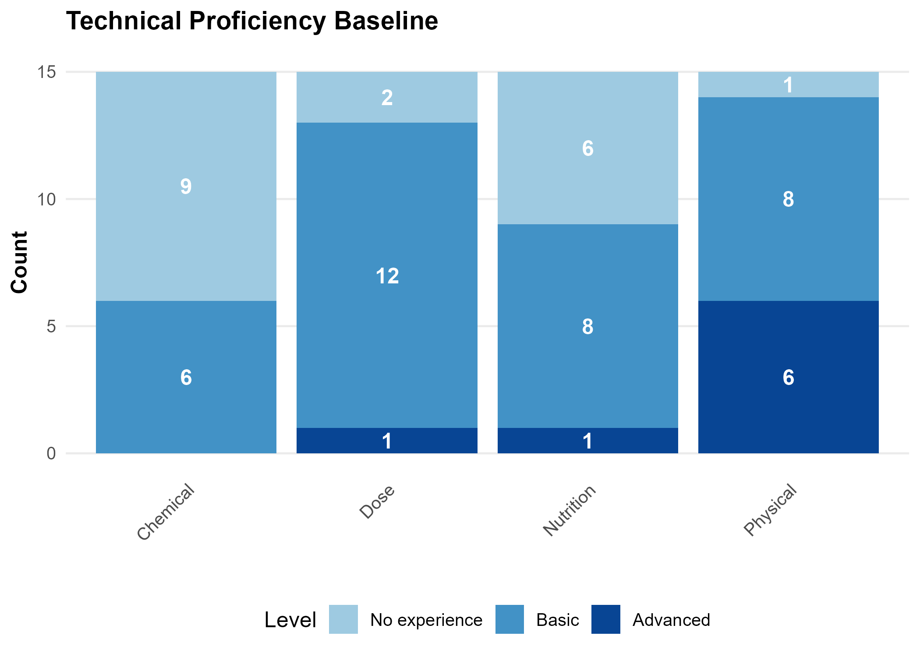
Figure 5. Proficiency baseline for core breeding and analysis techniques.

III. Strategic Priorities

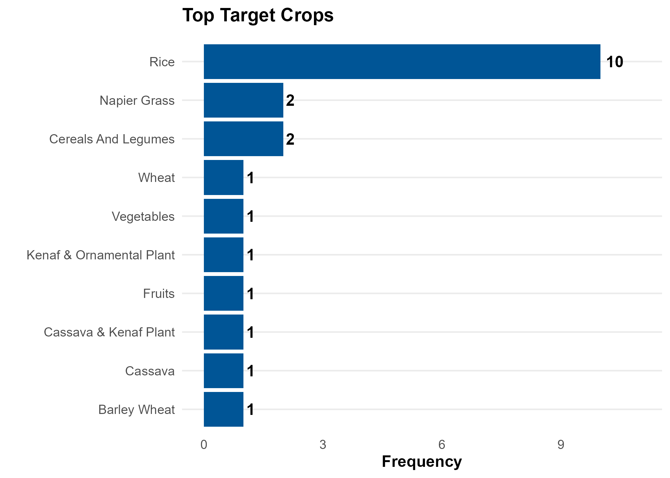
Figure 6. Key target crops identified for mutation breeding.

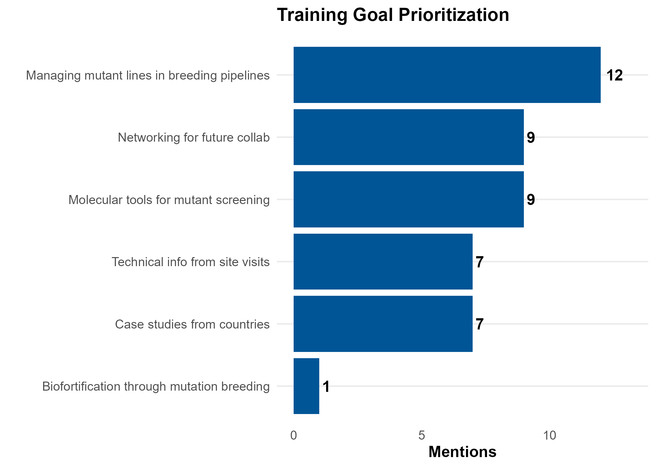
Figure 7. Participant learning goals for the Bangkok training.

