# **Classifying microfluidic droplet configurations at a constriction for determining periodicity and droplet break-up probability**

|  |  |
| --- | --- |
| Fengjiao Lyu  Department of Mechanical Engineering Stanford University  fengjiao@stanford.edu | Nicolas Castaño  Department of Mechanical Engineering Stanford University  ncastano@stanford.edu |

**Abstract**

*Droplet-based microfluidics uses nano- to picoliter volumes of liquid as reactors in a wide range of biological, chemical, and electrical applications from DNA sequencing and polymerase chain reactions to advanced particle synthesis. In this study, we focus on droplet interactions upstream of the constriction. We hypothesize that droplet configuration at the constriction is a characteristic that can help determine break-up probability and that there are a finite number of these configurations. We hope to convolutional neural networks (CNN) to uncover underlying droplet structures and interactions in order to classify droplet break-up.*

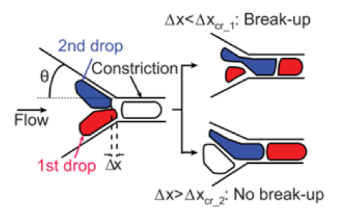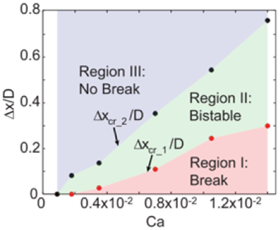

(A)

(B)

# Introduction

Droplet-based microfluidics, which utilizes micro-droplets as individual micro-reactors, has become one of the most powerful approaches for biochemical assays [1–3]. Typically, droplet-based biochemical assays involves the sequential detection of the contents in each droplet by passing the droplets through a narrow microchannel. In practice, the droplet passing rate should be as high as possible to reducing the detection time. However, passing droplets from wide channel to narrow channel at high flow rate can increase the probability of droplet break-up due to hydrodynamic instability [4]. Droplet break-up could cause errors and limit the maximum throughput of the biochemical assays.

Figure (A) The critical offset for a possible configuration of droplets entering the constriction. We will consider the configuration of all drops to the left of the constriction in our analysis. (B) There is a relation between Capillary number and critical offset that defines bounds for the three regions.

In previous studies, droplet break-up is seen to be dependent on the capillary number Ca and the critical offset ∆x, but the demarcation between the stable and unstable region is not well defined by these parameters [2]. For now, there is still a lack of accurate prediction method for the process of droplet break-up in this bi-stable region (Figure 1). One promising way to improve the accuracy of prediction in this region is to considering droplet configurations and construct a more complex model. In this study, we focus on droplet interactions upstream of the constriction. We hypothesize that droplet configuration at the constriction is a characteristic that can help determine break-up probability and that there are a finite number of these configurations. We hope to convolutional neural networks (CNN) to uncover underlying droplet structures and interactions in order to classify droplet break-up.

# Problem statement

We used the data provided by the Tang Lab in the Department of Mechanical Engineering at Stanford University. The data consists of ~3,000 high-speed videos of emulsion flowing at the same flow rate. Each video consists of 30-50 frames that were extracted from the original videos by instances that a new drop entered the constriction. The videos have already been partitioned by break-up or no break-up events and come with the measured critical offset, ∆x.

## Relating energy of droplet configuration to capillary number Ca

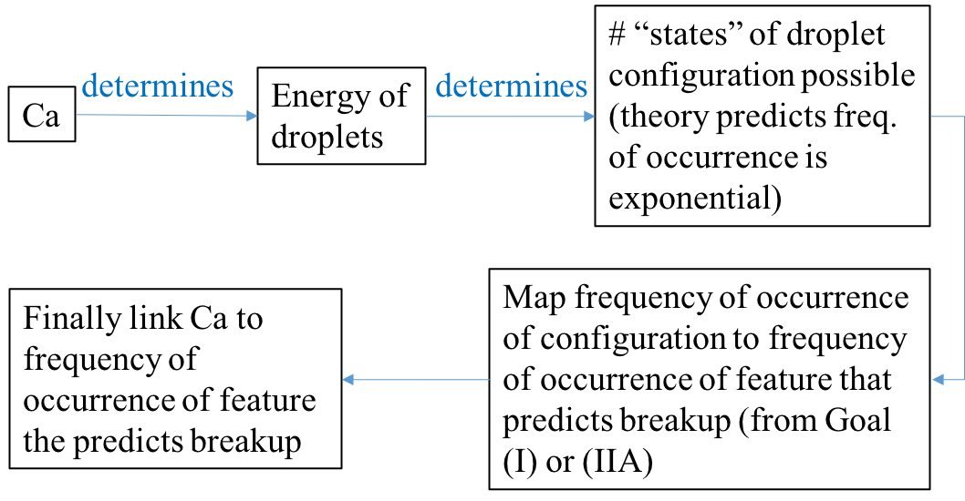Because machine learning is usually a black box that can solve problem without clear explanations, we decided to first extract features that has physical meaning from images and then used the features as input for break-up prediction. We plan to use the droplet energy that is defined in previous studies [5] as the connection between droplet configuration and break-up mechanism. We expect the configuration that causes droplet break-up has higher total energy than the configuration that doesn’t lead to break-up.

Figure Flow chart for problem-solving.

## The clustering of droplet configurations

The droplet configuration is shown in each still image. But our data are videos, each of which consists 30-50 frames of images. Therefore, the droplet configuration of each video keeps changing as time goes on. To study influence of the configuration changes on droplet break-up, we are going to: 1) clustering possible configurations with k-means clustering using edge and individual/cumulative droplet shape factors as features, 2) implement convolutional neural networks on videos of droplets entering a constriction to classify the configuration to determine a periodicity, and 3) train, test, and compare a neural network and support vector machine to binarily predict droplet break-up based on a given sequence of droplet configurations.

We will validate our clustering against empirical data that measures the frequency of some critical offset. Because each event’s break-up has already been classified, we can use this to verify our prediction of break-up based on configurations.

# Technical Approach

## Feature extraction and energy calculation

To calculate the energy of droplet, we first preprocess the raw images to label droplets before the narrow construction (Figure 3). Then, we can get the contour and position of each droplet.

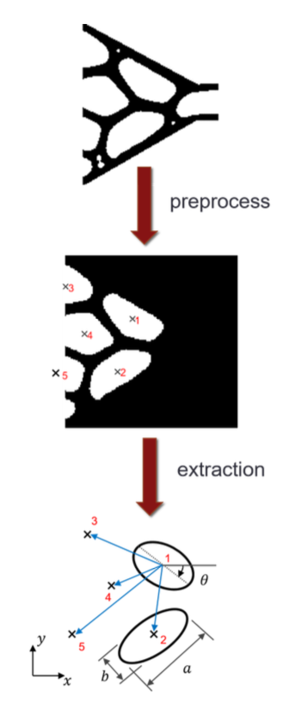

Figure Concept flow for extracting relative position vectors between droplets

After obtaining the position information of each droplet, we used Eq. (1) to calculate the energy of the droplet configurations. We also counted the number of occurrences of configurations for a given energy *E*.

Eq. (1)

Where is the effective spring constant, ; is the surface tension between water phase and oil phase, which is 26.25 mN/m; is the averaged radius of droplets; is the radius of the concerned droplets; is the relative position vector.

Based on the definition of droplet energy, we only considered the energy between drops that contact each other.

## Configuration clustering

Unsupervised learning algorithms, like k-means clustering, are useful for qualitative analysis of the unstable examples. Clusters are identified according to the features extracted from the image, and the corresponding pictures for each may be separated for visual comparison. The appropriate number of clusters to use is not clear, although redundant clusters seem to appear around k = 10. For a given cluster, there is often a second cluster which is its symmetric counterpart, which allows for the estimation 5 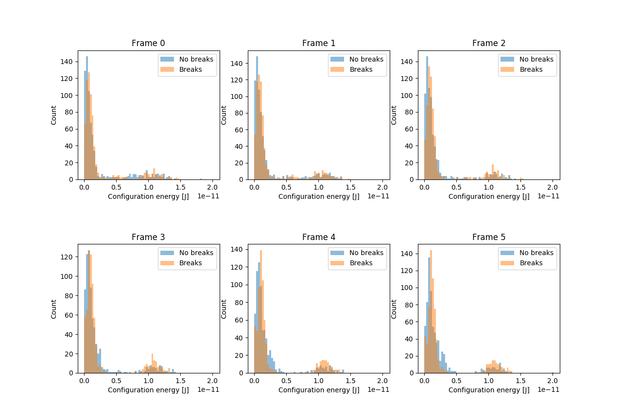≤ k ≤ 10.

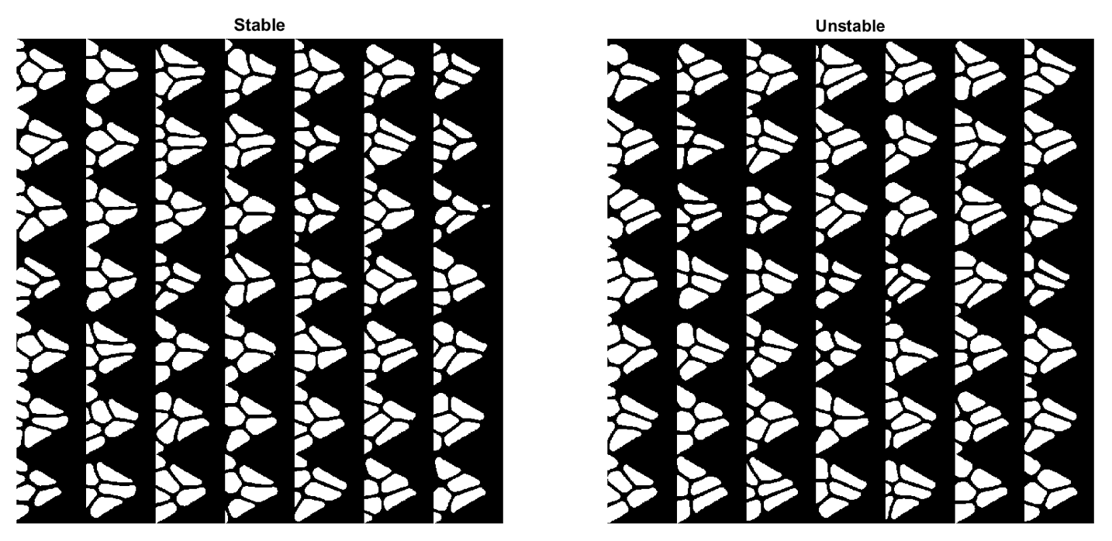

Figure 5 Clustering by no-break-up and break-up

Figure 4 Energy distribution of the first 6 frames in each video

# Preliminary Results

## Energy of droplet configuration

Because all the videos have the same start point ( starting at a new drop entered the constriction), we compared the droplet configuration of the same frame number among the whole batch. As shown in Figure 4, we found the energy distribution of break-up configurations are similar with the energy distribution of no-break-up configurations in the first 3 frames, while slightly more break-up configurations have higher energy in the following 3 frames.

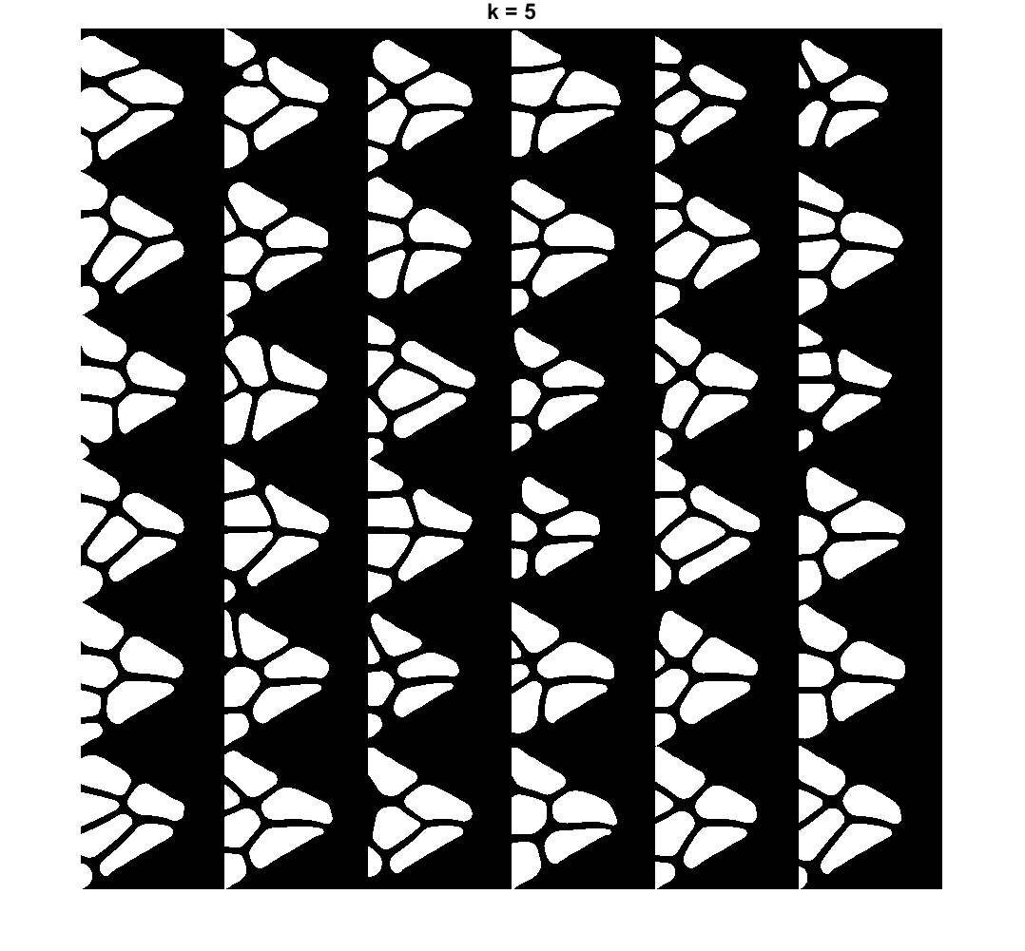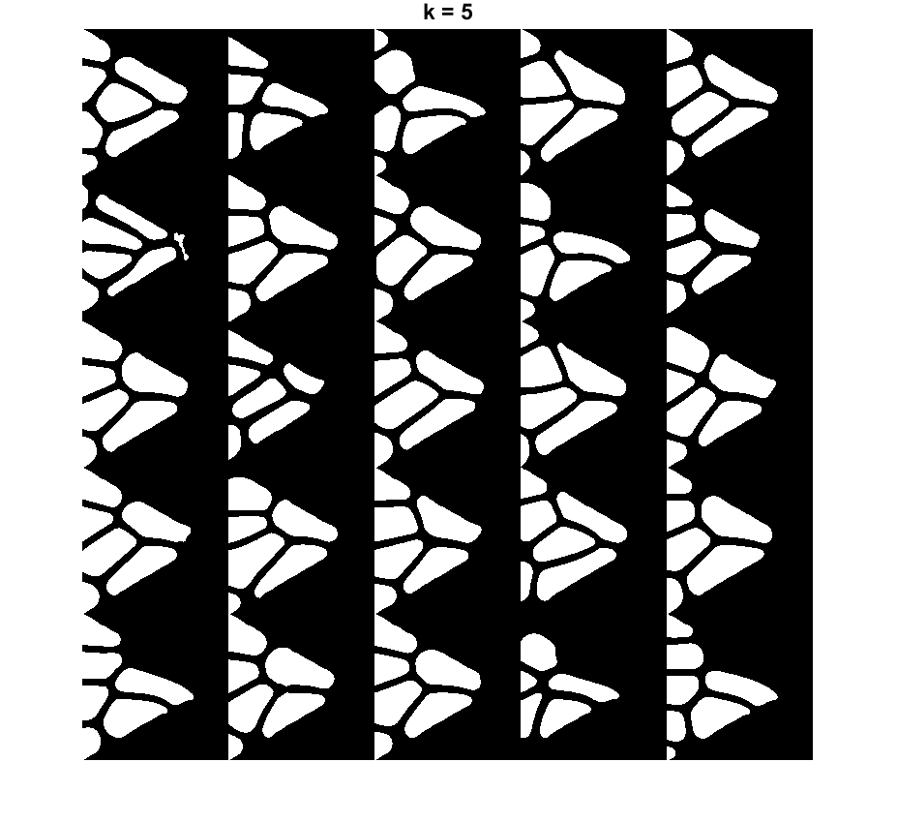

Figure k-means clustering (k = 5) of no-break-up configurations (left) and break-up configurations (right).

## Configuration clustering

The most simple clustering is distinguishing droplet configuration by break-up and no-break-up (Figure 5). Using k-means clustering (k = 5), we also got different clustering results among break-up configurations and no-break-up configurations (Figure 6).

# Next Step

As we can see in Figure 4, the current definition of droplet energy doesn’t help the classification of droplet break-up status. In the future, we are going to find a better definition of droplet energy to connect the machine learning results with physical explanations. In addition, we will focus on directly input the raw video for clustering and break-up classification.

# References

1. L. Rosenfeld, T. Lin, R. Derda, and S. K. Y. Tang, Review and analysis of performance metrics of droplet microfluidics systems. *Microfluid. Nanofluid*, 16(5): 921-939, 2014.
2. J. J. Agresti, E. Antipov, A. R. Abate, K. Ahn, A. C. Rowat, J. C. Baret, M. Marquez, A. M. Klibanov, A. D. Griffiths, and D. A. Weitz, Ultrahigh-throughput screening in drop-based microfluidics for directed evolution. *Proc Natl Acad Sci USA*, 107(9): 4004-4009, 2010.
3. M. T. Guo, A. Rotem, J. A. Heyman, and D. A. Weitz, Droplet microfluidics for high-throughput biological assays. *Lab Chip*, *12*(12): 2146-2155, 2012.
4. W. Khor, M. Kim, S. Schütz, T. Schneider, S. K. Y. Tang. Time-varying droplet configuration determines break-up probability of drops within a concentrated emulsion. *Applied Physics Letters*, 111(12): 124102, 2017.
5. D. J. Durian, Bubble-scale model of foam mechanics: melting, nonlinear behavior, and avalanches. *Phys Rev E*, 55(2): 1739, 1997.