Transfer Money from PayLetter to MePayment Process Flow:
- Register MePayment to PayLetter (one-time for current)
(give PayLetter MePayment-Signature as Public-key; give MePayment-service domain)
- Call register(*) method to register PayLetter (get PayLetter-Signature (PL-Sig) )
- Login and Check Login: at PayLetter
- Transfer



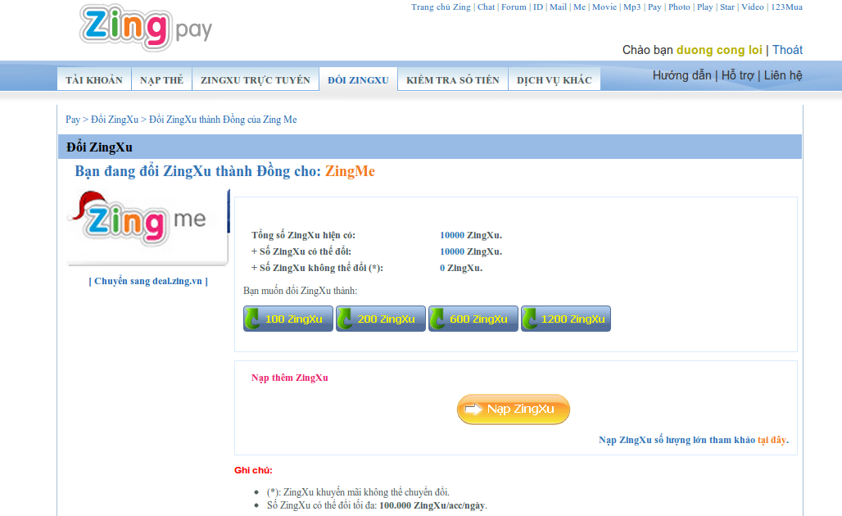

3.1 Set-up transfer-information (pl-transaction): at PayLetter
(userID, accountNo, chargeNo(pl-transactionID), amount, mac (PL-Sig))

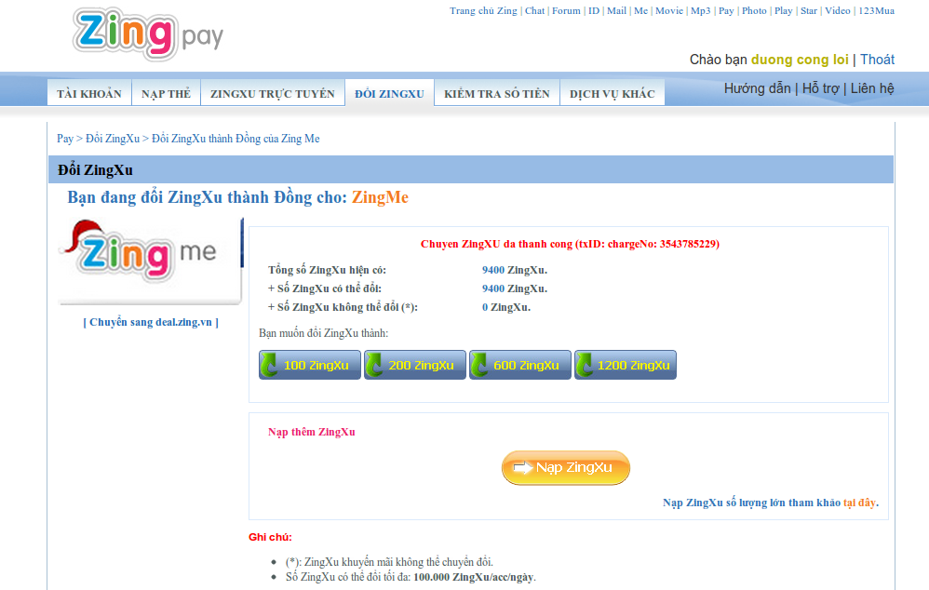

  - Transfer pl-transaction via web-service from PayLetter to MePayment
3.2.1 PayLetter call transfer (webservice-method), pl-transaction as param
3.2.2 MePayment receive pl-transaction at PaymentGateway-Webservice (PGWS)
3.3.3 PGWS forward message (call API) to PaymentGatewayModel (PGModel)
3.3.4 PGModel:
3.3.4.1 Check valid sender (using PL-Sig)
3.3.4.2 Generate MePayment-Transaction(Transaction) with transactionID for correlative (1-1) to pl-transactionID
3.3.4.3 Write this Transaction to Zookeeper(ZK) (as byte-array data)
3.3.4.4 Return result to PGWS
3.3.5 Return result to PayLetter
  - Return result for transfer method

- Internal-MePayment Push Money Process: Keep data has update success from ZooKeeper (ZK) to Balance Cache (balCache) and database (MySQL-database)
4.1 PaymentZKBackEnd (BE) receive data from ZK (at current via fire-event)
4.2 BE send Transaction to balCache
4.3 balCache-processing:
4.3.1 Received Transaction
4.3.2 Update Transaction to Storage (call updateBalance-function): add money to userID
4.3.3 Storage processing: updateBalance and return result to balCache
4.3.4 balCache update-cache (if updateBalance success at 4.3.2)
4.3.5 Return result to BE
  - BE has call UpdateCacheWorker (internal-BE module) to update LastestTranxCache
  - BE has call delete Transaction in ZK if result at 4.3 is success, else re-put to queue to re-process until success for this Transaction
  - Completed task

Note:
- (*) has been call by Administrator.
- View Logs: PGWS log, BE log, balCache log, Storage log, LastestTranxCache log to review flow again

Game Billing Process Flow:
- Register MePayment to Required GameServer (back-ground: when the GameServer require)
(when the Game require, MePayment send to it MePayment-Signature as Public-key)
- GameServer Register to MePayment (back-ground: when the first billing of the GameServer)
- Call method register(**) to register GameServer, GameServer ID (agentID), domain-name, domain-web-return as params; return Game-Key (G-Sig).
- Billing

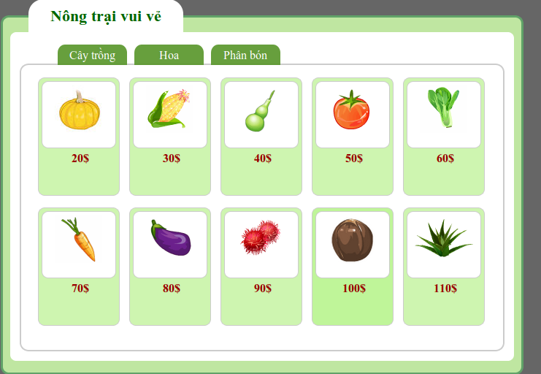

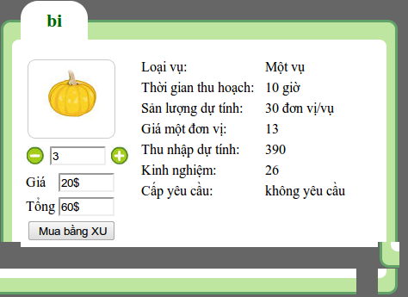

  - Set-up billing information (bill-transction): at GameServer
    - (userID, billNo(bill-transactionID), agentID, amount, array of Item-Order, mac(bill-transaction signature, using G-Sig))
    - Item-Order: (itemName, price, numbuyed)

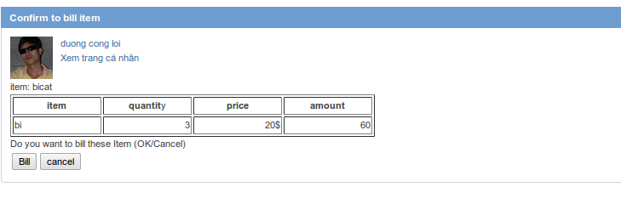

  - User has been redirected to RequestBilling-page (RQB-page) from Game-Order page (at GameServer), with bill-transaction as posted data
  - RQB-page processing:
    - RQB-page receive bill-transaction then call getToken to TokenServer (TK), append token into bill-transaction; token is MD5 of private-key, i32-random, userID, timestamp
    - Redirect to B-page, with bill-transaction and token as posted data

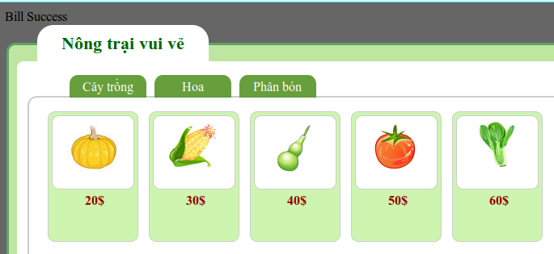

  - B-page receive contain bill-transaction and token then call bill method to request billing to PaymentGateway(PG); bill method has bill-transaction and token as params
  - PG processing:
    - Call function checkToken to TK to check valid user's request
    - Check valid bill-transaction (using mac with G-Sig)
    - Generate MePayment-Transaction(Transaction) with transactionID get from GenMasterServer
    - Call deduct to balCache with Transaction as param
  - balCache processing:
    - After method deduct has been call, checkandsub(cns): deduct money, then get result as res
      - If res is success then write Transaction to ZK,
      - If res fail, return fail with fail-code
    - Write Transaction to ZK, if write success return to PG, else rollback cns: add money return, then return fail with fail-code
  - Return result for bill method.

- Internal-MePayment Billing Processing: Keep data has update success from ZooKeeper (ZK) to database (MySQL-database).
  - PaymentZKBackEnd (BE) receive data from ZK (at current via fire-event)
  - BE put Transaction StorageWorker(internal-BE module, Sworker)
  - SWorker call Storage method updateBalance to sub money for userID in database
    - If fail, re-put Transaction to itseft
    - If success, put ResultReturn (a struct to return game: billNo, transactionID, amount) to AMQueue to request GameServer completed billing
    - Call UpdateCacheWorker (internal-BE module) to update LastestTranxCache
  - GameReturnConsumer: Module get ResultReturn from AMQueue and send request GameServer completed billing
    - After receive ResultReturn request GameServer completed billing via REST
    - If fail, re-put ResultReturn to AMQueue
    - If success, completed task

Note:
  - (**) has been call by Administrator.
  - View Logs: TK log, PG log, BE log, balCache log, Storage log, LastestTranxCache log to review flow again
GetBalance Money Process Flow:

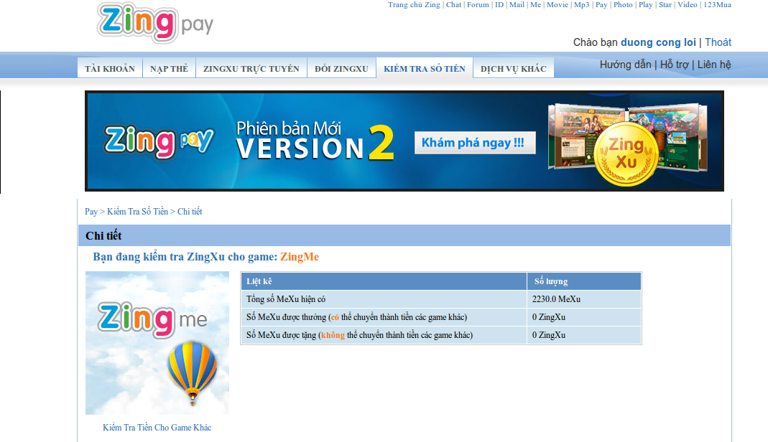

- Setup information to GetBalance Money
(UserID, Sig)
- Call method GetBalance in PaymentGateway

