Payment Between AppGame – ZingCredits
Integration Detail

Revision History
Version | Date | Change Description | Author | Approved By
1.0 | 29-Oct-2012 | Draft | LenTD

TABLE OF CONTENTS

1. Introduction 3
2. Popup 4
3. Boxy 5
4. Call page directly 6

Introduction
  - Overview
Purpose of this document is list all ways to integrate between AppGames and ZingCredits. There are 3 ways to integrate:
- Popup: use popup to confirm the payment from ZingCredits
- Boxy: use Boxy to confirm the payment from ZingCredits
- Direct: call page from ZingCredits directly to confirm the payment
This document is a part of AppGame_ZingCredits_Integration_v1_vn.pdf
It is an extra part of Billing URL in AppGame_ZingCredits_Integration_v1_vn.pdf

New Billing URL = Billing URL (AppGame_ZingCredits_Integration_v1_vn.pdf) + “&_v=4&_t=<CALL_TYPE>&_url=<CALLBACK_URL>”
<CALL_TYPE>: 1 or 2 or 3 (description in this document)
<CALLBACK_URL> (optional, is used for popup only): call back url
Parameter | Value | Description
_v | 4 | Version of ZingCredits
_t | 1 or 2 or 3 | Call type
_url | Value of call back url | Call back url, used for Popup only

New Billing URL: http://pay-credits-me.zing.vn/billing/balance?appID=<A>&data=<D>&_v=3&_t=<CALL_TYPE>&_url=<CALLBACK_URL>

  - Payment channels
  - Web: Call to ZingCredits to buy items in App games
  - Mobile: N/A

  - Integration between AppGame and ZingCredits system
Use javascript lib of ZingCredits to call payment page from ZingCredits
Register a callback method in javascript (callbackPayment) to process callback after finish from ZingCredits
- Billing url : refer to 1.1
- 3 ways to integrate:
  - popup: _t=1, _url=xxx (callback url, it is optional, the page will not be reloaded if without _url )
  - boxy (recommend): _t=2
DON'T need to put _url.
MUST register a method 'callbackPayment' in javascript to process callback.
  - Call page directly: _t=3, _url=xxx (callback url, it is optional, the page will not be reloaded if without _url )

Popup
a) JavaScript lib

<link href="http://css.me.zdn.vn/zmjs/zm.ui-1.46.css" media="screen" rel="stylesheet" type="text/css" />
<script type="text/javascript" src="http://static.me.zing.vn/v3/sdk-js/zmCore-1.54.min.js" ></script>
<script type="text/javascript" src="http://static.me.zing.vn/v3/sdk-js/zm.xcall-1.15.min.js" ></script>
<script type="text/javascript" src="http://static.me.zing.vn/v3/sdk-js/zm.ui-1.75.min.js" charset="utf-8"></script>
<script type="text/javascript" src="http://static.me.zing.vn/v3/sdk-js/sdkjs-1.00.min.js" charset="utf-8"></script>

b) Call popup from JavaScript
function openPopupWindow(name, url, width, height) {
zmjsSDKInCanvas.openPopupWindow(name, url, width, height);
}
name: name of window
url: new billing url, refer to 1.1 with _t=1

Example: openPopupWindow('myPayment_window', '<new biling url>', 910, 750);

c) Parameters:
_t : call type, _t=1 for this case
_url: callback url, it is optional, the page will not be reloaded if without _url

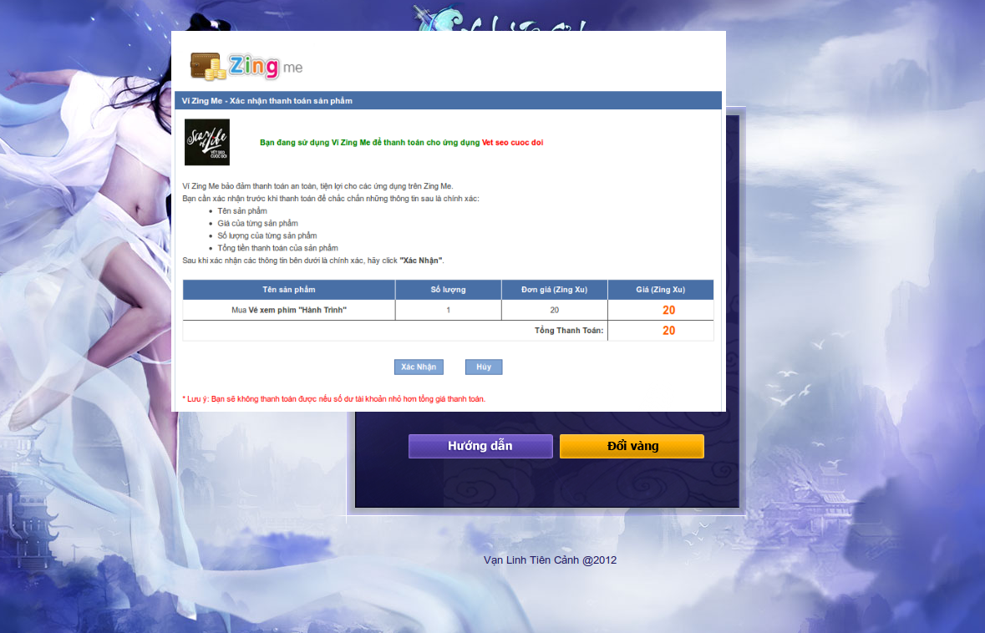

Boxy
a) JavaScript lib:

<link href="http://css.me.zdn.vn/zmjs/zm.ui-1.46.css" media="screen" rel="stylesheet" type="text/css" />
<script type="text/javascript" src="http://static.me.zing.vn/v3/sdk-js/zmCore-1.54.min.js" ></script>
<script type="text/javascript" src="http://static.me.zing.vn/v3/sdk-js/zm.xcall-1.15.min.js" ></script>
<script type="text/javascript" src="http://static.me.zing.vn/v3/sdk-js/zm.ui-1.75.min.js" charset="utf-8"></script>
<script type="text/javascript" src="http://static.me.zing.vn/v3/sdk-js/sdkjs-1.00.min.js" charset="utf-8"></script>

b) Call boxy from JavaScript
function openBoxy(title, url, width, height) {
zmjsSDKInCanvas.openBoxy(title, url, width, height);
}

title: title of window
url: new billing url, refer to 1.1 with _t=2
Example: openBoxy('ViZIngMe', '<new billing url>', 910, 750);

c) Parameters:
_t : call type, _t=2 for this case
_url: DON'T need to put _url.
MUST register a method 'callbackPayment' in javascript to process callback (refer to d) )

d) Register a callbackPayment method in javascript to process call back
After finishing from ZingCredit, App game will receive an event from callbackPayment
zmjsSDKInCanvas.callbackPayment = function (data) {
// TODO: for App games
alert("billNo =" + data.billNo + " step =" + data.step + " result =" + data.result);
};

data.billNo: billNo
data.step: step 1 or 2
data.result:
0: success
-1: boxy is closed by user
-2: error

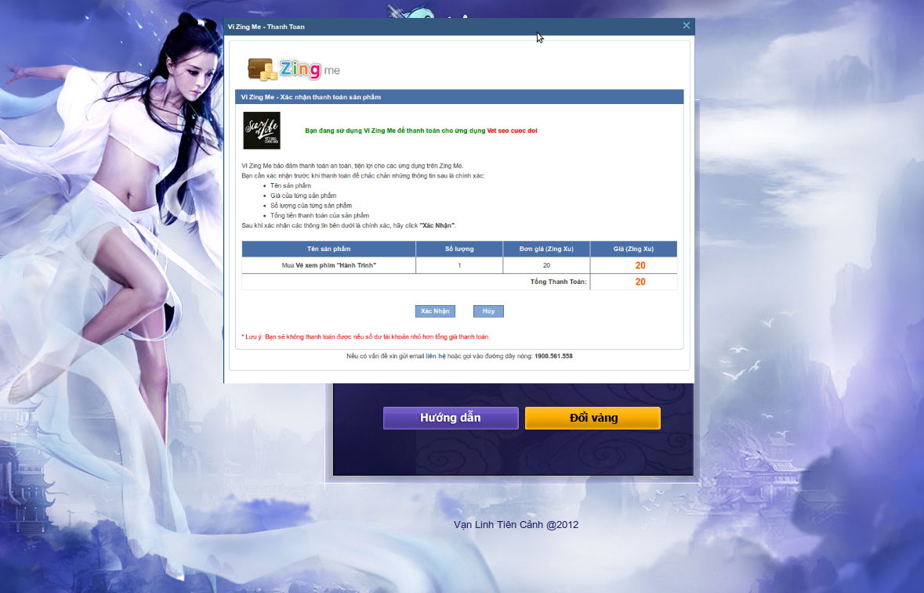

Call page directly
a) Javascript lib:
N/A

b) Call page from ZingCredits
<a href="<new billing url>"> Direct page </a>
<new billing url>: refer to 1.1 with _t=3
c) Parameters:
_t : call type, _t=3 for this case
_url: callback url, it is optional, the page will not be reloaded if without _url

