STMP：used this for sending email
Sending mail to people
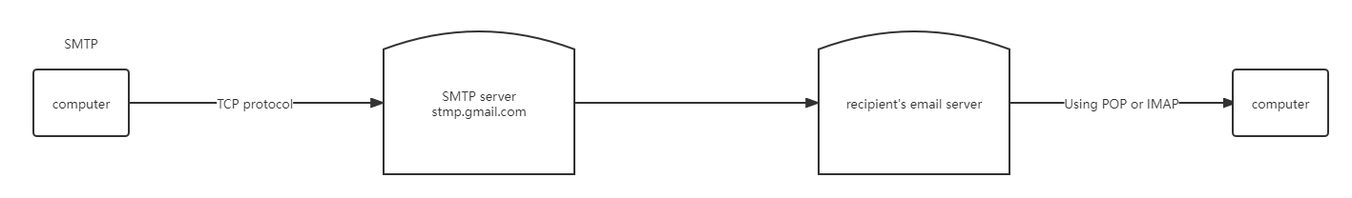
port：25
Port：587，邮件客户端向邮件服务器提交消息的推荐端口，就是上图的client到server的连接
Port：465，使用SSL加密消息，不被认可
Totally：25 used for server to server，465 deperted，587 used for client send email to server
So，I have to handed socket knowleage。Internet program

POP & IMAP：used for receiving email

