

SOFTWARE

USER

MANUAL

## December 2019

version 1.0

**TABLE OF CONTENTS**

**LOG-IN PAGE** 1

**DASHBOARD** 2

**EMPLOYEE PROFILE** 3

**DTR** 4

- Time Adjustment 5

-Time Adjustment Tab 6

-Change Shift 7

-Change Shift Tab 8

-Overtime 9

-Overtime Tab 10

* Work Verification 11
* Work Verification Tab 12

**UNDERTIME TAB** 13

**LEAVE TAB** 14

**OFFICIAL BUSINESS TRIP** 17

**LOAN TAB** 19

**ANNOUNCEMENT TAB** 20

**PAY SLIP TAB** 21

**CHANGE PASSWORD TAB** 22

*Log-In Page*

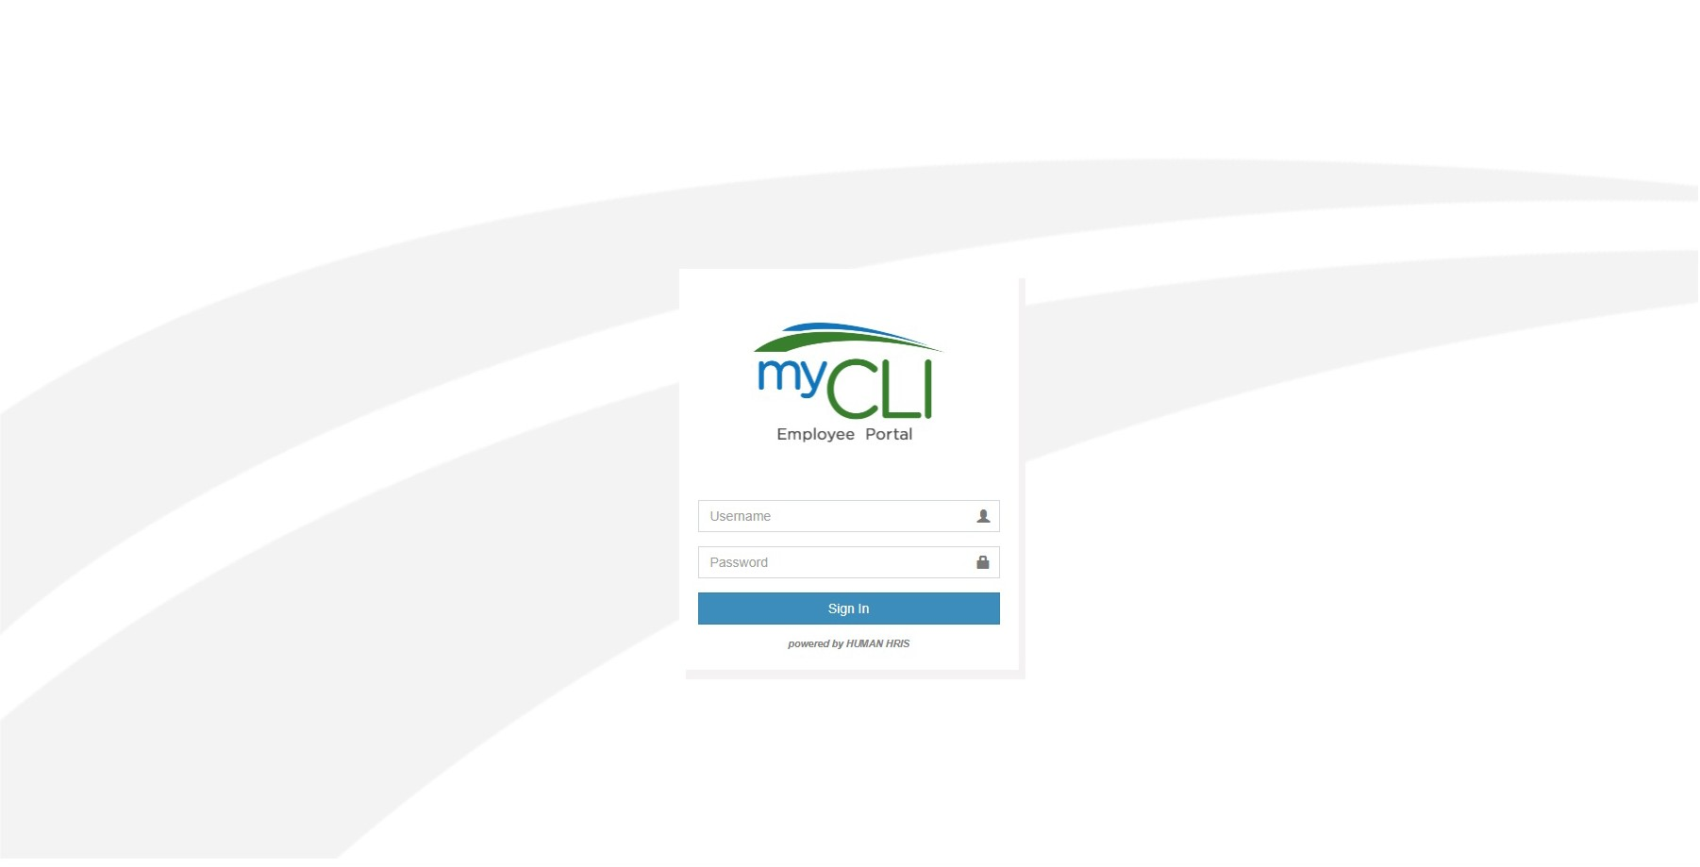

## Kindly key in your username and password in order to login on your HRIS account. As a reminder, do not share your credential to anyone.

*Dashboard*

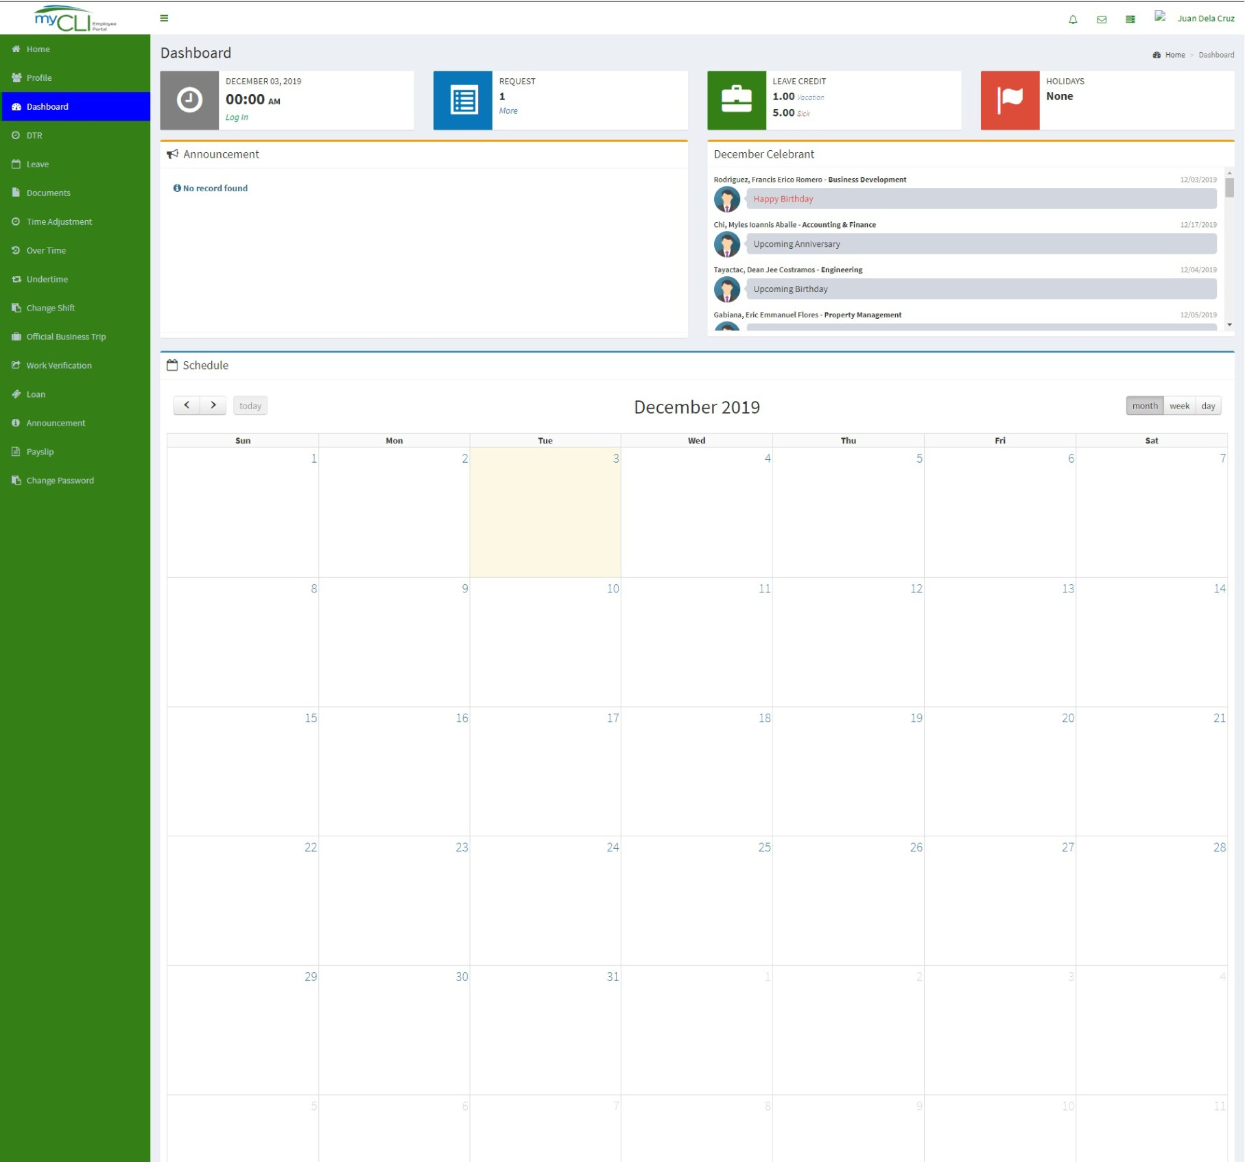

B

C

D

E

A

F

G

H

1. – These are the tab that will lead you to a different functionality.
2. – This shows the date and your daily real time Biometrics Logs.
3. – This is an indicator of all your pending request application.
4. – This shows you real time leave credit balance.
5. – This is to view the list of holiday announcements.
6. – On this section, it will show all important announcement made by HR/ Admin.
7. – This is the Celebrant Section. It highlighted the monthly posting of birthday celebrant and also to those employees who will be celebrating their Anniversary in the company.
8. - Calendar of Schedule: This will show your monthly, weekly or daily work schedule made by the scheduler.

*Employee Profile*

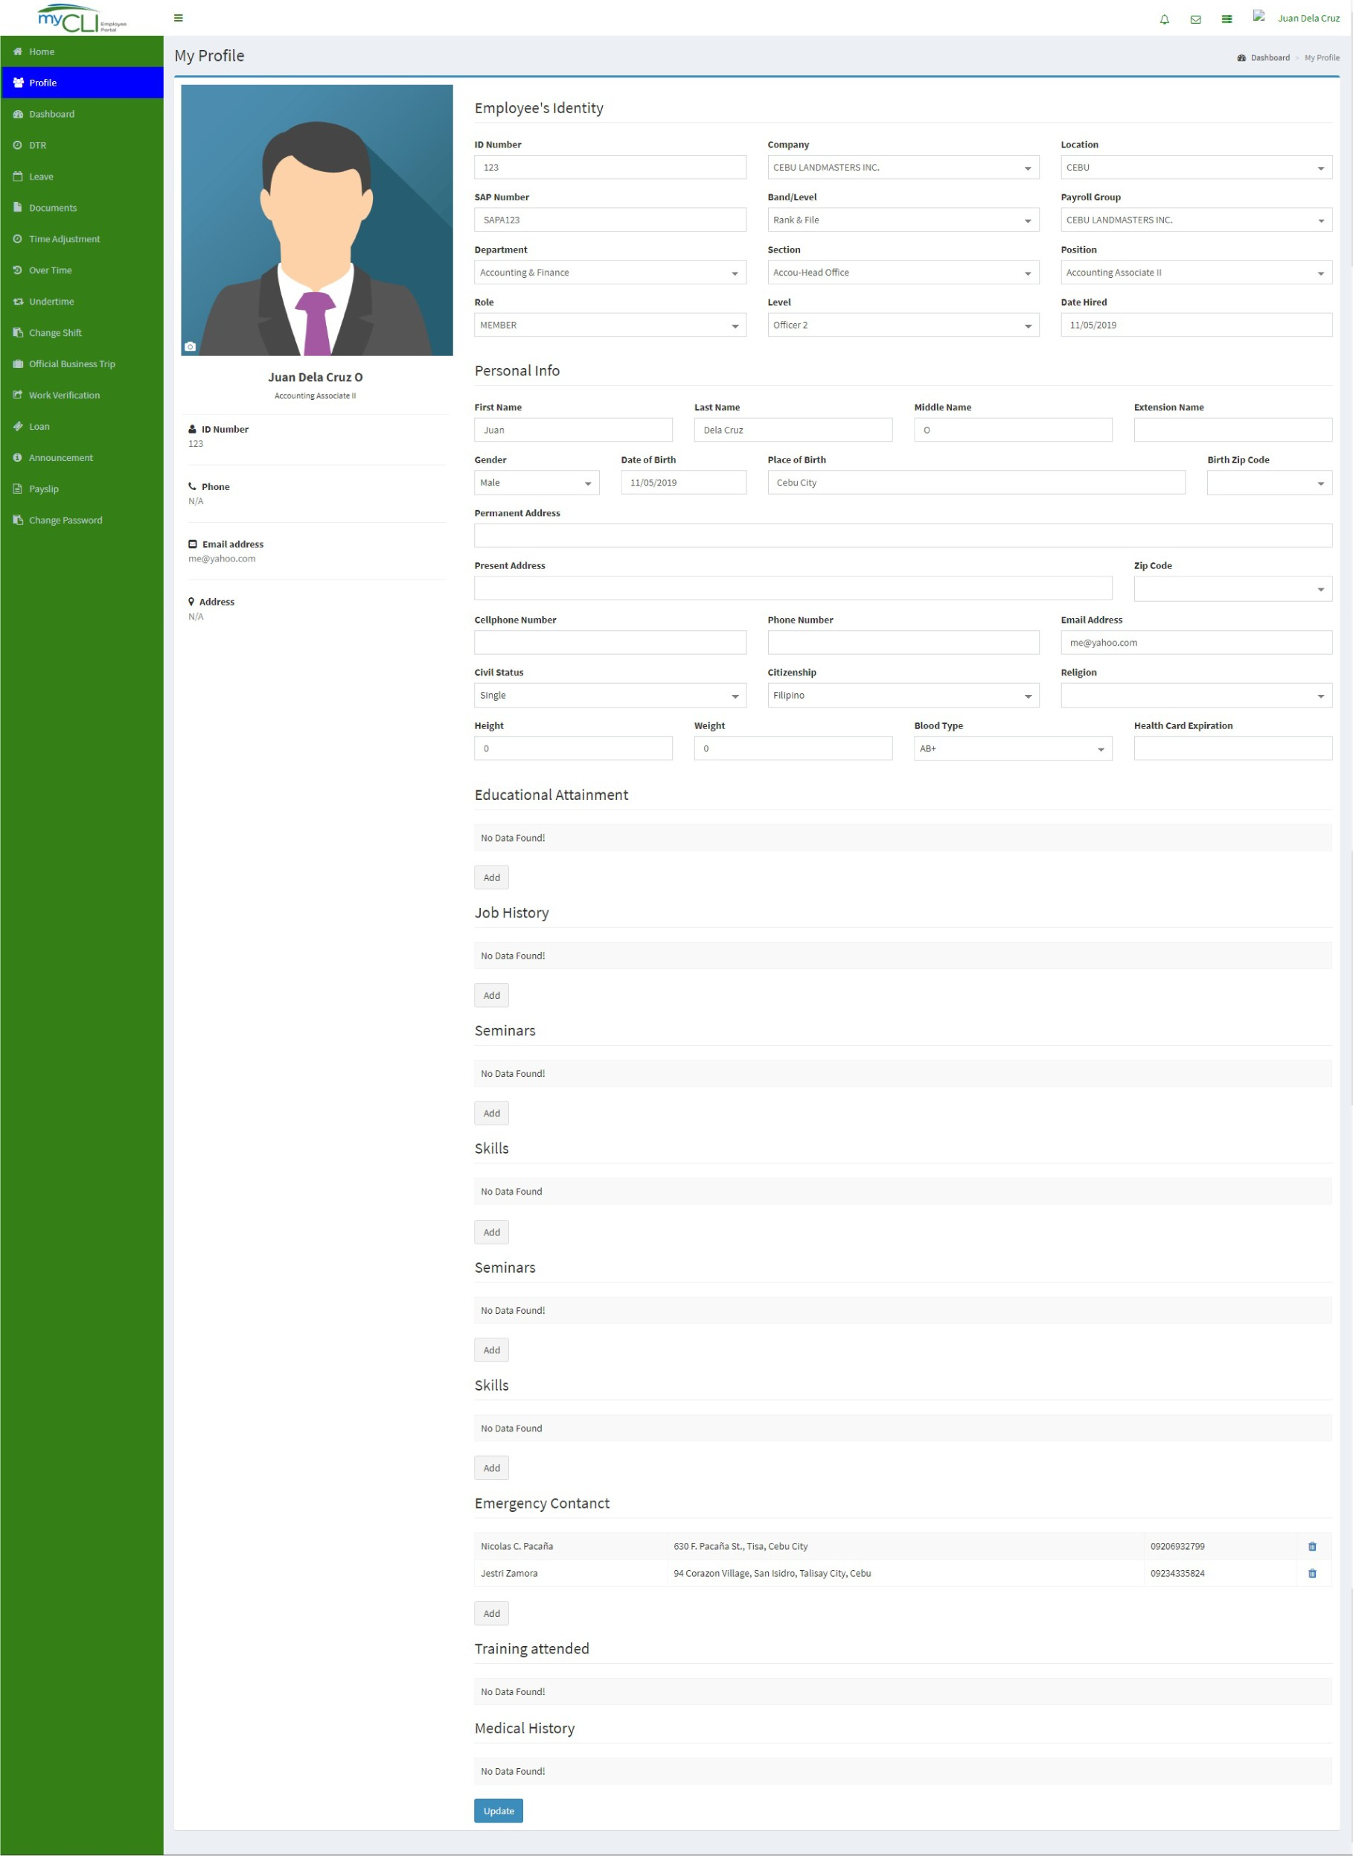

This is your “My Profile” page. This page allows you to view your demographic information. Take note that you cannot manually change or edit the information. If there is any information you would like to edit or change, kindly send email to your HR/ Admin. The only thing you can change/ update is your profile picture. Just don’t forget to click on update button below after you made changes.

*Daily Time Record - DTR*

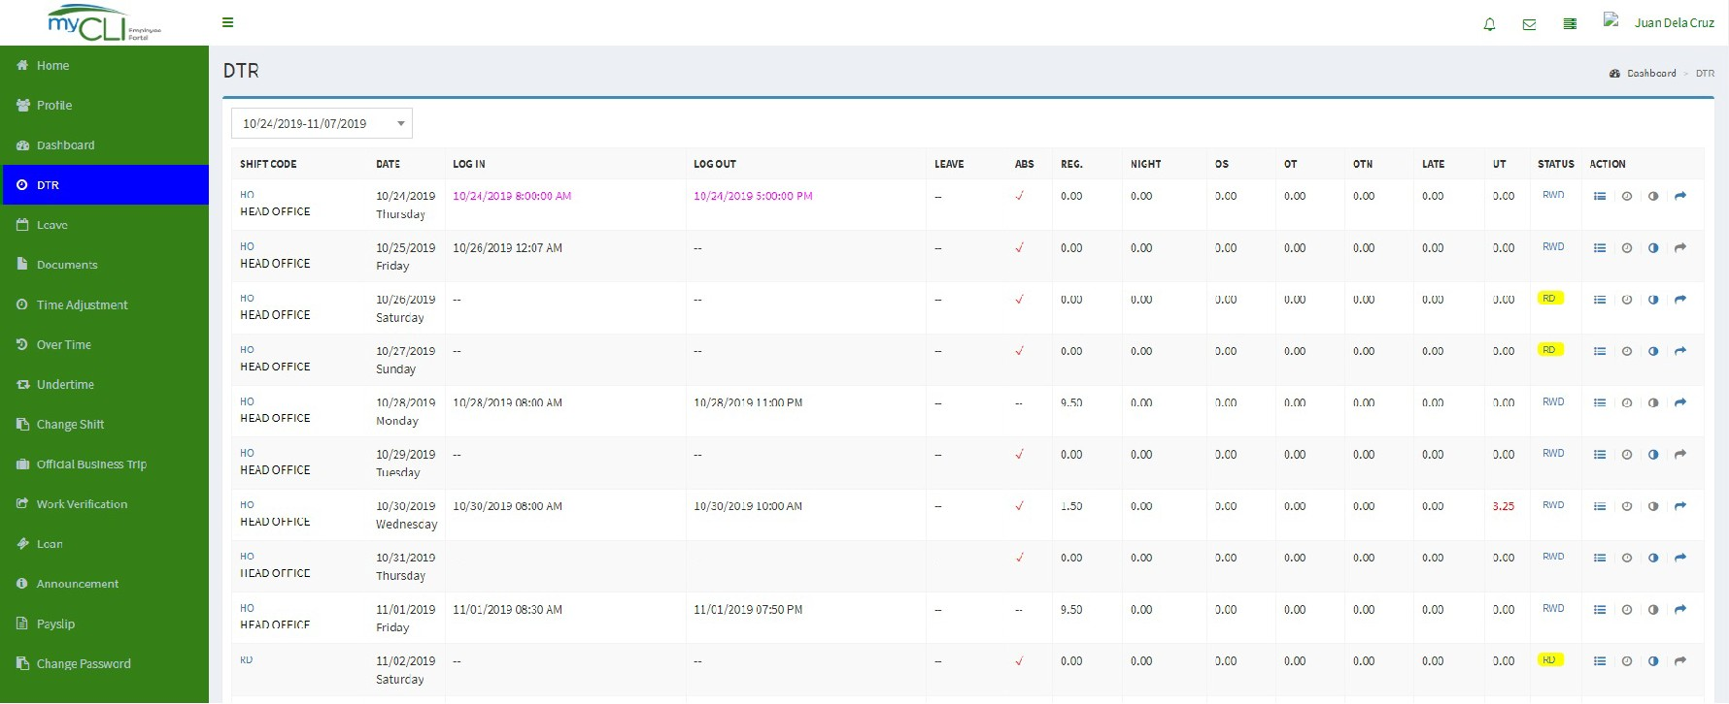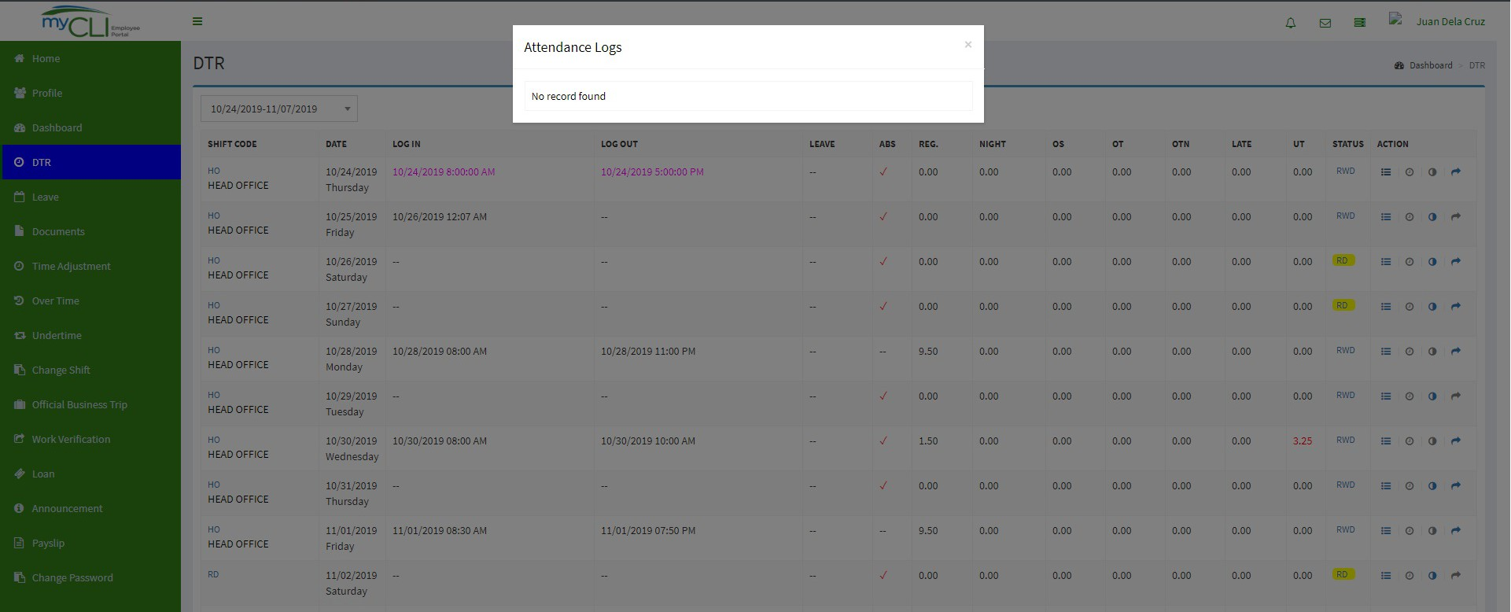

**2**

**1**

**3**

* Biometrics log -Allows you to view your raw logs.
* Overtime -Overtime Application.
* Time Adjustment -Time Adjustment Application.
* Change Shift -Change Shift Application

### How to check/view your Daily Time Record:

1. Click the DTR tab.
2. Select the drop-down for a specific payroll range.
3. A DTR Summary of your logs will appear.

*DTR - Time Adjustment*

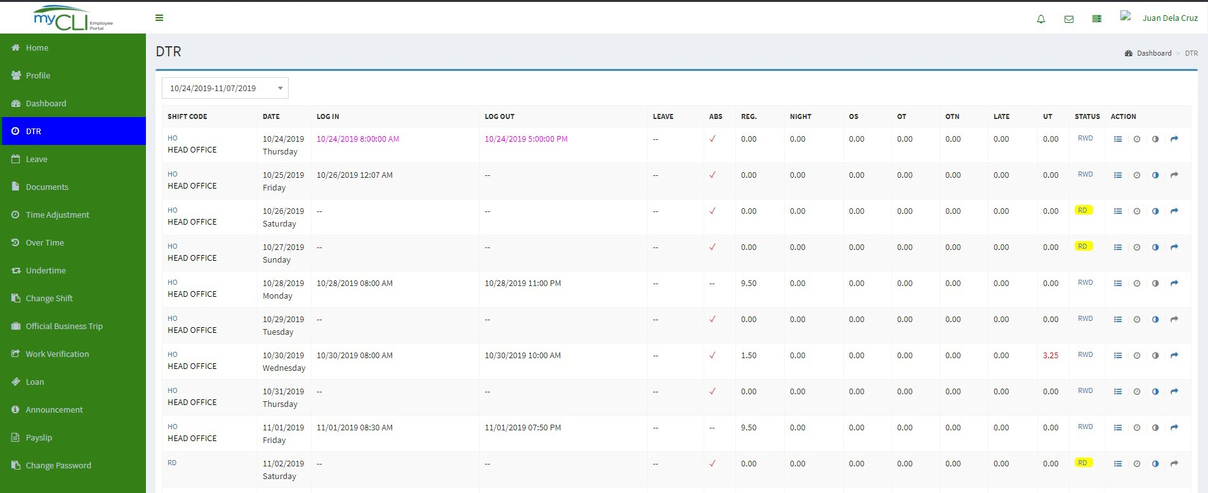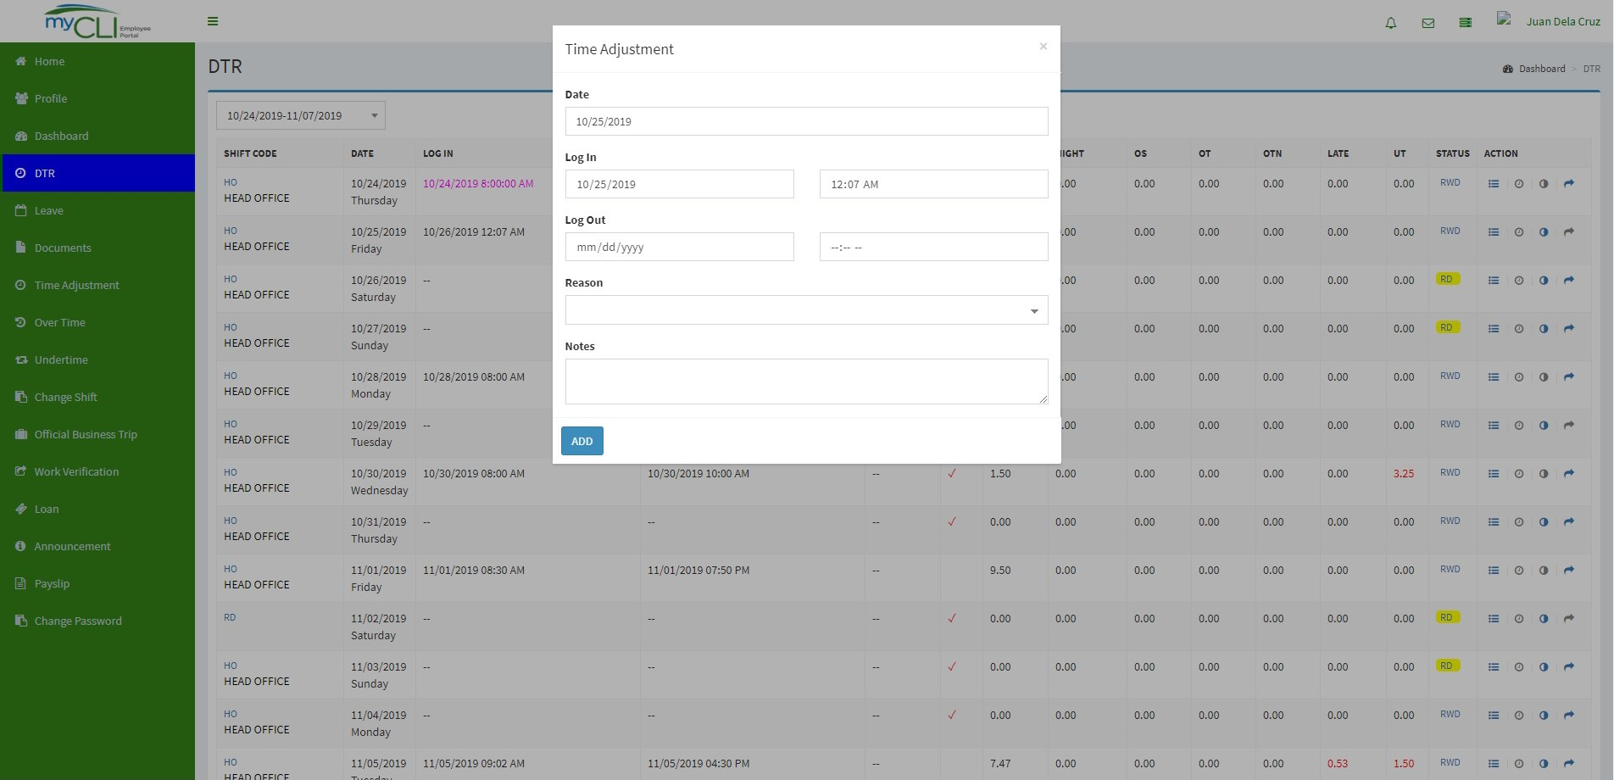

**1**

**2**

**3**

**4**

**5**

**6**

**Time Adjustment** – To correct some Daily Time Record Irregularity. Example:

1. Forgot to LOG IN

### How to file for Time Adjustment:

1. Click on the DTR Tab.
2. Select for a specific payroll range.
3. Check the dates which have a DTR irregularity.
4. Click on the half-moon icon. A Time Adjustment Pop-up will appear.
5. Correct attendance log and provide brief or narrative reason to justify the application being made.
6. Click ADD button to proceed the request.

### Note:

Time Adjustment application will be enabled when there is an irregularity from your DTR.

*Time Adjustment Tab*

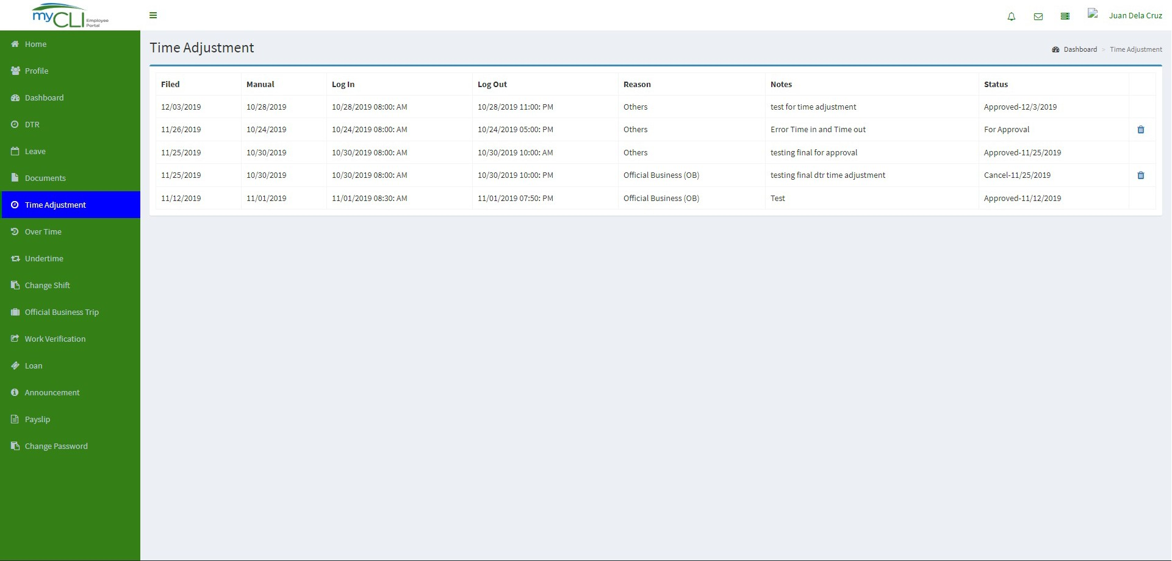

**2**

**1**

1. This tab allows the user to view history or previous time adjustment(s) and moni tor status once approved or cancelled.
2. User can also cancel filed adjustment(s) being made. Simply click the trash icon and provide brief or narrative reason to justify the cancellation.

*DTR - Change Shift*

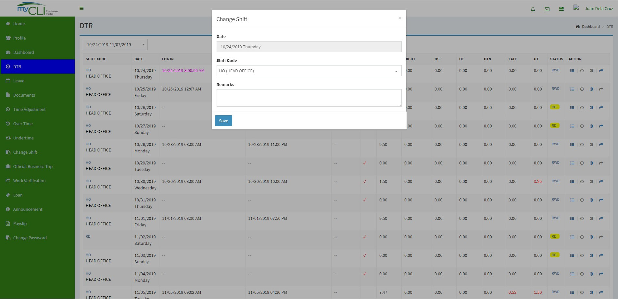

**1**

**2**

**3**

**4**

**6**

**Change Shift** – Allows you to correct your incorrect daily schedule. Example:

Shift Code: Monday; 8:00AM to 5:00PM (Incorrect Schedule) Shift Code: Monday; 9:00AM to 6:00PM (Correct Schedule)

### How to file for Change Shift:

1. Click on the DTR Tab.
2. Select for a specific payroll range.
3. Check the dates which would you like to have a change shift.
4. Click on the curve arrow icon. A Change Shift Pop-up will appear.
   1. Change shift dialog will popup.
      1. Correct shift code and encode a narrative/reason to justify time changes shift adjustment.
      2. Click save button to proceed request.
5. Correct the shift code and provide a brief or narrative reason to justify your change shift application.
6. Click the SAVE button to proceed the request.

*Change Shift Tab*

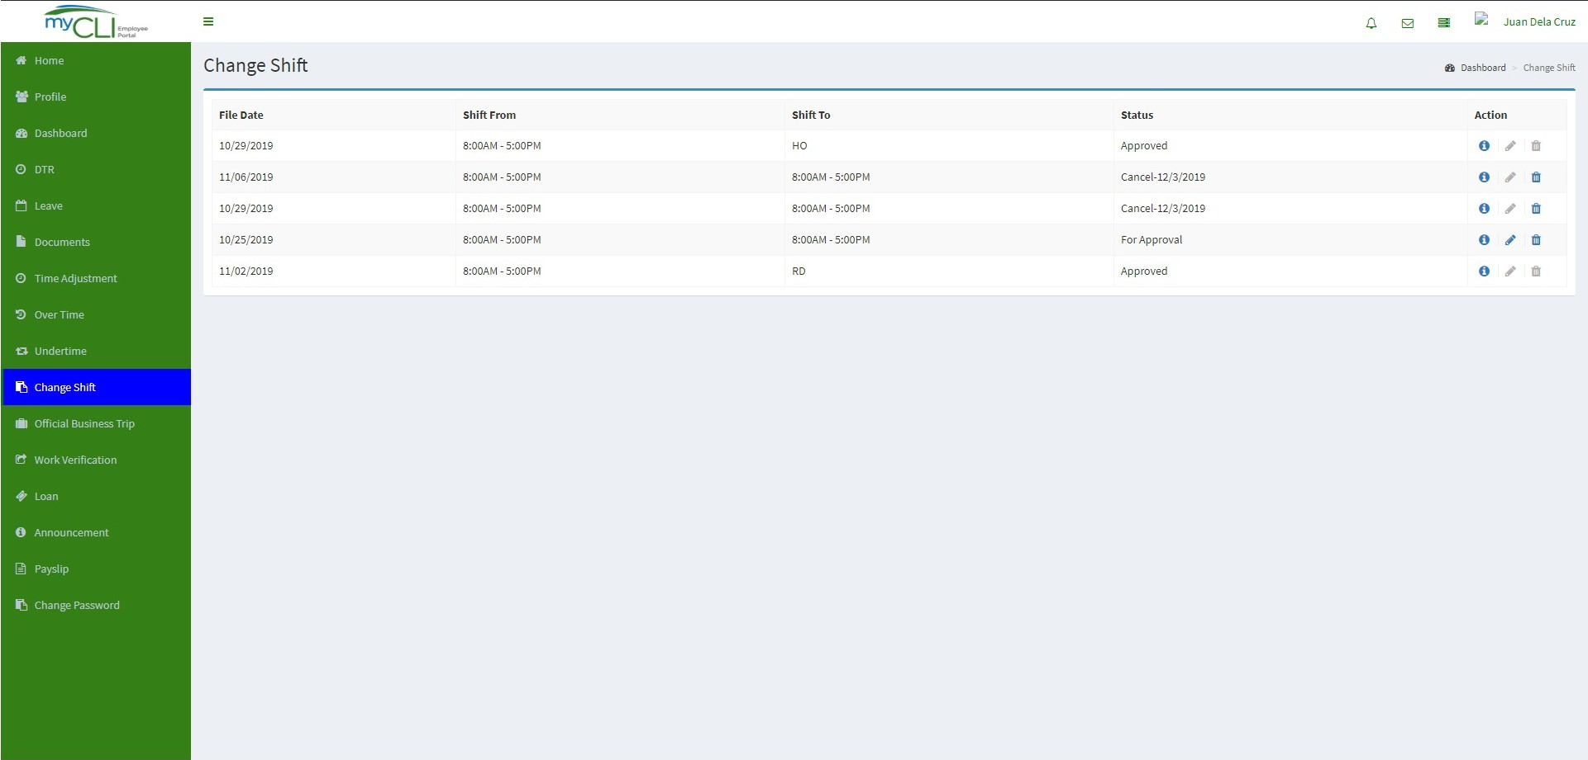

**1**

1. This page allows the user to view request(s) and monitor its status.

*DTR - Overtime*

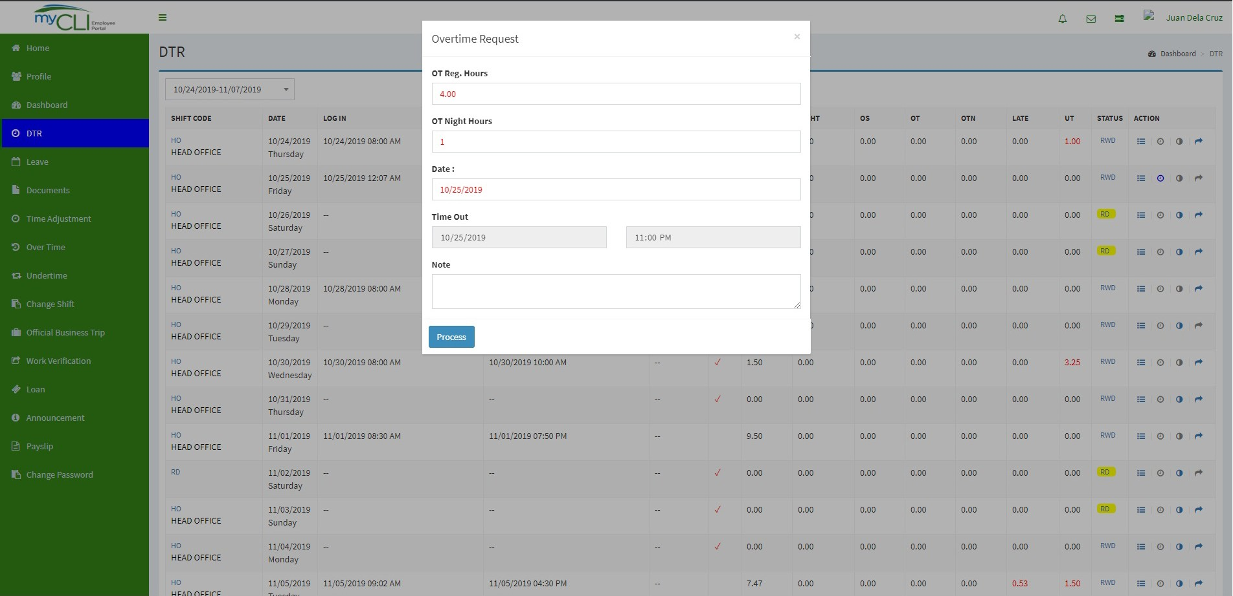

**1**

**2**

**3 4**

**5**

**6**

### How to file for Overtime Application:

1. Click on the DTR Tab.
2. Select for a specific payroll range.
3. Check the dates which have an excess minutes/hour.
4. Click on the clock icon. An Overtime Request Pop-up will appear.
5. On the Overtime Request Pop-up, fill in all necessary fields.
6. Click on the Process Tab.

### Note:

Overtime application will be enabled when there is exists hour from your schedule.

*Overtime Tab*

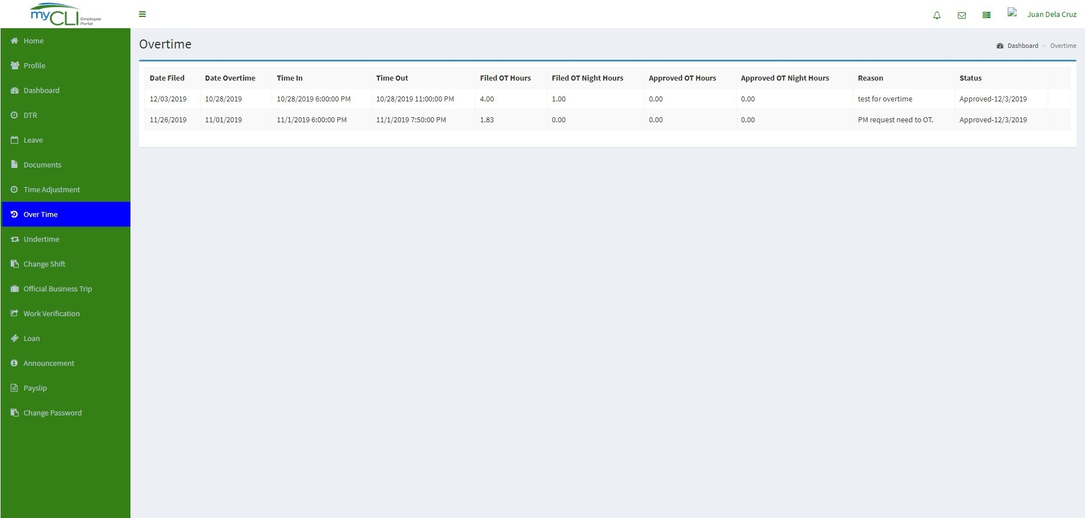

**1**

1. This Tab allows the user to view history or previous overtime request and moni- tor status once approved or cancelled.

*DTR - Work Verification*

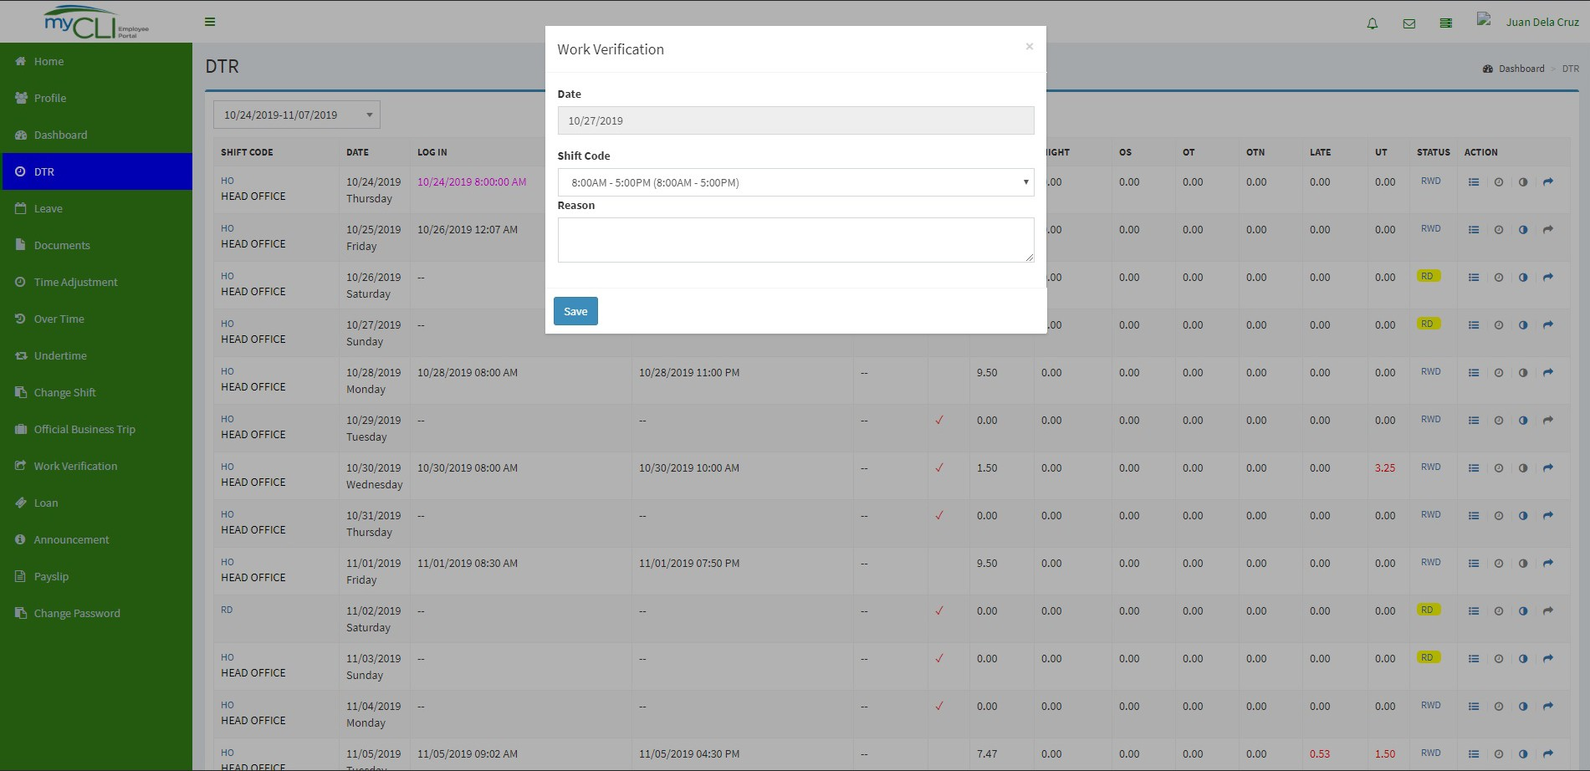

**2**

**1**

**3**

**4**

**5**

**6**

**7**

**Work Verification** – Allows the user to file a request in 2 ways, the function of this feature is to allow approvers to verify actual duty or attendance logs of their subordi- nate during working holidays / rest day.

* User can file “BEFORE” Attendance logs prior official working holiday schedule.
* User can file “AFTER” Attendance logs after working holiday schedule. Note: The user is allowed to do either way, as long as filed within the cut-off cycle.

### How to file Work Verification:

1. Click on the DTR Tab.
2. Select for a specific payroll range.
3. Look for the date/s you wish to apply for work verification.
4. Under STATUS column, click on (RWD, SH, RH, RD) that correspond on the date.
5. A work verification pop-up will appear. This will allow the user to provide the actual work verification request.
6. The user can also choose their shift code on that day.
7. Click on the SAVE button to finish.

*Work Verification Tab*

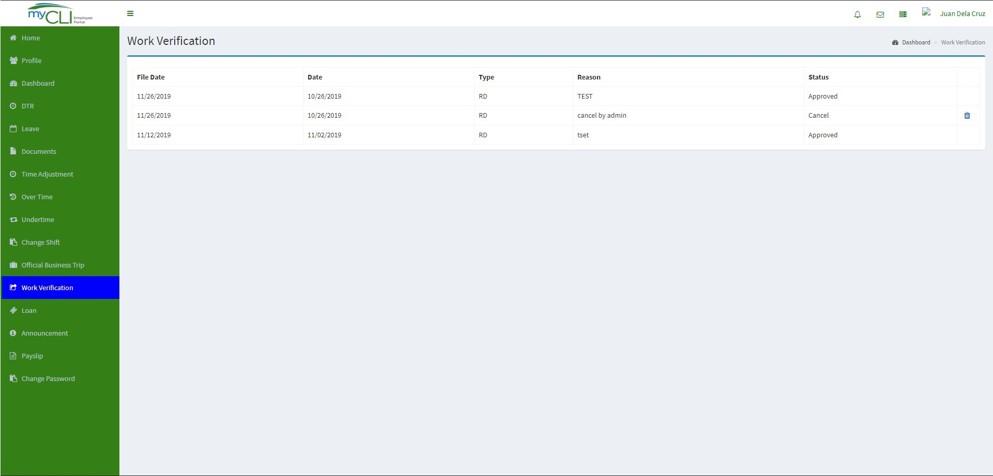

**2**

**1**

1. This Tab allows the user to view
2. User can also cancel filed request(s) applied. Simply click the trash icon and provide brief or narrative reason to justify the cancellation being made.

*Undertime Tab*

# 1

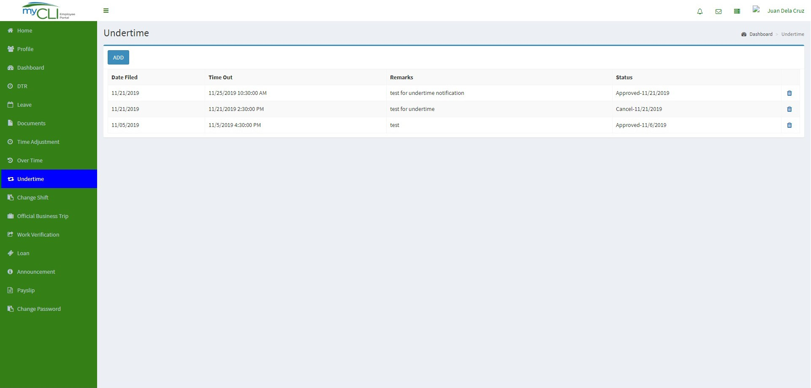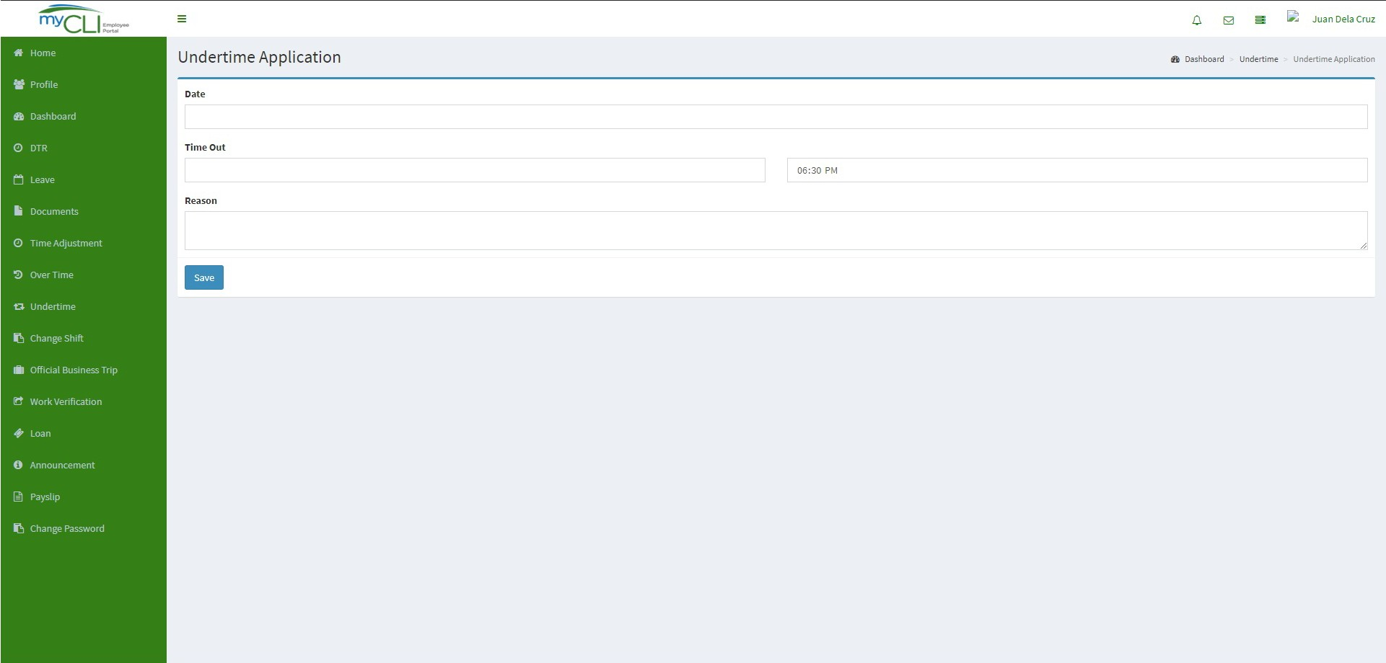

**2**

**3**

**4**

### How to file Undertime Application:

1. Click on the UNDERTIME Tab.
2. Click on the ADD button.
3. Complete the undertime application form.
4. Click on the SAVE button.

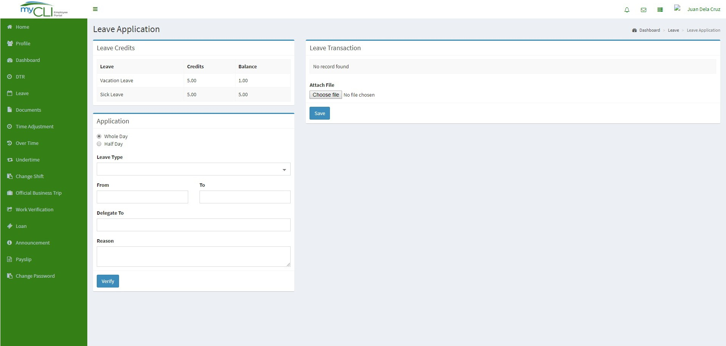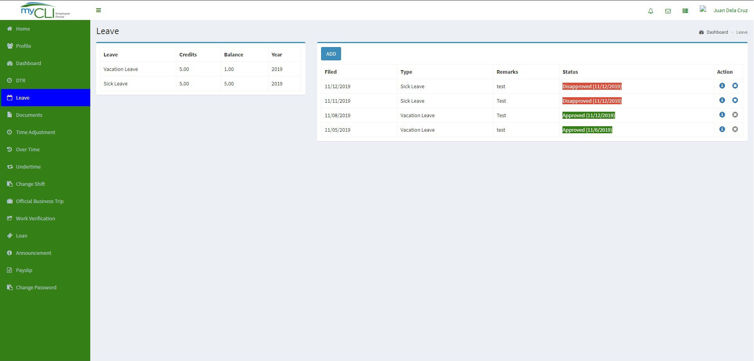

**3**

**1**

**5**

**Leave Tab** – This will allow you to Check for your VL/SL credit balance at the same time to apply for leave application.

### How to file leave application:

1. Click on the LEAVE Tab.
2. Check if you still have leave credit balance.
3. Click on the ADD button.
4. Fill in all leave request details.
5. Click on the VERIFY button to generate a leave transaction.

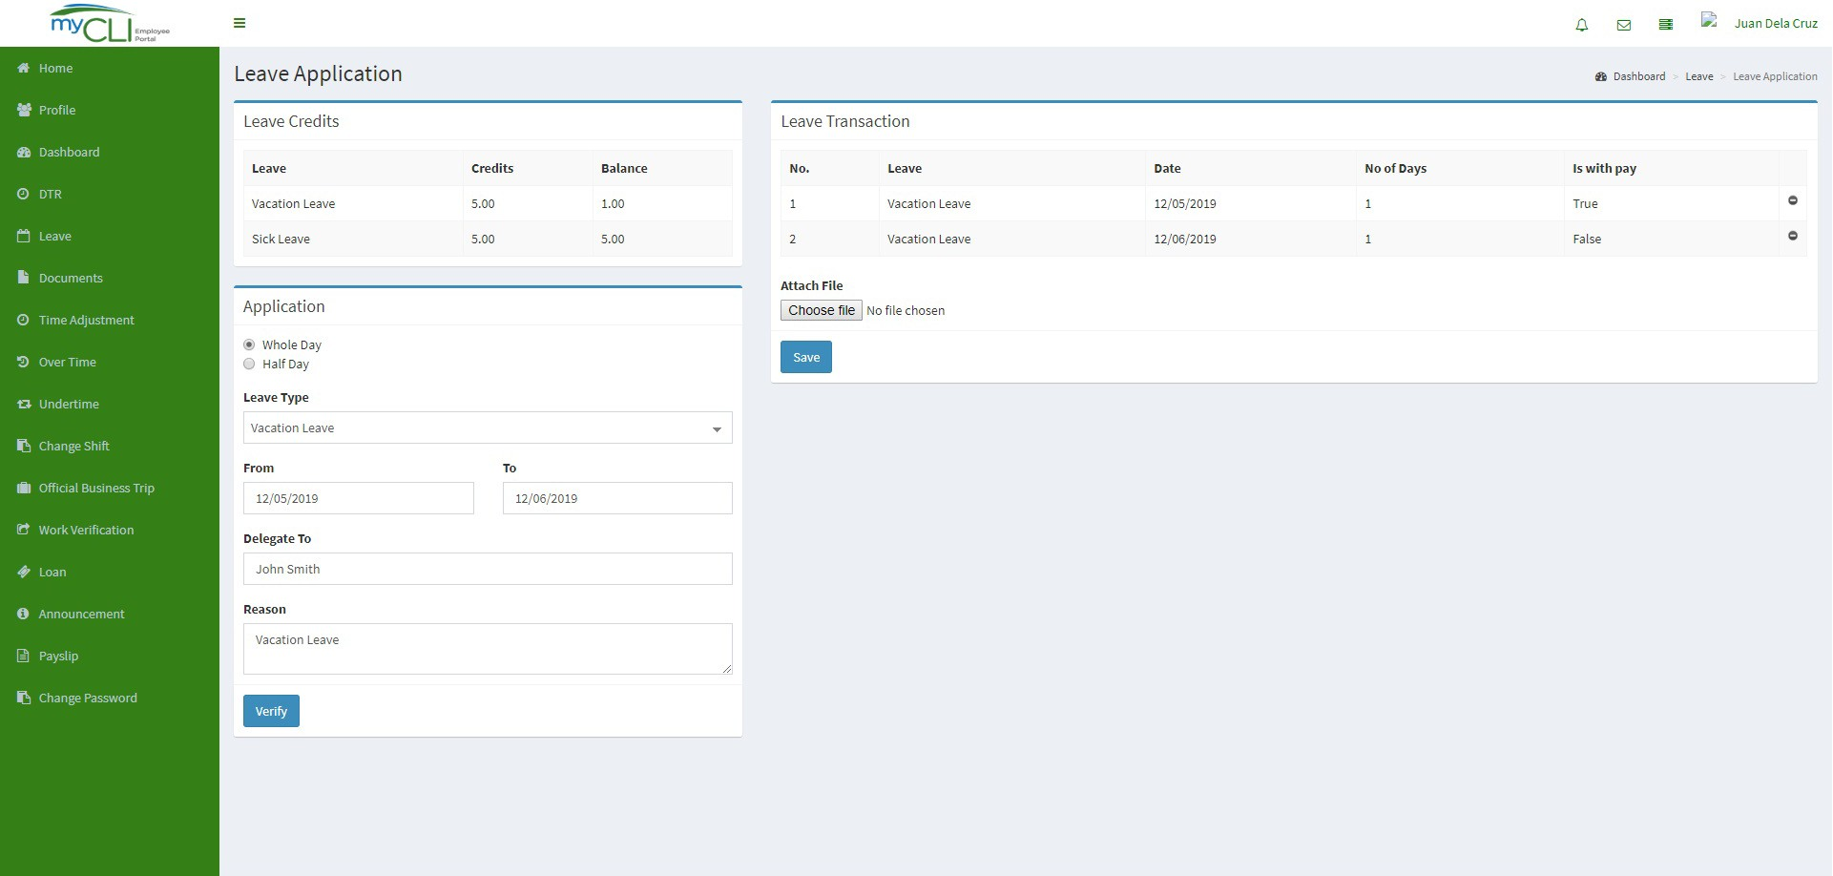

**6**

**7**

1. Check the leave transaction if all details are correct.

### Note:

* 1. You can attach supporting document for your application by clicking on the CHOOSE FILE button.
  2. Double check your application whether if it is TRUE or FALSE status to determine if paid or not.
  3. If you wish to decline the application, click on the NO ENTRY icon.

1. Click SAVE button to finish.

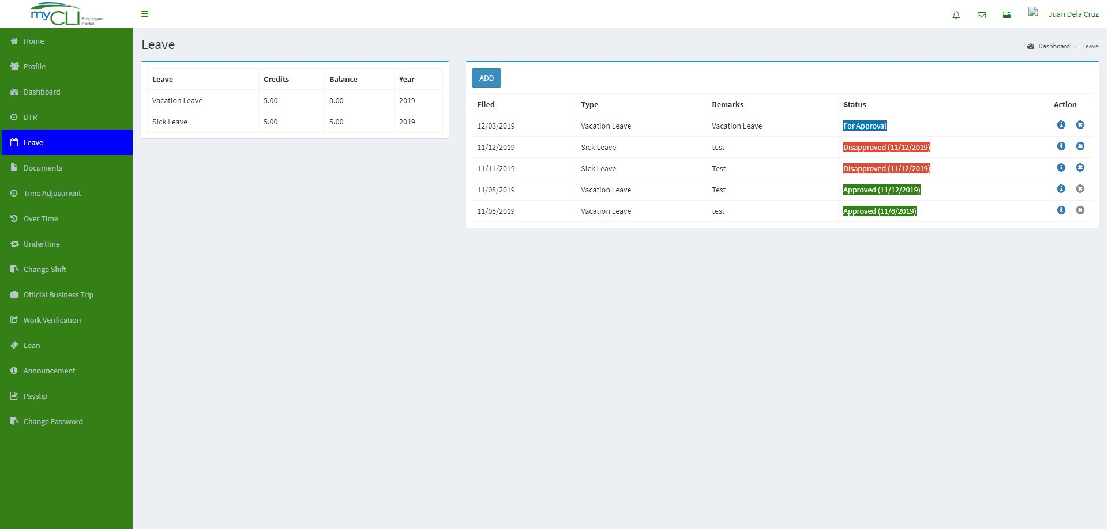

This section allows you to check the status of your leave application.

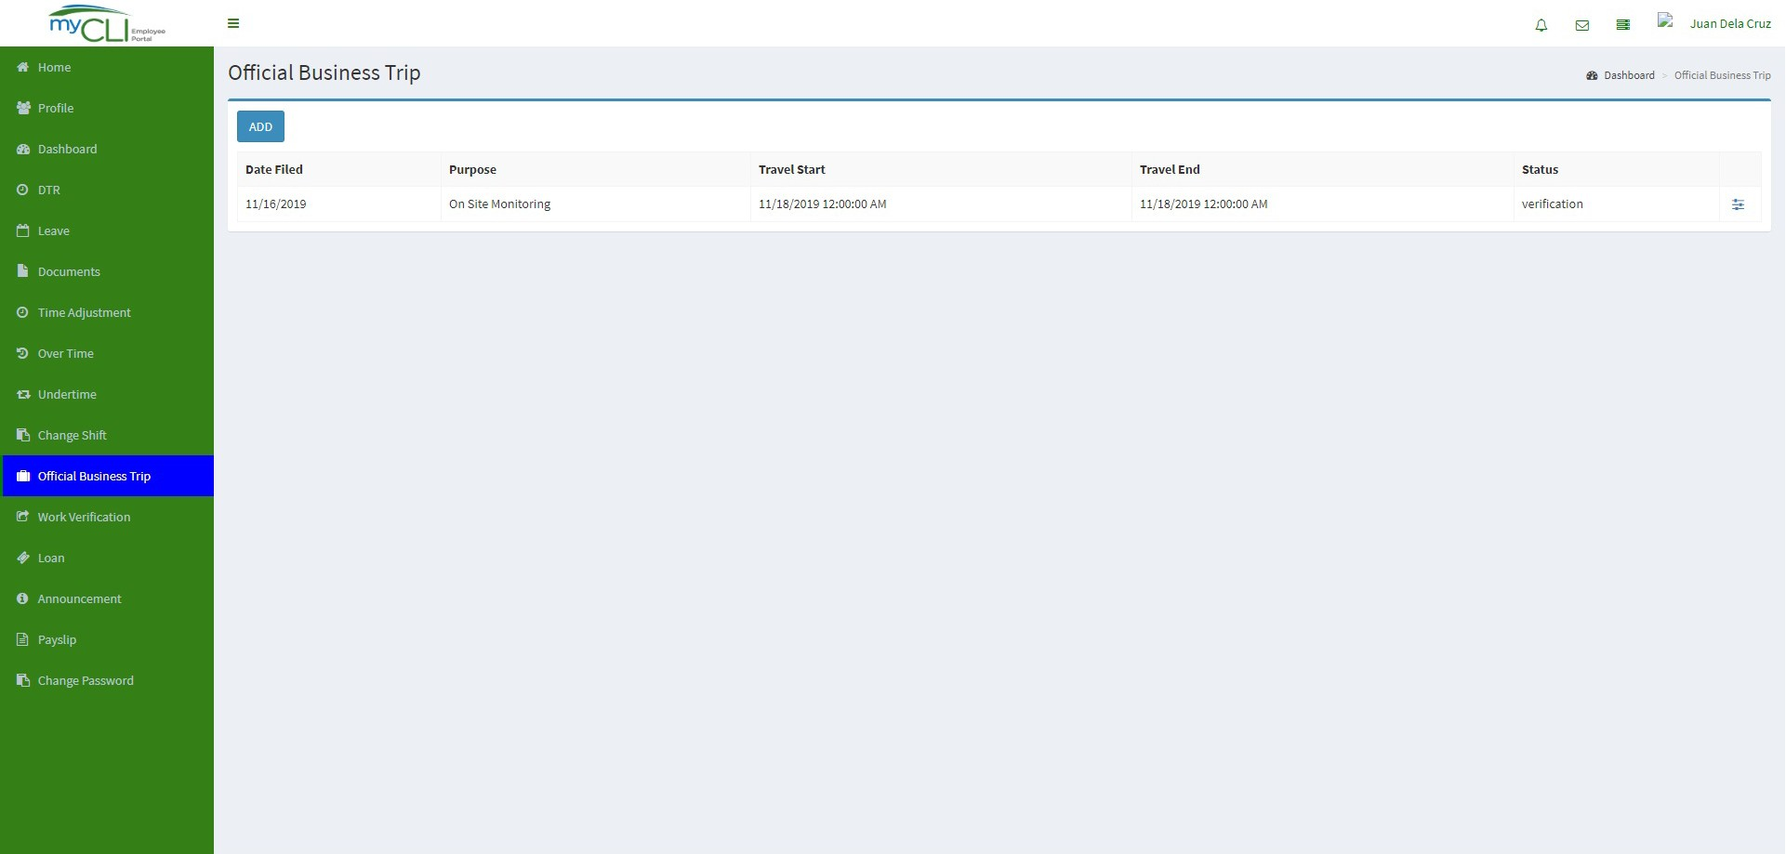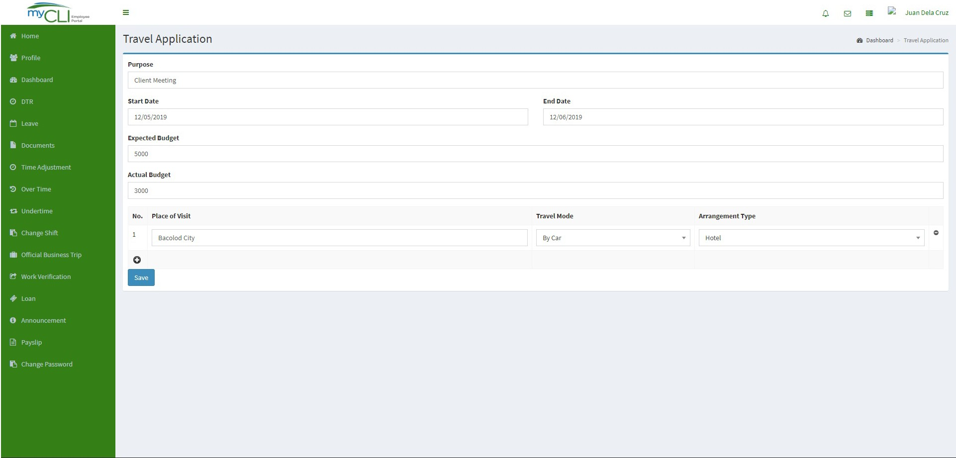

**2**

**1**

**4**

**3**

**Official business Trip (OBT) Tab** - Allows the user to create or file official business trip. This application is subject for approval of supervisor or manager.

### How to file Official Business Trip (OBT) Application:

1. Click on the Official Business Trip Tab.
2. Click on the ADD button.
3. Complete the travel request application form
4. Click on the SAVE button to finish the application.r

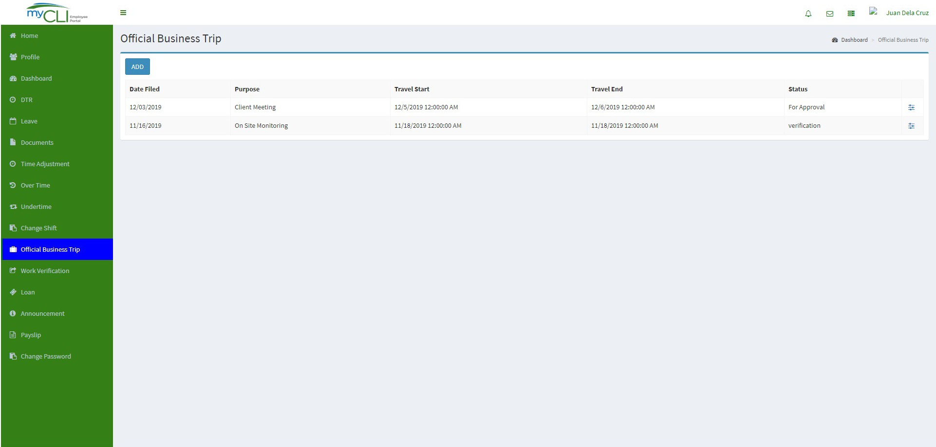

### Note:

1. Once the application is approved, you can use this as a supporting document in filling Time Adjustment (Pre-filling or Post-filling).
2. This application will not be going to supply daily logs. You still need to file for a time adjustment (Pre-filling or Post-filling) to correct you DTR.

*Loan Tab*

# 1

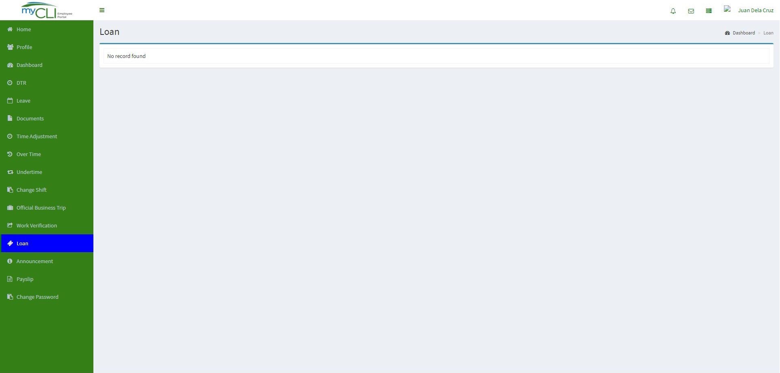

**2**

**Loan Tab** – This will serve as a monitoring of your LOAN (External or Internal).

* Request monitor status.
* View loan amortization.

1. Click on the LOAN Tab.
2. On the LOAN page, it allows you to check your Loan type, Loan amount, Interest Amount, Monthly amortization, Status, Remarks.
3. If you have any questions or clarifications, you may approach you HR in charge.

*Announcement Tab*

# 1

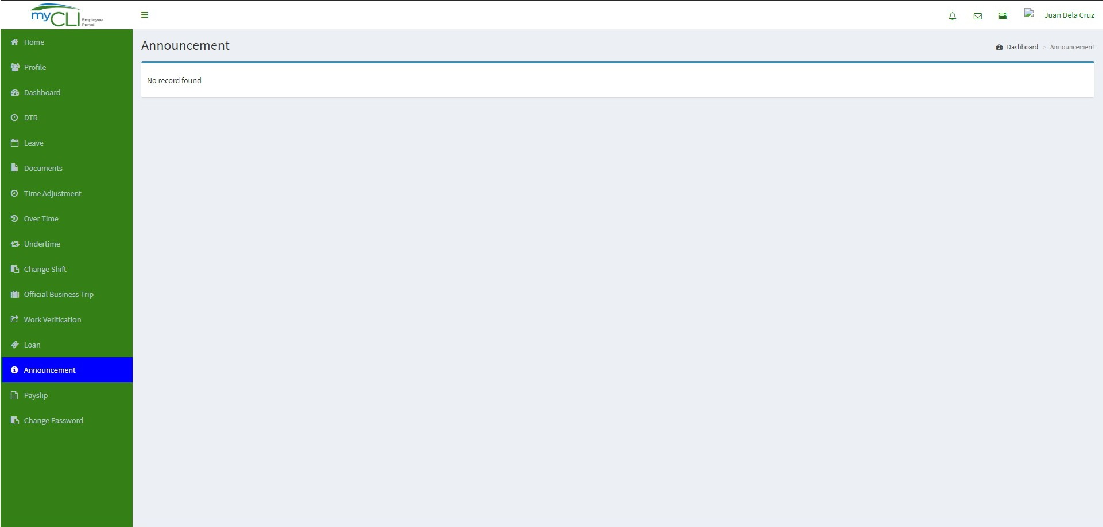

**Announcement Tab** – Allows you to read mandatory official announcements.

1. Click on the ANNOUNCEMENT Tab.
2. You can now view important announcement from the Admin/HR.

*Pay Slip Tab*

# 1

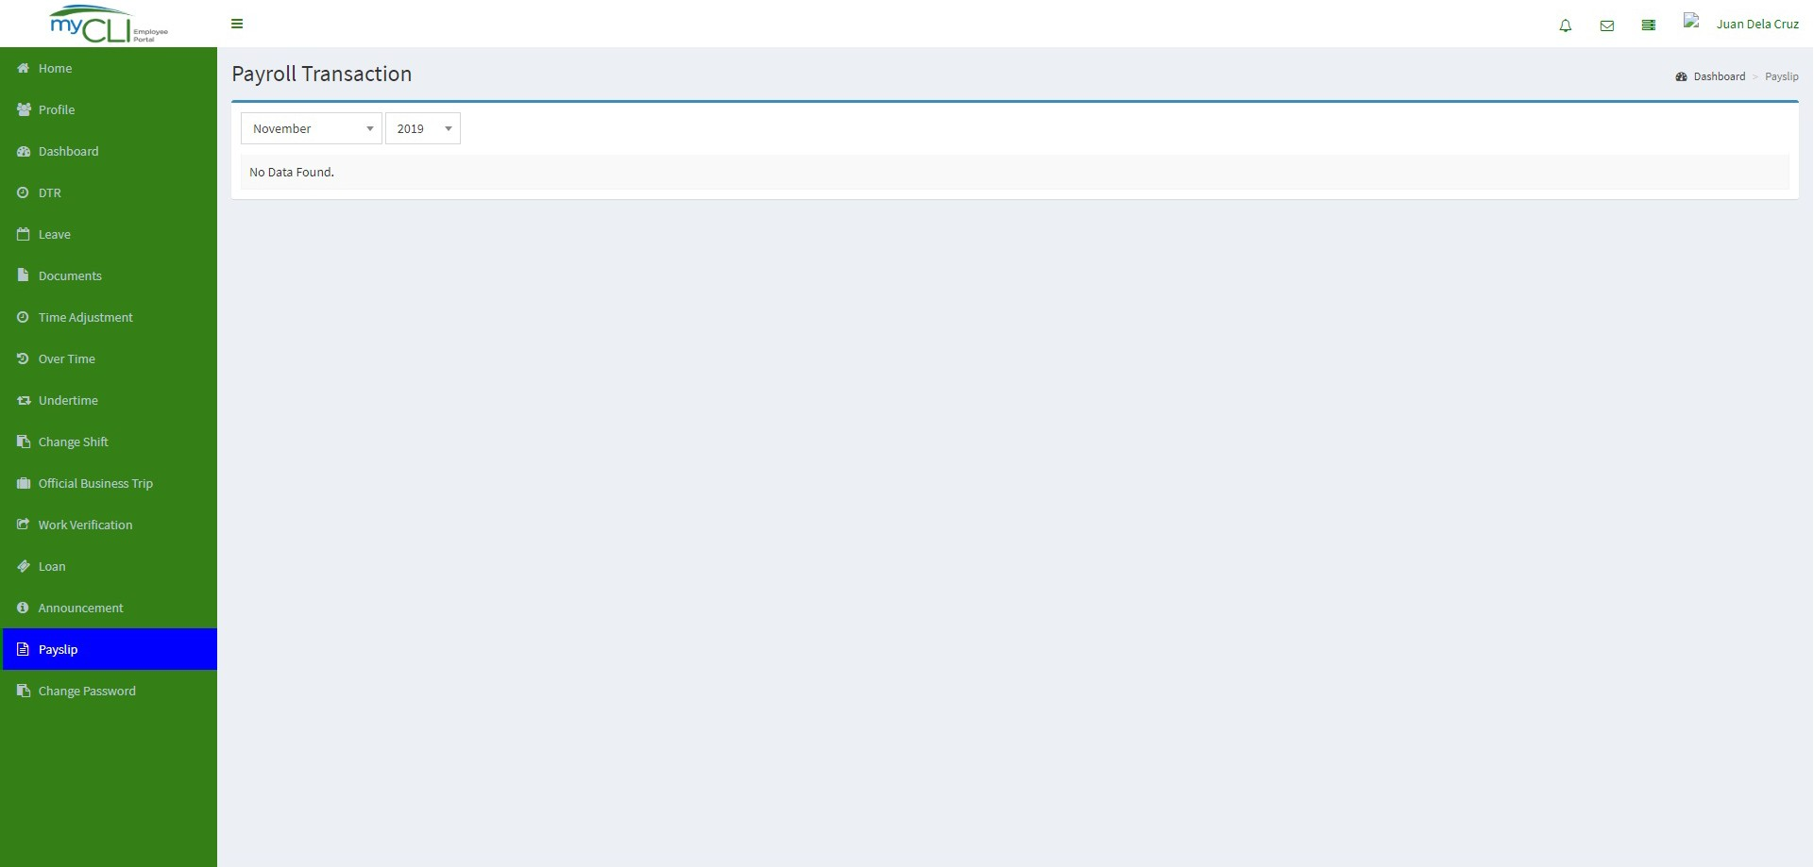

**2**

**3**

**Pay slip Tab** – Allows you to:

* Payroll Transactions/History such as the previous month and the current.
* Online Pay slip viewing.

How to view my pay slip:

1. Click on the pay slip tab.
2. Under Payroll Transaction, select preferred Month and Year.
3. Under ACTION, click on VIEW and you will be able to view your pay slip.

*Change Password Tab*

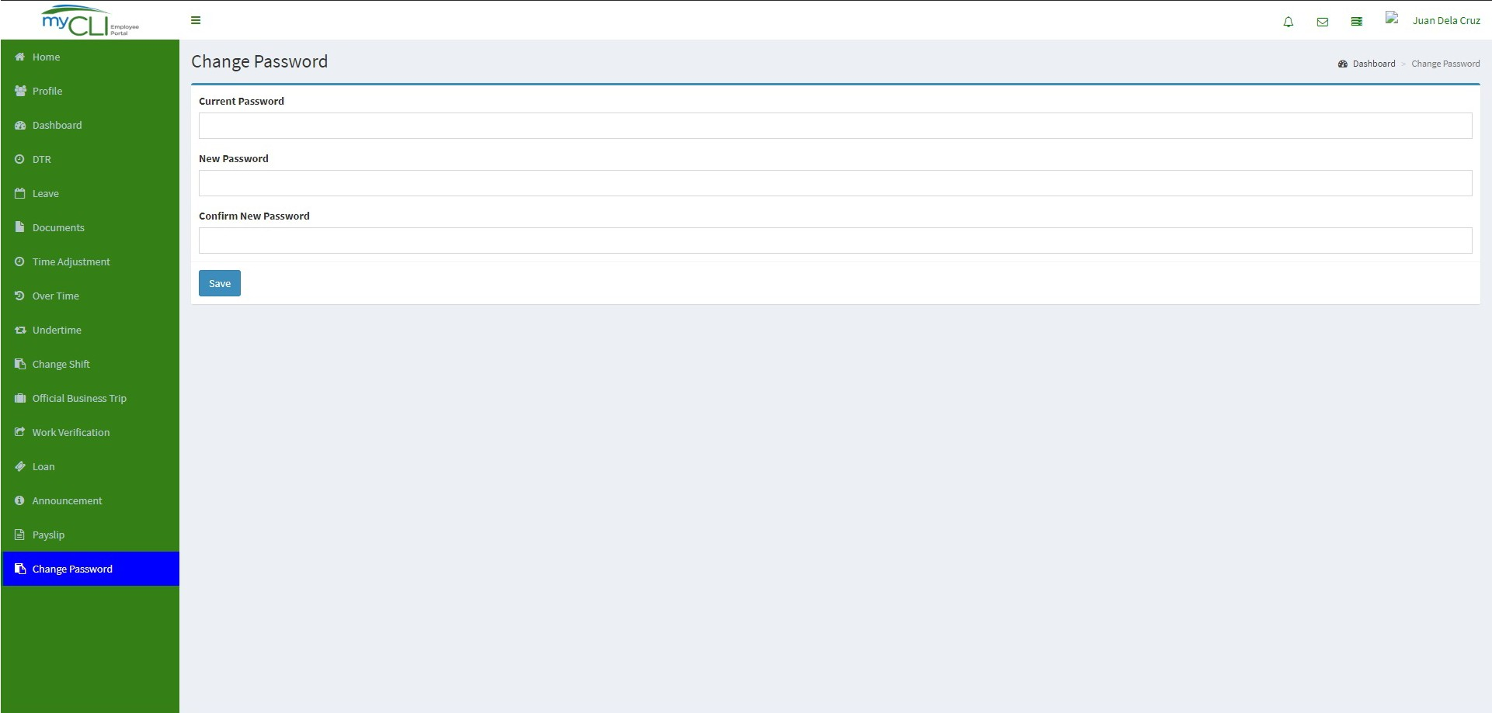

**2**

**3**

**4**

**1**

### How to change password:

1. Click on the CHANGE PASSWORD Tab.
2. Under Current password field, provide your default or current password
3. Then, supply your new password and confirm.
4. Click SAVE button to finish.

Reminders:

1. Do not divulge your password to anyone.
2. Once your password is revoked or you’re being lock out, kindly send email to your HR requesting for a PASSWORD RESET.