Hot-Air Recirculation in a Cooling-Tower Array
A Steady RANS Parametric Study and a Physics-Informed Field Surrogate
Computational Fluid Dynamics and Machine Learning

Table of Contents

List of Tables

Table of Figures

1. Introduction

1.1. Background and motivation
Cooling towers and packaged heat-rejection units reject waste heat by discharging warm, moist air into the atmosphere. When several of these units sit close together, the warm plume leaving one unit does not always clear the site. Under the right wind conditions it bends over and is drawn back down into the air intakes of neighbouring units. This hot-air recirculation raises the intake temperature above ambient, which lowers the thermal capacity of the affected units and forces the whole plant to work harder for the same duty. The effect is a familiar concern in the thermal design of data centres and industrial heat-rejection yards, where intake and exhaust are packed into a limited footprint.
The strength of recirculation is governed by a competition between two effects. Buoyancy lifts the warm plume away from the ground, while the crosswind bends it over and pushes it downstream toward the next row of units. Whether the intakes stay cool or ingest their neighbours’ exhaust depends on which of these wins, and that balance shifts with wind speed, discharge velocity, and the spacing of the array.

1.2. Objectives and scope
This study has two aims. The first is to characterise hot-air recirculation across a generic six-unit array using steady Reynolds-averaged CFD, and to show how the recirculation penalty tracks the balance between plume momentum and wind. The second is to demonstrate a physics-informed surrogate that learns the full three-dimensional temperature and velocity field as a function of the operating point, so that a new wind and discharge combination can be evaluated in milliseconds rather than by running the solver again. The geometry is deliberately generic and the mesh is intentionally coarse, because the purpose is to exercise the full pipeline from CFD to constrained learning on a representative thermal problem, not to certify a specific plant.

2. Physical Model and Governing Equations

2.1. Case description and geometry
The domain is a rectangular block of atmosphere 280 m long, 140 m wide, and 80 m tall. Six cooling-tower cells, each with a 12 m by 12 m footprint and a height of 10 m, are arranged in three columns along the wind and two rows across it. Wind enters through one vertical face as a uniform stream and leaves through the opposite face. Each tower discharges warm air upward from its top face at a fixed temperature of 313 K into an ambient of 298 K. The ground is treated as a no-slip wall and the lateral and top boundaries as symmetry planes. The layout and the two viewing planes used throughout the report are shown in Figure 1.
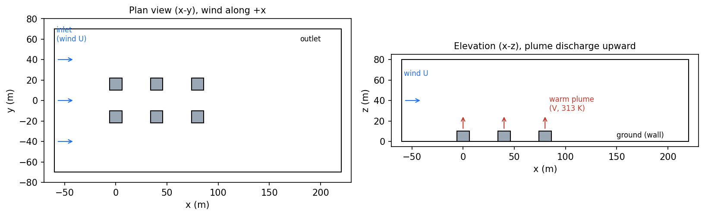
Figure : Plan and elevation views of the six-unit cooling-tower array, the crosswind direction, and the upward warm-air discharge.

2.2. Governing equations
The flow is modelled as steady, incompressible in the low-Mach sense, and turbulent. Mass conservation is expressed by the continuity equation for the mean velocity field.
$∇⋅\vec{V}=0$ Eq. 2.1
Momentum transport follows the Reynolds-averaged Navier-Stokes equation, with the turbulent stresses represented through an eddy viscosity and buoyancy entering as a body force proportional to the local density deficit relative to the reference state.
$ρ (\vec{V}⋅∇)\vec{V}=−∇p+∇⋅\left[(μ+μ_{t})\left(∇\vec{V}+∇{\vec{V}}^{T}\right)\right]+(ρ−ρ_{0}) \vec{g}$ Eq. 2.2
Heat is carried by the mean flow and spread by molecular and turbulent diffusion, the latter scaled by a turbulent Prandtl number. The mean energy equation is written in terms of temperature.
$ρ c_{p} (\vec{V}⋅∇)T=∇⋅\left[\left(k+\frac{c_{p} μ_{t}}{{Pr}_{t}}\right)∇T\right]$ Eq. 2.3
Buoyancy is captured through the dependence of density on temperature. Air is treated as an incompressible ideal gas, so density varies with temperature at the fixed operating pressure while acoustic effects are excluded.
$ρ=\frac{p_{op}}{R T}$ Eq. 2.4
Turbulence closure uses the realizable k-epsilon model with standard wall functions, which is a robust and widely used choice for buoyant plumes and bluff-body wakes at this scale.

2.3. Dimensionless parameters
Three dimensionless groups frame the physics. The Reynolds number based on the tower width confirms that the flow is fully turbulent across the whole sweep, with values between 1.2 and 4.8 million.
${Re}_{D}=\frac{ρ U_{∞} D}{μ}$ Eq. 2.5
The densimetric Froude number compares plume momentum with buoyancy at the discharge. Values above one indicate a momentum-dominated near field, which holds for every case here.
$Fr=\frac{V_{dis}}{\sqrt{g D \left(ΔT/T_{dis}\right)}}$ Eq. 2.6
The bulk Richardson number compares buoyant lift with wind-driven inertia over the tower height. It falls from about 2.2 at the lowest wind speed to about 0.14 at the highest, marking the shift from a buoyancy-dominated regime, where plumes rise cleanly, to a wind-dominated regime, where they bend over onto downwind intakes.
$Ri=\frac{g (ΔT/T_{amb}) H}{U_{∞}^{2}}$ Eq. 2.7
The engineering quantity of interest is the recirculation coefficient, defined as the rise of the intake air temperature above ambient normalised by the discharge excess temperature. A value of zero means the intakes draw clean ambient air; larger values mean more of the neighbours’ exhaust is being ingested.
$RC=\frac{T_{intake}−T_{amb}}{T_{dis}−T_{amb}}$ Eq. 2.8

3. Numerical Method

3.1. Computational domain and mesh
The fluid volume is the atmospheric block with the six tower solids removed. It is discretised with an unstructured tetrahedral mesh of 105,676 cells and 20,201 nodes, refined to a two-metre scale around the towers and through the plume corridor and coarsened to roughly twelve metres in the far field. The minimum orthogonal quality is 0.136 and the maximum aspect ratio is 10.4, both acceptable for this external buoyant flow. The geometry is held fixed for the entire sweep so that a single mesh serves every case and the surrogate sees a single, consistent spatial domain.

3.2. Boundary conditions and material model
The inlet is a uniform velocity boundary at 298 K with the wind speed set per case. The outlet is a zero-gauge pressure boundary. Each tower top is a velocity inlet directed upward at the discharge speed and fixed at 313 K, representing the warm-air release. Tower walls and the ground are adiabatic no-slip walls, and the side and top faces are symmetry planes. Air uses the incompressible-ideal-gas density so that the buoyancy body force follows the temperature field directly, with gravity acting downward and the operating pressure set to one atmosphere.

3.3. Solver settings and convergence
The cases are solved with the pressure-based steady solver using the SIMPLE pressure-velocity coupling and the PRESTO pressure interpolation, which suits buoyancy-driven flows. Each case is run in two stages, first with first-order momentum to establish the field and then with second-order momentum for accuracy, for a total of 600 iterations. Because interacting plumes and bluff-body wakes are mildly unsteady in reality, the continuity residual plateaus rather than falling indefinitely, so convergence is judged on global balances instead. Mass conservation closes to better than 0.03 percent and the energy budget to better than 0.1 percent for every case, and the inlet mass flow scales linearly with wind speed exactly as expected.

4. Parametric Study

4.1. Design of the sweep
Seven cases span the two operating variables, wind speed from 1.5 to 6 m/s and plume discharge velocity from 3 to 9 m/s. The set covers the centre of the design space and its edges and corners, so that the response can be read as a function of the plume bend-over ratio, the discharge velocity divided by the wind speed. Table 1 lists the cases together with the resulting array-mean and worst-tower recirculation coefficients.
Table : Parametric sweep and resulting hot-air recirculation coefficients.
Case | Wind U (m/s) | Discharge V (m/s) | V / U | Mean RC (%) | Worst RC (%)
c1 | 3.0 | 6.0 | 2.0 | 0.61 | 2.41
c2 | 1.5 | 6.0 | 4.0 | 0.24 | 0.83
c3 | 6.0 | 6.0 | 1.0 | 1.22 | 1.62
c4 | 3.0 | 3.0 | 1.0 | 0.59 | 1.38
c5 | 3.0 | 9.0 | 3.0 | 0.14 | 0.55
c6 | 1.5 | 3.0 | 2.0 | 0.27 | 1.33
c7 | 6.0 | 9.0 | 1.5 | 0.89 | 1.88

4.2. Flow and thermal field results
The vertical temperature slices make the regime change visible. In the wind-dominated case the plumes are bent sharply downstream and the warm air from the upwind towers sags into the wake, warming the region around the downwind units. In the buoyancy-dominated case the plumes rise almost vertically and separate cleanly, leaving the low-level air near the intakes largely undisturbed.
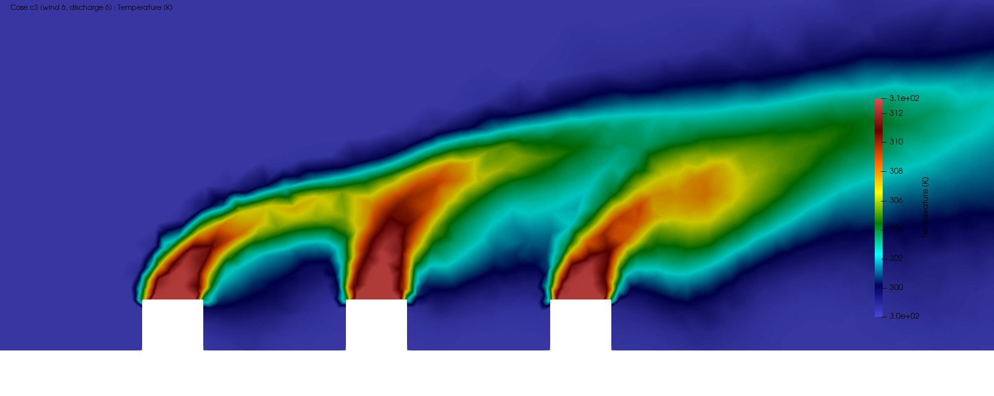
Figure : Temperature on a vertical slice through a tower row, wind-dominated case (wind 6 m/s, discharge 6 m/s). Plumes bend over and warm the downwind wake.
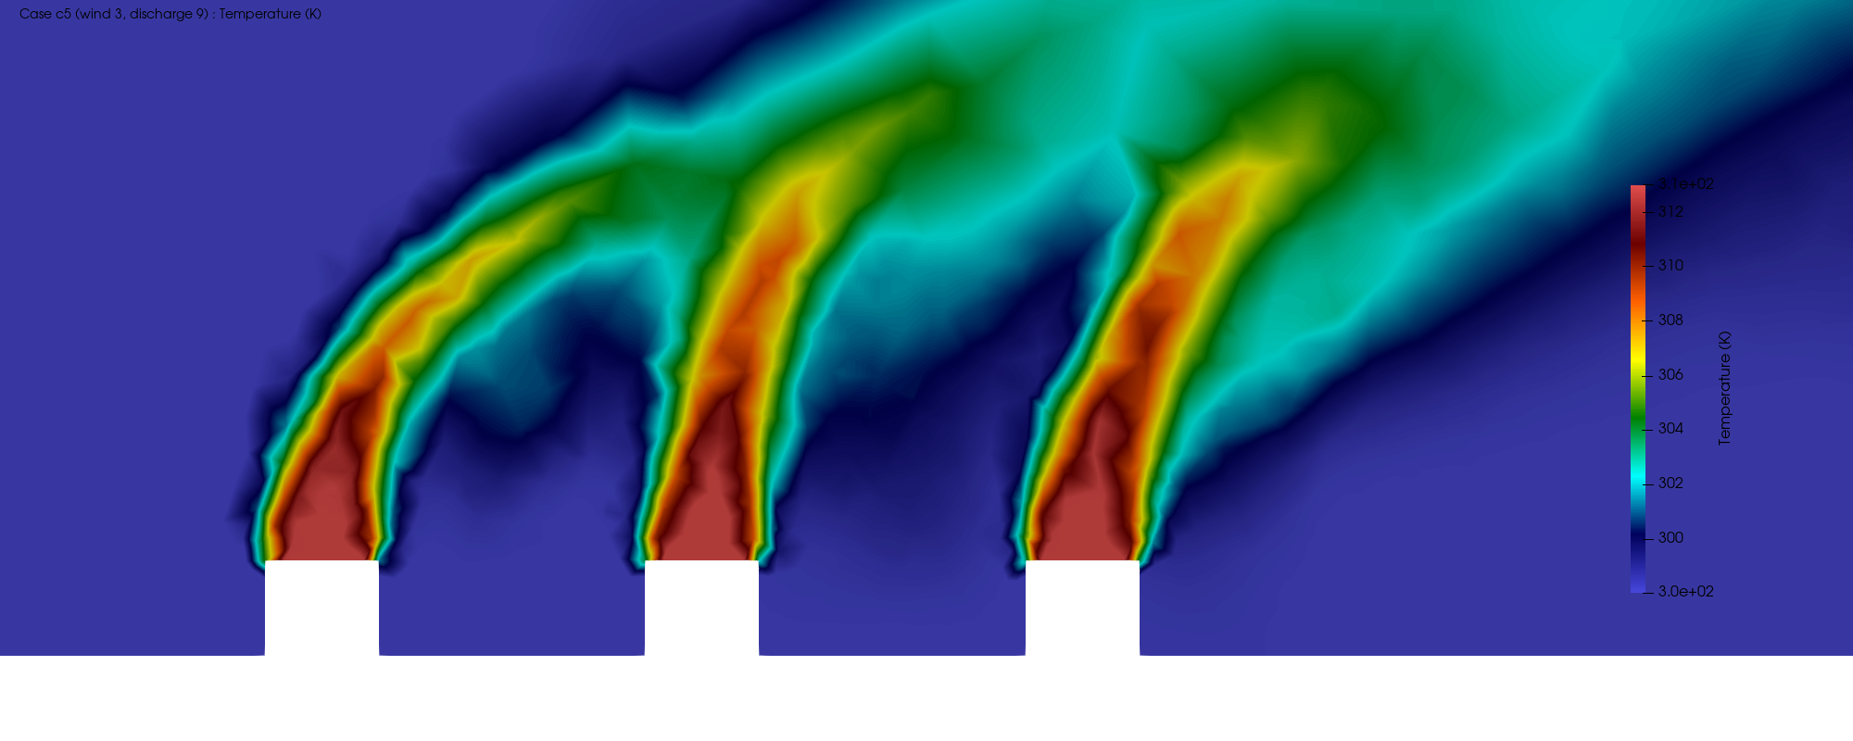
Figure : Temperature on a vertical slice through a tower row, buoyancy-dominated case (wind 3 m/s, discharge 9 m/s). Plumes rise steeply and intakes stay cool.
The velocity field shows the low-speed recirculating wakes that form immediately behind each tower, and the pressure field shows the expected stagnation high on the windward face of the leading tower together with the suction lows in the wakes. The turbulent kinetic energy concentrates in the shear layers at the plume edges, which is where mixing and entrainment are strongest.
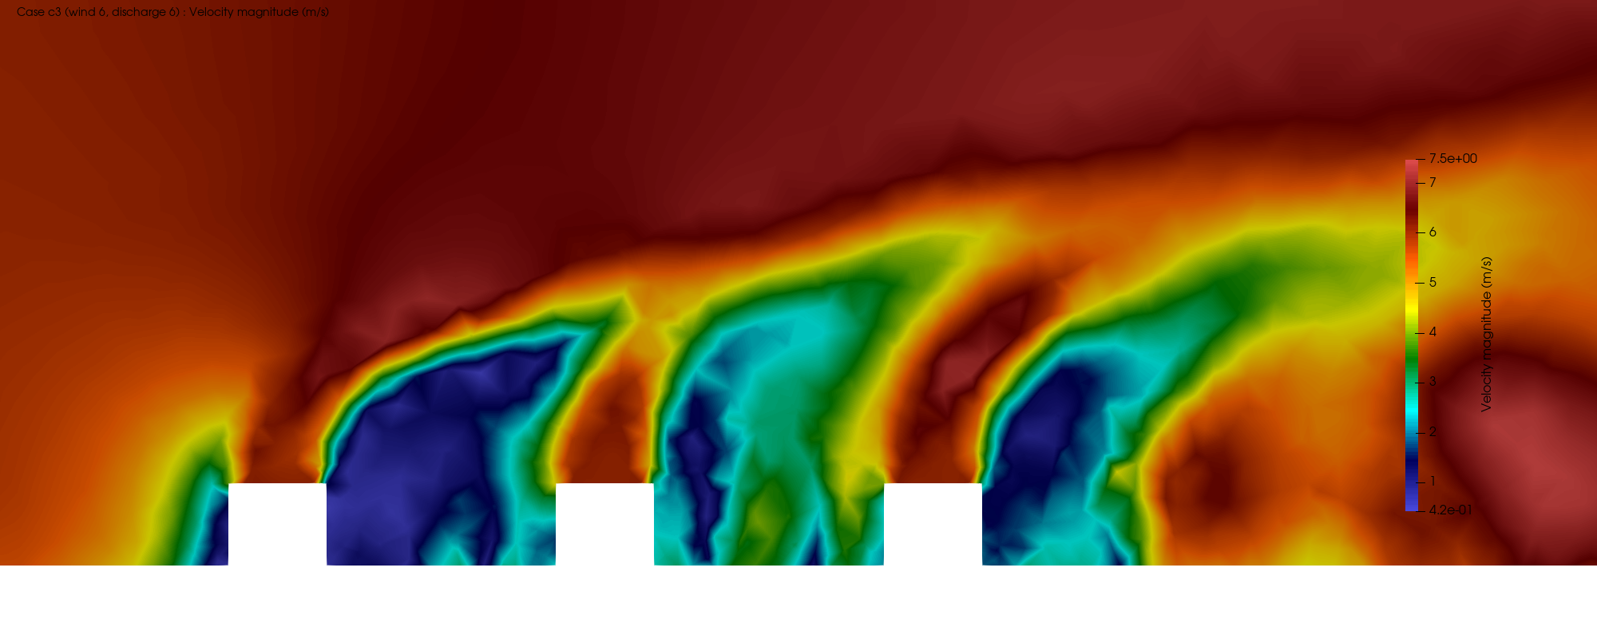
Figure : Velocity magnitude on the vertical slice, wind-dominated case, showing low-speed recirculating wakes behind each tower.
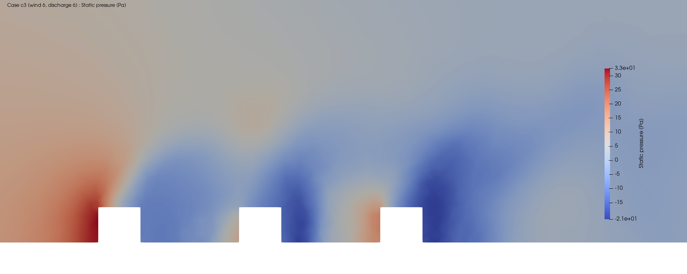
Figure : Static pressure on the vertical slice, wind-dominated case, with windward stagnation and wake suction.
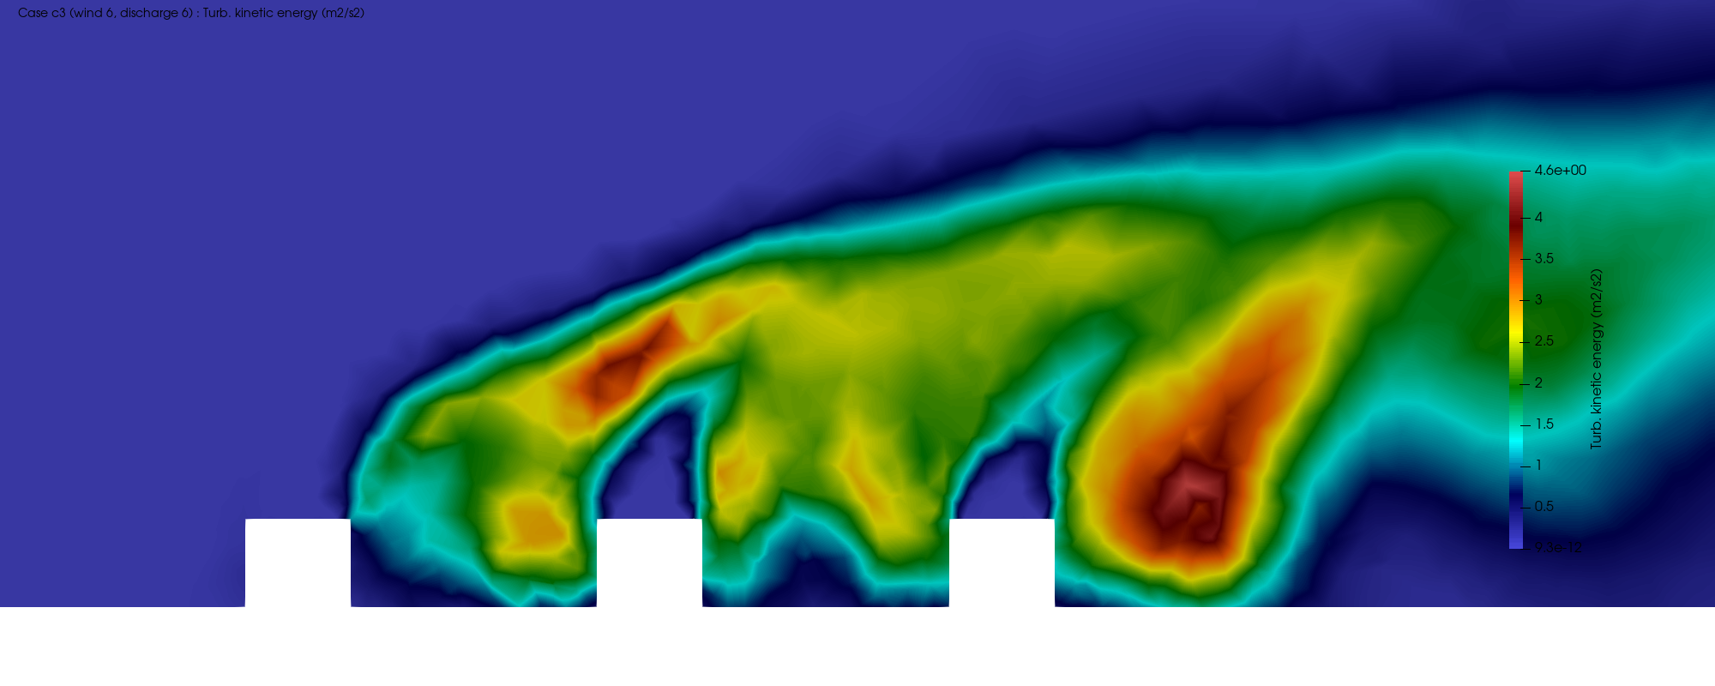
Figure : Turbulent kinetic energy on the vertical slice, concentrated in the plume shear layers.
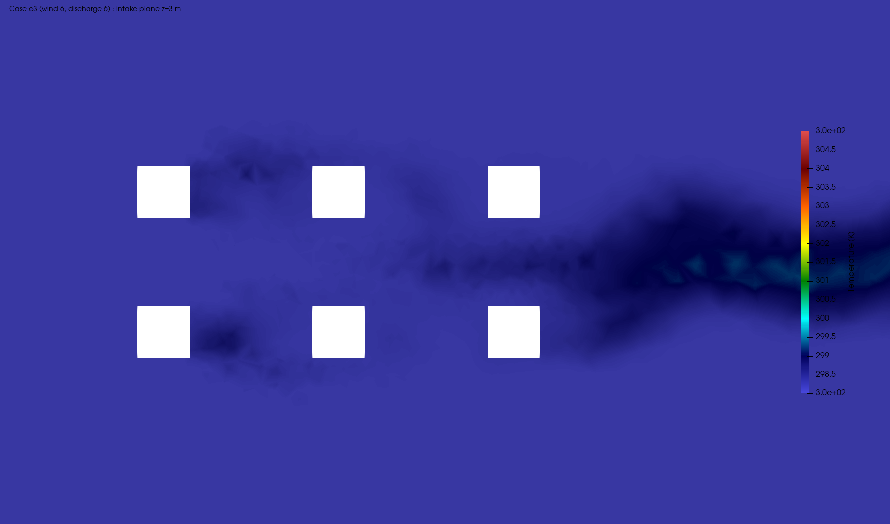
Figure : Temperature on a horizontal plane at intake height (3 m), wind-dominated case, showing the warm wake trailing between and behind the towers.

4.3. Recirculation trends
Collecting the intake temperatures across the sweep gives a clear trend. Recirculation rises as the bend-over ratio falls, that is, as the wind grows strong relative to the plume. The worst case is the wind-dominated point, where the array-mean recirculation reaches 1.22 percent and the worst tower reaches 1.62 percent. The best case is the strong-plume, low-wind point, where the array mean drops to 0.14 percent. The magnitudes are modest because the array is generic and well spaced, but the ordering is unambiguous and physically consistent, and it is the trend, not the absolute value, that a design study cares about.
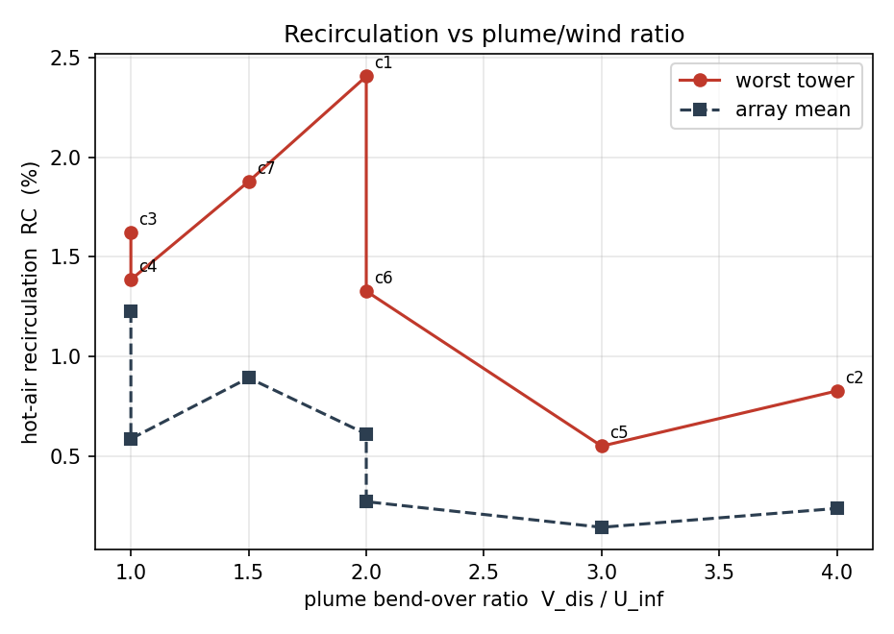
Figure : Array-mean and worst-tower recirculation coefficient against the plume bend-over ratio, discharge velocity over wind speed.
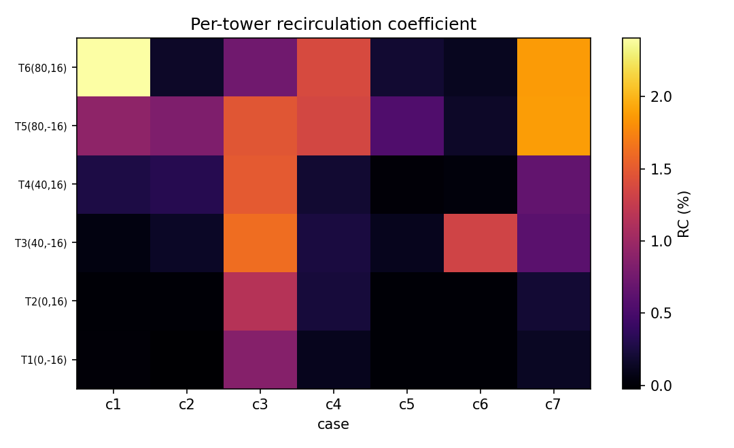
Figure : Per-tower recirculation coefficient across the seven cases.

5. Physics-Informed Surrogate Model

5.1. Formulation and architecture
The surrogate is a compact neural network that maps a position and an operating point to the local flow state, that is, it takes the three spatial coordinates together with the wind speed and the discharge velocity and returns the three velocity components and a normalised temperature. The temperature is normalised so that zero is ambient and one is the discharge condition.
$θ=\frac{T−T_{amb}}{T_{dis}−T_{amb}}$ Eq. 5.2
The spatial coordinates are encoded with Fourier features before entering the network, which lets a small model represent the sharp gradients at the plume edges that a plain coordinate network smears out. The network itself is a short multilayer perceptron with hyperbolic-tangent activations.

5.2. Training and physics loss
Training combines a data term with a physics term. The data term fits the network to cell values sampled from the CFD cases, with the sparse hot plume region oversampled so it is not drowned out by the ambient far field. The physics term penalises the divergence of the predicted velocity field, evaluated at random collocation points and random operating conditions, which pushes the surrogate toward a mass-conserving field rather than a pointwise curve fit and helps it generalise to operating points it has not seen.
L=1Ni​∥q(xi)−qi∥2+λ 1Mj​∇⋅V(xj)2 Eq. 5.1
The divergence is evaluated with a central finite-difference stencil on the network output, which keeps the training free of nested automatic differentiation and therefore fast and stable. The model is trained with Adam for roughly seventeen hundred epochs.

5.3. Generalization results
To test generalisation the network is trained on six of the seven cases and the centre operating point is withheld entirely. On that unseen case the surrogate reconstructs the full temperature field to 1.62 K root-mean-square error, a coefficient of determination of 0.76, and it returns a prediction in milliseconds rather than through a solver run. The velocity field is harder, as expected for a turbulent field learned by a compact model, with a coefficient of determination near 0.35. The parity plot and the training history are shown below, and the headline metrics are collected in Table 2.
Table : Surrogate performance on the held-out centre operating point.
Quantity | Value
Held-out case | c1 (wind 3 m/s, discharge 6 m/s)
Temperature RMSE | 1.62 K
Temperature R^2 | 0.76
Speed RMSE | 0.89 m/s
Speed R^2 | 0.35
Inference time | order of milliseconds per field
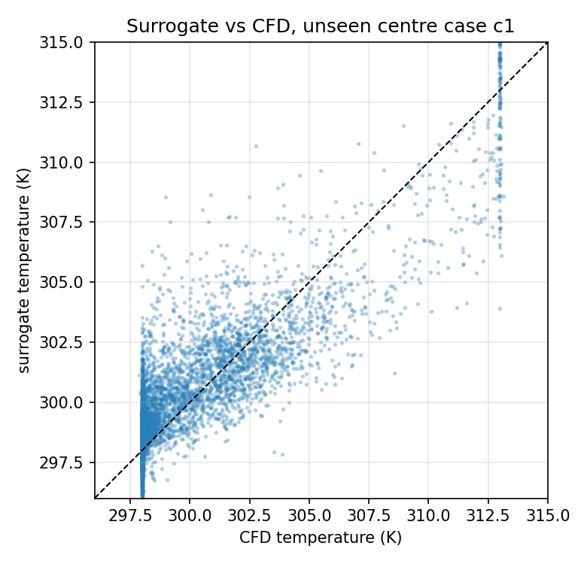
Figure : Surrogate temperature against CFD temperature on the unseen centre case.
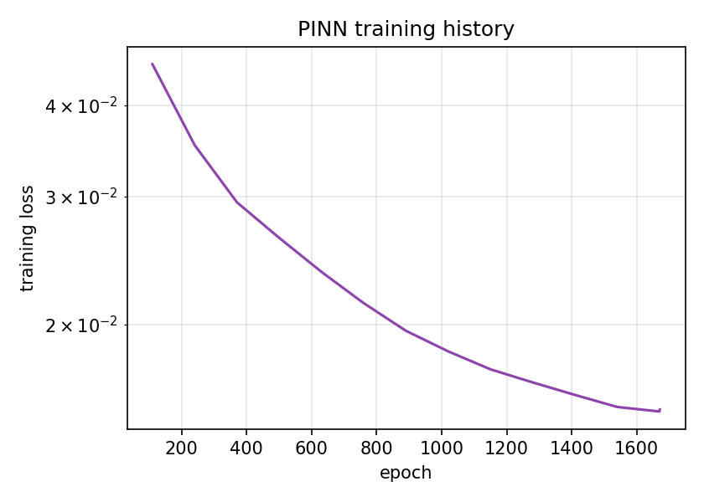
Figure : Training loss history of the physics-informed surrogate.

6. Discussion and Limitations
The study is a demonstrator and its limits should be read plainly. The mesh is coarse and the near-wall resolution is not fine enough to resolve the ground boundary layer, so wall functions carry that region and the reported recirculation magnitudes should be treated as indicative rather than final. Steady RANS cannot capture the unsteady meander of interacting plumes, which is part of why the residuals plateau, so the fields are best understood as time-averaged. On the learning side, a divergence penalty enforces mass conservation but is only part of the governing physics, and a fuller surrogate would add momentum and energy residuals and a turbulence treatment. None of this changes the two conclusions the study is built to support, that recirculation tracks the plume bend-over ratio in the expected way, and that a physics-constrained surrogate can reproduce an unseen operating point’s thermal field quickly and consistently.

7. Conclusions
A generic six-unit cooling-tower array was solved across seven operating points with steady buoyant RANS, and the hot-air recirculation onto the downwind intakes was shown to follow the balance between plume momentum and crosswind. Strong winds acting on weak plumes give the worst recirculation, near 1.6 percent for the worst tower, while strong buoyant plumes in light winds keep the intakes clean below 0.2 percent. A physics-informed surrogate was then trained on the sweep with a mass-conservation constraint, and it reconstructed the temperature field of a withheld operating point to within 1.6 K in milliseconds. Together the two pieces show a complete workflow, from a converged CFD sweep to a fast, physically constrained field model, on a thermal problem representative of data-centre and heat-rejection design.

