**Name: Coco Kariuki, Tommy Westerhold**

**Email:** [**coco.m.kariuki@vanderbilt.edu**](mailto:coco.m.kariuki@vanderbilt.edu)**,** [**thomas.westerhold@vanderbilt.edu**](mailto:thomas.westerhold@vanderbilt.edu)

**Project**

NCAA

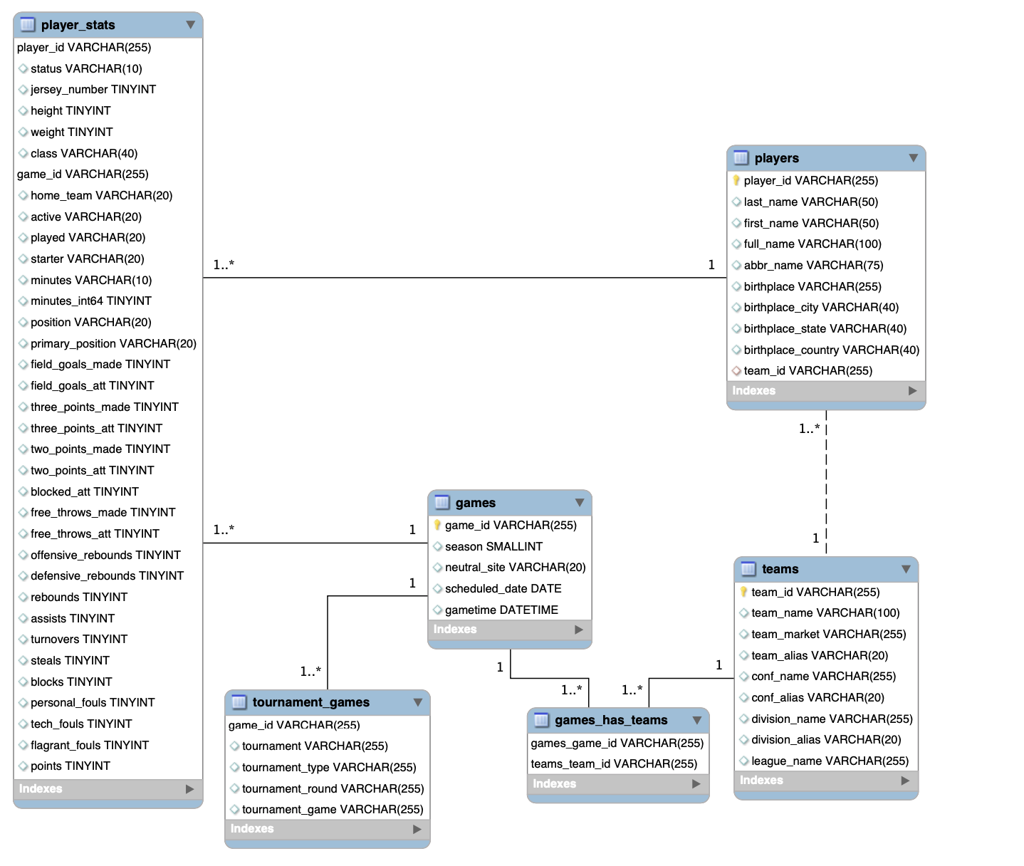

2