**How does deforestation for cropland affect trace gas production at depth in Southeastern Amazonian soils?**

Christine S. O’Connella,b,∗, Michael Coec, Eric Davidsond, KathiJo Jankowskie, Chris Neille, Rodney Ventereaf,g

aUMN, EEB; bUMN, IonE; cWHRC; dUMD; eMBL; fUSDA-ARS; gUMN, SWC

∗coconn@umn.edu

**Abstract**

Abstract!!! Too sleepy to write anything tonight; save for morning.

*Word count: XYZ*

*Keywords:* greenhouse gases, soil profiles, land use change, Amazonia

**Introduction**

*Fill in this part (aim for about 900 words) after gone to bed zzzzzzzzzz*

* Amazonian soils: not much known about dynamics at depth >5 meters, which is a gap because these soils are very deep and have huge stores of C and nutrients/water
* Not only do we not know much about how Amazonian soils operate, we know very little about how deforestation and agricultural impacts on soil propagate down the soil profile
  + Point to soil metaanaylses that usually max out at 20 cm
* What we do know about deep Amazonian soils indicates that they can have tons of productivity and that the deeper side of things has big implications for plant communities
  + Lots of these plants are deep rooted, getting water from far down, and maybe other stuff – this goes against common wisdom, but in eastern Amazon where there’s marked seasonality the “rapid top soil turnover” thing probably isn’t as dominant as in wet Amazonian forests
* They also matter for global biogeochem cycling because these soils are large reservoirs of C and N
* Let’s look at the literature: do a bar graph or table of studies that have looked below 1 meter and summarize what they say about soil biogeochem and if they had a global change implication, what we know about that, too
* There are a lot of gaps in our understanding of deep Amazonian soils. It’s important to figure out some of them because of the plant community implications and because of the landscape level biogeochem implications
* In this study, we focus on how trace gas emissions change down the soil profile and how those emissions differ between forest and agriculture

**Materials and methods**

***Site description***

Sampling was conducted at Tanguro Ranch, a 32,000 hectare industrial farm located in Mato Grosso, Brazil (Figure 1). Tanguro Ranch is surrounded by closed-canopy tropical forest (25m height) typical of southeastern Amazonia, a region of transitional forest between cerrado (tropical savanna) to the east and more diverse, high-statured forests to the northwest. This area of Amazonia is also marked by lower precipitation and higher seasonality than central Amazonia. Mean annual precipitation (MAP) at Tanguro Ranch averaged 1900 mm/year between 1987 and 2007 and ranged from 1500 to 2500 mm yr-1 (Tanguro Ranch, unpublished results). The wet season extends from September to April with a dry season between May and August. Mean annual temperature (MAT) is 27 C, but temperatures vary between forested areas and cropland areas both diurnially and on average over the year. Tanguro Ranch is located on the Brazilian Shield and the underlying parent material is Precambrian gneisses (Projeto Radambrasil, 1981). Upland soils are ustic Oxisols (55% sand, 2% silt, and 43% clay mean texture, Oliviera et al., 1992, Soil Survey Staff, 1999) with high infiltration rates and little lateral water movement in upper soil horizons (depth to water table estimated to be between 20-40m (*1*)). The site features little topographic variation and is generally flat plateaus interspersed with stream channels (Nagy et al., *in press*).

Originally deforested to support a pasture ranch (cleared between 1982-83), Tanguro now primarily plants soybeans, a nitrogen-fixing legume (conversion from pasture to soy between 2003-8). Highly intensively managed, Tanguro’s croplands receive multiple applications per year of fertilizer (phosphorous [P] and potassium [K]; nitrogen [N] on some double-cropped fields), pesticide, herbicide, fungicide and soil additives (lime) to moderate soil pH (Grupo A. Maggi, pers. comm.). The transition from low intensity pasture to intensive, mechanized cropland is representative of the land use trajectories taking place across eastern Amazonia (*2*, *3*). There have been numerous previous projects in this system, all with the logistical cooperation of farm leadership (*1*, *4*, *5*).

***Trace gas measurements***

Four 10m soil pits were permanently installed across Tanguro Ranch. C2, K4 and M8 are located in intact forest, while Mutum (MU) pit is located in the center of a soybean field. We installed 7 brass tubes horizontally into the side of each soil pit at depths of 15, 40, 75, 150, 250, 350 and 450 cm. Tubes were between 50 and 200 cm long in order to ensure that gas samples were drawn from soil pore space beyond the zone affected by the exposed pit wall (based on measured temperature and soil moisture pilot data, P. Lefebvre, personal communication). Each tube was fitted with a swage and septum for gas sampling. One week after installation, we withdrew between 24 and 96 mL of gas (depending on tube length) which we subsequently discarded as a flushing protocol; tubes subsequently equilibrated for at least 48 hours before the first sampling.

At each sampling date, three samples per depth were collected using a 12mL polypropylene syringe (Monoject) that withdrew 12mL of gas which was then injected into a 9mL glass vial (Grace Davidson) that had been pre-sealed with butyl rubber septa (Grace Davidson). Samples 1-3 generally had good agreement (Supplemental Figure 1), but we eliminated samples 1 and 2 in February based on systematic patterns based on vial order for CO2 and CH4. We used un-evacuated vials containing “ambient” (lab) air (*sensu* Venterea 2005 {Venterea:2005hd}). Sets of vials containing ambient air included four replicate vials with ambient air that were later analyzed for concentrations of CO2, N2O and CH4, which were then used to calculate trace concentration without dilution. Un-evacuated vials were preferred over evacuated vials in this study because evacuated vials sitting at ambient pressure for several weeks, as they would have been under field conditions in the absence of a reliable means to evacuate vials on site, have a high risk of inward air leakage.

Gas samples were analyzed by gas chromatography using a headspace autosampler at the University of Minnesota (Teledyne Tekmar, Mason, OH). The autosampler was modified to fill multiple sample loops from each vial. Sample loops fed into a flame ionization detector for CH4, an electron capture detector for N2O and a thermal conductivity detector for CO2. Standard curves and system calibration were done using analytical grade standards (Scott Specialty Gases, Plumsteadville, PA).

***Soil temperature measurements***

Thermocouple sensors were installed at soil pit depths of 15, 40, 75, 150, 250, 350 and 450 cm, also buried into the soil pit wall in order to avoid artifacts associated with the exposed soil pit interior. Temperature was recorded every 6 hours and temperature data the result of the average temperature over a short sensor period (variable, ~20 uS). Data was recorded by dataloggers (Campbell Scientific) and downloaded weekly. Temperature and moisture data are reported as averages over a single week in November, December, January and February. These months were chosen to complement gas samples taken during December, January and February, which were in turn chosen because soils are more dynamic in this system during the wet season. We also report temperature and moisture data for a representative week in November context for soils at depth in the early wet season.

***Soil volumetric water content measurements***

Time domain reflectometry (TDR) soil moisture meters were installed at 0, 30, 50, 100, 200, 300, 400, 500, 600, 700, 800 and 900 cm depths in each soil pit. Data was collected in the same datalogger as was used to record thermocouple data (Campbell Scientific) and was downloaded weekly. Data was calibrated and converted to volumetric water content (VWC).

Due to the limited space along soil pit walls, and the need to keep sensors apart, TDR sensors were not placed at the same depths as thermocouple sensors or gas sample tubes. To have fully comparable datasets, we estimated VWC at 15, 40, 75, 150, 250, 350 and 450 cm depth, using the simple assumption that the VWC at the midpoint between two sensors would be the mean of the two. We report both the measured data and the estimated data in depth figures (e.g, Figure 4), but statistical analyses using VWC as a predictor variable use the estimated, depth-matched VWC data.

**Results**

***Temperature and moisture results***

In two forest soil pits (K4 and M8), soil temperature at depth follows a consistent pattern, increasing between 15cm and 1m depth, before remaining steady at lower depths (Figure 3). Forest pit C2 also has higher temperatures at depth, but the increase continues after 1m depth and the temperature pattern is more variable, decreasing at 45cm (equipment error?), increasing at 75cm depth, before decreasing at 1.5m, after which temperatures continue to rise down the soil column. Mutum pit (soybean) has soil temperatures that have larger standard error values at each depth – the forest pits, by contrast, have variable surface soil temperatures, but relatively small standard errors for deeper temperatures. Further, Mutum’s soil temperatures are significantly warmer than the soil temperatures in other pits (p < 0.001, Table 1), and are similar across sampling month and depth, remaining between 25.5 and 27.5 °C, higher than all but 3 weekly average temperatures in any of the forest pit sites or depths. None of the four months considered (November-February) lead to distinct soil temperature patterns; month is not a significant predictor of temperature (Table 1).

Month is a significant predictor of VWC (p <0.001, Table 2, Figure 4), with pits C2, K4 and M8 having higher VWC values when sampled later in the wet season (which begins in approximately October and continues past February). The lone exception is that C2’s moisture values are larger during December 2013 than January 2015, which could be explained via inter-annual variation, though January 2015 moisture values are larger than December 2013 in pit K4. As with temperature, K4 and M8 pits are distinct from C2, which has generally higher VWC values (Table 2). Depth in all three cases is positively related to VWC (P<0.001). Mutum, in contrast to the forest pits, shows a pronounced decrease in in VWC from 15cm to 40cm and VWC remains low through 75cm depth, after which there is a positive relationship between VWC and depth.

***Trace gas concentrations***

Nitrous oxide concentrations fall at depth (p<0.01, Table 3), in some cases dramatically (e.g., January 2015, Figure 2) and in other cases concentrations fall at lower depths and stabilize after 1.5m (e.g., M8, Figure 2). Because of large drops in N2O in from shallow to deeper soil, the model points to an overall negative effect of depth on N2O, but there are several exceptions to this pattern: in February sampling, N2O rises at depth in pits C2 (forest) and Mutum (soy), while K4 sampling in December and February shows a slight increase with depth. Standing ppm values are routinely well above ambient values (~0.32 ppm {Blasing:2009bj}), indicating slow diffusion within the soil column. Neither VWC nor temperature are significant predictors of N2O (Table 3), even in models where Month is not used as a predictor variable.

These are super fun and awesome to think about. The patterns for the results sections are:

* Regression table (table 3): month and VWC are significant, but our R2 isn’t that high (0.417).
* CO2 – ppm values are crazy high – not surprising, but pretty cool to see. Lots of respiration going on, moreso in the wetter month. Can be seen in the regression table where VWC and month both come out as significant predictors (table 4, R2 = 0.661).
* CO2 – the pattern of whether soil resp goes up or down as you get deeper is pretty variable between pits – goes down in M8, goes up in the others. That said, M8 is only dropping to the same CO2 ppm as the other pits, so maybe it just had a particularly elevated top 1m of soil that week.
* Methane is pretty fascinating because sample depth comes out as the best explainer in the model (Table 5, I didn’t include the AIC info), the model only explains 33% of the variation.
* CH4 – the months don’t vary much, which is interesting.
* CH4 drops with depth (except M8, which is doing its own thing).
* CH4 – these standing ppm values are too high, which Eric pointed out, so I need to go back and make sure that these samples’ data got processed appropriately.

**Discussion**

***Nitrogen dynamics***

Mutum samples all decrease in N2O concentrations from 15cm to 75cm, perhaps indicating that in that area plants are competing well for available N, or that there isn’t as much N available in the immediate half meter below the surface soil. Rising N2O concentrations below the rooting zone could mean that leaching is moving available N beyond the reach of plants at that a larger proportion of N is being nitrified or denitrified.

Text here.

***Carbon dynamics***

Text here.

***Diffusion effects***

Any subsections

***Land use impacts and potential implications***

Any subsections

***Further research***

Inter-annual variability. Write.

Nutrient availability. Write.

Rooting depths. Write.

Microbial metabolism. Write.

**Figures:**

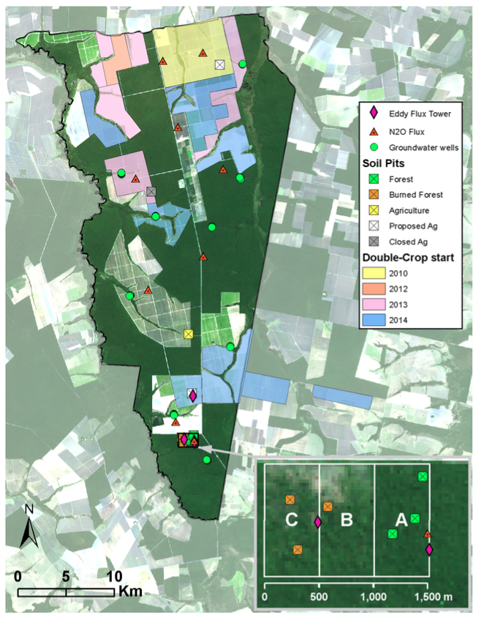

**Figure 1.** Map of study site Tanguro Ranch (courtesy Paul Leferve). Dark areas are forested parcels; light areas are agricultural fields. Soil pits (squares) sampled in this investigation include the southern three forest pits (green squares within forest block “A” in inset) and an agricultural forest pit (yellow square) in the southern half of the farm. Color overlay indicates what year soy/maize double cropping began, where applicable.

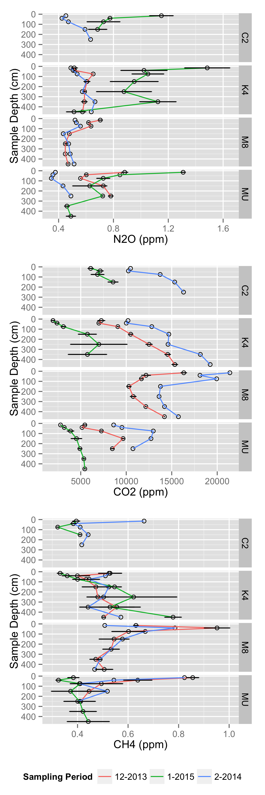

**Figure 2.** Standing presence (ppm) of trace gases in soil pore space in soil pits at Tanguro Ranch. Sampling was conducted in December 2013 and February 2014. C2, K4 and M8 are located within intact forest, while MU is located within cultivated soybean. Error bars represent the standard error.

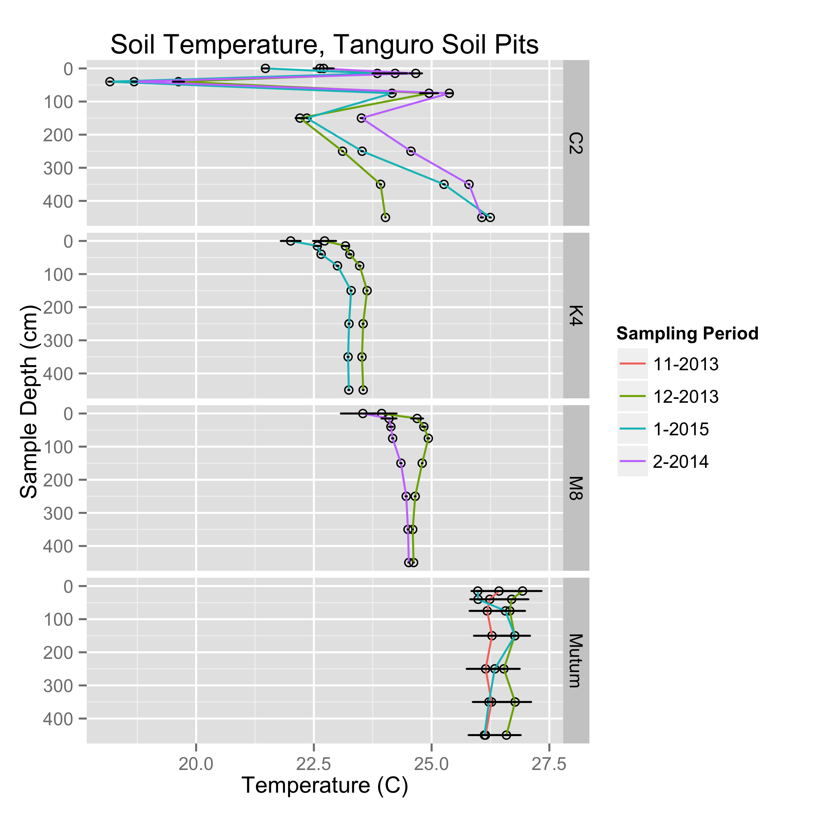

**Figure 3.** Soil temperature (C) in soil pits at Tanguro Ranch. Data is the mean and standard error of a week of thermocouple readings (taken every 6 hours) for the sampling months and a representative week earlier in the wet season (November) and later in the wet season (February) than when gas samples were collected.

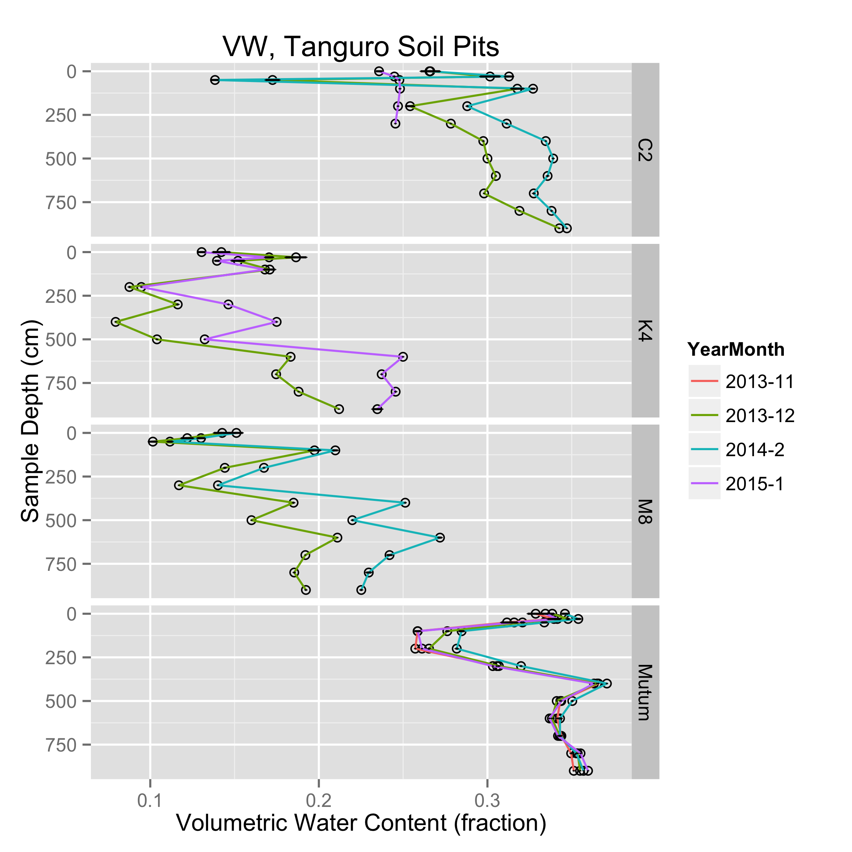

**Figure 4.** Soil volumetric water content (fraction) in soil pits at Tanguro Ranch. Data is the mean and standard error of a week of TDR readings (taken every 6 hours) for the sampling months and a representative week earlier in the wet season (November) and later in the wet season (February) than when gas samples were collected.

|  |  |  |  |  |
| --- | --- | --- | --- | --- |
|  | Estimate | Std. Error | t value | Pr(>|t|) |
| (Intercept) | 22.99158857 | 0.342607556 | 67.1076517 | < 0.001** |
| PitIDK4 | -0.124926073 | 0.404484936 | -0.3088522 | 0.758 |
| PitIDM8 | 0.894940007 | 0.39996541 | 2.2375435 | 0.028* |
| PitIDMutum | 3.172768309 | 0.420204216 | 7.550539 | < 0.001** |
| MonthFeb | 0.172198935 | 0.39996541 | 0.4305346 | 0.668 |
| MonthJan | -0.376660572 | 0.341091648 | -1.1042797 | 0.273 |
| MonthNov | -0.441827998 | 0.574487317 | -0.7690822 | 0.444 |
| sampledepth | 0.002732436 | 0.000866944 | 3.1518041 | < 0.01* |
| *Model: meanTemperature ~ PitID + Month + sampledepth*  *Multiple R-squared: 0.6112*  *F-statistic: 15.49 on 7 and 69 DF, p-value: 5.1e-12* | | | | |

**Table 1.** Regression table with mean temperature as the response variable and pit, month and depth as the predictor variables.

|  |  |  |  |  |
| --- | --- | --- | --- | --- |
|  | Estimate | Std. Error | t value | Pr(>|t|) |
| (Intercept) | 2.50E-01 | 6.01E-03 | 41.59680003 | < 0.001** |
| PitIDK4 | -1.18E-01 | 7.33E-03 | -16.0901418 | < 0.001** |
| PitIDM8 | -1.18E-01 | 7.14E-03 | -16.54334816 | < 0.001** |
| PitIDMutum | 4.27E-02 | 6.30E-03 | 6.775752323 | < 0.001** |
| MonthFeb | 2.08E-02 | 5.93E-03 | 3.50306348 | < 0.001** |
| MonthJan | 1.77E-05 | 6.14E-03 | 0.002878346 | 0.998 |
| MonthNov | -1.72E-04 | 9.23E-03 | -0.018660816 | 0.985 |
| sampledepth | 7.38E-05 | 8.48E-06 | 8.704220879 | < 0.001** |
| *Model: meanVWC ~ PitID + Month + sampledepth*  *Multiple R-squared: 0.8459*  *F-statistic: 152.9 on 7 and 195 DF, p-value: < 2.2e-16* | | | | |

**Table 2.** Regression table with mean VWC as the response variable and pit, month and depth as the predictor variables.

|  |  |  |  |  |
| --- | --- | --- | --- | --- |
|  | Estimate | Std. Error | t value | Pr(>|t|) |
| (Intercept) | 0.679790894 | 0.381337002 | 1.7826513 | 0.082 |
| meandegC | 0.006453654 | 0.017497908 | 0.3688243 | 0.714 |
| meanVW | -0.405730261 | 0.421060028 | -0.9635924 | 0.341 |
| Month.L | -0.201082049 | 0.045564176 | -4.4131611 | < 0.001*** |
| Month.Q | 0.186803752 | 0.048392842 | 3.8601525 | < 0.001*** |
| sampledepth | -0.000601249 | 0.000189835 | -3.1672234 | < 0.01** |
| lm(formula = meanN2Oppm ~ meandegC + meanVW + Month + sampledepth)  Multiple R-squared: 0.5113  F-statistic: 8.997 on 5 and 43 DF, p-value: 6.563e-06 | | | | |

**Table 3.** Regression table with ppm N2O as the response variable.

|  |  |  |  |  |
| --- | --- | --- | --- | --- |
|  | Estimate | Std. Error | t value | Pr(>|t|) |
| (Intercept) | 9665.0312 | 5428.7118 | 1.7803545 | 0.082 |
| meandegC | 203.3517 | 242.4184 | 0.8388461 | 0.406 |
| meanVW | -21383.7003 | 5714.0943 | -3.7422729 | < 0.001*** |
| Month.L | 3041.2511 | 660.5559 | 4.6040783 | < 0.001*** |
| Month.Q | -6101.0967 | 697.3367 | -8.7491402 | < 0.001*** |
| lm(formula = meanCO2ppm ~ meandegC + meanVW + Month)  Multiple R-squared: 0.7562  F-statistic: 33.34 on 4 and 43 DF, p-value: 1.144e-12 | | | | |

**Table 4.** Regression table with ppm CO2 as the response variable.

|  |  |  |  |  |
| --- | --- | --- | --- | --- |
|  | Estimate | Std. Error | t value | Pr(>|t|) |
| (Intercept) | 0.121531505 | 0.271265849 | 0.4480162 | 0.656 |
| meandegC | 0.021905682 | 0.012447219 | 1.7598857 | 0.086 |
| meanVW | -0.639102178 | 0.299523008 | -2.1337332 | 0.039* |
| Month.L | 0.049801542 | 0.032412289 | 1.5365019 | 0.132 |
| Month.Q | -0.035618331 | 0.034424473 | -1.0346805 | 0.307 |
| sampledepth | -0.000116009 | 0.00013504 | -0.8590712 | 0.395 |
| lm(formula = meanCH4ppm ~ meandegC + meanVW + Month + sampledepth)  Multiple R-squared: 0.2389  F-statistic: 2.7 on 5 and 43 DF, p-value: 0.03297 | | | | |

**Table 5.** Regression table with ppm CH4 as the response variable.

**References and Notes:**

1. S. J. HAYHOE *et al.*, Conversion to soy on the Amazonian agricultural frontier increases streamflow without affecting stormflow dynamics, *Global Change Biol* **17**, 1821–1833 (2011).

2. M. N. Macedo *et al.*, Decoupling of deforestation and soy production in the southern Amazon during the late 2000s, *Proceedings of the National Academy of Sciences* **109**, 20120171–20120171 (2012).

3. R. DeFries, M. Herold, L. Verchot, M. N. Macedo, Y. Shimabukuro, Export-oriented deforestation in Mato Grosso: harbinger or exception for other tropical forests? *Philosophical Transactions of the Royal Society B: Biological Sciences* **368**, 20120173–20120173 (2013).

4. J. K. Balch *et al.*, Negative fire feedback in a transitional forest of southeastern Amazonia, *Global Change Biol* **14**, 2276–2287 (2008).

5. P. M. Brando *et al.*, Abrupt increases in Amazonian tree mortality due to drought-fire interactions, *Proceedings of the National Academy of Sciences* **111**, 6347–6352 (2014).

**Acknowledgements**

FIELD TEAM!!!!! IPAM TEAM!!!!! We thank M. Dolan, P. Brando and P. Leferve (**Paul should be author when we write this up?**) for technical support and assistance with figure creation. We are grateful to M. Macedo, S. Hobbie, J. Finlay, and (**who else?**) for helpful conversations. Funding was provided by a National Science Foundation Graduate Research Fellowship and a University of Minnesota Graduate Student Fellowship to C.S.O., and grants from the National Science Foundation and the Gordon and Betty Moore Foundation. Stakeholder outreach and public engagement support was provided by the University of Minnesota Institute on the Environment, and contributions by General Mills, Mosaic, Cargill, Pentair, Google, Kellogg’s, Mars, and PepsiCo. Funders had no role in study design, data collection and analysis, decision to publish, or preparation of the manuscript.

**Supplemental Figures:**

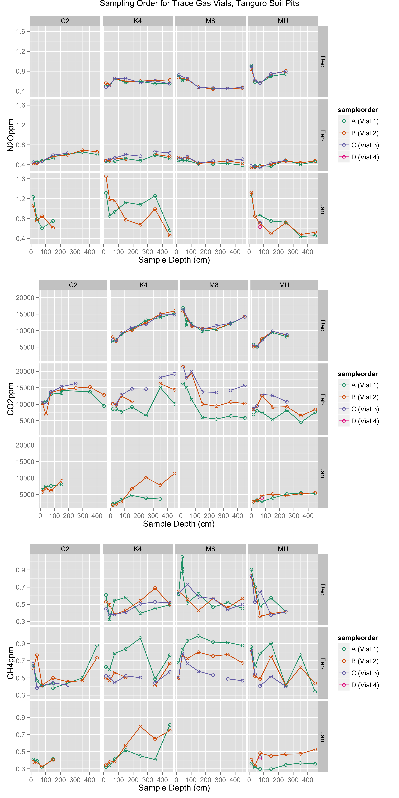

**Supplemental Figure S1.** Standing presence (ppm) of trace gases in soil pore space in soil pits at Tanguro Ranch. Colors indicate the order in which the vial was sampled (approximately 1 minute gap between samples), used to assess whether samples were in good agreement.