**Observed biogeochemical impacts of severe drought in a topographically-diverse wet tropical forest**

**Authors:** Christine S. O’Connell1,2*, Kimberly M. Carlson1, Santiago Cuadra3, Kenneth J. Feeley4,5, Paul C. West1, Jonathan A. Foley1,2, Stephen Polasky1,2,6

**Affiliations:**

1Institute on the Environment, University of Minnesota, Saint Paul, Minnesota, 55108 USA

2Department of Ecology, Evolution & Behavior, University of Minnesota, Saint Paul, Minnesota, 55108 USA

3Brazilian Agricultural Research Corporation - Embrapa, National Temperate Agriculture Research Center, Pelotas, RS 96010-971, Brazil

4Department of Biological Sciences, Florida International University, Miami, Florida 33199 USA

5Fairchild Tropical Botanic Garden, Coral Gables, Florida 33156 USA

6Department of Applied Economics, University of Minnesota, Saint Paul, Minnesota, 55108 USA

*Correspondence to: coconn@umn.edu

**Abstract**

As the planet’s dominant land use, agriculture often competes with the preservation of natural systems that provide globally and regionally important ecosystem services,.

**Keywords**

Conservation | Amazonia | Land use | Ecosystem services

**Introduction**

**Methods Summary**

***Field location information***.

***Experimental design***.

***Moisture, oxygen and rainfall measurements***.

***Gas flux measurements***.

***Soil variable sampling and processing***.

***Statistical analyses***.

***Study Plan For*:** **Belowground responses to an observed drought across a topographic gradient in a wet tropical forest**

September 16, 2015

*Sections included here:*

* Introduction
* Hypotheses/justification
* Study plan brief approach
* Methods details
* Significance and desired outcomes

*What else is Christine supposed to deliver? a.k.a. forthcoming things:*

* This is a rough, rough, rough draft of this study plan… nearly everything needs to be altered/amended

Christine S. O’Connell

University of California-Berkeley

Silver Lab

Dept. of ESPM

**Belowground responses to an observed drought across a topographic gradient in a wet tropical forest**

*Keywords: global change, oxygen availability, soil moisture, nutrient cycling, ecosystem thresholds*

**Introduction:**

Humans are altering climatic trends on a global scale. However, considerable uncertainty surrounds the effects of future precipitation changes on tropical forests1. Climate models generally agree that global warming is likely to decrease rainfall and increase drought events across the tropics2. In wet tropical forests, where plant species3 and soil microbial communities

4 are less likely to have adapted to combat drought stress, such droughts have the potential to drastically shift belowground nutrient cycling.

Drought mediates changes to the tropical terrestrial carbon (C), nitrogen (N) and phosphorus (P) and other nutrient cycles in several ways. First, droughts reduce soil moisture and increase soil oxygen, thus altering reduction-oxidation (redox) chemical conditions. These effects may change the rates at which soil microbes decompose organic C5,6 and produce CO2, methane (CH4) and nitrous oxide (N2O), three important greenhouse gases7,8. Changes to decomposition and so-called trace gas production may lead to a net change in soil C7, though both the direction and magnitude of this effect are not well quantified1. Changes to decomposition and to the redox dynamics of soil can also affect the availability of N, P and key exchangeable cations (calcium (Ca2+), magnesium (Mg2+), sodium (Na+) and potassium (K+)), though the direction of these patterns remains poorly understood and the driving mechanisms for post-drought changes in nutrient cycling likely vary widely by site. Shifting redox conditions9 can change the amount of available P and altered microbial activity10 can change the amount of available N, with implications for plant productivity and vegetative C storage1,11. In combination, droughts have the potential to substantially alter belowground nutrient dynamics in wet tropical forests.

In this study, we take advantage of high-resolution, temporal datasets that document the changing belowground context before, during, and after an observed drought in Luquillo Experimental Forest (LEF), Puerto Rico. The effect of drought on soil oxygen, moisture, and nutrient cycling like varies with small-scale topographic and edaphic variation. *Here, we document the changes to soil abiotic conditions and nutrient availability across a topographic gradient and observe non-linear, threshold responses to initial drought impacts and, potentially, recovery*.

**Study plan approach/hypotheses:**

I will conduct this research under the mentorship of Professor Whendee Silver (UC Berkeley), who has decades of experience researching the dynamics of wet tropical forests at the LEF and in Puerto Rico. LEF has heavy year-round precipitation (mean annual rainfall of 3500 mm/year10) but rainfall will likely decline in the future2.

The proposed study takes advantage of an established array of soil moisture and oxygen sensors across a ridge-to-valley slope in LEF and complements that high-resolution dataset with targeted soil sampling to measure changes to nutrient cycling.

We address two core questions:

Question 1: How do soil oxygen and moisture patterns change after drought across a topographic gradient?

*Hypothesis:*

(1.1) The observed drought will lead to threshold effects (e.g., non-linearities in soil moisture and O2 responses) from ridge to valley, with valley and low-slope soils having lower soil O2 availability than mid-slope and ridge soils.

Question 2: How do post-drought soil oxygen and moisture patterns alter soil nutrient pools across a topographic gradient?

*Hypotheses:*

(2.1) C will be affected like AAA.

(2.2) N will be affected like AAA.

(2.3) P will be affected like AAA.

(2.4) Fe? pH? What else?

To address these questions, we will record soil moisture and O2 at 35 locations in LEF (Figure 1). The sampling array has five transects associated with topographic locations: ridge, upper slope, mid slope, low slope, and valley transects. Each transect has 7 sensor locations (5 transects * 7 locations/transect = 35 observations). Each sensor location is, more precisely, the location of two sensors, one to record soil moisture and a second to record soil O2. Data is recorded hourly.

Additionally, we will conduct soil sampling along the ridge, mid-slope and valley transects periodically. The following things will be measured on those collected soils: A, B, C, D, and E. We collected soils before the drought (?), after the drought began (began in mid-April, 2015), longer after the drought was continuing, and after drought recovery.

This is the sketchy first-pass. Fill in much more methodological detail as you improve this document. Create a “methods” section.

This approach allows us to track the abiotic implications of drought at a high temporal frequency from beginning of drought through to the end, a rare opportunity to observe the immediate, medium-term and longer-term impacts of drought on soil moisture and O2, addressing Question 1, above. The periodic soil sampling will allow us to track changes to several nutrients of interest over the study period and draw correlative relationships between drought stage, topographic position and nutrient dynamics, addressing Question 2, above.

**Methods:**

Christine still needs to write this.

**Significance and desired outcomes:**

*Significance*: One of the major uncertainties in predicting future climate is how terrestrial nutrient cycles will be modified by climate changes12-14. Tropical forests in particular contain globally important C stocks12-14, including large vegetative biomass15 and soil organic carbon pools16. Decreases to either could lead to increases in atmospheric carbon dioxide (CO2) concentrations and associated climate impacts13 while alterations to N and P availability could have wide-reaching effects on terrestrial productivity. This study documents the below-ground effects of an observed drought on the abiotic consequences of drought in a wet tropical forest and how nutrient availability responds to those changes.

*Desired outcomes*: I see two key outcomes coming from this project. First, I will aim to efficiently and rapidly “get a handle on” the field context in PR during my initial months at Cal. Second, I expect that a manuscript will be written based on this project, which I initially anticipate could be aimed at a mid-tier soils or global change journal.

*Broader impacts*: I would like to write up a lesson plan for an 8th grade classroom on the “ecology of drought” that compares the California drought to a drought in a tropical forest. I will work with a friend (Tom McFadden) who teaches at San Mateo’s Nueva School to target the lesson appropriately and come visit his classroom when it works for his class schedule.

**Figures**

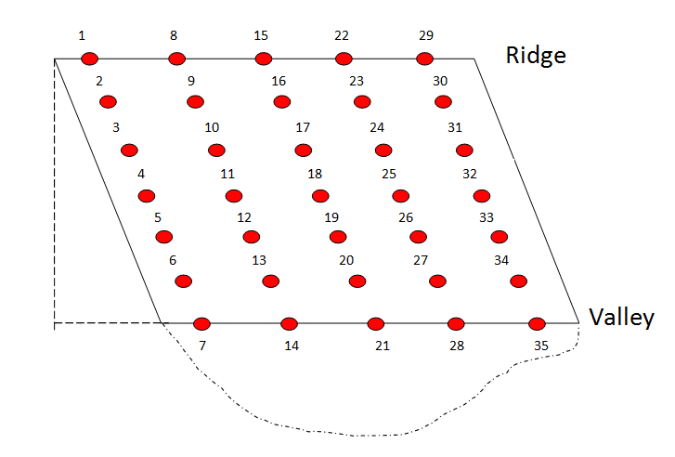

**Figure 1**. Soil moisture and O2 sensor locations across a topographic gradient in LEF. The sampling array has five transects associated with topographic locations: ridge, upper slope, mid slope, low slope, and valley transects (transects go left to right in the schematic here). Each transect has 7 site locations (5 transects * 7 locations/transect = 35 observations). Each site location is, more precisely, the location of two sensors, one to record soil moisture and a second to record soil O2. Data is recorded hourly.

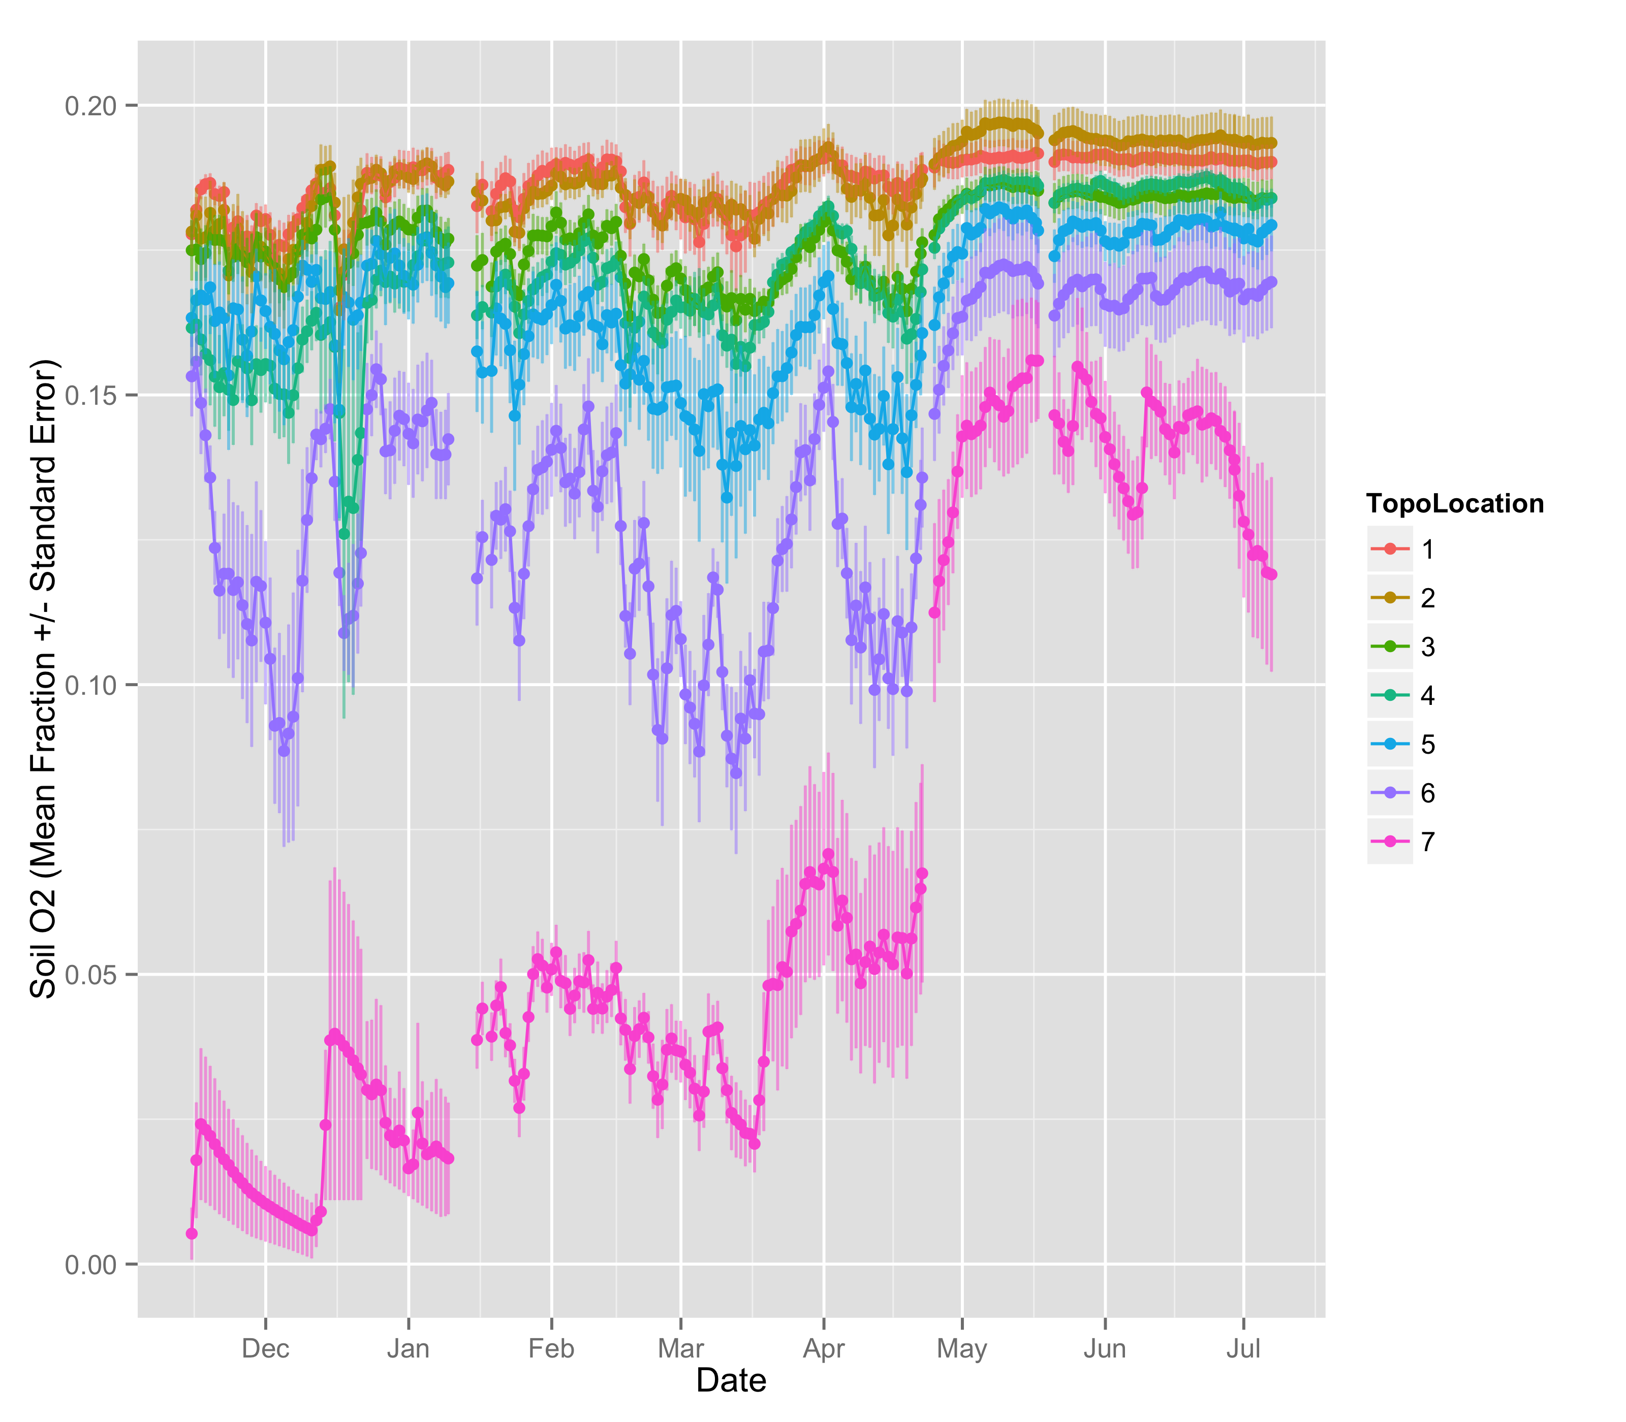

**Figure 2**. Initial data collection tracking soil O2 from pre-drought through the onset of drought (mid-April). Clear topographic patterns have emerged in how rapidly oxygen availability increases in some sites over others after drought conditions begin. Variability also differs across topography, with the valley sensors seeing larger standard error values.

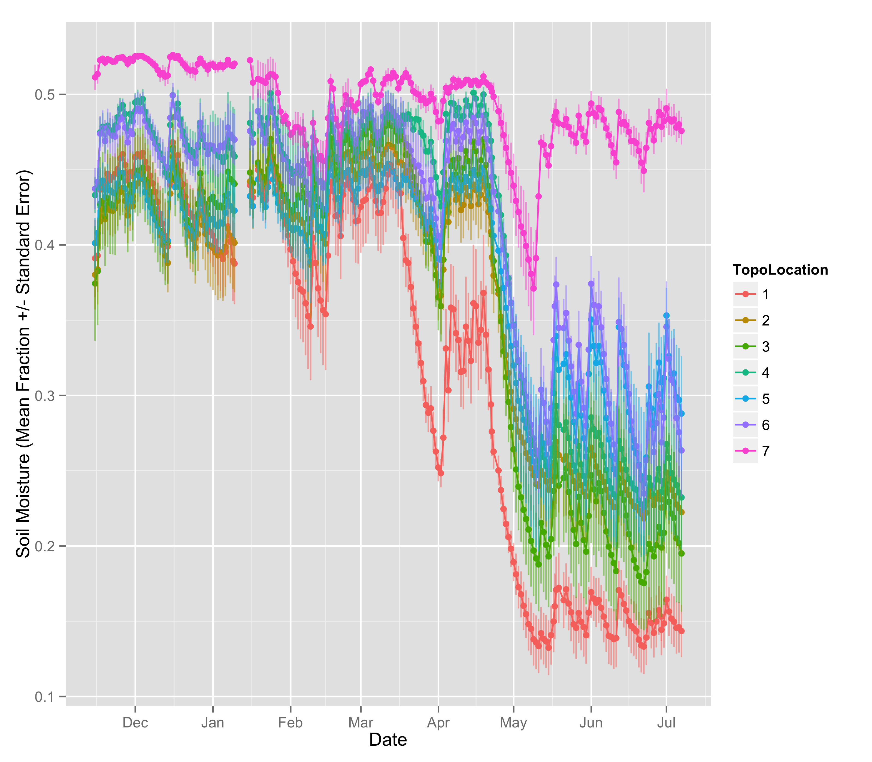

**Figure 3**. Initial data collection tracking soil moisture from pre-drought through the onset of drought (mid-April). Valley sites lose moisture less so than slope or ridge sites.

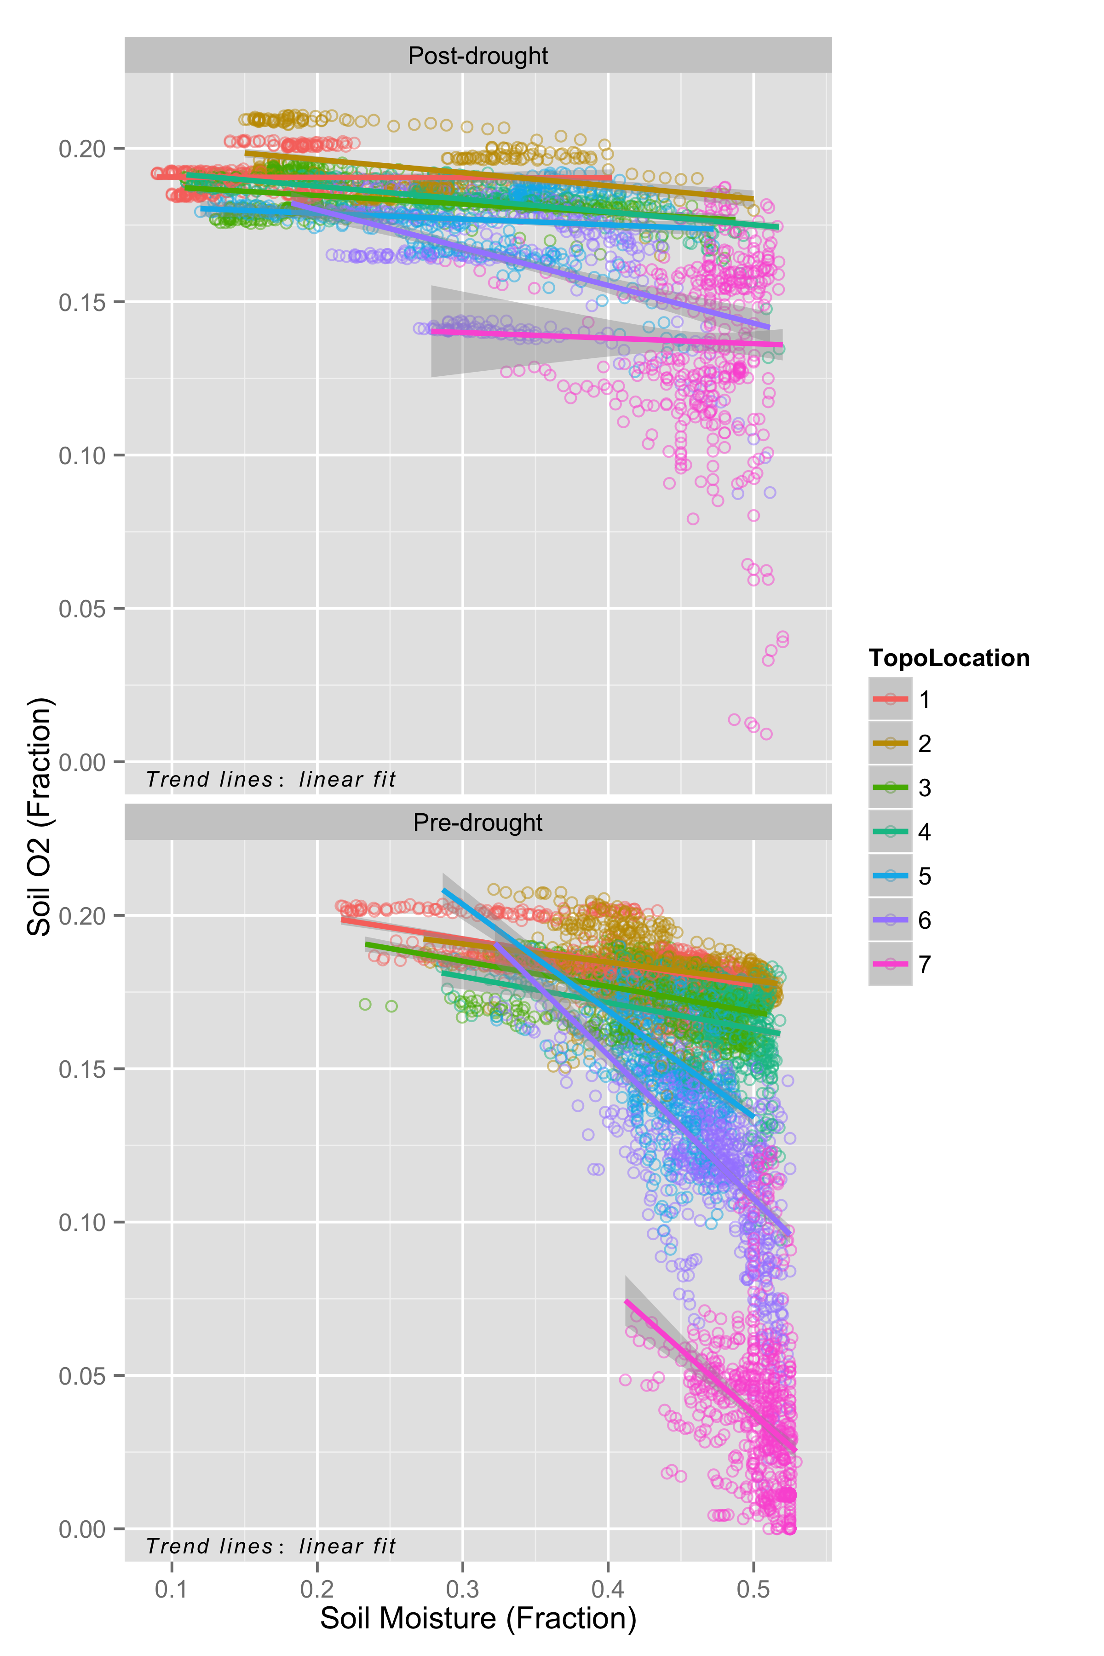

**Figure 4**. Write a better caption. This is just for Christine to check out how the O2-moisture relationship changes across the topo grandient and pre- and post-drought. Weird that the valley’s relationship between soil O2 and moisture flattens post-drought. ???

**Works Cited**

1. Chambers, J., Fisher, R., Hall, J., Norby, R. J. & Wofsy, S. C. Research Priorities for Tropical Ecosystems Under Climate Change Workshop. (2012).

2. Neelin, J. D., Münnich, M., Su, H., Meyerson, J. E. & Holloway, C. E. Tropical drying trends in global warming models and observations. *Proceedings of the National Academy of Sciences* **103,** 6110–6115 (2006).

3. Phillips, O. L. *et al.* Drought sensitivity of the Amazon rainforest. *Science* **323,** 1344–1347 (2009).

4. Bouskill, N. J. *et al.* Pre-exposure to drought increases the resistance of tropical forest soil bacterial communitiesto extended drought. *The ISME Journal* **7,** 384–394 (2012).

5. Hall, S. J. & Silver, W. L. Iron oxidation stimulates organic matter decomposition in humid tropical forest soils. *Global Change Biol* **19,** 2804–2813 (2013).

6. Hall, S. J., McDowell, W. H. & Silver, W. L. When Wet Gets Wetter: Decoupling of Moisture, Redox Biogeochemistry, and Greenhouse Gas Fluxes in a Humid Tropical Forest Soil. *Ecosystems* **16,** 576–589 (2012).

7. Wood, T. E., Cavaleri, M. A. & Reed, S. C. Tropical forest carbon balance in a warmer world: a critical review spanning microbial- to ecosystem-scale processes. *Biological Reviews* **87,** 912–927 (2012).

8. Davidson, E. A., NEPSTAD, D. C., Ishida, F. Y. & BRANDO, P. M. Effects of an experimental drought and recovery on soil emissions of carbon dioxide, methane, nitrous oxide, and nitric oxide in a moist tropical forest. *Global Change Biol* (2008). doi:10.1111/j.1365-2486.2008.01694.x

9. Liptzin, D. & Silver, W. L. Soil Biology & Biochemistry. *Soil Biology and Biochemistry* **41,** 1696–1702 (2009).

10. Wood, T. E. & Silver, W. L. Strong spatial variability in trace gasdynamics following experimental drought in a humid tropical forest. *Global Biogeochem. Cycles* **26,** n/a–n/a (2012).

11. Brando, P. M. *et al.* Drought effects on litterfall, wood production and belowground carbon cycling in an Amazon forest: results of a throughfall reduction experiment. *Philosophical Transactions of the Royal Society B: Biological Sciences* **363,** 1839–1848 (2008).

12. Bonan, G. B. Forests and Climate Change: Forcings, Feedbacks, and the Climate Benefits of Forests. *Science* **320,** 1444–1449 (2008).

13. Stocker, T. F. *et al.* IPCC, 2013: Summary for Policymakers. *Climate Change 2013: The Physical Science Basis. Contribution of Working Group I to the Fifth Assessment Report of the Intergovernmental Panel on Climate Change* (2013).

14. Jackson, R. B. *et al.* Protecting climate with forests. *Environmental Research Letters* **3,** 044006 (2008).

15. Saatchi, S. S. *et al.* Benchmark map of forest carbon stocks in tropical regions across three continents. *Proceedings of the National Academy of Sciences* **108,** 9899–9904 (2011).

16. Pan, Y. *et al.* A Large and Persistent Carbon Sink in the World's Forests. *Science* **333,** 988–993 (2011).

17. Foley, J. A. *et al.* Solutions for a cultivated planet. *Nature* **478,** 337–342 (2012).

18. Sollins, P. *et al.* Organic C and N stabilization in a forest soil: Evidence from sequential density fractionation. *Soil Biology and Biochemistry* **38,** 3313–3324 (2006).

19. Neill, C., Deegan, L. A., Thomas, S. M. & Cerri, C. C. Deforestation for pasture alters nitrogen and phosphorus in small Amazonian streams. *Ecol Appl* **11,** 1817–1828 (2001).

20. Hall, S. J., Treffkorn, J. & Silver, W. L. Breaking the enzymatic latch: Impacts of reducing conditions on hydrolytic enzyme activity in tropical forest soils. *Ecology* (2014).

21. Delire, C., Foley, J. A. & Thompson, S. Long-term variability in a coupled atmosphere-biosphere model. *J. Climate* **17,** 3947–3959 (2004).