IST 263

# Lab 02

## This lab covers:

1. What is an HTML tag/element?
2. Block versus inline elements
3. Void Elements
4. Character Escapes
5. Lists
6. Validating HTML

## SETUP

Create a new folder called lab02 and copy the lab file from the first week into this folder. Do not drag it from the lab01 folder to lab02. This will delete it from the lab01 folder and when we go to grade your lab 1 nothing will be there!!!!

## What is an HTML tag/element?

In the last lab we used several HTML elements without talking much about what we were doing. Let's take the time to look at the basic structure of HTML.

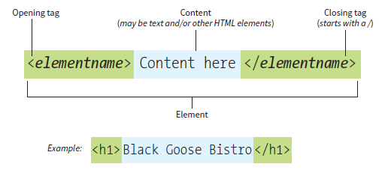

HTML elements are made up of:

* opening tags that start with the < symbol and end with the > symbol
* closing tags that add a / after the < symbol

A tag can define a paragraph, display an image, define a section of the document, etc. The example tag above says that the text "Black Goose Bistro" is going to be a heading on the page. The browser has a default way of displaying anything marked as a header and it will be bolder and larger than normal text.

## Block versus inline elements

Here's a list of the html elements we will add to our bio first. Notice I have marked them as block or inline. Block elements add a new line to the page and take up the width of the page. An inline element does not start on a new line and only takes up as much width as necessary.

|  |  |  |  |
| --- | --- | --- | --- |
| **Tag** | **Use** | **Block vs Inline** | **Example** |
| h1 | Most important heading | Block | <h1>Main Page Heading</h1> |
| h2 | Second most important heading | Block | <h2>Section Heading</h2> |
| p | Paragraph | Block | <p>Lots of text.</p> |
| strong | Define important text | Inline | <strong>Important</strong> |

We're going to work on adding these HTML tags to the bio you copied into the lab02 folder to describe different parts of our content. Here's what mine looks like right now:

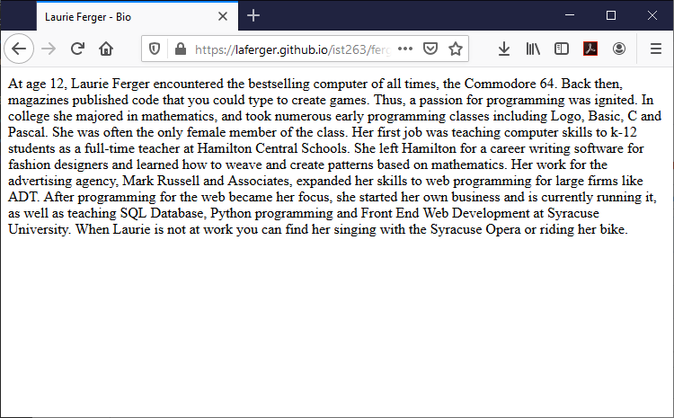

1. Remember all the content on an HTML page goes inside the <body></body> tags. We are going to add a heading to our bio using the h1 tag. At the top of your content add <h1> Your Name's Biography</h1>.
2. Let's add a subheading showing where our personal information in written to help break up the bio. Add a heading called Personal info before the paragraph where you wrote that. Make sure to put it inside <h2> tags.
3. We also need to identify the paragraphs in our HTML document. We do this with the <p> tag. Add an open and close <p> tag at the beginning and end of all your paragraphs in the bio.
4. Find some important text on your page that you would like to emphasize. I choose the text "Commodore 64". Add the <strong> tags around that text.

Here's what the code inside my body tags looks like right now:

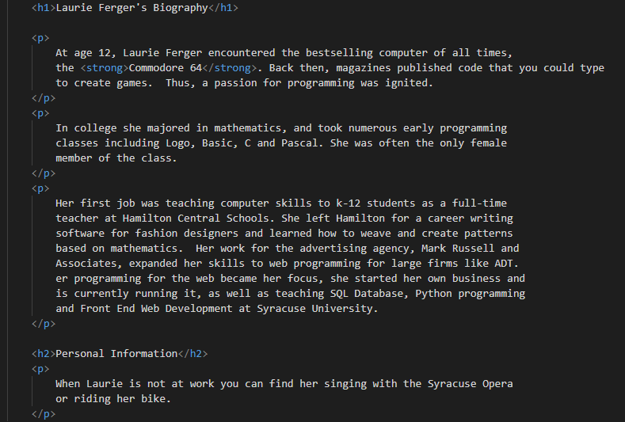  
Notice some of the tags are nested. That means a tag inside another tag. For example, the <strong> tag is inside the <p> tag. We'll talk more about tag nesting later, but for now I just want you to be aware that this happens.

## Void Elements

A void element doesn't require a closing tag. We've already used the void element <meta> in unit 01. See three common void elements below.

|  |  |  |
| --- | --- | --- |
| **Tag** | **Use** | **Example** |
| br | line break | <br> |
| hr | horizontal rule | <hr> |
| meta | information about content | <meta charset="utf-8"> |

The br tag is useful for writing lines in an address or lines in a poem. Use the <br> tag to enter line breaks, not to add space between paragraphs.

1. At the end of our bio let's add a horizontal rule just to try out a void element. All you need to do is type the tag in the hr example above just before the </body> tag.

## Character Escapes

™© ° è ÷ £ Σ  
  
The above wasn't my attempted to write a swear word in symbols! It’s a list of some of the characters that don't appear on a standard keyboard in the United States. You can't just copy and paste these symbols into an HTML document and make them appear on the page. You must use HTML character codes. For the first symbol above, the trademark character code looks like this:

&trade;

Anywhere that is typed into your HTML page, a trademark symbol will appear in the web browser.

1. Let's add © 2020 to the bottom of your bio page under the horizontal rule. The first thing you need is the character code for that symbol. There's a list of all the character codes here: <https://www.freeformatter.com/html-entities.html>.

## Lists

On your own.

|  |  |  |  |
| --- | --- | --- | --- |
| **Type** | **Unordered** | **Ordered** | **Descriptive** |
| **Example** | * First * Second | 1. First 2. Second | First  First item description  Second  Second item description |
| **HTML** | <ul>  <li>First</li>  <li>Second</li>  </ul> | <ol>  <li>First</li>  <li>Second</li>  </ol> | <dl>  <dt>First</dt>  <dd>First item description</dd>  <dt>Second</dt>  <dd>Second item description</dd>  </dl> |

Take a moment to examine the table of the different kinds of lists. You can read more about them on W3Schools here: <https://www.w3schools.com/html/html_lists.asp> or in your book chapter 5.

1. Add a list to your bio. It could be a list of skills, personal hobbies, or anything else. Choose the list style that best suits your content.

## Validating HTML

Did you make an error typing anything above? I make typos and forget things in my HTML all the time. Relax, there's a way to find out if you made a mistake and fix it. It's called validation. Validation checks your HTML to make sure you've followed all the rules and haven't made mistakes.

1. To validate your code your page must be on the web. Add this page to your github repository and view your work in the web browser. If you've forgotten how to do this consult the previous lab.
2. Go to the validator website at <https://html5.validator.nu/>. Copy the address of the bio web page you've been working on into the validator and press the validate button.
3. If all goes well on the validator, you should get a message that says, "The document is valid…" If you get an error, read it and make any changes you need to. Reupload you work to github and run the validator again until there are no error messages.

## What will You hand IN?

Create a word document, pdf or use the "write submission" option in blackboard to provide the following:

1. Submit the GitHub URL for this lab's bio web page.

**How do I find my Github server URL???**

The github link is: Github username + Github domain + path to your file + filename

If you named everything exactly the way I instructed it will be:

yourusername.github.io/ist263/lab02/lastname-bio.html

Mine looks like this:

laferger.github.io/ist263/lab02/ferger-bio.html

If you link does not work, then you will receive a deduction of half to full points off your lab. Make sure the URL has github.io in it!!!

1. Copy the URL of the validator after you have successfully submitted it (no errors left) and paste it into the lab submission.