COMP9900 semester 2 2018

**Project Report**

SkillStash

Driving the market

Automated system for job and employees search.

Team:

*Christopher Pollock*

*Eva Sheliukhina*

*Ekaterina Tsypkaikina*

*Liyu Xu*

21.10.2018

# **Background**

Nowadays the recruitment process is very sophisticated and complex for all participants: potential employees, hiring companies, and recruiters. We have identified major reasons why this is happening in the industry.

## High variety of skills

Many people have very diverse experience and often their skills vary in many subjects and fields. While many portals allow candidates to choose ‘up to three’ core skills, some people can count dozens. This issue is very important, as it expands the skillsets to a potentially unlimited number of fields.

## Unstructured data in CVs

Most of CVs are structured in a personalised way, which makes it very difficult to extract any data from them. It is crucial for employers and recruiters to see the previous experience and educational background in order to judge on candidate’s skills.

## Evidence for the skills

Unfortunately, many candidates understand that recruiting companies and employers will not be able to verify the skills of potential employees, so they exaggerate or even falsify their skills. This leads to wasted time during recruitment, and unfair hiring.

## Overly specific requirements for candidates

Employers tend to demand a lot from their candidates, and very often requirements are overly specific not only in terms of hard skills, but also in terms of soft skills. This leads to higher difficulty finding a matching candidate.

## Recruiters are dependent on their networks

Recruiters have limited professional networks, and have to spent time constantly updating their databases, so they lack time to focus on the quality of candidates and job offers.

# **Existing Systems and Drawbacks**

## LinkedIn

LinkedIn is a Social Network from a business side. Potential candidates can post their work experience and educational backgrounds, and add skillsets to their profile. Potential employers and recruiters can post job listings, fill out the profile of their company, and search for candidates. The drawback of the system is that users can only see profiles within the 3rd degree connection – if they are connected with somebody, who is connected with somebody, who is connected with that person. This limits the search outcome a lot.

In addition, the skills that a candidate chooses to put on their profile are not structured: candidate can put any word to be their skill. This way companies or recruiters have difficulty choosing the key words for their searches, considering all possible synonyms and acronyms.

## Seek

On this portal users can upload their CV and manually add their education and experience, with additional feature to add the list of their skills, though these skills have no structure and no autosearch. Jobs can be found by city, salary size and a category. Employers cannot choose required proficiency for the candidate.

## Ribit

On this platform Candidates can do the same, as on Seek, but with some limitations: even though the skills are categorized, candidate cannot choose more than five of them.

Employers also are limited in their search with the skillsets.

# **Aim**

We were aiming to create the system, where all three sides: candidates, employers and recruiters are feeling ease to work with and all their priorities are considered. System that gathers skills from candidates, offering the choice from a categorised and structured list of options. Employers can post job requirements, based on the skills they need, proficiency of those skills and the experience, but also in a structured way.

Recruiters are able to use the system as a great search tool for jobs and candidates, able to mark their proposed candidate to track their performance and able to prove a referral.

# **Project progress: epics**

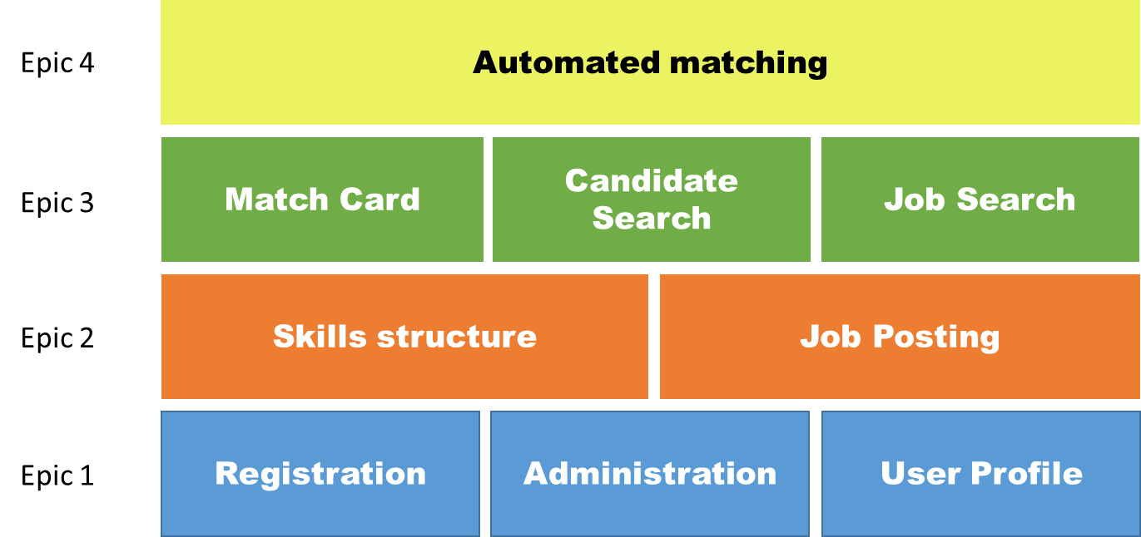

1. Registration, Admin Backend, User Profile

At this epic we created a baseline for the future application. The major parts were set up: registration, basic skills selection, user profile, administration function: adding possible skills.

We have chosen the Django REST framework for implementation, as it has many web-browsable APIs, is highly customizable, well documented and trusted internationally.

Pages implemented:

* Registration (front end + back end)(img1)
* Administration (back end)
* User profile (front end + back end)(img2)

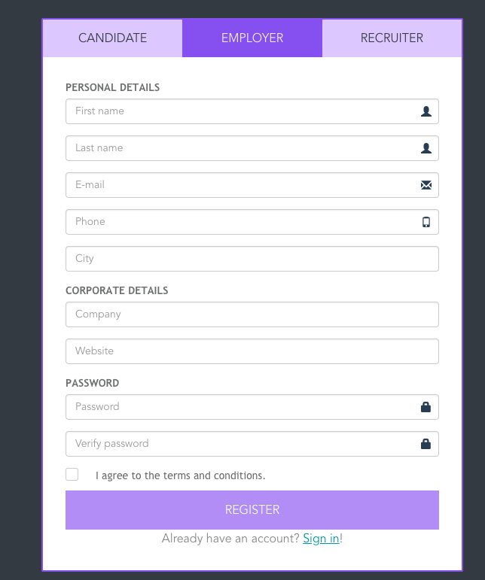

*Img1. User Registration*

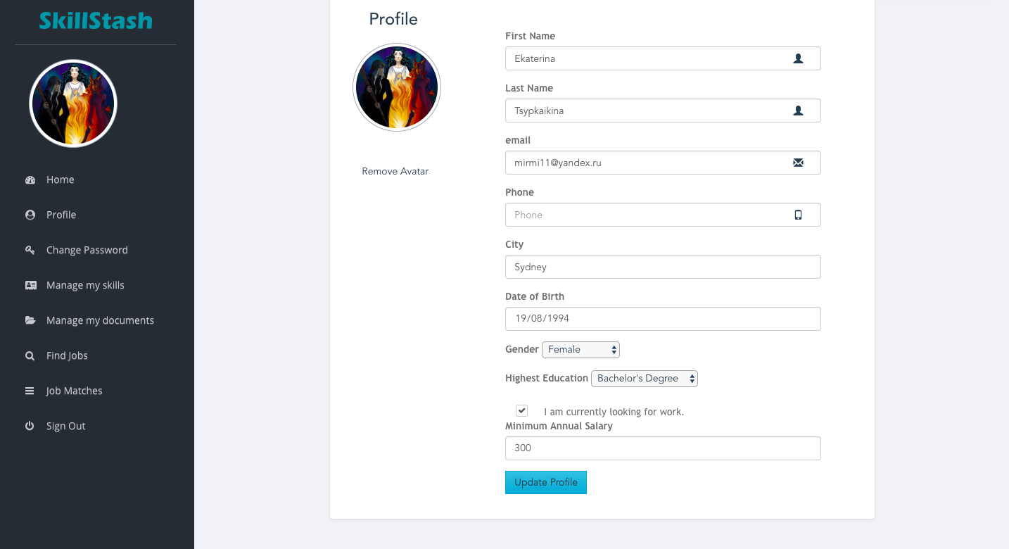

*Img2. User Profile*

1. Job Posting, Sophistication of Skills structure

At this epic skill structure was defined as following: tree starting with 0s nodes(img3):

* Technical & Knowledge
* Leadership & Management
* Communication
* Analysis & Research
* Personality

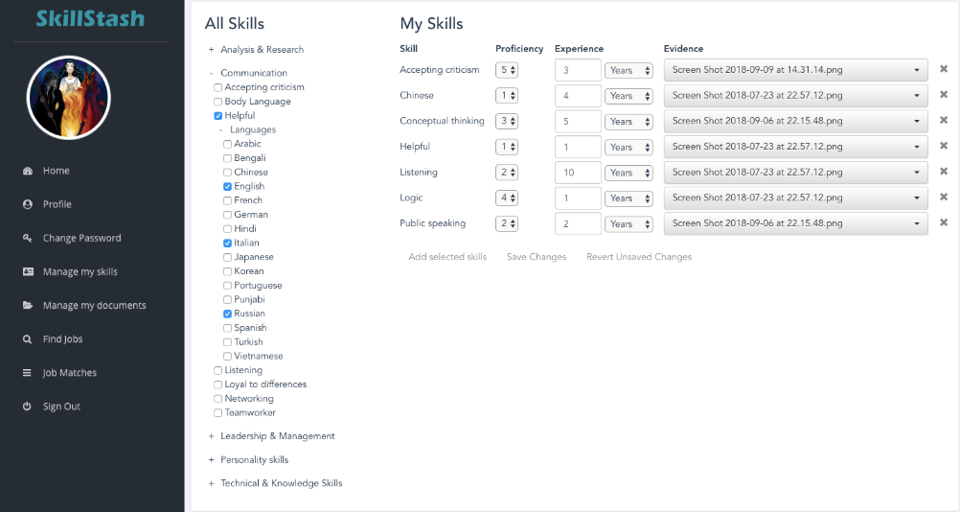

*Img3: Candidate’s skills*

The backend and front end part was implemented for Job Posting functionality.(img4)  
So far we had two users in the system: candidate and employer.

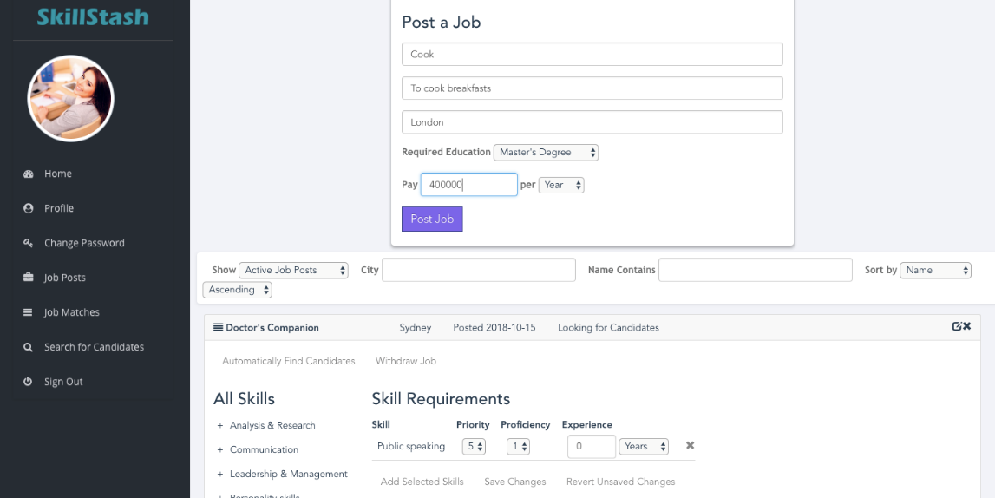

*Img4: Job Posting*

Users are able to enter their estimated proficiency at each skill, and provide evidence to prove that they have the skill in form of documents. Possible ways to prove are: to provide diploma\certificate, to confirm working experience, online certificates, read books, trainings or endorsement from an employee registered etc.   
From the employer side they can choose priority for each skill they choose. This will help to ease the process of prioritization for automated matching.

Only employers were assigned with a capability to job post functionality. Each job post contains:

* Title of Position,
* City,
* Description,
* Salary and
* Required skills with the proficiency level.

Pages implemented:

* Homepage (Front end + back end)(img5)
* Job Posting (Front end + back end)
* Update skills selection (Front end + back end)

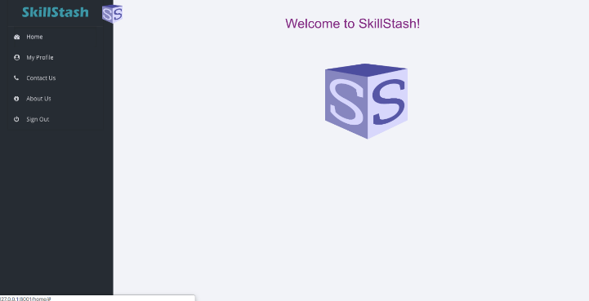 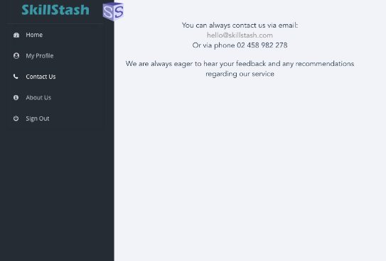

*Img5: Home Page*

1. Match creation for an employer and candidate, candidate search, job search

In this epic we created functionality to find a potential ‘match’ between an employer and a candidate. This match can be created by any type of user and will be presented and ‘created by’. At this epic we introduced the third user: recruiter. Every match has to be bound to a job post, and have one candidate. This match can be accepted or declined by any side at any time, the status of the match can be one of the following:

* ‘no action taken
* ‘in process’
* ‘declined’
* ‘hired’

Users can use action buttons i.e. ‘accept offer’, ‘decline’, ‘express interest’ etc. (Img6, Img7)

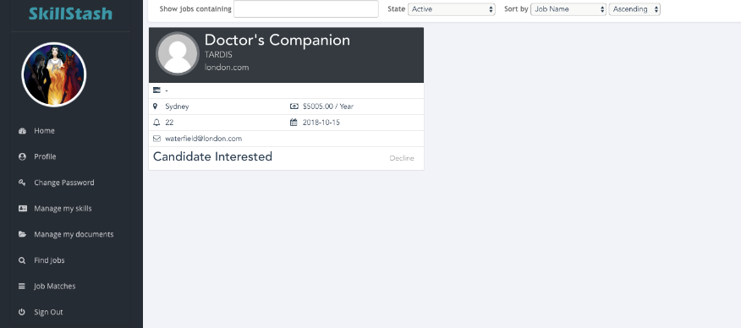

*Img6: Match view from the candidate view*

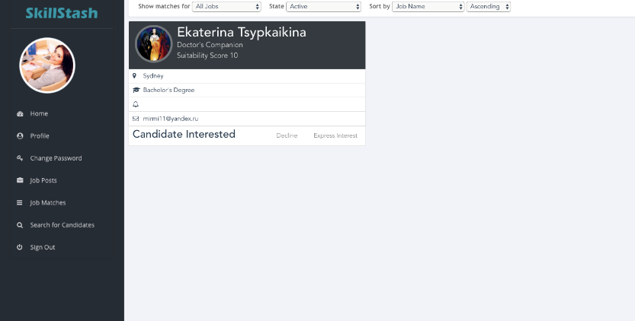

*Img7: Match view from an employer side*

Matches are visible to the employer who posted the job, the candidate in the match, and the creator of the match (In case it is a recruiter)

Candidate search is available for recruiters and employers.(Img8) Candidate search should consider city and a skillset, which requires filling up the 3P fields:

* Priority
* Proficiency

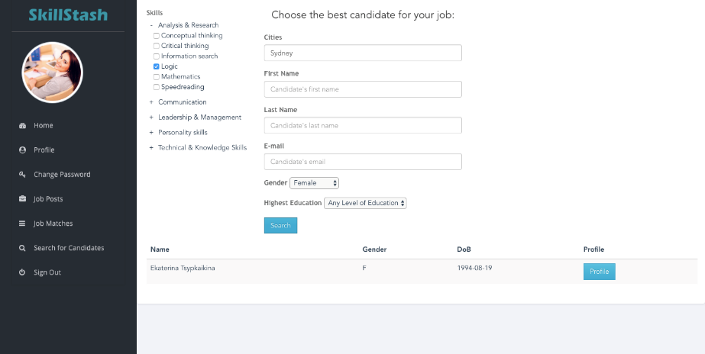  
*Img8: Candidate search*

By setting the skill priorities, the employer or recruiter can emphasize which skills are critical to the position and which are not. This is especially relevant for soft skills and communication skills. Proficiency will represent the skill level and provability is the way the employer is willing to allow the candidate to prove their skill.

Skills with the highest priority are considered essential, so the search function will only match candidates who possess all of the highest priority skills. For each lower priority skill that the candidate possesses, they will be assigned a score depending on their proficiency and the priority of the skill. The system will select candidates based on their total scores.

Job search has a similar process structure: even though it is possible to search by the title of the job, it is highly recommended to search according to the skills: this way candidates may find opportunities that they had never thought about before. Job search also includes a city field, title, description and salary range. (Img9)

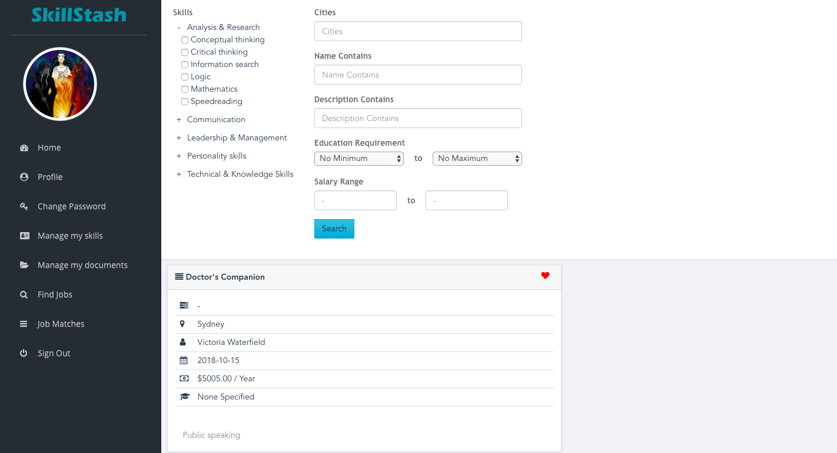

*Img9: Job search*

For recruiter the ‘favourites’ entity has been introduced: recruiter can add candidates and jobs to corresponding shortlists, and when performing the search, they can create matches with the particular search result exemplar and a shortlisted object from a drop-down list.(Img 10) This is done to simplify the manual matching component for recruiters.

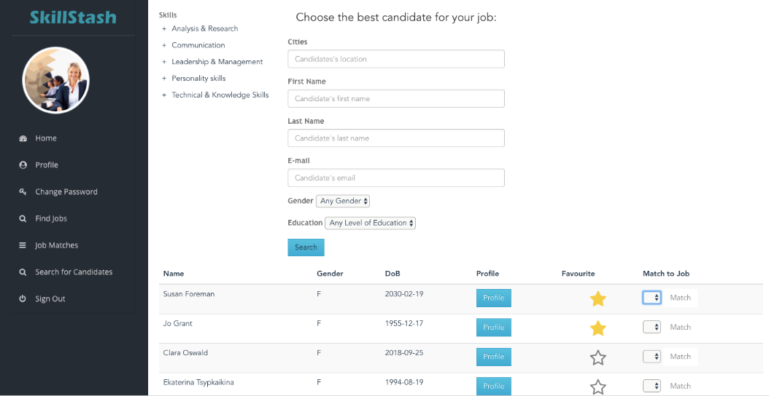

*Img10: Recruiter’s search and favourites functionality*

Pages implemented:

* Match (Front end + back end)
* Job Search (Front end + back end)
* Candidate Search (Front end + back end)

1. Automated matching

At the last epic for each job post the system filters the possible candidates, and for each candidate the system offers potential job postings.

These potential matches use the same interface as the manual ones, but the creator is the system.

For candidate recommendation:

This is performed by adjusting the priorities to different ranks and finding the matching candidates according to their skillsets.

For job recommendation:

Once a candidate registered and filled in their skills (updated the skills), the system scan potential roles in the city and create potential matches, which are displayed for the candidate. The same matches appear for the job posting creators, thus, each job post can be updated with newly registered candidates.

Pages implemented:

* Match (Updated back end)

# **Team Work**

Our team is represented by four postgraduate computer science students with complementary experiences.

We have most of the required skills covered for the successful project delivery.

Our workload can be tracked in the developers’ diaries in the BitBucket folder.

## Christopher Pollock

Software developer with more than 20 years commercial experience, mainly developing financial applications. Highly proficient at C++ programming, and also comfortable programming in Python, C#, or Java. Have some knowledge of many other languages. Have a solid understanding of common data structures and algorithms. Have a basic understanding of web technologies, but no experience developing web applications.

## Ekaterina Tsypkaikina

Proficient in Python, with prior experience in C/C++ and C#. Some experience in plain PHP with HTML/CSS/JavaScript (as part of several undergraduate degree projects), but none on the production scale. Written client/server applications in C++. More familiarity with back-end, rather than front-end development.  
Highly experienced in Trello, that is why was placed in a role of SCRUM Master.

## Evgeniia-Liza Sheliukhina

Software developer and data analyst with over 5 years of experience in tech. Fluent in Python and SQL, most of experience comes from Machine Learning and AI projects. Have experience in developing the back-end of web-applications. Highly efficient in building the methodologies and architecture of systems.

## Liyu Xu

Has 3 years working experience as Java engineer, familiar with web development. Key skills: html/css/nodejs/vue for front-end, j2ee/django for backend side.

# **Project Summary**

By the end of the project the team has presented fully-functioning web-application, that can be integrated into the recruitment process very smoothly. System is scalable and it’s model considers a lot of space for system evolution: adding new features, functionality and integration with other tools.

Remarkably, that the team did develop own scoring methodology for the automated matching and successfully implemented it.

# **References**

1. *Django rest framework tutorial: serialization. Encode OSS Ltd.*

[*https://www.django-rest-framework.org/tutorial/1-serialization/*](https://www.django-rest-framework.org/tutorial/1-serialization/)*[Accessed August 2018]*

1. *Build a REST API with Django. Jee Gikera. February 06, 2017*

[*https://scotch.io/tutorials/build-a-rest-api-with-django-a-test-driven-approach-part-1*](https://scotch.io/tutorials/build-a-rest-api-with-django-a-test-driven-approach-part-1)*[Accessed August 2018]*

1. *Django documentation. Django. Django Software Foundation*

[*https://docs.djangoproject.com/en/2.0/intro/tutorial01/*](https://docs.djangoproject.com/en/2.0/intro/tutorial01/)*[Accessed August 2018]*

1. *The Progressive JavaScript Framework. Evan You*

[*https://vuejs.org/*](https://vuejs.org/)*[Accessed August 2018]*

1. *Nodejs. Node.js Foundation. Linux Foundation TM.*

[*https://nodejs.org/en/*](https://nodejs.org/en/)*[Accessed August 2018]*

1. *GitHub, Inc. Contributor Puikinsh. Sufee admin dashboard.*

[*https://github.com/puikinsh/sufee-admin-dashboard*](https://github.com/puikinsh/sufee-admin-dashboard)*[Accessed August 2018]*

1. *UNSW, Project requirements and specification.*

[*https://webcms3.cse.unsw.edu.au/static/uploads/course/COMP9900/18s2/0aeab93cd98ee738bb01dce22bcd334fba31f6b19964372729096dbe58ad9458/COMP3900_9900_project2_18s2.pdf*](https://webcms3.cse.unsw.edu.au/static/uploads/course/COMP9900/18s2/0aeab93cd98ee738bb01dce22bcd334fba31f6b19964372729096dbe58ad9458/COMP3900_9900_project2_18s2.pdf)*[Accessed July 2018]*

1. *Skill Scan. Three Types of Skills Classification. 2012.*

[*https://www.skillscan.com/sites/default/files/Three%20Types%20of%20Skills%20Classification.pdf*](https://www.skillscan.com/sites/default/files/Three%20Types%20of%20Skills%20Classification.pdf)*[Accessed August 2018]*

1. *GALLIGAN, F. et al. (2000) Acquiring Skill In: GALLIGAN, F. et al., Advanced PE for Edexcel. 1st ed. Bath: Bath Press, p. 102-108[Accessed August 2018]*
2. *DAVIS, B. et al. (2000) The Nature and classification of skill. 4th ed. London: Harcourt Publishers, p. 284-285[Accessed August 2018]*
3. *MACKENZIE, B. (2001) Skill Classification [WWW] Available from: https://www.brianmac.co.uk/continuum.htm [Accessed August 2018]*

# **Appendix 1. User Manual**

## SkillStash

SkillStash is a web application that allows you to have a consistent electronic portfolio throughout your life, study, and career - or, if you are looking for the right person to do a job - to find the best matching candidate for it. SkillStash provides an extensive system to have a full tracking record of skills people obtain throughout their life and career, and a simple way to prove and review them.

## Homepage

The first thing you see is a homepage.

Here, you are greeted by the SkillStash logo and offered access to the navigation panel. From it, you can either click "Sign In", which would redirect you to the sign in page; "Register", allowing you to complete registration; and also see the information about the SkillStash goal, functionality, and (currently abstract) company contact details, if you are interested in them.

If you are signed in, the options differ slightly - and, instead of sign in / registration, you can "Sign Out" of the current user profile.

## Registration

There are 3 types of users that our system supports, and you can register as one of them:

1. Job candidate - a person for whom the electronic portfolio functionality is available. They can specify their skills and look for jobs, posted in the system, that best suit them.

2. Employer - this is a representative of a company, who has the ability to post jobs, and also look for people to fill created positions.

3. Recruiter - this is an authorised person, potentially from a recruiting company, who is not able to post jobs, but can match suitable candidates with already existing job posts.

Whatever the user type, you are asked to provide your first name (where you can specify your middle name as well, if needed), last name, email address, contact phone number (optional), and the city where you currently live/are looking for work/your company is located. You also need to provide and verify your password, which should contain at least 8 characters.

If you are a candidate, you are also required to provide your date of birth. You may also specify your highest level of education, gender (if willing), minimum annual salary, and whether or not you are currently looking for work.

Employers and recruiters are asked to provide details about their company - namely, its name and website.

You also need to agree to the terms and conditions, as the handling of personal details implies. But, as the legal issues are not part of the development task itself, the agreement is an abstract one - though still required.

After all fields have been correctly filled in, you can click "Register", so as to proceed to your now-registered profile.

Alternatively, if you have got to the registration page by accident, and already have an account you wish to use, there is a redirection link to the sign in page.

## Signing In

The process is rather straightforward: there are two fields you need to fill in - your email address and your password. When you have done so correctly, and if such account is indeed registered in the system - than you will be redirected to your respective profile.

A link to the registration page is also provided.

## Managing your profile

After you have successfully registered or logged in, you are redirected to your profile page. Depending on the user type, these differ in functionality, but there are some commonalities as well.

You can update any of the fields in your user profile at any time. To do so, simply click on "Profile" on the side bar, edit the appropriate field(s), and click the "Update Profile" button. You can also add an avatar image, which will be visible to any other users who view your profile. To set your avatar, simply click on the default avatar (a head and shoulders silhouette) on the profile editing form, and a file selector dialog will appear. You can use image files in any of the common formats with a maximum size of 512 kilobytes. You may change your avatar at any time, or remove it by clicking the "Remove Avatar" button, which appears after your avatar has been set.

## Candidate

### Managing your documents

SkillStash allows you to upload documents to provide evidence for your skills. These can be professional certifications, academic transcripts, letters of recommendation, or any other document that you think can serve as evidence. Any employer or recruiter who views your profile will be able to download these documents, so please do not upload anything that you wish to keep confidential. There is no restriction on the number or type of documents that can be uploaded, but the total size of your uploaded documents is limited to 100 megabytes.

To upload a document, click on "Manage my documents" on the sidebar. This will take you to the document management page. The upper part of this page ("Upload a Document") is for uploading new documents. Simply click on the “Choose File” button to open a file selector dialog and select a file. You can then select the document type from a dropdown menu, and enter a description for the document. Finally click the “Upload” button to upload the file to SkillStash.

The lower part of the page ("My Uploaded Documents") lists the documents that you have uploaded. You can change the document types or edit their descriptions here. Simply make the changes in the list, and click the tick icon at the end of the table row to save the changes. You can also delete a document by clicking the delete (x) icon. SkillStash will ask you for confirmation before deleting the document, to prevent accidental deletions.

### Managing your skills

In order for SkillStash to match you to available jobs, it needs to know your skills. To enter your skills, click on "Manage my skills" on the sidebar to show the skill management page.

The left hand side of the page (“All Skills”) shows the skill categories and skills that are recognised by the system. Skills are arranged in a hierarchical manner, with a several top-level skill categories, each of which contains a number of sub-categories, which may in turn contain sub-sub-categories, and so on. Under “All Skills”, you will initially see the five top-level categories. To see the sub-categories under a category, click the + icon to the left of the category.

The right hand side of the page (“My Skills”) contains a table listing the skills that you have added.

To add one or more skills, select them in the “All Skills” hierarchy, then click the “Add selected skills” button under the “My Skills” table. For example, to add Django to your skills you would first expand the “Technical & Knowledge Skills” category, then expand the “Computer Science”, “Frameworks”, and “Web development” categories, click the checkbox next to “Django”, and finally click “Add selected skills”. Django will then appear in your “My Skills” table.

After adding a skill, you need to enter your proficiency on a scale from 1 to 5, and your length of experience in years or months. You may also select one or more of your uploaded documents to provide evidence for the skill. You can do this using the controls in the “My Skills” table. You can also remove a skill by clicking the delete (x) icon on the right of the table.

None of the changes to your skill list are saved until you click the “Save Changes” button below the table. If you make a mistake and wish to undo your changes, you can click the “Revert Unsaved Changes” button, which will return your skill list to its last saved state.

## Profile: Employer

### Job Posts

Clicking on “Job Posts” on the sidebar takes you to the Job Post page. The top of the page has a form for posting new jobs. To post a job, simply enter the details in the dialog and click the “Post Job” button. You can enter a minimum education requirement for the job, ranging from high school to a Ph.D. If you do not care about a candidate’s education, you can choose “No Requirement”.

The lower part of the page lists the jobs that you have posted. Above the list is a a toolbar which allows you to choose the filtering and sorting options for the job posts. By default only active job posts (those that have not been withdrawn or filled) are shown.

Each job post is shown on a separate “card”. The top of the card shows its name, city, the date it was posted, and its current state.

There is an edit icon on the top right of the card, which opens an editing form to update the job post. There is also a delete (x) icon, which deletes the job post after asking for confirmation. Note that you cannot delete job posts once matches have been created.

Before SkillStash can match candidates to your job, you need to enter the required skills. The controls to do so are in the lower part of each job card. The left hand side of the card (“All Skills”) shows the skill categories and skills that are recognised by the system. Skills are arranged in a hierarchical manner, with a several top-level skill categories, each of which contains a number of sub-categories, which may in turn contain sub-sub-categories, and so on. Under “All Skills”, you will initially see the five top-level categories. To see the sub-categories under a category, click the + icon to the left of the category.

The right hand side of the page (“Skill Requirements”) contains a table listing the required skills that you have chosen for the job.

To add one or more skills, select them in the “All Skills” hierarchy, then click the “Add selected skills” button under the “Skill Requirements” table. For example, to add Django you would first expand the “Technical & Knowledge Skills” category, then expand the “Computer Science”, “Frameworks”, and “Web development” categories, click the checkbox next to “Django”, and finally click “Add selected skills”. Django will then appear in the job post’s “Skill Requirements” table.

You need to enter some additional parameters for each skill. The first is the priority, which specifies how important the skill is for the job, on a scale of 1 to 5. A higher number means more important. The next parameter is the required level of proficiency for the skill. It is also measured on a scale of 1 to 5, with a higher number meaning more proficient. You can also optionally specify a minimum length of experience in months or years. If you do not care about length of experience, you can leave this parameter at 0, and it will be ignored.

You set these parameters using the controls in the “Skill Requirements” table. You can also remove a skill requirement by clicking the delete (x) icon on the right of the table. None of the changes to the skill requirements are saved until you click the “Save Changes” button below the table. If you make a mistake and wish to undo your changes, you can click the “Revert Unsaved Changes” button, which will return the requirements to their last saved state.

## Profile: Recruiter & Employer

### Matching Candidates to Jobs

After all of the necessary skills for the job have been entered, if you are logged in as an employer, you can click on the “Automatically Find Candidates” button to match potential candidates to your job. Alternatively, if you are a recruiter, you can also do a manual matching via selecting a candidate in candidate search, a job in job search, and matching them. If they do not fulfil all of the required criteria, you will be warned, but would still be able to proceed.

SkillStash’s automatic job matching algorithm only considers candidates in the same city as the job, who have at least the required level of education. It excludes candidates who have specified a minimum acceptable salary below the salary for the job. (If the pay is per hour, day, or month, it is converted to an equivalent annual salary for this purpose.)

Priority 5 skills are considered essential, so only candidates who posses these skills at the required proficiency level, with the required length of experience, are considered.

After finding the suitable candidates with all the priority 5 skills, SkillStash assigns a suitability score to each candidate. For each relevant skill that the candidate possesses, they are assigned a score equal to the priority of the skill multiplied by the candidate’s proficiency. The candidate’s total score is equal to the sum of the scores for all the skills in the job post. Skills which are more important for the job therefore have a larger effect on the scores. Skills which are not listed in the job post are not used in the calculation.

After scoring the candidates, SkillStash creates at most 10 job matches. If more than 10 candidates meet the essential requirements for the job, it chooses those with the highest scores.

If job matches already exist for some of these candidates, SkillStash will update their scores. Scores may change because either the job requirements or the candidate’s skills have been updated.