3-2

using System;

namespace _3_2

{

class Program

{

static void Main(string[] args)

{

int[] myArray = new int[10];

Console.WriteLine("请输入十个数");

for (int i = 0; i < 10; i++)

{

myArray[i] = Convert.ToInt32(Console.ReadLine());

}

Array.Sort(myArray);

Console.WriteLine("最大的数为" + myArray[9].ToString());

Console.WriteLine("最小的数为" + myArray[0].ToString());

Console.ReadKey();

}

}

}

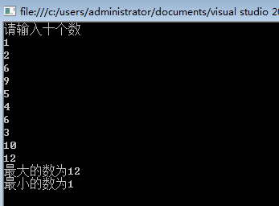

3-4

using System;

namespace _3_2

{

class Program

{

static void Main(string[] args)

{

int m;

while (true)

{

Console.WriteLine("请输入月份：");

m = Convert.ToInt32(Console.ReadLine());

if (0<m && m<13){ break; }

Console.WriteLine("您输入的月份有误，请重新输入。");

}

switch (m)

{

case 1: Console.WriteLine("31"); break;

case 2: Console.WriteLine("28"); break;

case 3: Console.WriteLine("31"); break;

case 4: Console.WriteLine("30"); break;

case 5: Console.WriteLine("31"); break;

case 6: Console.WriteLine("30"); break;

case 7: Console.WriteLine("31"); break;

case 8: Console.WriteLine("31"); break;

case 9: Console.WriteLine("30"); break;

case 10: Console.WriteLine("31"); break;

case 11: Console.WriteLine("30"); break;

case 12: Console.WriteLine("31"); break;

}

Console.ReadKey();

}

}

}

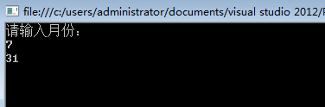

3-7

using System;

using System.Linq;

namespace _3_2

{

class Program

{

static void Main(string[] args)

{

int[] a = new int[5] { 1, 2, 3, 4, 5 };

Console.WriteLine("a.Max()=" + a.Max());

Console.WriteLine("a.Min()=" + a.Min());

Console.WriteLine("a.Average()=" + a.Average());

Console.WriteLine("a.Sum()=" + a.Sum());

Console.WriteLine("\nPress any key to quit.");

Console.ReadKey();

}

}

}

3-8

using System;

using namespace；

namespace _3_2

{

class Program

{

static void Main(string[] args)

{

Console.WriteLine("定义参与的人数： ");

String peoples = Console.ReadLine();

Console.WriteLine("定义规定的数字：");

String numbers = Console.ReadLine();

int nbs = Convert.ToInt32(numbers);

Queue<int> pes = new Queue<int>();

for (int i = 1; i <= Convert.ToInt32(peoples); i++) pes.Enqueue(i);

int flag = 1;

while (pes.Count >= 2)

{

if (flag == nbs)

{

Console.WriteLine("出队：" + pes.Dequeue());

flag = 1;

}

else

{

pes.Enqueue(pes.Dequeue());

flag++;

}

}

Console.WriteLine("约瑟夫环结束，最后出队的是：" + pes.Dequeue());

Console.WriteLine("\nPress any key to quit.");

Console.ReadKey();

}

}

}