课后作业第三次

3.2

using System;

using System.Collections.Generic;

using System.Linq;

using System.Text;

using System.Threading.Tasks;

namespace week_8

{

class Program

{

static void Main(string[] args)

{

Console.WriteLine("请出入一个字符串：");

string a = Console.ReadLine();

Console.WriteLine("请输入一个字符：");

string b = Console.ReadLine();

string result = a.Replace(b, "");

Console.WriteLine("删除字符后得出：");

Console.WriteLine(result);

Console.ReadKey();

}

}

}

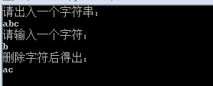

3.3

using System;

using System.Collections.Generic;

using System.Linq;

using System.Text;

using System.Threading.Tasks;

namespace week_8

{

class Program

{

static void Main(string[] args)

{

string contents = Console.ReadLine();

char[] temp = contents.ToCharArray();

Array.Reverse(temp);

string reverse = new string(temp);

if (contents == reverse)

Console.WriteLine("该字符串是回文数");

else

Console.WriteLine("该字符串不是回文数");

Console.ReadKey();

}

}

}

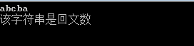

3.13

using System.Text;

using System.Threading.Tasks;

namespace week_8

{

class Program

{

static void Main(string[] args)

{

char[] Array = new char[10];

for (int i = 0; i <= 9; i++)

{

Array[i] = Convert.ToChar(Console.ReadLine());

}

string a = new string(Array);

string result = a.Substring(0, 5);

string result1 = a.Substring(6);

string b = string.Concat(result, result1);

char[] Array1 = b.ToCharArray();

Console.WriteLine(Array);

Console.WriteLine(Array1);

Console.ReadKey();

}

}

}