Set up development environment

* Executive Summary

The time it takes to download an IDE and learn the barebones basics of use will be very quickly recouped by the savings in development, debugging, and deployment times. I personally feel that the extra features of MyEclipse more than justify the very small cost vs. the totally free [regular Eclipse IDE](http://www.coreservlets.com/Apache-Tomcat-Tutorial/eclipse.html), but this is definitely a matter of taste, and both versions are widely used. Here is a quick summary of use; see the next sections for details.

1. **Download and install Java from** **[http://java.sun.com/javase/downloads/](http://java.sun.com/javase/downloads/" \t "_blank).** I use JDK 1.6.0\_14, but any Java 5 or 6 version will work.
2. **Unzip Tomcat.** Unzip [tomcat-6.0.18-preconfigured.zip](http://www.coreservlets.com/Apache-Tomcat-Tutorial/tomcat6.0-files/tomcat-6.0.18-preconfigured.zip) into the top level of the C drive.
3. **Install MyEclipse.** Download from <http://myeclipseide.com/> and run installer.
4. **Tell MyEclipse about Tomcat.** Select Window, Preferences, MyEclipse, Servers, Tomcat, Tomcat 6. Click "Enable". Select "Tomcat Home Directory" and hit "Browse". Navigate to the Tomcat installation directory Click Apply & OK.
5. **Run Tomcat.** Click on Servers tab at bottom. R-click on Tomcat 6, choose "Run Server". Open http://localhost/ in a browser.
6. **Add Maven plugin for MyEclipse**
7. **Download and** **install Jdk**

Step 1:

Download from <http://www.oracle.com/technetwork/java/javase/downloads/index.html>.**.**

Run the downloaded installer (e.g., "jdk-7uxx-windows-i586.exe"), which installs both the JDK (Java Development Kit) and JRE (Java Runtime). By default, the JDK will be installed in directory "C:\Program Files\Java\jdk1.7.0\_{xx}", where {xx} denotes the latest upgrade number; and JRE in "C:\Program Files\Java\jre7". Take note of you JDK installed directory.

Step 2:

To edit the PATH environment variable in Windows 2000/XP/Vista/7/8:

1. Click "Start" button ⇒ "Control Panel" ⇒ "System" ⇒ (Vista/7/8 only) "Advanced system settings".
2. Switch to "Advanced" tab ⇒ "Environment Variables..."
3. In "System Variables" box, scroll down to select "PATH" ⇒ "Edit..."
4. **(CAUTION: Read this paragraph 3 times before doing this step! There is no UNDO)** In "Variable value" field, INSERT "c:\Program Files\Java\jdk1.7.0\_{xx}\bin" (VERIFY that this is your JDK's binary directory) IN FRONT of all the existing directories, followed by a semi-colon (;) which separates the JDK's binary directory from the rest of the existing directories. DO NOT DELETE any existing entries; otherwise, some existing applications may not run.

Step 3:

Verify the JDK Installation

prompt> **java -version**

java version "1.7.0\_{xx}"

Java(TM) SE Runtime Environment (build 1.7.0\_{xx}-b11)

Java HotSpot(TM) Client VM (build 23.3-b01, mixed mode, sharing)

1. **Unzip Tomcat.**

Unzip [tomcat-6.0.18-preconfigured.zip](http://www.coreservlets.com/Apache-Tomcat-Tutorial/tomcat6.0-files/tomcat-6.0.18-preconfigured.zip) into the top level of the E drive.

1. **Install MyEclipse.** Download from <http://myeclipseide.com/> and run installer.
2. **Tell MyEclipse about Tomcat.** Select Window, Preferences, MyEclipse, Servers, Tomcat, Tomcat 6. Click "Enable". Select "Tomcat Home Directory" and hit "Browse". Navigate to the Tomcat installation directory Click Apply & OK. 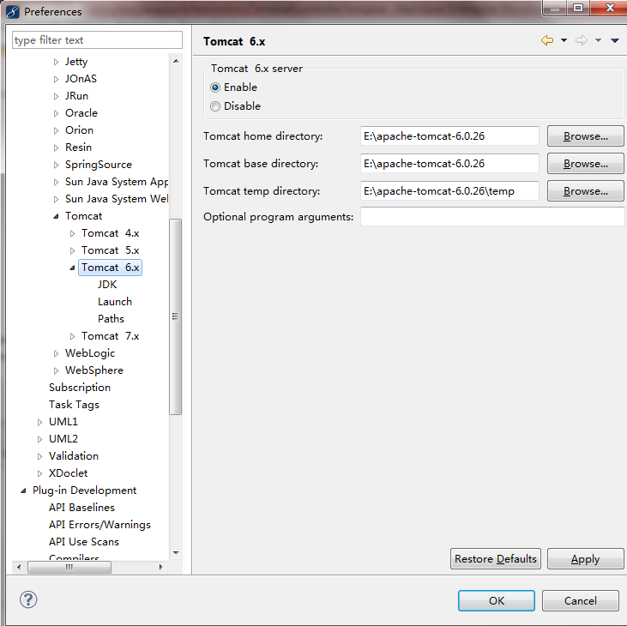
3. **Run Tomcat.** Click on Servers tab at bottom. R-click on Tomcat 6, choose "Run Server". Open http://localhost/ in a browser.
4. **Add plugin for Myeclipse**

Step 1:

Download a free version of apache installation - maven - 3.0.3. Zip after decompression, configure the environment variables:

Create a new environment variable M2\_HOME:

[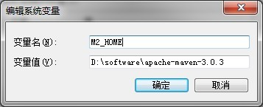](http://photo.blog.sina.com.cn/showpic.html#blogid=77cb836301015r9b&url=http://s6.sinaimg.cn/orignal/77cb8363gd2970c1f8645)

Add  %M2\_HOME%\bin; after the Variable path

[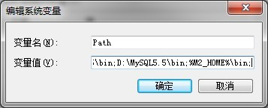](http://photo.blog.sina.com.cn/showpic.html#blogid=77cb836301015r9b&url=http://s3.sinaimg.cn/orignal/77cb8363gd297127a5312)

 Step 2:

check whether environment is configured correctly

 mvn -v

[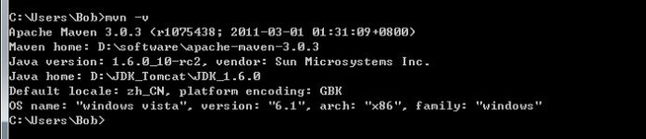](http://photo.blog.sina.com.cn/showpic.html#blogid=77cb836301015r9b&url=http://s16.sinaimg.cn/orignal/77cb8363gd2971b9cb3cf)

  Step 3:

First modigy the apache-maven-3.0.3\conf\settings.xml and

Add the following in the node of <settings>

 <localRepository>D:\software\mavenFactory</localRepository>.

Then open Myeclipse and Create M2\_REPO As bellow:

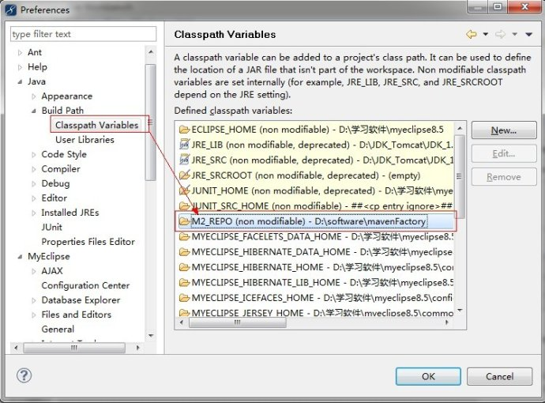

  Followly, click Window-->Preferences-->Myeclipse--> Maven4Meclipse and choose Enable as bellow: 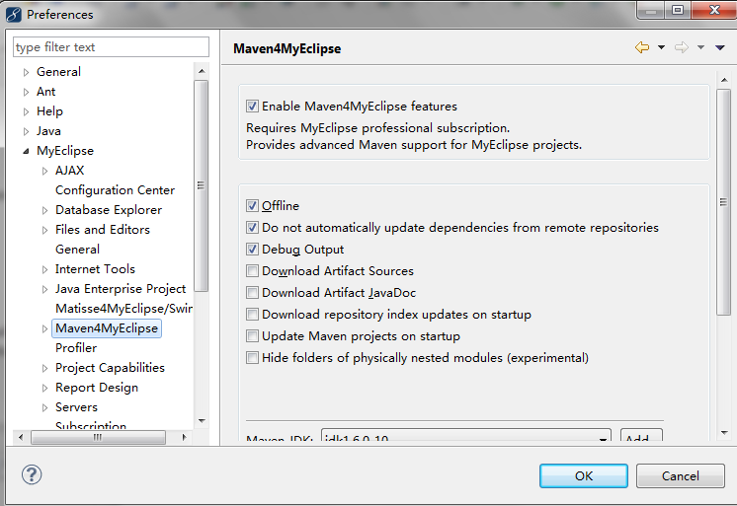

Then click  Window-->Preferences-->Myeclipse--> Maven4Meclipse -->Maven-->Installations and click add

button to select the maven solution we have installed .

[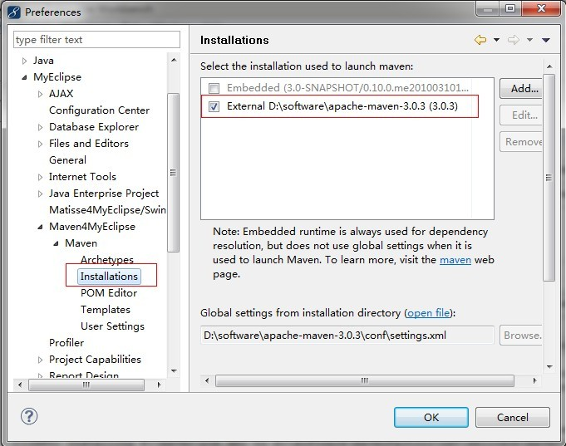](http://photo.blog.sina.com.cn/showpic.html#blogid=77cb836301015r9b&url=http://s5.sinaimg.cn/orignal/77cb8363gd2977ef26a64)  
Afterly : click

 Window-->Preferences-->Myeclipse--> Maven4Meclipse -->Maven-->User Settings.

[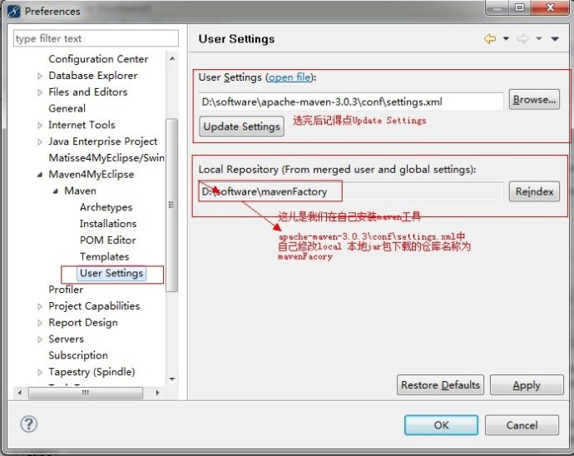](http://photo.blog.sina.com.cn/showpic.html#blogid=77cb836301015r9b&url=http://s5.sinaimg.cn/orignal/77cb8363g039ebdaad6c4)  
Now, the Maven has been associated with the Myeclipse.

Step 4:

Import Maven Project into workspace

File---->Import--->Exsiting Projects into Workspace--->Browse

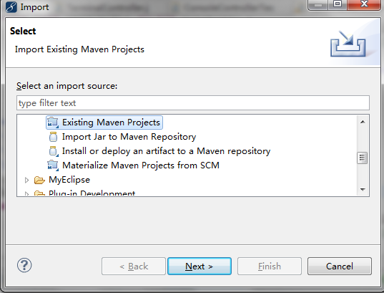

Step 5:

Add associate with Maven, right click on the Project choose

Maven4Meclipse--->Enable Dependency Management; At this time we found a m sign on the upper left corner of the project,

It means that the project of Maven have successed.

[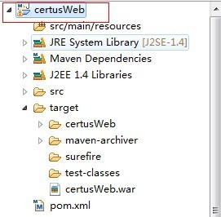](http://photo.blog.sina.com.cn/showpic.html#blogid=77cb836301015r9b&url=http://s16.sinaimg.cn/orignal/77cb8363gd297cd57132f)