SICSA Requirements Specification

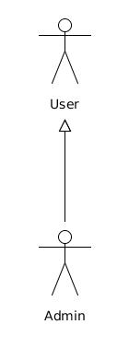
Figure 1

1. Actors
Figure 1 illustrates the relationships between actor roles in the system. A short summary of the actors is given below:

User represents an actor in the system who is able to search for experts most relevant to a query using SICSA look or university template look.

Admin inherits user and is able to modify look and feel, update academics and view queries information.

2. Use Cases
The core use cases for the system are:
- Administration (Section 2.1)
- Login
- Logout
- View status
- View queries frequency
- Change the way system updates academics
- Generate a custom look for university
- View publications details and visits statistics

- Common utility activities (Section 2.2)
- Search for experts most relevant to a query
- View academic profile

2.1 Administration

Use Case Diagram

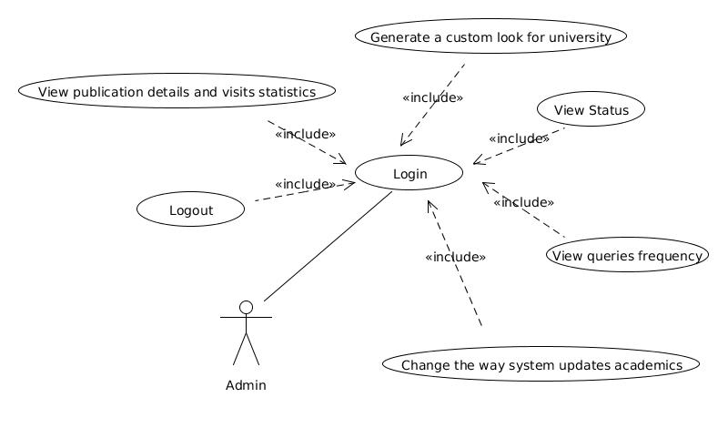

Use Case | Login
Description | 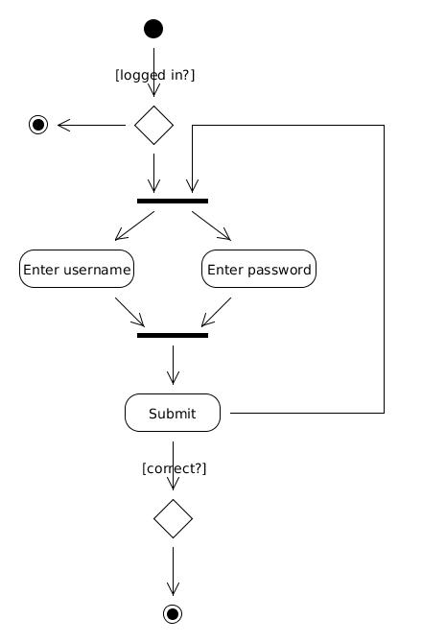
Rationale | The login use case allows administrator to access to the system. The username and password are provided by SICSA staff
Priority | Must Have
Status | Implemented
Actors | - Admin
Extensions
Includes
Conditions | post The user is logged in if correct credentials are provided
Scenarios
Risks
User Interface

Use Case | Logout
Description | The logout use cases changes a users account to logged out, requiring them to re-  authenticate to the system. Logout is invoked by the user
Rationale | The logout use case allows a user to leave the system to prevent unauthorised  access from an unattended terminal
Priority | Must Have
Status | Implemented
Actors | - Admin
Extensions
Includes | Login
Conditions | pre The user is logged in  post The user is logged out
Scenarios
Risks
User Interface

Use Case | View Status
Description | A user’s status (institution, email) is displayed.
Rationale | User needs to be able to view their status within the system.
Priority | Should Have
Status | Implemented
Actors | - Admin
Extensions
Includes | Login
Conditions | pre The user is logged in
Scenarios
Risks
User Interface

Use Case | View queries frequency
Description | The queries frequency associated to user university is displayed
Rationale | User needs to be able to view queries frequency in order to determine the popularity of a particular area
Priority | Should Have
Status | Implemented
Actors | - Admin
Extensions
Includes | Login
Conditions | pre The user is logged in
Scenarios
Risks
User Interface

Use Case | Change the way system updates academics
Description | Initially, the SICSA expertise search engine “scrapes” the contacts from your webpages. However, user would prefer XML feeds from each university. This takes 2 forms:  - an XML feed hosted on your website and accessed directly by the expertise search engine.  - manual uploading of the XML file to the SICSA expertise search engine.
Rationale | Allows user to update academics according to their preference.
Priority | Should Have
Status | Implemented
Actors | - Admin
Extensions
Includes | Login
Conditions | pre The user is logged in  post Change updated
Scenarios
Risks
User Interface

Use Case | Generate a custom look for university
Description | User modifies look and feel for their university. This look and feel is displayed to other users visiting SICSA using specific university look and feel.
Rationale | Allows user to modify template for their university.
Priority | Could Have
Status | Implemented
Actors | - Admin
Extensions
Includes | Login
Conditions | pre The user is logged in  post look and feel updated
Scenarios
Risks
User Interface

Use Case | View publications details and visits statistics
Description | User is able to view all academics, number of visits and publications associated with each academic in their university.
Rationale | Allows user to view publications details and visits statistics.
Priority | Should Have
Status | Implemented
Actors | - Admin
Extensions
Includes | Login
Conditions | pre The user is logged in
Scenarios
Risks
User Interface

2.2 Common utility activities

Use Case Diagram
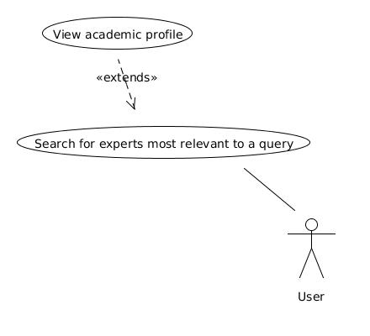

Use Case | Search for experts most relevant to a query
Description | 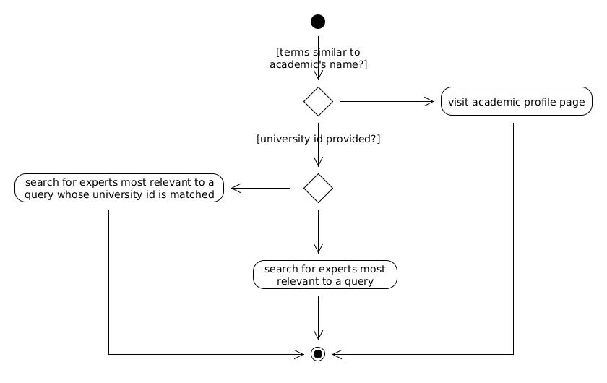  User is able to search for experts most relevant to a query. By default all experts retrieved are ones whose university is registered to SICSA.
Rationale | Allows user to search for experts most relevant to a query.
Priority | Must Have
Status | Partially Implemented
Actors | - User
Extensions
Includes
Conditions
Scenarios
Risks
User Interface

Use Case | View academic profile
Description | 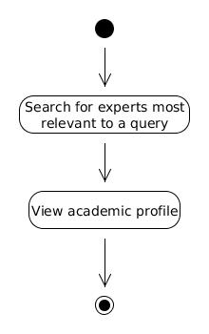  The academic profile page includes  - a list of publications most relevant to a query  - all publications  - most collaborated co-authors  - most popular terms  - project's abstract, status & principal investigator  - project funds & funder
Rationale | Allows user to view academic profile.
Priority | Must Have
Status | Partially Implemented
Actors | - User
Extensions | Search for experts most relevant to a query
Includes
Conditions
Scenarios
Risks
User Interface

3. Non Functional Requirements

Must Haves
Effectiveness | - Help user find relevant experts by using funded projects as evidence.  - Take evidence into account for ranking.
Availability | - Functional 24 hours a day.
Security | - Login and Password required.  - Inactivity timeouts – 30 minutes.
Performance | - Take less milliseconds to search experts.  - Take around 5 seconds to visit academic profile page.
Documentation | - Administrator manual provided.
Integrity | - Data downloaded from dblp database and Research to Gateway (GtR) database.  - Referential Integrity in database tables.  - File system.  - All indexes loaded into main memory.

Should Haves
Usability | - Show evidence of the experts matched to a particular query.  - emphasise simplicity.  - Fully functional for the purpose of the final demonstration.
Recovery | - Update data every 3 months.

