Game Playing Agent Heuristic Analysis
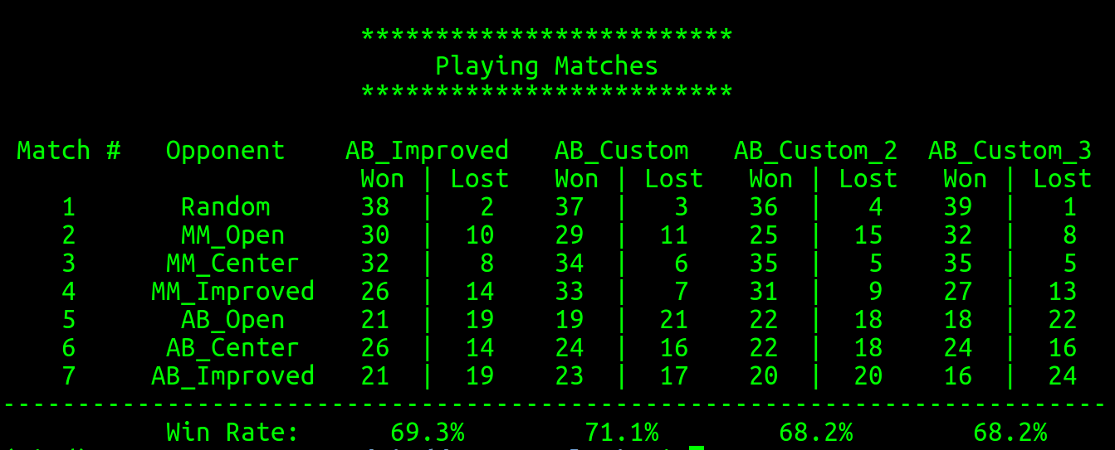
Note: 20 matches are played against each opponent

custom_score
#my_moves - #opp_moves - distance_from_center
This evaluation function is around the assumptions that
1. good moves should provide more moves than opponents’.
2. it’s better to stick around the center of the board if possible as a knight has more moves compared to the edge of the board. The distance function used is Manhattan distance.

custom_score_2
#my_moves - #opp_moves - distance_from_opponent
This evaluation function is around the assumptions that
1. good moves should provide more moves than opponents’.
2. it’s better to stay close to the opponent as much as possible as it has higher chance of blocking opponent’s moves compared to staying away from the opponent. The distance function used is Manhattan distance.

custom_score_3
-distance_from_center
This evaluation function is around the assumption that
1. it’s better to stick around the center of the board if possible as a knight has more moves compared to the edge of the board. The distance function used is Manhattan distance.

Conclusion
Based on the evaluation results, the baseline, improved_score #my_moves - #opp_moves, evaluation is a decent evaluation function giving 69.3% win rate. custom_score_3 uses a single strategy giving 68.2% win rate which is almost as good as the baseline. custom_score then combines both strategies together giving even better win rate of 71.1%. custom_score_2 on the other hand combines the baseline strategy with a different strategy trying to stay close to the opponent but it incurs the performance slightly giving the worst win rate of 68.2%. Therefore, considering all agents with different evaluation functions, custom_score is preferred amongst other evaluation functions.

Furthermore, it can be clearly seen that baseline and all student agents perform better than agents with Minimax. More specifically, agent AB_Improved performs better than agent MM_Improved. This shows that AlphaBeta is better than Minimax. This is because AlphaBeta allows for pruning which ignores search space not contributing to victory. This means agents with AlphaBeta can search more on paths that might lead to victory.

Peeranat Fupongsiripan

