

Cities 168 (2026) 106468
Contents lists available at ScienceDirect

Cities

journal homepage: www.elsevier.com/locate/cities


Real world community oriented high-definition social simulation: Combining reinforcement learning and large language models
Peng Lu ^{a,b,c}, Mengdi Li ^{a,c}, Yuhao Ke ^{b,c,*}, Siyang Liao ^{c,*}
ª School of Public Administration, Central South University, China
^{b} School of Automation, Central South University, China
^{c} Peking University Wuhan Institution for Artificial Intelligence, China

A R T I C L E I N F O

Keywords:
Artificial generative intelligence Large language model
Social simulation Reinforcement learning Machine learning
Dual rewards
A B S T R A C T

Current social simulation approaches face critical limitations in terms of the scale of agents, environmental complexity, and behavioral reliability. This study presents a novel framework combining reinforcement learning (RL) and large language models (LLM) to simulate community-level social dynamics with a large scale and the fidelity. We construct a high-definition virtual replica of Yisheng Garden Community (in Unreal Engine), populated with 3000 AI agents representing diverse demographic profiles derived from real community data. Our dual-reward system integrates micro-level LLM evaluations of individual behavioral appropriateness with macro-level statistical alignment to real smartphone usage patterns. The trained agents demonstrate remarkable behavioral consistency with real residents across multiple validation metrics: smartphone usage patterns achieve over 90 % correlation with real data throughout a week-long simulation, sleep patterns align with established research findings across different demographic groups, and daily activity distributions well reflect authentic social norms. Time-series analysis using Seasonal Auto Regressive Integrated Moving Average (SARIMA) models confirms internal consistency between simulated and real behavioral data. This framework has well addressed the problems about the agent scale limitation, environmental simplicity, and algorithmic bias that constrain existing approaches. Our validated framework establishes a foundation for city-scale social simulation and evidence-based social policy testing in virtual environments.

Introduction

Real world social experiment is one of the most challenging area in computational social science. Traditional empirical studies face ethical constraints, resource limitations, and the impossibility of controlled experimentation on real-world communities (Dunn et al., 2012). Generative AI agent is emerging as a critical methodology for social experiment and policy (interventions) test, which enables us to better understand emergent social phenomena and social changes, in order to achieve better social governance. In this direction, the Stanford Uni-versity team created an AI town with the concept and architecture of AI agents on April 13, 2023. They used the large language model (LLM) to generate 25 AI agents, which primarily realizes the simulation of human behavior with high reliability, thus showing realistic individual and group behaviors in various interactive applications. These AI agents have different personalities and can start spontaneous actions in the virtual world, including getting up, sleeping, working and playing. They
can exchange information about daily life and the environment through encounters and random dialogue. In this way, AI agents can recognize the current environment and decide what to do next. In addition, AI agents can also introspect, form new insights and make long-term plans (Park et al., 2023). This work has primarily shown the potential of using AI agents to simulate social interaction. Other than the AI town, there also exist many other related researches. Zhao et al. designed the Lyfe Agent utilizing the inferencing ability of LLM to simulate the process of crime solving (Zhao et al., n.d.). Tang et al. proposed GenSim, a platform simulating AI agents interacting on-line (Tang et al., 2024). Zheng et al. built AI Economist to simulate human economic activities in a simplified environment (Zheng et al., 2021).
After that, many studies have attempted to simulate human behavior using large language models (Aher et al., 2023; Gao et al., 2023; Park et al., 2023). However, studies have shown that LLM may have value biases, and it is challenging to ensure each generated behavior meets the expected standards (Tabone & De Winter, 2023). With the development

* Corresponding authors.
E-mail addresses: 254601004@csu.edu.cn (Y. Ke), liaosiyang@whai.pku.edu.cn (S. Liao).

https://doi.org/10.1016/j.cities.2025.106468
Received 17 January 2025; Received in revised form 23 August 2025; Accepted 6 September 2025
Available online 23 September 2025
0264-2751/© 2025 Elsevier Ltd. All rights are reserved, including those for text and data mining, AI training, and similar technologies.

of computational social science, RL was more and more used to model and analyze decision-making processes within complex, dynamic envi-ronments (Sutton, 2018). The core components of RL include an agent, a set of actions, a state space representing the environment, a reward signal, and the decision-making policy that the agent follows (Ding et al., 2020). The agent learns to make decisions by acting in an envi-ronment to achieve cumulative rewards by RL (Moussaoui & Ben-slimane, 2023). By learning a value model and using the rewards generated by the RL, it can be expected that the agent tend to behave more human-like (Al Nahian et al., 2024). However, there exist some problems unsolved in the field of social simulation, and we are trying to provide possible solutions to them:

- The scale remains the most obvious barrier. AI Town of Stanford University has only 25 AI agents, Lyfe Agents only supports simulation of 9 agents and there are only 10 AI Econo-mists simulated in the platform of AI Economist. GenSim enables a large number of agents but it has no visualizing method and has the simplest virtual environment overall. In a real community, people's behaviors and reactions are highly varied, but the limited number of agents in AI Town restricts the diversity of interactive scenes and modes for AI agents. This makes it quite difficult to accurately represent real-world communities' complex behaviors (Hutson & Ratican, 2023). This scale mismatch pre-vents researchers from studying the very social processes that matter most for real-world applications. In our framework, we provide simulation of 3000 AI agents which is larger than AI town, Lyfe Agents, and AI Economist. Only GenSim supports more agents than ours with the cost of simplest environment among all the researches mentioned;
- Environmental authenticity presents the second constraint. The AI Town of Stanford University uses simple pixel blocks (patches) to model the community environment. Lyfe Agents uses the graph engine Utility to build an animated 3d-world. GenSim does not have a virtual physical environment and it shows the simulation via a simple web interface. AI Economist constructs a two-dimensional grid world for the agents to interact with. The built environment influences social interactions, mobility pat-terns, and daily routines. Without environmental fidelity, behavioral realism becomes impossible to achieve or validate against real-world data. Our framework, on the other hand, construct the virtual environment exactly the same as a real community. We use Unreal Engine to develop the virtual physical world so that it can simulate the real interaction of the agents with the physical world;
- Algorithmic reliability poses the deepest challenge. AI Town of Stanford, Lyfe Agents, and GenSim all rely on LLM as the main reasoning engine, while AI Economist solely deploy RL. The complete reliance on LLM leads to potential inconsistencies in the actions across different contexts. It is challenging for LLM to ensure the behaviors generated each time meet expected stan-dards and thus poses the risk of uncontrollability. Meanwhile, standard RL is suitable for tasks in specific fields, like AI Econo-mist did with economy, but it is difficult to design the reward system for a much more general case, like human activities in community. Pure LLM-based approaches suffer from inconsis-tency, potential bias, and uncontrollable outputs that undermine scientific reproducibility. The complete reliance on language models leads to potential inconsistencies in actions across different contexts, making it challenging to ensure behaviors meet expected standards. Conversely, traditional RL frameworks excel at optimization but struggle with the open-ended nature of human social behavior. Neither approach alone can balance the flexibility needed for realistic behavior with the control required for scientific analysis. In order to solve the bias of algorithm, we
decide to combine the RL and LLM to avoid the uncontrollability of LLM and take advantage of its general inferencing.
- ABM combined with RL + LLM can be a possible solution.
ABM powered by RL and LLM are revolutionizing social simula-tion. ABM framework based on the RL and LLM has achieved a breakthrough, transitioning from simple task execution to com-plex social behavior simulation by integrating the three core components of planning, memory, and tool use. This enables AI agents to exhibit human-like independent planning, collaborative interaction, and creative behavior (Park et al., 2025). ABM powered by RL and LLM architectures successfully integrate LLM/RL with ABM to create transformational frameworks for understanding complex social systems. Through systematic development of LLM-augmented social simulations, this archi-tecture achieves unprecedented capabilities in modeling human behavior and social dynamics. The integration delivers powerful research toolsets that enable more nuanced, realistic, and comprehensive representations of complex systems, revolution-izing how researchers' study and predict social phenomena through sophisticated computational approaches (Gürcan, 2024). For example, ABM with LLM systems have demonstrated the ca-pabilities in simulating human-like behavior and replicating human prosocial behavior in public goods games across multiple experimental treatments. Beyond reproducing lab results, they predicted responses to novel conditions and exhibited real-world “unbounded actions” like collaboration and cheating (Sreedhar et al., 2025). LLM-powered ABM creates generative agents with human-like cognitive, memory, and decision-making capabilities that interact through natural language, enabling accessible and interpretable social science research by simulating complex public administration scenarios like crisis response without requiring extensive technical expertise (Xiao et al., 2023). It also can create large-scale social simulators by constructing human-like agents with cognition, emotions, and needs that interact in realistic urban environments, enabling low-cost policy experi-mentation and social phenomenon prediction through digital twin societies that can simulate complex behaviors like opinion polarization, crisis response, and economic dynamics (Piao et al., 2025).
Thus, we propose the RL + LLM framework. According to real GIS and BIM data of the real community (named Yisheng Garden Commu-nity), we construct a High-Definition 3D virtual community, as the
training environment of RL. According to real demographic data of this community, we have generated 3000 AI agents. We design the obser-vation capability and action spaces, to simulate 3000 AI agents living in the virtual community. We design a reward system combining both macro and micro level to guide action choices of AI agents. The micro-level LLM reward is based on instant responses from LLM grading. It provides the influence of large social laws on each individual AI agent. The macro-level statistical reward is based on the comparison between real data and simulations. It provides the behavioral pattern of group (macro) level. For the real data, we use the smartphone usage data for 3000 real residents, and the data is updated by each 1/12 h (5 min). Once the model is well trained, we generate community simulation of one week and evaluate the performance based on comparison with real
data and social common senses. This study will address these constraints through a novel integration (RL + LLM). By combining the consistency
of RL optimization with the behavioral sophistication of LLMs, we create a framework that maintains both scientific rigor and behavioral authenticity. Our approach scales to community-relevant populations while grounding simulations in real demographic data and validating outcomes against empirical behavioral patterns. The framework's effectiveness is demonstrated through simulation of a real community with comprehensive validation against multiple behavioral metrics, ensuring that our contributions extend beyond algorithmic novelty to

practical utility for researchers, planners, and policymakers who require evidence-based tools for understanding community dynamics at scale (Table 1).
Key differentiators emerge from this comparison. While GenSim achieves comparable agent numbers, it sacrifices environmental fidelity and uses pure LLM control. AI Town and Lyfe Agents provide sophisti-cated behavioral modeling but cannot scale beyond dozens of agents. AI Economist demonstrates RL effectiveness but only in narrow economic domains. Our framework uniquely combines large-scale capability with environmental realism and algorithmic control, validated against real community data rather than expert judgment. This combination ad-dresses the fundamental limitations that prevent existing approaches from supporting policy-relevant social simulation. With this proposed framework, we can even achieve the simulation of the whole city by integrating the simulations of all communities in the city. The results of such city simulation are able to advise urban policy and planning, such as traffic planning and garbage recycling. Our framework also supports multiple fine-tuning methods to be adopted in other cities or countries.

Results

We deploy the trained model and generate the community simula-tion of one week (7 days). It suggests that our framework (RL + LLM) can yield outcomes that match real data very well, and the action patterns of
AI agents are quite close to real residents in this community, in terms of social common sense.

  - Real data to align with

In order to verify the effectiveness of our simulation, we need to compute and compare the similarities between virtual 3D community and the real one (Stonedahl et al., 2011). The smartphone usage data of this community is obtained at group (macro) level, provided by the Tencent Company who is one of the biggest Internet Company in China. It provides popular mobile applications for Chinese people, such as WeChat, QQ, Tencent Video, and Tencent Meeting. In China, there are more than 1.2 billion people using the services and products provided by Tencent Company. Therefore, smartphone usage data from Tencent Company can largely reflect the real residents. In the rest of this paper, we define the smartphone usage data gathered from Tencent Company as the dataset of “Real Phone Usage”, and simulated phone usage in the virtual community as the dataset of “Simulated Phone Usage”. The dif-ference between two datasets is a key indicator to evaluate the matching degree between the 3D virtual and real community behaviors. There also exist rich amount of research about the sleep times and durations of residents. In this section, we also compare the sleep pattern of AI agents with real residents.
We understand that citizens in other countries present different phone usage habits. For a country where smartphones are not involved in daily life as much as China, other sources of data would be more appropriate. Nevertheless, our proposed framework supports the replacement of phone usage data with any kind of community-related data while remaining effective.
  - Statistical consistency in the week scale

In the one-week simulation, we count the number of people using smartphone inside the virtual community at each time step (t) and then compare it with the Real Phone Usage. In our model, we assume the AI agents use smartphone while they are reading, relaxing, shopping or exercising. In Fig. 1, the blue line shows the trends of Real Phone Usage while the orange one represents the Simulated Phone Usage as we have defined them in Section 2.1. Both Real Phone Usage and Simulated Phone Usage can well present synthetic periods of one day. Simulated Phone Usage has seven peaks from Monday to Sunday (Monday 92.38
%, Tuesday 97.66 %, Wednesday 78.13 %, Thursday 94.53 %, Friday
88.67 %, Saturday 96.48 % and Sunday 91.80 %), which coincides with seven peaks around similar times in the trend of Real Phone Usage. We also compare the timing of peaks between the Real and Simulated Phone Usage. As Fig. 1 shows, From Monday to Sunday, it reaches the peak at 21:15, 21:15, 20:20, 21:10, 21:25, 20:45 and 20:40 for Real Phone
Usage, while it also takes the maximum at 22:10, 21:30, 22:10, 22:10, 22:00, 23:00, and 21:40 for the Simulated Phone Usage. The differences in peaks' timing are less than 1 h. There are also 7 concaves in the Real Phone Usage (Monday 6.52 %, Tuesday 6.46 %, Wednesday 6.57 %, Thursday 5.62 %, Friday 5.33 %, Saturday 8.25 %, Sunday 8.17 %) while the Simulated Phone Usage takes its minimum at the similar times (Monday 8.40 %, Tuesday 7.42 %, Wednesday 9.37 %, Thursday 8.40 %, Friday 7.81 %, Saturday 7.23 %, Sunday 10.74 %). Therefore, the overall statistical outcome suggests that the smartphone usage of the virtual community simulated by the model matches with Real Phone Usage well.

  - Statistical consistency in the daily scale

Fig. 2 shows the trends and basic statistical information of both Real Phone Usage and Simulated Phone Usage in each day for a week. Sub-plots A-G represent the comparison between the Real Phone Usage and the Simulated Phone Usage. In these subplots, blue lines represent Real Phone Usage, and orange lines represent Simulated Phone Usage. Table H of Fig. 2 shows the mean and SD for Real and Simulated Phone Usage for each day. Like the observation made in the scale of one week, the daily result suggests that the trend of Simulated Phone Usage in each day is also consistent with the daily trend of Real Phone Usage. Fig. 2A represents the Real and Simulated Phone Usage on Monday. The blue line represents Real Phone Usage, and it shows that the phone usage continues to decline (78.55 %–9.65 %) between 0: 00 and 6: 00. After 6: 00, it begins to rise slowly until 8: 00. Then, the usage of smartphones is overall stabilized and shows a gradual upward trend until 18:00 when it begins to rise rapidly again. Real Phone Usage reaches the peak (100 %) at 21:15 and then declines immediately. The orange line representing Simulated Phone Usage shares the exact same pattern as the Real Phone Usage through the whole day in the perspective of both critical points and extreme values. The statistical information also shows trivial dif-ference in each day. The difference in mean value takes its minimum of
0.02 on Saturday and the difference in standard deviation (SD) takes its
minimum of 0.002 on Sunday as it shows in Fig. 2H.

Table 1
Systematic comparison with existing approaches.
Approach | Agent Scale | Environment | Algorithm | Validation Method
AI Town (Stanford) | 25 | Pixel-based 2D | Pure LLM | Qualitative observation
Lyfe Agents | 9 | 3D game engine | Pure LLM | Expert evaluation
GenSim | 1000+ | Web interface | Pure LLM | Limited metrics
AI Economist | 10 | 2D grid world | Pure RL | Economic indicators
Our Framework | 3000 | Photorealistic 3D | RL + LLM hybrid | Multi-level real data
 |  |  |  | Time Series Validation
 |  |  |  | Four Levels Similarity Validation

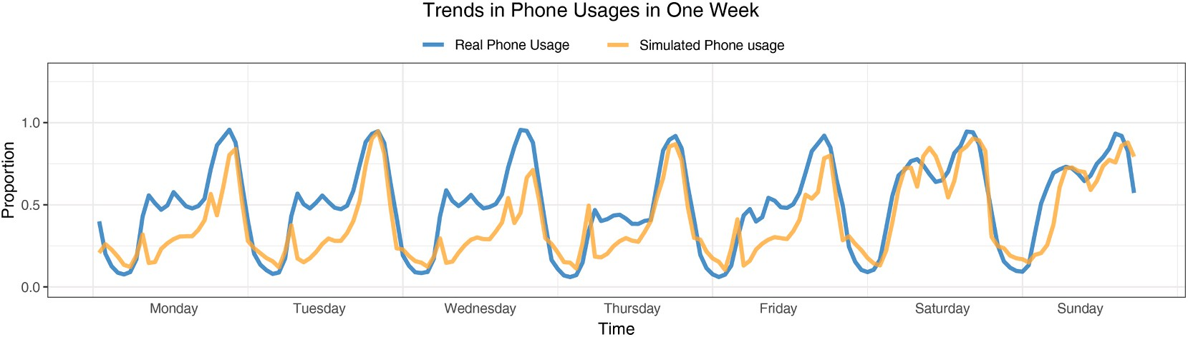

Fig. 1. The trend of Real Phone Usage and Simulated Phone Usage through a whole week. The x-axis coordinates represent time, and the y-axis represents the proportion of Phone Usages.
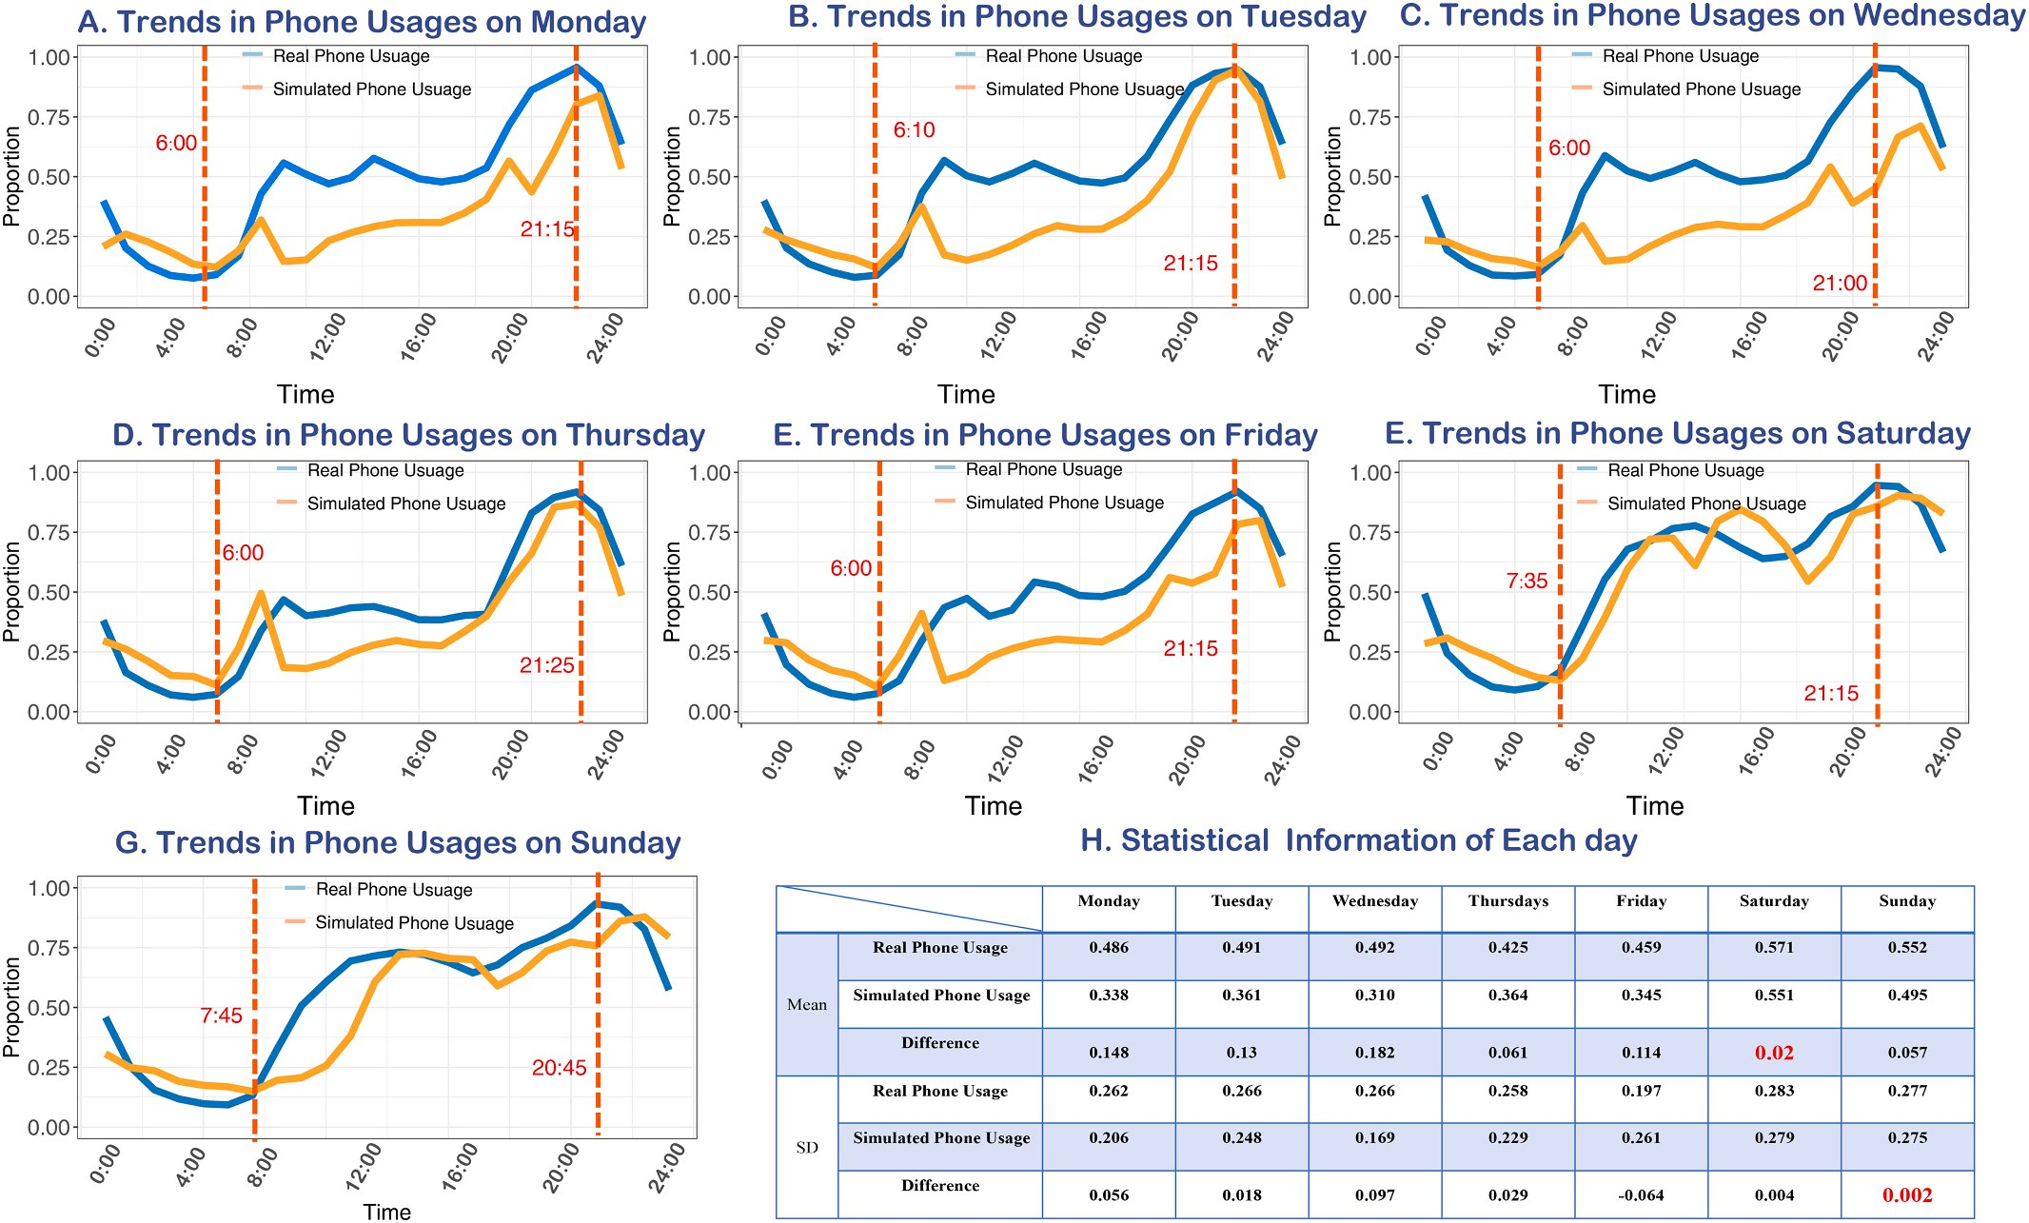

Fig. 2. Detail of Real Phone Usage and Simulated Phone Usage for each day in the week with basic statistical information. In subplots A-G, the blue line represents the percentage in phone usages of Real Phone Usage, and the orange line represent the percentage in phone usages of Simulated Phone Usage. The dotted red lines indicate the maximum and minimum of Real Phone Usage for each day. H is the table showing the mean and SD for Real and Simulated Phone Usage in each day. (For interpretation of the references to color in this figure legend, the reader is referred to the web version of this article.)

  - Inner consistency for two datasets

Other than statistical analysis, we also apply machine learning (ML) to prove (recheck) the well matchiness between Real Phone Usage and Simulated Phone Usage. We use time series analysis to validate the unity of trends and periods. Seasonal Auto Regressive Integrated Moving Average (SARIMA) is broadly used model, in the field of broadcasting features highly related to the time. It is made of two parts, seasonal and non-seasonal, and each part combines differencing with autoregression and a moving average model. For seasonal parameters and non-seasonal parameters, we set two sets. In each set, there are three major param-eters: p stands for the order of the autoregressive part; d stands for the degree of first differencing involved; q stands for the order of the moving average part (Sinuany-Stern, 2021). We divide the Real Phone Usage dataset into two parts, Monday to Thursday (training set) and Friday to
Sunday (validation set).
We have run multiple experiments and found out the optimal pa-rameters for both sets, such as (p ¼ 1, d ¼ 0, q ¼ 1) for seasonal parts and (p ¼ 1, d ¼ 0, q ¼ 1) for non-seasonal part. For Real Phone Usage data, Fig. 3A shows the target and predicted trend from Friday to Sunday
by the SARIMA model, with 95 % confidence interval (CI). The red line represents the Real Phone Usage trend. The blue dots are the predicted values from Friday to Sunday. The shaded band represents the CI range. All predicted points (values) fall into the 95 % CI, and our SARIMA model can predict the smartphone usage of real residents, which in-dicates that real data has inner consistency at the week scale.
For Simulated Phone Usage, we apply the same SARIMA model with the same parameter values, to check the inner consistency at the same time scale (week). We divide the Simulated Phone Usage into two sets, such as the training set (Monday to Thursday) and validation set (Friday

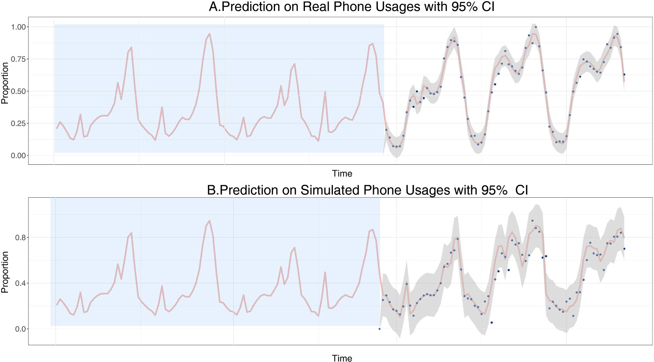

Fig. 3. Validation of matched patterns using the method of time series. Take the data from Monday to Thursday as training set, fit a time series model and use the data from Friday to Sunday to validate it. The red line indicates the data value from Friday to Sunday, the blue dots represent the predictions, and the shaded area represents the confidence interval. A shows the result for Real Phone Usage and B shows the result for Simulated Phone Usage. (For interpretation of the references to color in this figure legend, the reader is referred to the web version of this article.)

to Sunday). Like Fig. 3A, Fig. 3B shows the target trends, predicted value points, and 95 % CI range. Most predicted points are included in the 95
% CI, which indicates that the same SARIMA model can predict simu-lated smartphone usage behaviors of AI agents. Therefore, for either Real or Simulated Phone Usage, the validation set can be well predicted by the training set. Hence, the outcome of our simulation can largely reflect the inner consistency of real-world social actions of real residents.

  - Performance evaluation metrics

In this paper, we bring up 4 metrics to evaluate the performance of simulation. In order to evaluate, we smooth the real data simulated data by taking the hourly summation and evaluate the performance based on these smoothed data (Table 2).
Structural image similarity (SSIM) index is one of the most popular measurements for the similarity between images. It evaluates lumi-nance, contrast, and structure of two compared images in the set of corresponding windows around image pixels (Starovoytov et al., 2020). In our research, we construct two images – “real image” and “simulated image” using smoothed real data and simulated data. We first reshape the smoothed data into arrays with 24 rows and 7 columns representing 24 h and 7 days. We multiply the values inside the arrays by 255 to transform them into standard form of images. Then, we compute the SSIM index for these two images. The value of SSIM index represents the similarity in absolute value, trends within days and trends through the whole week between real and simulated phone usage. The range of SSIM index is between 0 and 1, and our simulation achieved an outstanding score as 0.79.
Fourier Transform (FT) is a mathematical operation that decomposes

Table 2
Summary of the metrics used and their values used for performance evaluation.

Metric Value
SSIM 0.79
Phase Shift —1.48 h/—0.06 h
KL-Divergence 0.071
DTW-R² 0.99
a time-domain signal into its constituent frequency components, revealing both amplitude and phase information across the frequency spectrum (Bracewell, 1989). In this paper, FT was applied to detect timing discrepancies between real and simulated data, leveraging its ability to decouple overlapping periodic behaviors. We compute the phase difference between the real and simulated data under two main
frequencies: one-day and half-day. The phase difference is —1.48 h under the frequency of one day and —0.06 h under the frequency of half
day. If we assume the period of phone usage is one day, then the apex of simulated phone usage is 1.48 h earlier than the real ones. Likewise, if we assume the period of phone usage is half a day, then the apex of simulated phone usage is only 0.06 h earlier than the real ones.
Kullback-Leibler Divergence (KL-Divergence) is a non-symmetric measure quantifying the difference between two probability distribu-tions (Biglieri, 2022). The divergence of distribution P from distribution
Q is computed as D_{KL}(P∣|Q) = ∑ P(x)log ^{P(x)}. In our research, we
Q(x)
normalize the real and simulated data to convert them into the form of distribution. Their value can be then considered as the probability of using mobile phone at a certain timestep. This approach and metric is suitable for assessing distributional alignment in phone usage data because it focuses on relative entropy rather than absolute values. The value of KL-Divergence of the simulated data from the real data is 0.071. The range of KL-Divergence is from zero to infinity and value below 0.1 is an indication of similar distribution in the field of statistics. The value
0.071 indicates that the simulated data only has minor deviation from the real data.
Dynamic Time Warping (DTW) is a robust algorithm designed to measure similarity between two temporal sequences that may vary in speed or length, by computing an optimal alignment path that mini-mizes the cumulative distance between them through nonlinear warping of the time axis (Müller, 2007). The optimal warping path identified in the analysis of real versus simulated data signifies the sequence of point-to-point matches that minimizes the total cumulative distance between these two temporal sequences. After we compute the optimal wrapping path, we let the time indices of real data in the point-to-point matches be the independent variable (x) and the time indices of simulated data as
dependent variable (y). If the linear equation y = x can fit the point-to-

point matches well, we can conclude that these two temporal sequences are quite similar. We calculate the predicted values using the equation y
= x and then compute R2. The value of R2 is 0.99, which means the optimal path is very close to the equation y = x, thus indicating the real data and simulated data are very similar. We visualize the pairs of time
indices and the desired regression line with 10 units y-intercept shifted region in Fig. 4. All the points fall inside the shifted region, which in-dicates that all the pairs of time indices have difference less than 10 units.
Overall, we evaluate the performance of simulation with four different metrics. SSIM evaluate the structural similarity between the real and simulated data, FT enables us to measure the phase shift of simulated data from real data, KL-Divergence evaluate the simulation by transforming the data into the form of distribution and DTW yields an optimal wrapping path that indicates the similarity between real and simulated data. With all of the four metrics, the simulation of the phone usage can be evaluated as sound and valid.

  - Matched sleep patterns for weekdays and weekends

Fig. 5A shows the number of AI agents sleeping at each timestep through a weekday. AI agents go to bed and wake up at different timings, but during the same time interval, which is close to real people. The number of AI agents sleeping starts relatively high at 0:00 and it in-creases for approximately 5 h. Then it drops rapidly between 6:00 and 8:00, indicating that most AI agents get up during this period. This pattern matches social natural norms of real residents. The number stays low during the daytime and begins to increase after 20:00. The gradual rising from22:00 to midnight indicates that most people go to bed in this time interval. The line continues going up smoothly after 0:00, indi-cating some people staying up late at night and therefore, go to bed at various times.
Besides the start time of the sleep, we also investigate the sleep duration of AI agents in the same day and compare it with existing
research, to further verify the effectiveness of our simulation. Fig. 5B & C show the distributions of sleeping duration in a weekday and on weekends. Fig. 5D & E show the difference in sleep duration distribution among different life stage groups. As Fig. 5B shows, 52.78 % of AI agents sleep 7–10 h at weekday. Researchers conducted questionnaire surveys
at the Boston Science Museum from February to May 2009, distributing 48-question surveys to adult visitors that included the Horne-O¨ stberg
MEQ, the Pittsburgh Sleep Quality Index (PSQI), the Epworth Sleepiness Scale (ESS), the Munich Chronotype Questionnaire, as well as 12 addi-tional questions addressing general sleep habits. Results showed most participants reported approximately 7.55 ± 1.22 h of weekday sleep (Roepke & Duffy, 2010), which is consistent with our study. Only 22.62
% of them sleeping for more than 10 h during the weekdays. Through large-scale cohort studies and objective measurement technologies, including wearable devices (such as Fitbit), activity recorders, stan-dardized questionnaires, and systematic reviews with meta-analysis, scientists analyzed 50 million nights of sleep data from 73,513 partici-pants in the British Biobank study, 38,015 participants in the Swedish national cohort study, and more than 220,000 total participants. The research found that participants slept more than 10 h on weekends, which also matches the empirical finding that some people sleeping for more than 10 h (Gallicchio & Kalesan, 2009).
Existing research indicates that sleep duration shows significant differences between weekdays and weekends. During the weekdays, people who accumulate considerable sleep debt compensate on week-end by lengthening their sleep by several hours (Roenneberg et al., 2003). Fig. 5C & E represent the sleep pattern of AI agents during the weekend. The values of sleep duration in these two subplots stand for the average of Saturday and Sunday. We found that during weekdays, considerable amount of AI agents sleep less than 6 h, and most AI agents (20.24 %) sleep for 8–9 h. However, Fig. 5C indicates no AI agents sleep less than 6 h, and most of them (26.19 %) sleep for 11–12 h in average and retired seniors sleep for 6.50 h in average during the weekday. This sleep pattern differences fit with the previous research that seniors tend

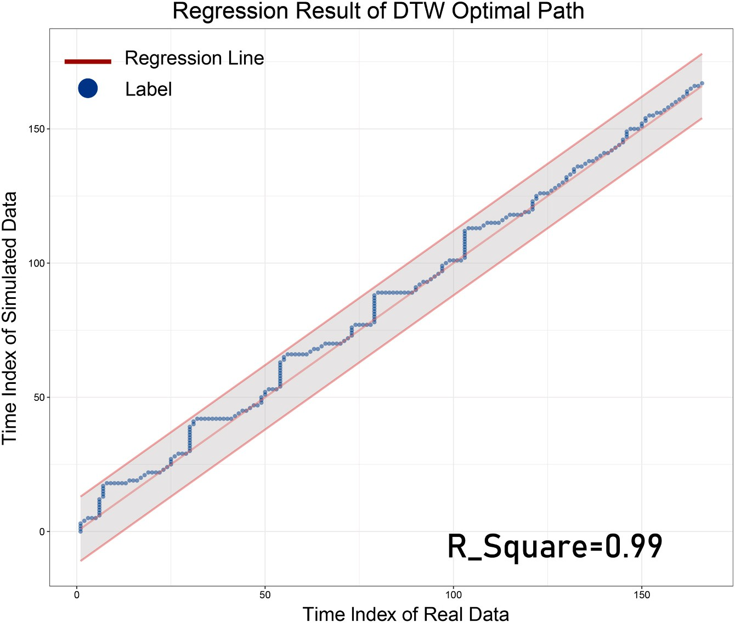

Fig. 4. DWT-R² and corresponding regression performance. We let the time indices of real data in the point-to-point matches be the independent variable (x) and the time indices of simulated data as dependent variable (y). We test if the line y = x is an appropriate regression for the data points. The blue dots in this figure represent the pairs of indices and the pink line represents the regression line y = x. The shaded area represents the shift with 10 units of y intercepts. (For interpretation of the references to color in this figure legend, the reader is referred to the web version of this article.)

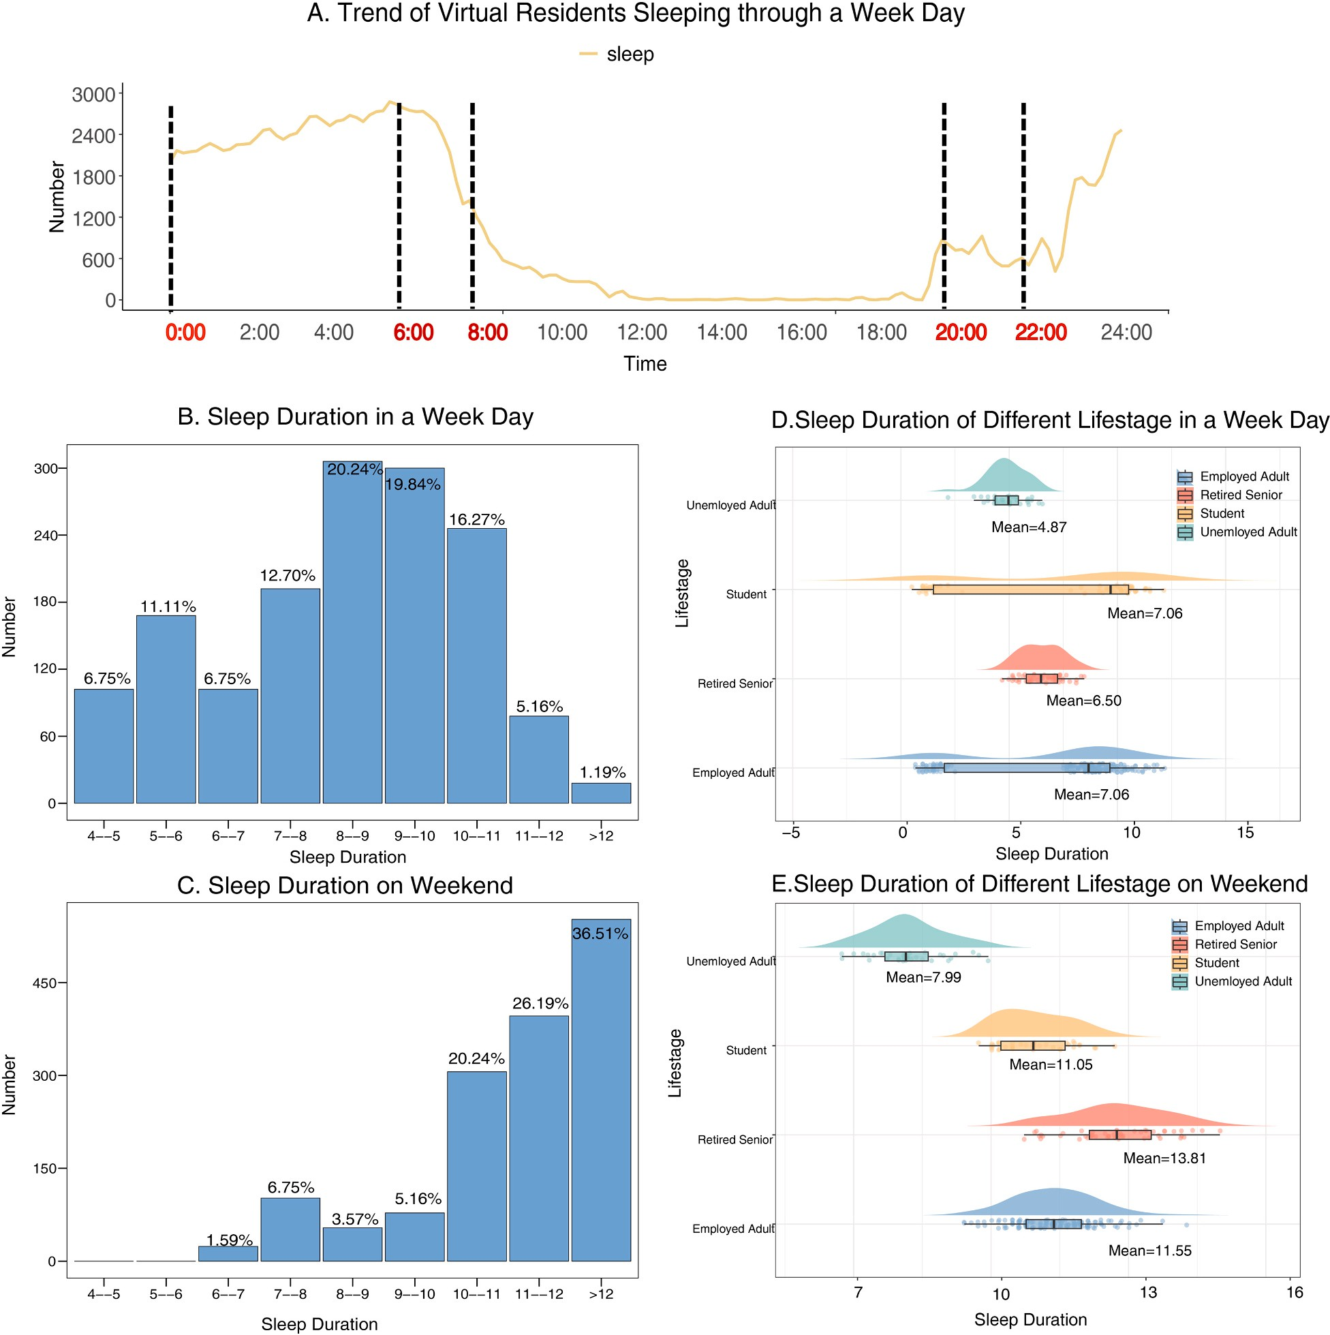

Fig. 5. The sleep patterns for different life stage groups in a weekday and on weekend. Panel A shows the number of AI agents sleeping at each timestep through a weekday. The x-axis coordinates represent time, and the y-axis represents the number of different people taking each action through a weekday. B and C show the distributions of sleeping duration in a weekday and on weekends. The x-axis coordinates represent sleep duration, and the y-axis represents the number of people. D and E shows the difference in sleep duration distribution among different life stage groups. The x-axis coordinates represent sleep duration, and the y-axis represents t different life stages.

to sleep for less time than students and adults (Hirshkowitz et al., 2015). For the weekend, Fig. 5E shows that unemployed adults and retired seniors sleep for 4 to 5 h, while the employed adults and students sleep for 8 to 9 h in the simulation. For our simulation of all life stage groups, AI agents sleep more during weekdays than during weekdays but employed adults and students still sleep for more hours than unem-ployed adults and retired seniors. This pattern can be explained and can reflect the behaviors of real residents. As employed people and students sleep less on weekdays, they tend to sleep more on the weekends.

  - Simulations supported by social common senses

Fig. 6A shows the trend (number) of AI agents doing each activity through a weekday (we take Monday as example). Based on this, we
compare the action patterns of two groups (employed adults and stu-dents) by the difference in action curves (working and studying). The trends of working and studying fit the observations of these actions in real community well. These two actions (working and studying) both rise rapidly in the morning, stay unchanged for the daytime, and then fall in the afternoon. The difference is that the curve for working starts to rise earlier than studying, and it declines later than studying. It also shows that the curve for working grows and drops more smoothly. In real society, people's day shifts start at various timings. Some start their work at 7:00, while some others start at 10:00 (Soldatos et al., 2005). Respectively, some people's shifts end at 16:00 while some others end at 20:00. For students, the period of school time is much more regular and stable. Most of the schools start and end at similar times, therefore students tend to start and end the action of studying at similar times

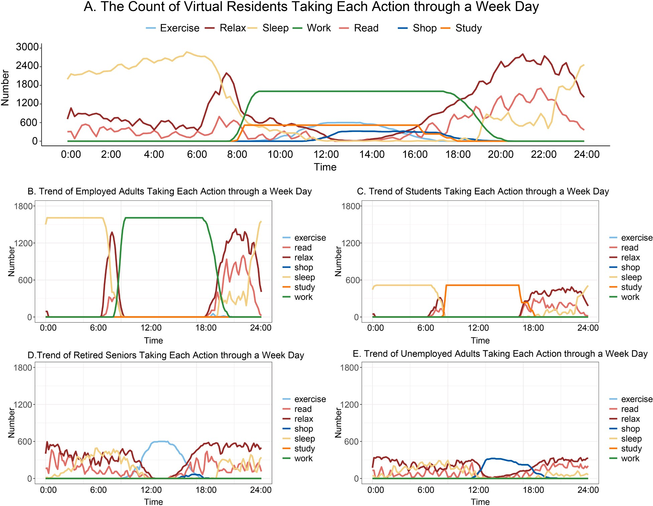

Fig. 6. Trend of AI agents taking each action through a weekday. The x-axis coordinates represent time, and the y-axis represents the number of people. A shows the trend for all the AI agents, B shows the trend for employed adults, C shows the trend for students, D shows the trend for retired seniors and E shows the trend for unemployed adults.

(Kelley et al., 2017). Therefore, the curves of these two simulated ac-tions can largely reflect the social common sense that also affects real residents.
We then focus on the difference among four typical life stage groups to further check whether simulated behaviors of AI agents can be vali-dated by social laws and regulations (social common sense). Fig. 6B, C, D&E represent the trend (number) of AI agents in each Life Stage doing each activity through the same week day. Generally, in the society, students and employed adults leave home for school or work in the morning and return home in the evening, showing strict regularities in their daytime schedules, which can be reflected by the stable and flat surface found in the curves of studying and working. However, most students would go to a school near home, while most of the employed adults have to endure commuting time over 30 min (Koslowsky et al., 2013), which leads to the timing difference in commuting. This pattern difference can be reflected by comparing the curve slopes of employed adults in Fig. 6B and students in Fig. 6C. It suggests that the curve slope of employed adults is much shallower than the students. The steeper slope for the students indicates that they would spend less commuting time than employed adults. Hence, the action pattern of AI agents (employed adults and students) can be largely supported by social common sense. The verification from social common sense can be also found in the other two groups. For the retired seniors, existing research shows that they tend to exercise inside the community while unem-ployed adults tend to go shopping during the daytime and they would take these actions casually (Simek et al., 2015). Fig. 6D & E show the
trends (numbers) of AI agents (unemployed adults and retired seniors) taking each action during a weekday. The curve of AI agents (retired seniors) exercising and the curve of AI agents (unemployed adults) shopping both grow in the morning, reach the peak in the noon, and start to drop in the afternoon. The AI agents (retired seniors) start to exercise at different times in the morning, during 6:00 and 12:00. The number of AI agents (retired seniors) exercising takes its maximum at 12:00. This maximum stays for an hour and then it keeps decreasing in the afternoon, indicating that they return home at various times in the afternoon. This action pattern of AI agents (retired seniors) is consistent with the real-world retired seniors that they tend to exercise inside the community during the daytime.
AI agents of unemployed adults start to go shopping at different times in the morning from 10:00 to 12:00. The number of them shopping takes its maximum at 13:00 and then decreases gradually in the after-noon, indicating they return home at various times. This action pattern of AI agents (unemployed adults) is consistent with real-world unem-ployed adults in this community that they tend to go shopping during the daytime (because they do not have to work). Generally, in real so-ciety, unemployed adults and retired seniors are free from strict daily working schedules and take their actions more casually than students and employed adults. By our simulation, the curves for trends (numbers) of them exercising and shopping have narrow peaks at their maximums, unlike the stable surfaces presented by the curves of employed adults and students in Fig. 6B & C. This indicates that the AI agents of retired seniors and unemployed adults follow less strict daily routine than

students and employed adults, which is consistent with real-world pat-terns of retired seniors and unemployed adults. Hence, the simulation of AI agents (retired seniors and unemployed adults) can be largely sup-ported by the social common sense.
Fig. 6 illustrates the crowd behavior from the perspective of actions, and Fig. 7 provides another independent proof source, by investigating typical locations of them at various timings for the same weekday as Figs. 5 & 6. Fig. 7 presents the location dynamics (distribution) of AI agents through a weekday. The curve of AI agents located at working place has the same shape of AI agents (employed adults) working in Fig. 6A. Similarly, the curve of AI agents located at school in Fig. 7A has the same shape of related AI agents (students) studying in Fig. 6A. This pattern consistent reflects social common senses that only students would go to school and employed adults go to workplaces (In our framework, we mark the school as working place for adults who works there). The curve of AI agents located at community public area in Fig. 7A has the same shape of AI agents (retired seniors) exercising in Fig. 6D, and the curve of AI agents located at shops in Fig. 7A has the same shape of AI agents (unemployed adults) shopping in Fig. 6E. These shared patterns can also be supported by social regulations in China that retired seniors would exercise in public area inside the community while the unemployed adults tend to go shopping nearby during the daytime. Fig. 7B, C & D provide the location distribution of AI agents at three different timings. At 8:00, most AI agents are still at home, some (employed adults and students) are already located in their working places or schools, and there is no AI agent located in the community public area or shops in Fig. 7B. Obviously, this pattern satisfies real-world social common sense in China that, in the morning, most stu-dents and employed adults would leave home earlier than unemployed adults or retired seniors. At 14:00, the AI agents are located more evenly in Fig. 7C. Most AI agents located in working place, which reflects the social fact worldwide that employed adults take the majority proportion in the society. At 19:00, most AI agents are located at home, but there are still some AI agents located at working places in Fig. 7D. This is also consistent with real social phenomenon in China that some employed adults would end their shifts later in the night and return home quite later than others. Hence, the location dynamics of AI agents can be largely supported by related social phenomena, social regulations and
social common sense in China or worldwide.

Discussion

In this paper, we have proposed a combined social simulation framework of AI agents, which has been applied to simulate the social actions of residents in the community level society. We have found that this framework is effective in community-level social simulation. The combined design of dual rewards in both micro-level and macro-level has also shown effectiveness for the training process. The macro-level statistical rewards are gained based on the difference between Real and Simulated Phone Usage, and the consistency between two datasets can validate the reasonability and effectiveness of macro-level statistical reward. The micro-level LLM reward is calculated based on the grades of LLM. It rates the normality degree of social actions for individual AI agents. In other words, the grade of LLM can train them to take appro-priate (normal) actions at different times. The matched behavior pat-terns between AI agents and real residents suggest that the micro-level LLM reward also largely supports our social simulation. Overall, our framework adopts mature and robust training methodology (RL) and it has been proven to be valid. It successfully trained a feasible and flexible policy via the comprehensive reward system containing two layers such as the macro-level (statistical data) and micro-level (LLM grading).
This social simulation framework yields promising results, and most
of them are close to real social system. Simulated Phone Usage (simu-lation results) is consistent with Real Phone Usage (real community level data). The inner consistency between them has also been proved by the ML method (time series analysis). The sleep patterns of AI agents agree with previous social research, for different life stage groups and for different timing (weekdays and weekends). The trends (numbers) of AI agents taking each action are well supported by the social common senses and the behavioral patterns of the 4 different life stage groups are well matched with real residents. The dynamical location distributions of AI agents share same patterns as real resident actions. This consis-tency is also supported by the social laws and regularities in China or worldwide.
In our research, we found general community rules by investigating the action and location history records and all of these records are open

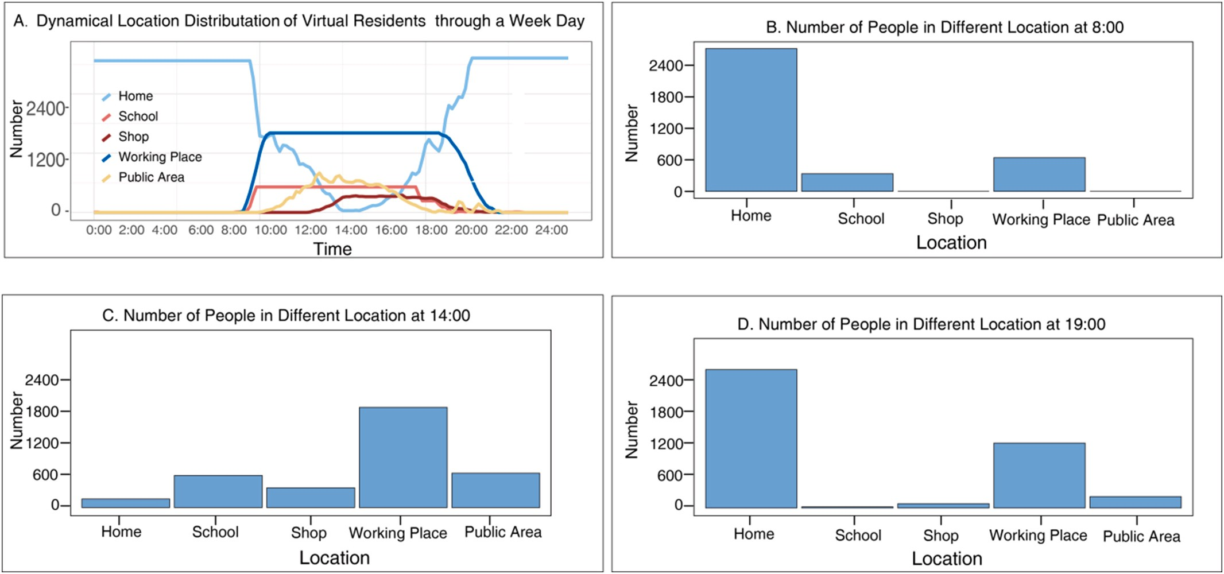

Fig. 7. The dynamical location distribution of AI agents at different timing during a weekday. A shows the overall dynamical location distribution of AI agents. The x-axis represents time, and the y-axis represents the number of people in different location. B, C and D indicate the location distribution of AI agents in three specific timings: 8:00, 14:00 and 19:00.

sourced to all scholars. These community rules can be further validated by scholars from other perspectives using data from other sources. For example, social organizations may be interested in the action histories of the elders. If they already gathered such data from real elders, our community rule about elders' action patterns can be further validated by them. We also look forward to new interpretations of our results from other filed of studies. For example, social activists may be interested in the number of people gathered in the public area inside the community. In this case, the location history record can provide the accurate data for them. Economists may be interested in the population flow through different gates of the community. The action history records the exact gate agents go through when going out or into the community. The accurate population flow through all directions can thus be computed. Our framework also provides considerable portability to be per-formed in different cities. The most resource expensive way is to train an entirely new model based on different cities and citizens. The second way is to fine tune the base model we already have using the data of new cities and citizens, which is a more economical method. The most resource friendly way is to adjust action masks in the configuration file representing specific rules or legislation of different countries or cities.
By either method, our framework is able to achieve valid community
simulation.
In the future, we will construct a city simulation system based on our proposed community simulation framework. Modern city is a complex system composed of communities; therefore, city simulation can be made by integrating the simulation of multiple communities. The results of such city simulation can be used for urban policy and planning. Traffic planning is an important work of urban governance. With our simulation framework, we are able to simulate the commuting destination and commuting method of each resident in each community, providing valuable reference for traffic planning of a city. Other than traffic planning, public resource distribution has also been a delicate and important task for urban governance. Once we build valid simulations for all the communities in the city, we are able to observe the difference in the needs of various resources among communities. For example, our simulation framework can provide information to infer the amounts of different types of garbage produced in each community. Decision maker of the city can adjust the resource for garbage recycling instructed by this simulation result.
Although the current framework can well simulate residents' be-haviors in specific community, we need to point out potential limitations and future improvements. The first is the variance of environment and actions. We have not constructed nearby environment of the commu-nity, such as the spaces like schools and companies. And we have not constructed the visualization for the actions in these spaces yet. In the future, we plan to expand the environment with more buildings and more complicated spaces, to enlarge our action space so that the AI agents can take more detailed actions such as sporting and napping. The second limitation is the lack of AI agents' inner motivation. Our frame-work now only simulates physical behaviors, which is not enough. The motivations of AI agents should be included. Peng et al. claim that evaluation of AGI should be rooted in dynamic embodied physical and social interactions (Peng et al., 2024), hence the construction of physical and emotional needs is necessary. In the future, we will introduce the element of motivations when we design the action policy model for AI agents to choose so that their behavior would also reflect how the motivation drives the actions of real residents. The third limitation is the portability of algorithm. The environment we built now is based on one specific community in Wuhan. We have not verified if the algorithm we developed is also applicable for other communities. In the future, we would deploy the same framework for other communities to verify the portability of our algorithm.

Materials and methods

  - Constructing high-definition virtual community

We initiate the modeling of movement within a specified community region using virtual simulations. This virtual modeling is accomplished with Unreal Engine (UE), which is a software development tool designed for creating interactive applications, which includes components such as a graphics engine, animation tools, physics engine, sound engine, and scripting capabilities. It is a versatile tool in the field of video games. Many famous games like PUBG, FIFA and Black Myth Wukong are built with it. With the support of UE, we can visualize the virtual community vividly.
Fig. 8 shows the details of virtual community (Yisheng Garden Community). Consisting of 1848 households, it is an accommodation-business mixed complex and is located at Wuhan City in China. Fig. 7J & K show the real GPS image of this real community and the upper view for the virtual community we constructed. All the buildings and path-ways in the real community are included in this virtual community. As it shows in Fig. 8A & C, we construct the virtual main entrances situated between Buildings 3 and 6 on the eastern side and between Buildings 7 and 11 on the southern side with all the details matched with the real community. These entrances are decorated by tall, orderly placed tree arrays, pedestrian pathways, and recreational green plazas. In total,
38.15 % of the community is covered by green land, enhancing the urban streetscape and creating a warm and vibrant community atmosphere.
Other than the main buildings and public area, we also model high-resolution details inside the buildings as shown in Fig. 8G & H & I. Our community-level social simulator provides users all the details of the resident in the community from bargains in the markets to evening walks in the park. Users can explore every corner of this virtual com-munity, keeping track of any resident of interest via a friendly interface.

  - Generative modeling of AI agents

Under real-world limitations, we cannot obtain detailed information (data) of individuals or residents in the community, which hinders the development of traditional social research. However, we can largely simulate real-world people using generative AI agents. Based on group-level features of the real residents, we generate following features for AI agents: Gender, Age, Marital Status, Educational Level, Life Stage, Car Ownership, Commuting Distance, Commuting Methods, Career, Routine Action, Action Time, and Go Home Time.
Table 3 shows the list of group features that we have collected from social surveys in this community. The features of Gender, Age and Commuting Method are generated independently with the ratio pre-sented in Table 3. The distribution of marital status in Table 3 indicates the married/single ratio among the eligible populations, which is composed of male no younger than 22 years old and female no younger than 20 years old (according to Civil Code of the People's Republic of China). Thus, we mark all the ineligible agents as single and then generate the Marital Status for the remaining individuals according to the distribution. We apply similar approaches to generate other features. There exist age bounds for each level of education. Residents need to be at least 12 years old to graduate from primary schools, at least 15 years old to finish middle school, at least 18 years old to graduate from high schools and at least 22 years old to graduate from colleges. Thus, we set the potential Educational Level for the agents according to their ages and then allocate the value according to the distribution. The law reg-ulates that people under 18 years old are not allowed to drive, so we mark all the ineligible agents as “No” for the feature of Car Ownership; the feature of the Life Stage is bounded by the value of Age and Gender as only male older than 60 or female older than 55 could be retired and only agents older than 18 could be employed/unemployed adults; the feature of the Commuting Duration is dependent on the Age and Life

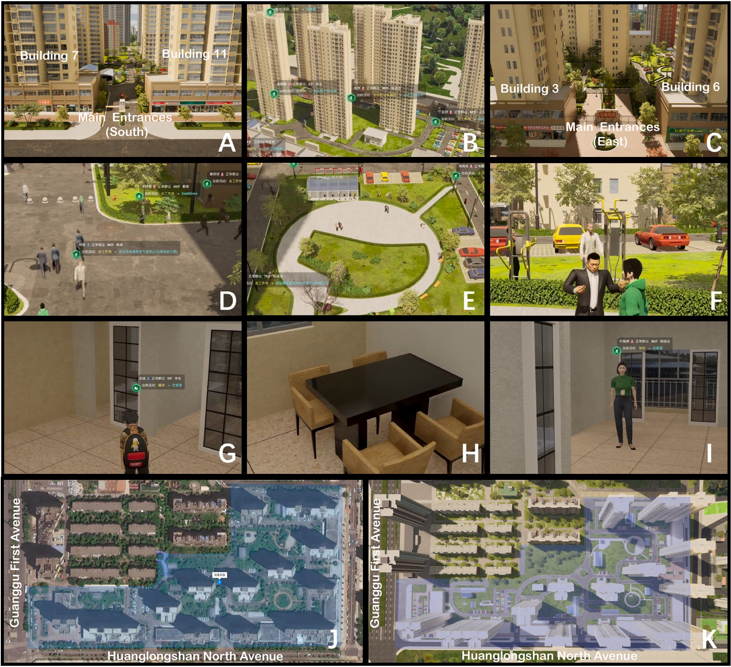

Fig. 8. This is a set of screenshots taken from the virtual community and a GPS image (J) showing the boundaries of the real community. A and C show the main entrances located in the southern and eastern side of the virtual community. B presents an overview of the whole virtual community. D shows the detail of the pathway inside the virtual community. E shows an overview of the exercise park in the virtual community and F gives a closer look with two residents in it. G, H and I shows the details inside the apartments of the virtual community.

Stage since retired agents and agents under 3 years old does not need to commute regularly. Besides, the feature Career for AI agents is generated from the statistical data collected in the Seventh National Census in 2021. The specific proportion is listed in Table 4.
Routine Action is the feature representing the daily action taken by the agent. It usually starts in the morning and is decided by the agent's Life Stage. In the real society, students spend most of their time studying and employed adults spend most time working. Thus, we assign “Go to School” and “Go to Workplace” for the agents of these two life stages. Unemployed adults and retired seniors, on the other hand, do not follow strict daily routine like students and employed adults. Therefore, we assign None to Routine Action of agents experiencing these two life stages.
The feature Action Time indicates the usual time of Routine Action. For students, we assume the start time of first class is normally distrib-uted. According to previous social surveys, the mean value of start time is 7:35 and the standard deviation (SD) is 30 min (Karan et al., 2021). We draw the start time from this distribution and subtract Commuting Duration from it to generate Action Time. For the employed adults, we set the Action Time as 9:00 subtracted by the agent's
Commuting Duration.
According to the data from Wuhan Municipal Education Bureau, the Class Release Time for primary school students is 16:30, and 17:30 for middle school students. The feature of Go Home Time for students is set the same as the Class Release Time. For employed adults, we draw the value of the working duration from the normal distribution N 9, 1² , and add it to the timing of going to work to generate the Go Home Time for employed agents.

  - Reinforcement learning algorithm
)

In a general RL framework, there exist an environment and agents can interact with the environment including other agents. We define the set of environment and agent as state space, which is denoted as S. Then, we define the action space set containing all possible actions for agents, denoted as A. After an action is taken, the state will somehow change.
We define the reward from s to s′ under action a as R_{a}(s, sʹ). At time step
t, the agent observes the state S_{t} and receive the reward R_{t}. Then, it takes the action A_{t} and interact with the environment. The environment
moves to a new state S_{t+1}, and then presents S_{t+1} and R_{t+1} to the agent, at next time step (t + 1). In this process, our goal is to find the relation, called policy function π : S × A→[0,1], which represents the probability

Table 3
The features and according distributions of the virtual residents from survey data.
Table 4
The features and according distributions of the virtual residents from statistical data.

Survey data |  |  | National census data in 2021
Gender |  |  | Career
Male | 51.17 % |  | Agriculture | 0.47 %
Female | 48.83 % |  | Mining | 2.04 %
 |  |  | Manufacture | 22.40 %

Marital status
Married 72.72 %
Resource 2.25 %
Construction 11.00 %
Retailing 4.71 %

Single | 27.28 % | Transportation | 4.65 %
 |  | Food and Accommodation | 1.53 %
Age |  | Information Technology | 3.17 %
0–17 | 21.11 % | Finance | 4.43 %
18–24 | 7.34 % | Real Estate | 3.07 %
25–30 | 8.36 % | Rental Service | 4.42 %
31–35 | 8.36 % | Scientific Research | 2.73 %
36–40 | 6.87 % | Public Service Management | 1.52 %
41–45 | 6.79 % | Resident Service | 0.54 %
46–60 | 23.36 % | Education | 11.69 %
>61 | 17.81 % | Health Industry | 6.68 %
 |  | Entertainment | 0.88 %
Educational level |  | Social Benefits | 11.82 %

Primary school | 12.78 %
Middle school | 17.80 %
High school | 7.75 %
Community college | 4.10 %
Bachelor degree | 3.44 %
Master degree | 0.35 %
PhD and higher 0.47 %

Life stage
Students 21.11 %
Employed adults 52.5 %
Unemployed adults 8.90 %
Retired seniors 14.10 %

Car ownership
Yes 41.67 %
No 58.33 %

Commuting method
Walk 2.60 %
Bike 5.30 %
Car 59.6 %
Public transportation 29.1 %
Other 3.4 %

Commuting duration
<15 min 36.40 %
15 min–30 min 35.80 %
30 min–60 min 19.9 %
>60 min 7.9 %

Class release time
Primary school 16:30
Middle school 17:30

of each action under a specific state, in order to maximize the long-term return defined in Eq. (1) (Sutton, 2018). Furthermore, the expected long-term return at the state s with the policy π is given by the Bellman Equation in Eq. (2). At state s, we would also want to know whether a specific action a would yield better return than other actions on average, under the policy π. This difference is defined by Advantage Function as shown in Eq. (3).
∞
∑
G = γ^{t}R_{t+1} = R₁ + γR₂ + … (1)
t=0
Equation 1: The Bellman Function representing the long-term return G as the sum of discounted instant reward with discount rate of γ from
Data source: The seventh National Census in 2021.

time step 0 to infinity.
V_{π}(s) = E_{π}[G_{t}|S_{t} = s] = E_{π}[R_{t} + γGt+1|S_{t} = s] (2)
Equation 2: The Bellman Equation defines the value function as the expected long-term return since timestep t given state s. It is also equal to the reward at timestep t plus the discounted return at timestep t + 1.
A_{π}(s, a) = Q_{π}(s, a) — V_{π}(s) (3)
Equation 3: The advantage function defines how much better the action a is than other actions at state s. Q_{π}(s, a) stands for the long-term return if the agent choose action a at this timestep and then perform under policy π. V_{π}(s) stands for the standard Value under policy π.
Mnih et al. (2015) introduced neural network to represent the policy function and successfully trained the agent to play video games properly (Mnih et al., 2015). It decides the agent's action and is then called policy network and the reward of each time step (t) is used for the training (Fig. 9). There are multiple state-of-the-art methods to optimize the policy network, and we decide to implement Proximal Policy Optimi-zation Algorithms (PPO). The main reason is that agents we created can be considered as players whose goal is to achieve the highest rate in “behaving normal” and PPO can achieve promising performance for various games (Yu et al., 2022). It constructs the surrogate loss for the policy network that restricts the update in a certain level and encourages the increase of entropy (Schulman et al., 2017).

  - The application and improvement of LLM

As large language model shows the potential to simulate human actions, we apply it to our RL framework. In earlier times, the language models are often small and aimed to do specific finite tasks. Then, Google researchers (2017 NeurIPS conference) introduced the trans-former architecture in their landmark paper “Attention Is All You Need” (Vaswani, 2017). This architecture eventually became a milestone for the technology of language models. The models inspired by the trans-former architecture could have enormous number of parameters, which brought up the concept of “Large” Language Model (LLM). By the time of September 2024, the most famous and probably the most powerful LLM is the model o1 published by OpenAI (Wang et al., 2024). It achieves to establish the long-term thinking ability for the model and can beat human experts in various academic competence. Despite the capability of o1, OpenAI does not provide the source code for users to set up locally. On the other hand, there also exist some other models available

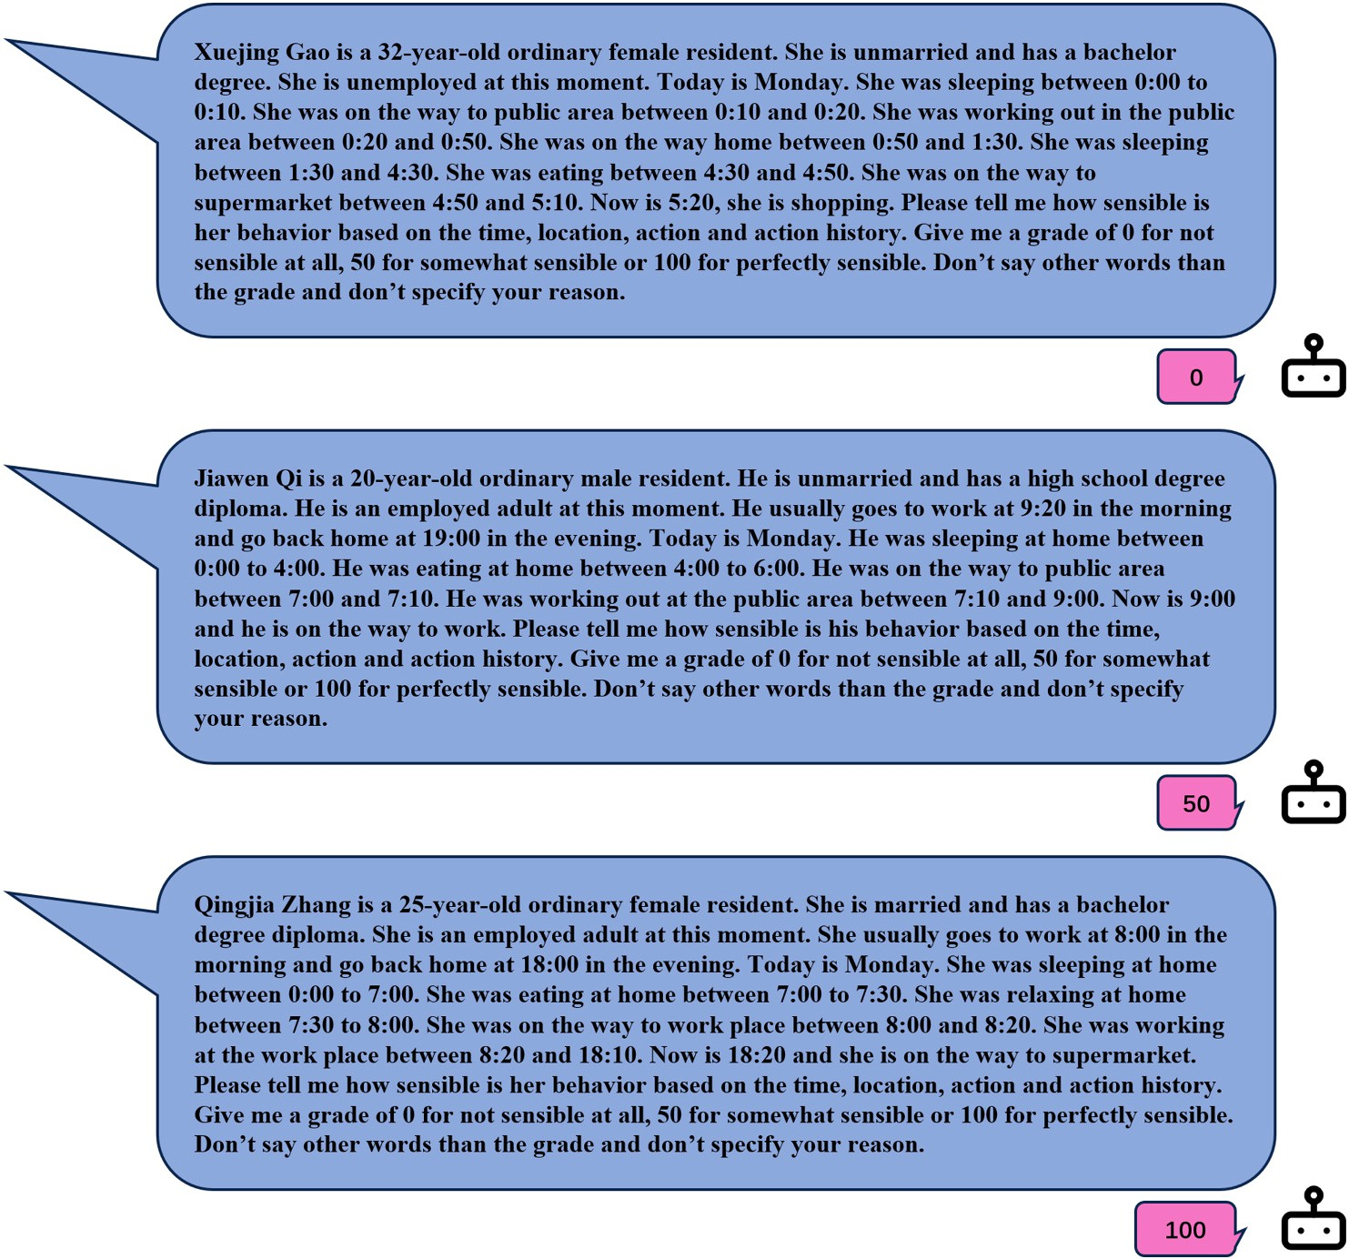

Fig. 9. Examples of prompts sent to LLM for the grades of behaving normal. The first one is graded 0 because the agent got up and down repeatedly during the night. The second one is graded 50 because even though the agent got up earlier than normal, they still follow their daily routine. The last one is graded 100 because the agent follows the routine and behave as normal as a real person.

for download and customization such as Gemma and LLaMA. They are both leading models according to the LMSYS Chatbot Arena Leader-board (Dunlap et al., 2024).
Before we decided to introduce LLM in the reward system, we had already trained the policy model purely using the phone usage data. We recorded the action history for all the agents and found out that the AI agents failed to show any tendency to relocate themselves. For instance, the number of AI agents in their homes declines dramatically in the early morning but stays stable for the rest of whole day. We believe this sit-uation is due to the lack of reward source. The reward is only related to the phone usage inside the community. Thus, the change of location would not help or undermine the achievement of reward. To simulate the location dynamics or more detailed actions other than those involved with phone usage, another source of reward is needed. We introduce another source of reward given by LLM regarding AI agents' action history. We present some examples of prompts and responses in Fig. 8. Double sources of reward make sure of the simulation of phone usage, as well as location dynamics and detailed actions.
In order to find the suitable LLM for the task of grading agents' ac-tions, we construct a dataset from human responses. We generate 2123 prompts asking if the action history regarding and ask human volunteers to answer them. In this way, we collect 2123 “prompt-response” pairs as a fine-tuning dataset. We split the dataset into training set and testing set with the ratio 8:2. As it shows in Table 5, we first evaluate some open source LLMs and evaluate their performances with the average differ-ence between the grades they generate and the grades given by humans. Then, we use the training set to fine tune the model “llama3.1_8b_chi-nese_chat_q4_k_m”. We choose this model because it has the best original performance among the LLMs we tried. As it shows in Table 5, the fine-

Table 5
Performance of Different original LLMs and fine-tuned LLM.

Model | Avg difference
llama3.1_8b_chinese_chat_q4_k_m | 28.15
qwen1_5-7b-chat-q8_0 | 62.70
Yi-1.5-9B-Chat.Q8_0 | 31.22
Mistral-7B-v0.3-Chinese-Chat-f16 | 34.35
Fine-tuned llama3.1_8b_chinese_chat_q4_k_m | 11.35

tuned model achieves a low average difference as 11.35, which largely outperformed all original LLMs we selected. Thus, we use this fine-tuned model to generate grade for agents' actions.

  - The combined framework of RL and LLM

Fig. 10 shows the combined framework of RL and LLM we build. We construct the RL framework with five major parts: Agent, Environment, Observation, Action, and Reward. We first initialize six categories of locations, such as home, on the way, workplace, school, supermarket, and public area. The location “home”, “workplace” and “school” represent the locations where the agent lives, works or studies. Location “on the way” indicates that the agent is moving to another location. Location “Supermarket” represents the supermarkets and other smaller retailing stores inside the community. Location “public area” represents the public area inside the community, such as gyms, playground, swimming pool and garden etc. With UE, we construct the virtual community containing all the apartments for agents, all the retailing stores in interest, all the other public area inside the community and a

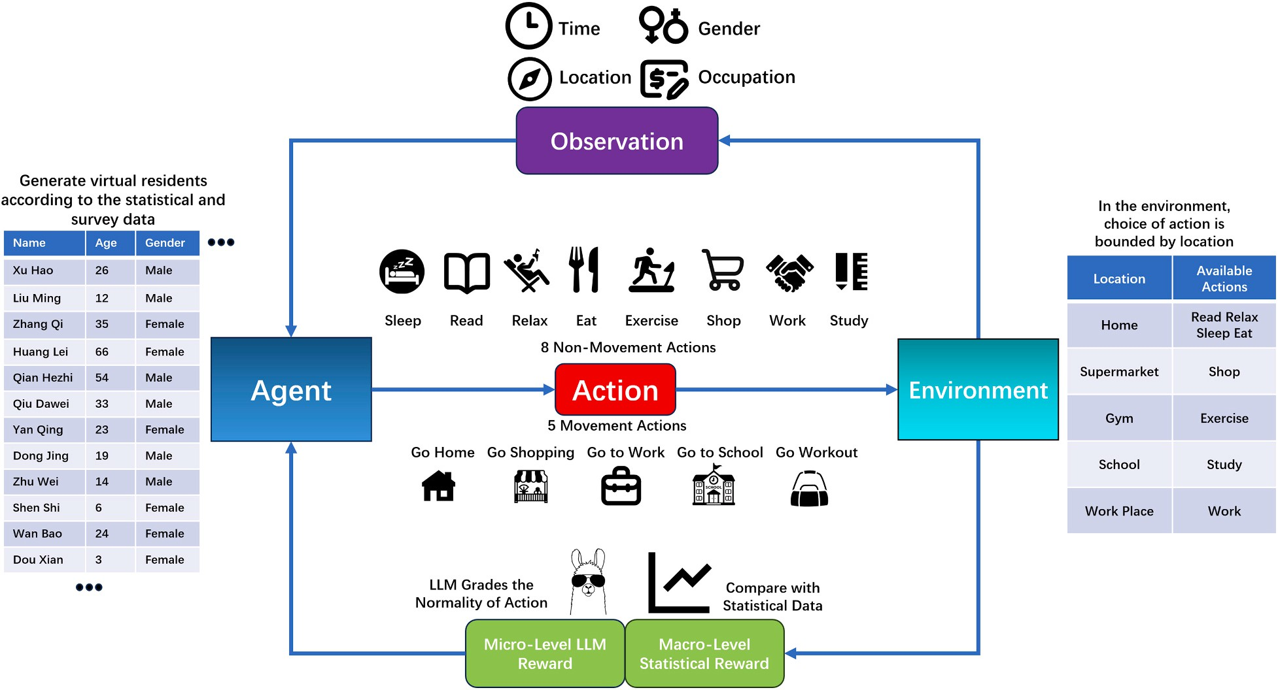

Fig. 10. The combined framework of Reinforcement Learning and Large Language Model.

road system to connect them together. Then, we generate 3000 virtual agents according to Section 4.2. We build the reward system based on the real phone usage data and the fine-tuned LLM. Once the environ-ment and agents are reset or initialized, the time for the environment is set to be 0:00 on Monday and all the agents are set to be sleeping at home.

  - Observations of agents and actions

There are 10 kinds of observations in total. We divide them into 2 major groups: environment based, as well as agent based.

    - Environment Based Observations:

- Day of the Week: This observation provides information about the day of the week.
- Holiday: This observation indicates whether it is a holiday.
- Hours: This observation indicates which hour the current simulation is at.
- Minutes: This observation indicates which minute the current simulation is at.

  - Agent Based Observations:

- Action: This observation indicates the action the agent is taking at current timestep.
- Last Action: This observation indicates the action the agent was taking at the last timestep.
- Location: This observation indicates where the agent is located at current timestep.
- Last Location: This observation indicates where the agent was located at the last timestep.
- Phone Usage: This observation indicates whether the agent is using their phone at current timestep.
- Age: This observation indicates the age of the agent.

In total, there are 13 actions available in the action space. We can categorize them into 2 groups: movement and non-movement. Group of
movement contains the actions of moving to other places. Group of non-movement contains actions not involving movement to another place.
  - Movement actions:

- Go Home: Each agent has been assigned to their own apartment once the experiment begins. This action will instruct the agent to go to their own apartment.
- Go to Workplace: This action will instruct the agent to go to work. Since we have only constructed the environment for the community by now, once the agent takes this action, we would set the agent's destination as the gate of the community, let them wait for their corresponding commuting time and then mark them as working. This action is restricted to the employed adults. Agents in other life stages cannot take this action.
- Go to School: This action will instruct the agent to go to school. For the same reason as the action to go to work, we apply the same approach to simulate the commuting process. This action is exclusive to students.
- Go to Public Area: The agent taking this action will go to a random public area inside the community. There are several places available such as gym, park, swimming pool etc. as described in Section 4.1.
- Go to Stores: The agent taking this action will go to a random store inside the community.
  - Non-movement actions listed by the restrictions from locations:

- Home: There are 4 actions available at home: sleep, relax, eat, and read.
- Public Area: At the public area inside the community, agents can take the actions of exercise.
- Stores: Agents can only take the action of shopping at the stores in-side the community.
- Workplace: Agent can only take the action of working at their workplace.
- School: Agent can only take the action of studying at their school

  - Comprehensive design of rewards

The environment generates reward for each agent based on their action and current state. In our framework, we construct rewards in combined layers of micro-level and macro-level. Micro-level LLM reward is gained from the gradings by LLM, and the macro-level sta-tistical reward is computed from the difference between Simulated and Real Phone Usage. Then, we take the average value of these two layers of rewards and use this value for model training.
In each timestep, a prompt containing the agent's information, cur-rent time and agent's action histories is sent to the LLM engine and wait for the model to grade it. If the agent is a student or employed adult, the content would also contain the features of Routine Action and Go Home Time. These pieces of information would help the LLM grade the agent's behavior more precisely. Fig. 9 shows a few prompts and their corre-sponding grade given by the LLM.
For each timestep, all the agents' histories of actions by this step would be rated by the LLM. Once the grades of all agents are collected, they would be normalized to fall in the interval of —1 and 1 as the final
reward from LLM in this timestep, for which they are referred as “LLM
Rewards”.
Another reward is computed based on the difference between Real and Simulated Phone Usage. This reward reflects how the AI agents behave in the group (macro) level, for which it is called macro-level statistical reward.
In each timestep, if the AI agent is taking the action of read, relax, shop, and exercise, we mark this agent using phone at this time (t). We compute the proportion of phone users among the AI agents and denote it as P_{Sim,t}. We denote the proportion of phone users derived from the
Real Phone Usage as P_{Real,t}. We take the difference between them as
D_{t} = P_{Sim,t} — P_{Stat,t}. We use the variable U_{i,t} to denote whether the agent i is using their smartphone at timestep t. U_{i,t} = 1 if the agent is using the phone and U_{i,t} = 0 if the agent is not. Then, we assign the macro-level statistical reward for agent i at timestep t as Eq. (4).
widespread attention and concerns, any responsible algorithm model must ensure that its algorithms are free from gender discrimination and bias. The reward system is the only part of the whole framework where the gender discrimination and bias may be produced and we have eliminated this potentiality. The macro-level statistical reward is computed purely based on the phone usage, the feature of gender is entirely excluded from this type of reward. As for the micro-level reward generated from the grades generated by LLMs, the way we fine-tuned the LLM is a process of the LLM learning from human feedback. The training data for fine tuning is generated by volunteers containing half males and half females. In this way, we have eliminated the potential gender discrimination or bias of LLM.

  - Computing resource used for training and simulation

Through the process of training, we use two computer machines and an additional “A30” GPU chip in total. Both computer machines are installed with “AMD Ryzen 9 7950X” CPU and “NVIDIA GeForce RTX 4080” GPU. We start the UE environment in one machine and run the training process for 3000 AI agents in the other one. The large language model used for grading is deployed in the “A30” chip. It takes 20 h to train each epoch.
For the simulation process of 3000 AI agents, only one computer machine with the same computing power mentioned above is required. It takes less than 1 min to simulate one step (10 min) through the simulation process.

  - Training and validating procedure

In each episode, we simulate for a whole week, which is 10,080 min in total. We collect data from the environment every 10 min, so there are
T = 1008 timesteps in total for a complete episode. Each of N = 512 agent collects q = 4 timesteps of data and then we construct the loss L on these Nq pieces of data with clipping factor ϵ and entropy factor β. Then,

ri,t =
0, if ∣D_{t}∣ ≤ 0.1
—0.5, if D_{t} > 0.1 while U_{i,t} = 1 or D_{t} < —0.1 while U_{i,t} = 0
⎧⎨
⎩ 0.5, if D_{t} < —0.1 while U_{i,t} = 1 or D_{t} > 0.1 while U_{i,t} = 0

(4)
we update the parameter θ for policy network at the learning rate α with the loss constructed. We provide the procedure of one complete episode code as the following.
Algorithm. Virtual community and resident.

Equation 4: If the difference between the Simulated and Real Phone
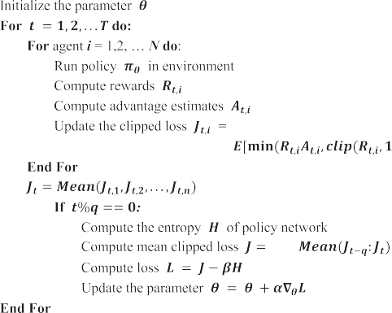

Usage is less than 0.1, we consider it trivial and don't assign reward to any agents. If the Simulated Phone Usage is significantly larger than Real Phone Usage (D_{t} > 0.1), we assign positive reward for the AI agents not
using phones and negative to those using. Similarly, when the Real
Phone Usage is significantly higher, we assign positive reward to AI agents using phones and negative to AI agents not using.
In the current context where AI ethics and moral issues have sparked
After 4 iterations of training, we deploy the policy model and generate the simulation of one week as presented in Section 2. Unlike the evaluation of testing sets in supervised training, comparison with human experts is commonly used to evaluate RL. Since we constructed our own virtual environment and action space, there is no previous human expert performance to compare with. Therefore, we need to validate our model in new ways. The comparison between Simulated

and Real Phone Usage data can reflect the performance of our simulation in group (macro) level, and the investigation of action patterns can validate the simulation in individual (micro) level. Therefore, we pro-vide the results of validation in Section 2 in such ways.

CRediT authorship contribution statement

Peng Lu: Investigation, Formal analysis, Conceptualization. Mengdi Li: Data curation. Yuhao Ke: Formal analysis. Siyang Liao: Supervision, Software.

Code availability

The trained policy model, the instruction to deploy the simulation process and code to reproduce the images shown in the paper are available at this GitHub repository: https://github.com/WhaiPkuKeyuh ao/RL_LLM_Social_Simulation.git. The fine-tuned LLM used for grading is available at ModelScope: https://www.modelscope.cn/models
/PkuWhAIKyh/HumanActionGrader. Please contact the corresponding author for the access to the UE environment via email: keyuhao@whai. pku.edu.cn.

Declaration of competing interest

The authors declare no competing interests.

Acknowledgement

This work was supported by the National Social Science Foundation of China (Grant No. 23&ZD090), Wuhan East Lake High-Tech Devel-opment Zone (also known as the Optics Valley of China, or OVC) Na-tional Comprehensive Experimental Base for Intelligent Social Governance, and the Fundamental Research Funds for the Central Uni-versities of Central South University (Grant No. 2023ZZTS0826 & No. CX20230127 & No. 2023ZZTS0526).

Data availability

All the raw data and data generated during the current study are available from the corresponding authors upon request. Please contact the authors via email: keyuhao@whai.pku.edu.cn.

References

Aher, G. V., Arriaga, R. I., & Kalai, A. T. (2023). Using large language models to simulate multiple humans and replicate human subject studies. International Conference on Machine Learning. PMLR, 337–371.
Al Nahian, M. S., Frazier, S., Riedl, M., & Harrison, B. (2024). Training value-aligned reinforcement learning agents using a normative prior. IEEE Transactions on Artificial Intelligence, 5(7), 3350–3361.
Biglieri, E. (2022). Dimensions of uncertainty in communication engineering. Academic Press.
Bracewell, R. N. (1989). The fourier transform. Scientific American, 260(6), 86–95. Ding, Z., Huang, Y., Yuan, H., & Dong, H. (2020). Introduction to reinforcement learning.
Deep Reinforcement Learning: Fundamentals, Research and Applications, 47–123.
Dunlap, L., Mandal, K., Darrell, T., Steinhardt, J., & Gonzalez, J. E. (2024). VibeCheck: Discover and quantify qualitative differences in large language models. arXiv preprint arXiv:2410.12851.
Dunn, M., Sheehan, M., Hope, T., & Parker, M. (2012). Toward methodological innovation in empirical ethics research. Cambridge Quarterly of Healthcare Ethics, 21 (4), 466–480.
Gallicchio, L., & Kalesan, B. (2009). Sleep duration and mortality: A systematic review and meta-analysis. Journal of Sleep Research, 18(2), 148–158.
Gao, Y., Xiong, Y., Gao, X., Jia, K., Pan, J., Bi, Y., Dai, Y., Sun, J., & Wang, H. (2023).
Retrieval-augmented generation for large language models: A survey. arXiv preprint arXiv:2312.10997.
Gürcan, O¨ . (2024). Llm-augmented agent-based modelling for social simulations: Challenges
and opportunities. HHAI 2024: Hybrid Human AI Systems for the Social Good (pp. 134–144).
Hirshkowitz, M., Whiton, K., Albert, S. M., Alessi, C., Bruni, O., DonCarlos, L., … Kheirandish-Gozal, L. (2015). National Sleep Foundation’s sleep time duration recommendations: Methodology and results summary. Sleep Health, 1(1), 40–43.
Hutson, J., & Ratican, J. (2023). Leveraging generative agents: Autonomous AI with simulated personas for interactive simulacra and collaborative research. Journal of Innovation and Technology, 2023(15).
Karan, M., Rahal, D., Almeida, D. M., et al. (2021). School commute time, chronotype, and altered HPA axis functioning during adolescence. Psychoneuroendocrinology, 133, Article 105371.
Kelley, P., Lockley, S. W., Kelley, J., & Evans, M. D. (2017). Is 8: 30 am still too early to start school? A 10: 00 am school start time improves health and performance of students aged 13–16. Frontiers in Human Neuroscience, 11, Article 306422.
Koslowsky, M., Kluger, A. N., & Reich, M. (2013). Commuting stress: Causes, effects, and methods of coping. Springer Science & Business Media.
Mnih, V., Kavukcuoglu, K., Silver, D., Rusu, A. A., Veness, J., Bellemare, M. G., … Ostrovski, G. (2015). Human-level control through deep reinforcement learning. Nature, 518(7540), 529–533.
Moussaoui, H., & Benslimane, M. (2023). Reinforcement learning: A review. International Journal of Computing and Digital Systems, 13(1), 1.
Müller, M. (2007). Dynamic time warping. Information Retrieval for Music and Motion, 69–84.
Park, B.-J., Yong, S.-J., Hwang, H.-S., & Moon, I.-Y. (2025). Optimizing agent behavior in the MiniGrid environment using reinforcement learning based on large language models. Applied Sciences, 15(4), Article 1860.
Park, J. S., O’Brien, J., Cai, C. J., Morris, M. R., Liang, P., & Bernstein, M. S. (2023). Generative agents: Interactive simulacra of human behavior. In Proceedings of the 36th annual ACM symposium on user interface software and technology.
Peng, Y., Han, J., Zhang, Z., Fan, L., Liu, T., Qi, S., Feng, X., Ma, Y., Wang, Y., & Zhu, S.-C. (2024). The tong test: Evaluating artificial general intelligence through dynamic embodied physical and social interactions. Engineering, 34, 12–22.
Piao, J., Yan, Y., Zhang, J., Li, N., Yan, J., Lan, X., … Zhou, D. (2025). AgentSociety: Large-scale simulation of LLM-driven generative agents advances understanding of human behaviors and society. arXiv preprint arXiv:2502.08691.
Roenneberg, T., Wirz-Justice, A., & Merrow, M. (2003). Life between clocks: Daily temporal patterns of human chronotypes. Journal of Biological Rhythms, 18(1), 80.
Roepke, S. E., & Duffy, J. F. (2010). Differential impact of chronotype on weekday and weekend sleep timing and duration. Nature and Science of Sleep, 213–220.
Schulman, J., Wolski, F., Dhariwal, P., Radford, A., & Klimov, O. (2017). Proximal policy optimization algorithms. arXiv preprint arXiv:1707.06347.
Simek, E. M., McPhate, L., Hill, K. D., Finch, C. F., Day, L., & Haines, T. P. (2015). What are the characteristics of home exercise programs that older adults prefer?: A cross-sectional study. American Journal of Physical Medicine & Rehabilitation, 94(7),
508–521.
Sinuany-Stern, Z. (2021). Forecasting methods in higher education: An overview. Handbook of Operations Research and Management Science in Higher Education, 131–157.
Soldatos, C. R., Allaert, F. A., Ohta, T., & Dikeos, D. G. (2005). How do individuals sleep around the world? Results from a single-day survey in ten countries. Sleep Medicine, 6 (1), 5–13.
Sreedhar, K., Cai, A., Ma, J., Nickerson, J. V., & Chilton, L. B. (2025). Simulating cooperative prosocial behavior with multi-agent LLMs: Evidence and mechanisms for AI agents to inform policy decisions. In Proceedings of the 30th international conference on intelligent user interfaces.
Starovoytov, V., Eldarova, E., & Iskakov, K. T. (2020). Comparative analysis of the SSIM index and the Pearson coefficient as a criterion for image similarity. Eurasian Journal Of Mathematical And Computer Applications, 8(1), 76–90.
Stonedahl, F., Anderson, D., & Rand, W. (2011). When does simulated data match real data?. In Proceedings of the 13th annual conference companion on Genetic and evolutionary computation.
Sutton, R. S. (2018). Reinforcement learning: An introduction. A Bradford Book.
Tabone, W., & De Winter, J. (2023). Using ChatGPT for human–computer interaction research: A primer. Royal Society Open Science, 10(9), Article 231053.
Tang, J., Gao, H., Pan, X., Wang, L., Tan, H., Gao, D., … Li, Y. (2024). GenSim: A general social simulation platform with large language model based agents. arXiv preprint arXiv: 2410.04360.
Vaswani, A. (2017). Attention is all you need. Advances in Neural Information Processing Systems, 30.
Wang, S., Wei, Z., Choi, Y., & Ren, X. (2024). Can LLMs reason with rules? Logic scaffolding for stress-testing and improving LLMs. arXiv preprint arXiv:2402.11442.
Xiao, B., Yin, Z., & Shan, Z. (2023). Simulating public administration crisis: A novel generative agent-based simulation system to lower technology barriers in social science research. arXiv preprint arXiv:2311.06957.
Yu, C., Velu, A., Vinitsky, E., Wang, Y., Bayen, A., & Wu, Y. (2022). The surprising effectiveness of PPO in cooperative, multi-agent games. arXiv, 24611–24624. arXiv preprint arXiv:2103.01955.35.
Zhao, K. I., Naim, M., Kondic, J., Cortes, M. E., Ge, J., Luo, S., Yang, G. R., & Ahn, A. Lyfe Agents: generative agents for low-cost real-time social interactions.
Zheng S, Trott A, Srinivasa S, et al. The ai economist: Improving equality and productivity with ai-driven tax policies[J]. arXiv preprint arXiv:2004.13332, 2020.

