**TODOIT APP**

**PERSONAL PROJECT | SEMI-SHOWCASE PROJECT**

**Start of Development: December 4, 2024**

Description:

This application is a to-do-list app, but unlike any other, it will have features that will help the user track its tasks and have the freedom of what the board should look like. It will have tools like inserting shapes, images, connecting cards, move them, group them, all these options to enable flexibility for the user to anything he want in the app, instead of following the generic one card containing lists of to do and check-box.

**LOGO:**

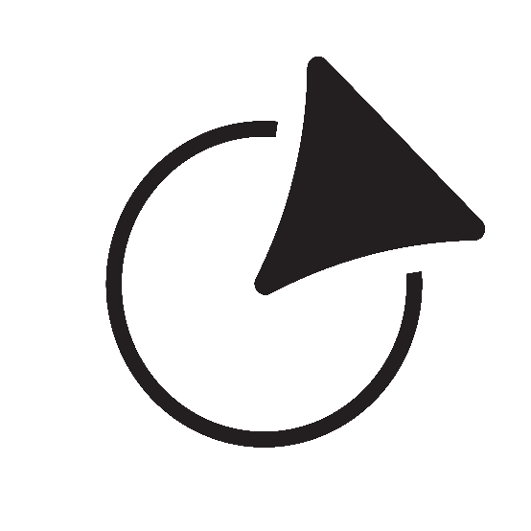

This logo is temporary but could be the base of future logo design for the app. This resembles an arrow hitting its mark, which the app aims to help you with, aim at your goals and hit them.

It features a triangle shape which is an arrow head, and the circle being its target.

**STYLE GUIDE:**

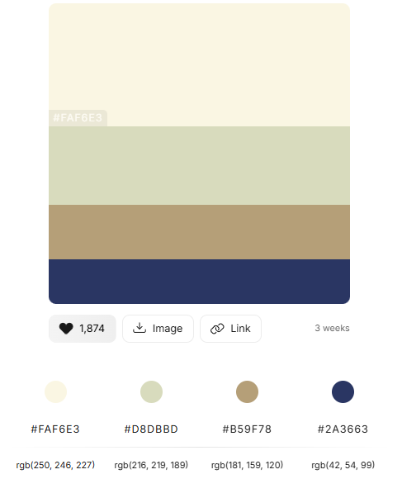

– Light Beige #FAF6E3

- Beige #DBDBBD

- Brown #B59F78

- Blue #2A3663

**SYSTEM ARCHITECTURE**:

**RETROSPECTIVE:**

**CONTRIBUTORS:**

**R. Lorenz “Lone” Yboa**

**REFERENCES:**