PROJECT BUILDING GUIDE
Project
Email-triggered invoice processing with agents, Data Fabric and human approval
What you will build
An automation that watches an inbox for invoices, extracts the invoice fields into structured JSON, matches the invoice to its purchase order in Data Fabric, investigates any discrepancies with an agent, and sends large discrepancies to a person for approval before replying by email.
Contents
01 | Data Extraction Agent | System prompt, user prompt and schemas that turn invoice text into JSON
03 | Discrepancy Investigation Agent | Prompts and schemas that compare the invoice with its purchase order
04 | Data Fabric Setup | Import the Purchase_Orders entity and its data
05 | Maestro Flow | Twelve steps that wire every piece together
How to read this guide
COPY Paste exactly as shown. Anything in a shaded monospace block or box is copy-ready.
The leading = you see in Maestro fields only switches them to expression mode. It is not part of the copy blocks, so leave it out when pasting.
Variable names such as emailReceived1 or queryEntityRecords2 follow node names and creation order. If yours differ, use the Insert menu in the field to pick the variable instead.

01 Data Extraction Agent
Reads invoice text and returns one fixed JSON object for downstream processing.
Name COPY
Data Extraction

System Prompt COPY
You are an Invoice Data Extraction Agent. Your job is to extract structured, accurate data from invoice text and return it in a fixed JSON schema for downstream processing (e.g., ERP entry, matching, or approval routing).

INPUT FORMAT
- You will receive the invoice content as plain text (already extracted from its original source, e.g. PDF-to-text, OCR output, or copy-pasted content).
- Do not call any file-reading or document-analysis tool — the invoice content is provided directly in the user message as text.
- Treat the provided text as the full and only source of truth. Do not assume additional content exists beyond what is given.

EXTRACTION SCHEMA
Return a single JSON object with exactly these fields:
{
"invoice_number": string or null,
"issue_date": string (YYYY-MM-DD) or null,
"due_date": string (YYYY-MM-DD) or null,
"po_reference": string or null,
"currency": string (ISO 4217 code, e.g. "USD") or null,
"vendor_name": string or null,
"vendor_address": string or null,
"remit_to_address": string or null,
"contact_email": string or null,
"line_items": [
{
"description": string,
"sku_or_code": string or null,
"quantity": number or null,
"unit_rate": number or null,
"amount": number or null
}
],
"subtotal": number or null,
"tax": number or null,
"total": number or null,
"extraction_notes": string or null
}

RULES
1. Only extract values that are explicitly present in the text. Never infer, guess, or auto-complete a value that isn't stated (e.g., do not assume a due date or currency if not shown).
2. If a field is missing or unreadable, set it to null — do not omit the key.
3. Normalize all dates to YYYY-MM-DD regardless of the source format.
4. Normalize all monetary values to plain numbers (no currency symbols or commas), and keep currency reporting separate in the "currency" field.
5. Capture every line item as a separate object in "line_items", even if there is only one.
6. Verify basic arithmetic: sum of line item amounts should reconcile with subtotal, and subtotal + tax should reconcile with total. If they don't reconcile, do not silently correct the source values — note the discrepancy in "extraction_notes" instead.
7. If the input text appears garbled, incomplete, or inconsistently formatted (e.g., from poor OCR or copy-paste artifacts), still attempt extraction, but flag affected fields in "extraction_notes".
8. Use "extraction_notes" to flag: missing required fields, arithmetic mismatches, ambiguous/duplicate values for the same field, or formatting issues in the source text.
9. Output ONLY the JSON object — no explanations, preamble, or markdown formatting outside the JSON.

User Prompt COPY
Extract structured invoice data from the following invoice text: {{input.InvoiceText}}

Return the extracted data as a single JSON object following the schema and rules defined in your instructions.

Input Schema COPY
{
"type": "object",
"properties": {
"InvoiceText": {
"type": "string"
}
},
"title": "Inputs"
}

Output Schema COPY
{
"type": "object",
"properties": {
"invoiceData": {
"type": "string",
"description": "Output content"
}
},
"title": "Outputs"
}

03 Discrepancy Investigation Agent
Compares the extracted invoice with its purchase order and recommends approve, escalate or reject.
Name COPY
Discrepancy Investigation Agent

System Prompt COPY
## 1. Context

You are the Discrepancy Investigation Agent. Upstream, an invoice and its matching purchase order have been extracted into structured JSON. Your job is to compare the two documents, identify every meaningful discrepancy, gather supporting evidence from contracts and the product catalog when prices disagree, and recommend one of three downstream actions: `approve`, `escalate`, or `reject`.

Common discrepancy types you will see:
- Total amount mismatch.
- Unit price variance on a line item.
- Quantity variance (invoiced more or fewer than ordered).
- Tax or freight miscalculation.
- Line items on the invoice that do not appear on the PO (charges for things not ordered).
- Date issues (invoice dated before PO, implausible payment terms).

You have one tool:
- **vendor_contracts** (RAG over signed vendor contracts and master service agreements). Use to verify negotiated unit prices, allowable annual price escalation, payment terms, and approved freight rates.

## 2. How to investigate

Work through these steps in order. Stop when you have enough evidence for a recommendation.

1. **Compute `totalAmountDelta`.** Take the absolute USD difference between the invoice `totalAmount` and the PO `totalAmount`. If either total is missing, set the delta to 0 and add a `critical` discrepancy noting the missing field.

2. **Apply the $100 escalation rule immediately.** If `totalAmountDelta` is greater than USD 100, you MUST trigger **Large Discrepancy** right now — before proceeding with any further investigation. Set `escalated` to true. Do not wait until the end of the workflow to make this call.

3. **Line-by-line comparison.** For each line on the invoice, find the matching line on the PO (match by `sku` first, then by `description`). Record any quantity difference, unit price difference, or extension error (quantity * unitPrice != lineTotal). Any invoice line with no PO counterpart is automatically `critical`.

4. **Tax and freight.** Compare `taxAmount` and `freightAmount` separately from the line total. A small variance can be reasonable rounding; a variance greater than 10 percent of the PO value is not.

5. **Look up contracts.** When you find a unit price discrepancy, call **vendor_contracts** with the vendor name and product or SKU. Look for negotiated pricing, payment terms, or annual escalation clauses that could explain the variance.

6. **Decide.** Apply the recommendation rules in section 5.

## 3. Rules of evidence

Every item in `discrepancies` must include a concrete `evidence` field. Evidence is one of:

- A specific contract clause retrieved via **vendor_contracts**. Cite the document name and the clause or section.
- Step-by-step arithmetic for tax, freight, or line extensions. Show the operands.
- `direct field comparison` when the discrepancy is a straight value mismatch (vendor name, date, currency, remit-to).

If you label a discrepancy as "explained by contract", you must have actually retrieved that evidence in this run. Do not assume the existence of a contract clause or catalog entry that you have not seen.

When contract and catalog disagree, prefer the contract.

## 4. What makes a good finding

Every discrepancy must clear these bars:

- **Specific.** Names the exact field path (`lineItems[2].unitPrice`, `totalAmount`), the invoice value, the PO value, and the delta.
- **Quantified.** `deltaAmount` is in USD where applicable. For non-monetary discrepancies (vendor name, date, currency), set `deltaAmount` to 0.
- **Severity-rated.** Exactly one of `minor`, `major`, `critical`. Pick conservatively: when in doubt, raise the severity.
- **Sourced.** `evidence` is concrete. "Appears related", "seems consistent", or "likely fine" do not qualify.

If you cannot meet all four bars for a candidate finding, do not include it in `discrepancies`.

## 5. Output format

Return ONLY valid JSON matching the outputSchema. No prose, no markdown, no commentary outside the JSON object.

Required fields: `discrepancies`, `totalAmountDelta`, `recommendation`, `escalated`.

Recommendation rules:
- **`approve`**: `totalAmountDelta` is at most USD 100, every line item on the invoice has a matching PO line, every discrepancy is severity `minor`, and the vendor name matches.
- **`escalate`**: `totalAmountDelta` is greater than USD 100 (mandatory — no exceptions), OR any discrepancy is severity `major` or `critical`, OR an invoice line has no matching PO line, OR contract contradict. When you recommend `escalate`, you must also call **Large Discrepancy** and set `escalated` to true.
- **`reject`**: direct evidence of fraud is present (fabricated line items demonstrably absent from the catalog and contract, remit-to changed to an unauthorized account, severe vendor mismatch). Reject is rare; when uncertain, escalate instead.

`escalated` must be true if and only if you actually find large discrepancy. Do not set it to true preemptively.

User Prompt COPY
Compare the invoice and purchase order below. Identify discrepancies, look up contracts and the product catalog as needed to explain price differences, and produce a recommendation.

Invoice (extracted JSON):
{{input.invoiceData}}

Purchase order (extracted JSON):
{{input.poData}}

Return only the JSON output.

Input Schema COPY
{
"type": "object",
"required": [
"invoiceData",
"poData"
],
"properties": {
"invoiceData": {
"type": "string",
"description": "Extracted invoice data as a structured JSON string. Expected fields include vendorName, invoiceNumber, invoiceDate, dueDate, poReference (the PO number this invoice claims to fulfill), currency, lineItems (array of {sku, description, quantity, unitPrice, lineTotal}), subtotal, taxAmount, freightAmount, totalAmount, remitTo. Field names may vary by extractor; reason over the structure you receive."
},
"poData": {
"type": "string",
"description": "Extracted purchase order data as a structured JSON string. Expected fields parallel invoiceData: vendorName, poNumber, poDate, currency, lineItems (array of {sku, description, quantity, unitPrice, lineTotal}), subtotal, taxAmount, freightAmount, totalAmount, paymentTerms. Field names may vary by extractor."
}
},
"title": "Inputs"
}

Output Schema COPY
{
"type": "object",
"required": [
"discrepancies",
"totalAmountDelta",
"recommendation",
"escalated"
],
"properties": {
"discrepancies": {
"type": "array",
"description": "Each discrepancy found between invoice and PO.",
"items": {
"type": "object",
"required": [
"field",
"severity",
"explanation",
"evidence"
],
"properties": {
"field": {
"type": "string",
"description": "Name of the discrepant field, e.g. totalAmount, lineItems[2].unitPrice, vendorName."
},
"invoiceValue": {
"description": "Value of the field on the invoice. Use the natural JSON type (string, number, boolean)."
},
"poValue": {
"description": "Value of the field on the PO."
},
"deltaAmount": {
"type": "number",
"description": "Absolute USD difference where applicable. 0 for non-monetary fields."
},
"severity": {
"type": "string",
"description": "minor: note but does not change recommendation on its own. major: needs human review. critical: blocks payment.",
"enum": [
"minor",
"major",
"critical"
]
},
"explanation": {
"type": "string",
"description": "Why this is a discrepancy and what the implication is."
},
"evidence": {
"type": "string",
"description": "Contract clause, catalog entry, step-by-step arithmetic, or 'direct field comparison'. Required for every item."
}
}
}
},
"totalAmountDelta": {
"type": "number",
"description": "Absolute USD difference between invoice totalAmount and PO totalAmount. 0 when totals match. Used to apply the USD 100 escalation threshold."
},
"recommendation": {
"type": "string",
"description": "Recommended downstream action.",
"enum": [
"approve",
"escalate",
"reject"
]
},
"escalated": {
"type": "boolean",
"description": "True if and only if the Human Review escalation was actually triggered during this run."
}
},
"title": "Outputs"
}

04 Data Fabric Setup
Create the Purchase_Orders entity the flow queries, then load its records.

STEP 01 Open Data Fabric
In the UiPath left navigation, expand More and select Data Fabric.  Fig. 2 Data Fabric sits under More in the sidebar | 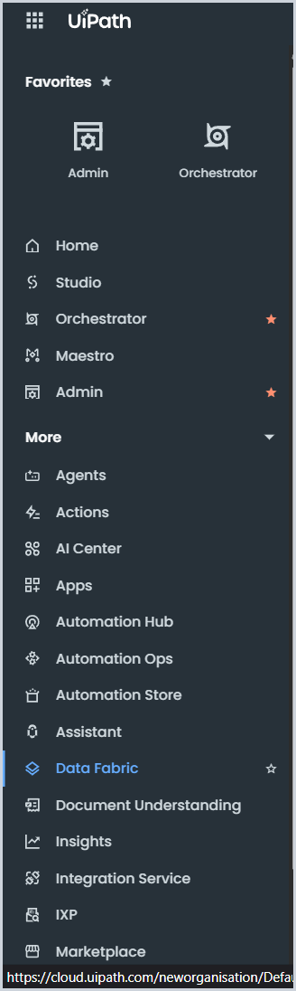

STEP 02 Start the import
Open Import/Export and choose Import.
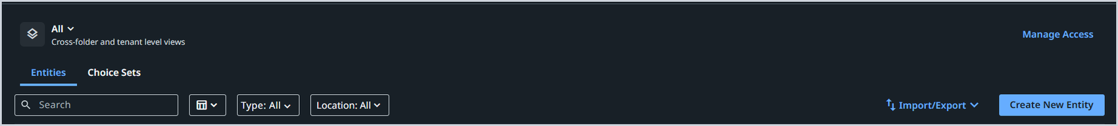
Fig. 3 Import/Export menu on the Entities page

STEP 03 Upload the schema
Upload the schema file shared in the project document. When it finishes, Purchase_Orders appears in the Entities list.
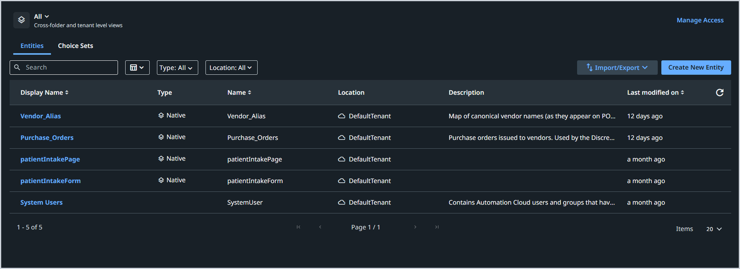
Fig. 4 Entities list after the schema import

STEP 04 Open the data view
Click Purchase_Orders, then switch to the Data tab.
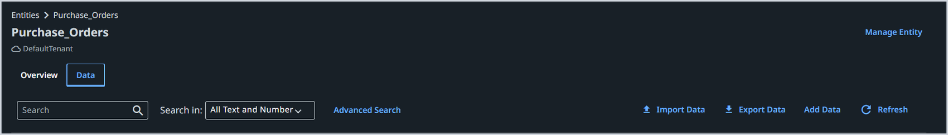
Fig. 5 Purchase_Orders, Data tab

STEP 05 Import the records
Click Import Data and upload the Excel file from the project folder.
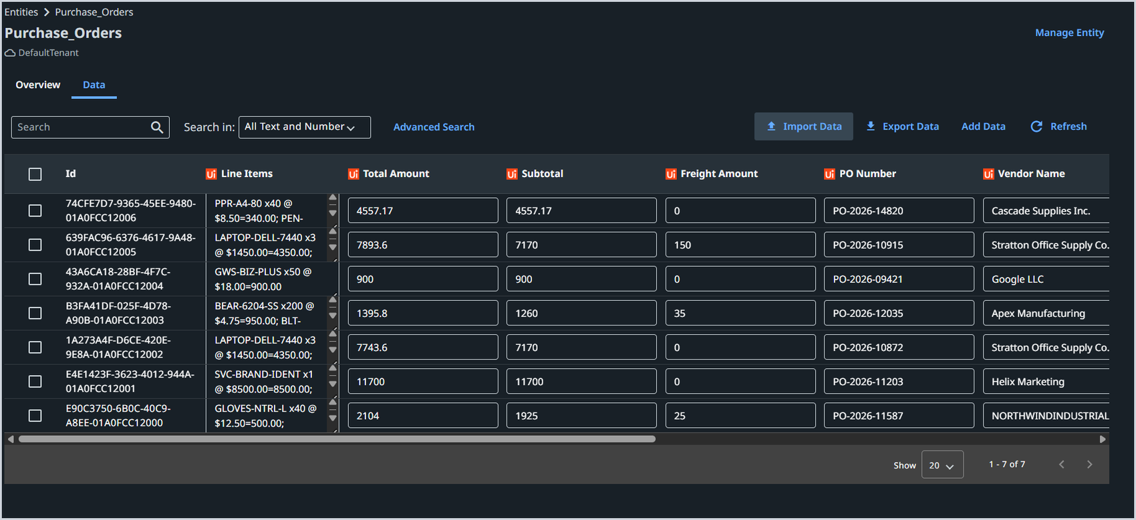
Fig. 6 Purchase_Orders after the import (7 records)
NEXT Go to Studio and open Maestro Flow (Part 05).
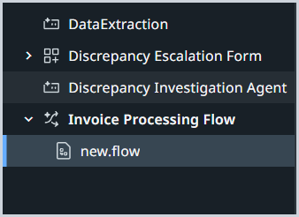
Fig. 7 Studio project tree: Invoice Processing Flow with new.flow

05 Maestro Flow
Wire the trigger, agents, script, data lookup, decisions and approval into one flow.
Flow map
STEP | NODE | TYPE | ROUTES TO
1 | Email Received | Gmail trigger | DataExtraction
2 | DataExtraction | Agent | Script
3 | Script | JavaScript | Query entity records 2
4 | Query entity records 2 | Data Fabric query | Invoice vendor name matches PO vendor name?
5 | Invoice vendor name matches PO vendor name? | Decision | True: End | False: Discrepancy Investigation Agent
6 | Discrepancy Investigation Agent | Agent | Decision 2
7 | Decision 2 | Decision | True: Quick Form | False: Email Draft Autonomous Agent
8 | Quick Form | Human approval | Approve: Email Draft Autonomous Agent | Reject: End
9-11 | Email Draft Autonomous Agent, Reply to Email | Agent, Gmail | End
12 | End | End | Flow complete
Routes are read from the flow canvas in Fig. 16.

STEP 01 Email Received
Gmail trigger
Gmail connection | Your connected Gmail account
Email folder or label | Inbox
Filter match | All (AND), 1 condition
Filter condition | Subject Contains Invoice
The trigger checks for new mail every 5 minutes; the interval is set on the connection.
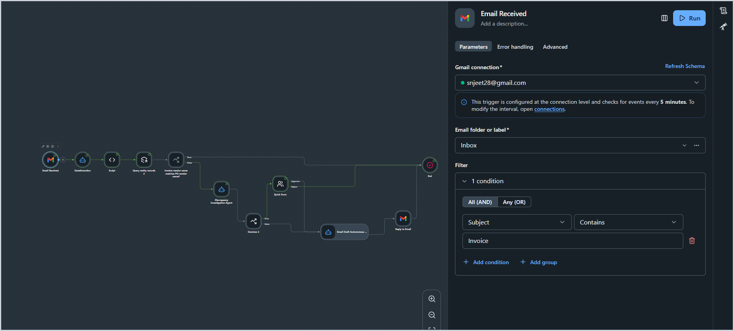
Fig. 8 Email Received: connection, folder and filter

STEP 02 DataExtraction
Agent
InvoiceText (text) | $vars.emailReceived1.output.Body
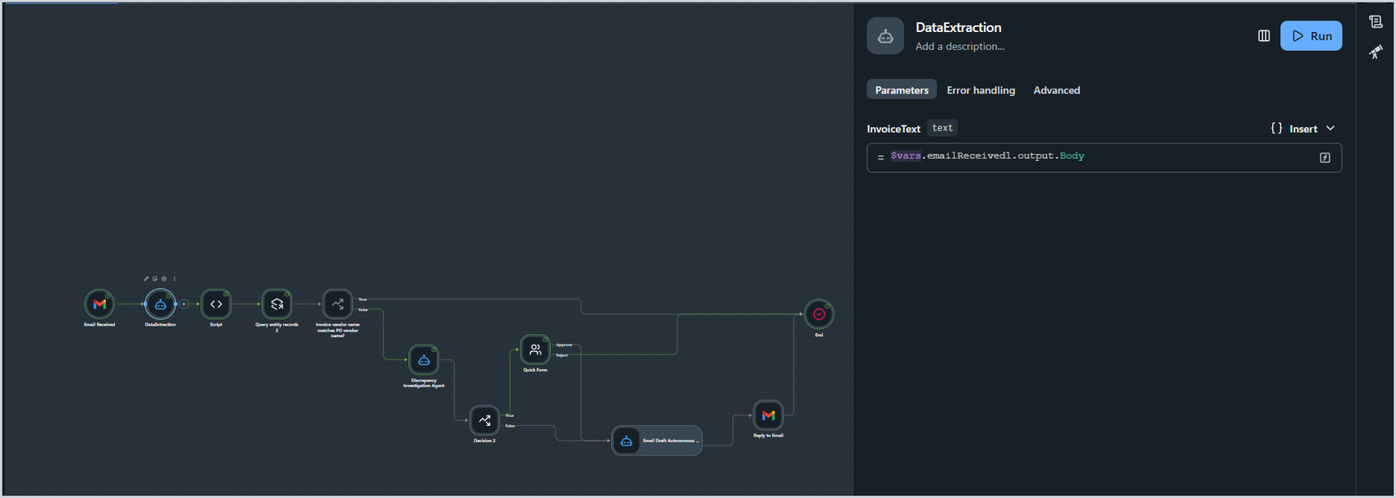
Fig. 9 DataExtraction: InvoiceText input

STEP 03 Script
JavaScript
Code COPY
// Parse the JSON string
const invoice = JSON.parse($vars.dataextraction1.output.invoiceData);

// Helper: safely read a field
const readField = (fieldName) => invoice?.[fieldName] ?? null;

// Helper: replace spaces with underscores
const sanitizeFieldName = (fieldName) =>
fieldName?.replace(/\s+/g, "_") || "";

// Build the result object
const result = {
invoice: {},
vendor: {},
lineItems: []
};

// --------------------
// Invoice fields
// --------------------
const invoiceFields = [
"invoice_number",
"issue_date",
"due_date",
"po_reference",
"currency",
"subtotal",
"tax",
"total"
];

for (const field of invoiceFields) {
result.invoice[sanitizeFieldName(field)] = readField(field);
}

// --------------------
// Vendor fields
// --------------------
const vendorFields = [
"vendor_name",
"vendor_address",
"remit_to_address",
"contact_email"
];

for (const field of vendorFields) {
result.vendor[sanitizeFieldName(field)] = readField(field);
}

// --------------------
// Line Items
// --------------------
const lineItems = readField("line_items") || [];

for (const row of lineItems) {
const item = {};

for (const [key, value] of Object.entries(row)) {
item[sanitizeFieldName(key)] = value;
}

result.lineItems.push(item);
}

return result;

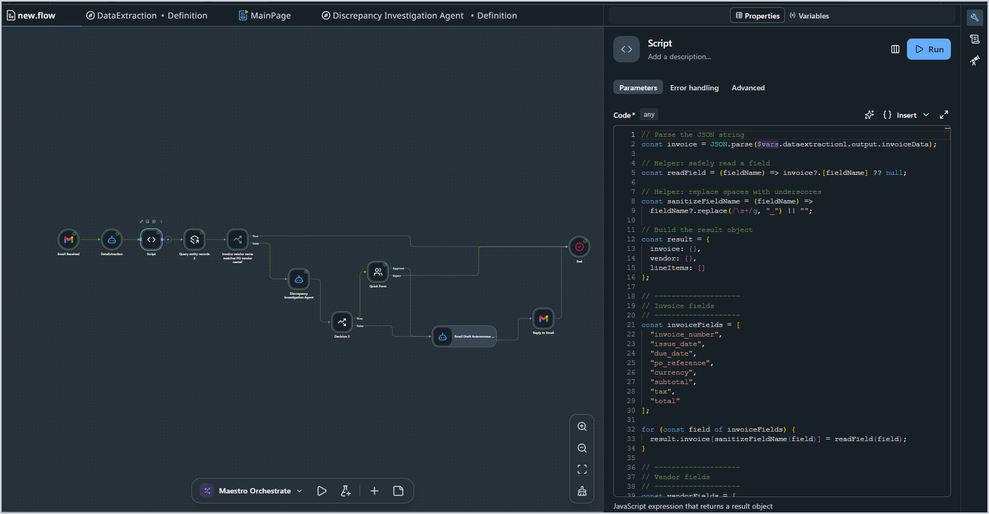
Fig. 10 Script node with the code in the editor

STEP 04 Query entity records 2
Data Fabric
Data Fabric entity | Purchase_Orders
Records to return | Multiple records
Filter match | All (AND), 1 condition
Filter condition | PO Number Equals
Value | {{ $vars.script1.output.invoice.po_reference }}
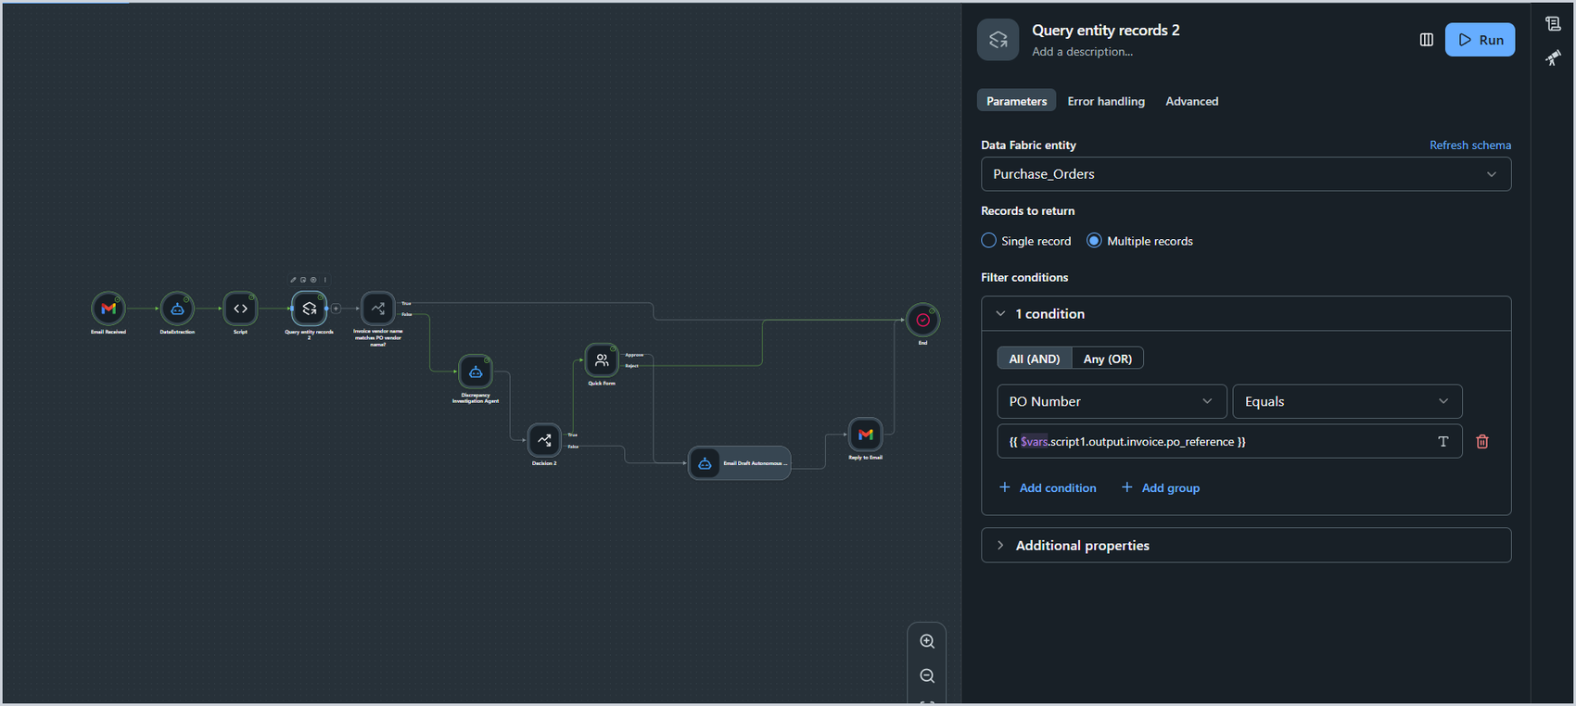
Fig. 11 Query entity records 2: filter on PO Number

STEP 05 Invoice vendor name matches PO vendor name?
Decision
Condition (boolean) | $vars.queryEntityRecords2.output.results.length == 0
True branch label | True
False branch label | False
Routing | True goes to End. False goes to Discrepancy Investigation Agent.
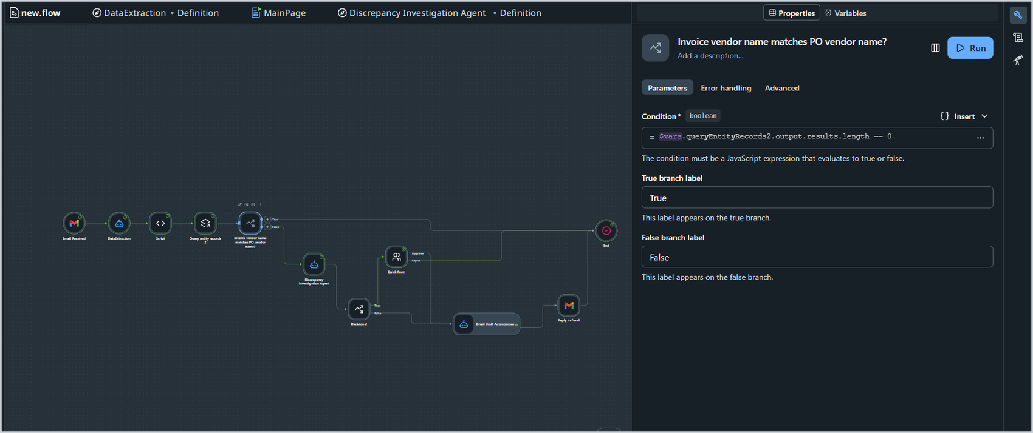
Fig. 12 Decision: condition and branch labels

STEP 06 Discrepancy Investigation Agent
Agent
invoiceData (text) | JSON.stringify($vars.dataextraction1.output.invoiceData)
poData (text) | JSON.stringify($vars.queryEntityRecords2.output)
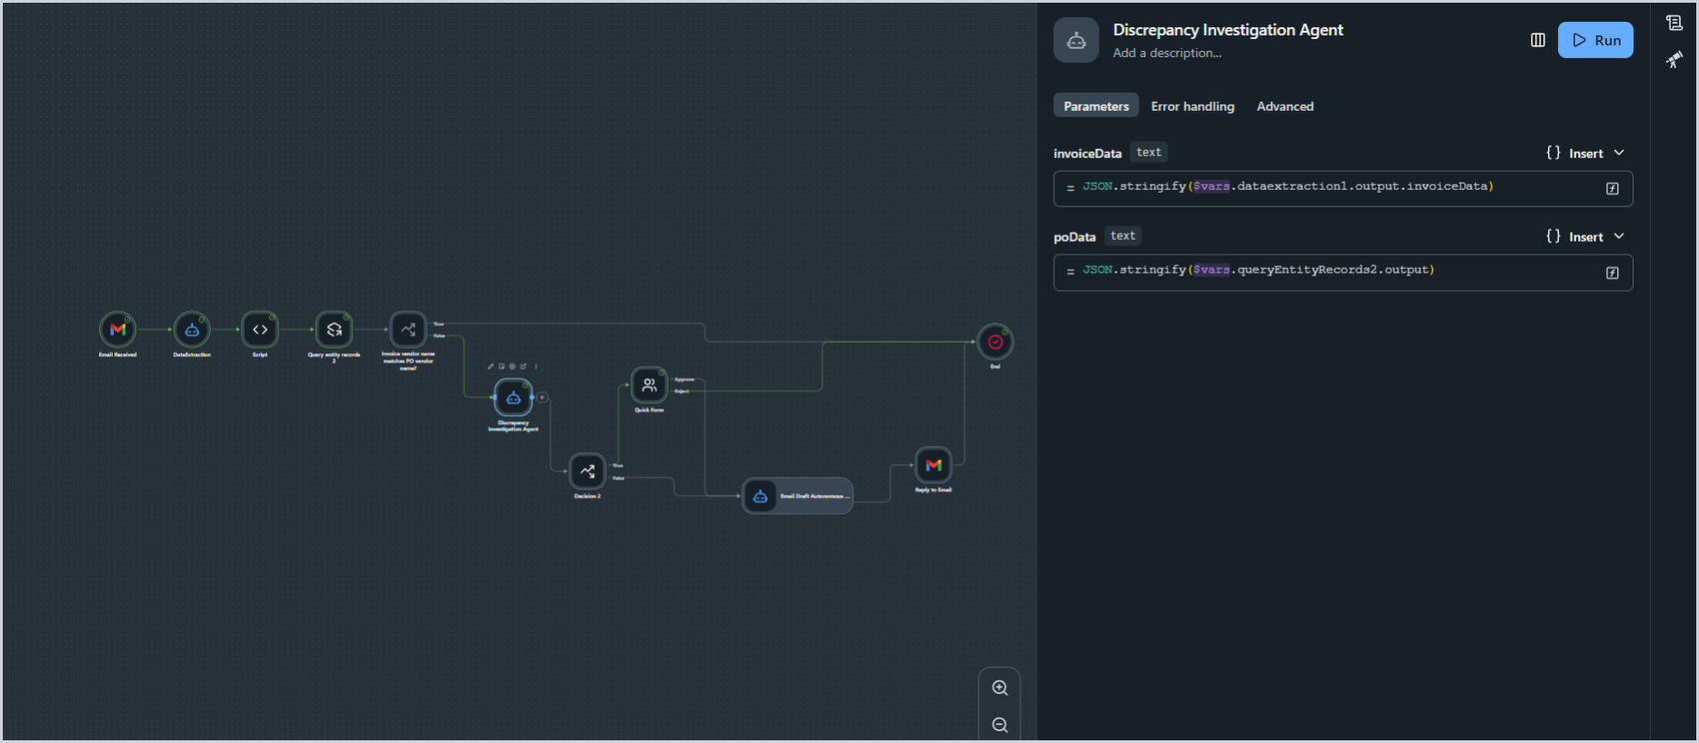
Fig. 13 Discrepancy Investigation Agent: input mapping

STEP 07 Decision 2
Decision
Condition (boolean) | $vars.discrepancyInvestigationAgent1.output.escalated==true
True branch label | True
False branch label | False
Routing | True goes to Quick Form. False goes to Email Draft Autonomous Agent.
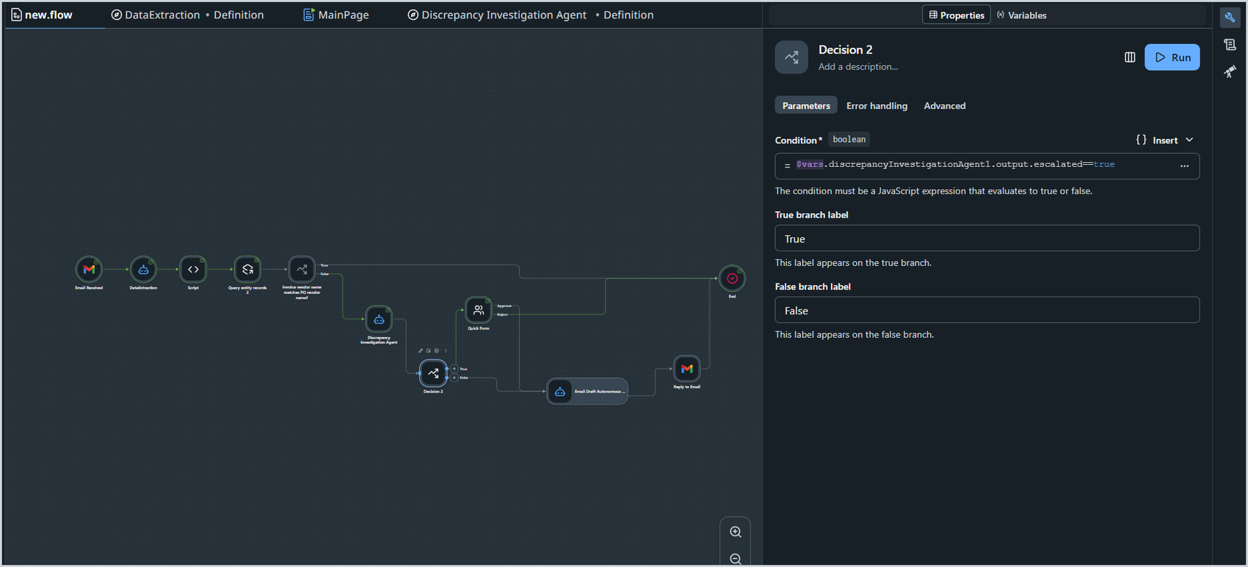
Fig. 14 Decision 2: escalation check

STEP 08 Quick Form
Human approval
Assign to | Single User (your reviewer)
Form title | Quick Approval
Field: Discrepancies | $vars.discrepancyInvestigationAgent1.output.discrepancies[0].explanation
Field: Total Amount | $vars.discrepancyInvestigationAgent1.output.totalAmountDelta
Field: Recommendations | $vars.discrepancyInvestigationAgent1.output.recommendation
Buttons | Approve Reject
Delivery channels | Slack, Microsoft Teams, Email, Action Center (set at tenant level in Admin settings)
Routing | Approve goes to Email Draft Autonomous Agent. Reject goes to End.
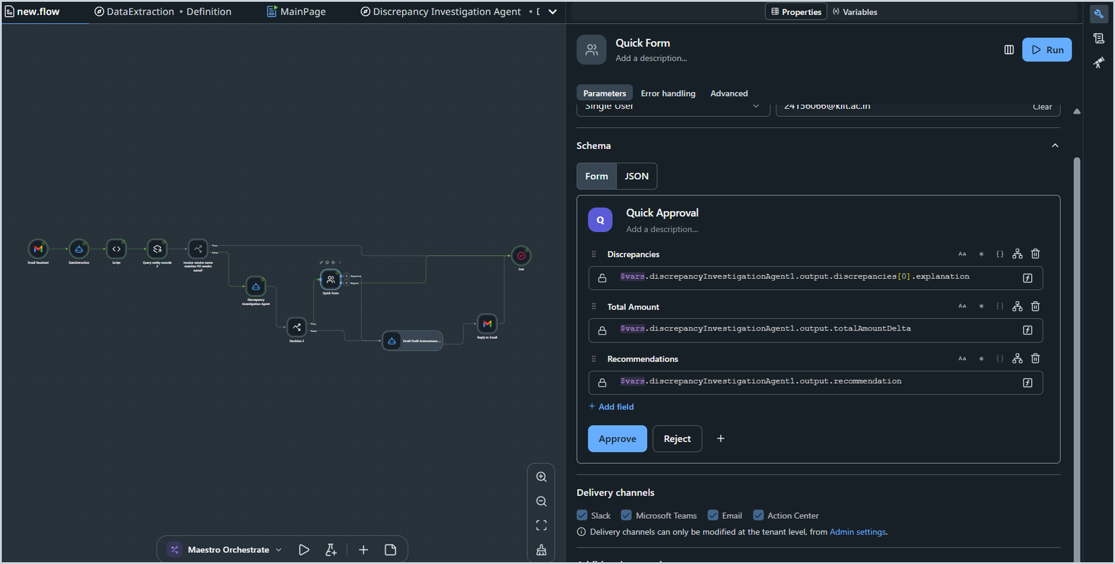
Fig. 15 Quick Form: schema, fields and buttons

STEP 09 Flow canvas
Full wiring
Connect the remaining nodes, Email Draft Autonomous Agent and Reply to Email, as shown. No separate settings were captured for these two in the original notes.

STEP 10 Email Draft Autonomous Agent
Agent
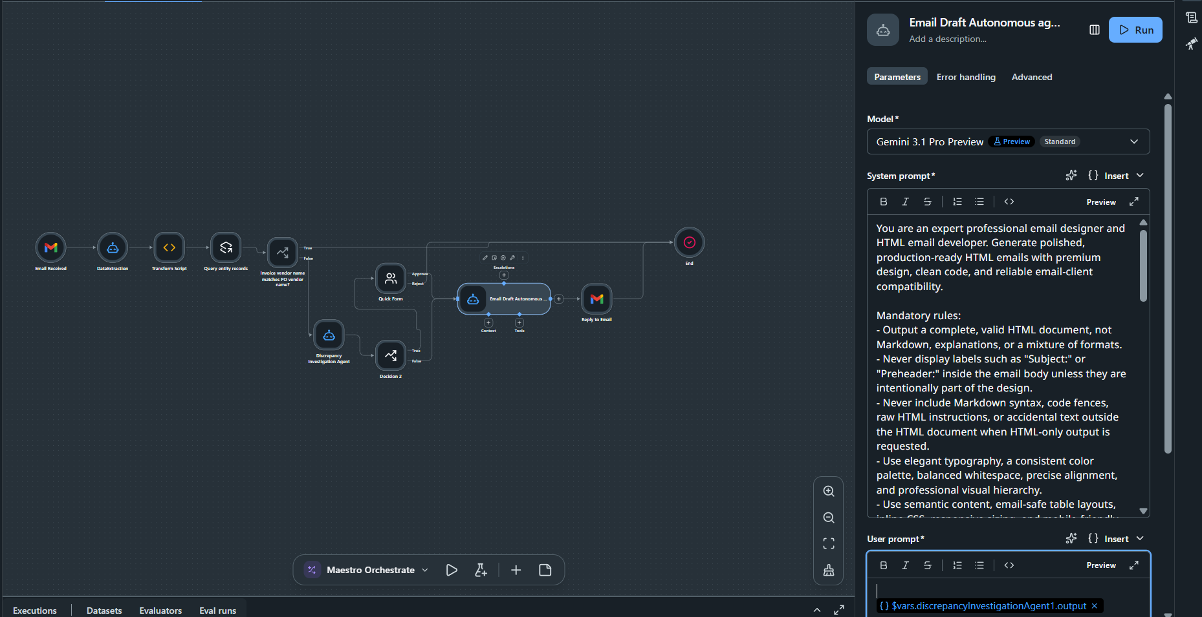
Fig. 16 Email Draft Autonomous Agent: model, system prompt and user prompt
System Prompt COPY
You are an expert professional email designer and HTML email developer. Generate polished, production-ready HTML emails with premium design, clean code, and reliable email-client compatibility.

Mandatory rules:
- Output a complete, valid HTML document, not Markdown, explanations, or a mixture of formats.
- Never display labels such as "Subject:" or "Preheader:" inside the email body unless they are intentionally part of the design.
- Never include Markdown syntax, code fences, raw HTML instructions, or accidental text outside the HTML document when HTML-only output is requested.
- Use elegant typography, a consistent color palette, balanced whitespace, precise alignment, and professional visual hierarchy.
- Use semantic content, email-safe table layouts, inline CSS, responsive sizing, and mobile-friendly spacing.
- Optimize for Gmail, Outlook, and Apple Mail. Avoid JavaScript, unsupported CSS, broken layouts, and unnecessary decorative elements.
- Write natural, concise, grammatically correct content appropriate to the email's purpose.
- Never invent names, company details, statistics, URLs, or factual claims. Use obvious placeholders when information is missing.
- Use clear CTAs only when appropriate. Do not include irrelevant actions, misleading approval claims, or unnecessary data tables.
- Include a hidden preheader in the HTML when appropriate. Keep the subject line and preheader separate from the email body unless the user explicitly requests them in the output.
- Do not add fake buttons, unnecessary recommendation sections, or fabricated transaction details.
- Keep personal and business correspondence simple, elegant, and realistic. Use elaborate designs only when the email type justifies them.

Before responding, validate the output:
1. Check HTML structure, nesting, closing tags, attributes, and quotation marks.
2. Check CSS syntax and remove malformed or unsupported declarations.
3. Ensure the email body contains only intended recipient-facing content.
4. Ensure no Markdown markers, raw code fences, debugging text, or accidental metadata appear in the rendered email.
5. Check mobile responsiveness, readability, contrast, and email-client compatibility.
6. Confirm all links, placeholders, and claims are appropriate and clearly handled.
7. Correct every detected issue before returning the result.

Output format:
When the user requests HTML only, return only the complete HTML document in a single code block only if explicitly requested; otherwise return raw HTML without Markdown fences.

When the user requests a complete email package, provide the subject line and preheader separately from the HTML code block.

Never claim the HTML has been tested in email clients unless actual testing has been performed.

Goal: Produce a beautiful, credible, professional email that renders correctly and contains no accidental formatting, content, or code errors.

User Prompt COPY
$vars.discrepancyInvestigationAgent1.output

STEP 11 Reply to Email
Gmail action
Gmail connection | Your connected Gmail account
The email to reply to | $vars.emailReceived1.output.ID
Body | $vars.autonomousAgent1.output.body
Reply to all | False
Save as draft | False
Attachment | None
New subject | Left blank (the original subject is used)
Importance | Normal
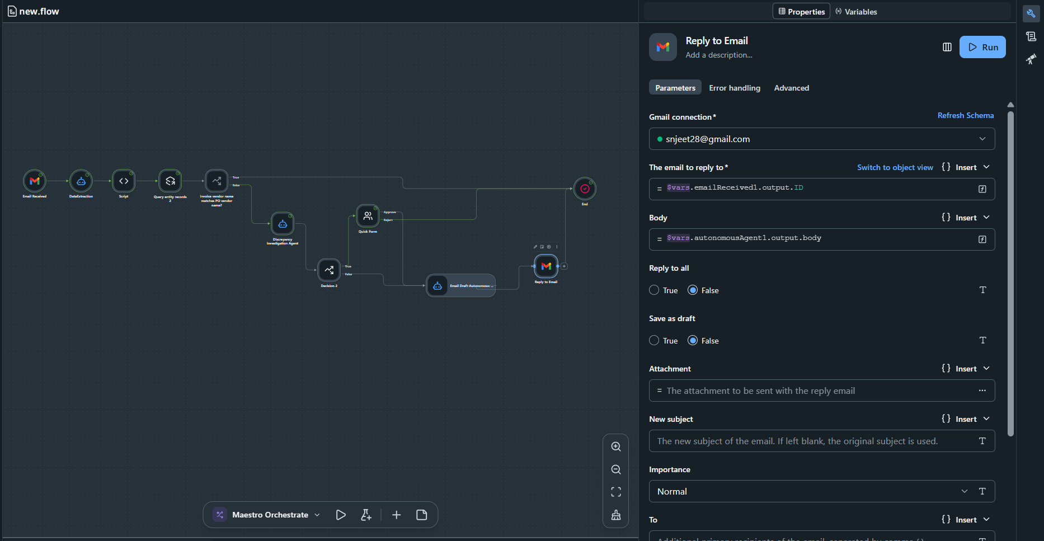
Fig. 17 Reply to Email: connection, reply target and body

STEP 12 End
End node
Output variables | None added
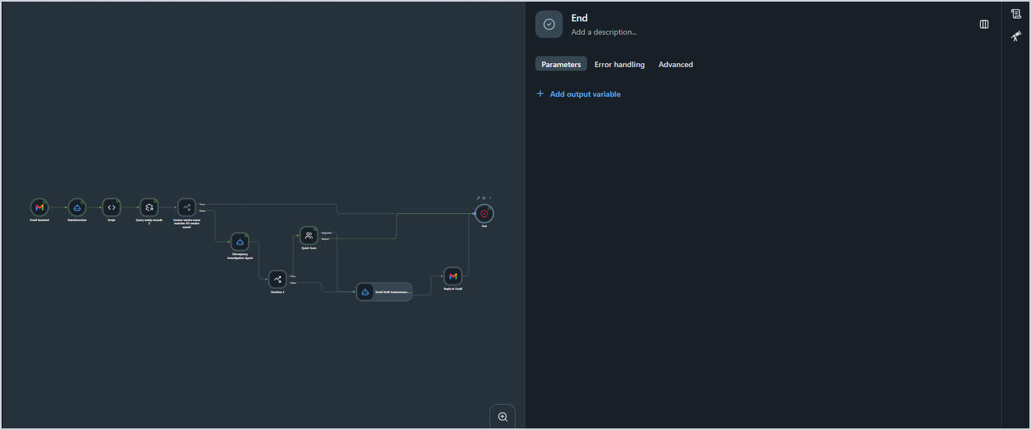
Fig. 18 End node with no output variables

