**Stuff4Hire - Component Docs**

**Navbar**

It support for branding, navigation, and more, including support for our collapse plugin. It Provides navigation for Messages, Accounts, About . Messages section will contain the list of message with recent message on the top. Accounts section will contain user profile, settings and logout option.

## **Supported content**

Navbars comes with built-in support for sub-components.

.navbar-brand is used for displaying company logo, messages, profile and about

.navbar-nav for a full-height and lightweight navigation (including support for dropdowns).

.navbar-toggler for use with our collapse plugin and other navigation toggling behaviors.

.form-inline for any form controls and actions.

.navbar-text for adding vertically centered strings of text.

Example:



Code:

<div class="container-fluid">

<nav class="navbar navbar-secondary container">

<a class="navbar-brand" href="#"><img class="logo-image"

src="logo.png"></a>

<div class="d-flex flex-row justify-content-end">

<ul class="navbar-nav flex-row">

<li class="nav-item dropdown">

<a class="nav-link dropdown-toggle" data-toggle="dropdown" href="#" role="button">

<i class="fa fa-envelope pr-1"></i> <span class="d-none">....</span>

</a>

<span>4</span>

<div class="dropdown-menu">

<a class="dropdown-item" href="#">

<div class="media">

<div class="media-body">

<div class="message-body-header">

<span class="message-card-user-name">....</span>

</div>

<div class="title">

<b>.....</b>

</div>

<div class="text">

</div>

</div>

</div>

</a>

<div class="dropdown-menu">

<a class="dropdown-item" href="#">....</a>

<a class="dropdown-item" href="#">....</a>

<a class="dropdown-item" href="#">....</a>

</div>

</li>

<li class="nav-item">

<a class="nav-link" href="#">....</a>

</li>

</ul>

</div>

</nav>

</div>

# **Jumbotron**

A lightweight, flexible component that can optionally extend the entire viewport to showcase the search for key marketing on our site.

Example:

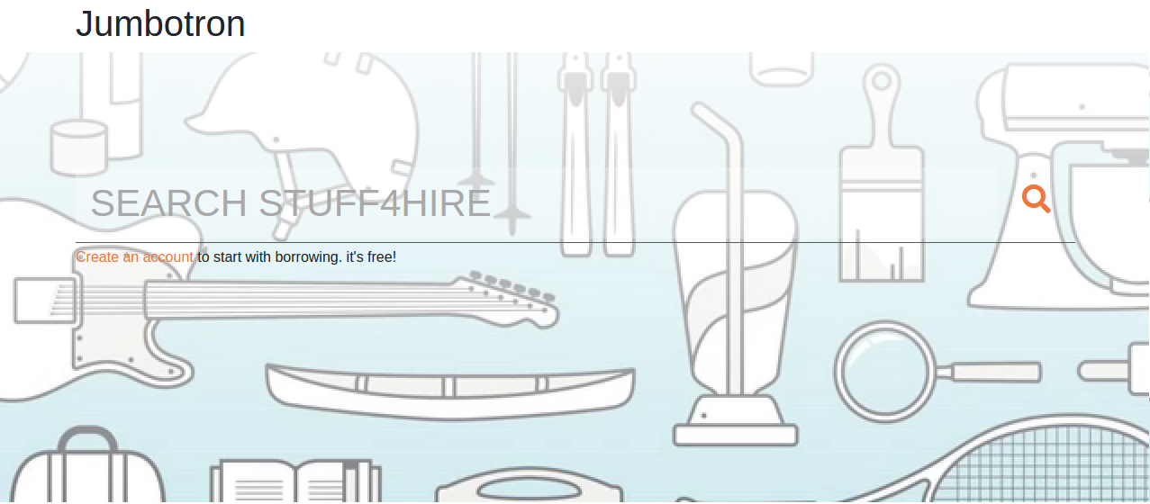

Code:

<div class="container"><h1>.....</h1></div>

<div class="jumbotron jumbotron-fluid">

<div class="container">

<form class="search-form">

<div class="input-group input-group-lg">

<input type="text" class="form-control" placeholder="Search">

<a class="btn btn-lg"><i class="fa fa-search" > </i></a>

</div>

</form>

<hr class="my-1">

<a href="" >....</a>

</div>

</div>

# **Carousel**

A slideshow component for cycling through product images . The carousel is a slideshow for cycling through a series of content, built with CSS 3D transforms and a bit of JavaScript. It works with a series of images, text, or custom markup. It also includes support for previous/next controls and indicators.

## **How it works**

The carousel is a slideshow for cycling through a series of content, built with CSS 3D transforms and a bit of JavaScript. It works with a series of images, text, or custom markup. It also includes support for previous/next controls and indicators.

Example:

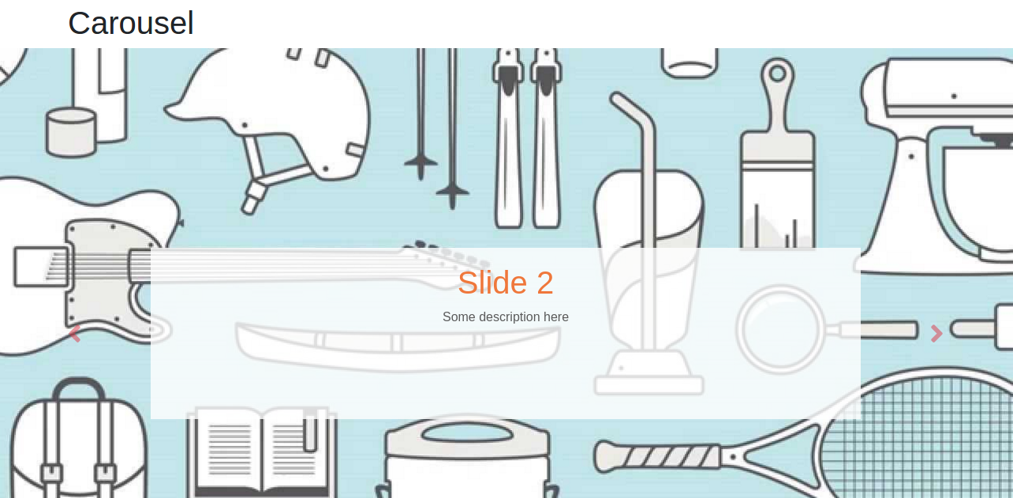

Code:

<div class="container"><h1>.....</h1></div>

<div id="carousel" class="carousel slide" data-ride="carousel">

<ol class="carousel-indicators ">

<li data-target="#carousel" data-slide-to="0" class="active "></li>

<li data-target="#carousel" data-slide-to="1" class="bg-blue"></li>

</ol>

<div class="carousel-inner">

<div class="carousel-item active">

<img class="d-block w-100" src="banner.jpg" alt="First slide">

<div class="carousel-caption">

<h1 class="text-title">....</h1>

<p class="txt-dark">....</p>

</div>

</div>

<div class="carousel-item">

<img class="d-block w-100" src="banner.jpg" alt="First slide">

<div class="carousel-caption">

<h1 class="title">....</h1>

<p class="text">....</p>

</div>

</div>

</div>

<a class="carousel" href="#carousel" role="button" data-slide="prev">

<span class="fa fa-angle-left" aria-hidden="true"></span>

<span class="sr-only">....</span>

</a>

<a class=" text-danger" href="#carousel" role="button" data-slide="next">

<span class="fa fa-angle-right" aria-hidden="true">....</span>

<span class="sr-only">....</span>

</a>

</div>

# **Product Grid View**

Product Grid View is used for showing the products one beside the other. It includes product image and the description about product with the button for reserving the item.

Example:

# 

Code:

<div class="container">

<div class="row">

<div class="col-md-4">

<div class="card border-radius-6" >

<img class="img-top" src="no-image.jpeg">

<div class="body">

<h5 class="title">....</h5>

<p class="text">.... </p>

<a href="#" class="btn btn-primary">....</a>

</div>

</div>

</div>

<div class="col-md-4">

<div class="card border-radius-6" >

<img class="img-top" src="no-image.jpeg" alt="Card image">

<div class="body">

<h5 class="title">....</h5>

<p class="text">....</p>

<a href="#" class="btn btn-primary">....</a>

</div>

</div>

</div>

<div class="col-md-4">

<div class="card border-radius-6" >

<img class="img-top" src="no-image.jpeg" alt="Card image">

<div class="body">

<h5 class="title">....</h5>

<p class="text">....</p>

<a href="#" class="btn btn-primary align-items-center">....</a>

</div>

</div>

</div>

</div>

# **Product List View**

List groups are a flexible and powerful component for displaying a series of content. It includes product image and the description about product with the button for reserving the item and also rating.

Example:

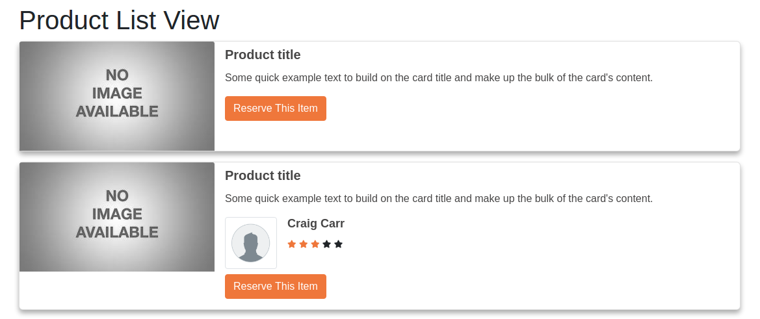

Code:

<div class="row">

<div class="col-lg-12">

<div class="card" >

<div class="media">

<div class="media-left">

<img class="card-img-top " src="no-image.jpeg" alt="Generic placeholder">

</div>

<div class="card-body">

<h5 class="title">....</h5>

<p class="text">....</p>

<a href="#" class="btn btn-primary">....</a>

</div>

</div>

</div>

</div>

<div class="col-lg-12">

<div class="card mb-3" >

<div class="media">

<div class="media-left">

<img class="card-img-top product-card-image" src="no-image.jpeg" alt="Generic">

</div>

<div class="body">

<h5 class="title">....</h5>

<p class="text">....</p>

<div class="rating">

<div class="media">

<div class="media-left">

<div class="avtar">

<img class="img-thumbnail" src="user.png">

</div>

</div>

<div class="media-body">

<div class="name">

<h5>Craig Carr</h5>

</div>

<div class="rating-stars">

<span class="fa fa-star checked txt-orange fa-xs"></span>

<span class="fa fa-star checked txt-orange fa-xs"></span>

<span class="fa fa-star checked txt-orange fa-xs"></span>

<span class="fa fa-star fa-xs"></span>

<span class="fa fa-star fa-xs"></span>

</div>

</div>

</div>

</div>

<div class="footer">

<a href="#" class="btn btn-primary">....</a>

</div>

</div>

</div>

</div>

</div>

</div>

</div>

</div>

# **Product Details**

It Contains carousel of images with product name and its description with customer rating about the product. It also contains button for reserve item.

Example:

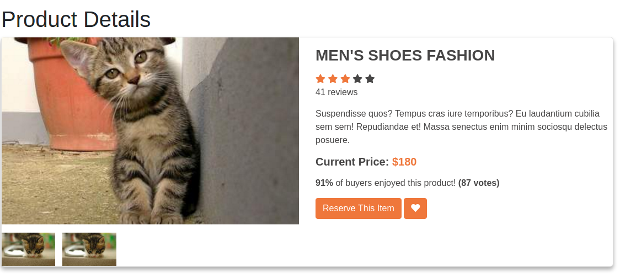

Code:

<div class="container">

<h1> .... </h1>

<div class="card">

<div class="container-fliud">

<div class="wrapper row">

<div class="preview col-md-6">

<div id="carousel" class=" carousel slide" data-ride="carousel">

<div class="carousel-inner preview-pic">

<div class="carousel-item active">

<img class="d-block" src="kitten” alt="First slide">

</div>

<div class="carousel-item">

<img class="d-block" src="kitten" alt="Second slide">

</div>

</div>

</div>

<ul class="preview-thumbnail nav nav-tabs">

<li data-target="ProductDetails" data-slide-to="0" class="active">

<img src="kitten" />

</li>

<li data-target="#carouse" data-slide-to="1" class="">

<img src="kitten”>

</li>

</ul>

</div>

<div class="details col-md-6 mt-3">

<h3 class="title">....</h3>

<div class="rating">

<div class="stars">

<span class="fa fa-star checked"></span>

<span class="fa fa-star checked"></span>

<span class="fa fa-star checked"></span>

<span class="fa fa-star"></span>

<span class="fa fa-star"></span>

</div>

<span class="review">41 reviews</span>

</div>

<p class="description">....</p>

<h4 class="price">....</h4>

<p class="vote">....</p>

<div class="action">

<button class="btn btn-primary " type="button">....</button>

<button class="btn-primary" type="button"><span class="fa fa-heart"></span></button>

</div>

</div>

</div>

</div>

</div>

</div>

**Messages Variation**

It contains the messages with variations, messages contains the user image with its name and the time of message. Some message contains only message text. Some contains the images of product returned or requested.

Example:

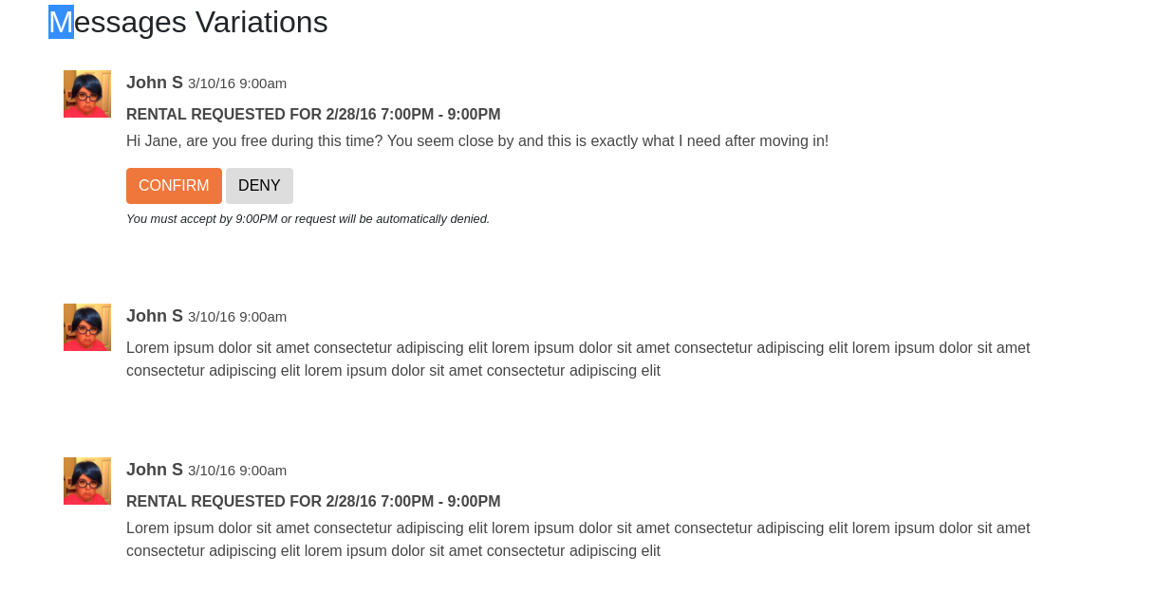

Code:

<div class="container">

<div class="row">

<div class="col-lg-12">

<div class="media">

<div class="media-left">

<img class="pull-left img-circle nav-user-photo" src="image">

</div>

<div class=" media-body">

<div class="header">

<p class="user-info">

<span class="user-name">....</span>

<span class="date-time">....</span>

</p>

</div>

<div class="title">

<p class="description">....</p>

</div>

<div class="text">

<p >.... </p>

</div>

<div class="message-card-confirm-button">

<button type="button" class="btn btn-primary">....</button>

<button type="button" class="btn btn-default">....</button>

</div>

<div class="message-card-note">

<p class="small">....</p>

</div>

</div>

</div>

</div>

</div>

<div class="row">

<div class="col-lg-12">

<div class="media">

<div class="media-left">

<img class="pull-left img-circle" src="image">

</div>

<div class="media-body">

<div class="header">

<p class="message-card-user-info">

<span class="message-card-user-name"> .... </span>

<span class="message-card-date-time">....</span>

</p>

</div>

<div class="message-card-text">

</div>

</div>

</div>

</div>

</div>

<div class="row">

<div class="col-lg-12">

<div class="media">

<div class="media-left">

<img class="pull-left img-circle nav-user-photo" src="image">

</div>

<div class=" media-body">

<div class="header">

<p class=”user-info">

<span class=”user-name">....</span>

<span class="date-time">....</span>

</p>

</div>

<div class="message-card-title">

<p class="message-card-description">....</p>

</div>

<div class="message-card-text">

</div>

</div>

</div>

</div>

</div>

<div class="row">

<div class="col-lg-12">

<div class="media">

<div class="media-left">

<img class="pull-left img-circle nav-user-photo" src="image">

</div>

<div class="message-card">

<div class="header">

<p class="user-info">

<span class="user-name">....</span>

<span class="date-time">....</span>

</p>

</div>

<div class="title">

<p class="description">....</p>

</div>

<img class="message-card-image " src="no-image.jpeg" alt="Generic placeholder">

</div>

</div>

</div>

</div>

</div>

# **Reviews**

It contains review of product with user name and its image.

Example:

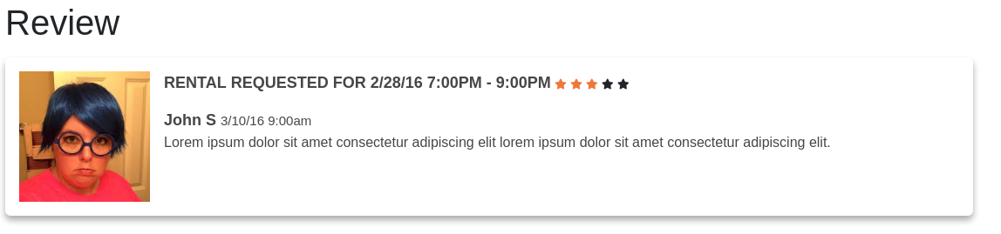

Code:

<div class="container">

<div class="row">

<div class="col-lg-12">

<h1>....</h1>

<div class="media review-card">

<div class="media-left">

<img class="pull-left img-circle nav-user-photo" src="image">

</div>

<div class="review-card">

<div class="review-card-title">

<p>.....</p>

</div>

<div class="rating-stars">

<span class="fa fa-star checked txt-orange fa-xs"></span>

<span class="fa fa-star checked txt-orange fa-xs"></span>

<span class="fa fa-star checked txt-orange fa-xs"></span>

<span class="fa fa-star fa-xs"></span>

<span class="fa fa-star fa-xs"></span>

</div>

<div class="user-info">

<span class="review-card-user-name">.....</span>

<span class="review-card-date-time">.....</span>

</div>

<div class="review-card-text">

</div>

</div>

</div>

</div>

</div>

</div>

</section>

# **Email**

This component contains email with its subject, name of customer, description and footer.

Example

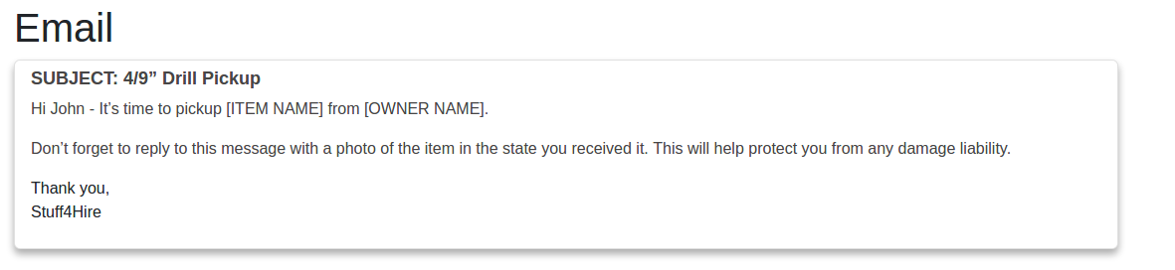

Code:

<div class="container">

<div class="row">

<div class="col-lg-12">

<h1>Email</h1>

<div class="card">

<div class="card-body">

<h6 class="card-title">.....</h6>

<div class="card-text">

<p>.....</p>

<p>.....</p>

</div>

<div class="card-footer">

<p>.....</p>

</div>

</div>

</div>

</div>

</div>

</div>

# **Profile Summary**

Customers Profile Summary the details of customer like the stuffed owned, stuff rented, review and rating with the location map

Example:

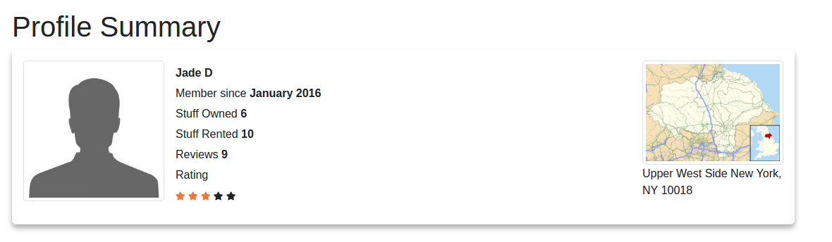

Code:

<div class="container">

<div class="row">

<div class="col-lg-12">

<h1>.....</h1>

<div class="media profile-card">

<div class="media-left profile-card-avatar">

<img class="img-thumbnail" src="user.jpg" alt="Generic placeholder image">

</div>

<div class="media-body">

<div class="card-title">

<h6>.....</h6>

</div>

<div class="profile-card-details">

<p>.....</p>

<div class="profile-rating-stars">

<span class="fa fa-star checked"></span>

<span class="fa fa-star checked"></span>

<span class="fa fa-star checked"></span>

<span class="fa fa-star fa-xs"></span>

<span class="fa fa-star fa-xs"></span>

</div>

</p>

</div>

</div>

<div class="media-right map">

<img class="img-thumbnail" src="map.png" alt="Generic placeholder image">

<div class="map-adderss">

</div>

</div>

</div>

</div>

</div>

</div>

# **Stuff I am borrowing Collapsible panel**

Toggle the visibility of content across the product and uses JavaScript plugins.

## **How it works**

The collapse JavaScript plugin is used to show and hide content. Buttons or anchors are used as triggers that are mapped to specific elements you toggle. Collapsing an element will animate the height from it’s current value to 0. Given how CSS handles animations, you cannot use padding on a .collapse element. Instead, use the class as an independent wrapping element.

Example:

Click the buttons below to show and hide another element via class changes: .collapse hides content

.collapsing is applied during transitions

.collapse.show shows content

You can use a link with the href attribute, or a button with the data-target attribute. In both cases, the data-toggle="collapse" s required.

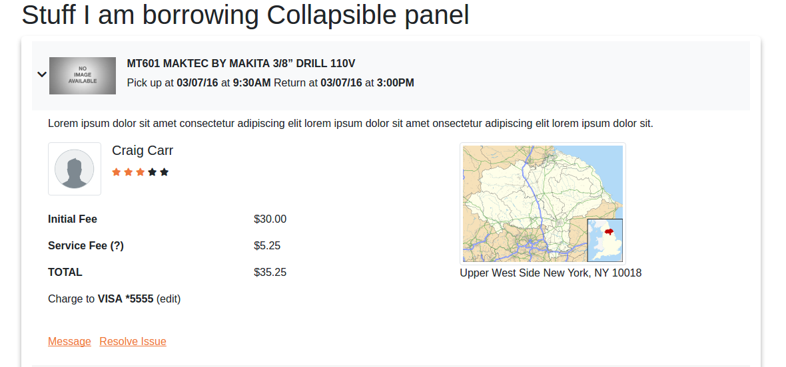

Code:

<div class="container">

<div class="row">

<div class="col-lg-12">

<h1>.....</h1>

<div class="collapse-panel collapsible-card-panel">

<div class="media bg-light collapsible-card-header" id="panelOne">

<div class="media-right”>

<i id="headingOne" class="fa fa-chevron-down pull-right" data-toggle="collapse" data-target="#collapseOne"></i>

<img src="no-image.jpeg" alt="Generic placeholder" class="collapsible-card-header-avtar">

</div>

<div class="media-body">

<div class="collapsible-card-header-title">

<h6>.....</h6>

</div>

<div class="collapsible-card-header-description">

<p>...... </p>

</div>

</div>

</div>

<div id="collapseOne" class="collapse data-parent="#panelOne">

<div class="collapsible-card-body-text">

</div>

<div class="row">

<div class="col-lg-7 col-md-7 col-sm-7 col-xs-12">

<div class="media">

<div class="media-left rating-user-avtar">

<img class="img-thumbnail" src="user.png" alt="Generic placeholder”>

</div>

<div class="media-body">

<div class="user-name">

<h5>....</h5>

</div>

<div class="product-rating-stars">

<span class="fa fa-star checked txt-orange fa-xs"></span>

<span class="fa fa-star checked txt-orange fa-xs"></span>

<span class="fa fa-star checked txt-orange fa-xs"></span>

<span class="fa fa-star fa-xs"></span>

<span class="fa fa-star fa-xs"></span>

</div>

</div>

</div>

<div class="fees-panel py-4">

<div class="row">

<div class="col-lg-6 col-md-6 col-sm-6 col-xs-12">

<div class="fees-title">

<strong>.....</strong>

</div>

</div>

<div class="col-lg-6 col-md-6 col-sm-6 col-xs-12">

<div class="fees-cost">

<p>.....</p>

</div>

</div>

</div>

<div class="row">

<div class="col-lg-6 col-md-6 col-sm-6 col-xs-12">

<div class="fees-title">

<strong>.....</strong>

</div>

</div>

<div class="col-lg-6 col-md-6 col-sm-6 col-xs-12">

<div class="fees-cost">

<p class="">.....</p>

</div>

</div>

</div>

<div class="row">

<div class="col-lg-6 col-md-6 col-sm-6 col-xs-12">

<div class=".....">

<strong>.....</strong>

</div>

</div>

<div class="col-lg-6 col-md-6 col-sm-6 col-xs-12">

<div class="">

<p class="">.....</p>

</div>

</div>

</div>

<div class="fees-charge-info">

<p>.....</p>

</div>

</div>

<div class="collapsible-card-links">

<u><a href="">.....</a></u>

<u class=""><a href="">.....</a></u>

</div>

</div>

<div class="col-lg-5 col-md-5 col-sm-5 col-xs-12">

<div class="media">

<div class="media-right profile-card-map">

<img class="map.png" alt="Generic placeholder image">

<div class="profile-card-map-adderss">

</div>

</div>

</div>

</div>

</div>

</div>

<hr>

<div class="media bg-light collapsible-card-header" id="panelTwo">

<div class="media-right px-2 py-4">

<i id="headingTwo" class="fa fa-chevron-down pull-right" data-toggle="collapse" data-target="#collapseTwo"></i>

<img src="no-image.jpeg" alt="Generic placeholder image" class="collapsible-card-header-avtar">

</div>

<div class="media-body collapsible-card-header-body">

<div class="collapsible-card-header-title">

<h6>.....</h6>

</div>

<div class="collapsible-card-header-description">

<p>

</p>

</div>

</div>

</div>

<div id="collapseTwo" class="collapse collapse-body px-4 py-2 collapsible-card-body" aria-labelledby="headingTwo" data-parent="#panelTwo">

<div class="collapsible-card-body-text">

</div>

<div class="row">

<div class="col-lg-7">

<div class="media">

<div class="media-left rating-user-avtar">

<img class="img-thumbnail" src="user.png" alt="Generic placeholder">

</div>

<div class="media-body mx-3">

<div class="user-name">

<p>Craig Carr</p>

</div>

<div class="product-rating-stars">

<span class="fa fa-star checked txt-orange fa-xs"></span>

<span class="fa fa-star checked txt-orange fa-xs"></span>

<span class="fa fa-star checked txt-orange fa-xs"></span>

<span class="fa fa-star fa-xs"></span>

<span class="fa fa-star fa-xs"></span>

</div>

</div>

</div>

<div class="fees-panel">

<div class="row">

<div class="col-lg-6">

<div class="fees-title">

<strong>...</strong>

</div>

</div>

<div class="col-lg-6">

<div class="fees-cost">

<p>...</p>

</div>

</div>

</div>

<div class="row">

<div class="col-lg-6">

<div class="fees-title">

<strong>.....</strong>

</div>

</div>

<div class="col-lg-6 col-md-6 col-sm-6 col-xs-12">

<div class="fees-cost">

<p class="">.....</p>

</div>

</div>

</div>

<div class="row">

<div class="col-lg-6 col-md-6 col-sm-6 col-xs-12">

<div class="fees-title">

<strong>.....</strong>

</div>

</div>

<div class="col-lg-6 col-md-6 col-sm-6 col-xs-12">

<div class="fees-cost">

<p class="">.....</p>

</div>

</div>

</div>

<div class="fees-charge-info">

<p>.....</p>

</div>

</div>

<div class="collapsible-card-links">

<u><a href="">.....</a></u>

<u class="px-2"><a href="">.....</a></u>

</div>

</div>

<div class="col-lg-5 col-md-5 col-sm-5 col-xs-12">

<div class="media product-card-rating">

<div class="media-right profile-card-map">

<img class="img-thumbnail" src="map.png" alt="Generic placeholder">

<div class="profile-card-map-adderss">

</div>

</div>

</div>

</div>

</div>

</div>

</div>

</div>

</div>

</div>

# **Product List carousel**

A slideshow component for cycling through product images or slides of text. The carousel is a slideshow for cycling through a series of content, built with CSS 3D transforms and a bit of JavaScript. It works with a series of images, text, or custom markup. It also includes support for previous/next controls and indicators.

## **How it works**

The carousel is a slideshow for cycling through a series of content, built with CSS 3D transforms and a bit of JavaScript. It works with a series of images, text, or custom markup. It also includes support for previous/next controls and indicators.

In browsers where the Page Visibility API is supported, the carousel will avoid sliding when the webpage is not visible to the user (such as when the browser tab is inactive, the browser window is minimized, etc.).

Please be aware that nested carousels are not supported, and carousels are generally not compliant with accessibility standards.

Example:

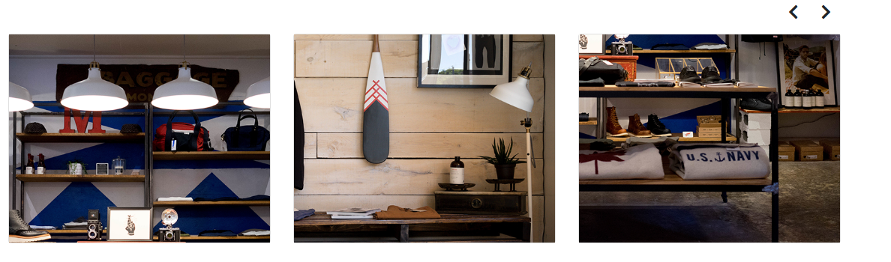

Code:

<section class=”carousel slide" data-ride="carousel" id="postsCarousel">

<div class="container">

<h1>.....</h1>

<div class="row">

<div class="col-12">

<a class="btn btn-secondary-outline prev" title="go back" data-target="#postsCarousel"><i class="fa fa-lg fa-chevron-left"></i></a>

<a class="btn btn-secondary-outline next" title="more" data-target="#postsCarousel"><i class="fa fa-lg fa-chevron-right"></i></a>

</div>

</div>

</div>

<div class="container">

<div class="carousel-inner">

<div class="carousel-item">

<div class="card-deck">

<div class="card">

<div class="card-img-top" data-toggle="modal" data-target="#myModal">

<img class="img-fluid" src="image.png" alt="Carousel 1">

</div>

</div>

<div class="card">

<div class="card-img-top">

<img class="img-fluid" src="image.png" alt="Carousel 2">

</div>

</div>

<div class="card">

<div class="card-img-top ">

<img class="img-fluid" src="image.png" alt="Carousel 3">

</div>

</div>

</div>

</div>

<div class="carousel-item">

<div class="card-deck">

<div class="card">

<div class="card-img-top">

<img class=image.png" alt="Carousel 4">

</div>

</div>

<div class="card">

<div class="card-img-top">

<img class="img-fluid" src="image.png" alt="Carousel 5">

</div>

</div>

<div class="card">

<div class="card-img-top product-list-avtar">

<img class="img-fluid" src="image.png" alt="Carousel 6">

</div>

</div>

</div>

</div>

</div>

</div>

<div class="modal fade" id="myModal">

<div class="modal-dialog">

<div class="modal-content">

<div class="modal-header">

<div class="pull-left">.....</div>

<button type="button" class="close" data-dismiss="modal" title="Close">

<i class="fas fa-window-close"></i>

</button>

</div>

<div class="modal-body">

<div id="myGallery" class="carousel slide" data-ride="carousel" data-interval="false">

<div class="carousel-inner">

<div class="carousel-item active"> <img src="image.png" alt="item0">

<div class="carousel-caption">

<h3>....</h3>

<p>....</p>

</div>

</div>

<div class="carousel-item"> <img src="image.png" alt="item1">

<div class="carousel-caption">

<h3>....</h3>

<p>.....</p>

</div>

</div>

<div class="carousel-item"> <img src="image.png" alt="item2">

<div class="carousel-caption">

<h3>....</h3>

<p>.....</p>

</div>

</div>

<div class="carousel-item"> <img src="image.png" alt="item3">

<div class="carousel-caption">

<h3>....</h3>

<p>.....</p>

</div>

</div>

<div class="carousel-item"> <img src="image.png" alt="item4">

<div class="carousel-caption">

<h3>....</h3>

<p>.....</p>

</div>

</div>

<div class="carousel-item"> <img src="image.png" alt="item5">

<div class="carousel-caption">

<h3>....</h3>

<p>....</p>

</div>

</div>

</div>

<a class="carousel-control-prev text-danger" href="#myGallery" role="button" data-slide="prev">

<span class="fa fa-angle-left" aria-hidden="true"></span>

<span class="sr-only">Previous</span>

</a>

<a class="carousel-control-next text-danger" href="#myGallery" role="button" data-slide="next">

<span class="fa fa-angle-right" aria-hidden="true"></span>

<span class="sr-only">Next</span>

</a>

</div>

</div>

<div class="modal-footer"></div>

</div>

</div>

</div>

</section>

# **Payouts**

Payouts cards provide a flexible and extensible content container with multiple variants and options. A **card** is a flexible and extensible content container. It includes options for headers and footers, a wide variety of content, contextual background colors, and powerful display options.

Example:

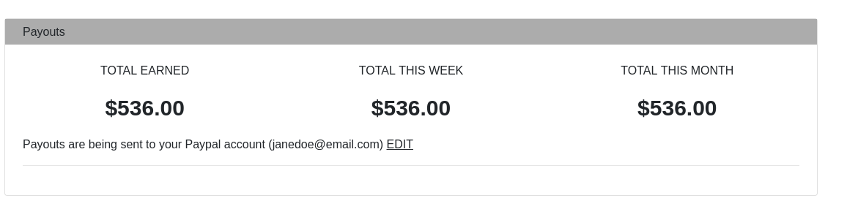

Code:

<div class="container">

<h1>....</h1>

<div class="row">

<div class="col-lg-12 col-md-12 col-sm-12">

<div class="card">

<div class="title">

</div>

<div class="payouts-card-body">

<div class="row">

<div class="col-lg-4">

<div class="payouts-heading">

<p>....</p>

</div>

<div class="payouts-amount">

<p>....</p>

</div>

</div>

<div class="col-lg-4 ">

<div class="payouts-heading">

<p>....</p>

</div>

<div class="payouts-amount">

<p>....</p>

</div>

</div>

<div class="col-lg-4 col-md-4 col-sm-4 text-center">

<div class="payouts-heading">

<p>....</p>

</div>

<div class="payouts-amount">

<p>....</p>

</div>

</div>

</div>

<div class="payouts-card-info">

<p>...</p>

</div>

</div>

</div>

</div>

</div>

</div>

</section>

# **Payouts-List**

A basic Bootstrap table has a light padding and only horizontal dividers. It contains simple bootstrap table with date, renter name item details and amount

Example:

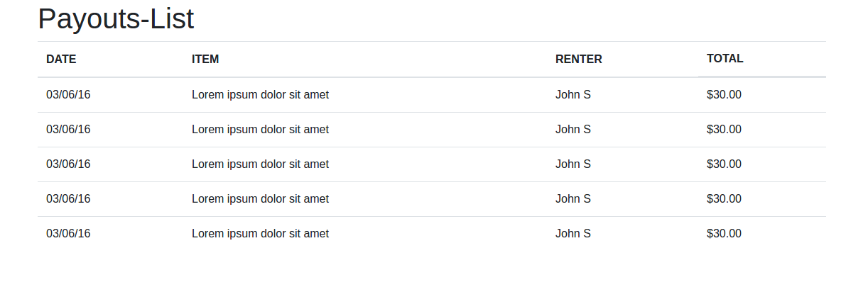

Code:

<section class="payouts-list">

<div class="container">

<div class="row">

<div class="col-lg-12 col-md-12 col-sm-12 col-xs-12">

<h1>....</h1>

<table class="table">

<thead>

<tr>

<th>.... </th>

<th>.... </th>

<th>....</th>

<th class="d-none d-sm-block">....</th>

</tr>

</thead>

<tbody>

<tr>

<td class="payouts-list-date">....</td>

<td class="payouts-list-description">....</td>

<td class="payouts-list-user-name">....</td>

<td class="payouts-list-amount d-none d-sm-block">....</td>

</tr>

<tr>

<td class="payouts-list-date">....</td>

<td class="payouts-list-description">....</td>

<td class="payouts-list-user-name">....</td>

<td class="payouts-list-amount d-none d-sm-block">....</td>

</tr>

<tr>

<td class="payouts-list-date">....</td>

<td class="payouts-list-description">....</td>

<td class="payouts-list-user-name">....</td>

<td class="payouts-list-amount d-none d-sm-block">....</td>

</tr>

<tr>

<td class="payouts-list-date">....</td>

<td class="payouts-list-description">....</td>

<td class="payouts-list-user-name">....</td>

<td class="payouts-list-amount d-none d-sm-block">....</td>

</tr>

<tr>

<td class="payouts-list-date">....</td>

<td class="payouts-list-description">....</td>

<td class="payouts-list-user-name">....</td>

<td class="payouts-list-amount d-none d-sm-block">....</td>

</tr>

</tbody>

</table>

</div>

</div>

</div>

</div>

**Message List**

A basic Bootstrap table has a light padding and only horizontal dividers. It contains simple bootstrap table with user image, name, discussion and last update status

Example:

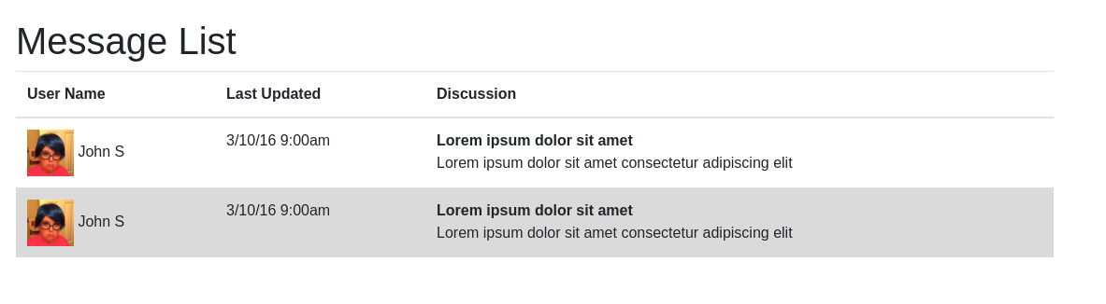

Code:

<section class="message-list">

<div class="container">

<div class="row">

<div class="col-lg-12 col-md-12 col-sm-12 col-xs-12">

<h1>....</h1>

<table class="table">

<thead>

<tr>

<th>....</th>

<th>....</th>

<th>....</th>

</tr>

</thead>

<tbody>

<tr>

<td class="message-list-user-avtar">

<img class="pull-left img-circle nav-user-photo" src="image.png”>

<span class="message-list-user-name">....</span>

</td>

<td class="message-list-last-update">.... </td>

<td class="message-list-description">.... </td>

</tr>

<tr class="table-active">

<td class="message-list-user-avtar">

<img class="pull-left img-circle nav-user-photo"src="image.png”>

<span class="message-list-user-name">....</span>

</td>

<td class="message-list-last-update">.... </td>

<td class="message-list-discription">.... </td>

</tr>

</tbody>

</table>

</div>

</div>

</div>

</section>

**Payment Methods**

Simple bootstrap form is used with various inputs and submit button

Example:

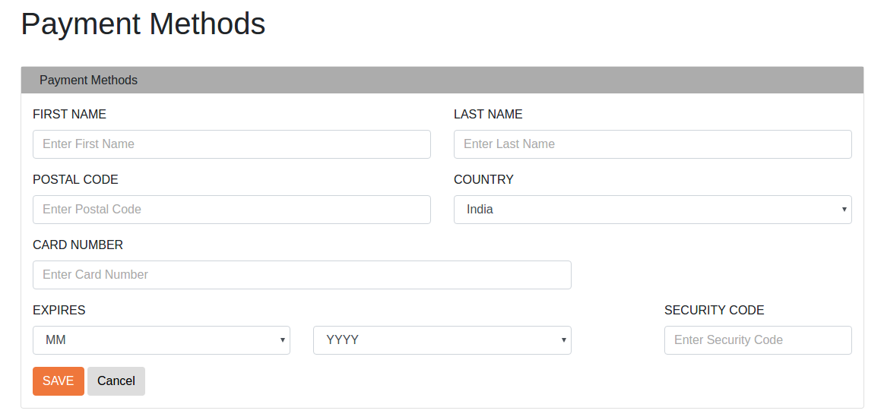

Code:

<section class="payment-method">

<div class="container">

<h1>Payment Methods</h1>

<div class="row">

<div class="col-lg-12">

<div class="card">

<div class="card-title”>

<h6>.......</h6>

</div>

<div class="container">

<form action="#">

<div class="row">

<div class="col-lg-6">

<div class="form-group">

<label for="first-name">.... </label>

<input type="text" class="form-control" id="first-name" placeholder="Enter First Name" name="first-name">

</div>

</div>

<div class="col-lg-6">

<div class="form-group pt-3">

<label for="last-name">.... </label>

<input type="last-name" class="form-control" id="last-name" placeholder="Enter Last Name" name="last-name">

</div>

</div>

</div>

<div class="row">

<div class="col-lg-6 col-md-6 col-sm-6 col-xs-6">

<div class="form-group">

<label for="postal-code">.... </label>

<input type="text" class="form-control" id="postal-code" placeholder="Enter Postal Code" name="postal-code">

</div>

</div>

<div class="col-lg-6 col-md-6 col-sm-6 col-xs-6">

<div class="form-group">

<label for="country">.... </label>

<select class="form-control" id="country">

<option>.... </option>

<option>.... </option>

</select>

</div>

</div>

</div>

<div class="row">

<div class="col-lg-8 ">

<div class="form-group ">

<label for="first-name">.... </label>

<input type="text" class="form-control" id="card-number" placeholder="Enter Card Number" name="card-number">

</div>

</div>

</div>

<div class="row">

<div class="col-lg-4">

<div class="form-group">

<label for="expires">....

</label>

<select class="form-control" id="expires-month">

<option value="" disabled selected>.... </option>

<option>.... </option>

<option>.... </option>

<option>.... </option>

</select>

</div>

</div>

<div class="col-lg-4">

<div class="form-group">

<label for="expire-year "></label>

<select class="form-control " id="expire-year">

<option value="" disabled selected>.... </option>

<option>.... </option>

<option>.... </option>

<option>.... </option>

</select>

</div>

</div>

<div class=" col-lg-1 ">

</div>

<div class="col-lg-3”>

<div class="form-group">

<label for=".... ">.... </label>

<input type="security-code" class="form-control" id="security-code" placeholder="Enter Security Code" name="last-name">

</div>

</div>

</div>

<div class="form-group">

<button type="button" class="btn btn-primary">.... </button>

<button type="button" class="btn btn-default">.... </button>

</div>

</form>

</div>

</div>

</div>

</div>

</div>

</section>

**Data Model**

On Click of data model it open the pop which may contain text, images

Example:

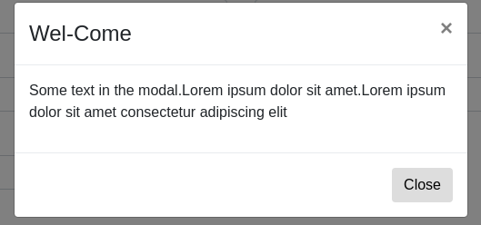

Code:

<section class="data-model">

<div class="container">

<div class="row">

<div class="col-lg-12">

<h1>Data Modal</h1>

<button type="button" class="btn btn-primary" data-toggle="modal" data-target="#myModal11">Modal</button>

<div class="modal fade" id="myModal11" role="dialog">

<div class="modal-dialog">

<div class="modal-content">

<div class="modal-header">

<h4 class="modal-title ">....</h4>

<button type="button" class="close" data-dismiss="modal">&times;</button>

</div>

<div class="modal-body">

<p>.... </p>

</div>

<div class="modal-footer">

<button type="button" class="btn btn-default" data-dismiss="modal">Close</button>

</div>

</div>

</div>

</div>

</div>

</div>

</div>

**Footer**

Footer contains links on social media and also quick link to Home, About, FAQ ,Legal, Contact Us

Example:



Code:

<footer class="container-fluid">

<div class="container">

<div class="row">

<div class="col-md-4">

<img class="img-responsive2"

src="logo-main.png">

<p>.... </p>

<a href="#"><i class="fab fa-facebook-f txt-white px-2"></i></a>

<a href="#"><i class="fab fa-twitter txt-white px-2"></i></a>

<a href="#"><i class="fab fa-instagram txt-white px-2"></i></a>

<a href="#"><i class="fab fa-google-plus-g txt-white px-2"></i></a>

</div>

<div class="col-md-4">

<h4 class="text">.... </h4>

<div class="row">

<div class="col-md-6">

<ul class="list-unstyled px-2">

<li>.... </li>

<li>.... </li>

<li>.... </li>

<li>.... </li>

<li>.... </a></li>

</ul>

</div>

<div class="col-md-6">

<ul class="list-unstyled px-2">

<li>....</li>

<li>.... </li>

<li>.... </li>

<li>.... </li>

</ul>

</div> </div>

</div>

<div class="col-md-4">

<h4 class="text">.... </h4>

<p class="">.... </p>

<p>

<div class="input-group">

<input type="text" class="form-control" placeholder="Search for...">

<span class="input-group-btn">

<button class="btn btn-default newsletter-btn" type="button">

<i class="fa fa-envelope"></i>

</button>

</span>

</div>

</div>

</div>

</div>

</footer>

Bootstrap classes for Text-Alignment

Class: Description

mt : Margin-Top

mb : Margin-Bottom

my : Margin-Top Margin-Bottom

mx : Margin left margin-right

mr : Margin right

ml : Margin left

py : Padding Top Padding-Bottom

px : Padding left Padding Right

pt : padding top

pb : Padding bottom

text-center : For taking text in center

txt-orange: For text in orange color

txt-dark: For text in dark grey color

txt-gray-light: For text in light grey color

txt-sky-blue : For text in sky blue color

bg-sky-blue : For background in sky blue color

bg-orange : For background in orange color

bg-dark : For background in dark-grey color

bg-light-grey: For background in light-grey color

bg-dark-blue: For background in light-grey color

border-orange: For border in Orange color

border-dark: For border in dark grey color

border-gray-light: For border in light grey color

border-white: For border in white color

Abouquickqu

* About
* FAQ
* Legal
* Contact Us
* FAQ
* Legal
* Contact Us

ome

* About
* FAQ
* Legal
* Contact Us