Organizers

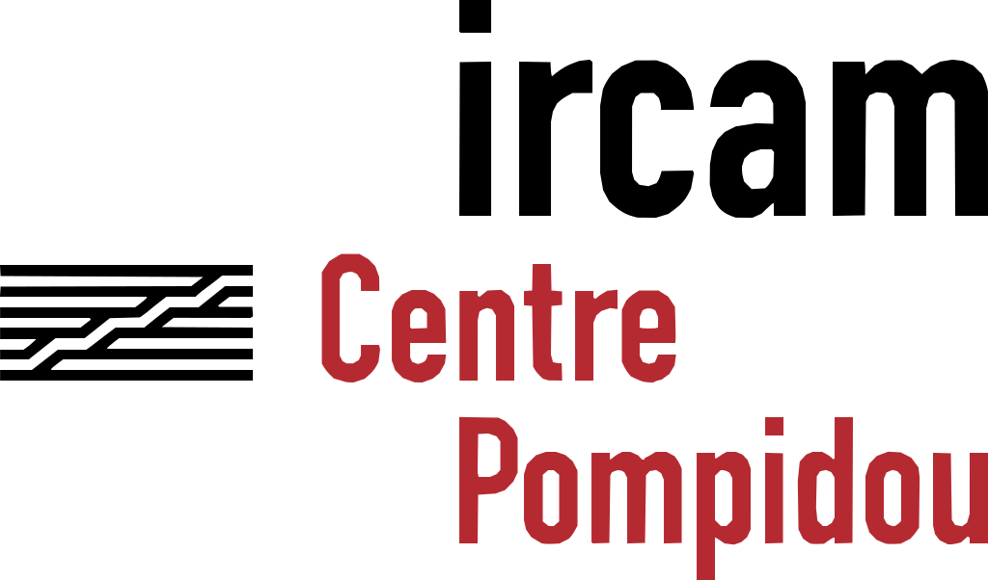

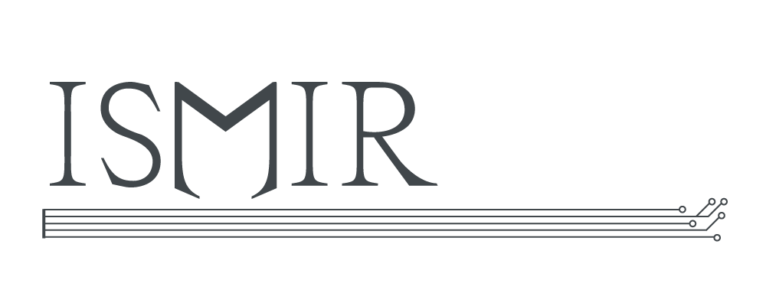

Sponsors

# Platinum Partners







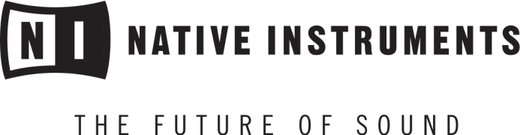



# Gold Partners



# 

# Silver Partners

https://ismir2017.smcnus.org/wp-content/uploads/2017/06/Adobe_Systems_Logo_002.svg_.pngW:\Dropbox\Conferences\ISMIR2017\ismirProceedings2017-master\2017_Proceedings_ISMIR\external\Sponsor Logos\SILVER acr_logo.png

# Bronze Partners



# WiMIR Sponsors



