Table of Contents
Philosophy 2
Etiquette 2
Usage of music-room 2
Security 2
Storage / cleanliness 3
Architecture 3
Centralized system 3
Balanced system 4
Audio-interface setup 4
DAW-DAWLESS setup 4
MIDI 4
Example usage 5
Jamming 5
Recording 6
Using outboard – effect gear 6
Practicing 7
Upgrade / to do list 7

Philosophy

Etiquette
It is of up most importance that all the equipment should be used respectfully. This equipment has all been donated by students! Do not use equipment that you don’t understand / did not read the manual off. If equipment is used in the wrong way, or configured in correctly then it could lead to permanent damage. This is especially true for the cabling in the room, do not unplug cables or switch around cables when you do not know what you are doing. Plugging in the wrong cables for the wrong equipment can lead to damage! You will have to pay for anything you break in the music-room if you handled it incorrectly or without care.

Usage of music-room
Primary usage:
- practice sessions*
- jam-sessions
- Mixing / editing audio
- recording audio

secondary usage:

- meditation (by meditation club)

The reason that a student wants to use the music should adhere to one of the usages described above. Anything activity that falls outside of this means that you should not use the music room. You are obliged to give up the music room if you are found doing another activity that does not fit into the primary or secondary usages and other students do want to do either a primary or secondary activity.
Even though meditation is not a musical activity, it has been agreed with the meditation club that it is allowed to meditate in the music-room went it is not used by any other student.

*practice sessions – the music room has been designed in such a way that multiple student should be able to practice multiple instruments individually without disturbing one another, all devices and instruments should have a headphone capability in other to isolate the practitioners for each other. So it is no excuse for one student to claim the entire music-room when the sole purpose is to practice!

Security
Security cameras are in place on both the inside or outside of the music-room. Anything you steal and cannot recover when you are confronted by your action will have to be payed for. Moreover, you will have to deal with the repercussions with Bocal.

Storage / cleanliness
Anytime you use the music-room it should be left just as you found it. If you have moved any equipment or changed cables (when you know what you are doing with the cables) then you should return said equipment back to its original location. Do not use the music-room to store any of your own personal stuff unless discussed with the maintainers / Bocal, especially if it is not musically related!

Architecture

Centralized system
As seen on the picture below, all equipment is wired back into the the patch-bays. This is in order to be able to centralize all equipment in order to combine the functionality of the different devices. The patch-bays receive all the incoming signals from all devices that are plugged in. These signals can then be rerouted to either analog audio devices-in order to add effects or change the audio signal in a certain way, to the mixer for mixing the sound for a jam-session or recording, or back into the audio interface in order to be used with a DAW or to record into a DAW.
Link to understand patch-bays
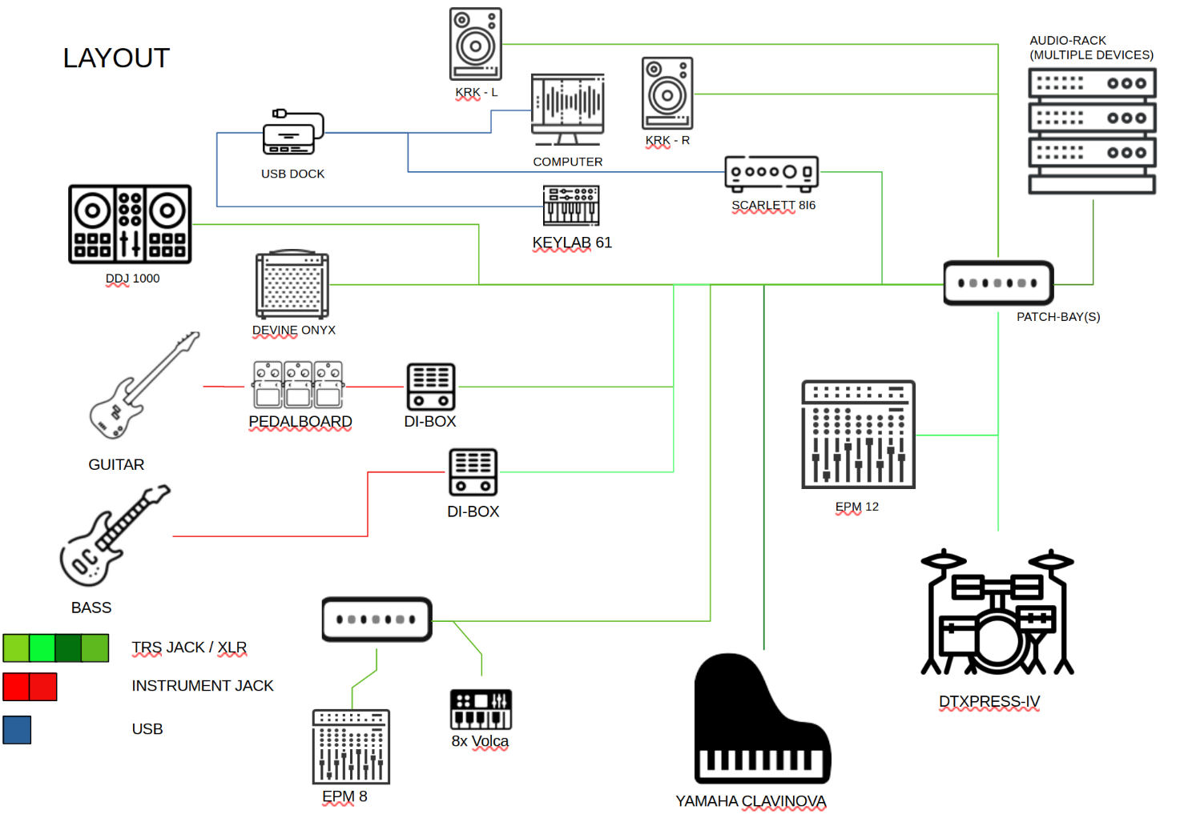
(picture might not be up to date, check most recent version for actual layout)

Balanced system
The reason it has been chosen for the system to be entirely balanced is to prevent issues with noise in the future. Unbalanced connection can be used on the peripherals of the system, but should preferably be transformed into balanced signals before reaching the core of the patch-bays / mixer. Therefore TRS JACK / XLR cables should be used primarily, and should also be taken into consideration for future planning.
Link to understand balanced / unbalanced

Audio-interface setup
The Scarlett Focusrite 18i6 3rd generation has been setup with the Focusrite Control Software. The audio interface remembers the configuration that has been setup via the software even when the computer / software is not connected. To find out more information about this checkout visualization diagrams of the audio room.

DAW-DAWLESS setup
The music-room tries to follow a dual-setup arrangement with both DAW and DAWLESS possibilities. Where in DAWLESS setup all devices audio is connected via audio cables to the mixer and then to the monitors, with all MIDI devices connected via 5-pin MIDI cables. In the DAW setup all devices that can connect with USB to will also be available via a USB dock to connect to a PC / laptop.
Link to an example of a DAW-DAWLESS setup

MIDI
With the MIDI format, midi signals can be send to each other via MIDI-channels in order to control a device from another device. The MIDI channel layout has been setup in such as way that most devices can be controlled from the Keylab MIDI keyboard that is on the main desk of the music room. Each device has been assigned a certain channel. Be sure to be using the User-1 map to change the different channels on the Keylab MIDI keyboard. This can be done via the “Map Select” button found on the left side of the keyboard. If a device can send a signal to another device depends on the flow of the MIDI signals and wether the device has MIDI-in or MIDI-out. Below a diagram can be found of the layout. Take a look at the manuals of each device to change or check the midi channel of a device. Note that some devices only have in or outputs, for simplification both the receive in and out will be set to the same channel default channel, expect for the Keylab. So everytime a channel is changed, for example-to control one of the volca’s with the drum-kit, then change the drum-kits out MIDI channel back to the original channel it was set up with.

*Some devices cannot store a default midi channel when turning on / off so it needs to be set everytime manually.

Link to understand MIDI
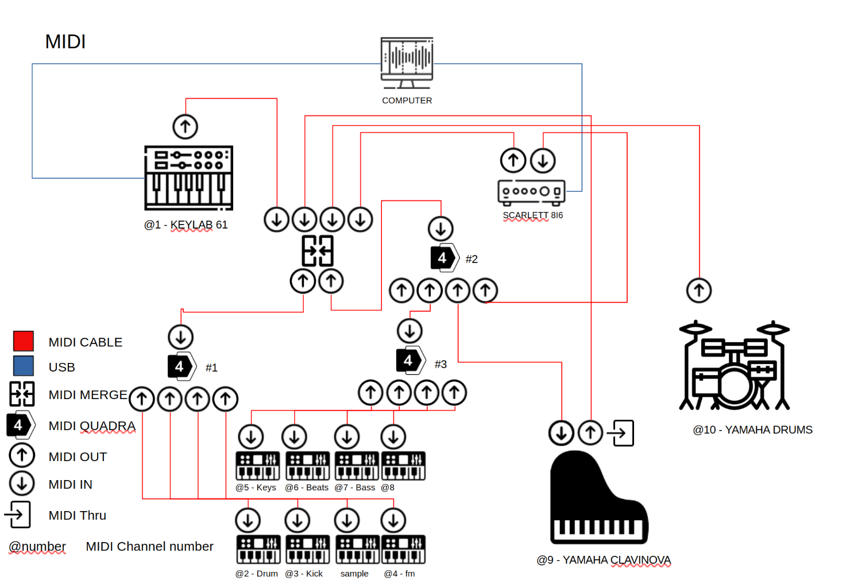

(picture might not be up to date, check most recent version for actual layout)

Example usage
In this section below, several examples are described for which the music-room can be chosen. The examples are such that it showcases what is all possible with the current setup without changing many cables or other configuration.

Jamming
- Pick instruments to play with. For example (drums, guitar, synth)
- Choose wether to have output from the Onyx speaker, monitors, and /or amplifiers. Let’s say in this case all of them.
- Turn on amplifier for guitar. No need to change cables since guitar is hooked up with pedalboard which sends audio signal to DI-box, which is connected already with amplifier. If you want to play bass instead of guitar, hook-up the bass with the pedalboard instead of guitar, and change wire from last pedal from guitar DI-box to bass DI-box. If you want to play guitar and bass together, then a decision has to be made which instrument goes through the pedalboard and which is only hooked up via the DI-box. Why is everything for the DI-box. That is due to recording which is explained in a second.
- Choose which instrument’s output goes to the monitors. The output of the EPM-12 mixer’s main channel is equal to what the output will be in the monitors. The volume can also be controlled via the focusrite, since the audio goes from the mixer to the focuswrite and then into the monitors.
- Choose which instrument’s output goes to the Onyx speaker. For this, the channel which has the instrument playing has to direct it’s output to the monitor AUX1 out, since this output is sent to the Onyx.
- If there is need to record the session as well then follow the steps in the recording example.

Recording
Single Instrument / Multiple instruments in one recording stem
- Choose which instrument to record, for example drums.
- Make sure audio of drum channels goes to main output of EPM12 mixer.
- Setup DAW to record correct input channel of audio-interface.
Multiple Instruments (seperate stems)
- Choose which instrument to record, for example drums and guitar.
- Choose which instrument goes through the main output of the EPM12 mixer, for example drums.
- Use patch cables to connect output of guitar to input channel of audio-interface on patch-bay and turn the channel of the guitar on the mixer all the way down.
- Or don’t use the mixer at all, and use patch cables for both drums and guitar.
- Setup DAW to record correct input channels of audio-interface.

Using outboard – effect gear
- Choose which instrument / audio from DAW to input into outboard gear. For example drums.
- Identify channel of drums on patch-bay
- Use patch cables to link output of drums into input of desired outboard gear on patch-bay
- Apply effect desired.
- Link output of outboard gear to desired output(Onyx, audio-interface, monitors)

Practicing
- Multiple people want to practice at the same time, separately. For example, drums, guitar, DJ, piano all at the same time.
- Piano, drums, DJ, guitar can all use headphones to play separately. Piano has phones output, drums has phones output, DJ controller has phones output, guitar amplifier has drums output. With most devices if phones output is used then the internal speaker will turn off.
- If one of the practitioners wants to play out loud then discuss together who plays out loud, and configure mixer / amplifier appropriately.

Upgrade / to do list
- Extend electronic drum-kit, to have multiple hihat’s / pads
- bass traps in corners of music-room

