In‌ ‌The‌ ‌Name‌ ‌of‌ ‌God‌ ‌

Statistical‌ ‌Inference‌ ‌HW#6 ‌

Amin‌ ‌Asadi‌ Sarijalou‌

810196410‌ ‌

Spring 1400

Contents

Problem 1 3

1-1 3

1-2 3

a) 3

b) 4

1-3 4

a) 4

b) 4

Problem 2 4

Problem 3 5

3-1 5

3-2 5

Problem 4 5

a) 5

b) 6

Problem 5 6

a. 6

b. 7

c. 7

d. 7

e. 7

f. 7

Problem 6 8

a) 8

b) 9

c) 10

d) 11

e) 12

f) 13

# Problem 1

## 1-1

$$CI=point estimate± SE×t_{df}^{*}$$

$$df=n-2=24-2=22$$

$$t_{22, 90\%}^{*}=1.71$$

$$→CI=2.52± 0.283×1.71$$

$$=(2.03, 3)$$

## 1-2

### a)

* Linearity
  + relationship between the explanatory and response variable should be linear
* Nearly Normal Residuals:
  + residuals should be nearly normally distributed
* Constant variability
  + variability of points around the least square line should be roughly constant

### b)

$T=\frac{b_{1}-Null Value}{SE_{b1}}=\frac{-5 - 0}{0.52}=-9.61$

$$→ pvalue≈ 0→$$

$$we confidently reject H_{0} in favor of H_{a} and hence we$$

$conclude that there is a linear relationship between these two$

$$variables.$$

## 1-3

### a)

True

### b)

False, it is a measure of (the strength of linear) association between two numerical variables.

# Problem 2

The outlier is point: (5, 160),

because it falls away from the cloud of points.

Effects:

* The correlation coefficient (R) will increase and get closer to 1.
* $b_{0}$ (y-intercept) of the regression line will decrease and slope will increase.
* The standard deviation of the residuals will decrease.

# Problem 3

### 3-1

No, because p-value for slope is 0.660 which is (much) greater than significance level (0.01) so we fail to reject $H_{0}$ and hence there isn’t enough evidence to claim that there is a linear relationship between these variables for all players in this population.

### 3-2

a is the correct choice

Since $α=0.05$ so result of the p-value method will be equivalent to the result of 95% confidence interval method.

Therefore, because the Null Value = 0 falls into the confidence interval, we fail to reject $H_{0}$ and hence Nader can’t conclude a linear relationship between how much toothpaste he uses and how long he brushes.

# Problem 4

### a)

$$\hat{y}=b_{0}+b_{1}x$$

$$→ \overline{y}=b_{0}+b_{1}\overline{x}$$

$$→ 3.9983=4.010 -0.0883×b_{1}$$

$$→ b_{1}≈0.13$$

### b)

Yes. According the given table, for a two-tailed test, the p-value is 0. Here we need a one-tailed test. Since the p-value for a one-tailed test is ½ of that of two-tailed test, and because half of the two-tailed p-value is still 0, so we have sufficient evidence to reject $H_{0}$ in favor of $H_{A} (=slope is positive)$ and conclude that the slope is positive.

# Problem 5

## a.

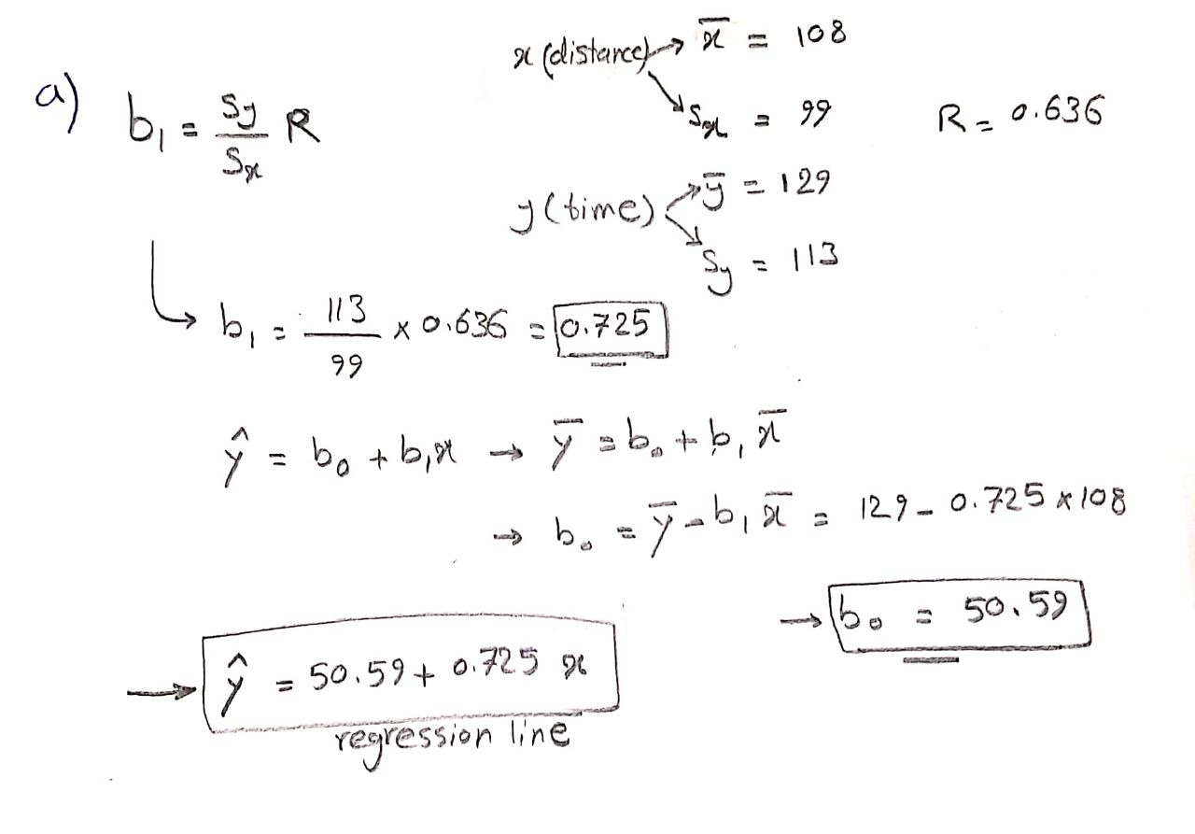

## b.

Interpretation of Slop: For each 1 mile increase in the distance between two stops, we would expect that the time of travelling between those points, to be more on average by 0.725 minutes.

Interpretation of Intercept: For two stops having zero distance between each other, it takes on average 50.59 minutes to travel between them.

## c.

$$R^{2}={0.636}^{2}≈0.40$$

It tells us that about 40% of the variability in the time of travel between stops is explained by the model (which include distance between stops as the variable).

Also 1 - 0.40 = 60% of the variability in the time of travel between stops is explained by other variables not included in the model.

## d.

$$\hat{y}=b0+b1×x=50.59+0.725×103≈125.37 minutes$$

## e.

$$residual=actual-estimated=168-125.07≈42.62 minutes$$

The residual is positive. This means that we have underestimated the response variable (time of travel) by about 42.62 minutes.

## f.

No, we cannot. Because in fitting out model, we don’t consider this much distant points. 500 miles distance, is a very long distance because it is $\frac{500-108}{99}≈4$ standard deviation away from the mean of the distances which we consider.

# Problem 6

## a)

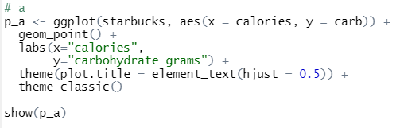

**The Data Points:**

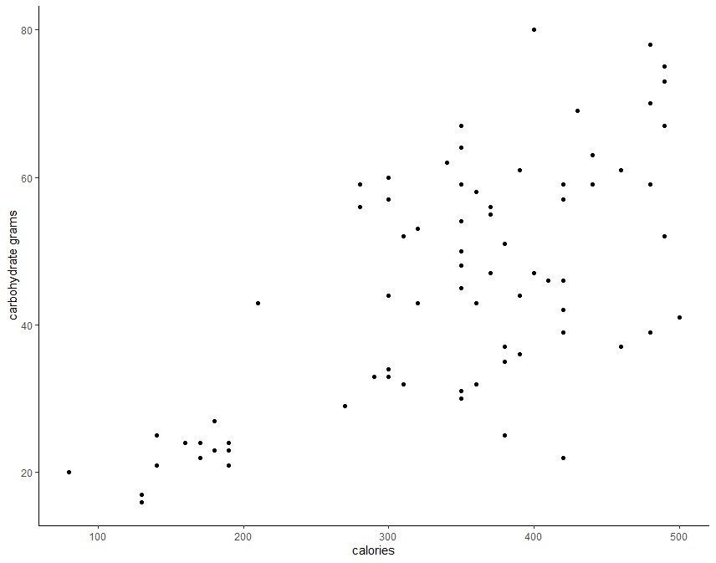

Scatterplot Description: I see that there seem to be a positive linear association between Carbohydrate Grams and number of Calories contained in each food item.

## b)

Explanatory Variable: Calories

Response Variable: Carbohydrate Grams

We construct the problem in this way because we want to fit a model in order to predict the amount of Carbohydrate based on number of Calories.

## c)

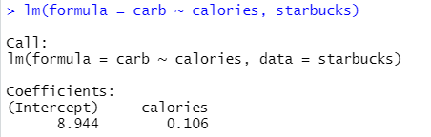



**The Fitted Regression Line:**

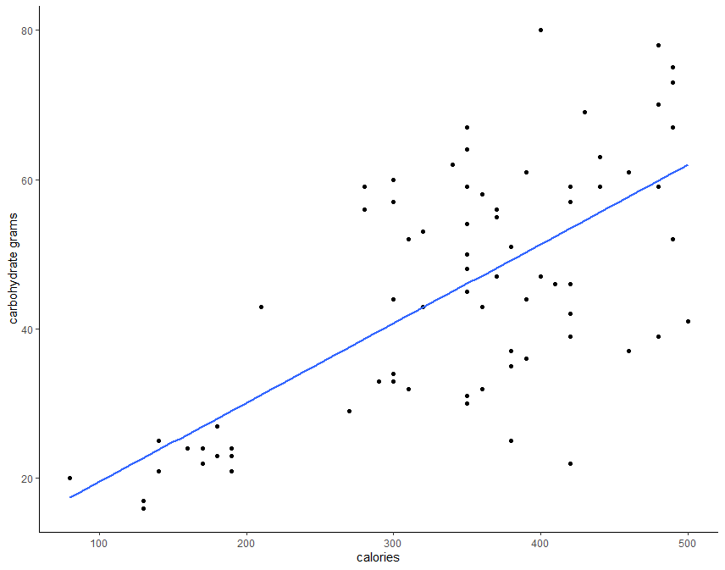

## d)

$$x= calories$$

$$y= calories$$

$$b_{0}=8.944, b_{1}=0.106$$

$$\hat{y}=0.106x+8.944$$

Interpretation of Slop: With increasing the number of Calories by 1, we would expect that the amount of Carbohydrate increases on average by 0.106 grams.

Interpretation of Intercept: If a food has zero Calories, we would expect that it has on average $8.944$ grams of Carbohydrate.

## e)

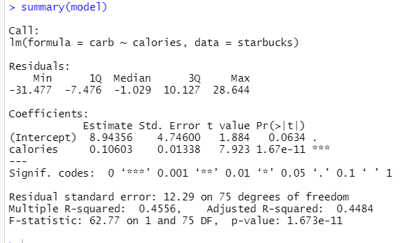

As we see in the summary of the fitted model, $R^{2}≈0.45$ which means that about 45% of the variability of the response variable (grams of Carbohydrate) is explained by the model (which includes number of Calories as the variable).

## f)

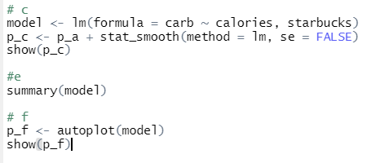

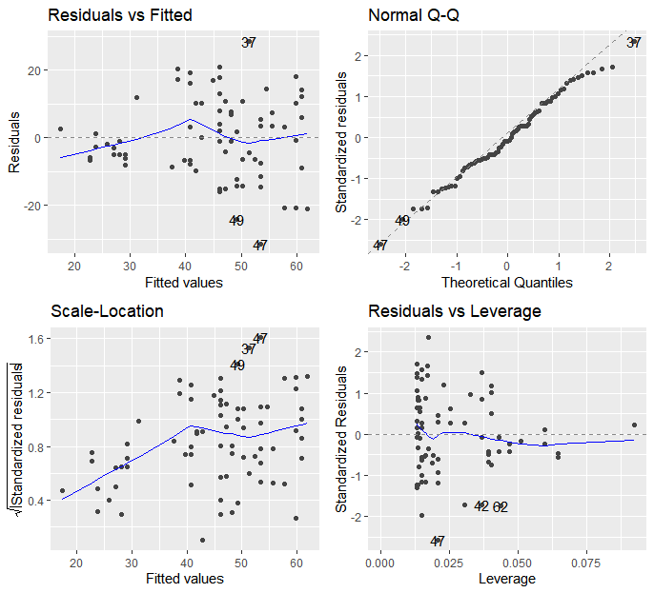

As we see in the Residuals Vs Fitted plot, the residuals seem to be different from the normal distribution at the tails. We can check that in the QQ-Plot beside it.

The QQ-Plot tells us that the same thing. The residuals are not normally distributed at tails.

We conclude that the fitted model is a good predictor in the middle parts, but it isn’t a good fit at the tails.