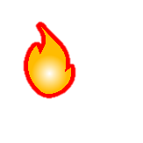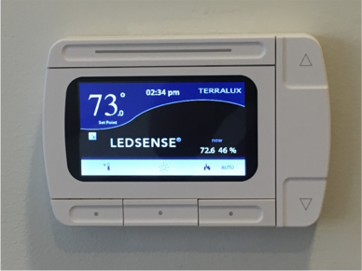

609-258-8000

Actual temperature & humidity

If the temperature is above 80° during the summer or below 67° during the winter, contact Facilities.

## **How dorm heating and cooling works**

Your room is heated or cooled by flowing hot or cold water through a pipe in the valence unit in your room. At any given time, only hot or cold water is available. For example, during the winter, the Cogeneration Plant heats water that runs through your pipes. Therefore, during the winter, no cold water is available to cool your room, regardless of the thermostat set point.

: Heating mode VS. : Cooling mode

(See Above)

Set Point

68°F to 75°F

## Daytime set back

* In order to conserve energy, these thermostats have a “set back” feature.
* If you leave your room during the day, the thermostat will set itself back a few degrees.
* When you return, it will return the set point the programmed set point.
* If you see a green leaf on the screen, the thermostat has not sensed anyone in the room.

Adjust set point

* Princeton does not cool rooms to below 68°F or heat room to above 75°F
* The maximum and minimum set points that are available may change with the seasons.

## Nighttime set back

The thermostat should not set back during the night.

Adjust screen brightness or turn off

Switch between Fahrenheit and Celsius