Team Members: Eric Hawkins & Sam Coday

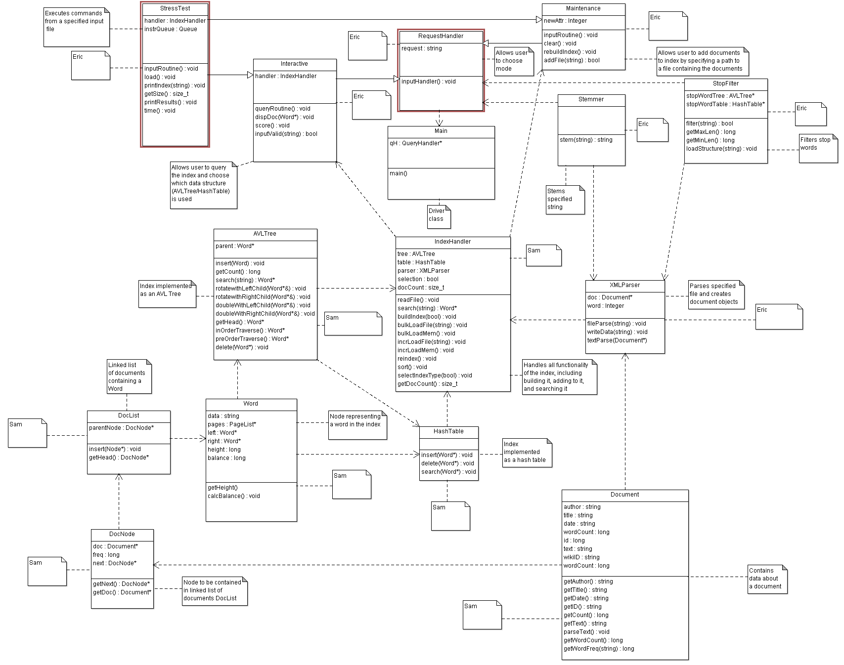

Stress Test Commands:

load <(string) path to file> (loads file at the specified path into the index)

printindex <(string) path to file> (print index to file at specified path)

getsize (prints to console the number of entries in the index)

printresults <(string) path to file> (prints results of a batch execution to file at specified path)

time (toggles timing of operations)