DATA MODEL FLOW
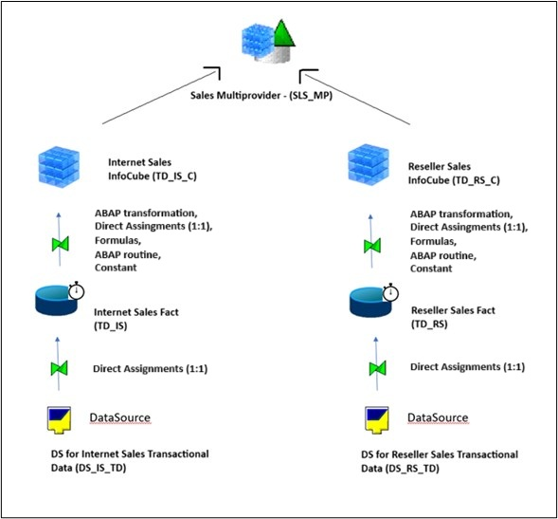

Scenario Overview: SAP BW Data Flow for Bike Sales Reporting
This scenario outlines the data flow architecture for reporting bike sales through two distinct sales channels: Internet Sales and Reseller Sales. The architecture is designed in SAP BW using standard InfoProviders and transformation logic to support unified and channel-specific reporting.
Sales Channels:
- Internet Sales
- Reseller Sales
Each channel has its own independent data acquisition and processing pipeline, yet they are ultimately consolidated for unified analysis.
Data Flow Description
1. Data Sources:
- DS for Internet Sales Transactional Data (DS_IS_TD): Captures transactional data related to online (internet-based) sales.
- DS for Reseller Sales Transactional Data (DS_RS_TD): Gathers transactional sales data from reseller partners.
These data sources serve as the initial entry point of raw sales data into the SAP BW system.
2. Data Targets (ODS Layer / DataStore Objects):
- Internet Sales Fact (TD_IS)
- Reseller Sales Fact (TD_RS)
Transactional data is loaded 1:1 into these DataStore Objects. These represent the consolidation layer where data is cleansed and harmonized before being pushed into analytical InfoCubes.
3. InfoCubes (Analytical Layer):
- Internet Sales InfoCube (TD_IS_C)
- Reseller Sales InfoCube (TD_RS_C)
Data is transferred from the facts layer into the InfoCubes using direct assignments (1:1), formulas, ABAP routines, constants, allowing for the enrichment of key figures and characteristics needed for reporting. These cubes store aggregated sales data for each channel, optimized for performance and analysis.
4. Consolidation for Reporting - Sales Multiprovider (SLS_MP)
The InfoCubes for both Internet and Reseller Sales are combined into a Multiprovider, enabling a unified view of total sales. This allows users to:
- Analyze sales by channel, region, time, product, and customer.
- Compare performance between Internet and Reseller sales.
- Generate comprehensive reports for management insights.

Transformations from DSO to CUBE
In this example we cover data transfer logic from ODSO TS_IS to CUBE TS_IS_C.
1. TD_IS.DSO.XLSX– contains TD_IS DSO structure
2. DSO - TD_IS - content.xls contains source records which have to be processed and transformed
3. TD_IS.CUBE.XLSX– contains TD_IS_C cube structure
4. CUBE - TD_IS_C - content.xls- contains the transformed records as they currently are in S13 Development system, to be used for validation of the result.

From DSO (TD_IS) To CUBE (TD_IS_C)
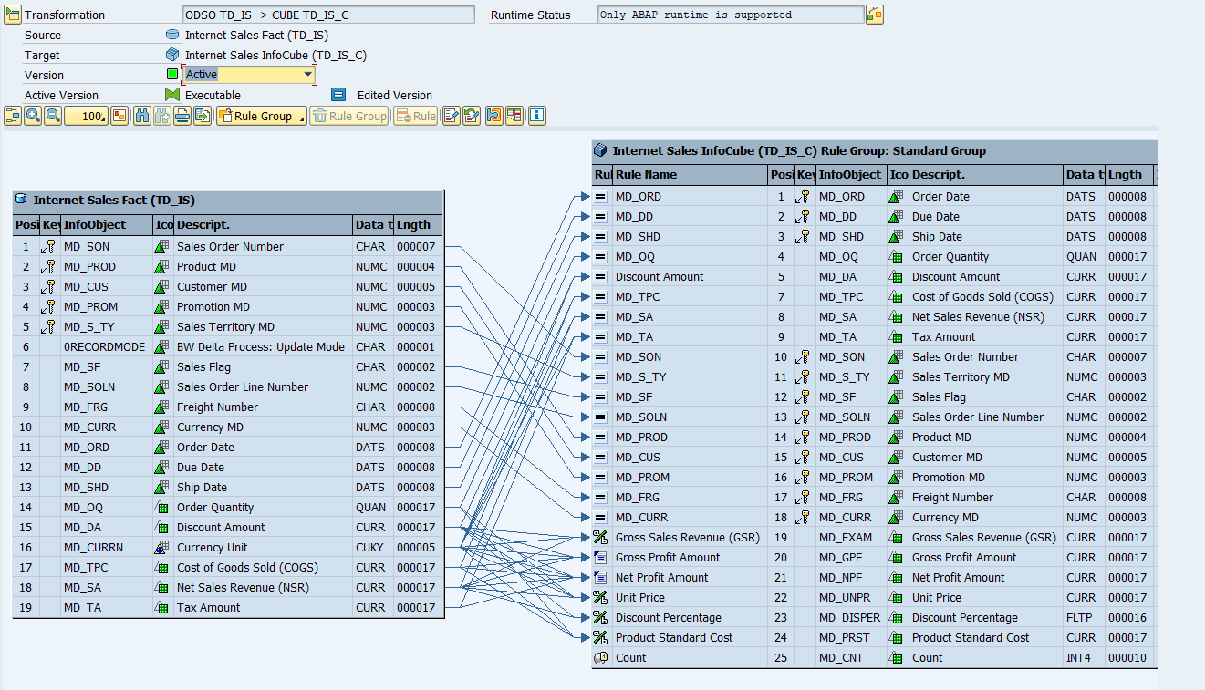

In this example we cover data transfer logic from ODSO TS_RS to CUBE TS_RS_C.
1. TD_RS.DSO.XLSX– contains TD_RS DSO structure
2. DSO - TD_RS - content.xls contains source records which have to be processed and transformed
3. TD_RS.CUBE.XLSX– contains TD_RS_C cube structure
4. CUBE - TD_RS_C - content.xls- contains the transformed records as they currently are in S13 Development system, to be used for validation of the result.

From DSO (TD_RS) To CUBE (TD_RS_C)
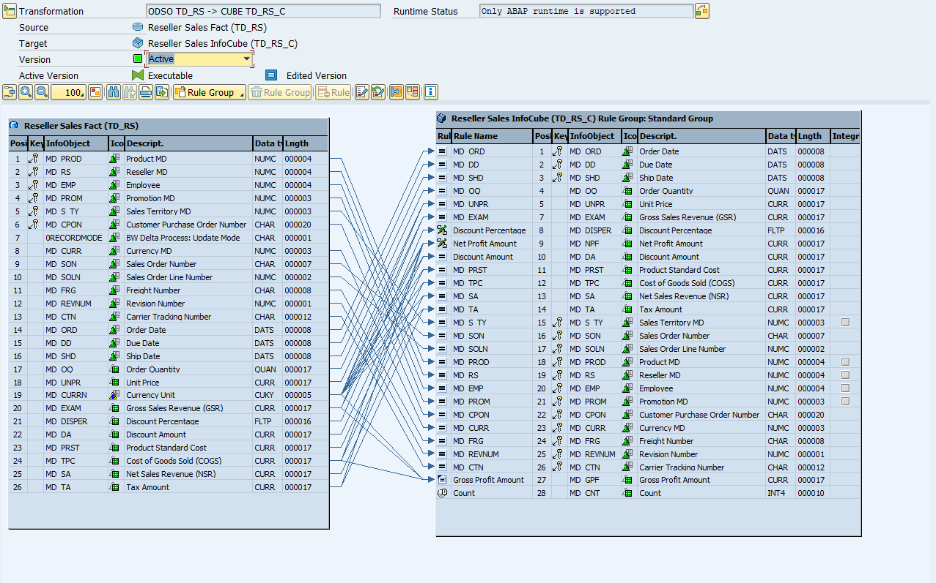

Transformations from Datasource to DSO
From Datasource (DS_IS_TD) To DSO (TD_IS)
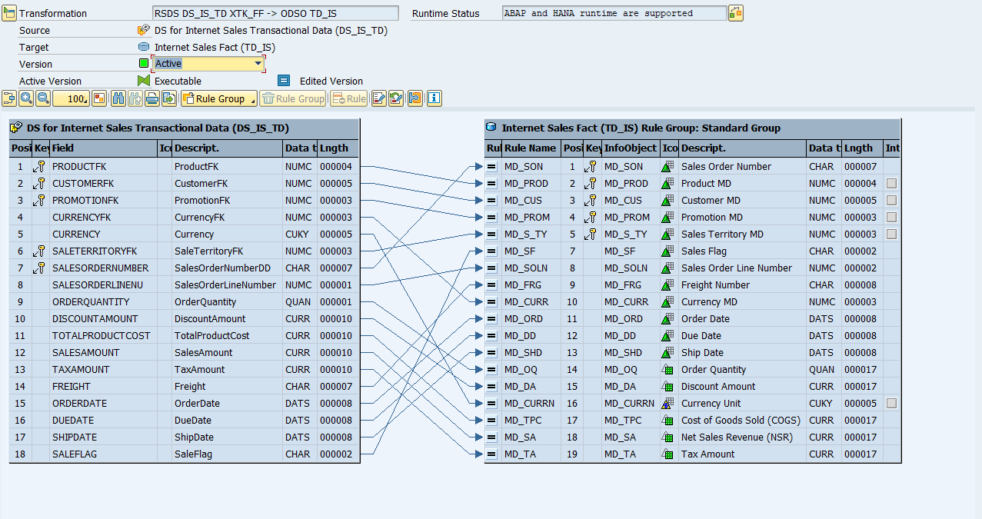

From Datasource (DS_RS_TD) To DSO (TD_RS)
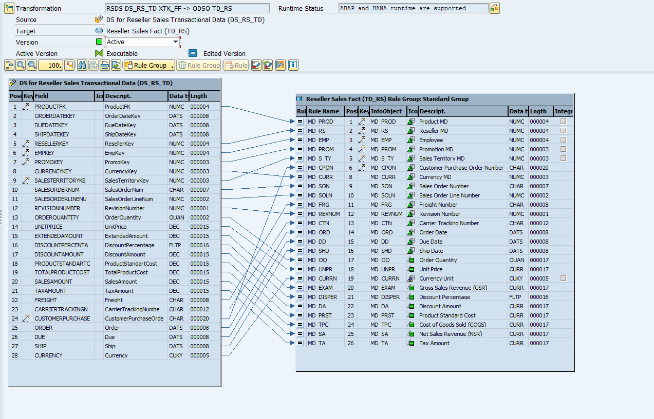

Transformations from Datasource to Infoobject

From DS to Customer MD (MD_CUS) – Attributes
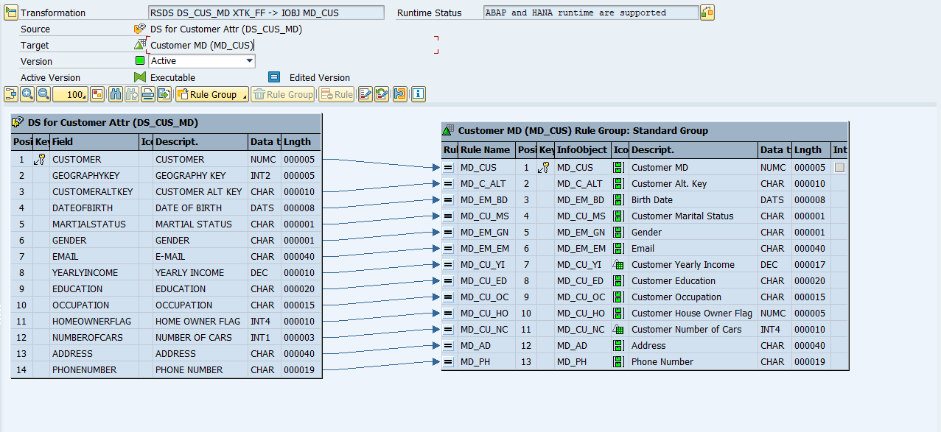

From DS to Customer MD (MD_CUS) – Texts
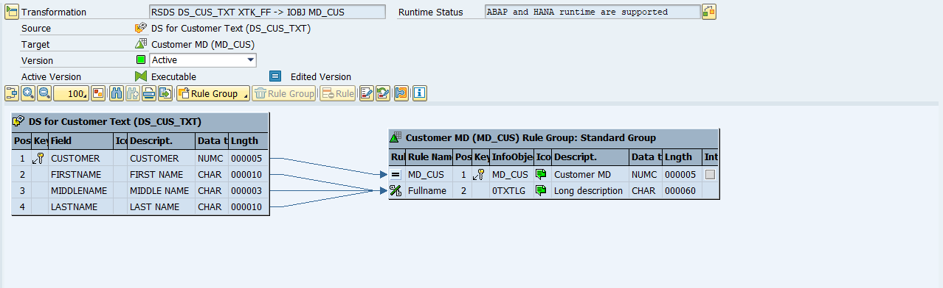

From DS to Department Group (MD_DP_GR) – Attributes
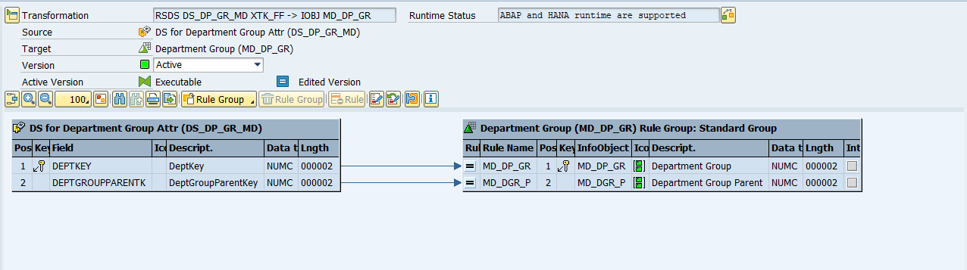
From DS to Department Group (MD_DP_GR) – Texts
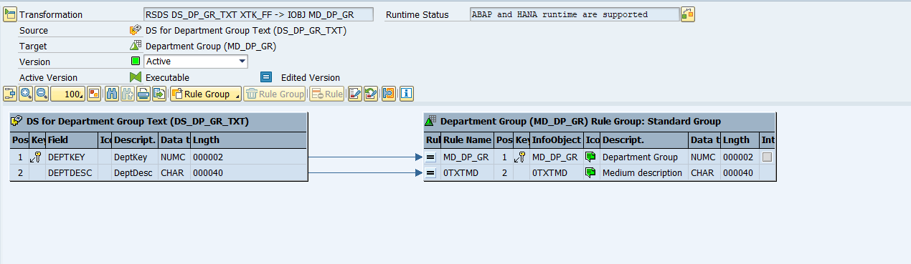

From DS to Employee (MD_EMP) – Attributes
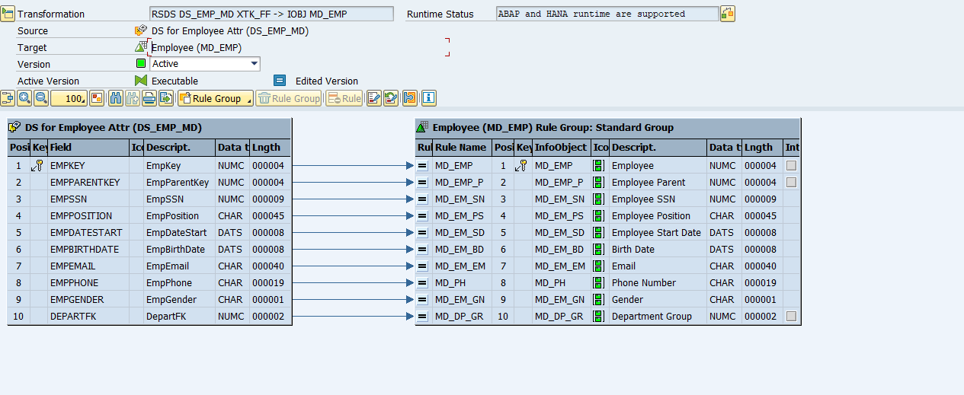

From DS to Employee (MD_EMP) – Texts
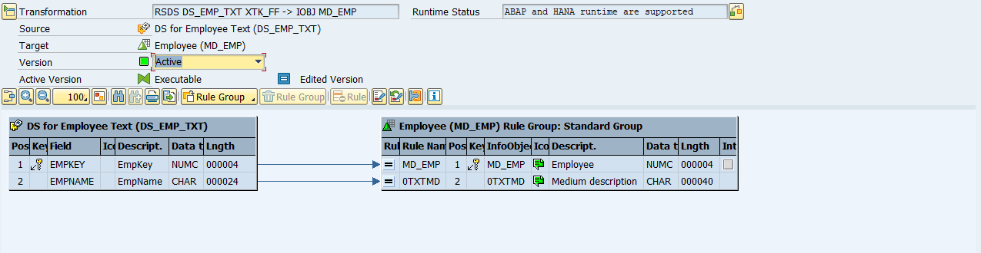

From DS to Product Category (MD_PR_CG) – Texts
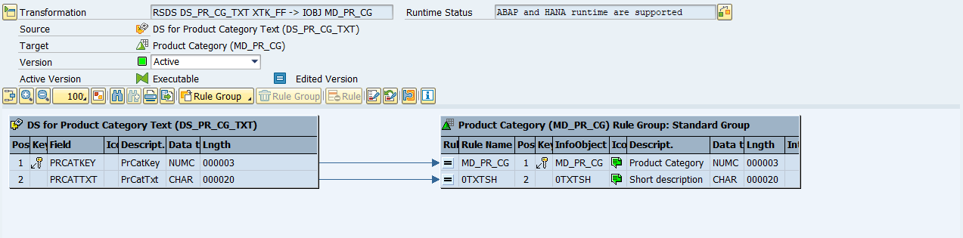

From DS to Product MD (MD_PROD) – Attributes
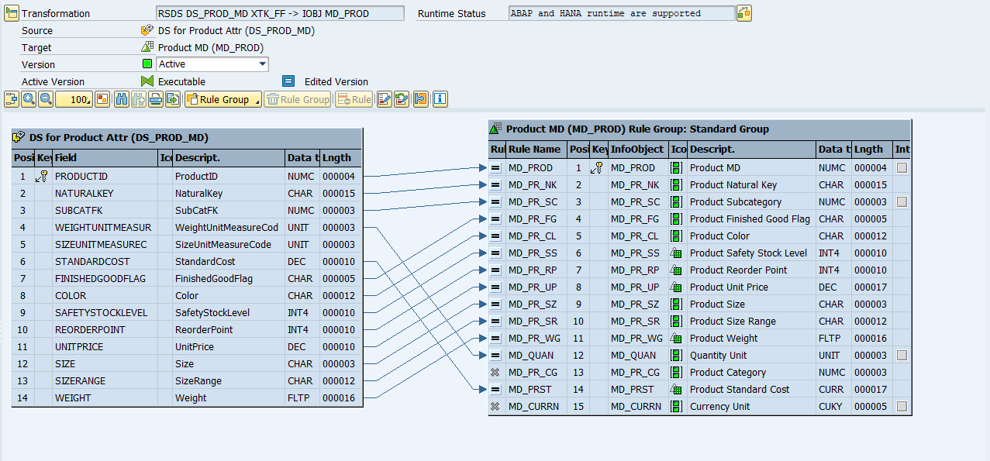
From DS to Product MD (MD_PROD) – Texts
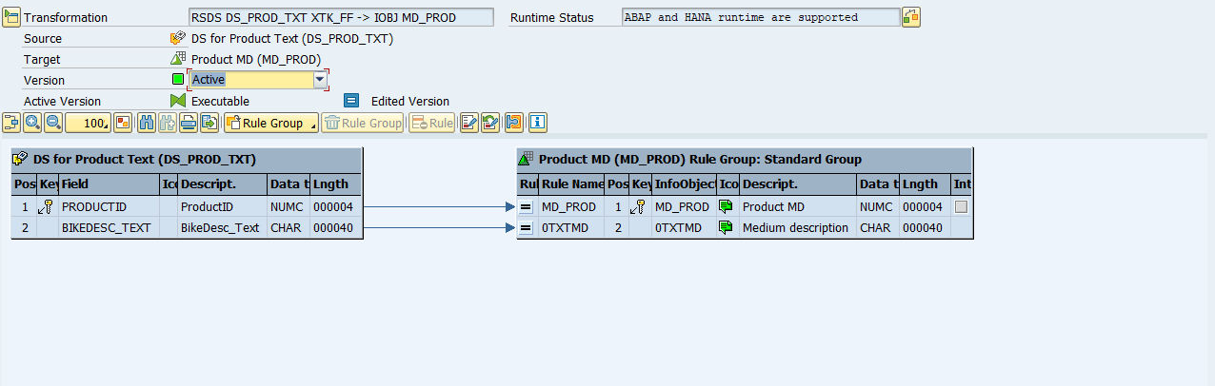

From DS to Product Subcategory (MD_PR_SC) – Attributes
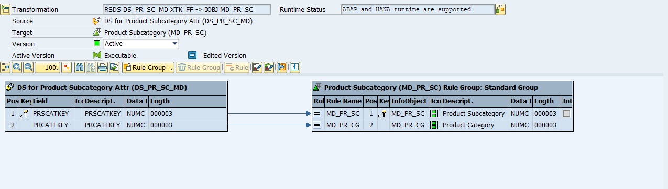

From DS to Product Subcategory (MD_PR_SC) – Texts
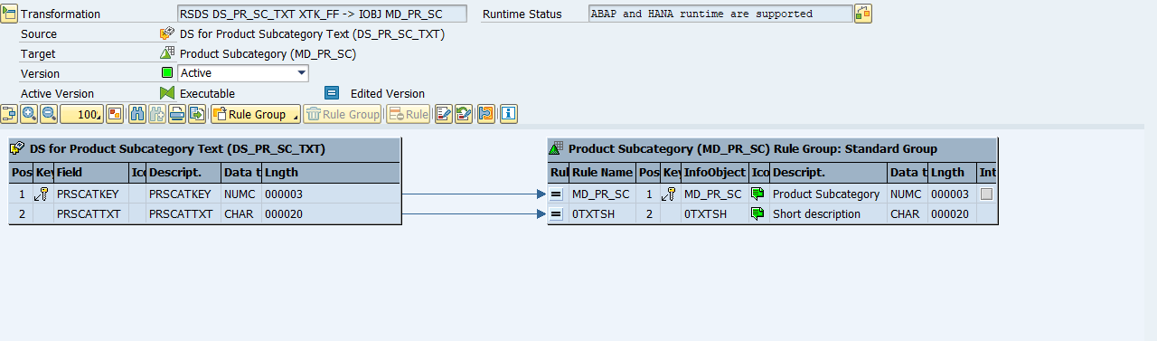

From DS to Promotion MD (MD_PROM) – Attributes
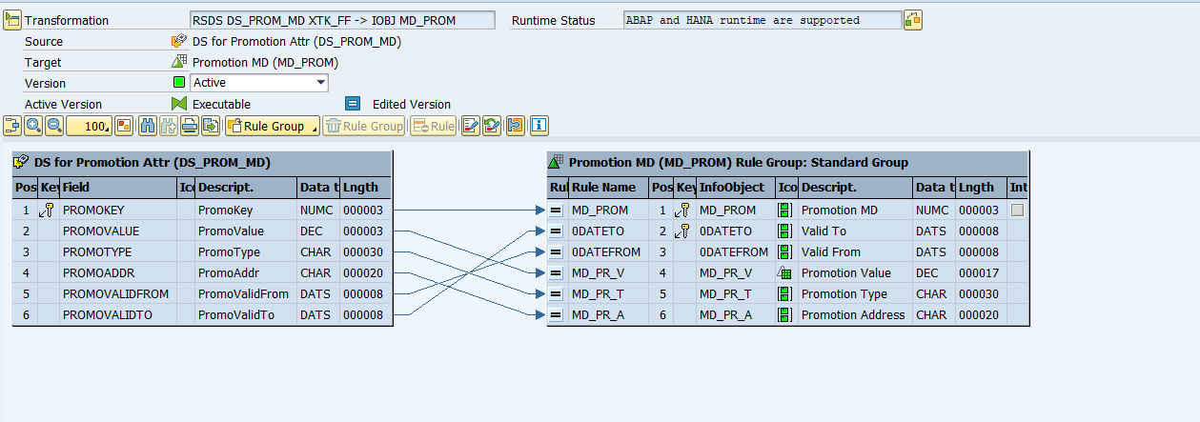
From DS to Promotion MD (MD_PROM) – Texts
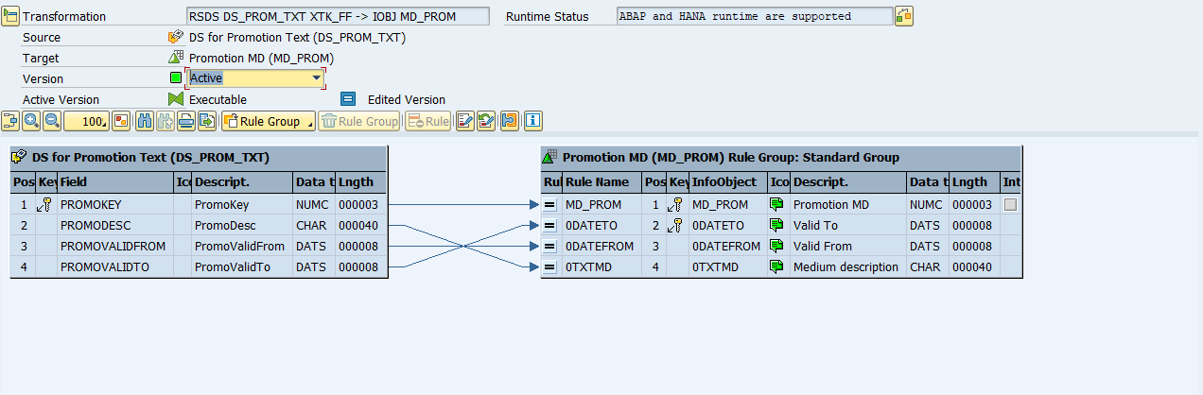

From DS to Reseller MD (MD_RS) – Attributes
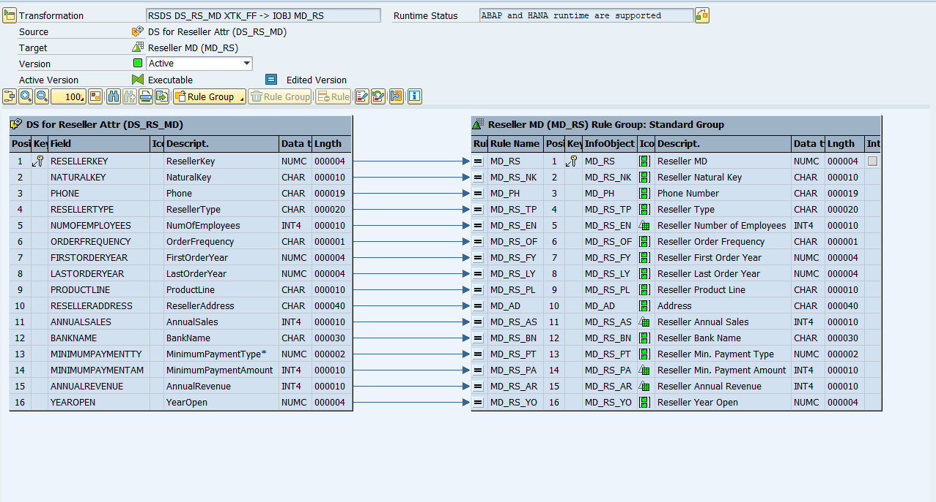
From DS to Reseller MD (MD_RS) – Texts
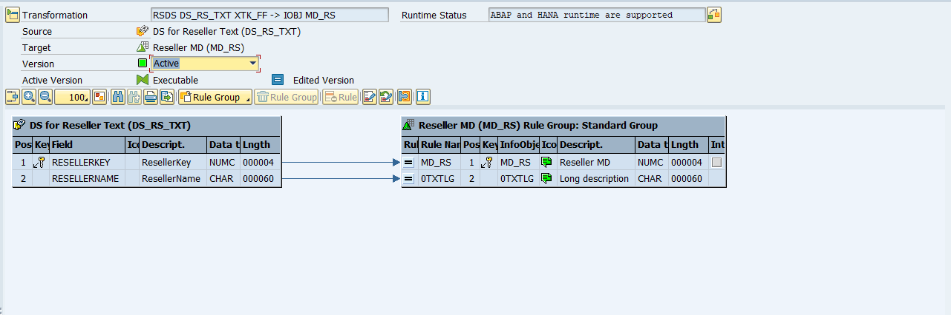

From DS to Sales Territory MD (MD_S_TY) – Attributes
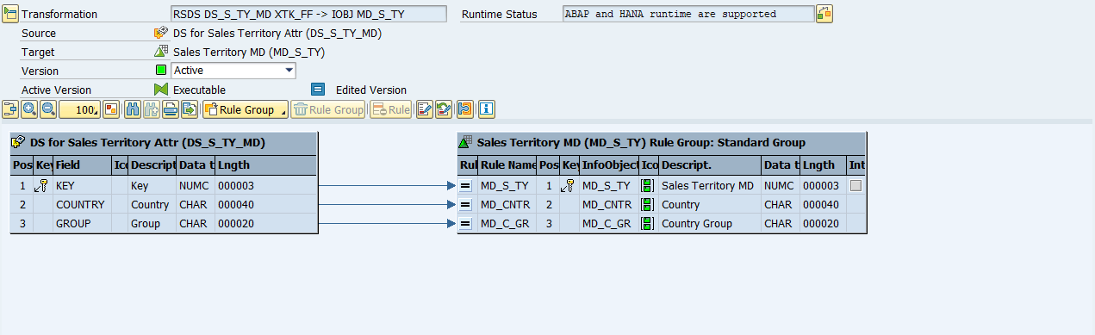

From DS to Sales Territory MD (MD_S_TY) – Texts
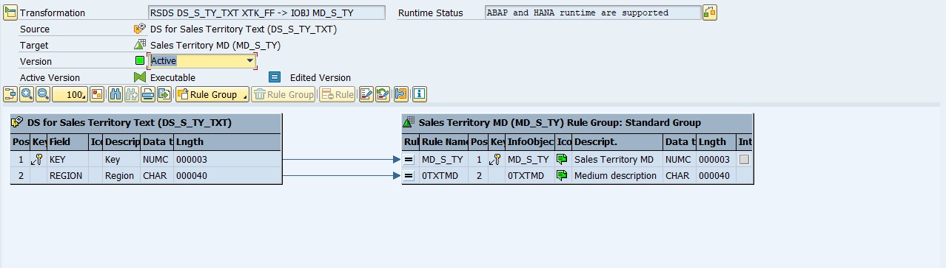

From DS to Currency MD (MD_CURR) – Texts
