FLASK + MONGODB ASSIGNMENT
Submission / Practical Demonstration Document

Name : Aditya Mishra
Assignment : Flask_MongoDB_Assignment_Submission
GITHUB REPO Link :

1. Objective
The objective of this assignment is to demonstrate practical use of Git and GitHub with a Flask application and MongoDB Atlas. The assignment covers SSH authentication, branch creation, commits, merging, conflict resolution, Git reset, and rebasing.
- Create and clone a GitHub repository using SSH.
- Create a username-based branch and merge it into main.
- Create a second username-based branch and update JSON data used by the /api route.
- Create master_1 and master_2 branches for frontend and backend development.
- Create a To-Do form and a /submittodoitem backend route using MongoDB.
- Create three separate commits for Item ID, Item UUID, and Item Hash.
- Use git reset --soft to restore main to the Item ID state.
- Rebase master_1 onto main while preserving individual commits.

2. Prerequisites
- Git installed on the local machine.
- GitHub account.
- Existing Flask project.
- MongoDB Atlas account and connection string.
- Python and required Flask/MongoDB packages.

3. Part 1 – GitHub Repository, SSH and Username Branch

3.1 Create a GitHub Repository
Create a new repository on GitHub. In this example, the repository is named flask-mongodb-assignment. The repository may be public or private according to the assignment requirements.

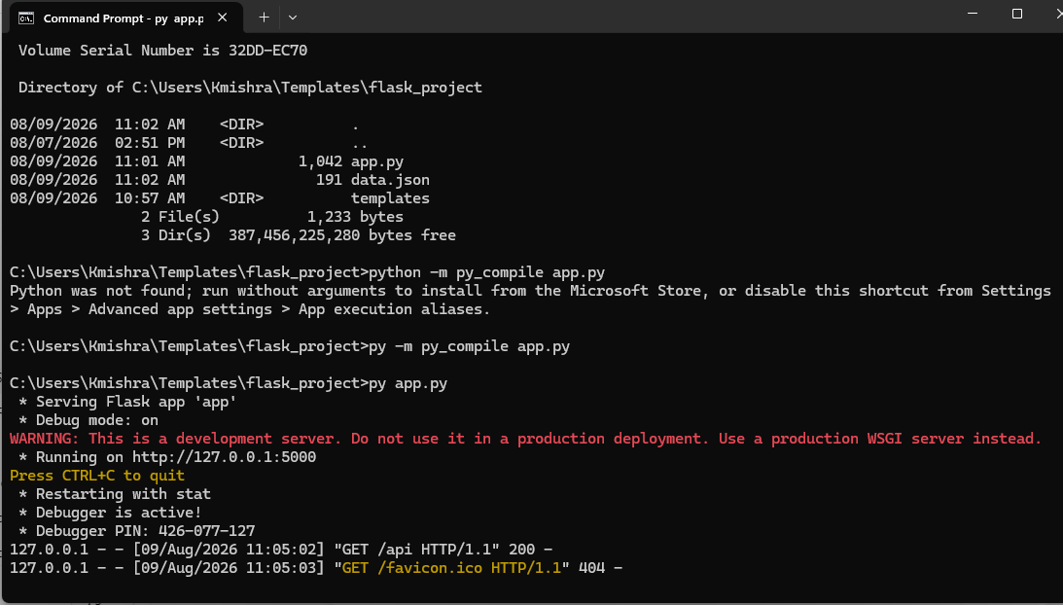
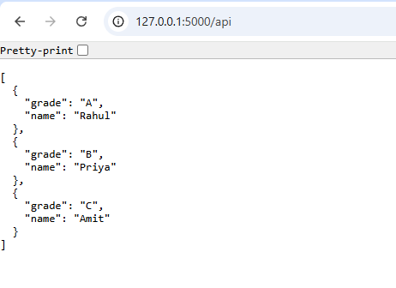

3.2 Verify Git Installation
git --version
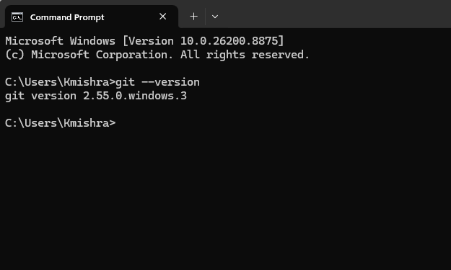

3.3 Configure Git
git config --global user.name "Your Name"
git config --global user.email "your-email@example.com"
git config --global –list
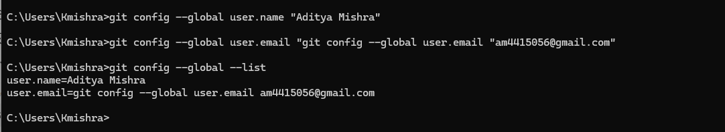

3.4 Generate an SSH Key
ssh-keygen -t ed25519 -C "your-email@example.com"
If an SSH key already exists, it can be reused. The public key should be added to GitHub under Settings → SSH and GPG keys.
cat ~/.ssh/id_ed25519.pub
On Windows Command Prompt, the public key can also be displayed using:
type %USERPROFILE%\.ssh\id_ed25519.pub

3.5 Test SSH Authentication
ssh -T git@github.com
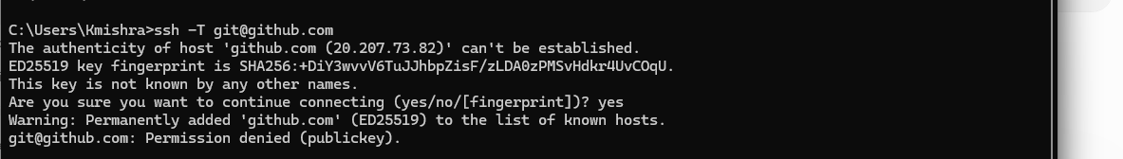
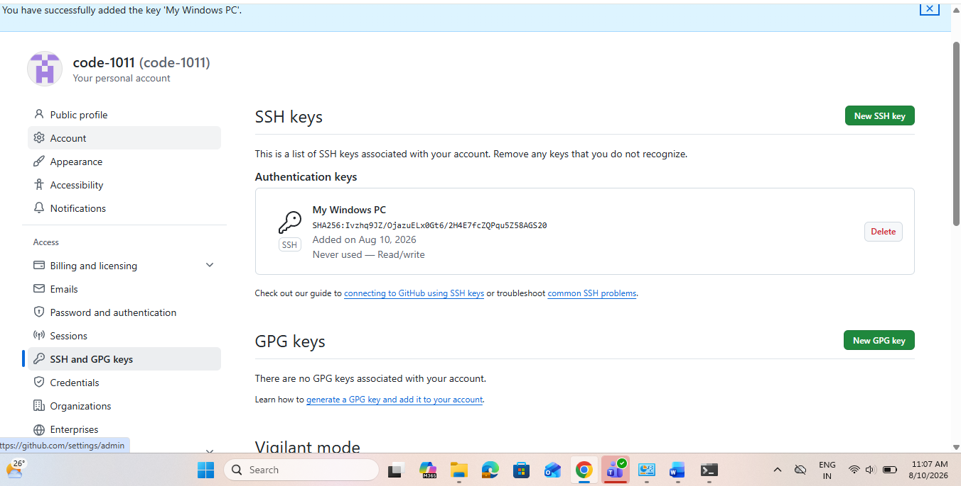
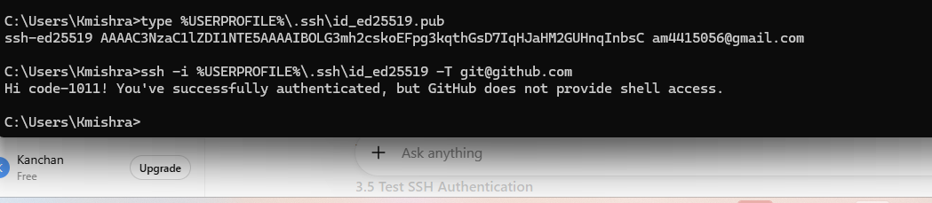

3.6 Clone the Repository Using SSH
git clone git@github.com:YOUR_USERNAME/flask-mongodb-assignment.git
cd flask-mongodb-assignment
git status
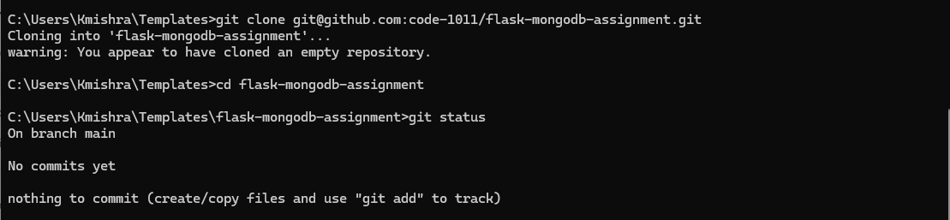

3.7 Create Username Branch
Replace Tutedude below with the actual GitHub username or username required by the assignment.
git checkout -b Tutedude
git branch

3.8 Add Flask Project, Commit and Push
git status
git add .
git commit -m "Add Flask project"
git push -u origin Tutedude
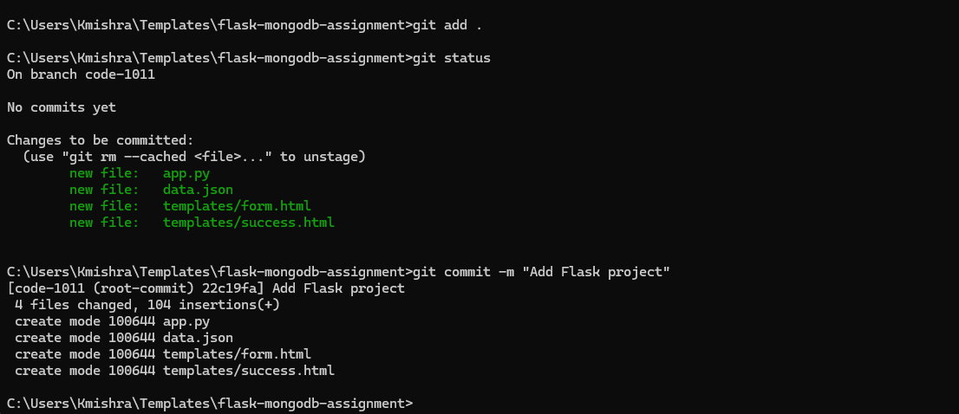
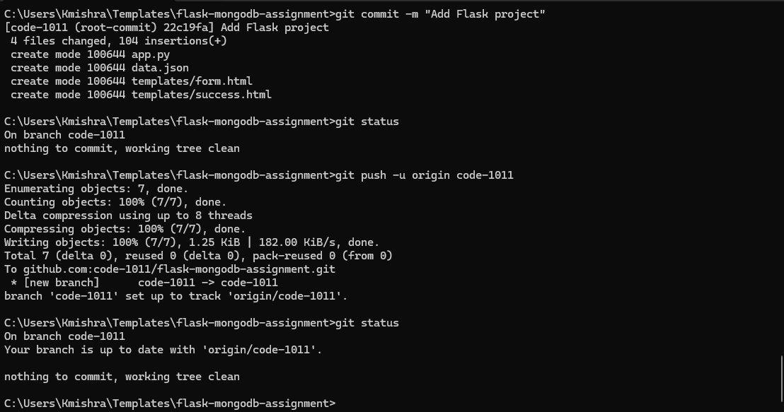

3.9 Merge Username Branch into main
git checkout main
git pull origin main
git merge Tutedude
git push origin main
git log --oneline --graph –all

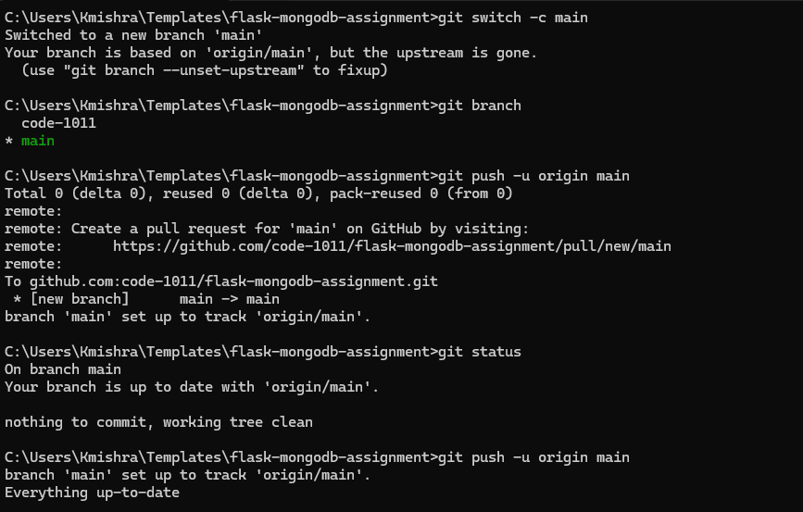

4. Part 2 – JSON Update Branch

4.1 Create <your_name>_new Branch
git checkout main
git pull origin main
git checkout -b Tutedude_new

4.2 Update JSON Used by /api
Update the JSON file used by the Flask /api route. For example, data.json may contain:
[
{"name": "Rahul", "grade": "A+"},
{"name": "Priya", "grade": "A"},
{"name": "Amit", "grade": "B+"}
]
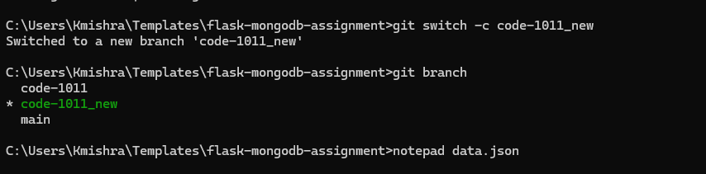

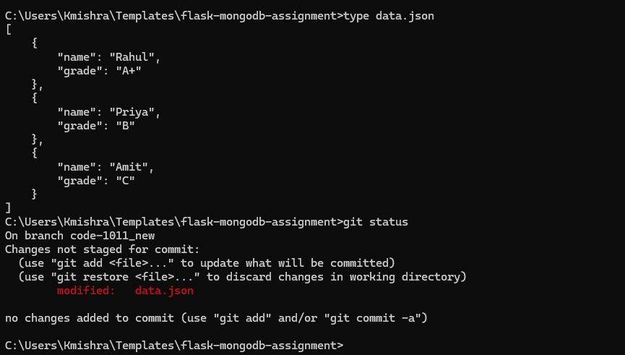
Explanation: The data.json file used by the /api route was updated in the code-1011_new branch. Rahul's grade was changed from A to A+, and git status confirmed that data.json was modified.

4.3 Commit and Push
git status
git add data.json
git commit -m "Update API JSON data"
git push -u origin Tutedude_new
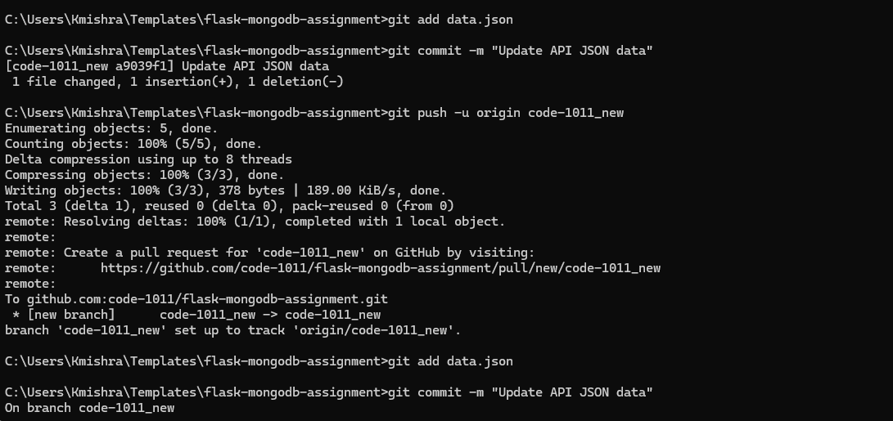
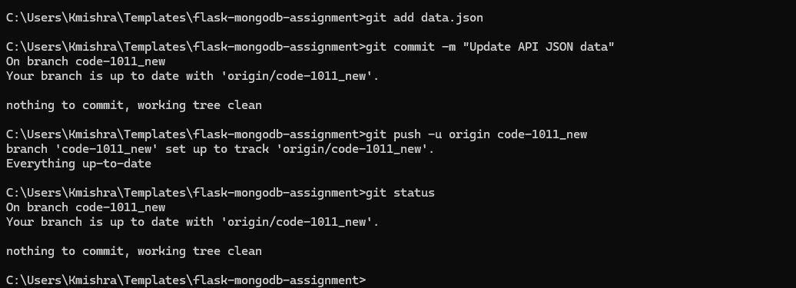

4.4 Merge into main
git checkout main
git pull origin main
git merge Tutedude_new
git push origin main
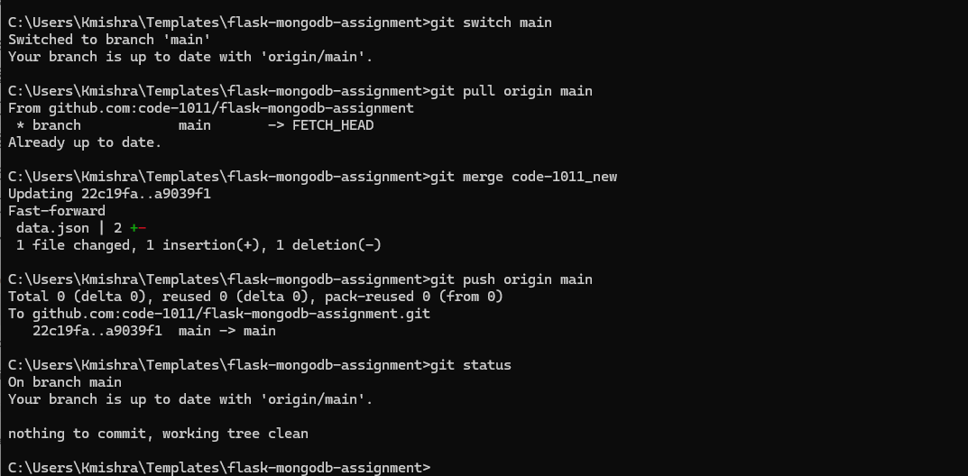

4.5 Conflict Resolution
If a merge conflict occurs, the assignment requires accepting the changes from the Tutedude_new branch. Open the conflicted file, retain the Tutedude_new content, remove the conflict markers, save the file, stage it, commit the resolution, and push.
git status
git add .
git commit -m "Resolve merge conflict using Tutedude_new changes"
git push origin main

5. Part 3 – master_1 and master_2 Development

5.1 Create master_1 and master_2
git checkout main
git pull origin main
git checkout -b master_1
git push -u origin master_1
git checkout main
git checkout -b master_2
git push -u origin master_2
git branch -a

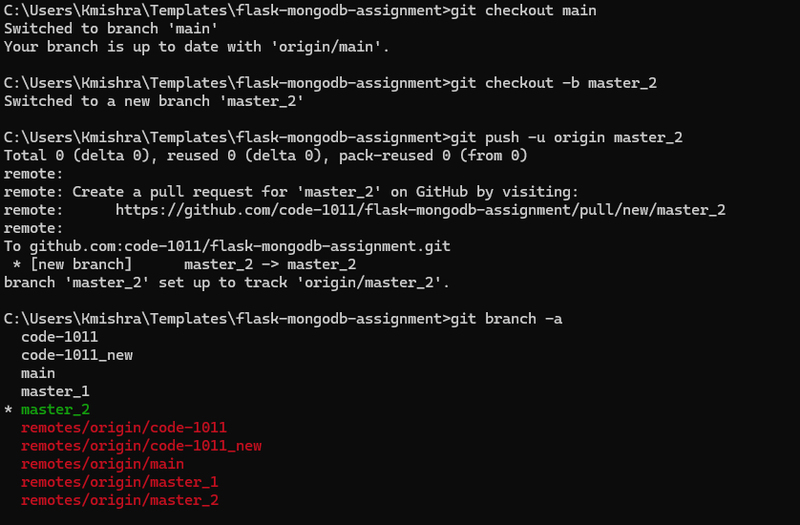

5.2 Frontend To-Do Page in master_1
git checkout master_1
Create templates/todo.html containing Item Name and Item Description fields.
<!DOCTYPE html>
<html>
<head>
<title>To-Do Page</title>
</head>
<body>
<h1>To-Do Form</h1>
<form action="/submittodoitem" method="POST">
<label>Item Name:</label>
<input type="text" name="itemName" required>
<br><br>
<label>Item Description:</label>
<textarea name="itemDescription" required></textarea>
<br><br>
<button type="submit">Submit</button>
</form>
</body>
</html>
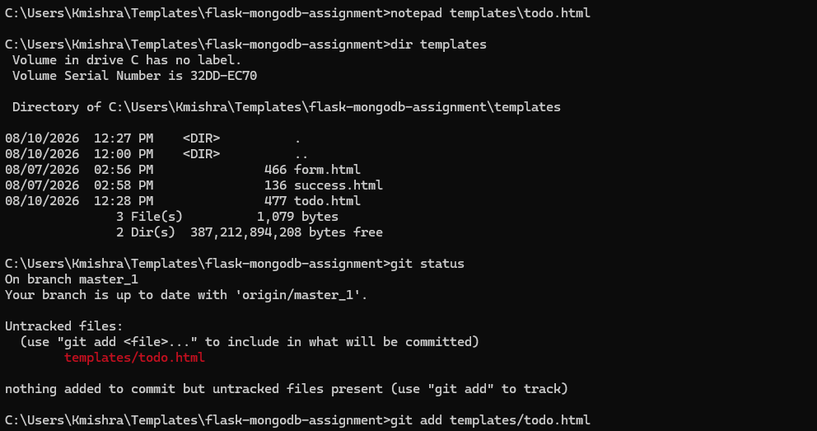
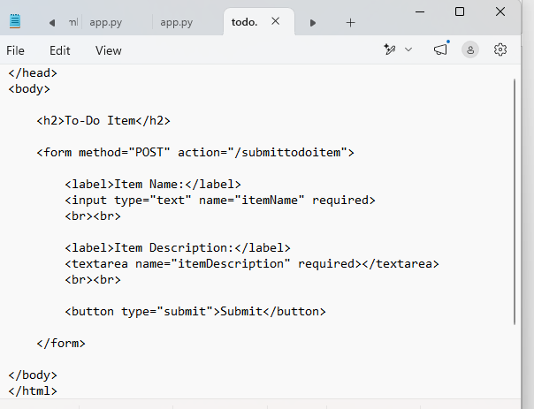
git status
git add templates/todo.html
git commit -m "Add To-Do page with item name and description"
git push origin master_1
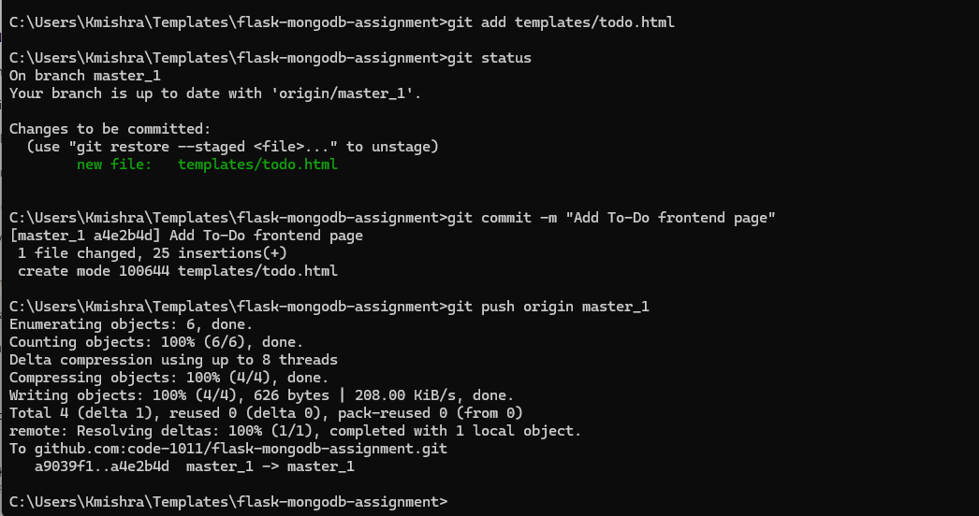

5.3 Backend API in master_2
git checkout master_2
Create a POST route named /submittodoitem. It accepts itemName and itemDescription and stores them in MongoDB Atlas.
@app.route('/submittodoitem', methods=['POST'])
def submit_todo_item():
item_name = request.form.get('itemName')
item_description = request.form.get('itemDescription')
todo = {
"itemName": item_name,
"itemDescription": item_description
}
collection.insert_one(todo)
return "To-Do item submitted successfully"
git status
git add app.py
git commit -m "Add backend API for To-Do item submission"
git push origin master_2
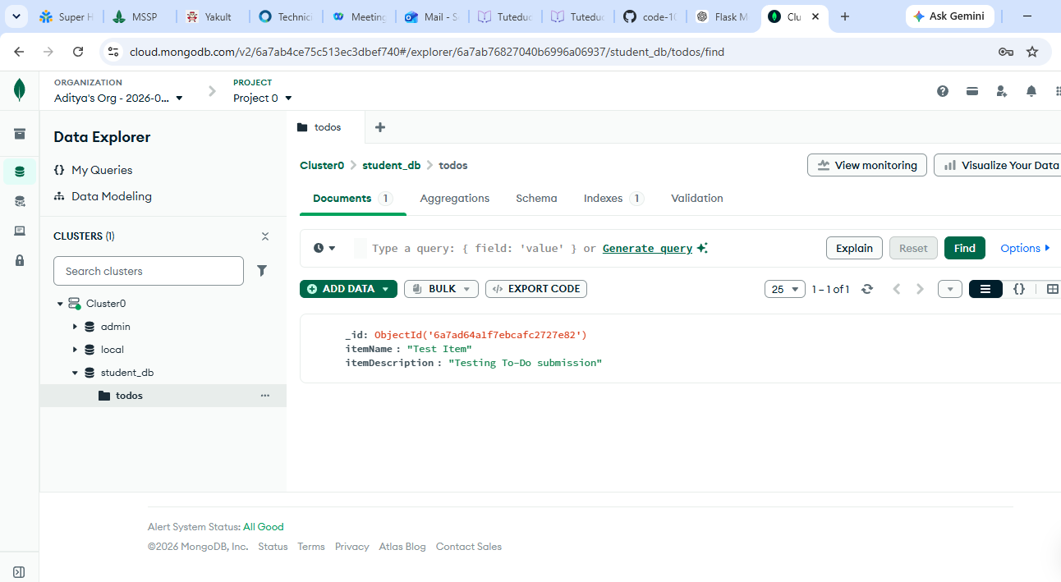

5.4 Merge master_1 and master_2 into main
git checkout main
git pull origin main
git merge master_1
git merge master_2
git push origin main
git log --oneline --graph –all
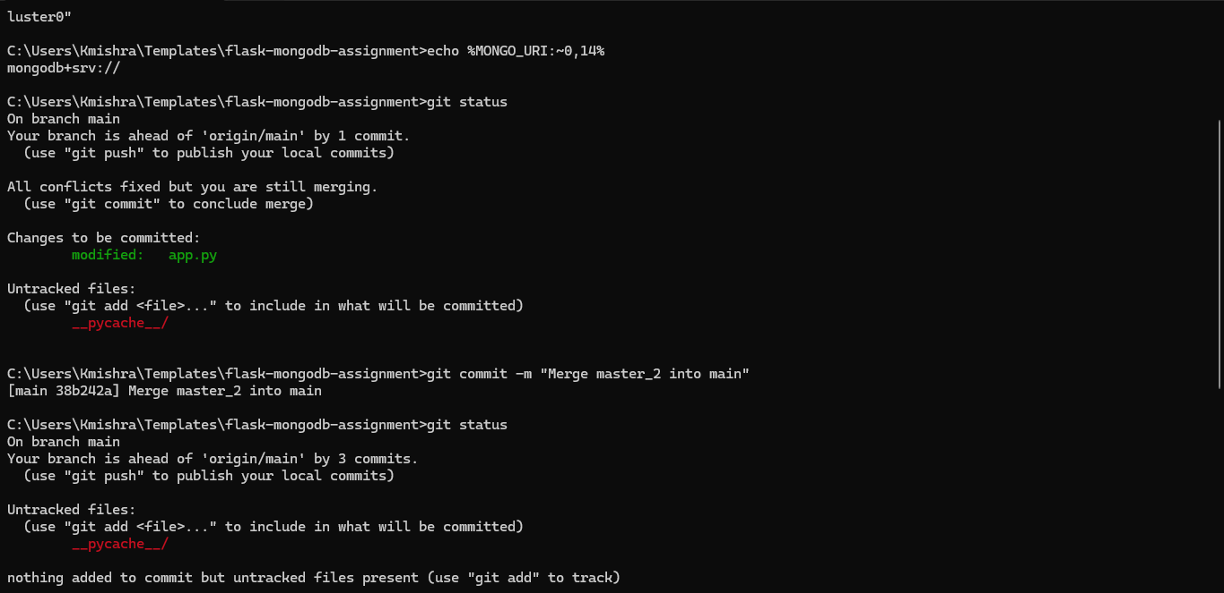
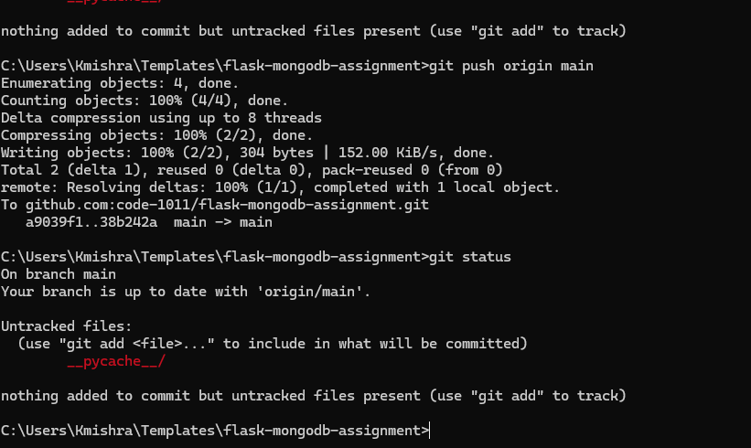

6. Part 4 – Sequential To-Do Form Commits
The following three fields must be added in three separate commits and in the specified order.

6.1 First Commit – Item ID
git checkout master_1
<label>Item ID:</label>
<input type="text" name="itemId" required>
<br><br>
git diff
git add templates/todo.html
git commit -m "Add Item ID field"
git push origin master_1

6.2 Second Commit – Item UUID
<label>Item UUID:</label>
<input type="text" name="itemUuid" required>
<br><br>
git diff
git add templates/todo.html
git commit -m "Add Item UUID field"
git push origin master_1

6.3 Third Commit – Item Hash
<label>Item Hash:</label>
<input type="text" name="itemHash" required>
<br><br>
git diff
git add templates/todo.html
git commit -m "Add Item Hash field"
git push origin master_1

6.4 Verify Separate Commits
git log --oneline --decorate -5
The history should show three individual commits, for example:
abc1234 Add Item Hash field
def5678 Add Item UUID field
ghi9012 Add Item ID field
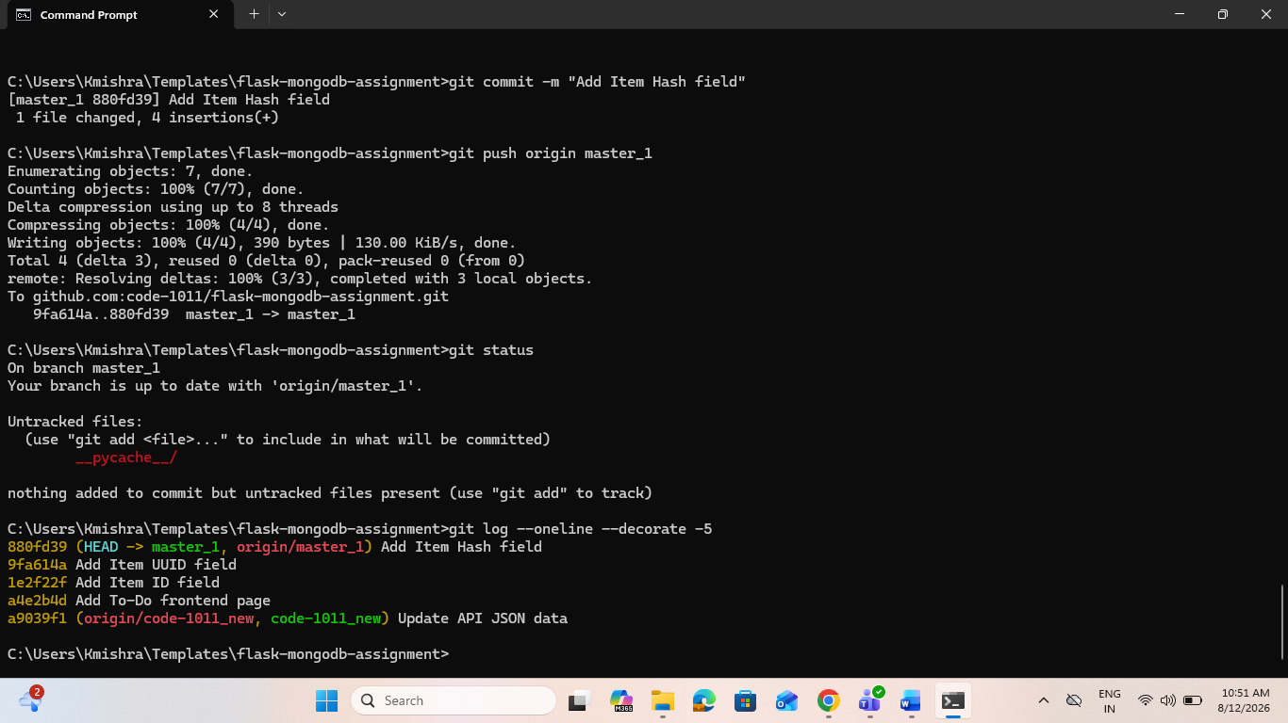

7. Git Reset – Restore Main to Item ID State
After merging master_1 into main, identify the commit where only Item ID was present. A backup branch is recommended before rewriting main history.
git checkout main
git branch backup-before-reset
git push origin backup-before-reset
git log --oneline --decorate --all
Copy the commit ID for the Item ID commit, then run:
git reset --soft <ITEM_ID_COMMIT_ID>
git status
git diff --cached
The --soft option moves the branch pointer while keeping the changes staged. The staged state can then be recommitted.
git commit -m "Restore main to Item ID state"
git push --force-with-lease origin main
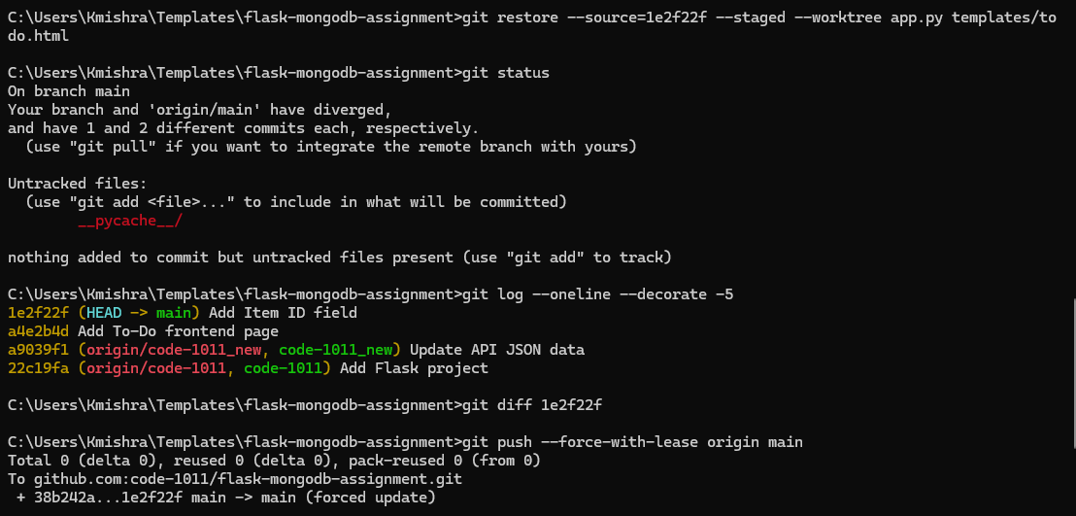

7.1 Note About the Requested Merge
After the reset and recommit are performed directly on main, the corrected state already exists on main. Therefore, a separate merge of main into itself is not required. The final main history should be verified with git log.

8. Rebase Updated main into master_1
The assignment requires rebasing master_1 using main as the base while preserving the individual commits. Do not squash the Item ID, Item UUID, and Item Hash commits.
git checkout master_1
git fetch origin
git rebase main master_1
If conflicts occur:
git status
# Resolve the conflicted file(s)
git add .
git rebase --continue
Repeat the conflict-resolution process until the rebase completes.
git rebase --abort
Use the command above only if the rebase needs to be cancelled.
git log --oneline --graph --decorate --all
git push --force-with-lease origin master_1
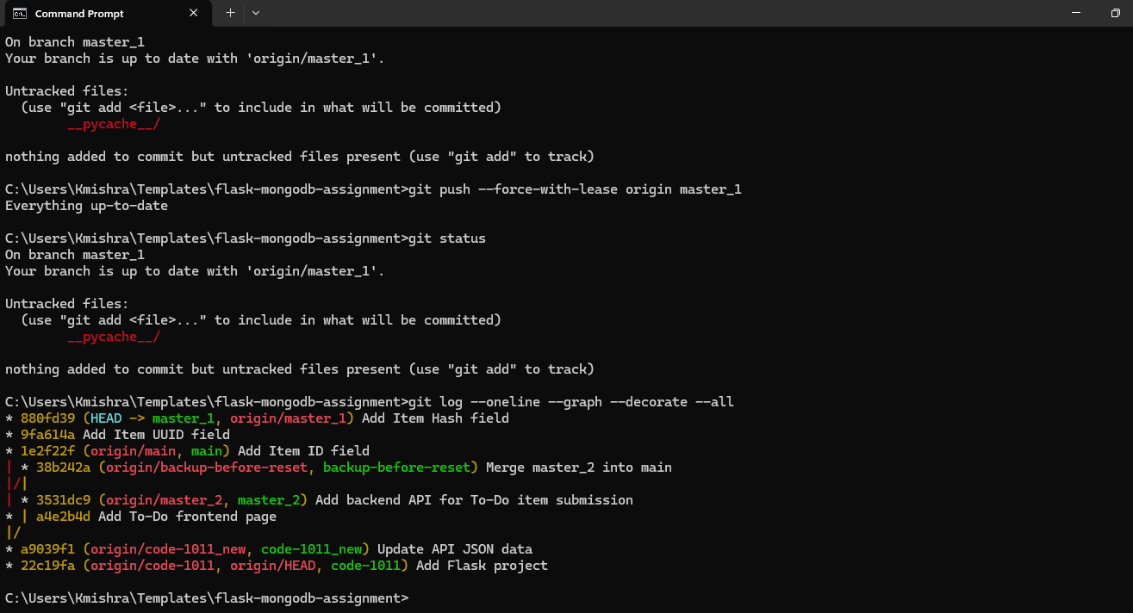

9. Final Verification
git branch -a
git status
git log --oneline --graph --decorate --all
Expected branches may include:
- main
- master_1
- master_2
- Tutedude
- Tutedude_new

