**Workshop 2**

**a) Declaration**

We, Ruyuan Sun, Steven David Pillay, Syed Moonis Iqbal, and Olha Hodovaniuk, declare that the attached assignment is our own work in accordance with the Seneca Academic Policy. We have not copied any part of this assignment, manually or electronically, from any other source including websites, unless specified as references. We have not distributed our work to other students.

**b) Task Distribution**

|  | Name | Task(s) |
| --- | --- | --- |
| 1 | Syed Moonis Iqbal | Code and report for Questions 1 and 2 |
| 2 | Olha Hodovaniuk | Code and report for Questions 1 and 2 |
| 3 | Steven David Pillay | Code and report for Questions 1 and 2 |
| 4 | Ruyuan Sun | Code and report for Questions 1 and 2 |

**c) All answers and outputs for all the workshop questions**

***Ruyuan Sun***

Question 1. Getting familiar with image manipulation in Python – OpenCV. Read the image "bicycle.bmp" from the data directory using the OpenCV flag cv2.IMREAD_UNCHANGED and then find and print the following information about this image

a) find image height (number of rows)

Image Height: 300

b) find image width (number of columns)

Image Width: 453

c) find the image number of channels.

Number of Channels: 3

d) find image datatype.

Image Datatype: uint8

e) find the image number of pixels.

Number of Pixels: 407700

f) convert the image to gray level and then save it in the output directory with name "bicyclegray.jpg"

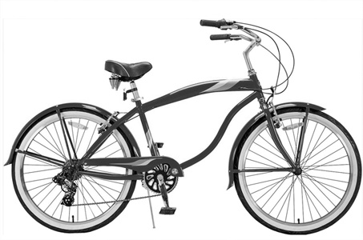

g) find the maximum value of the pixel values.

Maximum Pixel Value: 255

h) Calculate the mean/average of the pixel values.

Mean Pixel Value: 217.15924208977188

i) Change the image's pixel values in the following way: all pixels’ values less than the average value calculated at point (h) will be equal to 0 and all the other pixels will be equal to 1. Then, save it in the output directory with name "bicycleoutA.jpg"

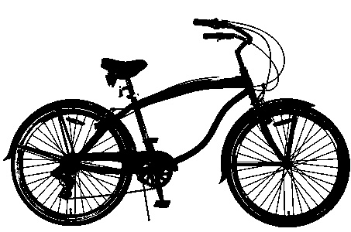

j) What type of image is generated at (i)?

The image generated at (i) is a binary image.

Question 2. Reducing the Number of Intensity Levels in an Image Write a computer program capable of reducing the intensity levels in a gray image from 256 to 2 levels, in integer powers of 2. That is intensity levels: 256 defaults, 128, 64, 32, 16, 8, 4, 2. Use the image "lena.tif" from the data directory. Note: Your code should generate the image with the required intensity and then write/save the image to the output directory. The name of generated images as following lena256.jpg, lena128.jpg, lena64.jpg, lena32.jpg, lena16.png, lena8.png, lena4.png, and lena2.png.

**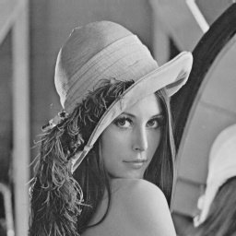  
lena256.jpg**

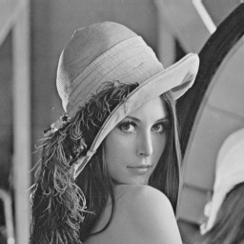

**lena128.jpg**

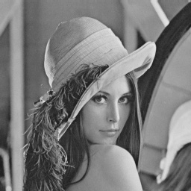

**lena64.jpg**

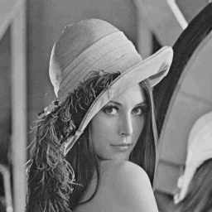

**lena32.jpg**

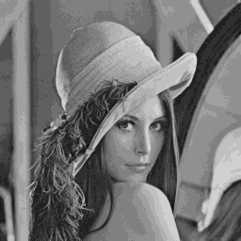

**lena16.png**

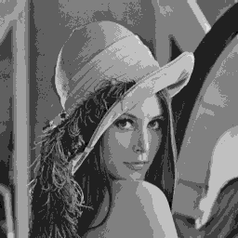

**lena8.png**

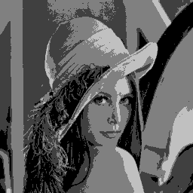

**lena4.png**

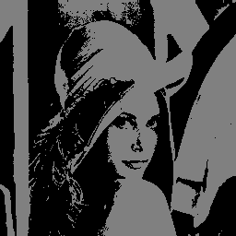

**lena2.png**

***Olha Hodovaniuk***

Question 1. Getting familiar with image manipulation in Python – OpenCV. Read the image "bicycle.bmp" from the data directory using the OpenCV flag cv2.IMREAD_UNCHANGED and then find and print the following information about this image

a) find image height (number of rows)

Image Height: 300

b) find image width (number of columns)

Image Width: 453

c) find the image number of channels.

Number of Channels: 3

d) find image datatype.

Image Datatype: uint8

e) find the image number of pixels.

Number of Pixels: 407700

f) convert the image to gray level and then save it in the output directory with name "bicyclegray.jpg"



g) find the maximum value of the pixel values.

Maximum Pixel Value: 255

h) Calculate the mean/average of the pixel values.

Mean Pixel Value: 217.15924208977188

i) Change the image's pixel values in the following way: all pixels’ values less than the average value calculated at point (h) will be equal to 0 and all the other pixels will be equal to 1. Then, save it in the output directory with name "bicycleoutA.jpg"



j) What type of image is generated at (i)?

The image generated at (i) is a binary image.

Question 2. Reducing the Number of Intensity Levels in an Image Write a computer program capable of reducing the intensity levels in a gray image from 256 to 2 levels, in integer powers of 2. That is intensity levels: 256 defaults, 128, 64, 32, 16, 8, 4, 2. Use the image "lena.tif" from the data directory. Note: Your code should generate the image with the required intensity and then write/save the image to the output directory. The name of generated images as following lena256.jpg, lena128.jpg, lena64.jpg, lena32.jpg, lena16.png, lena8.png, lena4.png, and lena2.png.

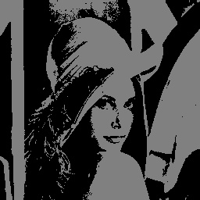

lena2.jpg

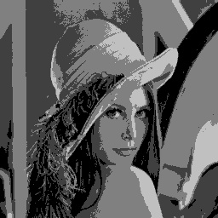

lena4.jpg

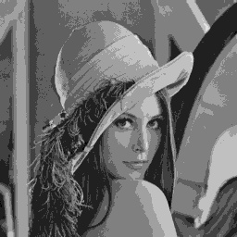

lena8.jpg

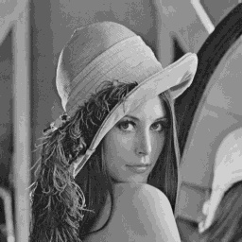

lena16.jpg

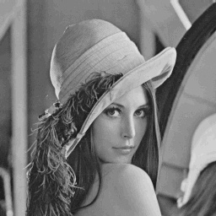

lena32.jpg

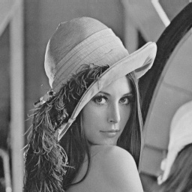

lena64.jpg

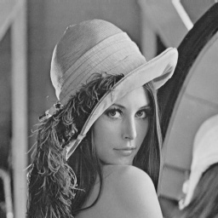

lena128.jpg

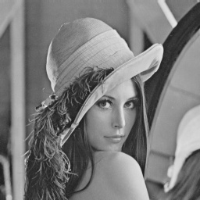

lena256.jpg

***Steven David Pillay***

Question 1. Getting familiar with image manipulation in Python – OpenCV. Read the image "bicycle.bmp" from the data directory using the OpenCV flag cv2.IMREAD_UNCHANGED and then find and print the following information about this image

a) find image height (number of rows)

Image Height: 300

b) find image width (number of columns)

Image Width: 453

c) find the image number of channels.

Number of Channels: 3

d) find image datatype.

Image Datatype: uint8

e) find the image number of pixels.

Number of Pixels: 407700

f) convert the image to gray level and then save it in the output directory with name "bicyclegray.jpg"

bicyclegray.jpg



g) find the maximum value of the pixel values.

Maximum Pixel Value: 255

h) Calculate the mean/average of the pixel values.

Mean Pixel Value: 217.15924208977188

i) Change the image's pixel values in the following way: all pixels’ values less than the average value calculated at point (h) will be equal to 0 and all the other pixels will be equal to 1. Then, save it in the output directory with name "bicycleoutA.jpg"



j) What type of image is generated at (i)?

The image generated at (i) is a binary image.

Question 2. Reducing the Number of Intensity Levels in an Image Write a computer program capable of reducing the intensity levels in a gray image from 256 to 2 levels, in integer powers of 2. That is intensity levels: 256 defaults, 128, 64, 32, 16, 8, 4, 2. Use the image "lena.tif" from the data directory. Note: Your code should generate the image with the required intensity and then write/save the image to the output directory. The name of generated images as following lena256.jpg, lena128.jpg, lena64.jpg, lena32.jpg, lena16.png, lena8.png, lena4.png, and lena2.png.

len2.jpg



len4.jpg



len8.jpg



Len16.jpg



Len32.jpg



Len64.jpg



Len128.jpg



Len256.jpg



***Syed Moonis Iqbal***

Question 1. Getting familiar with image manipulation in Python – OpenCV. Read the image "bicycle.bmp" from the data directory using the OpenCV flag cv2.IMREAD_UNCHANGED and then find and print the following information about this image

a) find image height (number of rows)

Image Height: 300

b) find image width (number of columns)

Image Width: 453

c) find the image number of channels.

Number of Channels: 3

d) find image datatype.

Image Datatype: uint8

e) find the image number of pixels.

Number of Pixels: 407700

f) convert the image to gray level and then save it in the output directory with name "bicyclegray.jpg"



g) find the maximum value of the pixel values.

Maximum Pixel Value: 255

h) Calculate the mean/average of the pixel values.

Mean Pixel Value: 217.15924208977188

i) Change the image's pixel values in the following way: all pixels’ values less than the average value calculated at point (h) will be equal to 0 and all the other pixels will be equal to 1. Then, save it in the output directory with name "bicycleoutA.jpg"



j) What type of image is generated at (i)?

The image generated at (i) is a binary image.

Question 2. Reducing the Number of Intensity Levels in an Image Write a computer program capable of reducing the intensity levels in a gray image from 256 to 2 levels, in integer powers of 2. That is intensity levels: 256 defaults, 128, 64, 32, 16, 8, 4, 2. Use the image "lena.tif" from the data directory. Note: Your code should generate the image with the required intensity and then write/save the image to the output directory. The name of generated images as following lena256.jpg, lena128.jpg, lena64.jpg, lena32.jpg, lena16.png, lena8.png, lena4.png, and lena2.png.



lena2.jpg



lena4.jpg



lena8.jpg



lena16.jpg



lena32.jpg



lena64.jpg



lena128.jpg



lena256.jpg