GUJARAT POLICE INNOVATION HACKATHON 2026
Sentinel
High-Level Design
A central camera registry and GIS platform with read-only feed integration, live video analytics, watchlist matching, alerts, journeys and audit controls.
DATE | 1 September 2026
ARCHITECTURE | Central registry and GIS, direct read-only feed integration, separate analytics workers and an authenticated operator console

Built by Vatsal Mehta, Sidharth Chakrat and Pratham Shah
Gujarat Police Innovation Hackathon 2026 CCTV Integration Challenge (Sentinel)

Contents
1 System purpose
2 Detailed component architecture
3 Deployment and runtime topology
4 Observation to alert sequence
5 Integrating cameras, NVRs and VMS
6 Live stream ingestion and processing
7 Analytics, watchlists and investigation
8 Alert workflow and operator console
9 Target statewide architecture
10 Logical data model
11 Security, privacy and audit
12 Department prerequisites and assumptions
13 Technology and measured performance

1 System purpose
Sentinel brings camera inventory, GIS, live viewing, analytics, watchlist matching, alerts and investigation into one department-scoped platform. It connects to authorised camera feeds without replacing departmental VMS, NVR or DVR systems.
The platform stores camera and event metadata centrally. Source video stays with the existing department system unless an authorised user opens a live preview or uploads a recording for investigation. This reduces network and storage load and keeps each department's recording setup unchanged.
METADATA-FIRST | READ-ONLY CONNECTORS | SOURCE-TIME EVENTS | EDGE INFERENCE | DEPARTMENT-SCOPED ACCESS | REGIONAL RELAY | CENTRAL GOVERNANCE

SOURCES | Cameras and recorders  IP cameras, NVR, DVR and VMS outputs | Camera catalogues  Department inventory and source metadata | Watchlist systems  Authorised vehicle and person lists
SENTINEL | Registry and GIS  Ownership, location, capability and health | Media and analytics  Read-only capture, detection and tracking | Operations  Matching, alerts, journeys, audit and investigation
USERS | Department operators  Live view and alert response | Command centres  District and statewide awareness | Administrators  Access, catalogues, maintenance and audit
Figure 1. System context. Source systems remain authoritative; Sentinel provides a governed operational view.
- Different camera and recorder types are normalised through a connector layer before the console or analytics uses them.
- Unknown codec, location or timing values remain unknown until a probe or survey provides evidence.
- Department grants are checked before camera, media, sighting, alert, journey or investigation data is returned.
- Raw stream endpoints stay inside the backend and worker boundary. The browser receives an authenticated relay URL.
The result is one auditable path from a registered camera to an operator action. Each alert can be traced back to the camera, source time, model output, watchlist entry and operator response.

2 Detailed component architecture
The implementation separates the control plane, the media and analytics workers, and the operator console. PostgreSQL with PostGIS is the durable system of record. The backend runs the API and business rules, while separate Python workers handle video decoding and model inference.
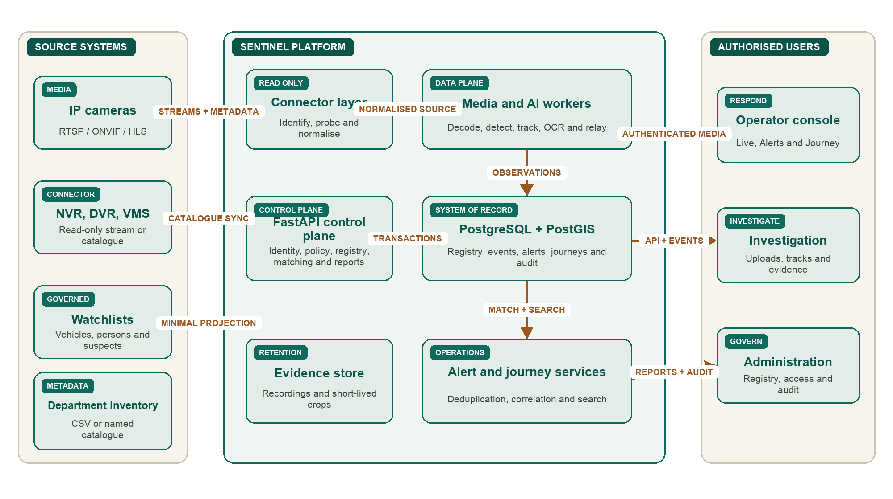
Figure 2. Component architecture and primary interactions across source, control, data and user boundaries.
The backend is a modular monolith. This keeps authentication, database transactions and business rules in one process. Video processing stays outside that process because model and decoder workloads need separate resources and independent restart behaviour.

3 Deployment and runtime topology
OPERATOR DEVICE | Authenticated browser  React console, maps and HLS/WebRTC player | Same-origin API  No raw camera endpoint is exposed | Role-aware actions  Server rechecks every request
APPLICATION HOST | FastAPI  Business rules, API and static console | Supervisors  Live analytics and offline ingest processes | Media relay  HLS proxy, FFmpeg and MediaMTX
PERSISTENCE | PostgreSQL 17  Operational records and job state | PostGIS  Locations, coverage and journey maps | File store  Recordings and short-lived evidence crops
Figure 3. Current deployment topology.
At startup, the backend removes orphaned live workers and clears old analytics intent. A camera does not resume continuous analytics until an operator enables it again. Offline ingest jobs follow their database state because they may run for much longer.

4 Observation to alert sequence
The sequence below shows how a confirmed observation becomes an alert and how the operator response is recorded. It separates source media, analytics, transactional matching and operator state.
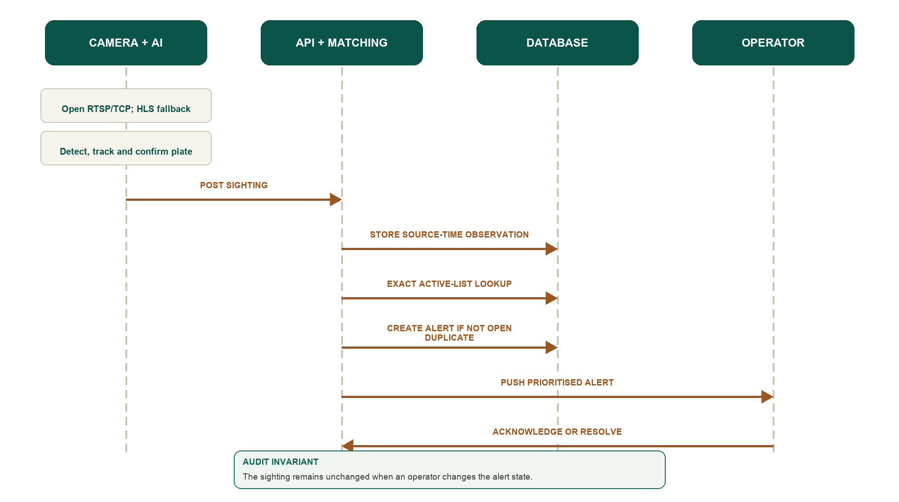
Figure 4. Observation-to-alert sequence. The source observation stays unchanged when the alert state changes.
Every confirmed sighting is stored even when it does not create an alert. The confidence threshold controls interruption, not data retention. Acknowledging or resolving an alert does not change the observation that created it.

5 Integrating cameras, NVRs and VMS
Sentinel accepts camera information through the registry first. A stream can be added later, so a camera can still appear on the GIS map and in maintenance reports when no network feed is available.
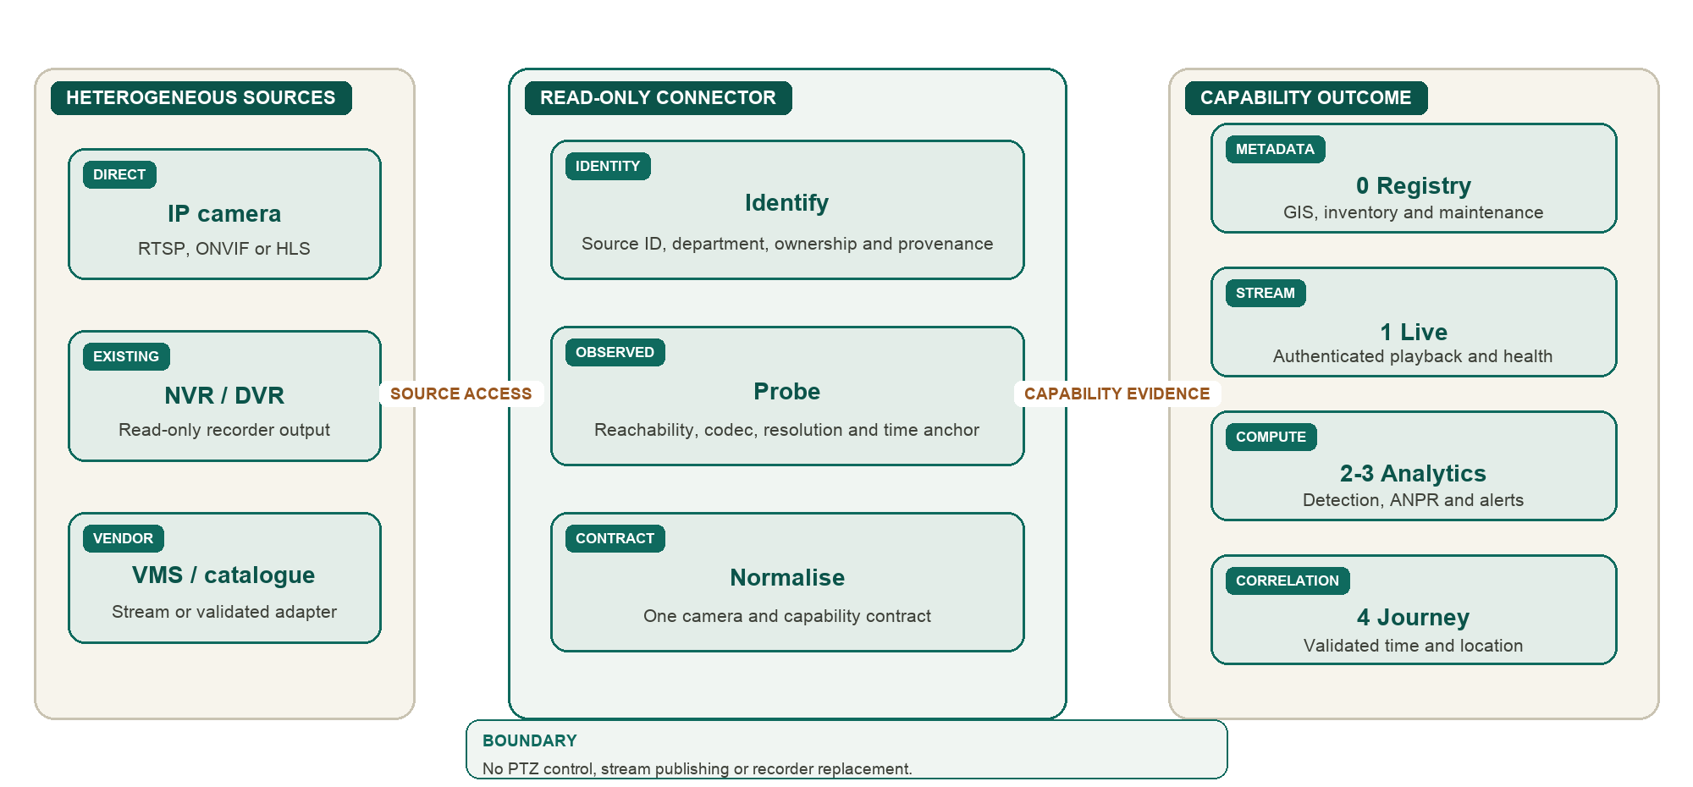
Figure 5. Read-only integration path for heterogeneous cameras, NVRs, DVRs and VMS catalogues.
The connector layer is read-only. It discovers sources, normalises fields and reports health. It does not publish a stream, move a PTZ camera or call a recorder control API. Camera IDs come from the catalogue or the registry and are not hard-coded into analytics.
Empty codec, resolution, frame-rate or location fields are not filled with guessed values. Stream probing and geocoding add separate observed values and confidence information. Raw endpoints remain inside the backend and worker boundary.

6 Live stream ingestion and processing
Live media follows two controlled lanes: sampled frames go to analytics workers, while authenticated HLS or focused WebRTC serves operator playback. Analytics workers publish observations through a separate machine-token path.
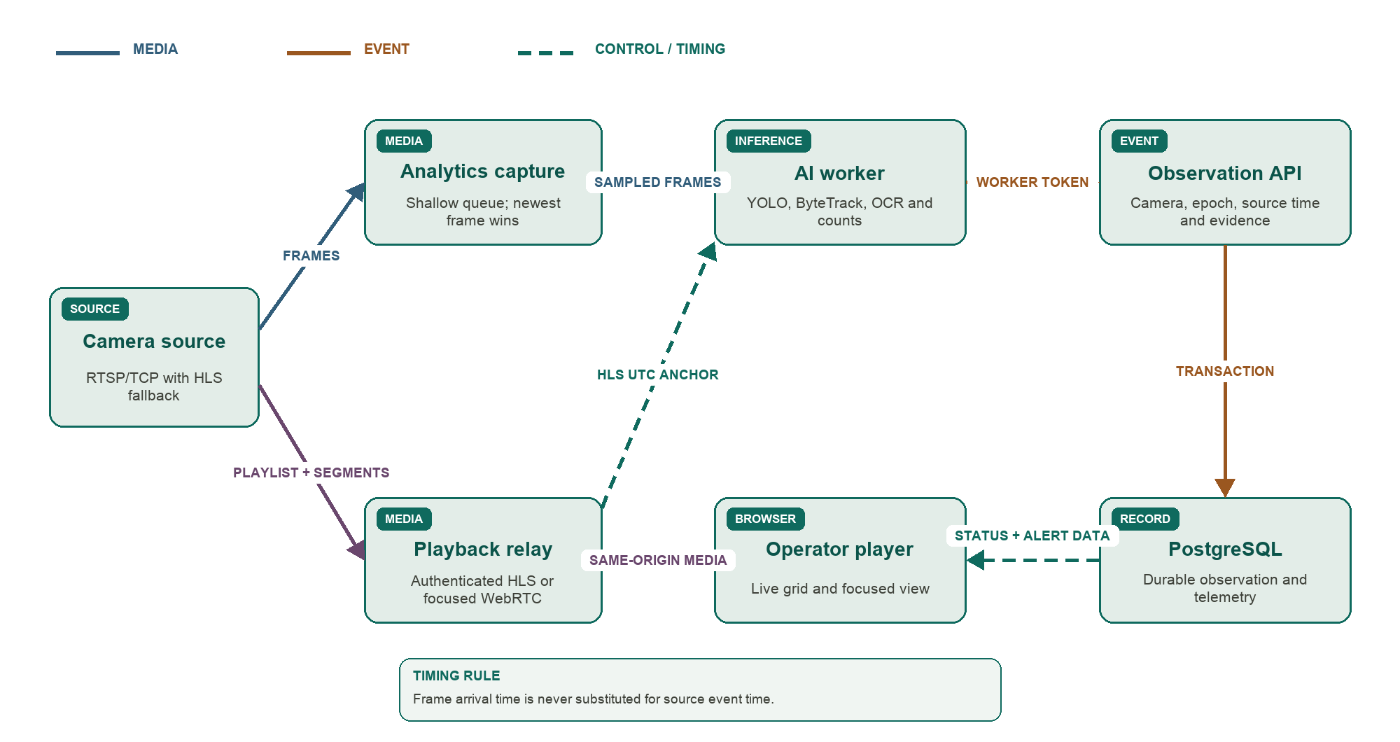
Figure 6. Live media, inference, observation and operator data flow.

6.1 Timing
Frame arrival time is not used as the event time. The worker keeps the frame's connection-relative presentation timestamp and maps it to the latest HLS program date and time. The mapping is refreshed during the connection.
A reconnect or backward timestamp jump creates a new stream epoch. Timestamps are compared only inside the same camera and epoch. If the worker cannot obtain an absolute time anchor, it does not invent one.

6.2 Resilience and load control
- A shallow queue keeps the newest frame and drops stale frames when inference falls behind.
- A failed stream reconnects with increasing delay, capped to avoid a tight retry loop.
- RTSP falls back to HLS when both are registered and RTSP cannot open.
- A backward timestamp or reconnect starts a new epoch and resets unsafe timing state.
- Vehicle, person, suspicious-activity and offline-ingest workloads have separate concurrency limits.
- Inactive relay sessions close after their idle period. The console shows connected, reconnecting, offline and unknown as different states.

7 Analytics, watchlists and investigation

7.1 Analytics and continuous correlation
YOLO11 detects vehicles and ByteTrack keeps a track across frames. Plate OCR runs only when the crop is large enough to be useful. Several reads from the same track are combined before the worker publishes one confirmed sighting.
Plate text is normalised before exact comparison with active watchlist entries. A lower-confidence sighting remains searchable but does not interrupt the operator. Match creation, deduplication, prioritisation and alert state changes remain separate from the immutable source observation.
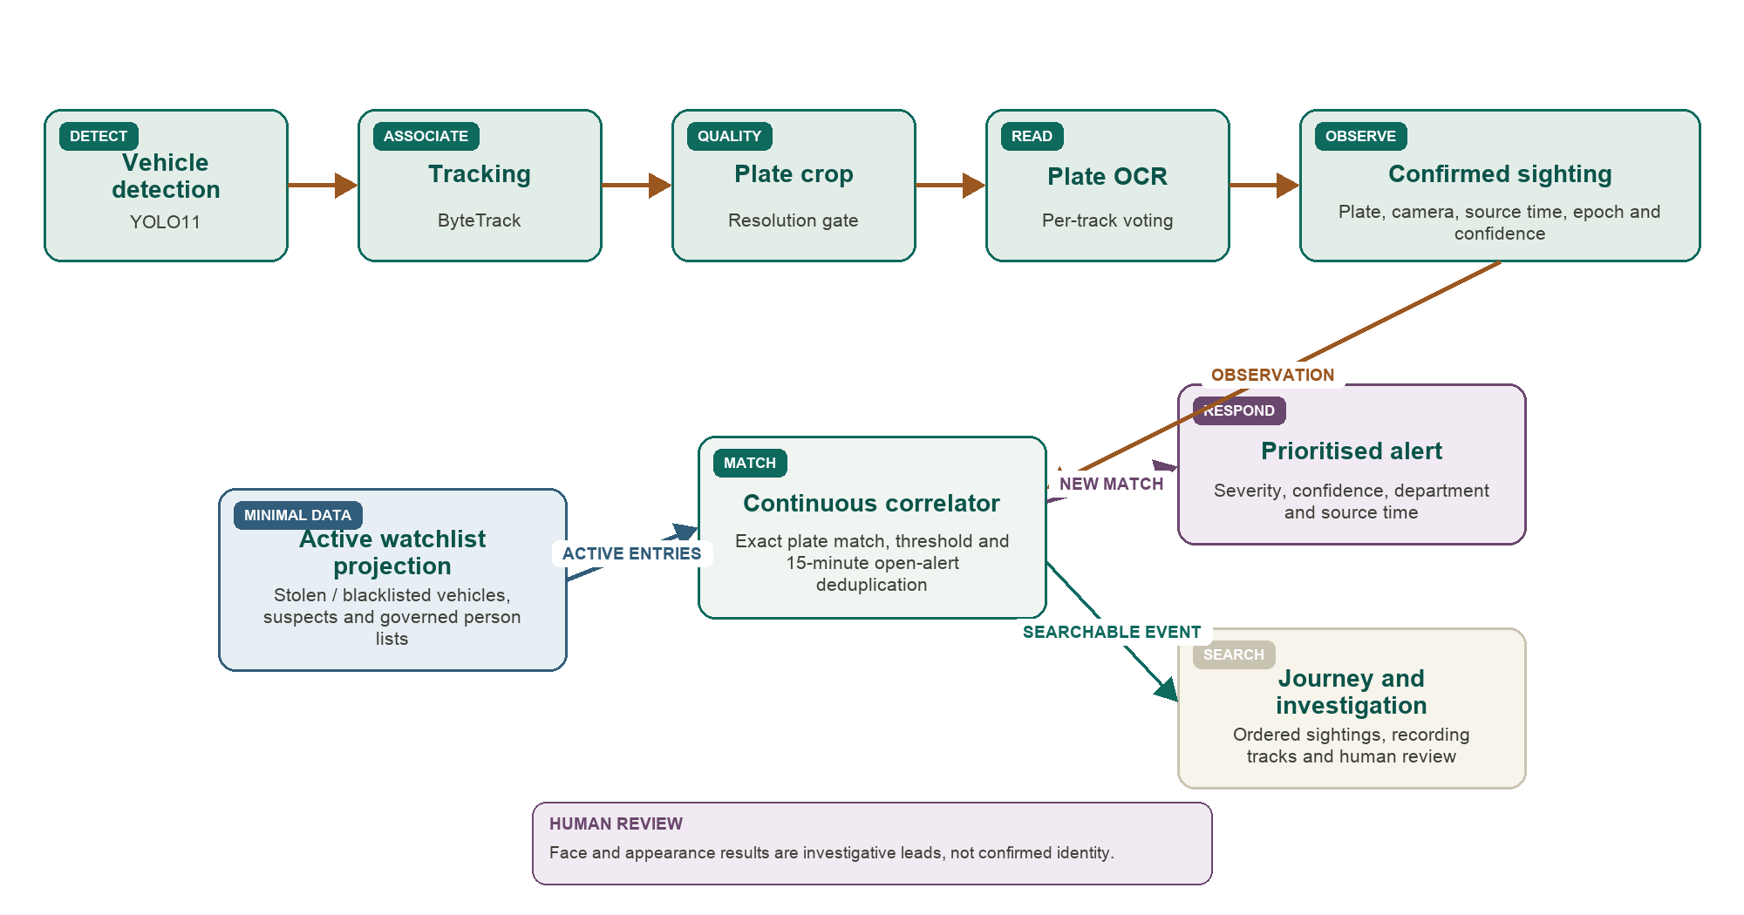
Figure 7. AI analytics, watchlist correlation, alert generation and investigation paths.

7.2 Journey and investigation
Journey search orders sightings for a normalised plate by source time and joins each stop to camera coordinates. The same database query supplies the map, timeline and JSON, CSV, HTML or PDF exports, which keeps the formats consistent.
Investigate normalises and hashes uploaded recordings, then runs vehicle or person tracking. Plate search supports exact and fuzzy review. Person-photo search returns ranked appearance similarity without asserting identity. Subject links require an exact plate match or an explicit operator decision.

7.3 Watchlist sources and governed person matching
The active path matches vehicle plates. The same governed contract can accept authorised stolen-vehicle, blacklisted-vehicle, suspect, wanted-person and missing-person lists. Each entry keeps ownership, severity, validity, classification and access rules.
A minimal local projection keeps live correlation available when an external database is offline. Personal details are not copied into the observation store. Any authorised single-record enrichment lookup records the operator, purpose, entity, time and result.
Facial recognition uses the same observation contract only after legal authorisation, privacy review, controlled enrolment and expiry, representative accuracy testing and human confirmation. A face or appearance result is an investigative lead, not a confirmed identity.

8 Alert workflow and operator console

8.1 Prioritisation
The alert queue is ordered first by watchlist severity, then by match confidence and source event time. A specific watchlist match ranks above a generic behavioural alert. The statewide policy may also use incident proximity, repeat detections on a plausible route, department rules and time-of-day rules. These policy inputs remain configurable and auditable.
Severity and  alert type | > | Match confidence  and source time | > | Department and  camera routing | > | Rate limit and  deduplication | > | Prioritised  operator queue
Figure 8. Alert prioritisation and queueing.

8.2 Notification and routing
ROUTING POLICY | Scope  Department, camera group and alert type | Priority  Severity, confidence and time of day | Escalation  Next authorised group if not acknowledged
PRIMARY ROUTE | Operator console  Department-filtered real-time queue | Control room  District or zone display | Audit trail  Delivery, acknowledgement and resolution
OPTIONAL ROUTES | Mobile push  High severity; minimal notification text | SMS / email  Rate-limited summary without evidence | Webhook  Signed delivery to an allowlisted endpoint
Figure 9. Alert notification and escalation routes.
Routing evaluates department, camera group, severity, alert type and time of day. A configured escalation rule sends an unacknowledged high-severity alert to the next authorised group. Duplicate suppression, confidence thresholds and per-camera rate ceilings prevent one noisy feed from overwhelming the queue.

8.3 Operator interaction
The operator workspace groups work into Respond (Live, Alerts and Journey), Investigate (uploads, tracks and evidence) and Administer (registry, watchlists, access and audit). The interface reflects the user's role, while the server rechecks every data, action and media request.

9 Target statewide architecture
The target design supports approximately 80,000 registered cameras without centralising every video stream. It places capture and inference close to camera sites, moves observations through regional services, and keeps statewide records and policy at the centre. This section is a capacity design. Its planning values require benchmark and procurement validation.
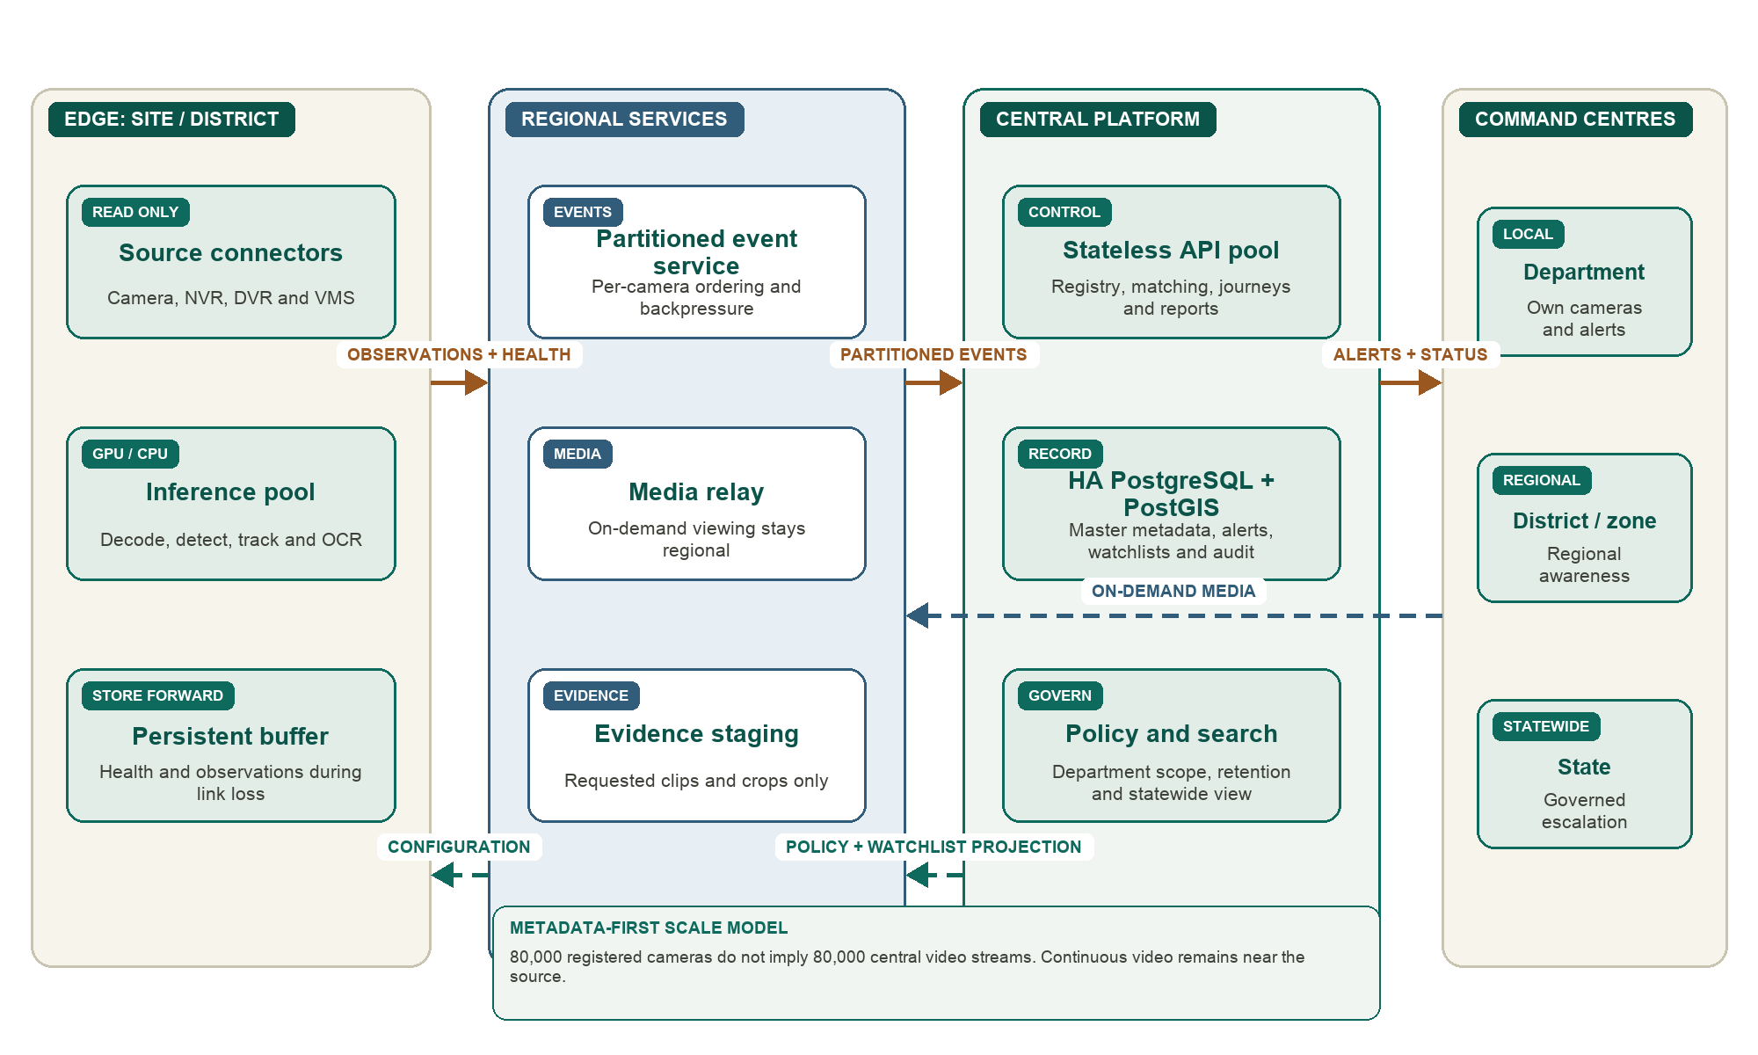
Figure 10. Statewide edge, regional, central and command-centre architecture. Continuous video stays near its source.

9.1 Tier responsibilities
Edge nodes own source connectivity, bounded inference and store-forward buffering. Regional services preserve per-camera event order, relay on-demand media and stage requested evidence. The central platform holds master metadata, matching, search, policy and audit. Department, district and state views expose only the scope authorised for each command centre.

9.2 Workload and capacity model
Camera tier | Planning share | Cameras | Processing
Continuous ANPR | 10% | 8,000 | Plate-capable sites, sampled at 5 to 10 frames per second.
Light analytics | 20% | 16,000 | Detection, counting or authorised event rules, sampled at 1 to 2 frames per second.
Registry and on demand | 70% | 56,000 | GIS, health and on-demand viewing or investigation.

The shares above are planning assumptions, not measured demand. Camera surveys and department policy assign the final tier. The measured implementation runs three concurrent ANPR workers at 6.9 to 11.9 frames per second per camera on a developer-class machine. Production GPU density must be benchmarked on representative footage before procurement.

9.3 Network and storage
At an assumed 2.5 Mbps per stream, centralising 80,000 feeds would require about 200 Gbps before protocol overhead. The metadata-first design avoids that continuous load by moving observations instead of every video stream.

9.4 Scale, availability and interoperability
- Inference is partitioned by site and district. A node failure affects a bounded camera group.
- Event ordering is preserved per camera. Observation storage is partitioned by time and department.
- API services remain stateless and can be load balanced. Regional media relays keep video local to the viewer's region.
- Replicated regional event services and a high-availability central database provide recovery paths. Restore and failover tests are required before production acceptance.
- Connectors use documented contracts and open transports such as RTSP, ONVIF and HLS. Vendor SDK or API adapters stay outside the core registry and analytics logic.
- Backpressure uses bounded frame queues, worker limits and event-lag controls. Degraded cameras remain visible in health and operations views.

10 Logical data model
This is the HLD view of the database. It shows the main business entities and relationships, not every column, index or migration. PostgreSQL is the system of record, while PostGIS adds location and spatial queries to camera and journey data.
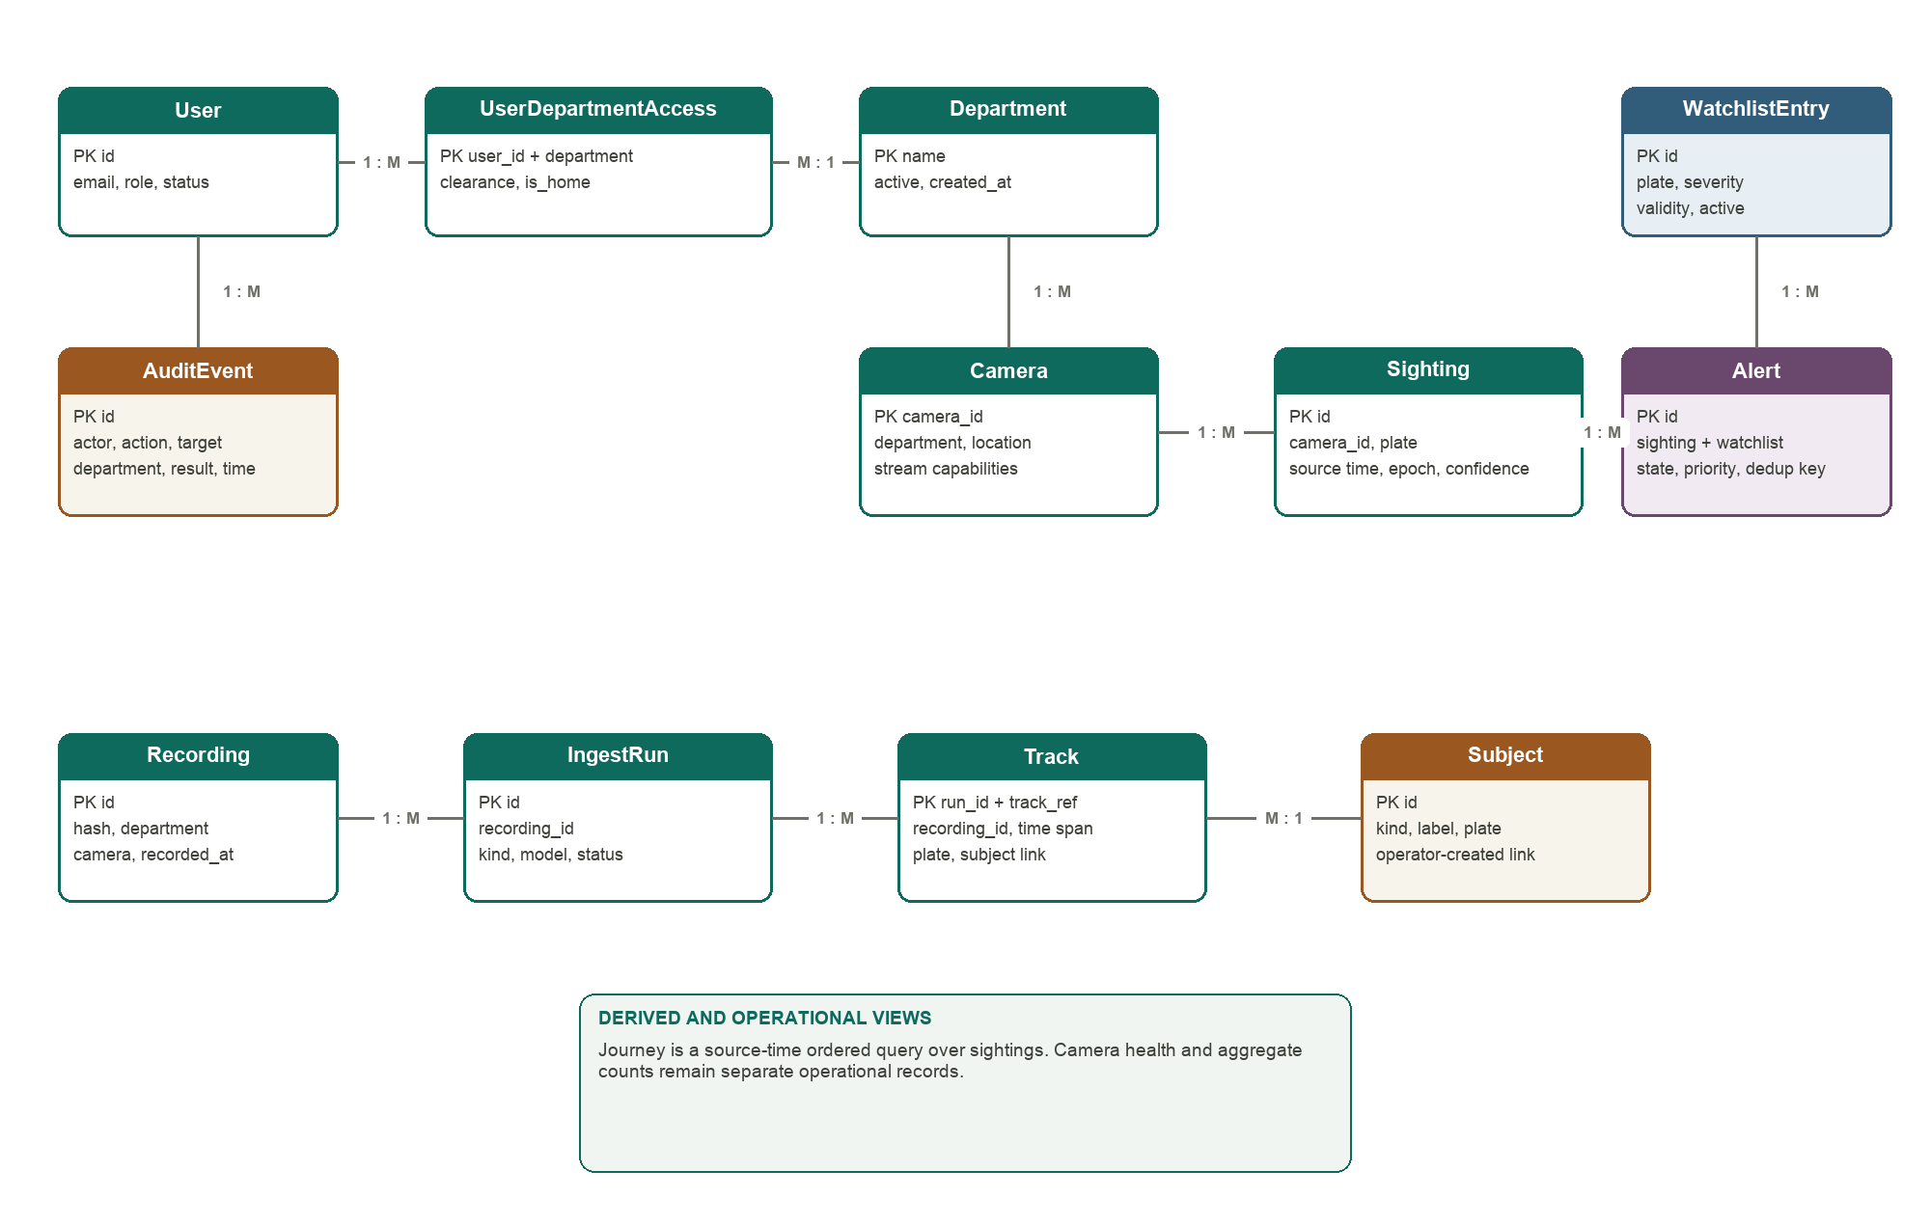
Figure 11. Logical database model. Relationship labels show the main one-to-many directions.
- A department owns cameras and scopes users, recordings, alerts and operational access.
- A sighting is an immutable source observation. An alert refers to a sighting and may also refer to a watchlist entry.
- A journey is a time-ordered query over sightings rather than a second copy of the same event data.
- A recording can have several ingest runs. Each run produces tracks, and a track links to a subject only after an exact plate match or an operator confirmation.
- Audit events keep the actor, action, target, department, result and time even when the target is not represented by a strict foreign key.

11 Security, privacy and audit
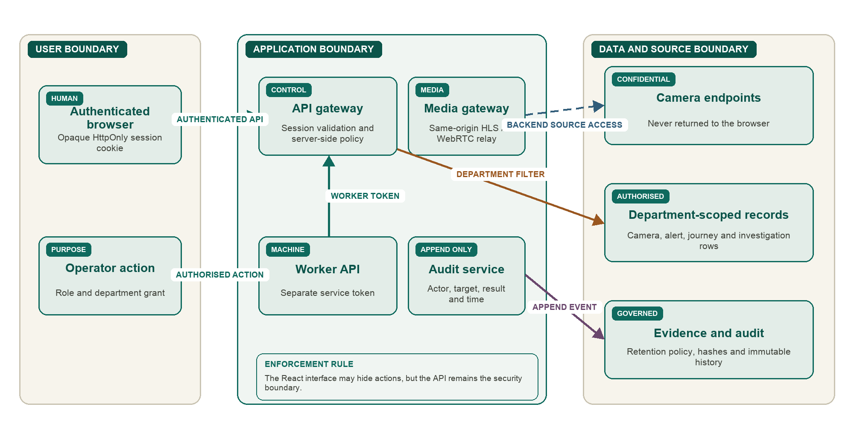
Figure 12. Security trust boundaries, service identities and server-side enforcement points.
- Only the session digest is stored. Passwords use scrypt with a separate salt.
- Audit records cover login, denial, grants, camera changes, watchlists, alerts, exports and investigations.
- Evidence crops expire after the configured period, which defaults to 72 hours. The source sighting remains.
- Audit exports include a SHA-256 digest. Development fixtures use synthetic values and no real endpoints or footage.
Successful high-frequency media and telemetry reads are not written as one audit row per request because that would create uncontrolled audit volume. Access denials are still recorded. Development fixtures use synthetic cameras and watchlist values and do not contain real endpoints, credentials or footage.

12 Department prerequisites and assumptions
A department can begin with metadata only. Live viewing and analytics are enabled only after the required access, network and governance checks pass. The intake below determines the integration level for each camera.

12.1 Working assumptions
Assumption | If it is not met
The department authorises read-only access for named cameras and a documented purpose. | The cameras remain registry-only.
A technical nodal officer and an authorising officer are nominated. | Onboarding pauses because ownership and approval cannot be established.
RTSP, ONVIF, a vendor SDK or a gateway API is available. | The camera remains metadata-only until a supported path exists.
Edge compute, power and network access can be provided at a site or district location. | Inference runs centrally for that site, subject to WAN capacity.
Camera time is NTP disciplined or an in-stream absolute time reference exists. | Cross-camera timing uses a wider uncertainty range.
Legal purpose and retention rules exist for each analytic and data type. | The analytic remains disabled or retention is reduced.
A production identity provider and secret manager are available. | Production access is not enabled.

12.2 Information required from participating departments
Intake group | Required information
Ownership and inventory | Department, technical contact, authorising officer, camera count, site breakdown, local IDs, names, addresses, coordinates, ownership and camera type.
Camera and recorder | Camera make, model and age; VMS, NVR or DVR make, model and firmware; analog or IP; fixed, PTZ or specialist role.
Protocols and media | ONVIF profile and port; RTSP endpoint form and TCP support; HLS, WebRTC or catalogue availability; codec, resolution, frame rate, bitrate and GOP interval.
Access and network | Read-only credential process, NAT and firewall posture, VPN or permitted source ranges, addressing, available bandwidth and concurrent-client limit.
Deployment | Permission for an edge node, power and UPS details, site reachability, support contact and fault-escalation hours.
Governance | Permitted analytics, exclusion zones, ANPR authorisation, data-sharing approval, retention, masking needs, approval expiry and maintenance responsibility.

12.3 Integration readiness
0 Metadata  Registry and GIS | > | 1 Stream  Live and health | > | 2 Analytics  Detection and tracks | > | 3 ANPR  Matches and alerts | > | 4 Time + location  Journeys
Figure 13. Department integration readiness levels.

13 Technology and measured performance
Layer | Technology
Backend | Python 3.13, FastAPI, Uvicorn, SQLAlchemy and Alembic
Database and GIS | PostgreSQL 17, PostGIS and GeoAlchemy
Operator console | React 19, Vite, React Router, Leaflet, React Leaflet and hls.js
Media | FFmpeg, ffprobe, OpenCV and MediaMTX
Analytics | YOLO11, ByteTrack, fast-alpr and ONNX Runtime
Reports | Jinja templates and WeasyPrint

Measured check | Recorded result
Detection to visible alert | 2.1 to 2.9 seconds across four full-pipeline runs
Feed interruption recovery | 1.3 seconds with no spurious reconnects in the recorded run
Backend restart | 1.6 seconds with counts unchanged
Database connection loss | 1.1 seconds without a worker process crash
Duplicate alert handling | One alert for two matching sightings inside the deduplication window
Concurrent ANPR workers | Three workers sustained at 6.9 to 11.9 frames per second per camera
Mixed codec handling | H.264 and HEVC/H.265, including 960 x 540 at 15 frames per second

These measurements describe the recorded synthetic and protocol-compatible test runs. They show the behaviour of the current implementation and are not an accuracy score for plate recognition on operational CCTV footage.
Sentinel keeps departmental camera systems read-only, moves continuous analytics close to camera sites, stores governed metadata and audit centrally, and gives authorised operators a traceable path from observation to action.

