SVKM'S NMIMS INDORE
Hand Theremin: A Gesture-Controlled Musical Instrument Using Real-Time Hand Tracking and Audio Synthesis
Course: Image and Video Processing
Student Name(s): Anaya Doneriya, Khushi Patel, Anuva Rathi
Roll Number(s): F034, F027, F014
Programme / Semester / Division: B.Tech Computer Engineering / 5th / A
Faculty Name: Dr. Raj Gaurav Mishra
Institute / Department: SVKM's NMIMS Indore, Department of Computer Engineering
Academic Year: 2026-27

Abstract
A real theremin is a fascinating instrument: you play it without touching it. But it needs special antennas, it is expensive, and it is hard to tune. Most regular instruments are no easier, since they take years of practice. In this project we asked a simple question: can an ordinary laptop webcam do the job of those antennas?
Our answer is the Hand Theremin. The webcam watches your hands, and a pretrained model from MediaPipe finds 21 key points on each hand in every frame. From those points we measure three easy things: how high the wrist is, how far apart the thumb and index finger are, and whether the other hand is closed into a fist. These become pitch, volume, mute, and a drum hit. The pitch is snapped to a chosen musical scale, so even rough hand movements sound pleasant.
The sound comes from a small audio engine with six instruments: piano, guitar, violin, flute, saxophone, and drums. Where we have a real recording, we speed it up or slow it down to reach the right note. Where we do not, the engine builds the sound itself using layered sine waves shaped by an ADSR envelope and a little vibrato, so there is always something to hear.
In the latest version we also improved the on-screen experience. Small coloured music notes now float up from the playing fingertip whenever a note actually sounds, and their colour changes with the pitch. Closing the left hand into a fist sends out a warm-coloured burst of notes, so a drum hit is clearly visible as well as audible. The whole project runs locally with only a webcam and speakers.

1. Introduction

1.1 Background of the Problem
Touch-free interfaces are now part of everyday life, from hand-wave controls on phones to gesture menus on smart displays. The theremin, invented around 1920, was one of the first touch-free instruments. The player moves their hands near two antennas: one hand changes the pitch and the other changes the volume. It is beautiful in theory, but real theremins are costly and delicate, which is why very few people ever get to try one.
Today, hand-tracking models such as Google's MediaPipe HandLandmarker can follow a hand using just a normal camera. That means we can copy the idea of the theremin using something almost everyone already owns: a laptop with a webcam. Instead of sensing radio fields, the computer sees the hands through video.

1.2 Why the Problem Is Relevant
Gesture control is useful in many places: accessibility tools, touch-free kiosks, AR and VR, and interactive art. In music, it lowers the barrier to entry. Someone with no training, or someone who cannot comfortably hold a traditional instrument, can still make music just by moving their hands. It is also a good learning project, because the result can be checked by ear and by eye, which makes it very different from typical image-processing exercises.

1.3 Role of Image/Video Processing in Solving It
Video processing is the sensing layer of the whole project. Every webcam frame is flipped to look like a mirror, converted from BGR to RGB, and passed to the hand-landmark model. We then run simple distance calculations on the landmarks to understand the gesture. The project also produces its own processed video: a live view with a tracked-point marker, a pitch meter, on-screen text, and, in the latest version, floating music notes drawn directly onto each frame.

1.4 Motivation for Selecting the Project
We were inspired by a reference project shared in the course: a webcam "invisibility cloak" built with OpenCV and MediaPipe. It showed us that hand landmarks make a simple and reliable control signal. We wondered what would happen if we used that signal to control sound instead of hiding parts of a video, and that became this project.

2. Problem Statement and Objectives
Making music without touching an instrument is mostly limited to special, expensive hardware like a real theremin. Our goal is to read hand gestures from a live webcam feed, using real-time video processing and hand-landmark tracking, and use them to control the pitch, volume, and sound of a musical instrument as it plays.
Our specific objectives are:
- Capture live webcam video, clean it up, and use a pretrained model to find the hand landmarks in every frame.
- Turn simple, easy-to-explain hand measurements into musical controls (pitch, volume, mute, and a drum trigger) instead of training a separate gesture classifier.
- Snap the hand position onto a musical scale so that natural, imprecise movement still gives pleasant notes.
- Play six instrument voices in real time, using real recordings where we have them and generated sound where we do not, so the system always makes sound.
- Give the player live visual feedback: a marker, a pitch meter, status text, and floating music notes that react to what is being played.

3. Scope of the Project

3.1 What the Project Covers
- Real-time capture of one performer's hands using a single standard webcam in normal indoor light.
- Two-hand playing: one hand controls pitch and volume, while the other hand controls muting and triggers drums with a fist.
- Six instruments (piano, guitar, violin, flute, saxophone, and drums) that can be switched while playing.
- Live visual effects: a pitch meter, status text, and a floating music-note particle system.
- Fully local sound generation and playback, with no internet needed once the project is set up.

3.2 What It Does Not Cover
- More than one performer, or more than two hands.
- AI-generated music. All sound comes from regular digital signal processing (sample playback and additive synthesis).
- Recording, composing, or looping tools. These are ideas for future work.
- Chords. The instrument plays one note at a time.

3.3 Type of Images/Videos Used
We do not use a stored dataset. The system works on a live RGB video stream from a normal laptop webcam, at the camera's default resolution and frame rate.

3.4 Application Domain
Human-computer interaction, gesture-based control, and creative or accessible music technology. Here, computer vision acts as a live control signal rather than a tool for analysing saved images.

4. Dataset / Input Description
This project does not train on a labelled image dataset. Hand detection uses MediaPipe's HandLandmarker, which Google has already trained on a large collection of hand images, and we only use it to make predictions on live video. So the project has two real inputs: the live video stream, and a small set of real audio recordings that we pitch-shift to make instrument sounds.

4.1 Video Input
Property | Value
Source | Live webcam (OpenCV VideoCapture, device index 0)
Dataset name | Not applicable (live stream, not a stored dataset)
Number of frames | Continuous; depends on how long the user plays
Resolution | Webcam default (commonly 640x480; depends on the device)
Format | Raw BGR frames from OpenCV, converted to RGB for MediaPipe
Duration | Continuous real-time session, started and stopped by the user

4.2 Audio Sample Input
Each instrument needs one reference recording so that we can shift it to other notes. We sourced single-note recordings as follows:
Instrument | Source | Format
Piano | Freesound.org (CC-licensed single note) | WAV
Guitar | Freesound.org (CC-licensed recording) | WAV
Flute | Freesound.org (CC-licensed single note) | WAV
Saxophone | Freesound.org (CC-licensed single note, soprano sax) | WAV
Drum | Freesound.org (CC-licensed single hit) | WAV
Violin | Not yet sourced; uses the generated fallback sound | N/A

5. Methodology / Proposed Approach
The system is one continuous pipeline that turns raw video frames into sound and visuals, as shown below.
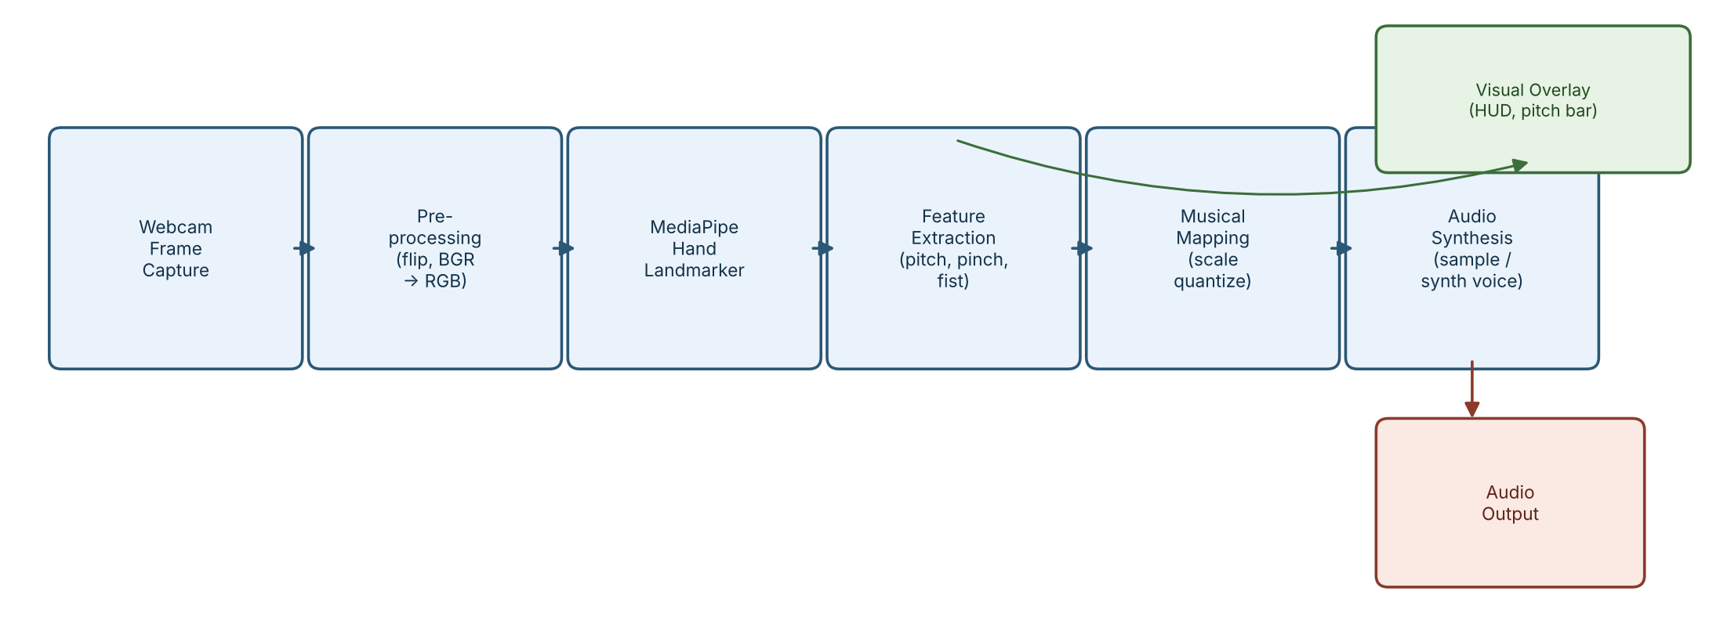
Figure 5.1: End-to-end pipeline, from webcam frame to audio and visual output.

5.1 Pipeline Stages
- Frame acquisition. OpenCV's VideoCapture keeps reading frames from the webcam.
- Pre-processing. Each frame is flipped so it behaves like a mirror, and converted from BGR to RGB.
- Hand landmark detection. MediaPipe's HandLandmarker (Tasks API, VIDEO mode) returns 21 three-dimensional points for each of up to two hands.
- Hand role assignment. We decide which hand plays pitch and which is the control hand by where each hand is on the screen, not by MediaPipe's Left/Right label, which turned out to be unreliable after mirroring (see Section 9).
- Feature extraction. On the pitch hand, wrist height gives pitch and the thumb-to-index distance gives volume. If the control hand is visible, that mutes or unmutes the sound. A closed fist on the control hand (measured as average fingertip-to-wrist distance divided by the wrist-to-knuckle distance) triggers a drum hit.
- Musical mapping. The continuous pitch value is snapped to the nearest note of the chosen scale (chromatic, major, or major/minor pentatonic), so imprecise hand height still gives a musical note.
- Audio synthesis. A real-time audio callback (sounddevice, 44.1 kHz, 1024-sample blocks) plays the current instrument. It uses pitch-shifted recordings when available and additive synthesis with an ADSR envelope otherwise.
- Percussion. When a fist closes, a one-shot drum sound plays. A short cooldown stops a held fist from retriggering again and again.
- Mixing. The pitched voice and any active drum hits are added together for each audio block and softly clipped so the sound never gets harsh.
- Visual feedback. The frame is drawn on with a tracked-point marker, a pitch meter, and status text, and shown to the performer.
- Floating-note effects (new). While a note is sounding, the particle system spawns small music notes at the playing fingertip. Each note drifts upward and fades in and out, and its colour follows the current pitch. A fist on the control hand adds a short warm-coloured burst at the fist. These are drawn onto the frame just before it is shown.

5.2 How the Floating Notes Work
The effect lives in its own file, note_particles.py, and uses only OpenCV drawing, so it needs no new libraries. In simple terms:
- A note is spawned only when sound is truly being produced, meaning the player is unmuted and the thumb-index gap is wide enough to be heard. Silence produces no notes.
- Each note is a small particle with a position, upward drift, age, and lifetime. Every frame, the system moves each particle, ages it, and removes it when its life is over.
- Particles fade in from transparent, stay visible for a while, then fade out. Because of this, a particle that was just created does not show on screen until it has aged by one update.
- The colour comes from the pitch: as the hand moves up or down, the hue moves through the rainbow, so the colour tells you roughly which note is playing.
- A fist creates a short burst in warm colours, so a drum hit looks like a "pop" rather than another floating note.
- There is a maximum number of particles at one time, and particles near the screen edge are clipped, so the effect never slows down the video or draws outside the frame.

6. Techniques / Algorithms Used

6.1 Image Processing
- Converting BGR to RGB so OpenCV frames match what MediaPipe expects.
- Horizontal flipping so the video behaves like a mirror.
- Deep-learning landmark detection (MediaPipe HandLandmarker) instead of older methods such as skin-colour thresholding or edge-based hand segmentation. It copes much better with messy backgrounds and changing light.
- Geometric feature calculation: Euclidean distances between landmarks (thumb to index for pinch, and fingertips to wrist, scaled by hand size, for the fist).
- Drawing and overlays: markers, a filled pitch meter, and text drawn straight onto the video frame.
- Alpha blending for the floating notes, so each music-note shape can fade smoothly into and out of the video. Colours come from an HSV hue that is converted to BGR for drawing.

6.2 Video Processing
- Reading and processing a live video stream frame by frame, rather than analysing single images.
- Tracking in VIDEO mode, where the landmark model remembers the previous frames. This makes tracking steadier than treating each frame on its own.
- Turning a stream of hand positions into smoothly changing control signals. This plays a similar role to optical-flow motion tracking, but is done with a pretrained landmark tracker. We considered classical optical flow and frame differencing, but the landmark model made them unnecessary.
- Edge-triggered gestures: the fist ratio is a continuous number, and we turn it into a single event at the moment it crosses a threshold, so each fist produces exactly one drum hit.
- A simple particle system with a per-frame update-then-draw loop: move, age, remove dead particles, then draw the survivors.

7. Implementation

7.1 Programming Language and Environment
We used Python 3.10. Our first attempt on Python 3.14 failed because MediaPipe and NumPy did not yet have ready-made installation packages for such a new version. Installing Python 3.10 next to the default one fixed this without changing any code (see Section 9).

7.2 Software / Tools
- Windows 11 with PowerShell for development and running the project.
- A Python virtual environment (venv) so that everyone installs the same library versions.
- Audacity (optional) for listening to and trimming downloaded audio samples.
- Git and GitHub for version control and for submitting the project.

7.3 Libraries / Frameworks
Python 3.10, OpenCV (opencv-python 4.10), MediaPipe 0.10.14 (Tasks API), NumPy 1.26, sounddevice, and soundfile. The floating-note effect needs no extra libraries.

7.4 Hardware
A normal laptop webcam and speakers or headphones are enough. No GPU is needed, because the MediaPipe hand model is light enough to run in real time on a CPU.

7.5 Project Structure and Key Implementation Steps
Module | What it does
main.py | Main program. Captures webcam frames, assigns hand roles, extracts gesture features, draws the on-screen display, updates and draws the floating notes, and handles keyboard keys for switching instrument and scale.
hand_tracker.py | Wraps MediaPipe's HandLandmarker. Gives access to landmarks and calculates pinch distance and the fist ratio.
audio_engine.py | Runs the real-time sound output. Handles pitch-shifted sample playback, the generated fallback voice (ADSR envelope and vibrato), and drum hits.
instruments.py | Stores each instrument's sample file, reference pitch, looping behaviour, and fallback sound settings.
scales.py | Builds the note table for the chosen scale and snaps a 0 to 1 hand-height value to the nearest valid note.
note_particles.py (new) | The floating music-note effect: creating, moving, fading, limiting, and drawing particles on the video frame.

Key implementation steps:
- Hand roles are decided by on-screen horizontal position, which stays reliable when the frame is mirrored.
- The sample player reads a recording at a speed equal to target frequency divided by recorded frequency, using linear interpolation between samples for in-between positions.
- The fallback voice uses a per-sample ADSR state machine (Attack, Decay, Sustain, Release) that is switched on and off by whether the volume is above a small threshold.
- Block size and latency were tuned to remove crackling caused by buffer underruns (see Section 9).
- The particle system was added as a separate module with a clear update() then draw() order in the main loop, so main.py only needed small changes.

8. Results and Discussion
We built and tested the system step by step, checking each stage before moving to the next.

8.1 Functional Results
- Hand tracking ran smoothly from a normal laptop webcam. Pitch followed hand height and volume followed the pinch distance.
- Switching between the six instruments and the musical scales worked correctly with keyboard shortcuts during a live session.
- The fist gesture triggered drums reliably once calibrated, and an on-screen "HIT!" flash matched the drum sound.
- Real recordings for piano, flute, saxophone, and drums sounded clearly more realistic than the generated fallback. Guitar and violin sample calibration was still in progress at the time of writing (see Section 9).
- Floating music notes appeared whenever a note was sounding and stopped when the sound stopped. Their colour changed with pitch, giving instant visual confirmation of what was being played.
- A fist produced a distinct warm-coloured burst, so drum hits are now easy to tell apart from pitched notes at a glance.
- We checked the particle logic separately: spawning, lifetime and removal, the maximum-particle cap, edge clipping, and fade-in/fade-out all behaved correctly. The effect added no noticeable slowdown to the live video.

8.2 The Updated Interface
The live window now shows the mirrored webcam view with a tracked-point marker, the pitch meter, the current instrument and scale, and the floating notes. Together these make the instrument easier to understand for someone watching a demo: you can see which hand is playing, when sound is happening, and roughly how high the pitch is.
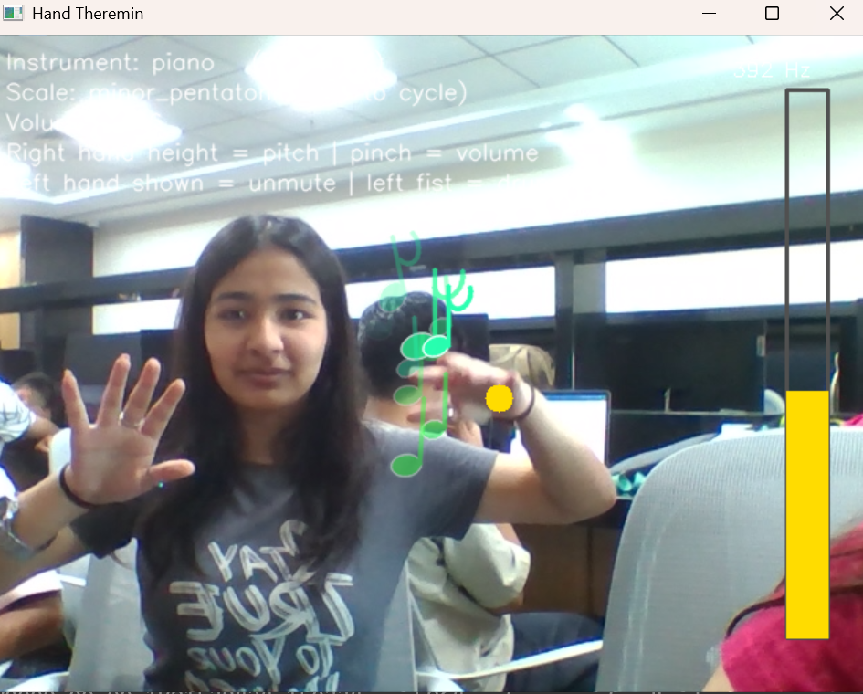Figure 8.1: The updated interface with floating music notes. Colour follows pitch.

8.3 Engineering Parameters
The audio engine processes sound in blocks of 1024 samples at 44.1 kHz. Each block lasts about 23.2 ms (1024 / 44100 seconds). The output stream uses a "high" latency setting, which favours smooth, glitch-free sound over the lowest possible delay.

9. Challenges / Limitations
- Python version. Python version problem. Python 3.14 had no ready packages for MediaPipe and NumPy. We fixed it by using Python 3.10 in its own virtual environment.
- Hand labels. Left/Right confusion. After mirroring the video, MediaPipe's handedness label sometimes swapped the hands, so pitch and drums switched roles. We fixed it by assigning roles from each hand's position on screen.
- Audio buffer. Crackling sound. Our first audio setup crackled because the buffer was too small for reliable real-time playback on our laptop. A bigger block size and a higher-latency stream fixed it.
- Instrument realism. Synthetic sound limits. Pure synthesis made instruments hard to tell apart. Envelopes and vibrato helped, but real recordings were needed for a realistic sound.
- Pitch-shifting. Pitch-shifting limits. Speeding up or slowing down a recording also changes its tone, so notes far from the original pitch can sound unnatural. More advanced methods such as a phase vocoder could help, but were outside our scope.
- Sample sourcing. Finding samples. It was hard to find free, clearly labelled single-note recordings. Some files had no pitch information and we had to identify them by ear.
- Gesture calibration. Fist threshold. The fist detection depends on hand size and distance from the camera, so it may need re-calibration for each person or setup.
- Particle fade-in. Visual effect timing. When we first tested the particle system by spawning and drawing in a single step, nothing appeared. This was not a bug: particles start fully transparent and only become visible after one update. In the real loop, update() runs before draw() every frame, so the effect works as intended.
- Camera limits. Single camera. As with any one-camera tracker, performance drops in poor light, when a hand is hidden, or when a hand leaves the frame.
- No chords. One note at a time. The system plays one note per hand and cannot play chords.

10. Conclusion
We built a working gesture-controlled instrument that turns live webcam video into music. On the video side, it combines frame capture, colour conversion, pretrained hand-landmark detection, and simple geometric measurements. On the sound side, it combines scale quantisation, pitch-shifted samples, additive synthesis with ADSR envelopes and vibrato, and one-shot drums. The latest addition, floating music notes coloured by pitch, makes the instrument feel more alive and gives clear visual feedback for both pitched notes and drum hits.
The project uses both classical and modern ideas: colour-space conversion, distance-based features, alpha-blended overlays, and a deep-learning landmark model used as a stronger alternative to classical hand segmentation. It also draws on core audio signal processing. The final result runs locally, offers six instruments, and needs only a webcam and speakers.
Along the way we learned how to design a real-time video pipeline under delay limits, how a pretrained model can behave unexpectedly in live use (such as the mirrored handedness problem), and how to build and test a visual effect on top of a live stream. We also learned that managing Python versions, tuning audio buffers, and making something actually sound good are harder than they look on paper.
Possible future work includes finishing the guitar and violin samples, adding recording and looping, supporting chords, using better pitch-shifting, and offering a browser version so more people can try it.

11. References
- Google, "MediaPipe Hand Landmarker," MediaPipe Solutions Documentation. [Online]. Available: https://ai.google.dev/edge/mediapipe/solutions/vision/hand_landmarker
- OpenCV, "OpenCV: Open Source Computer Vision Library," documentation. [Online]. Available: https://docs.opencv.org/
- sounddevice documentation, "Play and Record Sound with Python." [Online]. Available: https://python-sounddevice.readthedocs.io/
- python-soundfile documentation. [Online]. Available: https://python-soundfile.readthedocs.io/
- Freesound.org, Creative-Commons-licensed audio sample community. [Online]. Available: https://freesound.org/
- University of Iowa Electronic Music Studios, "Musical Instrument Samples." [Online]. Available: https://theremin.music.uiowa.edu/MIS.html
- L. S. Termen (Theremin), historical background on the theremin as an early touchless electronic instrument.
- Reference project (LinkedIn): webcam-based hand-tracking "invisibility cloak" built with OpenCV and MediaPipe, shared as a course example and cited as the inspiration for this project's use of hand-landmark tracking.

