 |  | SR UNIVERSITY  Campus Warangal
 |  | Program: II - B. Tech (CS& AI) Batch: 57
 |  | Name: ABHISHEK KUMAR Reg. No:2503A54008
 |  | Department: Computer Science and AI Semester: I
 |  | AI Assisted Coding-Assignment Date: 18/09/2026
Instructions:
- Use AI Tools like VS code+ GitHub Copilot and Cursor AI for code generation
- This test will be evaluated for 20 Marks (16 Marks for Tasks and 4 Marks for viva based on regular lab activities)
- Students need to submit only the answer scripts for the evaluation
- Students who are absent for lab will receive 0 Marks

Answer all Question Q1. Class with Conditional Logic – Employee Salary
Scenario:
An AI coding assistant is used to develop a simple employee salary management program.
Task:
Using AI-assisted code completion, write a Python class Employee that:
- Stores employee name and basic salary.
- Has a method calculate_bonus() that:
  - Returns 10% of salary if salary is ₹50,000 or above.
  - Returns 5% of salary otherwise.
- Has a method display_details() to display the employee name, salary, and bonus.
- Create at least two employee objects and test the class. Prompt:
Create a Python program using an Employee class with name and basic_salary. Calculate a 10% bonus if salary ≥ ₹50,000, otherwise 5%. Calculate and display the total salary. Create two employee objects and test both conditions.
Code:
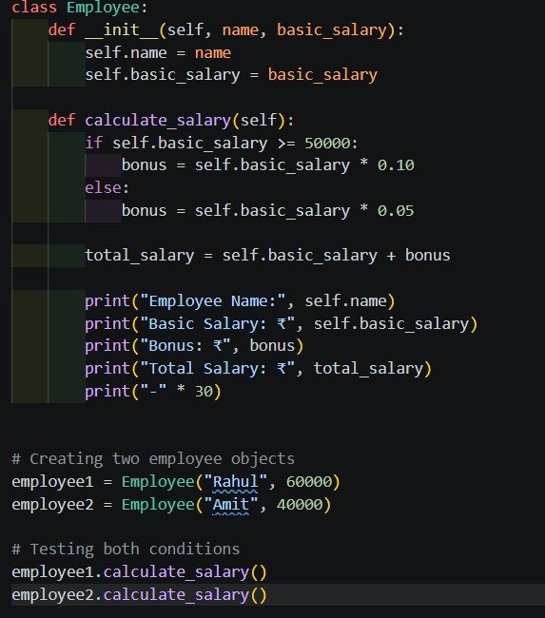

Output:
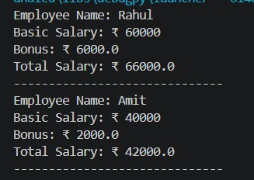
Observation:
From the output, Rahul with a salary of ₹60,000 received a 10% bonus, making his total salary ₹66,000. Amit with a salary of ₹40,000 received a 5% bonus, making his total salary ₹42,000.

Q2. Loop and Conditional Logic – Student Marks
Scenario:
A teacher wants to analyze the marks of students using an AI coding assistant.
Task:
Using AI-assisted code completion, write a Python program that:
- Accepts a list of student marks.
- Uses a loop to process each mark.
- Displays:
o "Distinction" for marks ≥ 75 o "Pass" for marks ≥ 40 and < 75 o "Fail" for marks < 40
- Ignores invalid marks outside 0–100.
- Calculates and displays the number of students in each category.
- Test the program with a suitable list of marks.
Prompt:
Create a Python program using a list of student marks. Use a loop to classify each mark as "Distinction" for marks ≥ 75, "Pass" for marks ≥ 40 and < 75, otherwise "Fail". Ignore invalid marks outside 0–100. Count and display the number of students in each category. Test the program with a suitable list including all conditions.

Code:
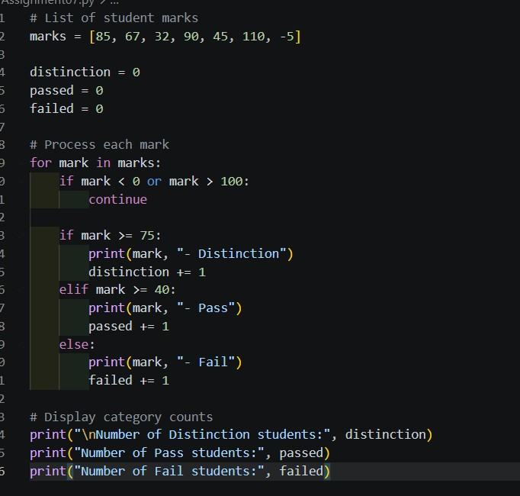
Output:
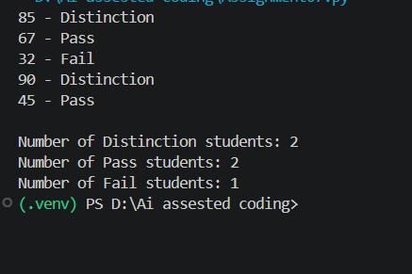
Observation:
The program successfully classified all valid student marks into Distinction, Pass, and Fail categories. Invalid marks outside the 0–100 range were ignored, and the total number of students in each category was calculated correctly.
Q3. Class + Loop – Product Inventory
Scenario:
A small store wants to maintain product inventory using a Python program generated with AI assistance.
Task:
Using AI-assisted code completion, create a class Product that:
- Stores product name, price, and quantity.
- Has a method total_value() that calculates price × quantity.
- Create a list of multiple Product objects.
- Use a loop to calculate the total inventory value.
- Display the products whose quantity is less than 5 as "Low Stock".
- Test the program with at least three products.
Prompt:
Create a Python program using a Product class with name, price, and quantity. Add a total_value() method to calculate price × quantity. Create a list of at least three Product objects and use a loop to calculate the total inventory value. Display products with quantity less than 5 as "Low Stock". Test the program with suitable product values. Create a Python program using a
Product class with name, price, and quantity. Add a total_value()
method to calculate price × quantity. Create a list of at least three Product objects and use a loop to calculate the total inventory value. Display products with quantity less than 5 as "Low Stock". Test the program with suitable product values.
Code:
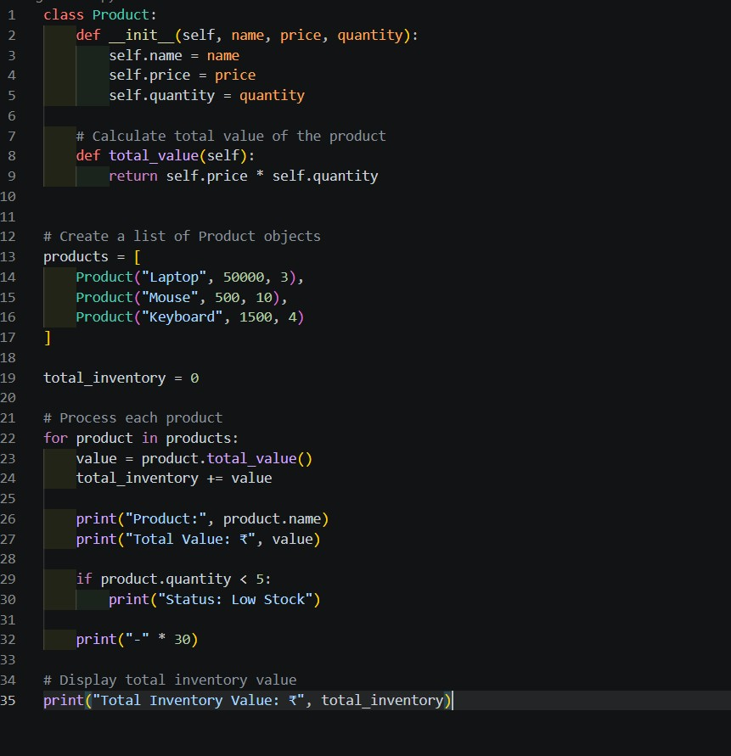
Output:
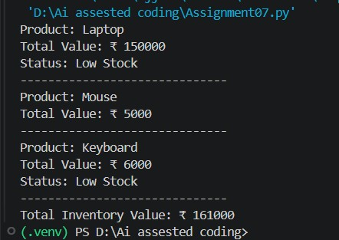
Observation:
The program successfully calculated the total value of each product and the overall inventory value of ₹1,61,000. It also correctly identified Laptop and Keyboard as Low Stock because their quantities are below 5.

Q4. Class + Loop + Nested Conditions – Electricity Bill
Scenario:
An electricity board wants to calculate bills based on units consumed.
Task:
Using AI-assisted code completion, create a Python class ElectricityBill that:
- Stores the consumer name and units consumed.
- Calculates the bill using:
o First 100 units → ₹2/unit o 101–200 units → ₹3/unit o Above 200 units → ₹5/unit
- Uses appropriate loops and conditional statements where required.
- Displays the consumer name, units, and total bill.
- Create at least three objects and display their bills.
- Test the program with different unit values, including an edge value such as 100 or 200.
Prompt:
Create a Python program using an ElectricityBill class with
consumer_name and units_consumed. Calculate the bill using ₹2/unit for the first 100 units, ₹3/unit for 101–200 units, and ₹5/unit above 200 units. Use conditional statements and a loop to process multiple consumers. Display the consumer name, units consumed, and total bill. Create at least three objects and test different unit values, including 100 and 200 units.

Code:
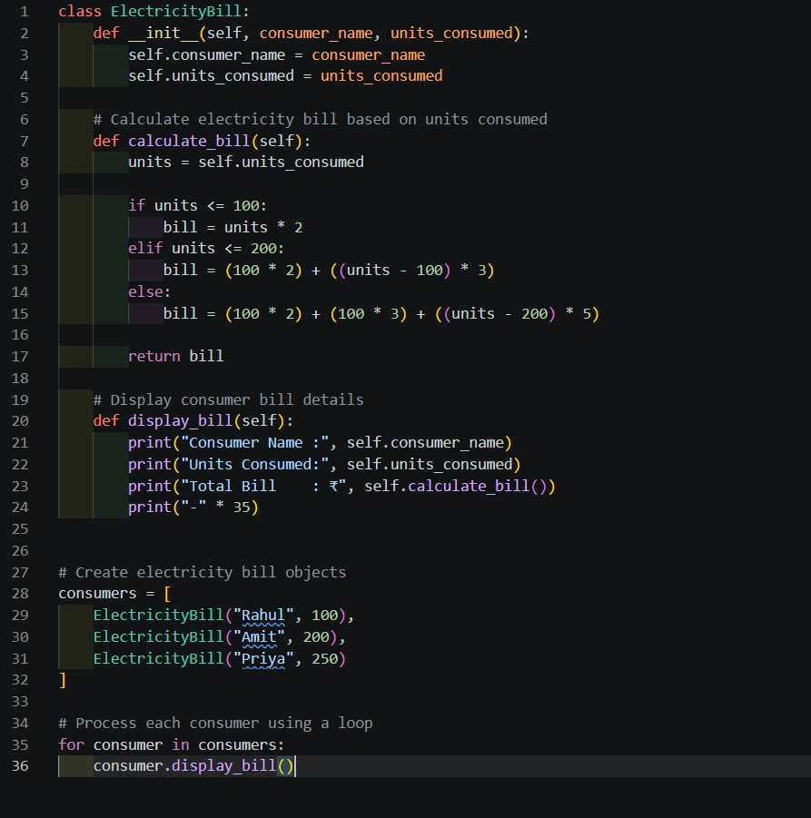
Output:
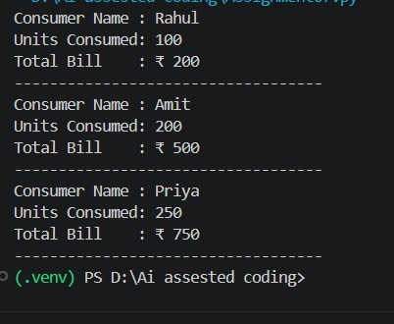
Observation:
The program successfully calculates electricity bills according to the given unit slabs. The edge values of 100 and 200 units are handled correctly, while the bill for 250 units includes the additional charge of ₹5 per unit above 200 units.

