**Q1. List down the advantages of Microservices Architecture.**

|  |  |
| --- | --- |
| **Advantages of Microservices Architecture** | |
| **Advantage** | **Description** |
| ***Independent Development*** | All microservices can be easily developed based on their individual functionality |
| ***Independent Deployment*** | Based on their services, they can be individually deployed in any application |
| ***Fault Isolation*** | Even if one service of the application does not work, the system still continues to function |
| ***Mixed Technology Stack*** | Different languages and technologies can be used to build different services of the same application |
| ***Granular Scaling*** | Individual components can scale as per need, there is no need to scale all components together |

**Q2. What do you know about Microservices?**

* **Microservices**, aka ***Microservice Architecture***, is an architectural style that structures an application as a collection of small autonomous services, modeled around a **business domain.**
* In layman terms, you must have seen how bees build their honeycomb by aligning hexagonal wax cells.
* They initially start with a small section using various materials and continue to build a large beehive out of it.
* These cells form a pattern resulting in a strong structure which holds together a particular section of the beehive.
* Here, each cell is independent of the other but it is also correlated with the other cells.
* This means that damage to one cell does not damage the other cells, so, bees can reconstruct these cells without impacting the complete beehive.

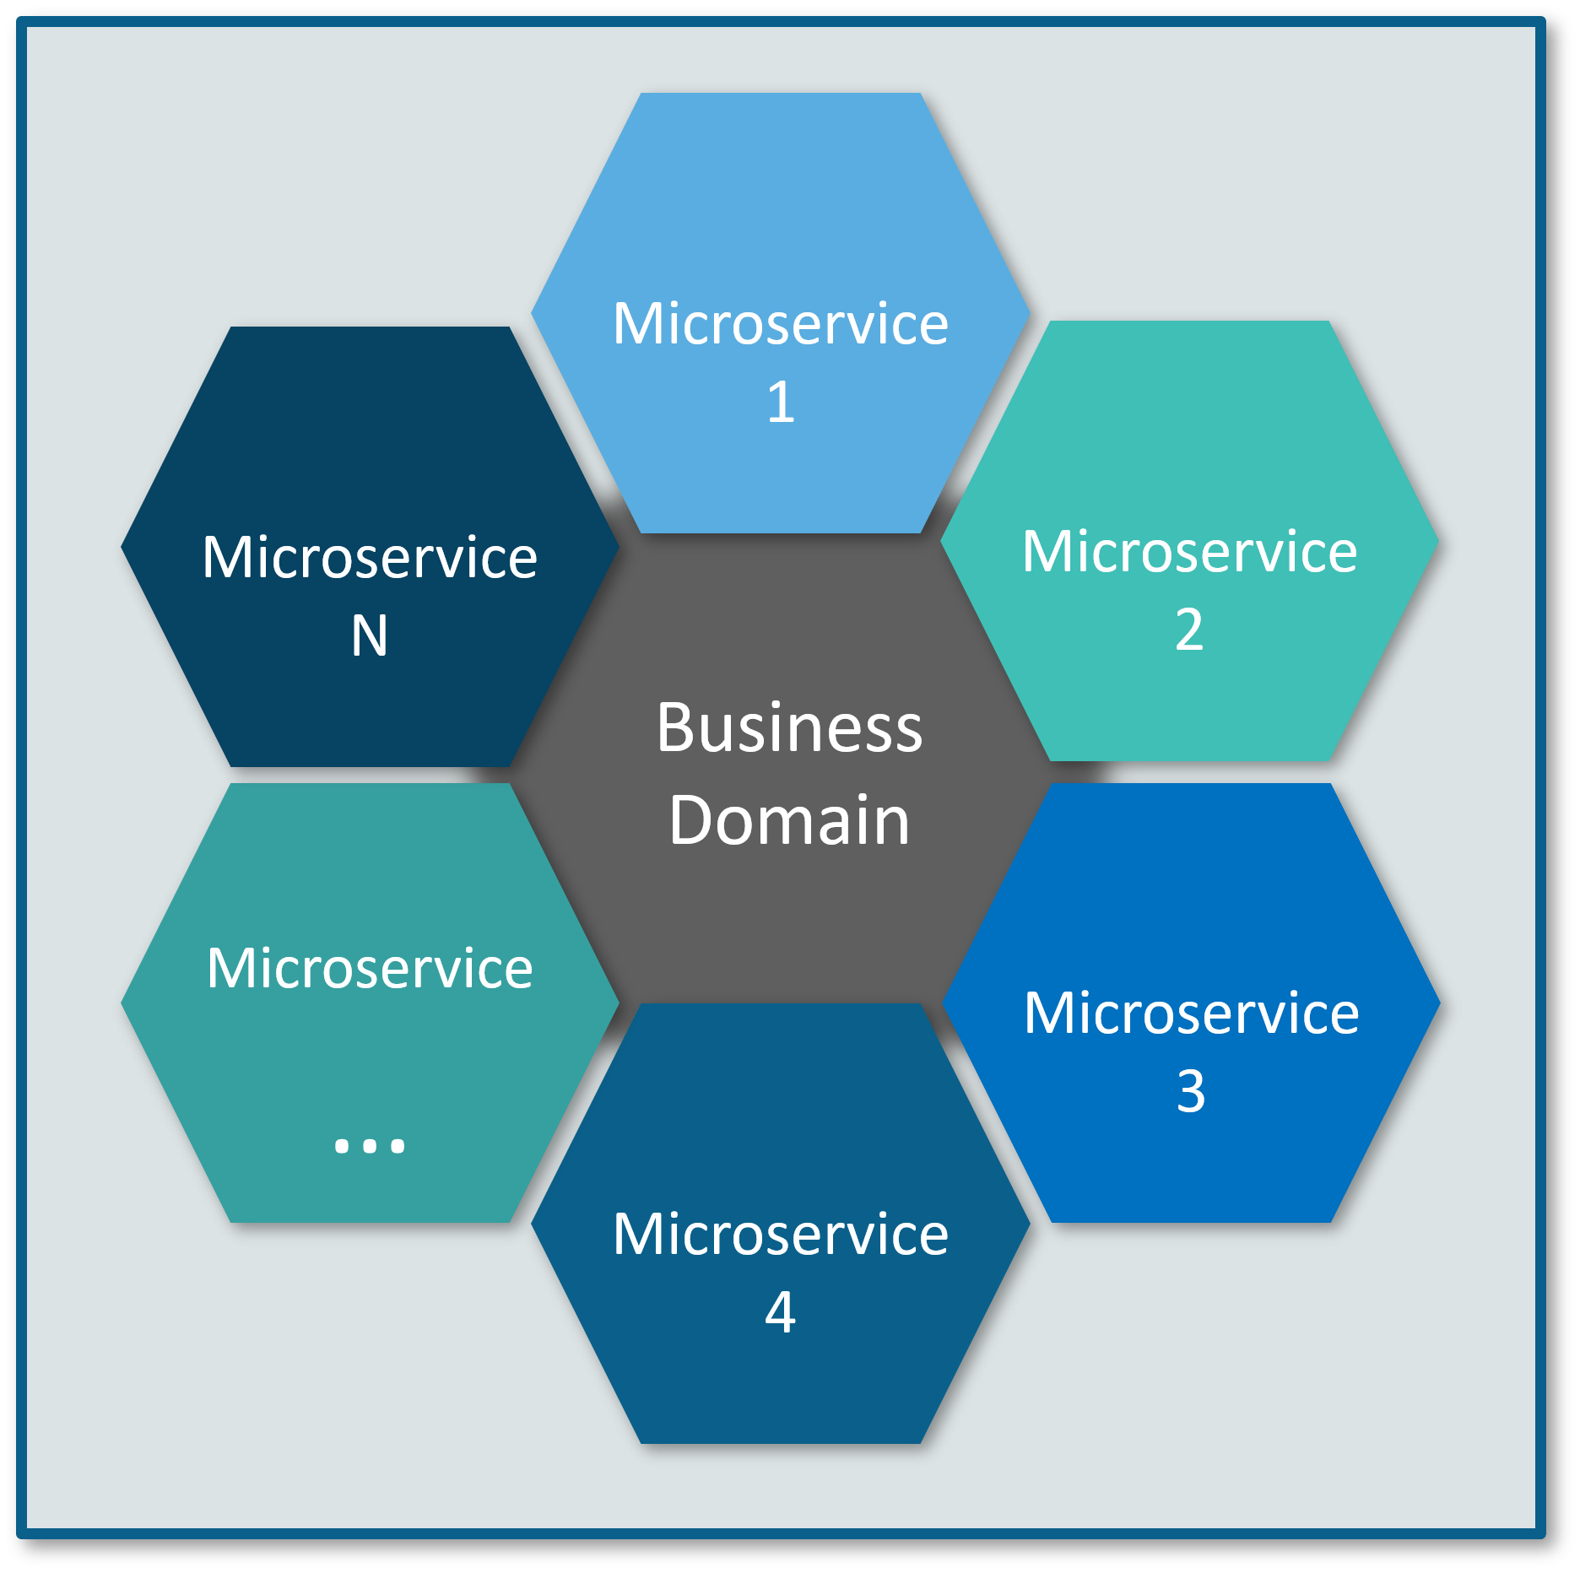

**Fig 1:** Beehive Representation of Microservices – Microservices Interview Questions

Refer to the above diagram. Here, each hexagonal shape represents an individual service component. Similar to the working of bees, each agile team builds an individual service component with the available frameworks and the chosen technology stack. Just as in a beehive, each service component forms a strong microservice architecture to provide better scalability. Also, issues with each service component can be handled individually by the agile team with no or minimal impact on the entire application.

**Q3. What are the features of Microservices?**

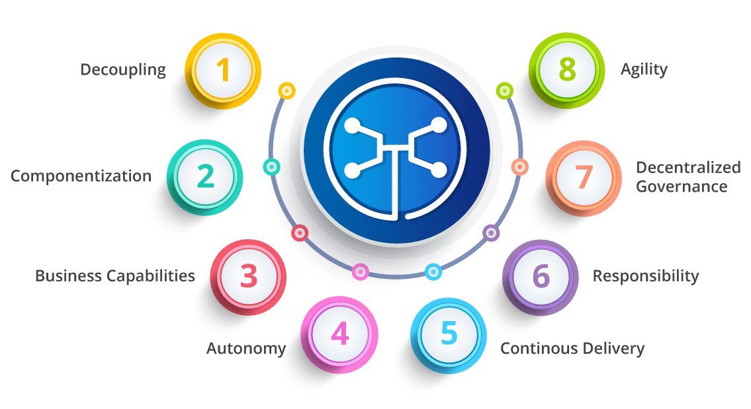

**Fig 3:**Features of Microservices – Microservices Interview Questions

* **Decoupling** – Services within a system are largely decoupled. So the application as a whole can be easily built, altered, and scaled
* **Componentization** – Microservices are treated as independent components that can be easily replaced and upgraded
* **Business Capabilities** – Microservices are very simple and focus on a single capability
* **Autonomy** – Developers and teams can work independently of each other, thus increasing speed
* **Continous Delivery** – Allows frequent releases of software, through systematic automation of software creation, testing, and approval
* **Responsibility** – Microservices do not focus on applications as projects. Instead, they treat applications as products for which they are responsible
* **Decentralized Governance** – The focus is on using the right tool for the right job. That means there is no standardized pattern or any technology pattern. Developers have the freedom to choose the best useful tools to solve their problems
* **Agility** – Microservices support agile development. Any new feature can be quickly developed and discarded again

**Q4. What are the best practices to design Microservices?**

The following are the best practices to design microservices:

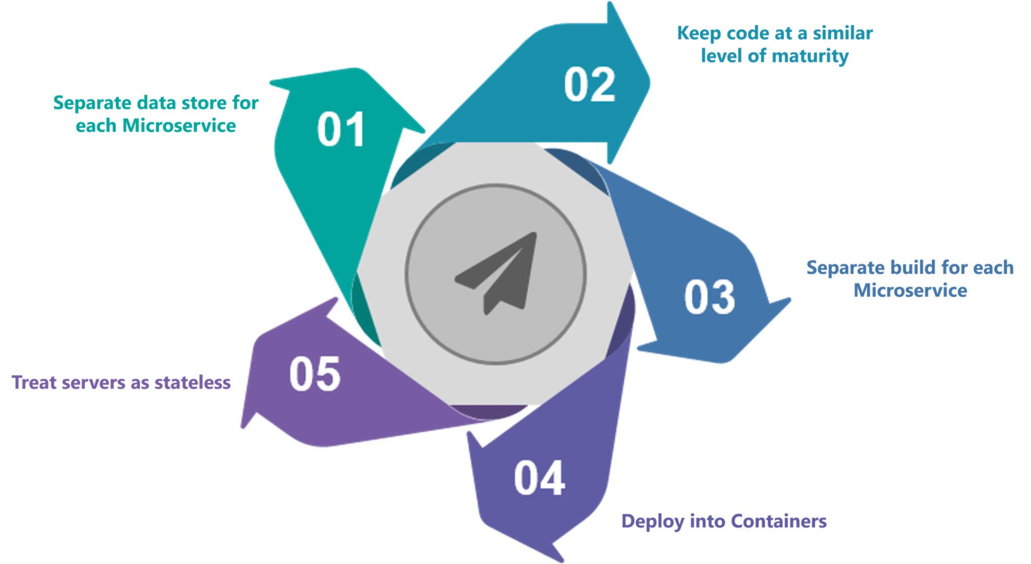

**Fig 4:**Best Practices to Design Microservices – Microservices Interview Questions

**Q5. How does Microservice Architecture work?**

A microservice architecture has the following components:

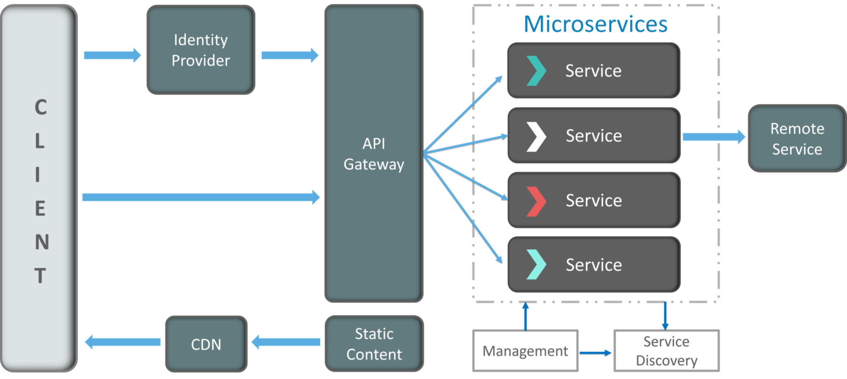

**Fig 5:**Architecture of Microservices – Microservices Interview Questions

* **Clients** – Different users from various devices send requests.
* **Identity Providers** – Authenticates user or clients identities and issues security tokens.
* **API Gateway** – Handles client requests.
* **Static Content** – Houses all the content of the system.
* **Management** –  Balances services on nodes and identifies failures.
* **Service Discovery** – A guide to find the route of communication between microservices.
* **Content Delivery Networks** – Distributed network of proxy servers and their data centers.
* **Remote Service** – Enables the remote access information that resides on a network of IT devices.

**Q6. What are the pros and cons of Microservice Architecture?**

|  |  |
| --- | --- |
| **Pros of Microservice Architecture** | **Cons of Microservice Architecture** |
| Freedom to use different technologies | Increases troubleshooting challenges |
| Each microservices focuses on single capability | Increases delay due to remote calls |
| Supports individual deployable units | Increased efforts for configuration and other operations |
| Allow frequent software releases | Difficult to maintain transaction safety |
| Ensures security of each service | Tough to track data across various boundaries |
| Mulitple services are parallelly developed and deployed | Difficult to code between services |

**Q7. What is the difference between Monolithic, SOA and Microservices Architecture?**

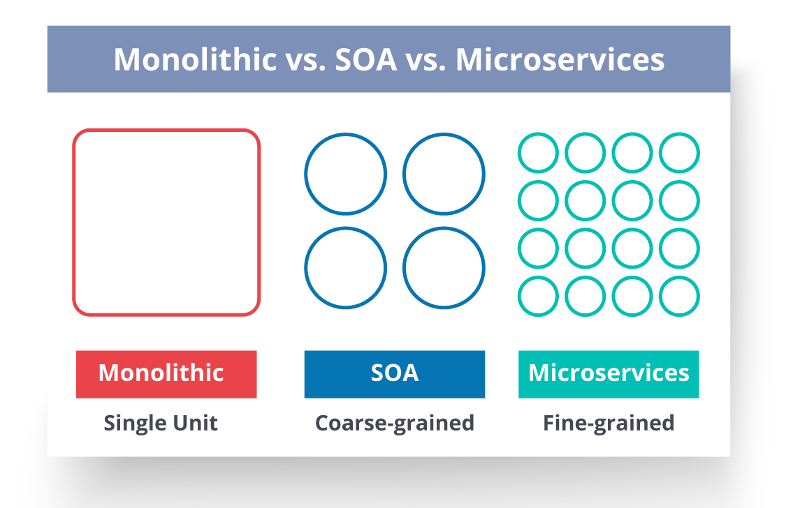

**Fig 6:**Comparison Between Monolithic SOA &Microservices – Microservices Interview Questions

* **Monolithic Architecture** is similar to a big container wherein all the software components of an application are assembled together and tightly packaged.
* A **Service-Oriented Architecture** is a collection of services which communicate with each other. The communication can involve either simple data passing or it could involve two or more services coordinating some activity.
* **Microservice Architecture** is an architectural style that structures an application as a collection of small autonomous services, modeled around a business domain.

**Q8. What are the challenges you face while working Microservice Architectures?**

Developing a number of smaller microservices sounds easy, but the challenges often faced while developing them are as follows.

* **Automate the Components**: Difficult to automate because there are a number of smaller components. So for each component, we have to follow the stages of  Build, Deploy and, Monitor.
* **Perceptibility**: Maintaining a large number of components together becomes difficult to deploy, maintain, monitor and identify problems. It requires great perceptibility around all the components.
* **Configuration Management**: Maintaining the configurations for the components across the various environments becomes tough sometimes.
* **Debugging**: Difficult to find out each and every service for an error. It is essential to maintain centralized logging and dashboards to debug problems.

**Q9. What are the key differences between SOA and Microservices Architecture?**

The key differences between SOA and microservices are as follows:

|  |  |
| --- | --- |
| **SOA** | **Microservices** |
| Follows “**share-as-much-as-possible**” architecture approach | Follows “**share-as-little-as-possible**” architecture approach |
| Importance is on **business functionality** reuse | Importance is on the concept of “**bounded context**” |
| They have **common** **governance** and standards | They focus on **people** **collaboration** and freedom of other options |
| Uses **Enterprise Service bus (ESB)** for communication | Simple messaging system |
| They support **multiple message protocols** | They use **lightweight protocols** such as **HTTP/REST** etc. |
| **Multi-threaded** with more overheads to handle I/O | **Single-threaded** usually with the use of Event Loop features for non-locking I/O handling |
| Maximizes application service reusability | Focuses on **decoupling** |
| **Traditional Relational Databases** are more often used | **Modern Relational Databases**are more often used |
| A systematic change requires modifying the monolith | A systematic change is to create a new service |
| DevOps / Continuous Delivery is becoming popular, but not yet mainstream | Strong focus on DevOps / Continuous Delivery |

**Q10. What are the characteristics of Microservices?**

You can list down the characteristics of microservices as follows:

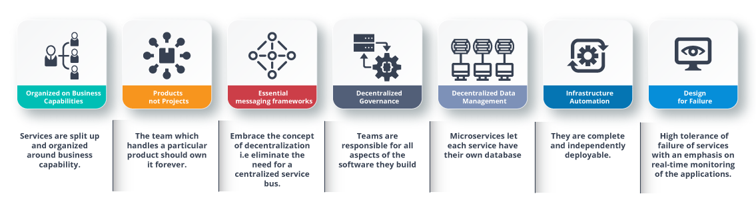

**Fig 7:**Characteristics of Microservices – Microservices Interview Questions

**Q11. What is Domain Driven Design?**

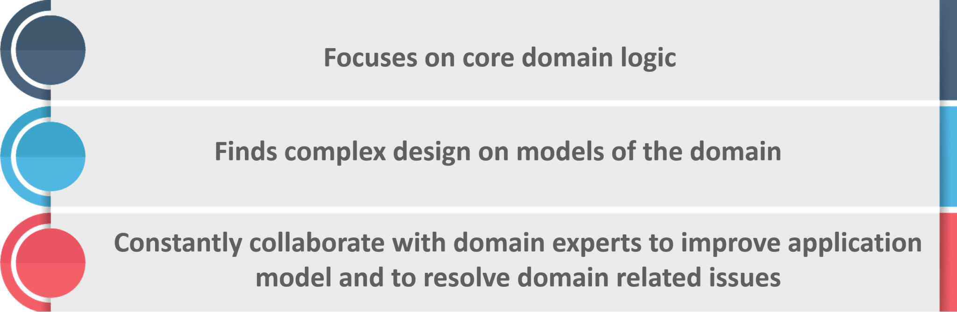

**Fig 8:**Principles of DDD – Microservices Interview Questions

**Q12. Why there is a need for Domain Driven Design (DDD)?**

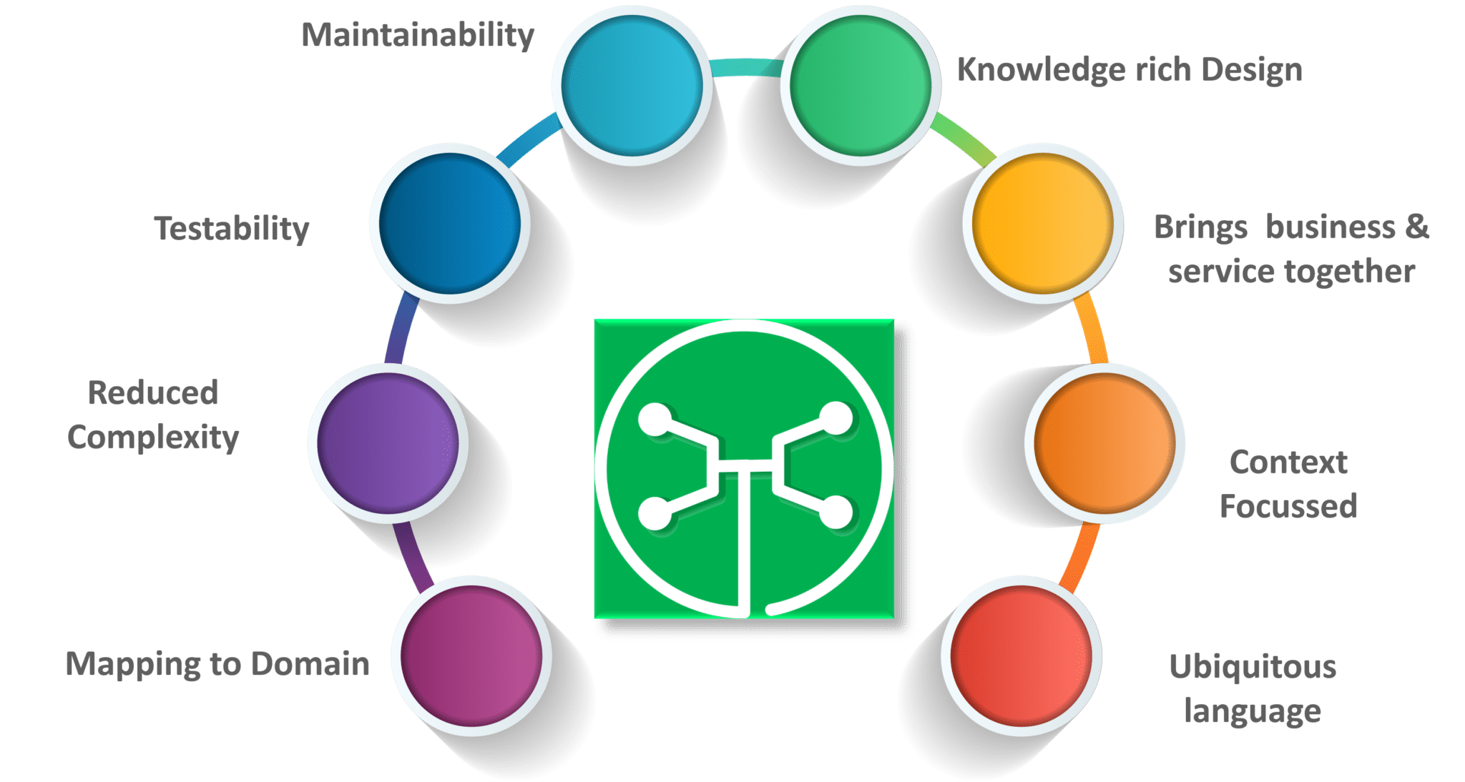

**Fig 9:**Factors Why we need DDD – Microservices Interview Questions

**Q13. What is Ubiquitous language?**

If you have to define the**Ubiquitous Language (UL)**, then it is a common language used by developers and users of a specific domain through which the domain can be explained easily.

The ubiquitous language has to be crystal clear so that it brings all the team members on the same page and also translates in such a way that a machine can understand.

**Q14. What is Cohesion?**

The degree to which the elements inside a module belong together is said to be **cohesion**.

**Q15.  What is Coupling?**

The measure of the strength of the dependencies between components is said to be **coupling**. A good design is always said to have **High Cohesion** and**Low Coupling**.

Subscribe to our youtube channel to get new updates..!

**Q16.  What is REST/RESTful and what are its uses?**

**Representational State Transfer (REST)/RESTful** web services are an architectural style to help computer systems communicate over the internet. This makes microservices easier to understand and implement.

Microservices can be implemented with or without RESTful APIs, but it’s always easier to build loosely coupled microservices using RESTful APIs.

**Q17. What do you know about Spring Boot?**

It’s a knows fact that spring has become more and more complex as new functionalities have been added. If you have to start a new spring project, then you have to add build path or add maven dependencies, configure application server, add spring configuration. So everything has to be done from scratch.

**Spring Boot** is the solution to this problem. Using spring boot you can avoid all the boilerplate code and configurations. So basically consider yourself as if you’re baking a cake spring is like the ingredients that are required to make the cake and spring boot is the complete cake in your hand.

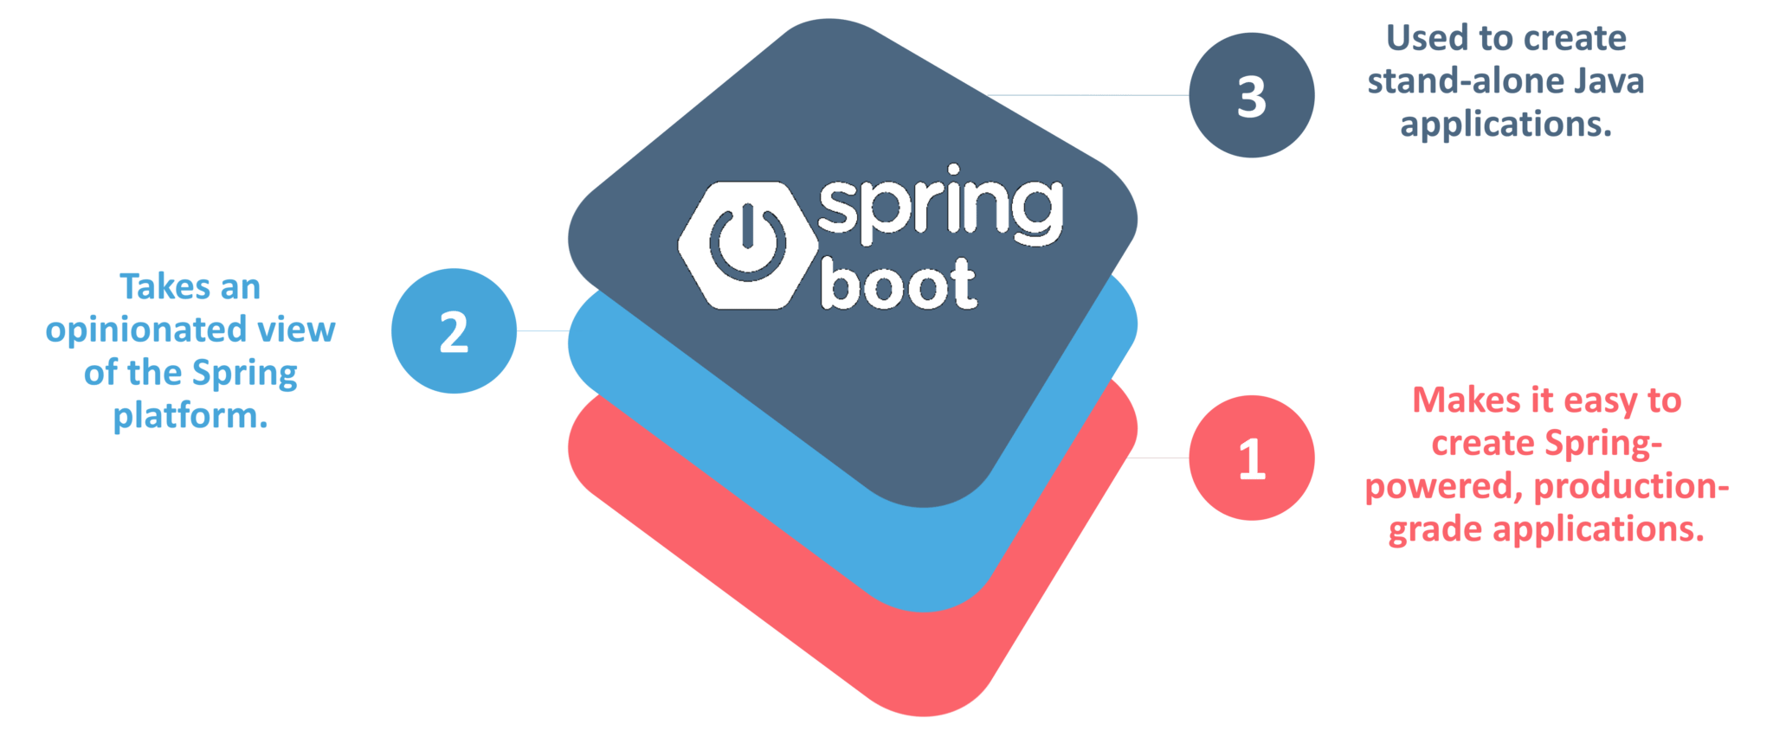

**Fig 10:**Factors of Spring Boot – Microservices Interview Questions

**Q18. What is an actuator in Spring boot?**

Spring Boot actuator provides restful web services to access the current state of running an application in the production environment. With the help of actuator, you can check various metrics and monitor your application.

**Q19. What is Spring Cloud?**

According to the official website of Spring Cloud, Spring Cloud provides tools for developers to quickly build some of the common patterns in distributed systems (e.g. configuration management, service discovery, circuit breakers, intelligent routing, leadership election, distributed sessions, cluster state).

**Q20. What problems are solved by Spring Cloud?**

While developing distributed microservices with Spring Boot we face few issues which are solved by Spring Cloud.

* **The complexity associated with distributed systems –**This includes network issues, Latency overhead, Bandwidth issues, security issues.
* **Ability to handle Service Discovery –**Service discovery allows processes and services in a cluster to find each other and communicate.
* **Solved redundancy issues –**Redundancy issues often occur in distributed systems.
* **Load balancing –**Improves the distribution of workloads across multiple computing resources, such as a computer cluster, network links, central processing units.
* **Reduces performance issues –**Reduces performance issues due to various operational overheads.

**Q21.  What is the use of WebMvcTest annotation in Spring MVC applications?**

**WebMvcTest** annotation is used for unit testing Spring MVC Applications in cases where the test objective is to just focus on Spring MVC Components. In the snapshot shown above, we want to launch only the ToTestController. All other controllers and mappings will not be launched when this unit test is executed.

**Q22. Can you give a gist about Rest and Microservices?**

**REST**

Though you can implement microservices in multiple ways, REST over HTTP is a way to implement Microservices. REST is also used in other applications such as web apps, API design, and MVC applications to serve business data.

**Microservices**

Microservices is an architecture wherein all the components of the system are put into individual components, which can be built, deployed, and scaled individually. There are certain principles and best practices of Microservices that help in building a resilient application.

In a nutshell, you can say that REST is a medium to build Microservices.

**Q23. What are different types of Tests for Microservices?**

While working with microservices, testing becomes quite complex as there are multiple microservices working together. So, tests are divided into different levels.

* At the **bottom level**, we have **technology-facing tests** like- unit tests and performance tests. These are completely automated.
* At the **middle level**, we have tests for **exploratory testing** like the stress tests and usability tests.
* At the **top level,**we have **acceptance tests** that are few in number. These acceptance tests help stakeholders in understanding and verifying software features.

**Q24. What do you understand by Distributed Transaction?**

**Distributed Transaction** is any situation where a single event results in the mutation of two or more separate sources of data which cannot be committed atomically. In the world of microservices, it becomes even more complex as each service is a unit of work and most of the time multiple services have to work together to make a business successful.

**Q25. What is an Idempotence and where it is used?**

**Idempotence** is the property of being able to do something twice in such a way that the end result will remain the same i.e. as if it had been done once only.

**Usage**: Idempotence is used at the remote service, or data source so that, when it receives the instruction more than once, it only processes the instruction once.

Want to learn more about microservices?[Learn Now](https://www.edureka.co/microservices-architecture-training)

**Q26. What is Bounded Context?**

Bounded Context is a central pattern in Domain-Driven Design. It is the focus of DDD’s strategic design section which is all about dealing with large models and teams. DDD deals with large models by dividing them into different Bounded Contexts and being explicit about their inter-relationships.

**Q27. What is Two Factor Authentication?**

Two-factor authentication enables the second level of authentication to an account log-in process.

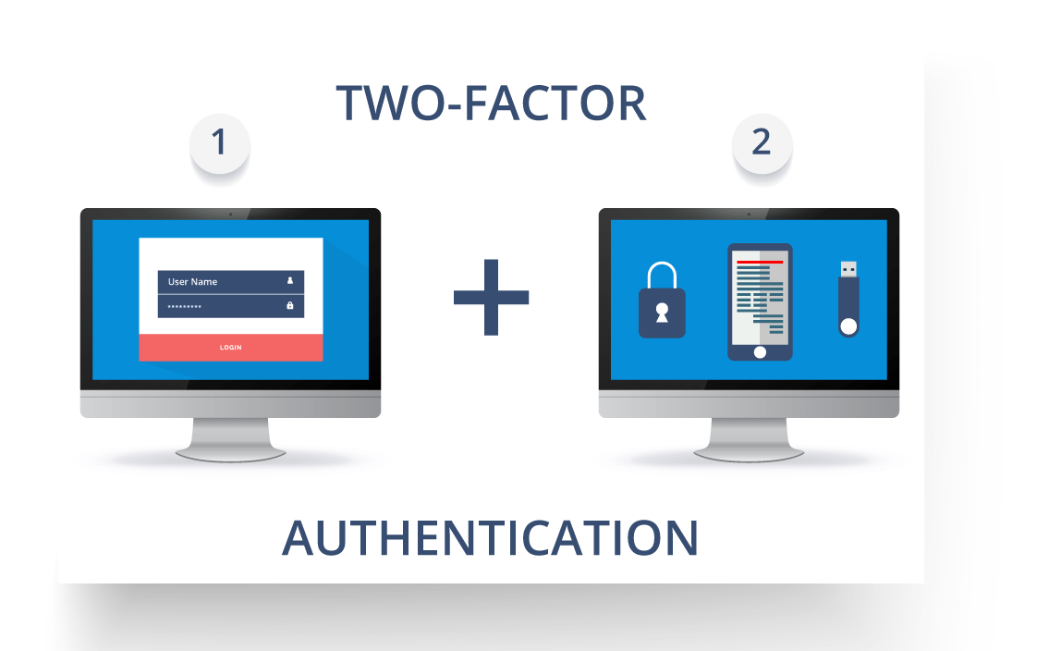

**Fig11:**Representation of Two Factor Authentication – Microservices Interview Questions

So suppose a user has to enter only username and password, then that’s considered a single-factor authentication.

**Q28. What are the types of credentials of Two Factor Authentication?**

The three types of credentials are:

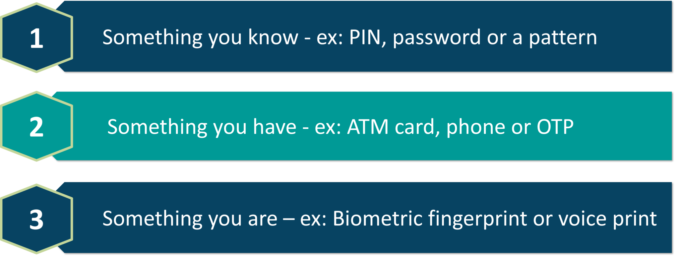

**Fig 12:**Types of Credentials of Two Factor Authentication – Microservices Interview Questions

**Q29. What are Client certificates?**

A type of digital certificate that is used by client systems to make authenticated requests to a remote server is known as the**client certificate**. Client certificates play a very important role in many mutual authentication designs, providing strong assurances of a requester’s identity.

**Q30. What is the use of PACT in Microservices architecture?**

**PACT**is an open source tool to allow testing interactions between service providers and consumers in isolation against the contract made so that the reliability of Microservices integration increases.

**Usage in Microservices:**

* Used to implement Consumer Driven Contract in Microservices.
* Tests the consumer-driven contracts between consumer and provider of a Microservice.

**Q31. What is OAuth?**

**OAuth**stands for open authorization protocol. This allows accessing the resources of the resource owner by enabling the client applications on HTTP services such as third-party providers Facebook, GitHub, etc. So with this, you can share resources stored on one site with another site without using their credentials.

**Q32. What is Conway’s law?**

*“Any organization that designs a system (defined broadly) will produce a design whose structure is a copy of the organization’s communication structure.” –****Mel Conway***

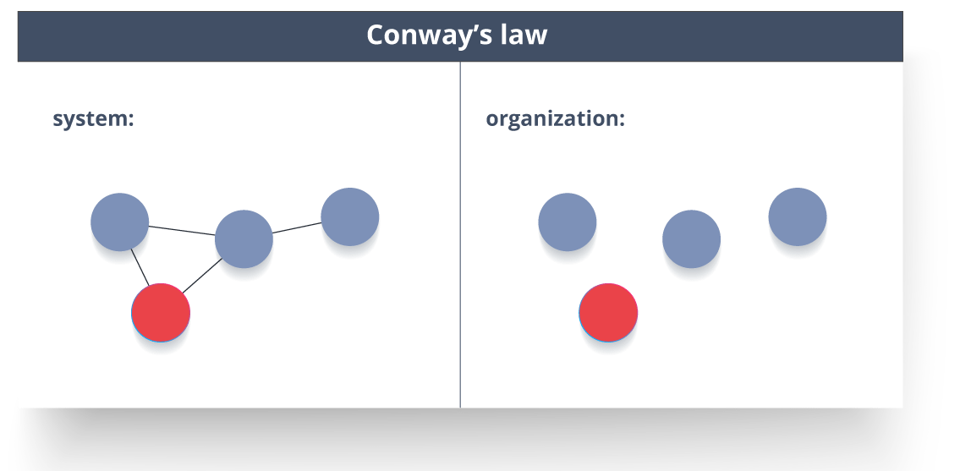

**Fig 13:**Representation of Conway’s Law – Microservices Interview Questions

This law basically tries to convey the fact that, in order for a software module to function, the complete team should communicate well. Therefore the structure of a system reflects the social boundaries of the organization(s) that produced it.

**Q33. What do you understand by Contract Testing?**

According to Martin Flower,**contract test**is a test at the boundary of an external service which verifies that it meets the contract expected by a consuming service.

Also, contract testing does not test the behavior of the service in depth. Rather, it tests that the inputs & outputs of service calls contain required attributes and the response latency, throughput is within allowed limits.

**Q34. What is End to End Microservices Testing?**

End-to-end testing validates each and every process in the workflow is functioning properly. This ensures that the system works together as a whole and satisfies all requirements.

In layman terms, you can say that end to end testing is a kind of tests where everything is tested after a particular period.

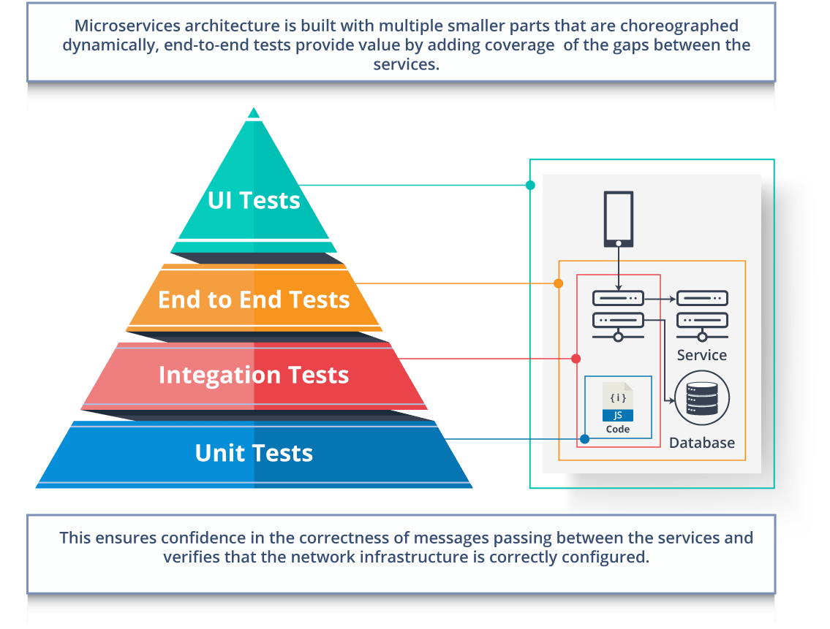

**Fig 14:**Hierarchy of Tests – Microservices Interview Questions

**Q35. What is the use of Container in Microservices?**

Containers are a good way to manage microservice based application to develop and deploy them individually*.* You can encapsulate your microservice in a container image along with its dependencies, which then can be used to roll on-demand instances of microservice without any additional efforts required.

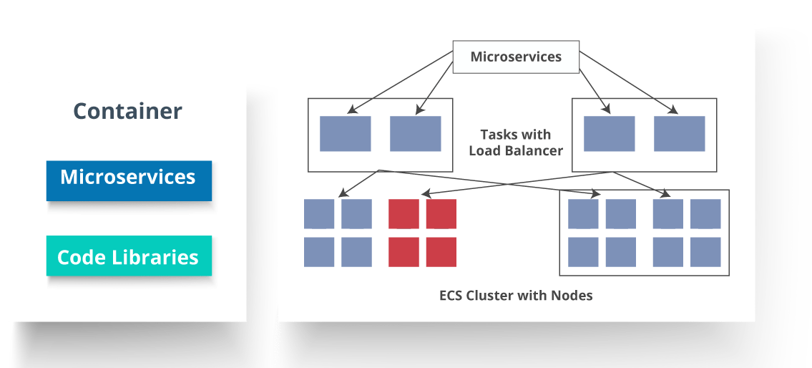

**Fig 15:**Representation of Containers and How they are used in Microservices – Microservices Interview Questions

**Q36. What is DRY in Microservices architecture?**

**DRY** stands for **Don’t Repeat Yourself**. It basically promotes the concept of reusing the code. This results in developing and sharing the libraries which in turn result in tight coupling.

**Q37. What is a Consumer-Driven Contract (CDC)?**

This is basically a pattern for developing Microservices so that they can be used by external systems. When we work on microservices, there is a particular provider who builds it and there are one or more consumers who use Microservice.

Generally, providers specify the interfaces in an XML document. But in Consumer Driven Contract, each consumer of service conveys the interface expected from the Provider.

**Q38**. **What is the role of Web, RESTful APIs in Microservices?**

A microservice architecture is based on a concept wherein all its services should be able to interact with each other to build a business functionality. So, to achieve this, each microservice must have an interface. This makes the web API a very important enabler of microservices. Being based on the open networking principles of the Web, RESTful APIs provide the most logical model for building interfaces between the various components of a microservice architecture.

**Q39. What do you understand by Semantic monitoring in Microservices architecture?**

Semantic monitoring, also known as**synthetic monitoring** combines automated tests with monitoring the application in order to detect business failing factors.

**Q40. How can we perform Cross-Functional testing?**

Cross-functional testing is a verification of non-functional requirements, i.e. those requirements which cannot be implemented like a normal feature.

**Q41. How can we eradicate non-determinism in tests?**

**Non-Deterministic Tests** (NDT)  are basically unreliable tests.  So, sometimes it may happen that they pass and obviously sometimes they may also fail. As and when they fail, they are made to re-run to pass.

Some ways to remove non-determinism from tests are as follows:

1. Quarantine
2. Asynchronous
3. Remote Services
4. Isolation
5. Time
6. Resource leaks

**Q42. What is the difference between Mock or Stub?**

**Stub**

* A dummy object that helps in running the test.
* Provides fixed behavior under certain conditions which can be hard-coded.
* Any other behavior of the stub is never tested.

For example, for an empty stack, you can create a stub that just returns true for empty() method. So, this does not care whether there is an element in the stack or not.

**Mock**

* A dummy object in which certain properties are set initially.
* The behavior of this object depends on the set properties.
* The object’s behavior can also be tested.

For example, for a Customer object, you can mock it by setting name and age. You can set age as 12 and then test for isAdult() method that will return true for age greater than 18. So, your Mock Customer object works for the specified condition.

**Q43. What do you know about Mike Cohn’s Test Pyramid?**

**Mike Cohn** provided a model called **Test Pyramid.** This describes the kind of automated tests required for software development.

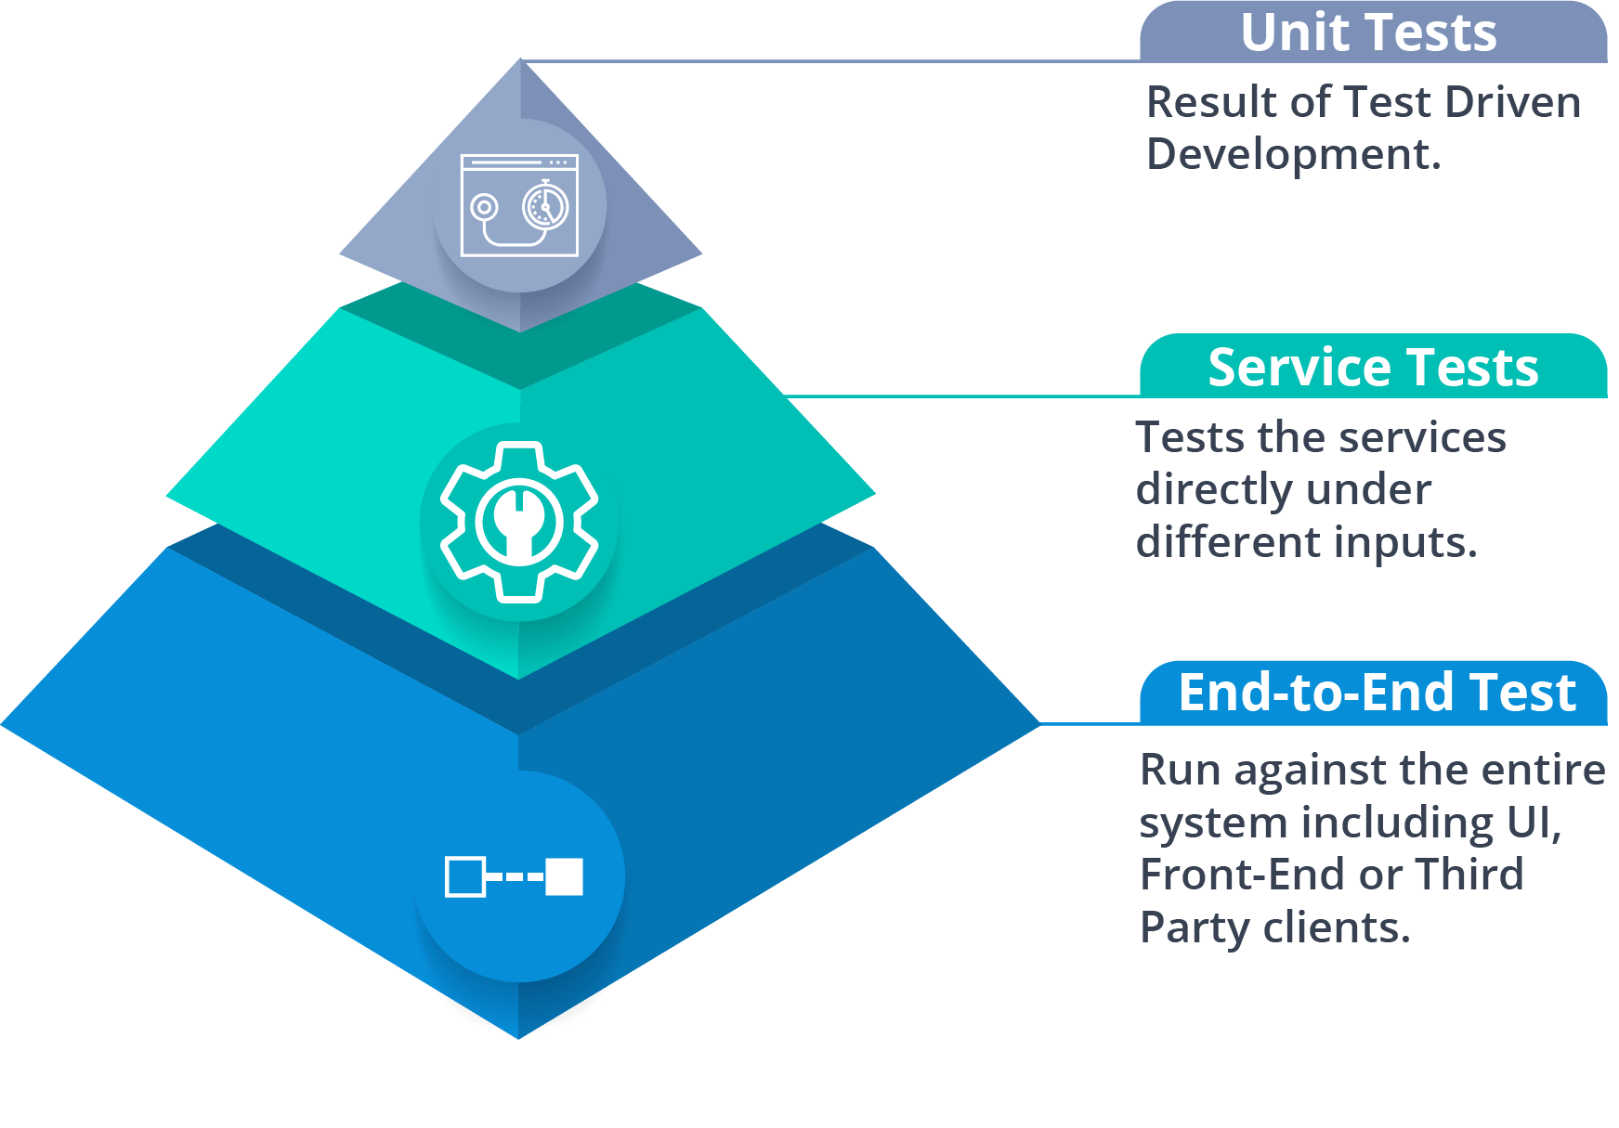

**Fig 16:**Mike Cohn’s Test Pyramid – Microservices Interview Questions

As per pyramid, the number of tests at first layer should be highest. At service layer, the number of tests should be less than at the unit test level, but more than at the end-to-end level.

**Q44. What is the purpose of Docker?**

**Docker** provides a container environment that can be used to host any application. In this, the software application and the dependencies which support it are tightly-packaged together.

So, this packaged product is called a **Container** and since it is done by Docker, it is called **Docker container!**

**Q45. What is Canary Releasing?**

**Canary Releasing** is a technique to reduce the risk of introducing a new software version in production. This is done by slowly rolling out the change to a small subset of users before giving it out to the entire infrastructure, i.e. making it available to everybody.

**Q46. What do you mean by Continuous Integration (CI)?**

**Continuous Integration (CI)** is the process of automating the build and testing of code every time a team member commits changes to version control. This encourages developers to share code and unit tests by merging the changes into a shared version control repository after every small task completion.

**Q47. What is Continuous Monitoring?**

**Continuous monitoring**gets into the depth of monitoring coverage, from in-browser front-end performance metrics, through application performance, and down to host virtualized infrastructure metrics.

**Q48. What is the role of an architect in Microservices architecture?**

An architect in microservices architecture plays the following roles:

* Decides broad strokes about the layout of the overall software system.
* Helps in deciding the zoning of the components. So, they make sure components are mutually cohesive, but not tightly coupled.
* Code with developers and learn the challenges faced in day-to-day life.
* Make recommendations for certain tools and technologies to the team developing microservices.
* Provide technical governance so that the teams in their technical development follow principles of Microservice.

**Q49. Can we create State Machines out of Microservices?**

As we know that each Microservice owning its own database is an independently deployable program unit, this, in turn, lets us create a State Machine out of it. So, we can specify different states and events for a particular microservice.

For Example, we can define an Order microservice. An Order can have different states. The transitions of Order states can be independent events in the Order microservice.

**Q50. What are Reactive Extensions in Microservices?**

Reactive Extensions also are known as Rx. It is a design approach in which we collect results by calling multiple services and then compile a combined response. These calls can be synchronous or asynchronous, blocking or non-blocking. Rx is a very popular tool in distributed systems which works opposite to legacy flows.