No compelling evidence that women with more attractive faces show stronger preferences for masculine men

Ciaran Docherty¹, Anthony J Lee², Amanda C Hahn³, Benedict C Jones¹

- Institute of Neuroscience & Psychology, University of Glasgow, Scotland
- Faculty of Natural Science, Division of Psychology, University of Stirling, Scotland
- Department of Psychology, Humboldt State University, USA

Data and analysis code publicly available at https://osf.io/36fs5/

The authors thank Lisa DeBruine for providing software for this project and Iris Holzleitner for helpful discussions about these data and code check.

No compelling evidence that women with more attractive faces show stronger preferences for masculine men

Abstract
Many researchers have suggested that more attractive women will show stronger preferences for masculine men, potentially because such women are better placed to offset the potential costs of choosing a masculine mate. Perhaps the most compelling evidence for this proposal has come from work reporting a positive association between third-party ratings of women’s facial attractiveness and women’s preference for masculinized versus feminized versions of men’s faces as hypothetical long-term partners. Because this finding was based on only a small sample of women (N = 35), we attempted to replicate this result in a much larger sample (N = 454). We found that women, on average, preferred masculinized versions of men’s faces to feminized versions and that this masculinity preference was slightly stronger when women assessed men’s attractiveness as short-term, rather than long-term, mates. However, we found no compelling evidence that women’s masculinity preferences were related to their own attractiveness. These results underline the importance of ensuring that studies of individual differences in mate preferences are adequately powered.

Introduction
Trade-off theories of women’s preferences for masculine men propose that men displaying more masculine physical characteristics are more likely to be healthy, physically strong, and able to compete for resources, but also less likely to invest time and effort in their mates and offspring (Little et al., 2001; Penton-Voak et al., 2003). According to such theories, women may then differ systematically in how they weigh up the costs and benefits of choosing a masculine mate (Little et al., 2001; Penton-Voak et al., 2003).

One factor that is widely thought to influence how women resolve this trade off between the potential costs and benefits of choosing a masculine mate is women’s own physical attractiveness (Little et al., 2001; Penton-Voak et al., 2003). The rationale for predicting these attractiveness-contingent masculinity preferences is that more physically attractive women will be better able to retain and secure investment from masculine men and/or better able to replace masculine men in the event of relationship dissolution (Little et al., 2001; Penton-Voak et al., 2003). In other words, more attractive women are better able to minimize the potential costs of choosing a masculine mate.

Several studies have investigated possible correlations between women’s own attractiveness and their preferences for facial masculinity by measuring women’s own attractiveness via self-ratings. However, results from studies using this methodology are mixed. While Little et al. (2001) found that women who rated their own attractiveness higher showed stronger preferences for men with masculine facial characteristics (see also Little & Mannion, 2006), subsequent studies did not replicate this significant positive correlation between women’s self-rated attractiveness and masculinity preferences (Penton-Voak et al., 2003; Zietsch et al., 2015).

Other work has tested for evidence that women’s own physical attractiveness predicts the strength of their masculinity preferences by assessing women’s own attractiveness via third-party attractiveness ratings of face photographs. Using this methodology, Penton-Voak et al. (2003) found that more attractive women showed stronger preferences for men with masculine facial characteristics when assessing men’s attractiveness for hypothetical long-term, but not short-term, relationships. This result was interpreted as strong evidence for trade-off theories of women’s preferences for masculine men because the potential costs of choosing a masculine mate are generally assumed to be more pronounced for long-term, than short-term, relationships (Penton-Voak et al., 2003).

Many other findings that have been widely interpreted as evidence for trade-off theories of women’s preferences for masculine men, such as putative effects of hormonal status and/or conception risk, have not been observed in large-scale replication studies (see Jones et al., 2019 for a recent review of these non-replications). Consequently, and because we know of no large-scale replication of Penton-Voak et al. (2003), we tested for possible relationships between third-party attractiveness ratings of women’s face photographs and their preferences for men with masculine facial characteristics as hypothetical long-term and short-term relationships.

Methods
Participants
Participants were 454 heterosexual women (mean age = 21.43 years, SD = 3.18 years), participating as part of a longitudinal study of potential hormonal correlates of women’s face preferences and own facial appearance. To match Penton-Voak et al’s (2003) study design, only face preferences and face images from each participant’s first test session were analyzed in the current study.

The order in which women completed the face preference tests and had their face photograph taken was fully randomized. All participants were staff or students at the University of Glasgow.

Simonsohn (2015) recommends that sample sizes for replication studies be at least two-and-a-half times larger than the sample size in the original study. The total sample size in Penton-Voak et al. (2003) was 82 women and the critical correlation between facial attractiveness and long-term masculinity preferences was based on an analysis of responses from 35 women. Thus, our sample exceeds the size that Simonsohn (2015) recommends for replications.

Assessing women’s preferences for facial masculinity
The methods we used to manufacture stimuli to test women’s preferences for facial masculinity have been used in many previous studies, including Penton-Voak et al. (2003). Stimuli from this study are publicly available at www.osf.io/9b4y7. Briefly, we first manufactured a female prototype (i.e., average) face by using specialist software (Tiddeman et al., 2001) to average the shape, color, and texture information from images of 50 young white women’s faces. A male prototype face was also manufactured in this way by averaging the shape, color, and texture information from images of 50 young white men’s faces. Next, we randomly selected 10 images from the set of 50 individual male faces. We then created a feminized and a masculinized version of each of these 10 male images by adding or subtracting 50% of the linear (i.e., vector) differences in 2D shape between symmetrized versions of the female and male prototypes to (or from) each individual image. This process created 10 pairs of face images in total, with each pair consisting of a feminized and a masculinized version of one of the individual face images. Examples of these stimuli are shown in Figure 1. Note that our feminized and masculinized versions of faces differed in sexually dimorphic shape characteristics only (i.e., were matched in other regards, such as identity, color, and texture, Tiddeman et al., 2001).
.
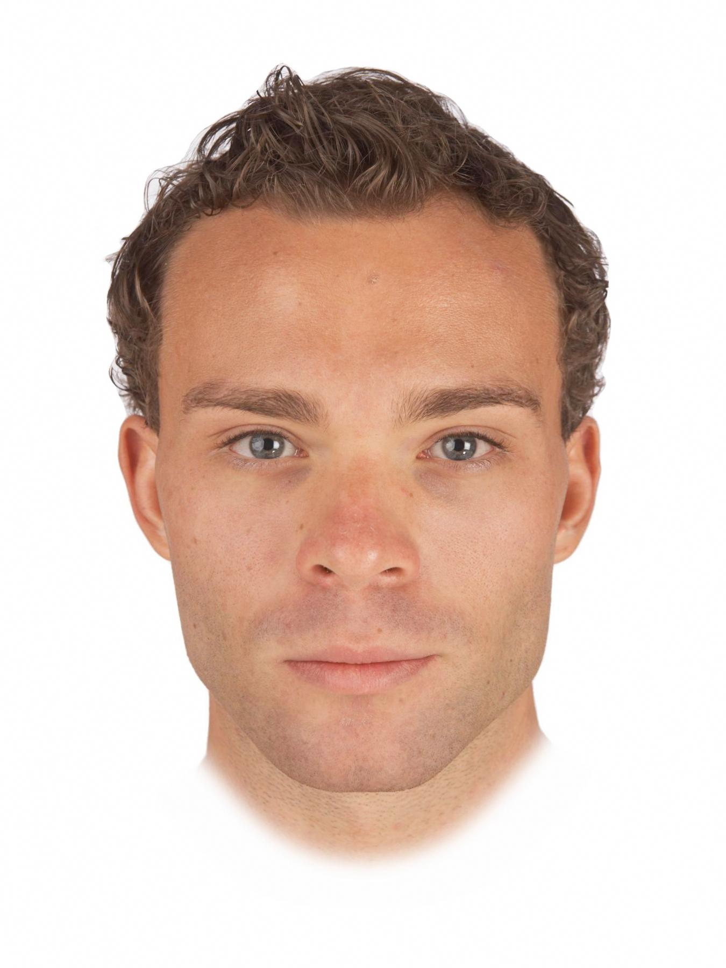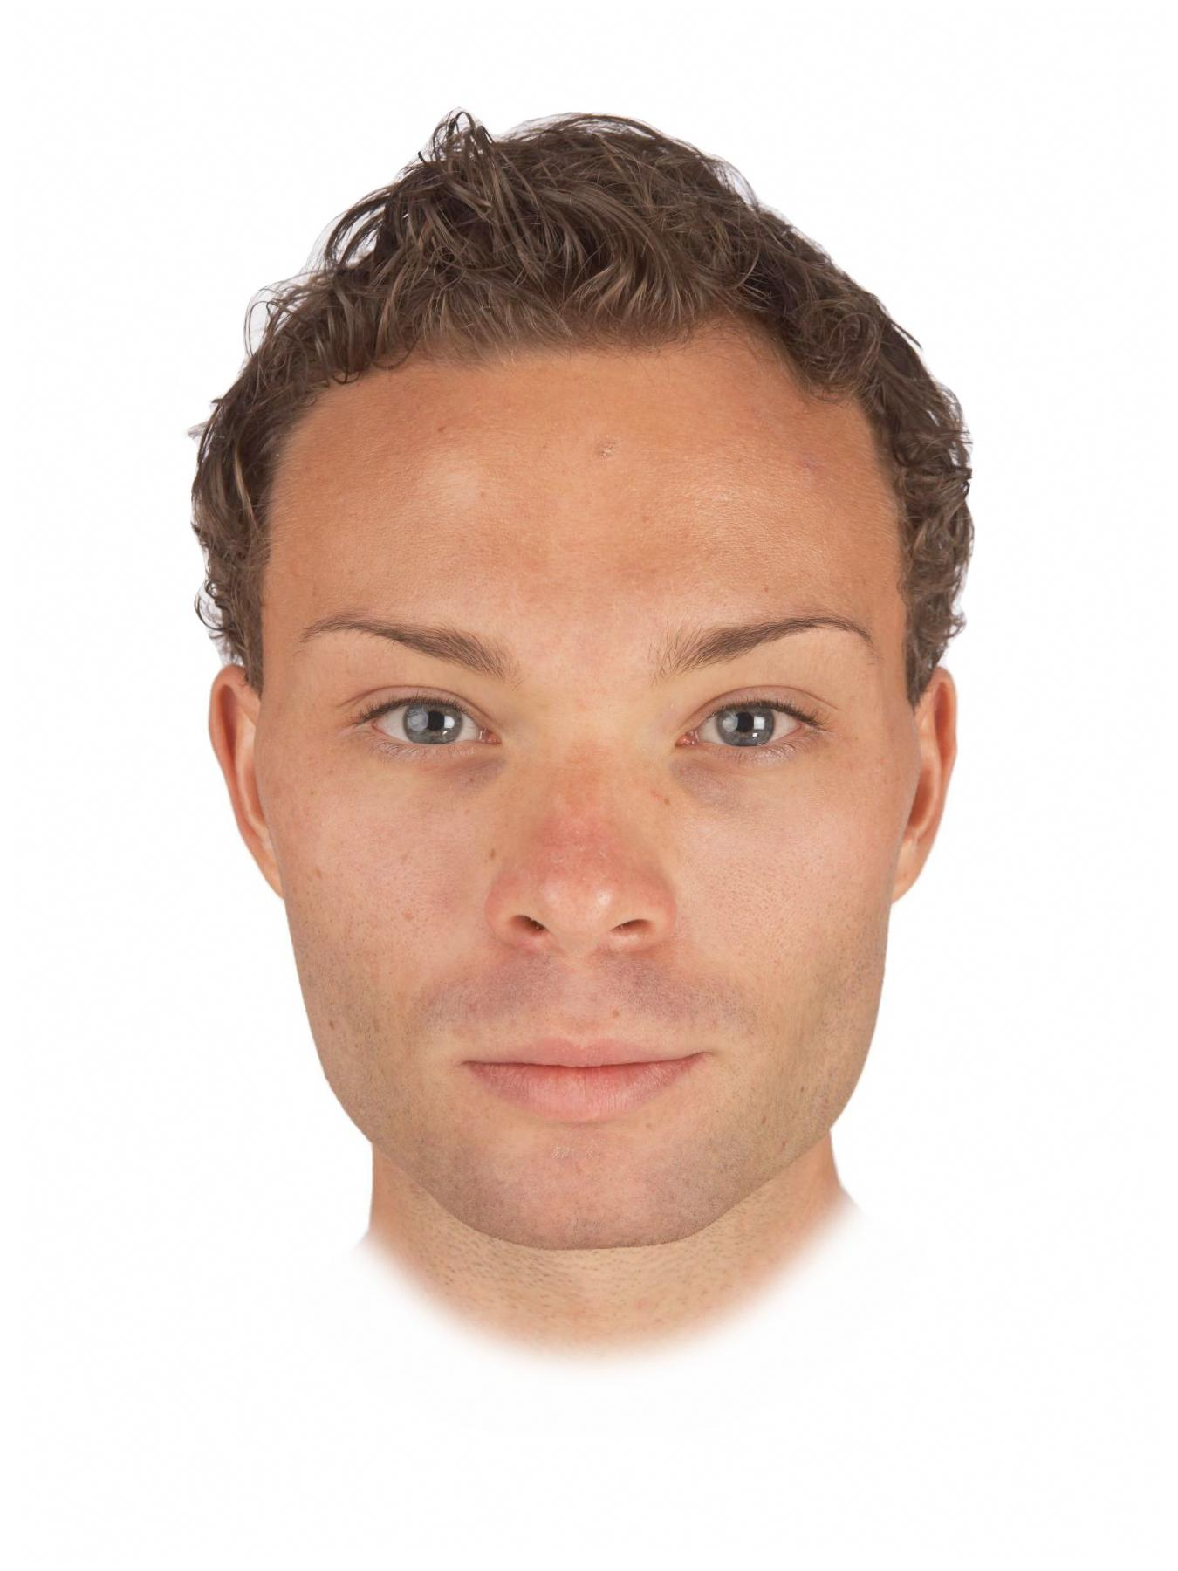
Figure 1. Examples of masculinized (left) and feminized (right) versions of men’s faces used to assess facial masculinity preferences in our study.

Each participant completed two face preference tests (one assessing men’s attractiveness for a short-term relationship, the other assessing men’s attractiveness for a long-term relationship). Trial order within each test was fully randomized and the order in which the two face preference tests were completed was also fully randomized.

In the two face preference tests, women were shown the 10 pairs of male faces, each pair consisting of a masculinized and feminized version of a given individual. Women were instructed to select the more attractive face in each pair and to indicate the strength of that preference by choosing from the options “slightly more attractive”, “somewhat more attractive”, more attractive”, and “much more attractive”. This procedure has been used to assess masculinity preferences in previous studies (e.g., Zietsch et al., 2015). In each face preference test, the 10 trials assessing preferences for sexually dimorphic shape characteristics were interspersed among 30 filler trials assessing preferences for other facial traits. Definitions of short-term and long-term relationships were identical to those used in Penton-Voak et al. (2003). Face preferences were collected using the Experimentum interface (DeBruine, 2019).

In the short-term attractiveness test, women were told: “You are looking for the type of person who would be attractive in a short-term relationship. This implies that the relationship may not last a long time. Examples of this type of relationship would include a single date accepted on the spur of the moment, an affair within a long-term relationship, and possibility of a one-night stand.”

In the long-term attractiveness test, women were told: “You are looking for the type of person who would be attractive in a long-term relationship. Examples of this type of relationship would include someone you may want to move in with, someone you may consider leaving a current partner to be with, and someone you may, at some point, wish to marry (or enter into a relationship on similar grounds as marriage).”

Responses on the face preference test were coded using the following scale (higher scores indicate stronger masculinity preferences and the scale is centered on chance, i.e., zero):

0.5 to 3.5: masculinized face rated ‘slightly more attractive’ (=0.5), ‘somewhat more attractive’ (=1.5), ‘more attractive’ (=2.5) or ‘much more attractive’ (=3.5) than feminized face.

-0.5 to -3.5: feminized face rated ‘slightly more attractive’ (=-0.5), ‘somewhat more attractive’ (=-1.5), ‘more attractive’ (=-2.5) or ‘much more attractive’ (=-3.5) than masculinized face.

Assessing women’s own facial attractiveness
Ratings of women’s own facial attractiveness were collected and analyzed previously in Holzleitner et al. (in press). Each woman first cleaned her face with hypoallergenic face wipes to remove any make up. A full-face digital photograph was taken a minimum of 10 minutes later. Photographs were taken in a small windowless room against a constant background, under standardized diffuse lighting conditions, and participants were instructed to pose with a neutral expression. Camera-to-head distance and camera settings were held constant. Participants wore a white smock covering their clothing when photographed to control for possible effects of reflectance from clothing. Photographs were taken using a Nikon D300S digital camera with an AF Micro-Nikkor 60mm f/2.8D lens. A GretagMacbeth 24-square ColorChecker chart was included in each image for use in color calibration. Images were color-calibrated using a least-squares transform from an 11-expression polynomial expansion developed to standardize color information across images (Hong et al., 2001). Each image was masked so that hairstyle and clothing were not visible, placed on a black background, and standardized on pupil positions prior to rating.

The face images were then rated for attractiveness using a 1 (much less attractive than average) to 7 (much more attractive than average) scale by 16 men and 16 women. Trial order was fully randomized. Inter-rater agreement was high for these ratings and ratings by male and female raters were highly correlated (see Holzleitner et al., in press). Consequently we calculated an average attractiveness score for each image to use in our analyses.

Results
Masculinity preferences were analyzed using linear mixed effects models using the lme4 (Bates et al., 2015) and lmerTest (Kuznetsova et al., 2015) packages in the R statistical software (R Core Team, 2013). Predictors were facial attractiveness, which was z-standardized, and relationship context, which was effect coded (-.5 = short-term context, .5 = long-term context). Random intercepts were specified for participants and stimuli and random slopes were specified maximally (Barr et al., 2013; Barr, 2013). The model included main effects of facial attractiveness and relationship context, as well as the interaction between facial attractiveness and relationship context. Full analysis code and results can be seen at https://osf.io/36fs5/.

 | Estimate (Std Error) | t-value (approx df.) | p-value
Intercept | .38 (.13) | 2.88 (9.52) | .017*
Relationship Context | -.04 (.02) | -2.11 (63.98) | .039*
Facial Attractiveness | .02 (.02) | .75 (363.63) | 0.456
Relationship Context * Facial Attractiveness | -.02 (.02) | -1.16 (80.55) | 0.249
Table 1. Summary of results of masculinity-preference analysis.

Results are summarized in Table 1 and Figure 2. The intercept was significant and positive (estimate = 0.37880, SE = 0.13162, df = 9.52424, t = 2.878, p = 0.0172), indicating that women generally preferred masculinized versions of men’s faces to feminized versions. The main effect of relationship context was also significant and positive (estimate = -0.03757, SE = 0.01785, df = 63.98154, t = -2.105, p = 0.0392), indicating that women’s masculinity preferences were generally stronger for short-term than long-term relationships. Neither the main effect of facial attractiveness (estimate = 0.01728, SE = 0.02318, df = 363.62765, t = 0.745, p = 0.4565) nor the interaction between facial attractiveness and relationship context (estimate = -0.02017, SE = 0.01736, df = 80.55434, t = -1.162, p = 0.2486) were significant, indicating that women’s own attractiveness did not predict masculinity preferences.

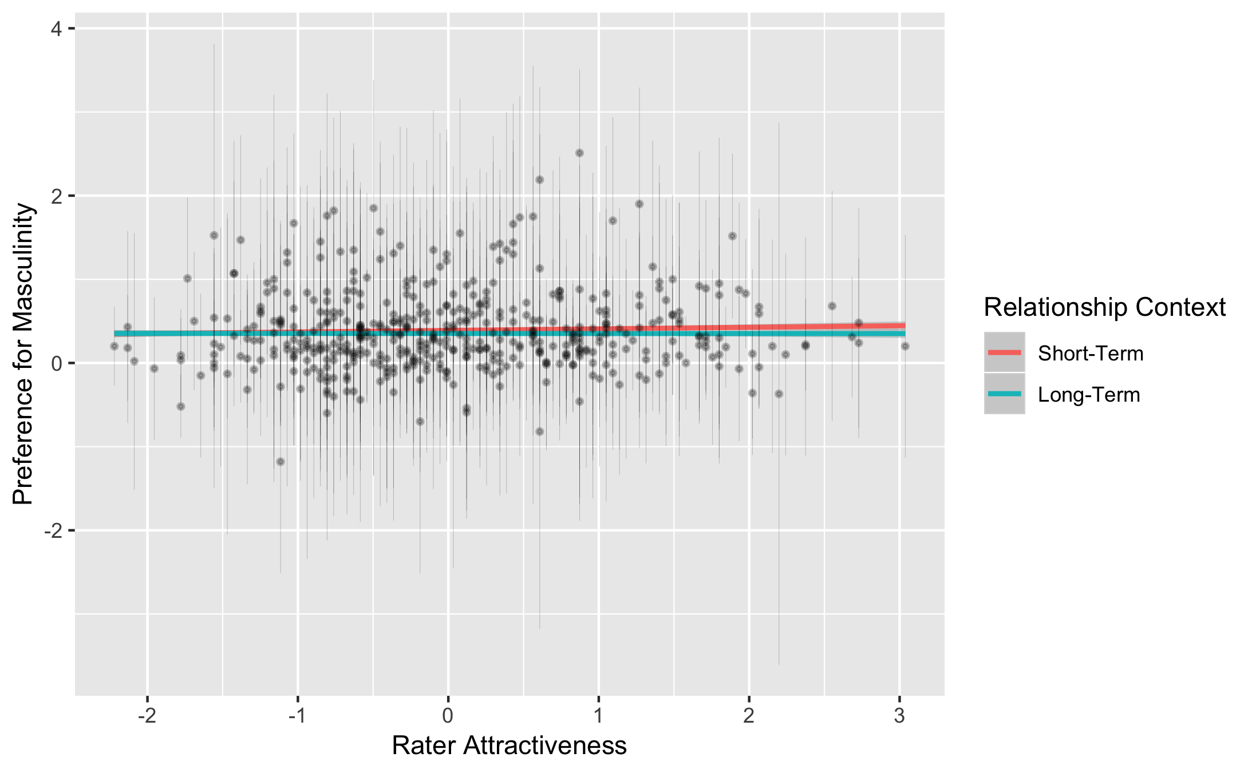
Figure 2. The relationship between facial attractiveness and women’s masculinity preferences in short- and long-term contexts.

Discussion
We investigated the relationship between third-party ratings of women’s facial attractiveness and those women’s preferences for masculinized versus feminized versions of men’s faces for hypothetical short- and long-term relationships. We found that women, on average, preferred masculinized versions of men’s faces over feminized versions, and that this masculinity preference was slightly stronger when judging men’s attractiveness for short-term relationships. However, we found no compelling evidence that women with more attractive faces showed stronger preferences for masculine men. In particular, we did not replicate Penton-Voak et al’s (2003) finding that women with more attractive faces showed stronger preferences for masculine men as hypothetical long-term partners. Together with other recent studies that did not replicate previously reported associations between women’s self-rated attractiveness and masculinity preferences (Zietsch et al., 2015), this result does not support the proposal that women’s own attractiveness is an important source of individual differences in their preferences for masculine mates (Little et al., 2001; Penton-Voak et al., 2003).

Although we did not find any compelling evidence that women’s own attractiveness modulated the strength of their masculinity preferences, we did find that women showed slightly stronger preferences for masculine men for hypothetical short-term relationships. This result is then consistent with the proposal that the anti-social traits masculine men are perceived to have are unattractive in long-term partners and/or that perceived traits like dominance that are reliably associated with facial masculinity in men are particularly attractive in short-term relationships (Little et al., 2001; Penton-Voak et al., 2003).

Our null results for own attractiveness and masculinity preferences are the latest in a series of null results from studies attempting to replicate putatively established findings for sources of variability among and within women in the strength of their preferences for masculine men. For example, although several earlier studies reported that women showed stronger preferences for masculine men around ovulation (e.g., Johnston et al., 2001; Little & Jones, 2012; Penton-Voak et al., 1999) or showed weaker preferences for masculine men when using the combined oral contraceptive pill (Little et al., 2002), these findings have not been replicated in more recent studies (see Jones et al., 2019 for a comprehensive review of these recent studies). Crucially, and as was the case in the current study, these non-replications have typically come from studies with considerably larger samples than the original work, underlining the importance of adequately powering studies of individual differences in women’s masculinity preferences.

References
Barr, D. J. (2013). Random effects structure for testing interactions in linear mixed-effects models. Frontiers in Psychology, 4, 328.

Barr, D. J., Levy, R., Scheepers, C., & Tily, H. J. (2013). Random effects structure for confirmatory hypothesis testing: Keep it maximal. Journal of Memory and Language, 68(3), 255-278.

Bates, D., Mächler, M., Bolker, B. M., & Walker, S. C. (2015). Fitting linear mixed-effects models usng lme4. Journal of Statistical Software, 67(1), 1-48.

DeBruine, L. M. (2019). Experimentum: Beta release 1 (Version v.0.1). Zenodo. http://doi.org/10.5281/zenodo.2634356

Holzleitner, I. J., Lee, A. J., Hahn, A., Kandrik, M., Bovet, J., Renoult, J. P., …
Jones, B. C. (in press). Comparing theory-driven and data-driven attractiveness models using images of real women’s faces. Journal of Experimental; Psychology: Human Perception and Performance.

Hong, G., Luo, M. R. and Rhodes, P. A. (2001). A study of digital camera colorimetric characterization based on polynomial modelling. Color Research and Application, 26, 76-84.

Johnston, V. S., Hagel, R., Franklin, M., Fink, B., & Grammer, K. (2001). Male facial attractiveness: Evidence for hormone-mediated adaptive design. Evolution & Human Behavior, 22, 251-267.

Jones, B. C., Hahn, A. C., Fisher, C. I., Wang, H., Kandrik, M., Han, C., … DeBruine, L. M. (2018). No compelling evidence that preferences for facial masculinity track changes in women’s hormonal status. Psychological Science, 29, 996–1005.

Jones, B. C., Hahn, A. C., & DeBruine, L. M. (2019). Ovulation, sex hormones, and women’s mating psychology. Trends in Cognitive Sciences. in press.

Kuznetsova, A., Brockhoff, P. B., & Christensen, R. H. B. (2015). lmerTest: Tests for random and fixed effects for linear mexed effect models. Retrieved from https://CRAN.R-project.org/package=lmerTest

Little, A. C., & Jones, B. C. (2012). Variation in facial masculinity and symmetry preferences across the menstrual cycle is moderated by relationship context. Psychoneuroendocrinology, 37, 999-1008.

Little, A. C., & Mannion, H. (2006). Viewing attractive or unattractive same-sex
individuals changes self-rated attractiveness and face preferences in women. Animal Behaviour, 72, 981-987.

Little, A. C., Jones, B. C., Penton-Voak, I. S., Burt, D. M., & Perrett, D. I. (2002). Partnership status and the temporal context of relationships influence human female preferences for sexual dimorphism in male face shape. Proceedings of the Royal Society of London, B, 269, 1095-1100.

Little, A. C., Burt, D. M., Penton-Voak, I. S., & Perrett, D. I. (2001). Self-perceived
attractiveness influences human female preferences for sexual dimorphism and symmetry in male faces. Proceedings of the Royal Society B: Biological Sciences, 268, 39-44.

Penton-Voak, I. S., Little, A. C., Jones, B. C., Burt, D. M., Tiddeman, B. P., &
Perrett, D. I. (2003). Female condition influences preferences for sexual
dimorphism in faces of male humans (Homo sapiens). Journal of Comparative Psychology, 117, 264–271

Penton-Voak, I. S., Perrett, D. I., Castles, D. L., Kobayashi, T., Burt, D. M., Murray, L. K., & Minamisawa, R. (1999). Menstrual cycle alters face preference. Nature, 399, 741-742.

R Core Team. (2013). A language and environmental for statistical computing. Vienna, Austria: R Foundation for Statistical Computing.

Simonsohn, U. (2015). Small Telescopes: Detectability and the Evaluation of Replication Results. Psychological Science, 26, 559-569.

Zietsch, B. P., Lee, A. J., Sherlock, J. M., & Jern, P. (2015). Variation in women’s
preferences regarding male facial masculinity is better explained by genetic differences than by previously identified context-dependent effects. Psychological Science, 1-9.

