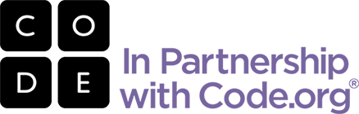

**[TEACHER NAME’S] CLASS IS LEARNING COMPUTER SCIENCE!**

**[SCHOOL NAME], [GRADE LEVEL]**

In [CLASS NAME], we’re teaching **Code.org’s Computer Science Fundamentals** course to your child.

**WHAT IS IT?**

Computer Science Fundamentals is fun, collaborative, and creative! It’s designed to inspire students to continue learning how technology improves real world relationships, connections, and life.

**Students learn:**

how the Internet works

basic computer programming

logic, problem solving and creativity

The course features puzzles, video lectures by Bill Gates, Mark Zuckerberg and Chris Bosh of the Miami Heat, as well as familiar characters from popular games Angry Birds and Plants vs. Zombies. Using a blended learning model, your children are learning with a mix of online, self-guided activities and “unplugged” activities that use no computer at all.

**WHY COMPUTER SCIENCE?**

Software is everywhere. It’s shaping almost every aspect of how we live our lives. But very few kids are learning how to actually create games, apps and programs.

**Did you know?**

Most American schools don’t teach computer science.

Computing jobs are the number 1 source of new wages in the US!

All students can learn to code. But girls and many minorities are severely underrepresented in computer science.

Computer science is a foundation for every student. That’s why we’re introducing ours to these critical 21st century skills.

Code.org is a non-profit dedicated to giving every student in every school the opportunity to learn computer science, and expanding participation by girls and underrepresented minorities. Learn more at [www.Code.org](http://www.Code.org).