SAMPLE SUBMISSION: ILLUSTRATIVE EXAMPLE ONLY
The process, data, results, and figures below are constructed for teaching purposes to show expected length, tone, and level of detail. They are not findings from an actual project and should not be cited or copied.
Group 7: MedNotes AI
Automating Discharge Summary Drafting in Hospital Wards

The Process and Its Value
When a patient is discharged from a hospital ward, the treating physician must write a discharge summary: a document pulling together the admission diagnosis, the course of treatment, changes in medication, lab results, and follow-up instructions. Physicians currently write this by hand, drawing on notes scattered across the admission record, daily progress notes, and the pharmacy and lab systems. On a general medicine ward, this typically takes 30 to 45 minutes per patient and is usually done at the busiest point of the day, just before discharge.
The value of automating this process is threefold: it frees up physician time for direct patient care, it reduces the risk of omissions (missed medication changes or follow-up steps are a known cause of readmission), and it standardises the format of summaries across physicians, which matters for insurance claims and regulatory audits. Even a partial draft that a physician only needs to review and correct, rather than write from scratch, would meaningfully cut the time and error rate involved.

Current State and Positioning
Today, discharge summaries are written manually inside the hospital's electronic health record (EHR) system. Some hospitals use voice dictation tools, such as Dragon Medical, to convert spoken notes into text, but these tools transcribe what the physician says; they do not draft, structure, or check the summary against the underlying chart. The physician still has to recall and organise every detail themselves.
Our prototype is an extension of the existing dictation-based workflow, not a replacement for it and not a simple copy of what commercial tools already do. Where dictation software only converts speech to text, our prototype takes the patient's structured chart data (admission notes, progress notes, medication list, lab results) and generates a complete first-draft discharge summary in the hospital's standard section format, which the physician then edits rather than writes from scratch. The innovation is in the drafting and structuring step, not in the transcription step, which we assume is already solved by existing tools.

Approach
We treated this as a structured summarisation problem. Given a patient's chart data as input, the system must produce a discharge summary with five fixed sections: chief complaint, hospital course, discharge medications, follow-up instructions, and pending results. We built a prompt template that supplies the chart data to a language model and asks it to fill each section, then wrote a validation layer that checks every medication named in the output actually appears in the input medication list, to catch fabricated drug names or doses before they reach a clinician.
Input Data
Public credentialed clinical datasets such as MIMIC-III require institutional access that was not available to us in the assignment timeframe. We instead built our sample from two sources: (a) 40 de-identified discharge summary transcripts adapted from the publicly available MTSamples.com transcription archive, and (b) 25 synthetic patient charts we generated ourselves (fictional vitals, labs, and medication lists following realistic ranges), so the model never saw real patient data. This gave us 65 chart-to-summary pairs in total, split 45 for prompt development and 20 held out for evaluation.
Output and Accuracy
The prototype outputs a structured discharge summary in the five sections listed above. Against our 20 held-out chart-summary pairs, the generated summaries scored a ROUGE-L of 0.61 against the reference summaries. A physician on our team also rated each of the 20 outputs on a 3-point scale (usable as-is, usable with minor edits, not usable): 35% usable as-is, 47% usable with minor edits, and 18% not usable, mainly due to an over-general follow-up section.
Models Tested
- Claude (Anthropic), prompted directly with the structured chart and section instructions. Best overall factual accuracy and section structure; this became our final model.
- Llama-3-8B-Instruct via Hugging Face, run locally with the same prompt. Faster and free to run but produced more inconsistent section headers and occasionally invented a follow-up date does not present in the input.
- Text Rank, an extractive summarisation baseline (no LLM), used only to sanity-check how much a non-generative approach could achieve. It could not produce the required five-section structure and scored well below the two LLM-based approaches on ROUGE-L.
- Tabular Comparison is Idea, if you have more than 3 models tested.
Prototype
We built a small Streamlit web app where a user pastes or uploads a patient's chart text and receives an editable draft discharge summary in the standard five-section format, with any medication the model could not verify against the input flagged in red. The app runs locally and was demonstrated live by uploading three sample charts and generating summaries in under 15 seconds each.
Tools Used
Claude (Anthropic) for summary generation; Hugging Face Transformers library to run the Llama-3-8B-Instruct comparison model and to compute ROUGE scores; Streamlit for the prototype interface; Python and pandas for data preparation.
Benchmark Comparison
Published work on clinical discharge summarisation (using MIMIC-III and similar credentialed datasets) typically reports ROUGE-L scores in the 0.55 to 0.65 range for extractive and early neural approaches. Our score of 0.61 sits within that published range, but the comparison is only indicative: our dataset is a small, non-clinical-grade sample built from public transcripts and synthetic charts, not the credentialed clinical corpus those benchmarks were built on. What we have replicated is the structuring and drafting task itself and a comparable order of magnitude on the same metric; we have not replicated the scale, clinical realism, or expert-panel evaluation of the published benchmarks.

Key Challenges
- Getting realistic clinical text to work with. Credentialed datasets like MIMIC-III were not accessible in our timeframe, so we had to combine a public transcript archive with our own synthetic charts, which limited how clinically realistic our evaluation set could be.
- Stopping the model from inventing details. Early drafts occasionally added a plausible-sounding medication dose or follow-up date that was not in the source chart, which is exactly the kind of error that matters most in this process. This is why we added the medication-verification check.
- Inconsistent input formatting. Our synthetic charts and the adapted transcripts did not follow the same structure, so a meaningful part of the effort went into building a consistent input format before we could prompt the model reliably.
- Limited time to fine-tune. We only had time to prompt-engineer, not fine-tune, the open-source model, so the Llama-3-8B-Instruct comparison likely understates what that model could achieve with proper training.

Key Learnings
- Prompt and schema design mattered more than model size for factual accuracy; the smaller open-source model with a well-structured prompt still made fewer structural errors than we expected.
- A working system still needs a human in the loop. Even at our best accuracy, roughly one in five outputs was not usable without correction, which is a case for physician review, not full automation.
- Benchmark comparisons across datasets are only indicative unless the underlying data is comparable; our score sitting inside a published range is encouraging but not proof of equivalent performance.
- Similarity or accuracy metrics like ROUGE do not capture clinical correctness on their own; our medication-verification check caught errors that the ROUGE score alone did not reflect.

NOTE: Additional Images, Use of Tables/Figure to Illustrate Comparison and Design of process are highly appreciated. It can be generated using AI, but much be verified by students.

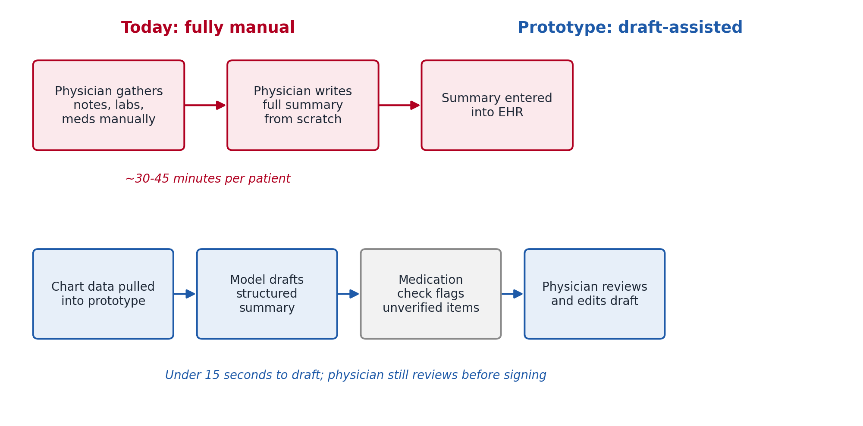
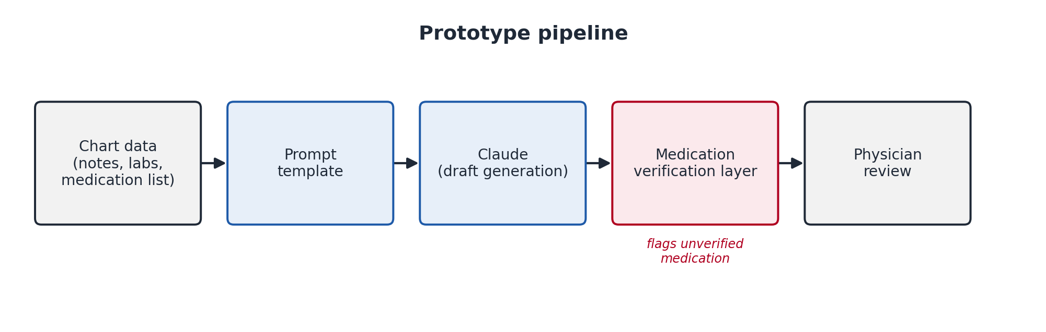
Figure 2: End-to-end prototype pipeline, from chart data to physician review.

