**AnimOBJ Maya Plug-in v0.1**

Dongsoo Han ([Dongsoo@seas.upenn.edu](mailto:Dongsoo@seas.upenn.edu))

Feb 28th 2010

AnimOBJ is a simple Autodesk Maya plug-in to load a series of OBJ files.

*• How to Compile*

1. Load solution file in Visual Studio 2005. Set up include/lib directories path for Maya SDK accordingly.
2. Build a project.
3. ‘AnimOBJPlugin.mll’ will be generated under ‘.\AnimOBJ\plug-ins’ folder.

*• How to Install*

1. Open ‘AnimOBJ.6_module’ provided in ‘.\AnimOBJ’ folder in any text editor.
2. Change the path to point the directory correctly.
3. Save it.
4. Copy ‘AnimOBJ.6_module’ into the directory similar to below.

C:\Documents and Settings\dhan\My Documents\maya\modules

1. Launch Maya and find if the new tab (AnimOBJ) shows up as below.

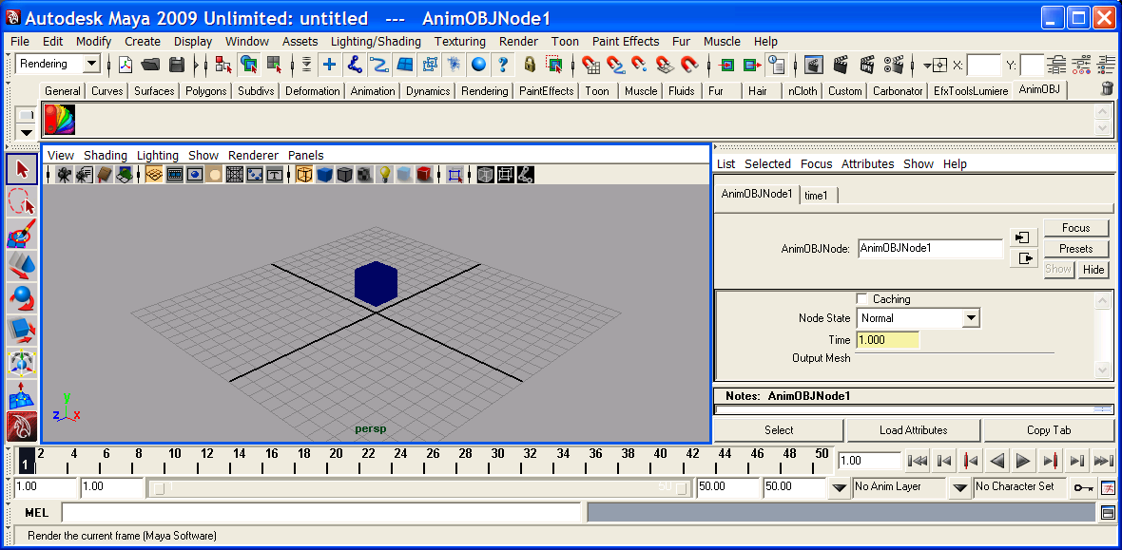

• *How to Use*

1. Sample OBJ animation files are provided in ‘example’ directory.
2. Go to Window > Settings/Preferences > Plug-in Mangers and set up as below.

Please note that the path would be different according to where you install it.

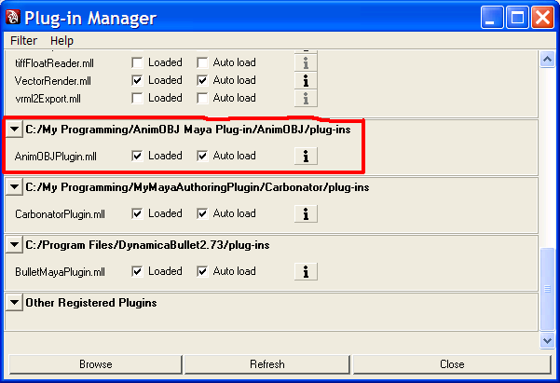

1. Once Maya is launched, go to ‘AnimOBJ’ tab and click the icon.
2. Open File Dialog will be open. Select any OBJ file from ‘example’ directory.
3. OBJ model will be loaded based on the current frame number.

• *Known issues*

1. Once OBJ files are loaded, if you try to load again, AnimOBJ will fail.
2. Performance was not my concern as this was quickly implemented to test my personal project.
3. Only vertex and face information in OBJ file will be loaded. Texture or any other information will be ignored. This is a very simple OBJ loader!

• *Notes*

1. If you want to see the rendered animations, please go to link below.

<http://www.youtube.com/user/saggitasaggita>

1. Icon was obtained from below and converted to xpm file format.

<http://www.kde-look.org/content/show.php/Frugal+KDE+Icon+Theme?content=112028>

1. There is absolutely no warranty. Use it at your own risk.
2. Do not use it for any commercial purpose without any agreement with the author.

• *License*

GPL (<http://www.gnu.org/licenses/gpl.txt>)