NobleEye-

Object Sensor and detector for visually impaired

Pratham Jain  
COE Dept Netaji Subhas University of Technology New Delhi, India  
jainpratham28@gmail.com

Gaurav Singal  
Professor  
COE DEPTNetaji Subhas University of Technology  
New DelhiAmanjot Singh   
COE Dept Netaji Subhas University of Technology New Delhi, India  
amanjot3589@gmail.com

Ashish Kant  
COE Dept Netaji Subhas University of Technology New Delhi, India ashishkant9082@gmail.com

***Abstract*—*Currently, there is lack of easily available, cost effective and efficient devices to the help the visually impaired people to deal the with the daily challenges they face and help them live life like the normal human being. The various efficient devices available in the market are either costly or possess difficulty with portability. The project's goal is to provide a low-cost, efficient method of assisting visually impaired people to navigate with increased ease, speed, and confidence by employing ultrasonic waves and ESP-32 camera module to identify surrounding objects and alert them with a DFPlayer mini(voice module). One of the most notable features of this innovation is that it is accessible to anyone. This device will be employed on a belt which makes it portable to use.***

***Keywords—Visual impairment, low cost, Internet of things, tinyML, telegram bot, NodeMCU***

# Introduction

According to the World Health Organization, 39 million individuals worldwide are considered to be blind. The complete loss or the deterioration of existing eyesight can feel frightening and overwhelming, leaving those affected to wonder about their ability to maintain their independence, pay for needed medical care, retain employment, and provide for themselves and their families. Vision impairment poses an enormous global financial burden with an estimated annual global productivity loss of about US$ 411 billion purchasing power parity. Visual impairment affects different age groups in different manners. Visual impairment in adults leads to reduced workforce leading to financial burden and young children with early onset severe vision impairment can experience delayed motor, language, emotional, social and cognitive development with lifelong consequences. We are always dedicated to giving back to society in any manner we can. It was only when we three were hanging out in a cafe named 'Echoes' in Satya Niketan that we came up with this idea. That café is run by differently abled staff and they were so welcoming and polite. Even a disability couldn’t ruin their zeal to serve their customers and we just wanted to contribute in making their life easy. This is when we decided to create a device that would at the very least assist them in navigation.

The objective of our project is to provide a low cost, high-efficiency method of assisting visually impaired people to navigate with increased ease, speed, and confidence by employing ultrasonic waves to identify surrounding objects and alerting them through voice commands. This device will be employed on a belt which makes it portable to use.

# Literature work

In a paper published by Ihab A.Satan, and Mokhaled Hamadani[1], a design for a smart blind stick, which helps visually impaired

people navigate their surroundings is presented. The stick uses an ultrasonic sensor and a GPS

module to detect obstacles and provide audio feedback to the user through a speaker

or headphones. This device is designed to improve the mobility and independence of

visually impaired individuals. The research paper provides a detailed description of the design and implementation of the smart blind stick, along with the challenges faced during the development process. The results of the study suggest that the device can be a valuable tool for visually impaired individuals.

Nagaraju Vankadari and Lakshmi Narayanan [2], presented the design of a smart voice-enabled walking stick for the visually impaired. The walking stick is equipped with an ultrasonic sensor and a microphone to detect obstacles and provide audio feedback to the user. The stick can

also be controlled using voice commands and features a GPS module for navigation. The study discusses the design and implementation of the walking stick and evaluates its effectiveness in assisting visually impaired individuals. The results suggest that the device can help users navigate their surroundings more easily, improving their mobility and independence.

In the article by Jinsoo Cho [3], he discusses the use of wearable technologies in assisting visually impaired individuals. The article presents a review of various wearable technologies, including smart glasses, tactile feedback devices, and haptic interfaces, that have been developed to aid in navigation and object recognition. The review examines the advantages and limitations of each technology and discusses their potential for future development. The article concludes that wearable technologies have the potential to significantly improve the quality of life for visually impaired individuals.

Hussein-Abdel-Jabbar in article [4] describes the development of a smart cane for visually impaired

individuals. The cane is equipped with an ultrasonic sensor and a microcontroller that

provides audio feedback to the user about the distance and location of obstacles. The study evaluates the effectiveness of the smart cane in assisting visually impaired individuals in navigating their surroundings. The results suggest that the device can help users avoid obstacles and improve their mobility and independence.

In the article presented by Ankush Yadav, Manish Kumar and Vijay Gupta [5] design of an Arduino-based third eye for visually impaired individuals is presented. The device is equipped with an ultrasonic sensor and a vibration motor that alerts the user to obstacles in their path. The study evaluates the effectiveness of the device in assisting visually impaired individuals in navigation and object recognition. The results suggest that the device can be a valuable tool for improving the mobility and independence of visually impaired individuals.

In the article by the Instructables [6], a step-by-step guide for building a third eye wearable device for visually impaired individuals is showcased. The device uses an ultrasonic sensor and a vibration motor to detect obstacles and provide haptic feedback to the user. The instructions

include a list of materials and tools required for the project and provide detailed instructions for assembling the device. The article also includes a discussion of the potential benefits of the device for visually impaired individuals.

Muhammad Azhar [7] presents the design and implementation of a third eye wearable device

for visually impaired individuals. The device uses an ultrasonic sensor and a vibration motor to detect obstacles and provide haptic feedback to the user. The study evaluates the effectiveness of the device in assisting visually impaired individuals in navigation and object recognition. The results suggest that the device can be a valuable tool for improving the mobility and independence of visually impaired individuals. The article includes a detailed description of the design and implementation of the device,

along with a list of materials and tools required for the project.

Venkata Naga Krishna Vamsi Chamakura [8], discusses the challenges and opportunities for visually impaired people to access information and communication technologies (ICTs). The author presents an overview of the current state of ICT accessibility, including assistive technologies such as screen readers and braille displays. The article also examines the role of policymakers in promoting accessible ICTs and ensuring that ICT infrastructure is inclusive. The author concludes that while progress has been made, more needs to be done to improve accessibility, particularly in developing countries. The article suggests that

a multi-stakeholder approach, involving government, industry, and civil society, is

necessary to ensure that ICTs are accessible to everyone, regardless of ability.

# Methodology

We tried to make a portable device which will make the lives of visually impaired persons easy by eliminating the use of traditional wooden sticks. NobleEye when fired above connects to the hotspot of the user’s mobile’s hotspot. The hotspot’s name and password will be stored in NobleEye’s code. Our device uses two ultrasonic sensors (one each for left and right) which detects the distance of nearby objects and if the distance is less than some threshold value will give a voice command(through a voice module) by warning about the same. The output also specifies whether an object has been detected using a left ultrasonic sensor or right ultrasonic sensor. The output voice that comes out of the voice module is stored in a 32 GB SD card which is embedded in a DF Player mini.

**

Fig 1

NobleEye also has a ESP32e module which captures images. If the quality of the captured image is above some threshold quality and also its contrast and brightness is in some suitable range then it  uses a predefined and pretrained ML model which can identify a car/bus/stop/traffic light in front of the user and also warn about it through voice module. It will also help in reducing the road accidents of visually impaired people. The model that has been used has not been trained by us. The model has been implemented with the use of an API.

NobleEye also contains an emergency SOS button which uses the GPS module to send the location of the user in case of emergency through an automated bot on telegram application to the relative or friend whose name is connected to the bot. The SOS button will not work while the user is in a closed building. The SOS button is designed to work only in open space.

There are various models already made so far but mostly use a stick which we tried to eliminate. Also, most of premade models sent signals to the user in form of vibration  through a buzzer which doesn’t warn the user whether there is a person or an object or any vehicle, which we tried to solve by using an esp 32 cam module, trained dataset of vehicle and voice module to provide a better user friendly solution to the user.

NobleEye is powered by a 27 Watt power bank connected with  two MicroUSB cables.

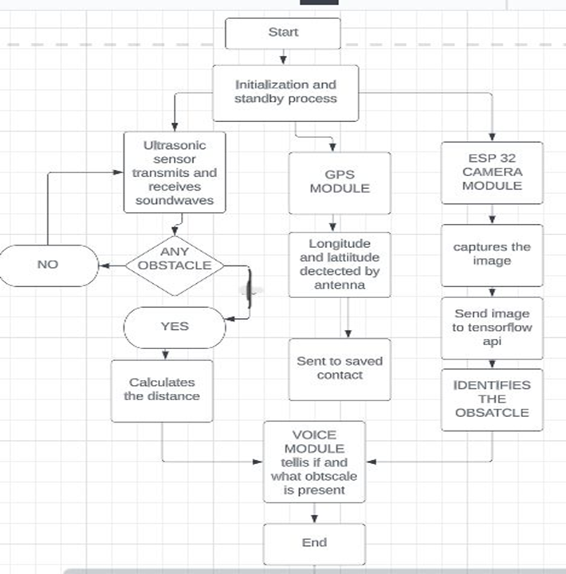

Fig 2

## Components required

1. LM7805 Voltage Regulator

2. Hcsr04 ultrasonic sensor

3. esp.32 cam module

4. NodeMCU Esp12e module

5.  DFPlayer mini with SD card

6. Resistor

7. Switch

8. Jumpers

9. GPS Antenna

10. Battery/Power Bank

11. MicroUSB Cable

12. ESP-32 Camera module

13. 32 GB SD CARD

* 1. *Project circuit*

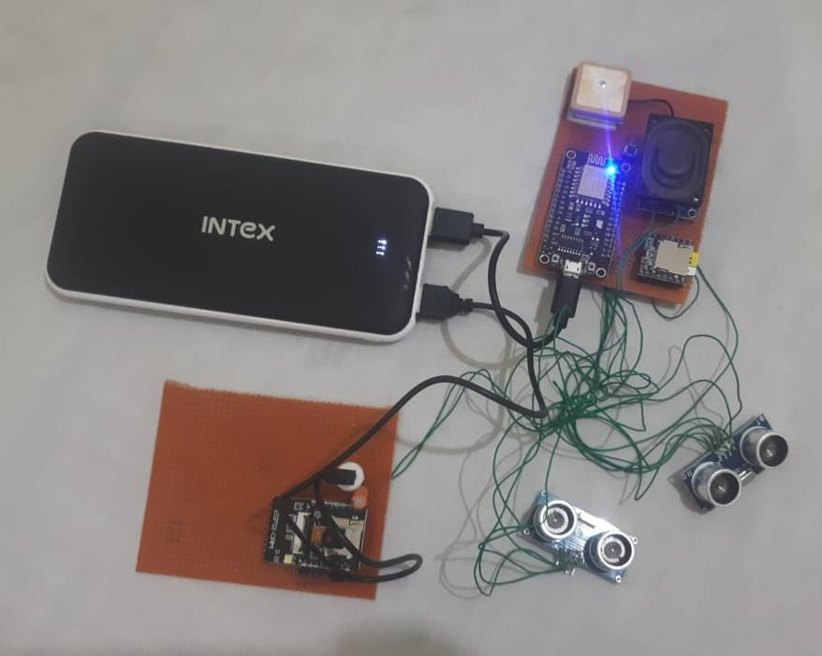

Fig 3

1. Performance Analysis

**Ultrasonic sensor reads from 2cm to 400cm (0.8inch to 157 inch) with an accuracy of 0.3cm (0.1inches).**

**Confusion matrix-**

Actual positive-an obstacle is present in front of the module within a certain range.

Actual negative- no obstacle is present in front of the module within a certain range.

Predicted positive- an obstacle is detected by the module within a certain range.

Predicted negative- no obstacle is detected by the module within a certain range.

|  | Actual positive | Actual negative |
| --- | --- | --- |
| Predicted positive | 81 | 2 |
| Predicted negative | 13 | 4 |

Precision = 0.975

Accuracy = 0.85

Recall = 0.86

F1 score = 0.913

The few times NobleEye gave false positives was when the person wearing the belt took a sharp turn and the sensor detected an object that was not in front of the man.

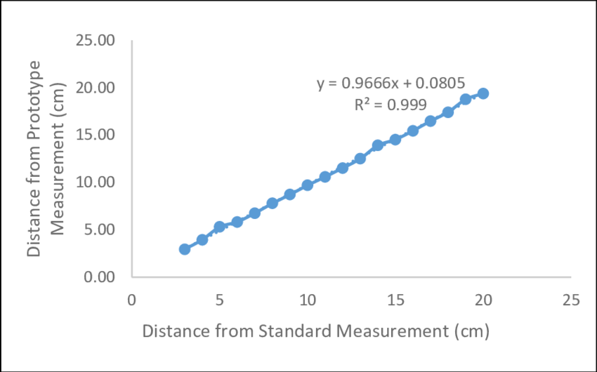

Figure 4

The above diagram [figure 4.1] represents the relation between the actual distance of object from the person or the prototype (Y-axis) and distance measured by the NobleEye (X-axis).

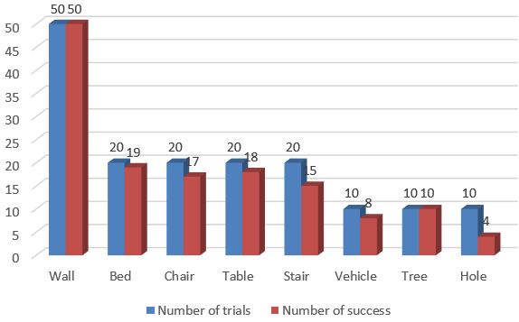

Figure 4.2

The above graph [figure 4.2] shows the bar graph comparing the number of trials performed to check the working of NobleEye and number of successful outcomes.

**Comparison with ultrasonic sensors-** NobleEye is much more efficient than ultrasonic sensors on a stick. Since the sensor is on a stick which moves a lot unnecessarily, the stick gives a lot of false negative results leading to poor efficiency. An ultrasonic sensor on a belt may have better performance than the stick in terms of accuracy and range as the belt can provide a stable and consistent position for the sensor. On the other hand, an ultrasonic sensor on a belt may offer greater mobility and flexibility, allowing for more versatile applications.

**Comparison with GSM Module- Many previous incarnation of SOS buttons have used a GSM module instead of telegram bot to send messages. Sending messages through telegram bot is much more efficient due to low power consumption and better connectivity.**

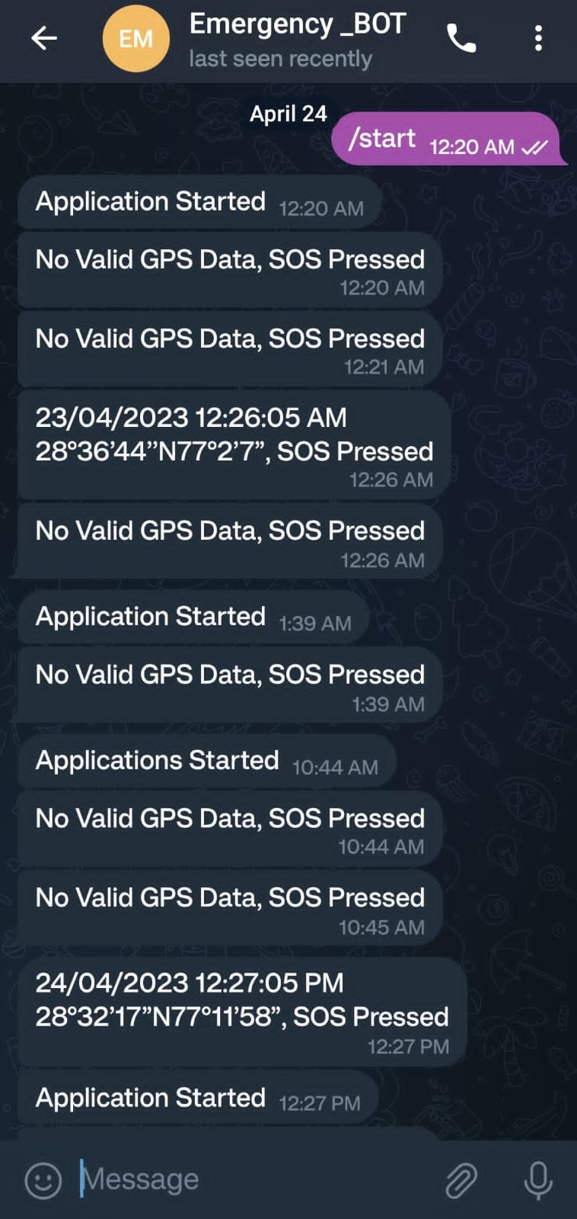

Fig 5

1. Conclusion

In this paper, we propose a method to achieve easily available and efficient devices to help the visually impaired people to deal with daily challenges. Our method works to achieve a low-cost solution.

According to our tests, the solution has shown promising results when faced with the typical problems encountered by visually impaired people. Some trade-offs are made to maintain the cost-effective nature of the solution, which limits the performance of the device, but we believe that such trade-offs are necessary to protect the original intention of the solution, which is to create an easily accessible, viable and affordable product. However, certain components of the solution can be reasonably improved to increase the performance of the product. Number of objects that can be recognized with ESP 32 CAM can be increased to increase the efficiency of the project. We can also improve the efficiency and accuracy of the model by using raspberry Pi Camera module instead of ESP 32 CAM.

At present we have used two ultrasonic sensors one for left and one for right. We can increase the number of ultrasonic sensors to four (one for each of the four directions).

##### References

[1] Ihab A.Satan, and Mokhaled Hamadani, “Design and implement a smart blind stick”,Journal of Advanced Research in dynamic and control system(2019).

# [2] Nagaraju Vankadari and Lakshmi Narayanan, **“**design of smart voice enabled walking stick for visually impaired”,(september 2022).

[3] Jinsoo Cho, “Smart Glass System using deep learning for the blind and visually impaired”,(September 2021).

[4] Hussein-Abdel-Jabbar, “Mobile based IOT solution for helping visually impaired people”,(October 2021).

[5] Ankush Yadav, Manish Kumar and Vijay Gupta,

“ Arduino based third eye for blind people”

[6] Instructables, “third Eye for the blind people”.

[7] Muhammad Azhar, “Third Eye for the blind”,(June 2017)

[8] Venkata Naga Krishna Vamsi Chamakura and Vamshhi Mallula, “ Detecting object position using sensor data”, Dept. of Mathematics and Natural Sciences, Blekinge Institute of Technology,Sweden.

[9] Mohd Hakimi Zohari, “GPS Based Vehicle Tracking System”,International Journal of Scientific & Technology Research (June 2021).

[10] Henry Dietz, Dillon Abney, paul Eberhart, “ ESP32-CAM as a programmable camera research platform.

# [11] Yogender Singh Parihar, “Internet of Things and Nodemcu A review of use of Nodemcu ESP8266 in IOt

Products.”(June 2019)

[12] Wai Kit Wong, Chi Jie Tan, Min Thu Soe, “Fuzzy Logic Based Perceptual Image Hashing Algorithm in Malaysian Banknotes Detection System for the Visually Impaired.”(May 2021)

**IEEE conference templates contain guidance text for composing and formatting conference papers. Please ensure that all template text is removed from your conference paper prior to submission to the conference. Failure to remove template text from your paper may result in your paper not being published.**