Analysis for Table 1

Aaron R. Caldwell

2/25/2021

# Tc Max

ANOVA

|  |  |  |  |  |  |  |
| --- | --- | --- | --- | --- | --- | --- |
| .y. | n | statistic | DFn | DFd | p | method |
| tcmax | 242 | 35.4 | 3 | 78.05306 | 0 | Welch ANOVA |

Pairwise Comparisons

|  |  |  |  |  |  |  |
| --- | --- | --- | --- | --- | --- | --- |
| group1 | group2 | estimate | conf.low | conf.high | p.adj | p.adj.signif |
| EHI0 | EHI1 | 0.310 | 0.221 | 0.398 | 0.000 | **** |
| EHI0 | EHI3 | 0.214 | 0.124 | 0.305 | 0.000 | **** |
| EHI0 | EHI7 | 0.026 | -0.064 | 0.115 | 0.873 | ns |
| EHI1 | EHI3 | -0.095 | -0.204 | 0.014 | 0.107 | ns |
| EHI1 | EHI7 | -0.284 | -0.392 | -0.176 | 0.000 | **** |
| EHI3 | EHI7 | -0.189 | -0.298 | -0.079 | 0.000 | *** |

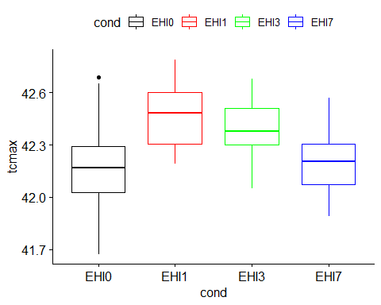

# Time to Tcmax (Heating Time)

ANOVA

|  |  |  |  |  |  |  |
| --- | --- | --- | --- | --- | --- | --- |
| .y. | n | statistic | DFn | DFd | p | method |
| heat_time | 257 | 38.72 | 3 | 72.04163 | 0 | Welch ANOVA |

Pairwise Comparisons

|  |  |  |  |  |  |  |
| --- | --- | --- | --- | --- | --- | --- |
| group1 | group2 | estimate | conf.low | conf.high | p.adj | p.adj.signif |
| EHI0 | EHI1 | 69.9581081 | 47.65527 | 92.260950 | 0.00e+00 | **** |
| EHI0 | EHI3 | 48.4490172 | 26.06613 | 70.831904 | 5.00e-06 | **** |
| EHI0 | EHI7 | 47.9969970 | 28.77509 | 67.218905 | 1.00e-07 | **** |
| EHI1 | EHI3 | -21.5090909 | -50.80527 | 7.787086 | 2.24e-01 | ns |
| EHI1 | EHI7 | -21.9611111 | -49.06959 | 5.147371 | 1.53e-01 | ns |
| EHI3 | EHI7 | -0.4520202 | -27.57913 | 26.675087 | 1.00e+00 | ns |

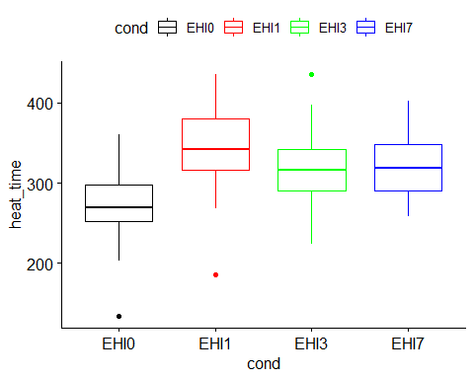

# Thermal Load

ANOVA

|  |  |  |  |  |  |  |
| --- | --- | --- | --- | --- | --- | --- |
| .y. | n | statistic | DFn | DFd | p | method |
| thermal_load | 240 | 72.42 | 3 | 63.22244 | 0 | Welch ANOVA |

Pairwise Comparisons

|  |  |  |  |  |  |  |
| --- | --- | --- | --- | --- | --- | --- |
| group1 | group2 | estimate | conf.low | conf.high | p.adj | p.adj.signif |
| EHI0 | EHI1 | 313.87106 | 238.3485 | 389.39359 | 0.000 | **** |
| EHI0 | EHI3 | 249.92361 | 171.3314 | 328.51587 | 0.000 | **** |
| EHI0 | EHI7 | 200.93785 | 132.2139 | 269.66180 | 0.000 | **** |
| EHI1 | EHI3 | -63.94745 | -166.6081 | 38.71317 | 0.363 | ns |
| EHI1 | EHI7 | -112.93321 | -208.6498 | -17.21662 | 0.014 | * |
| EHI3 | EHI7 | -48.98576 | -146.9885 | 49.01703 | 0.554 | ns |

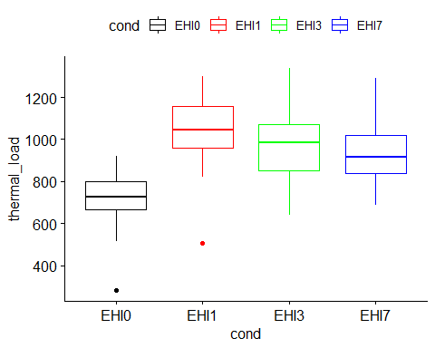

# Running Time

ANOVA

|  |  |  |  |  |  |  |
| --- | --- | --- | --- | --- | --- | --- |
| .y. | n | statistic | DFn | DFd | p | method |
| time | 257 | 38.6 | 3 | 71.97754 | 0 | Welch ANOVA |

Pairwise Comparisons

|  |  |  |  |  |  |  |
| --- | --- | --- | --- | --- | --- | --- |
| group1 | group2 | estimate | conf.low | conf.high | p.adj | p.adj.signif |
| EHI0 | EHI1 | 70.2425676 | 47.80153 | 92.683601 | 0.00e+00 | **** |
| EHI0 | EHI3 | 47.9387797 | 25.37026 | 70.507301 | 7.10e-06 | **** |
| EHI0 | EHI7 | 48.1509009 | 29.04261 | 67.259187 | 1.00e-07 | **** |
| EHI1 | EHI3 | -22.3037879 | -51.83831 | 7.230737 | 2.03e-01 | ns |
| EHI1 | EHI7 | -22.0916667 | -49.23823 | 5.054893 | 1.50e-01 | ns |
| EHI3 | EHI7 | 0.2121212 | -26.99156 | 27.415804 | 1.00e+00 | ns |

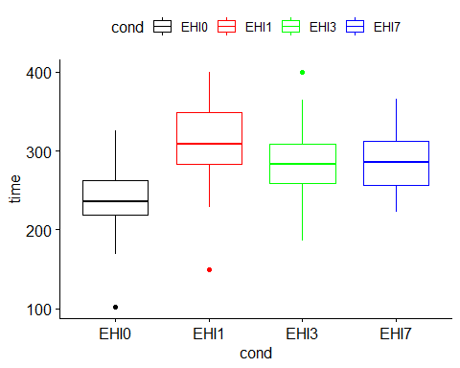

# Distance Run

ANOVA

|  |  |  |  |  |  |  |
| --- | --- | --- | --- | --- | --- | --- |
| .y. | n | statistic | DFn | DFd | p | method |
| dist | 257 | 26.61 | 3 | 70.43644 | 0 | Welch ANOVA |

Pairwise Comparisons

|  |  |  |  |  |  |  |
| --- | --- | --- | --- | --- | --- | --- |
| group1 | group2 | estimate | conf.low | conf.high | p.adj | p.adj.signif |
| EHI0 | EHI1 | 599.93784 | 367.1010 | 832.77466 | 1.00e-07 | **** |
| EHI0 | EHI3 | 379.18111 | 158.8785 | 599.48375 | 2.25e-04 | *** |
| EHI0 | EHI7 | 427.34598 | 219.7183 | 634.97362 | 1.01e-05 | **** |
| EHI1 | EHI3 | -220.75673 | -519.5738 | 78.06035 | 2.19e-01 | ns |
| EHI1 | EHI7 | -172.59186 | -462.9509 | 117.76721 | 4.06e-01 | ns |
| EHI3 | EHI7 | 48.16487 | -232.1025 | 328.43224 | 9.69e-01 | ns |

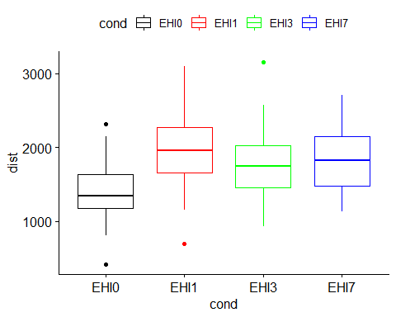

# Dehydration (%)

ANOVA

|  |  |  |  |  |  |  |
| --- | --- | --- | --- | --- | --- | --- |
| .y. | n | statistic | DFn | DFd | p | method |
| dehyd | 268 | 22.72 | 3 | 75.59299 | 0 | Welch ANOVA |

Pairwise Comparisons

|  |  |  |  |  |  |  |
| --- | --- | --- | --- | --- | --- | --- |
| group1 | group2 | estimate | conf.low | conf.high | p.adj | p.adj.signif |
| EHI0 | EHI1 | 1.7639575 | 0.7817904 | 2.746125 | 8.88e-05 | **** |
| EHI0 | EHI3 | 2.2192682 | 1.2782569 | 3.160279 | 7.00e-07 | **** |
| EHI0 | EHI7 | 1.6348742 | 0.8364796 | 2.433269 | 7.80e-06 | **** |
| EHI1 | EHI3 | 0.4553106 | -0.7873657 | 1.697987 | 7.70e-01 | ns |
| EHI1 | EHI7 | -0.1290833 | -1.2745808 | 1.016414 | 9.91e-01 | ns |
| EHI3 | EHI7 | -0.5843939 | -1.6941479 | 0.525360 | 5.11e-01 | ns |

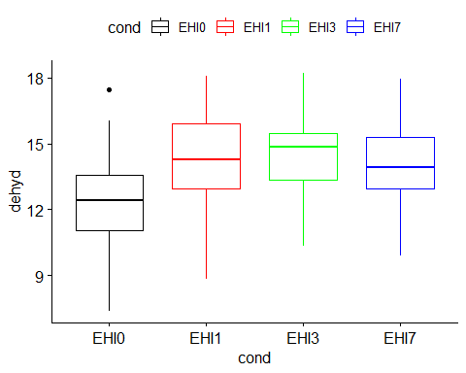

# Hypothermic Depth (Tcmin)

ANOVA

|  |  |  |  |  |  |  |
| --- | --- | --- | --- | --- | --- | --- |
| .y. | n | statistic | DFn | DFd | p | method |
| tcmin | 172 | 237.55 | 3 | 35.39524 | 0 | Welch ANOVA |

Pairwise Comparisons

|  |  |  |  |  |  |  |
| --- | --- | --- | --- | --- | --- | --- |
| group1 | group2 | estimate | conf.low | conf.high | p.adj | p.adj.signif |
| EHI0 | EHI1 | 3.176192 | 2.8632524 | 3.4891325 | 0.00e+00 | **** |
| EHI0 | EHI3 | 1.750081 | 1.1420918 | 2.3580708 | 1.00e-06 | **** |
| EHI0 | EHI7 | 1.798831 | 1.3265884 | 2.2710742 | 0.00e+00 | **** |
| EHI1 | EHI3 | -1.426111 | -2.0439130 | -0.8083093 | 1.66e-05 | **** |
| EHI1 | EHI7 | -1.377361 | -1.8640762 | -0.8906460 | 3.00e-07 | **** |
| EHI3 | EHI7 | 0.048750 | -0.6433747 | 0.7408747 | 9.97e-01 | ns |

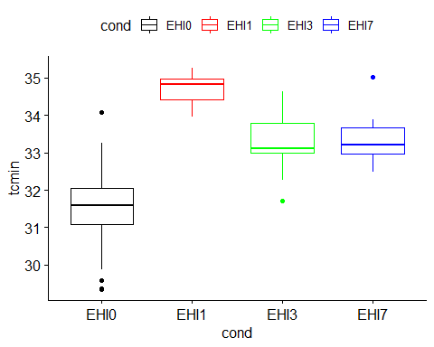

# Duration of Hypothermia

ANOVA

|  |  |  |  |  |  |  |
| --- | --- | --- | --- | --- | --- | --- |
| .y. | n | statistic | DFn | DFd | p | method |
| duration | 170 | 240.26 | 3 | 33.10347 | 0 | Welch ANOVA |

Pairwise Comparisons

|  |  |  |  |  |  |  |
| --- | --- | --- | --- | --- | --- | --- |
| group1 | group2 | estimate | conf.low | conf.high | p.adj | p.adj.signif |
| EHI0 | EHI1 | -244.62810 | -268.59179 | -220.66441 | 0.00e+00 | **** |
| EHI0 | EHI3 | -119.44810 | -180.16473 | -58.73147 | 1.98e-04 | *** |
| EHI0 | EHI7 | -115.65935 | -161.51900 | -69.79970 | 5.30e-06 | **** |
| EHI1 | EHI3 | 125.18000 | 63.63617 | 186.72383 | 1.13e-04 | *** |
| EHI1 | EHI7 | 128.96875 | 81.87709 | 176.06041 | 9.00e-07 | **** |
| EHI3 | EHI7 | 3.78875 | -66.43627 | 74.01377 | 9.99e-01 | ns |

