## 📝 Handcrafted Haven – Weekly Meeting Summary

**Date:** May 12, 2025  
**Participants:**

* Jeremiah Ebizo (Solo Developer)

**Meeting Summary:**

As the sole team member currently assigned to the Handcrafted Haven project, I completed the initial planning and design phase this week. This includes the following progress:

1. **Project repository**
   * Created a GitHub repository and cloned it successfully to local development environment.
   * Created a new **Project** associated with the repository handcrafted-heaven-project.
2. **README.md Created**
   * Added a comprehensive project overview, specifications, tech stack, and placeholder for team members.
3. **Design Theme Finalized**
   * Defined the color palette, typography, UI/UX layout, and accessibility considerations.
   * Documented this theme in a Word file for easy sharing and team onboarding.
4. **User Stories & Work Items**
   * Drafted 10 initial user stories and work item descriptions based on the project specs.
   * These stories serve as the foundation for the project board on GitHub for task tracking.

URL OF THE GROUP REPOSITORY PROJECT:

https://github.com/code-lova/wdd430-Handcrafted-Haven-project

**Evidence of cloned local copy of the group project repository**

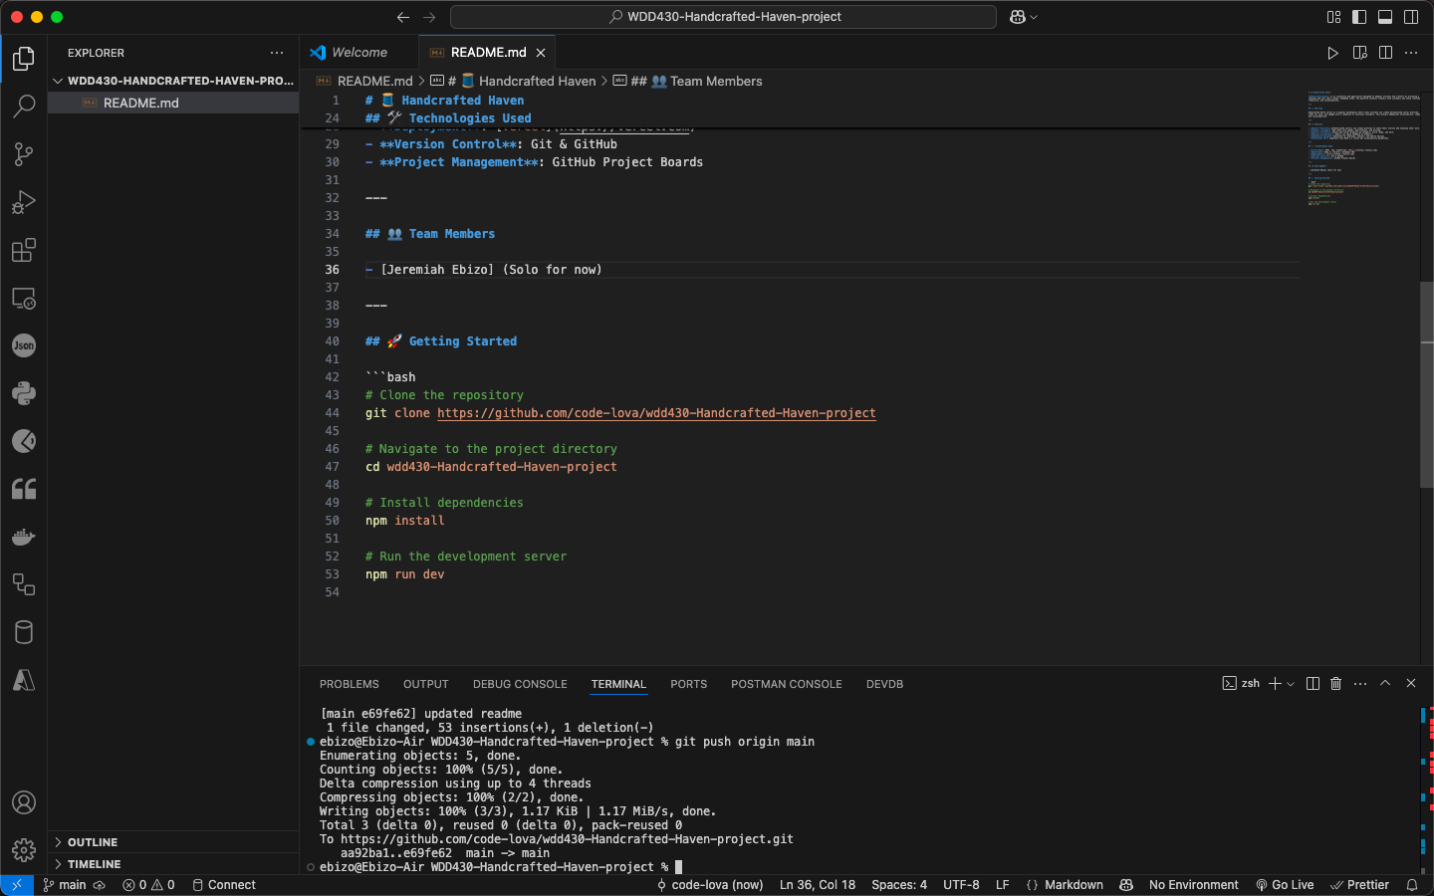

🎨 Design Theme for Handcrafted Haven

# Color Palette

Warm Beige | Background, base UI | #F5F3EF  
Deep Olive | Buttons, accents, headers | #4A5A40  
Terracotta | Call-to-action elements, badges | #D96459  
Soft Gold | Highlights, icons, secondary text | #D9B382  
Rich Brown | Text, borders | #3C2F2F  
*My Inspiration*: Earthy tones to reflect nature, sustainability, and artisanal goods.

# Typography

Heading | Playfair Display (serif) – Elegant, artistic feel  
Body Text | Inter or Lato (sans-serif) – Readable, modern support font  
- Use larger font weights for titles and clear spacing for visual hierarchy.  
- Line height: 1.5 for body, 1.25 for headings.

# Layout & UX

- Grid-based layout for homepage and listings (2–4 column responsive grid).  
- Card-style product previews with hover effects.  
- Clear navbar with logo, categories, and user profile access.  
- Prominent search bar and filters (category, price, availability).  
- Clean footer with links to About, Contact, Terms, etc.

# UI Elements

- Buttons: Rounded, medium padding, hover color shift.  
- Forms: Clean, spacious with floating labels.  
- Modals/Toasts: Subtle, with slide-in transitions.

# Accessibility

- Color contrast ratios will meet or exceed WCAG 2.1 AA.  
- All UI components keyboard-navigable.  
- Alt text for all images, aria labels for custom UI components.

## **🧩 User Stories & Work Items**

### 1. User Authentication

**User Story:**  
As a user, I want to sign up and log in so that I can access personalized features.

**Work Item Description:**  
Implement authentication using credentials, store session token securely, and protect private routes.

### 2. Seller Profile Page

**User Story:**  
As a seller, I want to create and manage my profile so I can present myself and my brand.

**Work Item Description:**  
Allow sellers to edit bio, upload profile image, link social media, and show their listed products.

### 3. Product Listing Form

**User Story:**  
As a seller, I want to upload handcrafted items with details so that they can be listed for sale.

**Work Item Description:**  
Form with fields: title, price, category, description, photos. Connect with database.

### 4. Product Catalog View

**User Story:**  
As a buyer, I want to browse all available handcrafted products easily.

**Work Item Description:**  
Create homepage grid view of products with images, titles, and price.

### 5. Product Filters

**User Story:**  
As a buyer, I want to filter products by category and price range so I can find what I want faster.

**Work Item Description:**  
Add sidebar filter component with dynamic filtering based on selected options.

### 6. Product Details Page

**User Story:**  
As a buyer, I want to view detailed product info including images, description, and seller profile.

**Work Item Description:**  
Create individual item page with full product data and “Add to cart” option.

### 7. Ratings and Reviews

**User Story:**  
As a user, I want to leave a review and rate a product after purchasing.

**Work Item Description:**  
Build review form and display system with star ratings and user comments.

### 8. Shopping Cart

**User Story:**  
As a buyer, I want to add items to my cart and proceed to checkout.

**Work Item Description:**  
Build cart system using local state or context, and UI to modify or remove items.

### 9. Responsive Design

**User Story:**  
As a mobile user, I want the site to work smoothly on my phone or tablet.

**Work Item Description:**  
Ensure responsive layouts using TailwindCSS and media queries. Test across devices.

### 10. Accessibility Compliance

**User Story:**  
As a user with disabilities, I want the site to be accessible via screen readers and keyboard navigation.

**Work Item Description:**  
Audit for WCAG 2.1 AA compliance, implement ARIA roles, alt text, and keyboard-friendly navigation.