Task 1

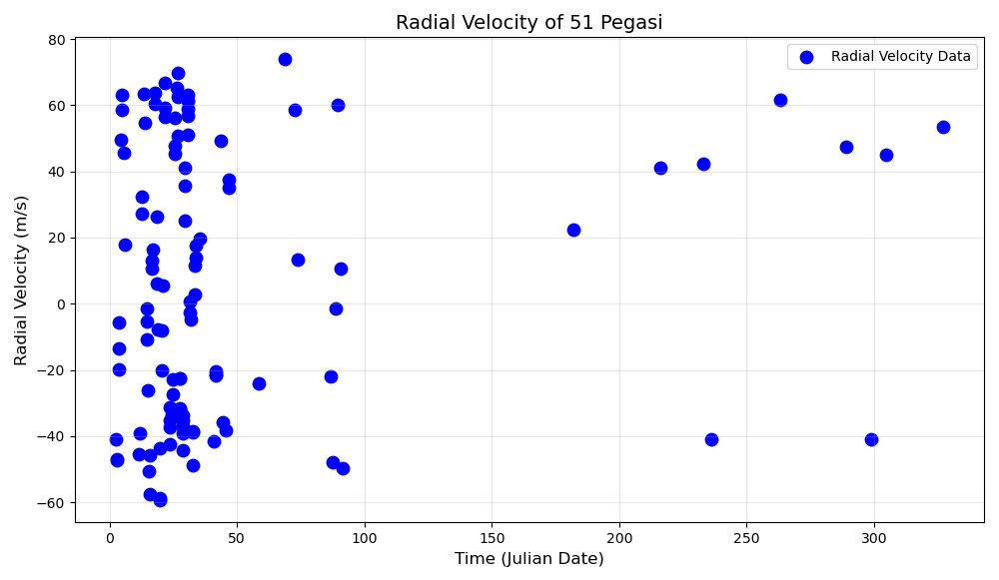

Task 2

From the scatter plot, we can observe a repeating oscillation in the radial velocity of 51 Pegasi. This periodic motion indicates the "wobble" of the star caused by the gravitational pull of an orbiting exoplanet. To estimate the orbital period:

A full cycle corresponds to one peak (maximum radial velocity) followed by a trough (minimum radial velocity) and returning to the next peak.

Observing the scatter plot, the cycles repeat approximately every 4 days, especially in the dense region of data between days 0–50.

Conclusion: The estimated orbital period of the exoplanet is approximately 4 days.

Task 3

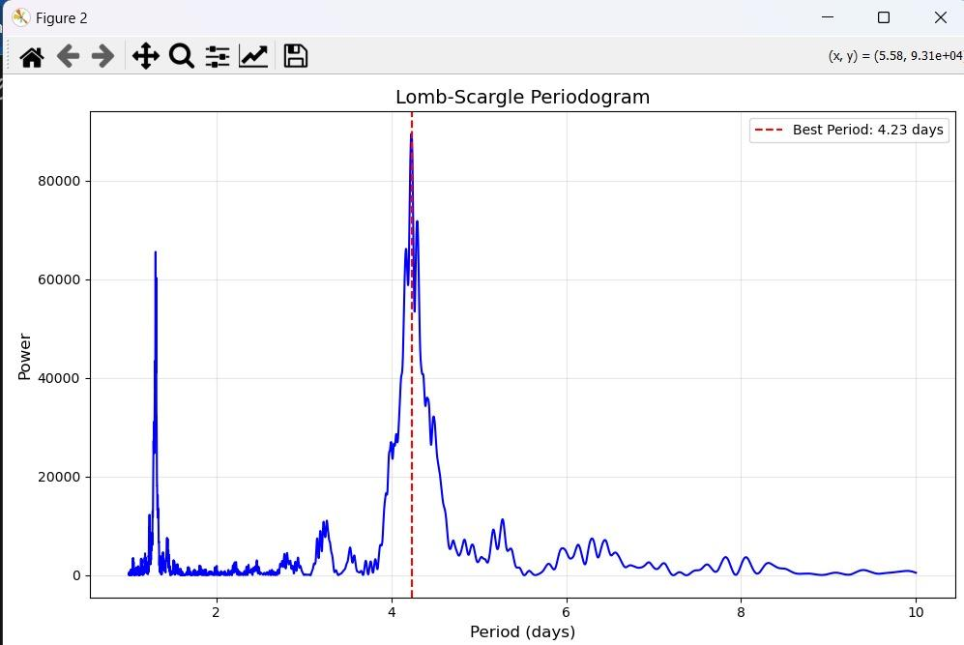

**Explanation of Steps**

Phase Calculation:

Each observation's phase is calculated using the modulo operation with the orbital period.

This wraps the data into a single orbital cycle, representing where each point falls in that cycle.

Sorting by Phase:

Sorting ensures the curve appears smooth and continuous in the plot.

Folded Curve:

The folded radial velocity curve shows the periodic motion of the star due to the gravitational influence of the exoplanet.

**Explanation of Parameters**

Frequency Range: A frequency range of 0.1 to 1.0 cycles/day was chosen based on the scatter plot, where cycles appeared to repeat approximately every 4 days. This frequency range corresponds to periods between 1 day and 10 days.

Angular Frequencies: The Lomb-Scargle formula operates on angular frequencies (ω), which are derived from frequencies (𝑓) using the formula:   
 **ω=2πf**

**Normalization:**

**Time normalization ensures the starting time (t=0) for the dataset, eliminating numerical biases during the analysis.**

**Radial velocity normalization subtracts the mean of radial velocity, centering the analysis around variations instead of absolute values.**

Resolution:

Using 10,000 frequency points provides a fine resolution, enabling precise identification of the peak in the periodogram and ensuring accurate determination of the orbital period.

Task 4

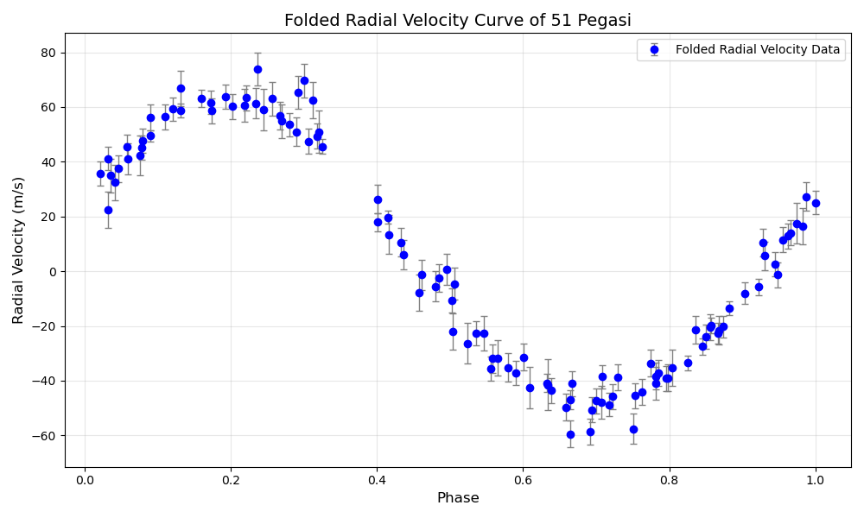

**Discussion of Trends and Noise in the Folded Radial Velocity Curve:**

Notable Trends:

Clear Sinusoidal Pattern:

The data exhibits a strong sinusoidal pattern, confirming a periodic orbital motion caused by the gravitational pull of the exoplanet.

The periodicity aligns with the derived orbital period, and the symmetry of the curve suggests the orbit is nearly circular.

Phase Coverage:

The curve spans the full phase range (0 to 1), providing a complete representation of the star's radial velocity variation over one orbital cycle.

The radial velocity transitions smoothly from peak (positive velocity) to trough (negative velocity), reflecting the motion of the star toward and away from the observer.

Amplitude:

The peak-to-peak amplitude reflects the magnitude of the star’s motion, which is proportional to the planet's mass and the inclination of the orbit.

Noise and Measurement Errors:

Higher Errors at Extreme Radial Velocities:

The error bars are noticeably larger at the extreme ends of the curve (e.g., radial velocity peaks near ±60 m/s). This is likely due to the challenges of accurately measuring high velocities, where instrument precision might be more limited.

Phases with Higher Noise:

Around the phases of 0.2–0.3 and 0.7–0.8, the scatter appears more pronounced. These are the regions where the velocity transitions occur most rapidly, leading to greater uncertainty in pinpointing exact values.

Smaller Errors Near Mid-Phase (0.4–0.6):

In the mid-phase region (where the velocity is near zero), the error bars are smaller, and the data points are more tightly clustered around the sinusoidal trend. This could be due to reduced Doppler shifts when the star's motion is perpendicular to the observer's line of sight.

Outliers:

A few points deviate significantly from the sinusoidal trend, particularly at phases 0.1 and 0.9. These outliers could arise from stellar activity, such as spots or pulsations, or instrumental errors.

Conclusion:

The folded radial velocity curve demonstrates a robust sinusoidal pattern with clear periodicity, strongly supporting the presence of an exoplanet. While errors are more pronounced at extreme radial velocities and rapid transitions (phases near 0.2–0.3 and 0.7–0.8), the overall trend remains intact, with smaller uncertainties near mid-phase. These insights highlight the importance of accounting for noise when modelling the orbital parameters and improving measurement techniques for future observations