Database Output:

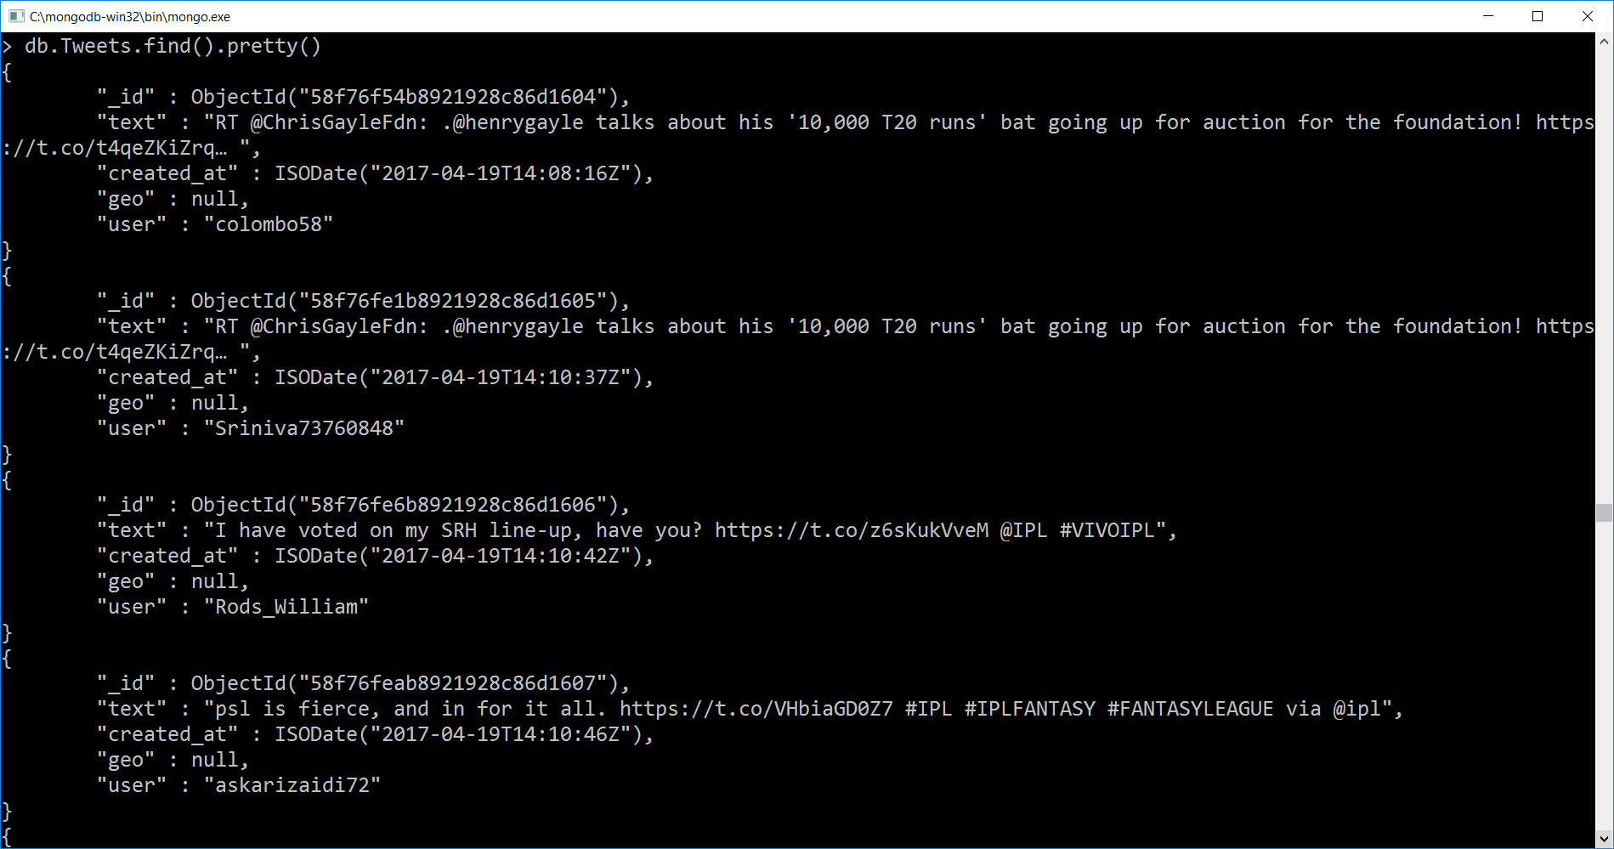

**Time-series analysis Using Python**:

It helps in understanding the interesting events occurred in temporal data. The figure below shows the graph generated at particular times to the volume of the tweets. High peak of the graph shows that during a particular time an interesting phase (such as the batsman hits the six or gets out) has come and hence the users tweeted more, So that the person can understand and simply can jump to that particular event rather than seeing it in whole afterwards. In our graph, at 17:00 the maximum peak level is seen when the #srh team won against #dd.

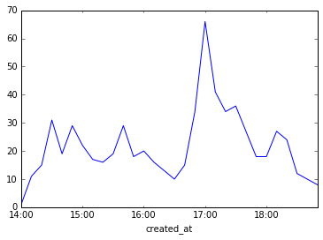

Fig_1.Time series analysis