Name: Majid Ahmed Khan

Roll No.: 19i-1796

Question 1: List all Nobel Prize categories

PREFIX nobel: <http://data.nobelprize.org/terms/>

PREFIX rdf: <http://www.w3.org/1999/02/22-rdf-syntax-ns#>

PREFIX rdfs: <http://www.w3.org/2000/01/rdf-schema#>

PREFIX foaf: <http://xmlns.com/foaf/0.1/>

PREFIX xsd: <http://www.w3.org/2001/XMLSchema#>

select distinct ?o where {

?s nobel:category ?o.

}

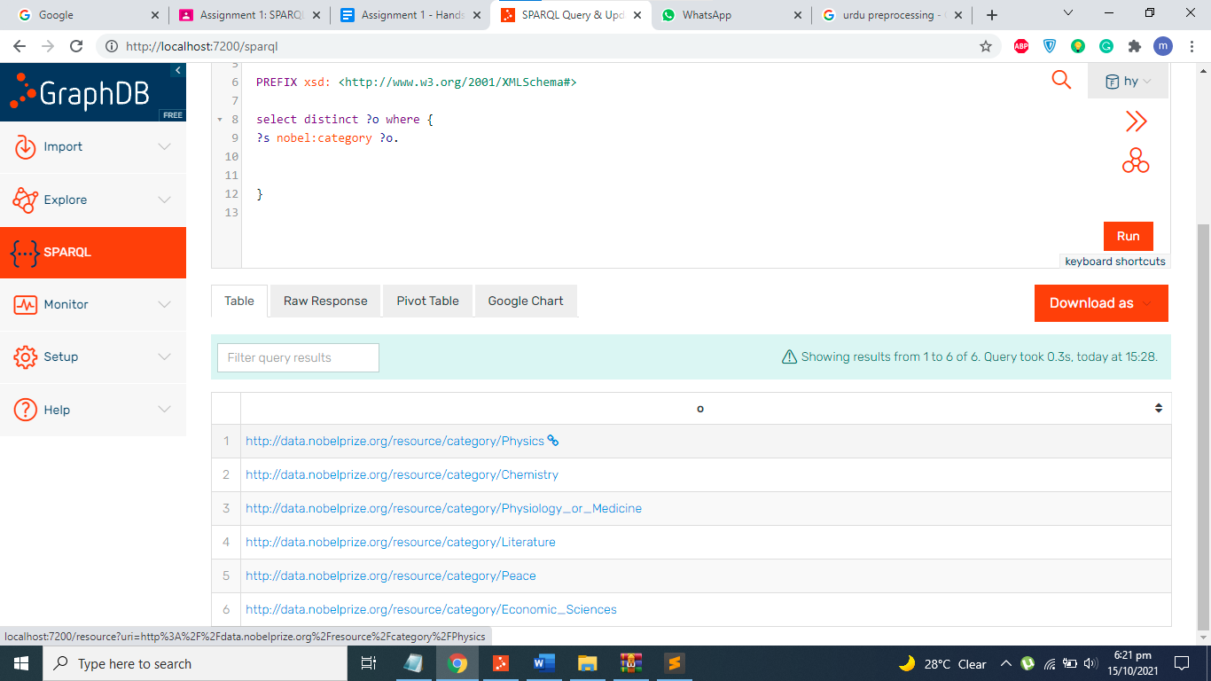

Question 2: List the names of all persons who won the Nobel Prize in Chemistry

PREFIX nobel: <http://data.nobelprize.org/terms/>

PREFIX rdf: <http://www.w3.org/1999/02/22-rdf-syntax-ns#>

PREFIX rdfs: <http://www.w3.org/2000/01/rdf-schema#>

PREFIX foaf: <http://xmlns.com/foaf/0.1/>

select * where {

?win rdf:type nobel:Laureate;

nobel:nobelPrize ?prize;

foaf:givenName ?name.

?prize nobel:category <http://data.nobelprize.org/resource/category/Chemistry>.

}

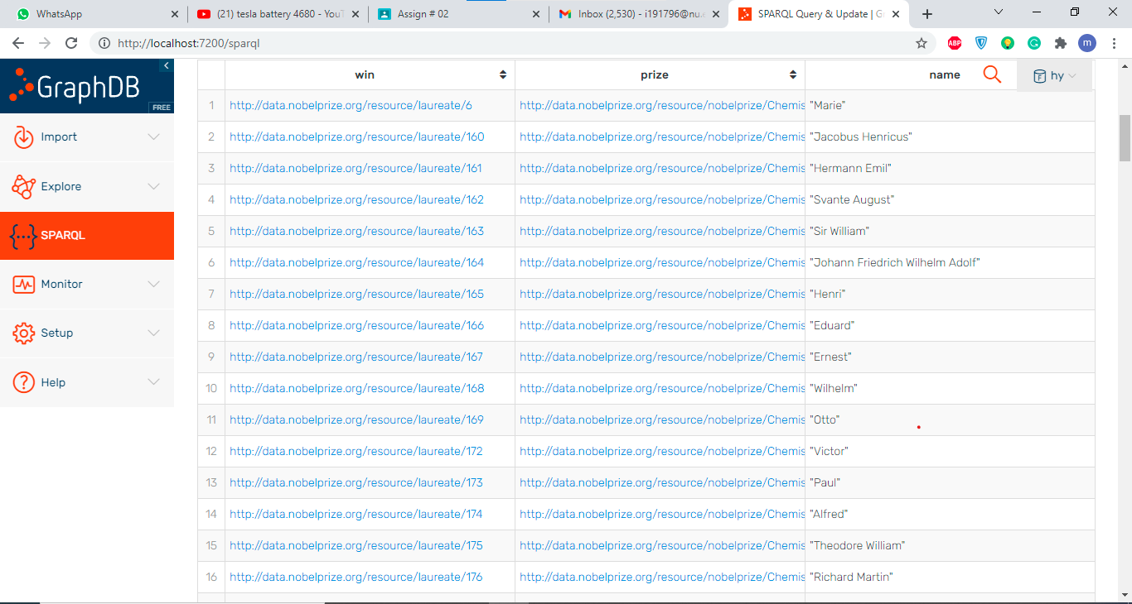

Q3.

PREFIX nobel: <http://data.nobelprize.org/terms/>

PREFIX rdf: <http://www.w3.org/1999/02/22-rdf-syntax-ns#>

PREFIX rdfs: <http://www.w3.org/2000/01/rdf-schema#>

PREFIX foaf: <http://xmlns.com/foaf/0.1/>

select distinct ?name where {

<http://data.nobelprize.org/resource/laureateaward/169> ?p ?o;

rdfs:label ?name.

}

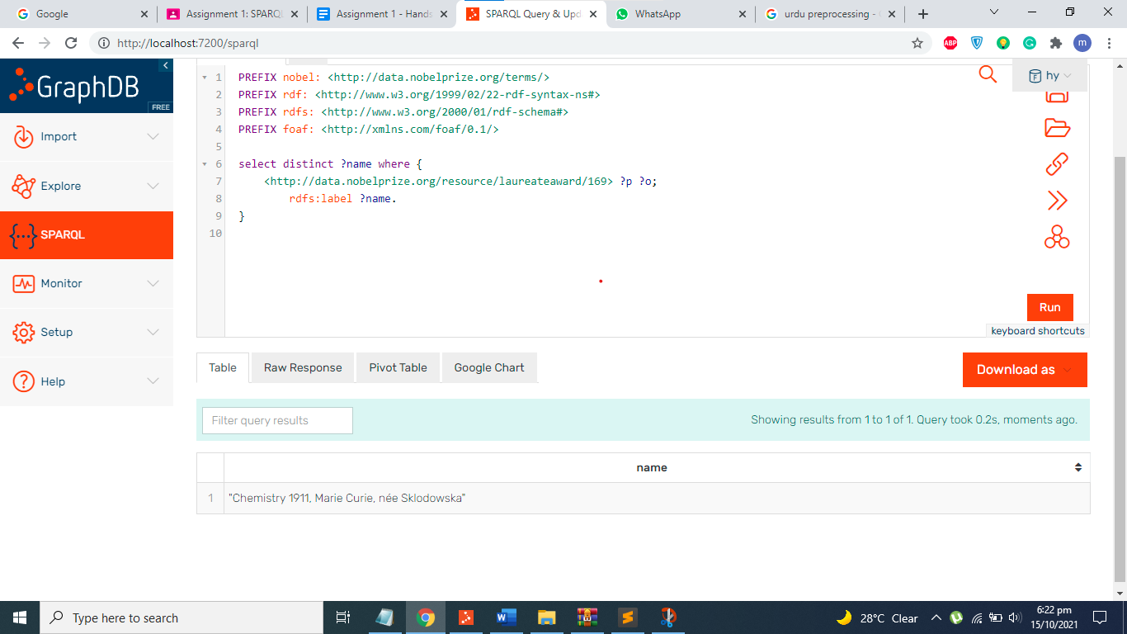

Q4

PREFIX nobel: <http://data.nobelprize.org/terms/>

PREFIX rdf: <http://www.w3.org/1999/02/22-rdf-syntax-ns#>

PREFIX rdfs: <http://www.w3.org/2000/01/rdf-schema#>

PREFIX foaf: <http://xmlns.com/foaf/0.1/>

select * where {

?win rdf:type nobel:Laureate;

nobel:nobelPrize ?prize;

foaf:givenName ?name.

?prize nobel:category <http://data.nobelprize.org/resource/category/Chemistry>.

} order by ?prize

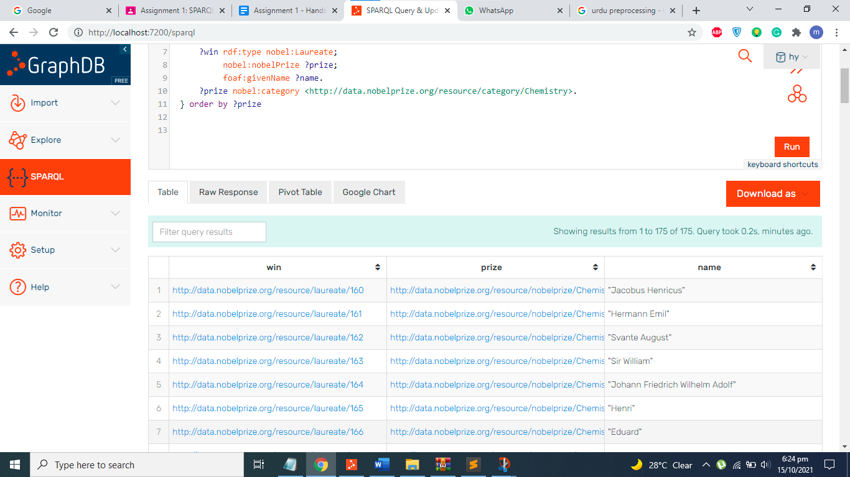

Q5

PREFIX nobel: <http://data.nobelprize.org/terms/>

PREFIX rdf: <http://www.w3.org/1999/02/22-rdf-syntax-ns#>

PREFIX rdfs: <http://www.w3.org/2000/01/rdf-schema#>

PREFIX foaf: <http://xmlns.com/foaf/0.1/>

select * where {

?s <http://data.nobelprize.org/terms/nobelPrize> ?o.

?s foaf:gender ?gender.

FILTER (?gender = "female").

}

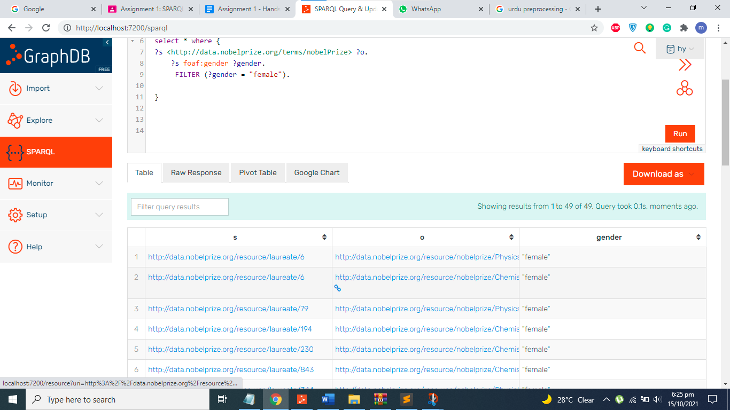

Q6

PREFIX nobel: <http://data.nobelprize.org/terms/>

PREFIX rdf: <http://www.w3.org/1999/02/22-rdf-syntax-ns#>

PREFIX rdfs: <http://www.w3.org/2000/01/rdf-schema#>

PREFIX foaf: <http://xmlns.com/foaf/0.1/>

select * where {

?s <http://data.nobelprize.org/terms/nobelPrize> ?o.

OPTIONAL{?s <http://dbpedia.org/property/dateOfBirth> ?dob;

<http://dbpedia.org/property/dateOfDeath> ?dod;

foaf:givenName ?name.

?o <http://data.nobelprize.org/terms/year> ?awarddate.

}

FILTER (?awarddate = 2000 ).

}

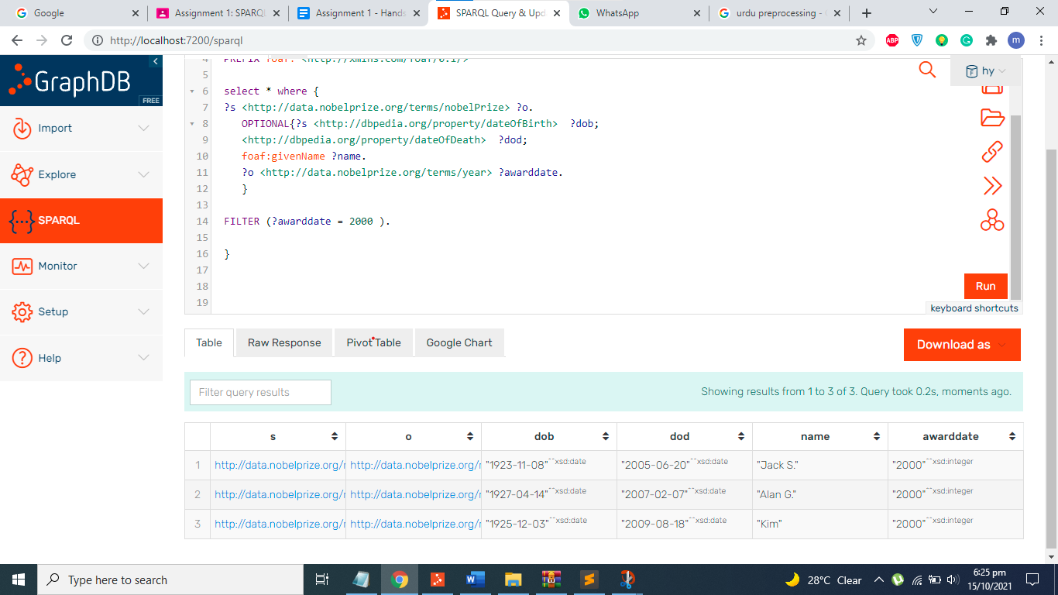

Q7

PREFIX country: <http://data.nobelprize.org/resource/country/>

PREFIX bp: <http://dbpedia.org/ontology/>

select * where{ {

?s bp:birthPlace country:Sweden.

}

UNION

{

?s bp:birthPlace country:Finland.

}}

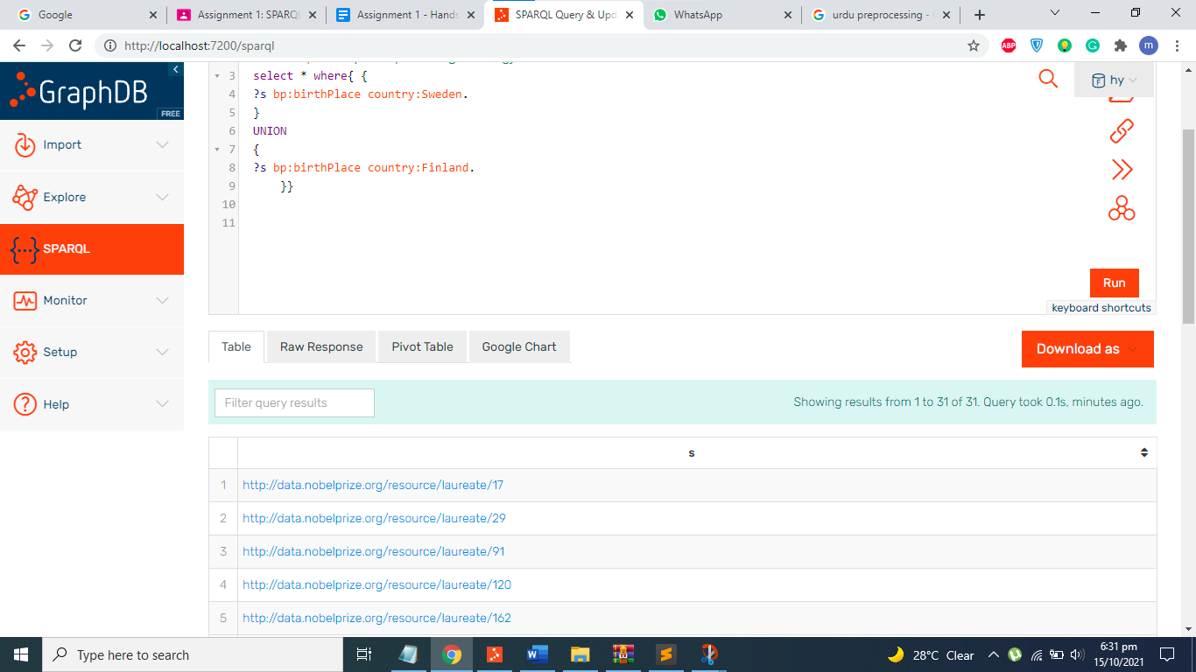

Q8

PREFIX nobel: <http://data.nobelprize.org/terms/>

PREFIX rdf: <http://www.w3.org/1999/02/22-rdf-syntax-ns#>

PREFIX rdfs: <http://www.w3.org/2000/01/rdf-schema#>

PREFIX foaf: <http://xmlns.com/foaf/0.1/>

select * where {

?win rdf:type nobel:Laureate;

nobel:nobelPrize ?prize;

<http://dbpedia.org/property/dateOfBirth> ?dob;

foaf:givenName ?name.

?prize nobel:category <http://data.nobelprize.org/resource/category/Chemistry>.

}

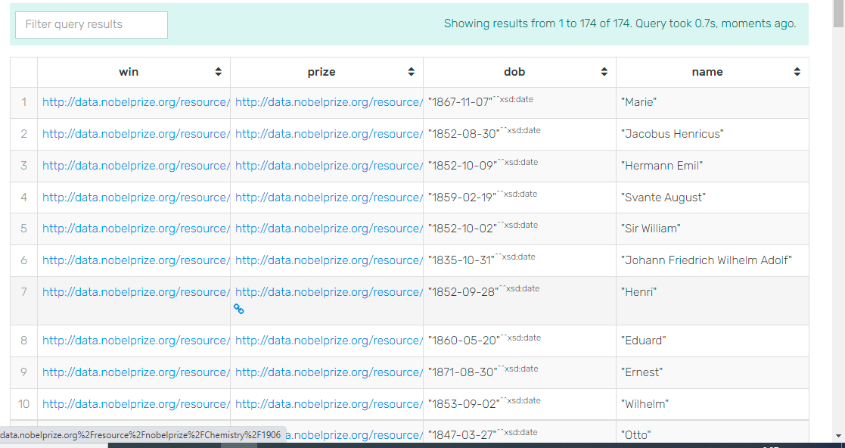

Q9

PREFIX nobel: <http://data.nobelprize.org/terms/>

PREFIX rdf: <http://www.w3.org/1999/02/22-rdf-syntax-ns#>

PREFIX rdfs: <http://www.w3.org/2000/01/rdf-schema#>

PREFIX foaf: <http://xmlns.com/foaf/0.1/>

PREFIX xsd: <http://www.w3.org/2001/XMLSchema#>

select (avg((?do - year(xsd:dateTime(?dob)))) as ?avg_duration)

where {

?win rdf:type nobel:Laureate;

nobel:nobelPrize ?prize;

<http://dbpedia.org/property/dateOfBirth> ?dob;

foaf:givenName ?name.

?win <http://data.nobelprize.org/terms/laureateAward> ?o.

?prize nobel:category <http://data.nobelprize.org/resource/category/Chemistry>.

?o <http://data.nobelprize.org/terms/year> ?do.

}

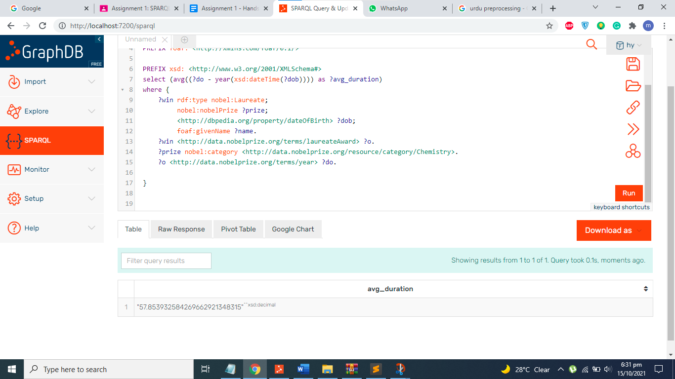

Q10

REFIX rdfs: <http://www.w3.org/2000/01/rdf-schema#>

PREFIX rdf: <http://www.w3.org/1999/02/22-rdf-syntax-ns#type>

PREFIX foaf: <http://xmlns.com/foaf/0.1/>

PREFIX nobel: <http://data.nobelprize.org/terms/>

PREFIX owl: <http://www.w3.org/2002/07/owl#>

PREFIX award: <http://data.nobelprize.org/terms/laureateAward/>

PREFIX prop: <http://dbpedia.org/property/>

PREFIX xsd: <http://www.w3.org/2001/XMLSchema#>

SELECT ?lb (avg((?yearwn - year(xsd:dateTime(?dob)))) as ?avg_duration)

WHERE

{

?laureate a nobel:Laureate.

?laureat foaf:givenName ?laureatename;

prop:dateOfBirth ?dob.

?laureate nobel:nobelPrize ?award.

?award nobel:category ?var.

?award nobel:year ?yearwn.

?var rdfs:label ?lb.

} group by ?lb

