**Type Your Group Name**

**Health** **Management System**

**Introduction:**  This project is related to health management system that will tracks the weight of patients visiting Clinic. The system administrator should be able to view the weight, the average weights and the number of visits of each patient.

**Technology and tool:** python, anaconda, not book (ipynb file)

**Problem solve:**

I explain step by step how we solve problem. As per requirement of project this project related to file handling base with text file Inside this project we had to read the data and then we had to show it properly so that the user can see what data we have done. this project had seven function which are given below some function had own calculation which I explain in description of each method

* **main()**
* **get Weight(weight)**
* **getAllPatientRecord( )**
* **getPatient(patientID)**
* **update(patientID, weight)**
* **addPatient(Name, patientID)**
* **Delete Patient**
* **Exit**

1. **Main function**

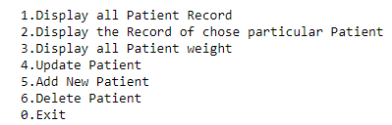This function show main menu to user 1 to 6 option and 0 for exit project in this function we used the loop which continuity work if we do not exit project by entering 0 until this loop will be work in under loop we call 6 function this function will call when user input choice the user will any call these functions by entering the number as you see in my output screen

1. 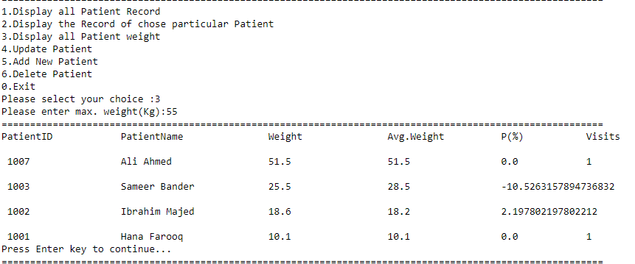**get Weight(weight)**

This method will be prompts and reads a maximum weight from the user. Then it displays all patients with weight less than or equal to the given weight when the user press 3 then call get weight function this function take a perimeter which name weight in the body of function we use exception handling by using try catch because we want read text file if file does not exit then our programe show error which is not proper way by using try catch we can easily handle this exception and show proper error msg on screen so after reading the file we split string then store dictionary After that we use some calculation according to requirement and show proper weight as per requirement on screen p=((float(y[2])-float(y[3]))/float(y[3]))*100 at last we use temp variable for press any key to execute

1. 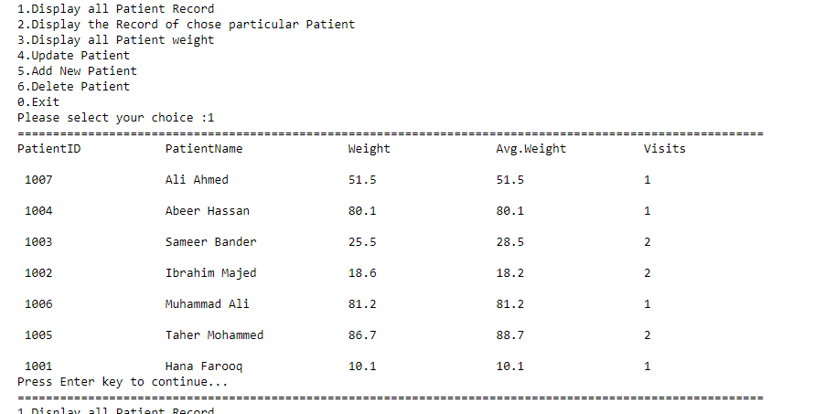**getAllPatientRecord( )**

This method will displays all the Patients information recorded, when the user press 1 then call get All patient Record function in the body of function we use exception handling by using try catch because we want read text file if file does not exit then our programe show error which is not proper way by using try catch we can easily handle this exception and show proper error msg on screen so after reading the file we split string then store dictionary after using for loop read line by line from text file and show proper out put in the tabular form.

1. 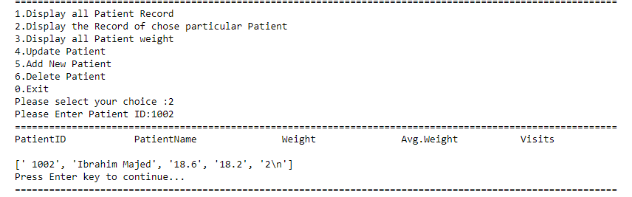**getPatient(patientID)**

1.This method will search PatientID in the text-file. If the Patient is found then show all information about person otherwise will show appropriate error message is displayed when the user press 2 then call get A patient Record particular patient this function take a 1 perimeter of id then function in the body of function we use exception handling by using try catch because we want read text file if file does not exit then our programe show error which is not proper way by using try catch we can easily handle this exception and show proper error msg on screen so after reading the file we split string then store dictionary after that use loop and read from file data and compere 1 by 1 patient id and show id again data on screen as you can see picture if we search 1002 then the data will be show Ibrahim majied,18.6,18.2

1. **update(patientID, weight)**

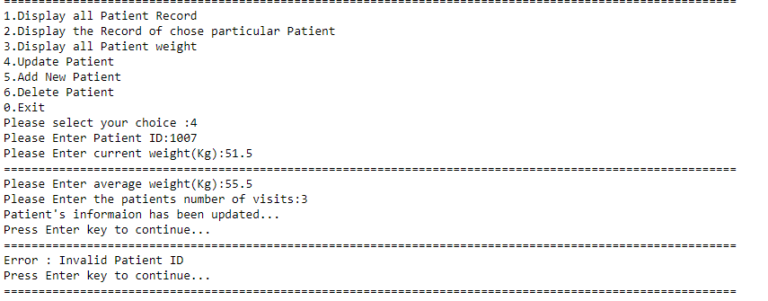This function update take two perimeters from user(patientID, weight) and update recorded of patient when the user press 4 then call get update patient this function take a 2 perimeter of id and weight then function in the body of function we use exception handling by using try catch because we want read text file if file does not exit then our programe show error which is not proper way by using try catch we can easily handle this exception and show proper error msg on screen so after reading the file we split string then store dictionary after that use loop and read from file data and compere 1 by 1 patient id if it is not exit then our method will be show proper msg on screen like this patient is not exit if patient already exit as compare to id them our function will update the data and show proper msg on screen the **Patient information has been updated**

1. **addPatient(Name, patientID)**

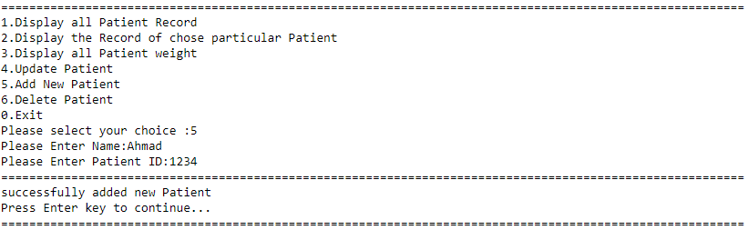this method will append the new record by search patient id if Already exit then this method show error massage patient when the user press 4 then call get update patient this function take a 2 perimeter of id and name then function in the body of function we use exception handling by using try catch because we want read text file if file does not exit then our programe show error which is not proper way by using try catch we can easily handle this exception and show proper error msg on screen so after reading the file we split string then store dictionary after that use loop and read from file data and compere 1 by 1 patient id if it is not exit then our method will be add new person data in to file and show msg successfully added new patient if patient already exit as compare to id them our function will show proper msg on Error the patient already exit

**Delete Patient**

this search method will match the PatientID from text-file the and deleted the patient if not search then show error msg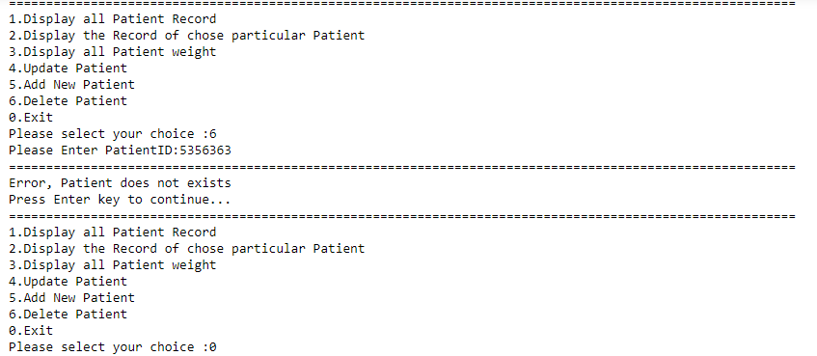 when the user press 4 then call get update patient this function take a 2 perimeter of id and name then function in the body of function we use exception handling by using try catch because we want read text file if file does not exit then our programe show error which is not proper way by using try catch we can easily handle this exception and show proper error msg on screen so after reading the file we split string then store dictionary after that use loop and read from file data and compere 1 by 1 patient id if id is exit then our method will be delete and show proper msg on screen if id not exit then show proper msg as you can see in the picture

**Exit :** when the user enter 0 then our program stop as per requirement of project.

**After doing this project we have been able to take data from** a file and run it in any program and it is really a matter of great pride for me. I really enjoyed doing this project. This project is a challenge for me. I worked very hard and after working hard I did this project. I have learned a lot from doing this project and I have done a lot of work with interest